The Conduct of Ms Burch MLA
Standing Committee on Administration and Procedure
June 2015
Report 6

Committee membership

Vicki Dunne MLA (Chair)

Chris Bourke MLA

Shane Rattenbury MLA

Brendan Smyth MLA

Secretariat

Tom Duncan (Secretary)

Anne Shannon (Acting Assistant Secretary)

Contact information

Telephone 02 6205 0173

Facsimile 02 6205 3109

Post GPO Box 1020, CANBERRA ACT 2601

Email admin.proc@parliament.act.gov.au

Website www.parliament.act.gov.au

Resolution of appointment

In 1995 the Legislative Assembly for the Australian Capital Territory (‘the Assembly’) amended Standing Order 16, which established the Standing Committee on Administration and Procedure (‘the Committee’).

Standing Order 16 authorises the Committee to inquire into and report on, among other things, the practices and procedure of the Assembly.

Terms of reference
Continuing resolution 5AA

COMMISSIONER FOR STANDARDS

This resolution provides for the appointment of a Legislative Assembly Commissioner of Standards.

Resolution agreed by the Assembly
31 October 2013

COMMISSIONER FOR STANDARDS
That this Assembly requests the Speaker to appoint a Legislative Assembly Commissioner for Standards on the following terms:
- The Speaker must, after each Assembly is elected or whenever the office becomes vacant, appoint a Commissioner for the life of that Assembly and the period of three months after each election. The initial appointment is for the term of the 8th Assembly and the period of three months after the election at the conclusion of that term.
- Before appointing a Commissioner, the Speaker must consult with the Chief Minister, the Leader of the Opposition and Crossbench Members.
- The Commissioner may be dismissed only following a resolution of the Legislative Assembly resolving to require the Speaker to end the Commissioner’s appointment—
  - for misbehaviour; or
  - for physical or mental incapacity, if the incapacity substantially affects the exercise of the Commissioner’s functions.
However, a motion for such a resolution may only be debated after the Standing Committee on Administration and Procedure (‘the Committee’) has reported to the Assembly that it is satisfied that the Commissioner is unfit for the office or unable to fulfil the Commissioner’s functions.
- The functions of the Commissioner are to:
  - investigate specific matters referred to the Commissioner—
    - by the Speaker in relation to complaints against Members; or
    - by the Deputy Speaker in relation to complaints against the Speaker; and
  - report to the Standing Committee on Administration and Procedure.
- Members of the public, members of the ACT Public Service and Members of the Assembly may make a complaint to the Speaker about a Member’s compliance with the Members’ Code of Conduct or the rules relating to the registration or declaration of interests.
- If the Speaker receives a complaint about a Member pursuant to paragraph (5) and the Speaker believes on reasonable grounds that—
  - there is sufficient evidence as to justify investigating the matter; and
  - the complaint is not frivolous, vexatious or only for political advantage;
the Speaker may refer the complaint to the Commissioner for investigation and report.
- Members of the public, members of the ACT public service and Members of the Assembly may make a complaint to the Deputy Speaker about the Speaker’s compliance with the Members’ Code of Conduct or the rules relating to the registration or declaration of interests.
- If the Deputy Speaker receives a complaint about the Speaker pursuant to paragraph (7) and the Deputy Speaker believes on reasonable grounds that—
  - there is sufficient evidence to justify investigating the matter; and
  - the complaint is not frivolous, vexatious or only for political advantage;
the Deputy Speaker may refer the complaint to the Commissioner for investigation and report.
- In exercising the functions of Commissioner the following must be observed:
  - The Commissioner must not make a report to the Committee if the Member or the Speaker about whom the complaint was made has agreed that he or she has failed to register or declare an interest if —
    - in the Commissioner’s opinion the interest involved is minor or the failure was inadvertent; and
    - the Member concerned has taken such action to rectify the failure as the Commissioner may have required within any procedure approved by the Committee for this purpose.
  - The Commissioner must not make a report to the Committee unless the Commissioner has—
    - given a copy of the proposed report to the Member or the Speaker who is the subject of the complaint under investigation;
    - the Member or the Speaker has had a reasonable time to provide comments on the proposed report; and
    - the Commissioner has considered any comments provided by the Member or the Speaker.
  - The Commissioner must report by 31 August each year to the Speaker on the exercise of the functions of the Commissioner.
- The Committee must review the operation of the Commissioner after two years following the initial appointment of the Commissioner and report to the Assembly in the first sitting period in 2016.

Continuing resolution 5
CODE OF CONDUCT
FOR ALL MEMBERS OF THE LEGISLATIVE ASSEMBLY
FOR THE AUSTRALIAN CAPITAL TERRITORY

This resolution provides for a code of conduct for Members of the Legislative Assembly.

Resolution agreed by the Assembly
25 August 2005 (amended 16 August 2006, 24 October 2013)

CODE OF CONDUCT FOR ALL MEMBERS OF THE LEGISLATIVE ASSEMBLY FOR THE AUSTRALIAN CAPITAL TERRITORY
The Members of the Legislative Assembly for the Australian Capital Territory acknowledge that, in a parliamentary democracy they cannot command, but must constantly strive to earn and maintain, the respect and support of those who have elected them to their positions of honour and privilege as Members.
In committing to this Code of Conduct, Members undertake, to the community and to one another, that the following principles shall guide their conduct as Members in all matters:
- Members should at all times act with integrity, honesty and diligence.
- Members should act only in the interests of, and with respect for, the people of the Australian Capital Territory and in conformity with all laws applicable in the Territory.
- Members should always act in the public interest, make decisions and choices on merit, and not seek to gain financial or other benefit for themselves, their family or friends.
- Members should be reasonably accessible to the people of the electorate they have been elected to serve, and should represent their interests conscientiously.
- Members should be transparent in, and accountable for, their decisions and actions, should avoid or appropriately resolve any actual or reasonably perceived conflicts of interest and should submit themselves to appropriate scrutiny.
- Members should make only proper use of those public resources to which they have access.
- Members should respect the dignity and privacy of individuals, and not disclose confidential information to which they have official access other than with consent or as permitted by law.
- Members should observe proper standards of parliamentary conduct, and observe respect for differences and fairness in their political dealings.
- Members should promote and support these principles by leadership and example, in order to maintain and support public trust and confidence in the integrity of the Assembly and the conduct by its Members of public business.
Consistent with the above principles, Members further undertake that they should:
- Actively seek to prevent any conflict of interest, or the perception of such a conflict, arising between their duties as a Member and their personal affairs and interests, take all reasonable steps to resolve any such conflict or perception of a conflict that does arise, and:
  - comply with section 15 of the Australian Capital Territory (Self-Government) Act 1988 (Cwth);
  - declare their pecuniary interests and ensure that their declaration is kept up to date pursuant to the resolution of the Assembly ‘Declaration of Private Interests of Members’ agreed to on 7 April 1992 (as amended or replaced from time to time). Include in the Member’s Statement of Registrable Interests all gifts, payments, fees, rewards or benefits valued at more than $100 received in connection with the Member’s functions as a Member; and
  - disclose in a manner appropriate to the circumstances any other financial or non-financial interest that they may hold, or which they may be reasonably perceived to hold (other than as a member of the public or of a broad class of persons) which a reasonable observer, informed of that interest, might perceive as giving rise to a conflict of interest with the performance of the Member’s duty as a Member.
- Not solicit to undertake, or undertake, any activity as a Member in return for the provision, promise or expectation of any improper benefit to the Member or to another person.
- Take care to consider the rights and reputations of others before making use of their unique protection of parliamentary privilege consistent with the resolution of the Assembly ‘Exercise of freedom of speech’ agreed to on 4 May 1995 (as amended or replaced from time to time).
- Not use information received by them as a Member that is not in the public domain in breach of any obligation of confidence applicable to their receipt of that information, or improperly for the private benefit of themselves or another person.
- In their capacity as an employer on behalf of the Territory under the Legislative Assembly (Members’ Staff) Act 1989:
  - familiarise themselves and comply with the terms and conditions on which their personal staff are engaged and with all applicable policies and practices (including those related to occupational health and safety, discrimination, harassment and bullying, equal employment opportunity and use of information technology);
  - not employ a family member as defined in that Act;
  - direct their personal staff to be mindful of the Member’s commitment to this Code of Conduct, and to assist the Member to comply with this Code of Conduct; and
  - direct their personal staff to comply with any code of conduct applicable to those staff from time to time.
- In all their dealings with staff of the Assembly and members of the ACT Public Service:
  - extend professional courtesy and respect; and
  - recognise the unique position of impartiality and the obligations of Public Service officials.
- Only make a complaint about the compliance of another Member with this Code of Conduct where they believe there are reasonable grounds to suspect non-compliance and not make any such complaint that is frivolous or vexatious or only for political advantage.
- Cooperate fully with any official inquiry that may be commenced in connection with their compliance with this Code of Conduct, or that of another Member.

Table of contents
Committee membership xxix
Secretariat xxix
Contact information xxix
Resolution of appointment xxx
Terms of reference xxx
Recommendation xxxvi
1 Introduction 1
2 Conduct of the Commissioner’s inquiry 1
3 The Commissioner’s Findings 1
4 The Committee’s Recommendation 1
Appendix A Letter to the Speaker from Mr Jeremy Hanson CSC MLA, dated 23 February 2015 3
Appendix B Letter to the Commissioner of Standards from the Speaker, dated 26 February 2015 34
Appendix C The Conduct of Ms Burch MLA—Report by The Hon Dr Ken Crispin QC, dated 28 May 2015. 36

Recommendation
Recommendation 1
That no further action be taken in relation to this matter.

Introduction
On 23 February 2015 Mr Jeremy Hanson MLA wrote to the Speaker to claim that Ms Joy Burch MLA had breached sections 3, 5, 9 and 10 of the Members’ Code of Conduct (see Appendix A). The matter was referred to the Commissioner for Standards, the Honourable Dr Ken Crispin QC, by the Speaker of the Legislative Assembly, Mrs Vicki Dunne MLA on 26 February 2015 (see Appendix B).
The Standing Committee on Administration and Procedure has now received a report from the Commissioner for Standards on his investigation into a complaint raised by Mr Hanson.
A copy of the Commissioner’s findings is published as Appendix C to this report.

Conduct of the Commissioner’s inquiry
The Commissioner wrote to Ms Burch MLA, Mr Martin Fisk (CEO Menslink), Mr Hanson MLA and an officer of Menslink, Mr Neale Roberts. He also received a brief of a report by Rear Admiral Clarke, the then chair of Menslink. Having considered all of that material he drafted a report which he sent to Ms Burch. The Commissioner considered the response of Ms Burch and then forwarded a copy of his report to this Committee.

The Commissioner’s Findings
The Commissioner found as follows:
132 The complaint raised potentially serious issues about the conduct of the Minister who holds high offices in the Australian Capital Territory. In my opinion, there was sufficient evidence to warrant referral of the matter for an independent investigation. However, that investigation has now been completed and, after examining the issues raised, I have formed the view that no breach of the Minister’s duty has been substantiated.
133 I recommend that the complaint be dismissed.

The Committee’s Recommendation
The Committee, in accordance with continuing resolution 5AA, has considered the Commissioner’s report and concurs with his conclusion.
The Committee therefore recommends:
Recommendation 1
That no further action be taken in relation to this matter.
The Committee has chosen to publish the Commissioner’s report in full as an appendix to this report, but has decided not to publish the appendices to the Commissioner’s report as the Committee considered some of the content to be outside the scope of the issue before the Committee.

Vicki Dunne MLA
Chair
June 2015

              - Letter to the Speaker from Mr Jeremy Hanson CSC MLA, dated 23 February 2015

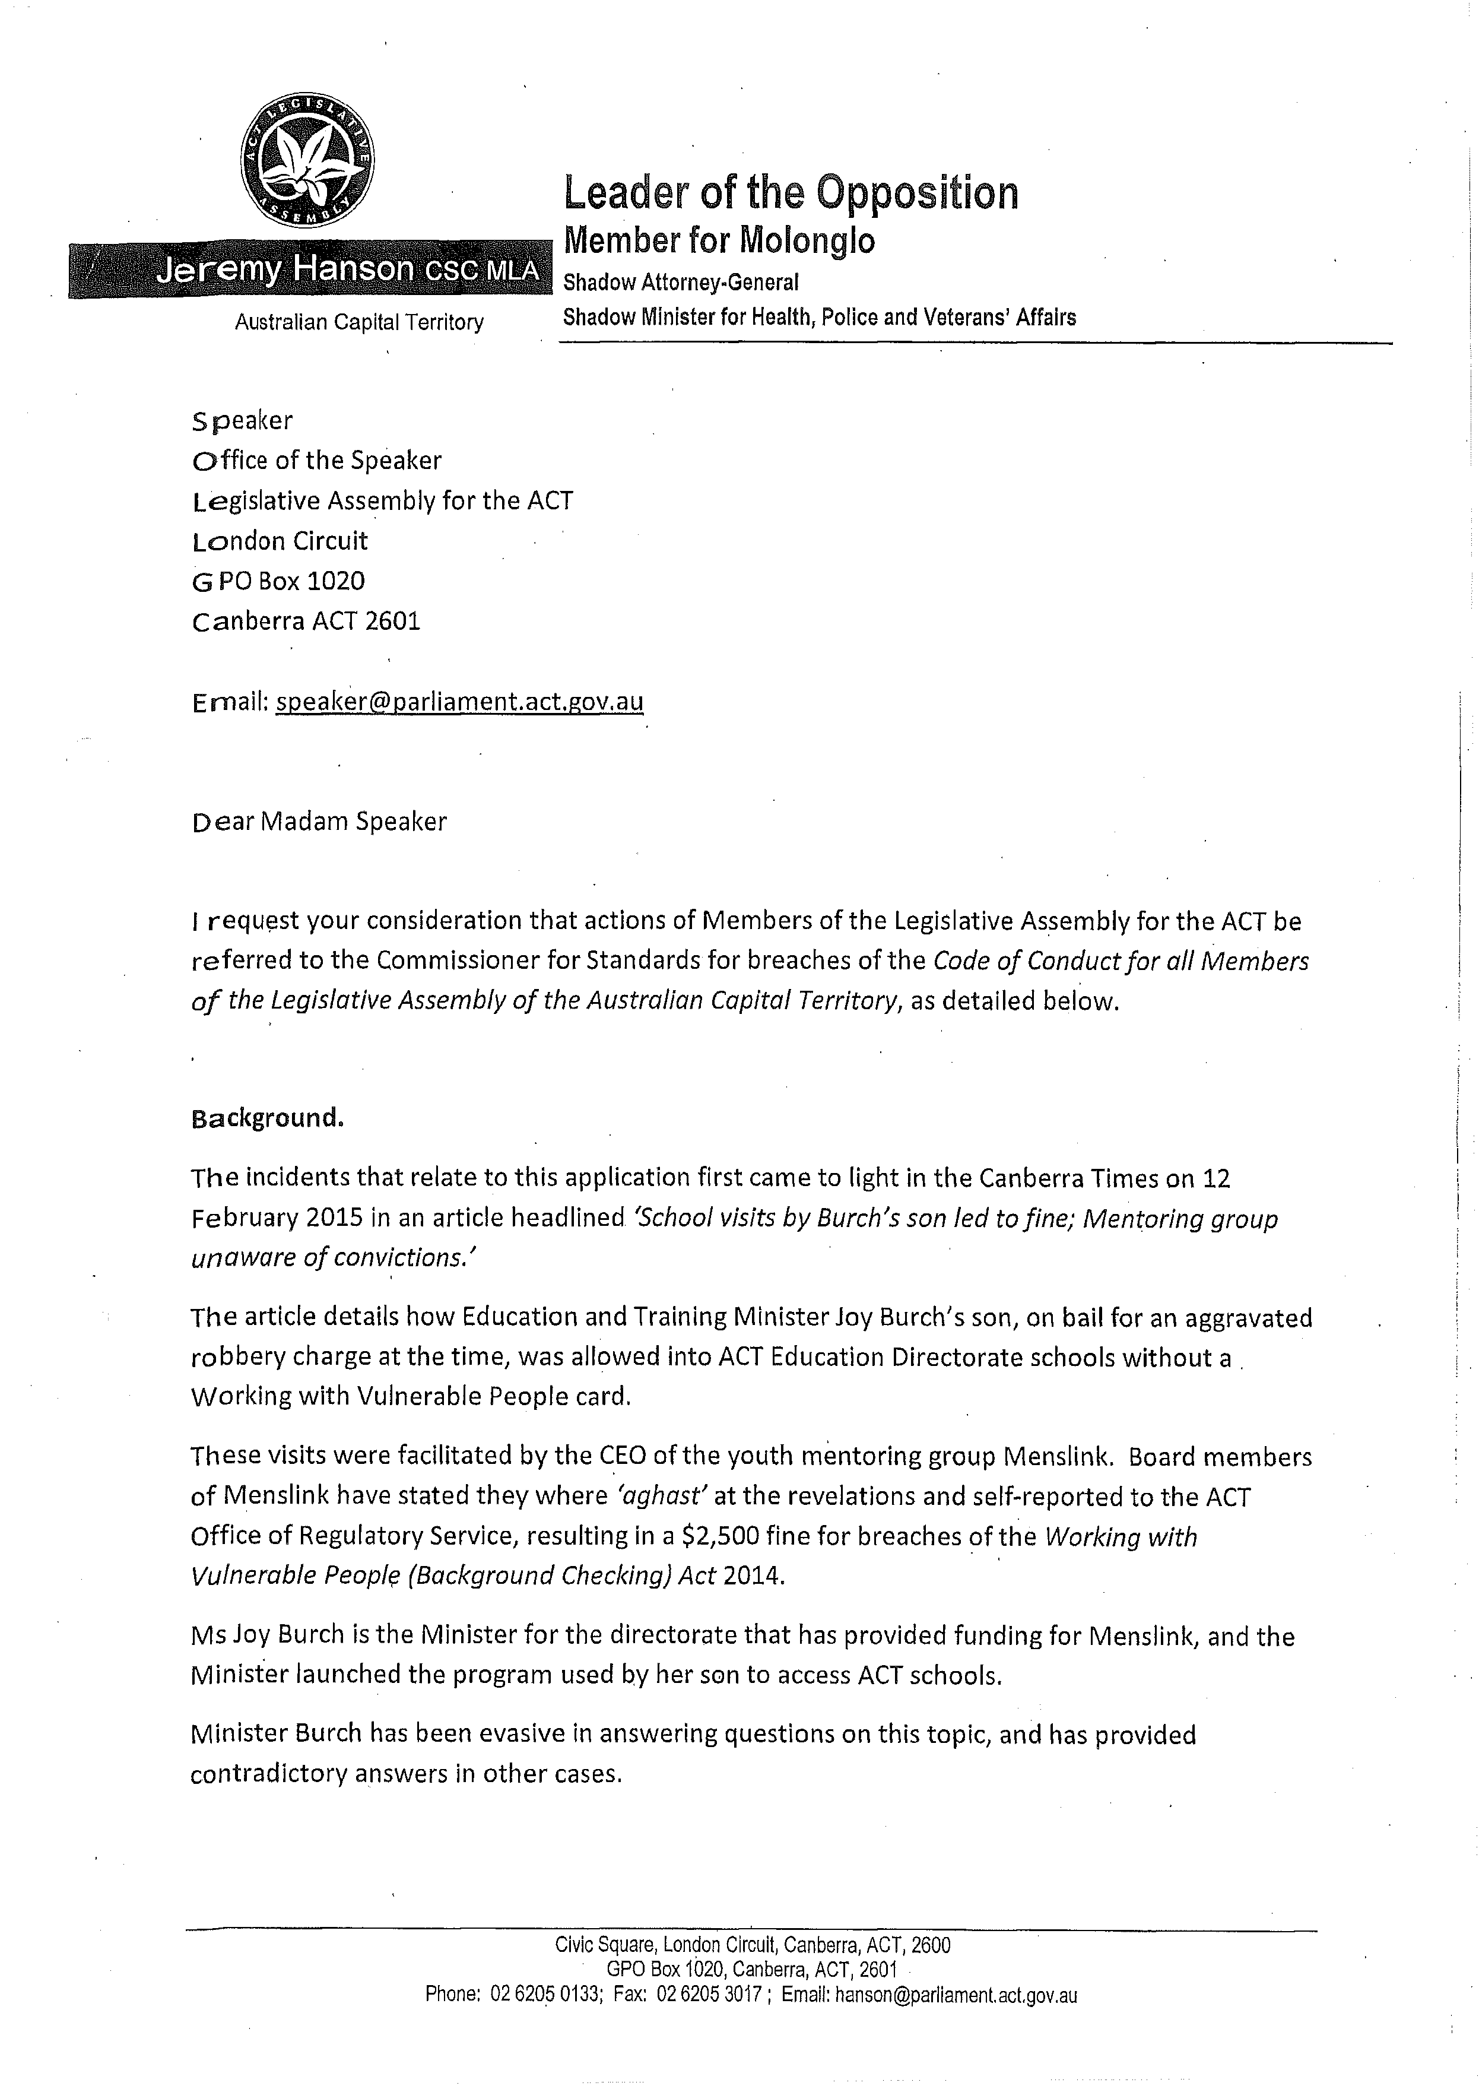
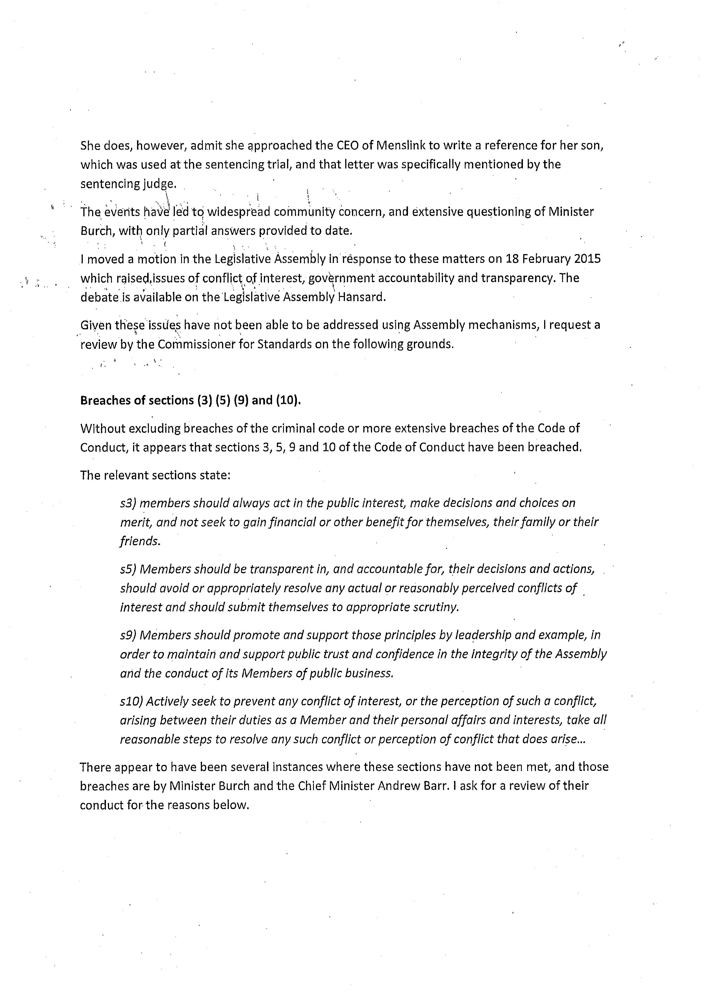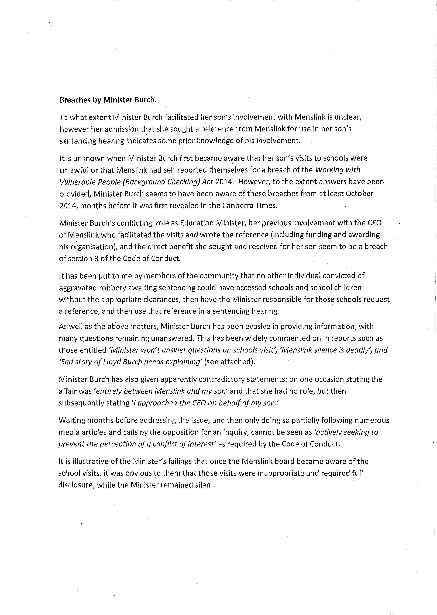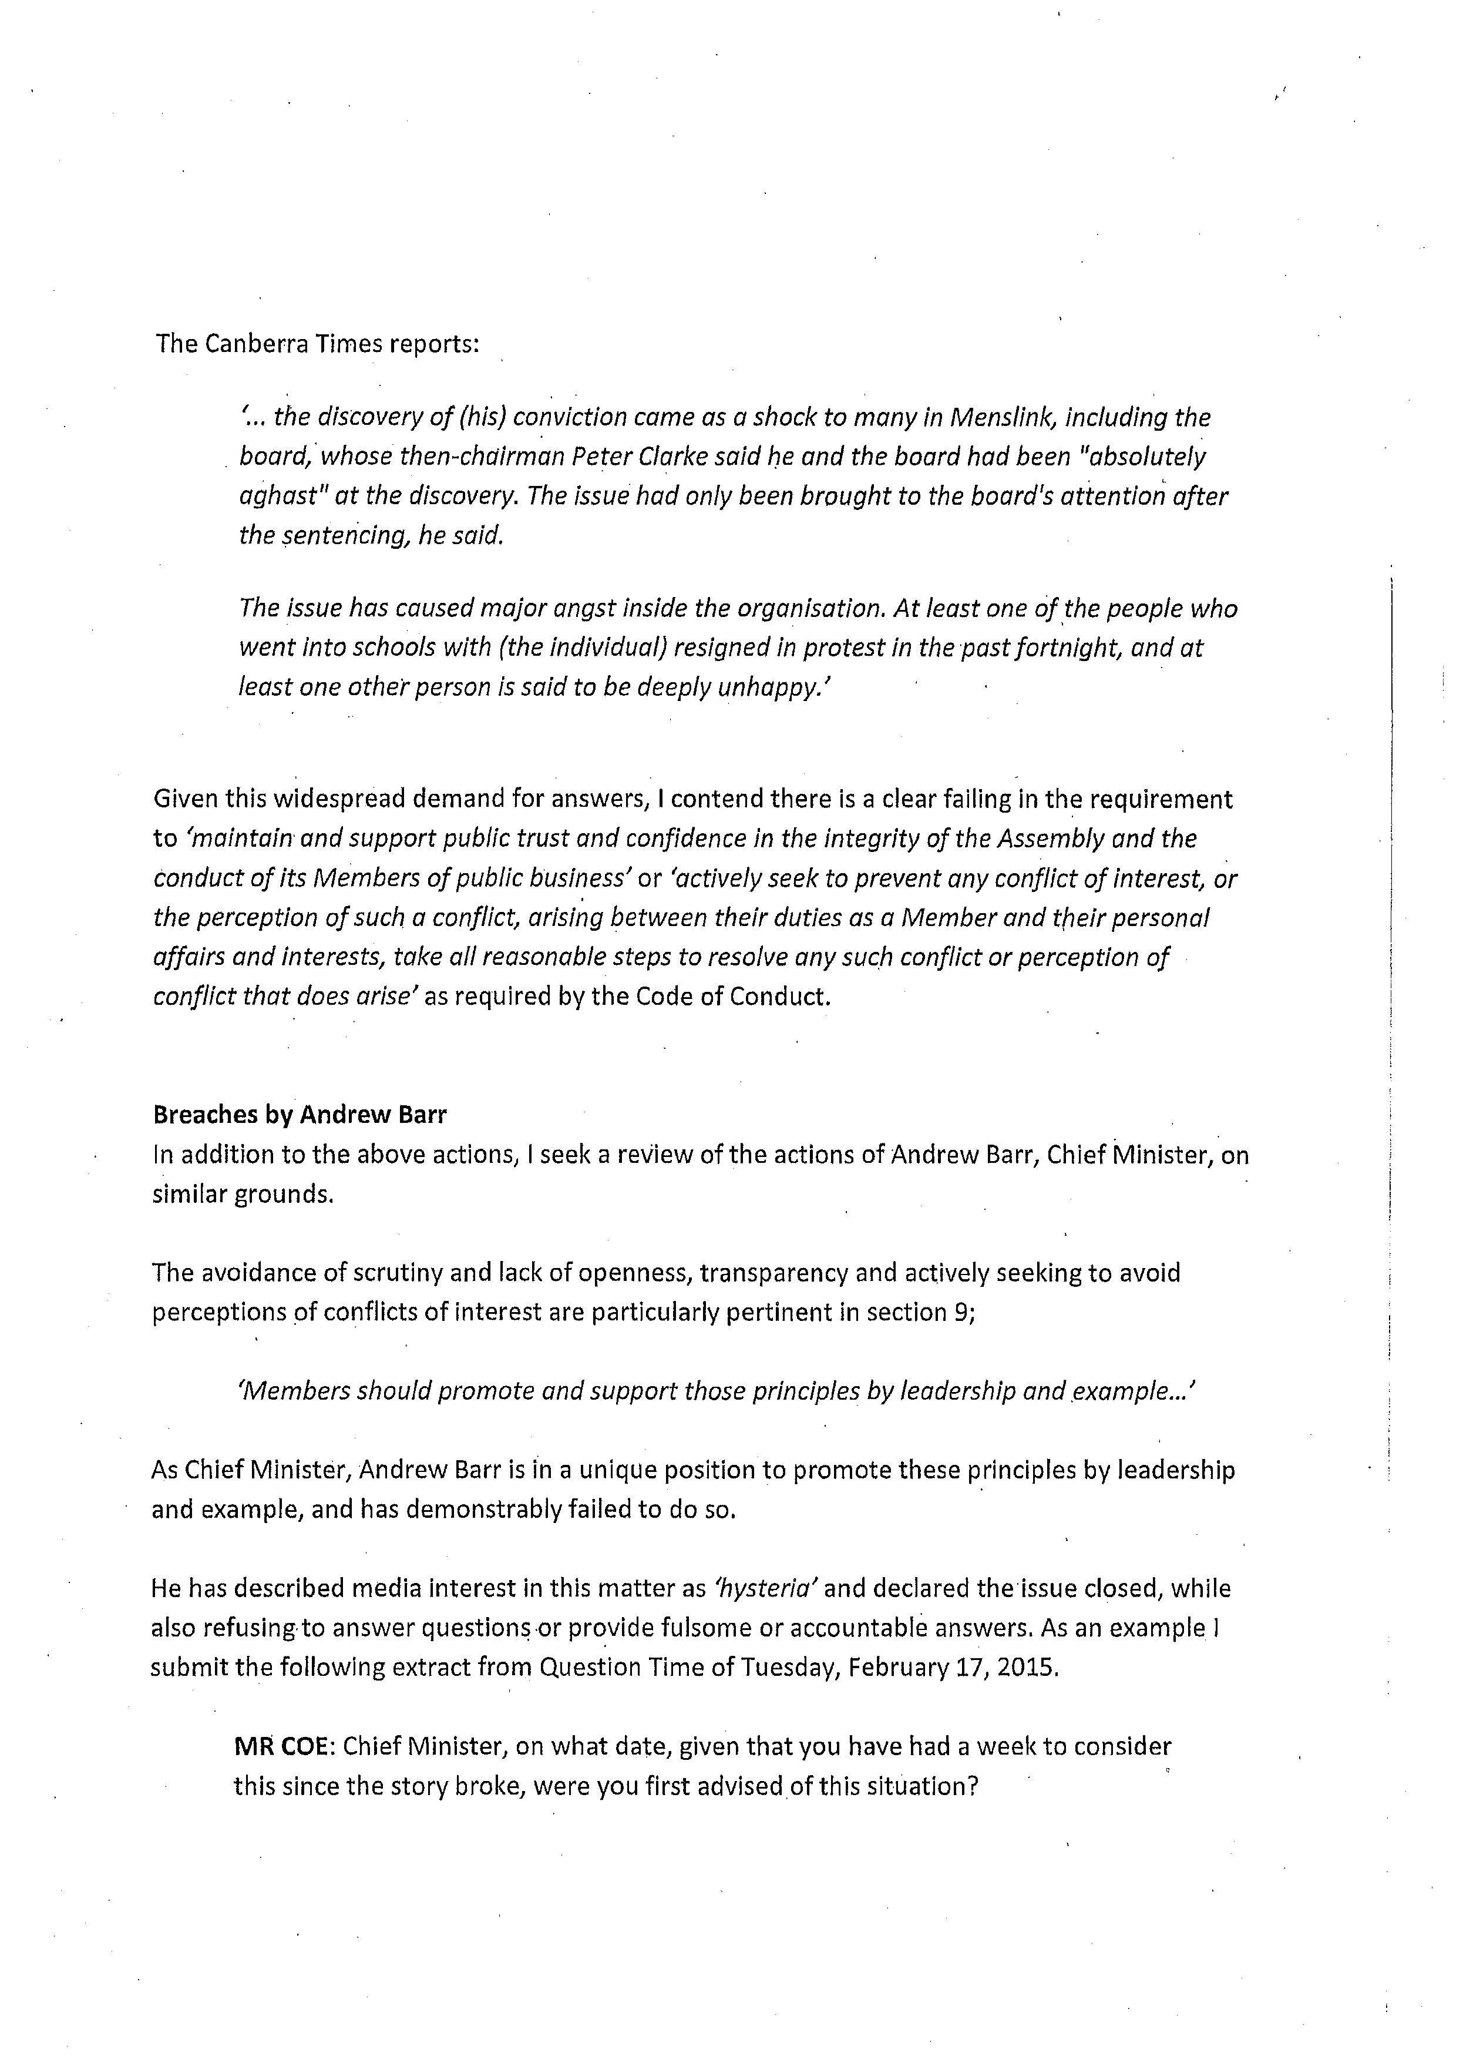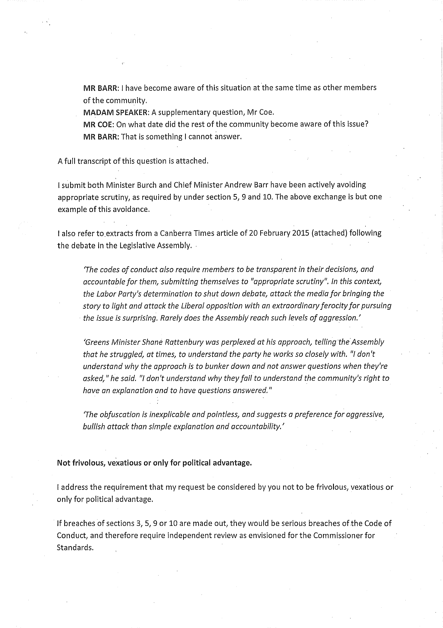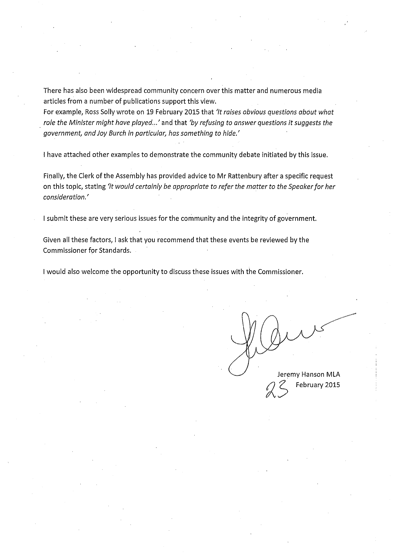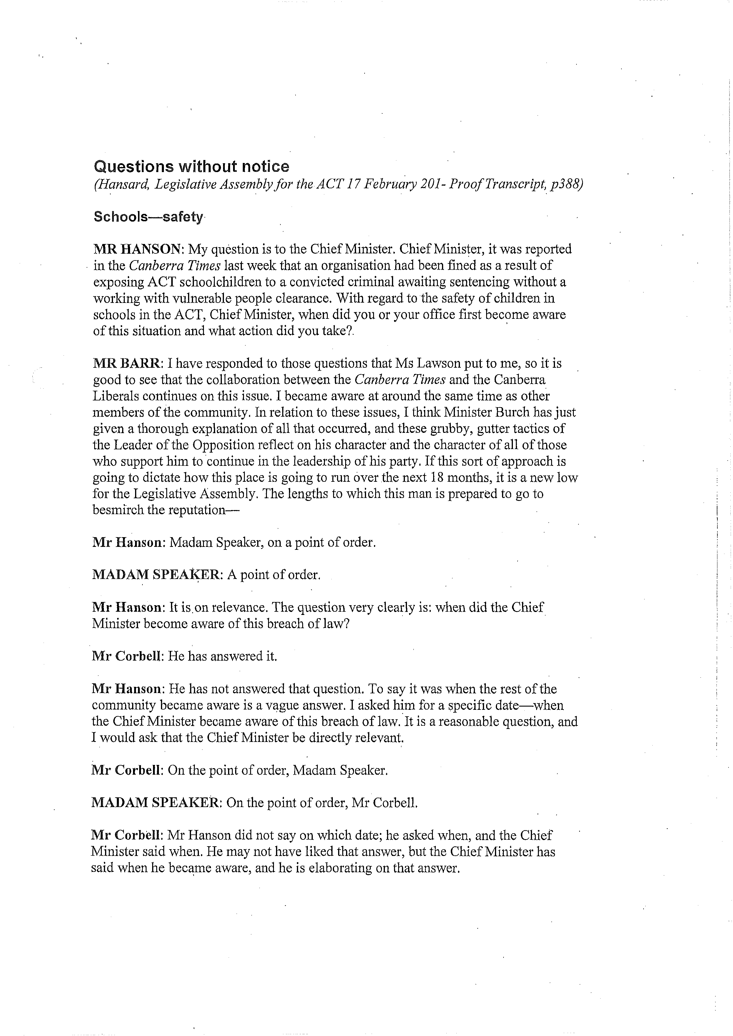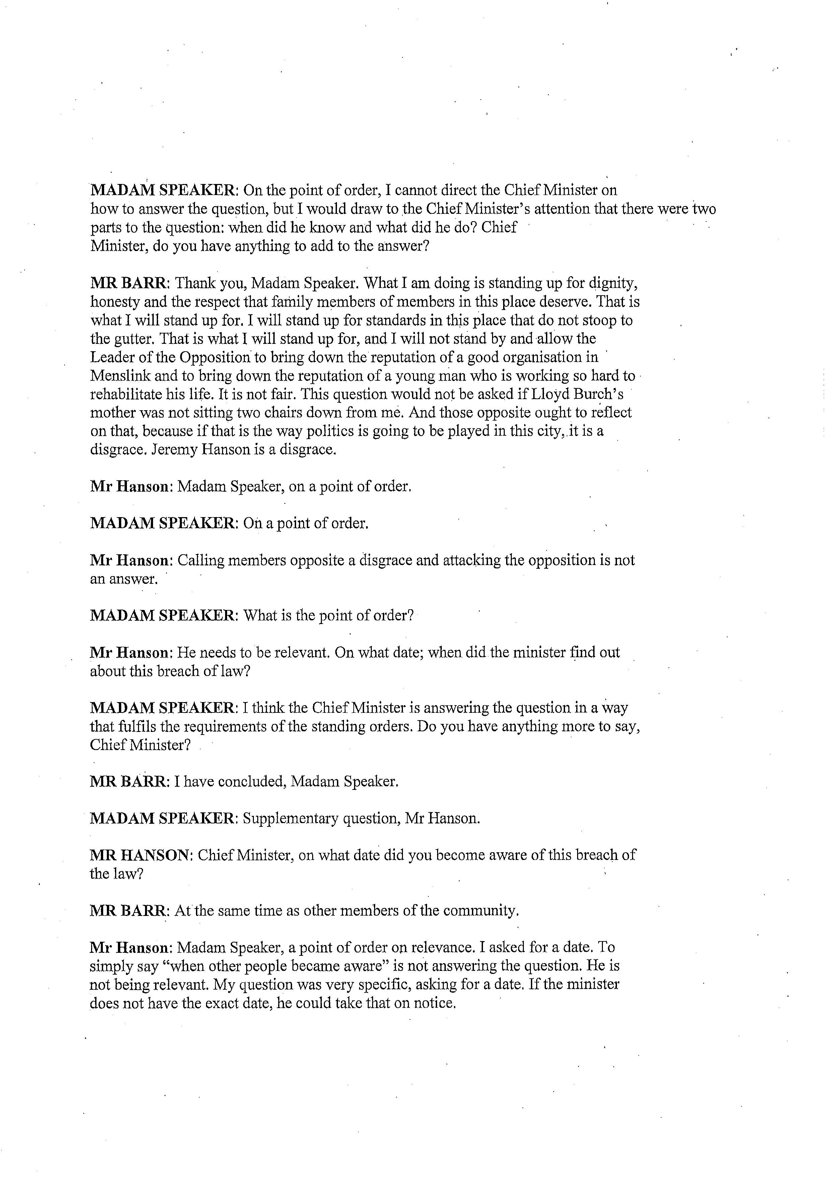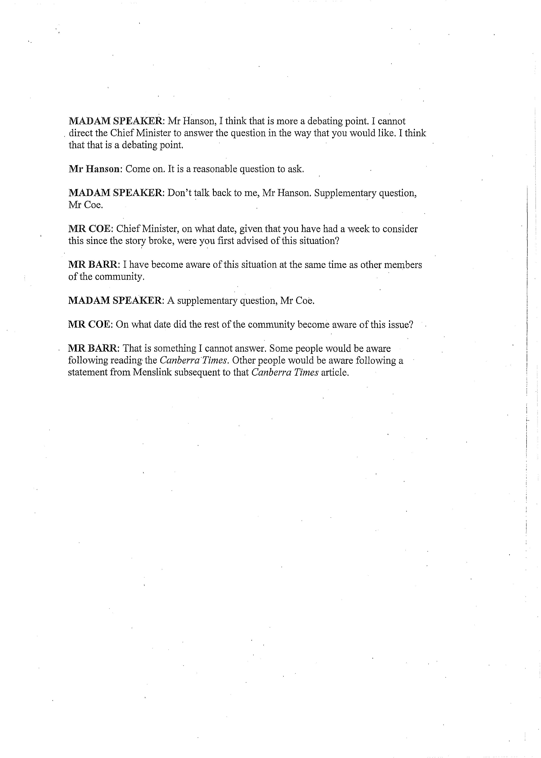
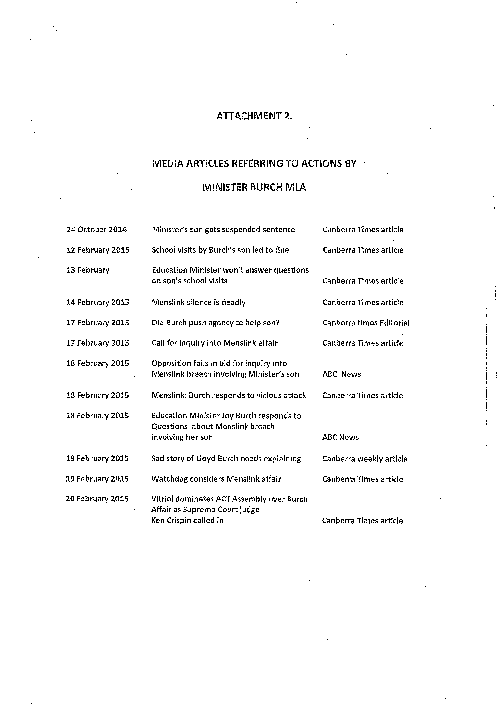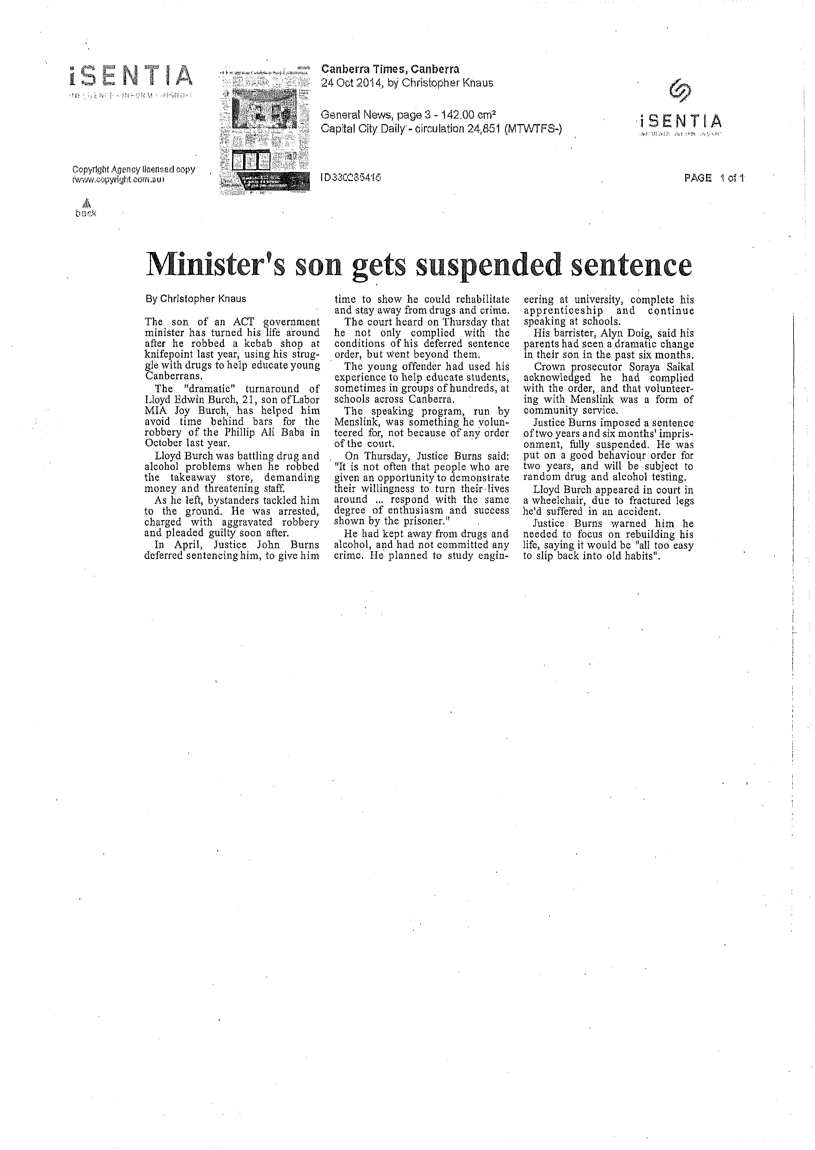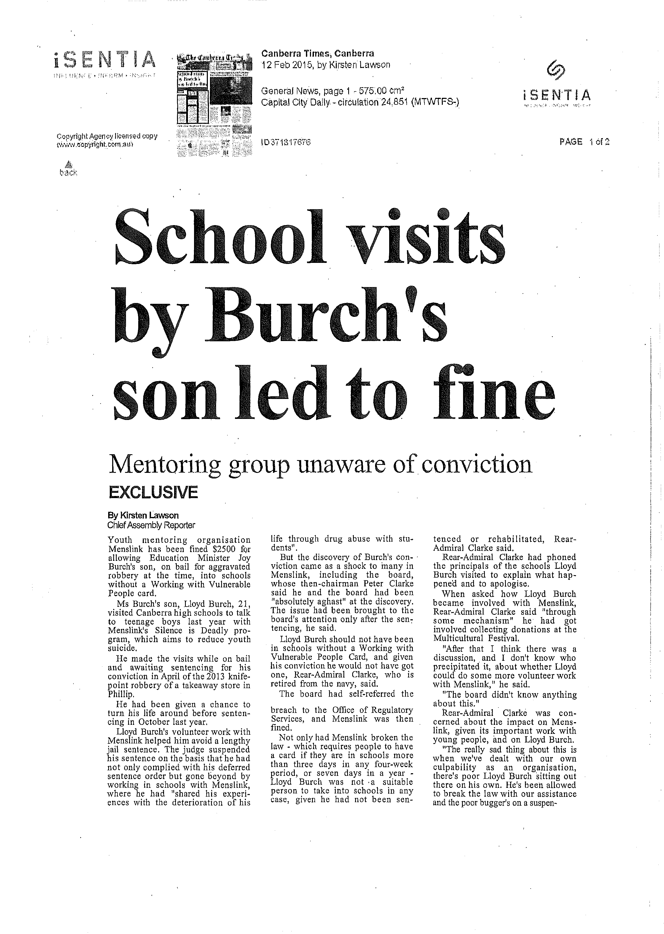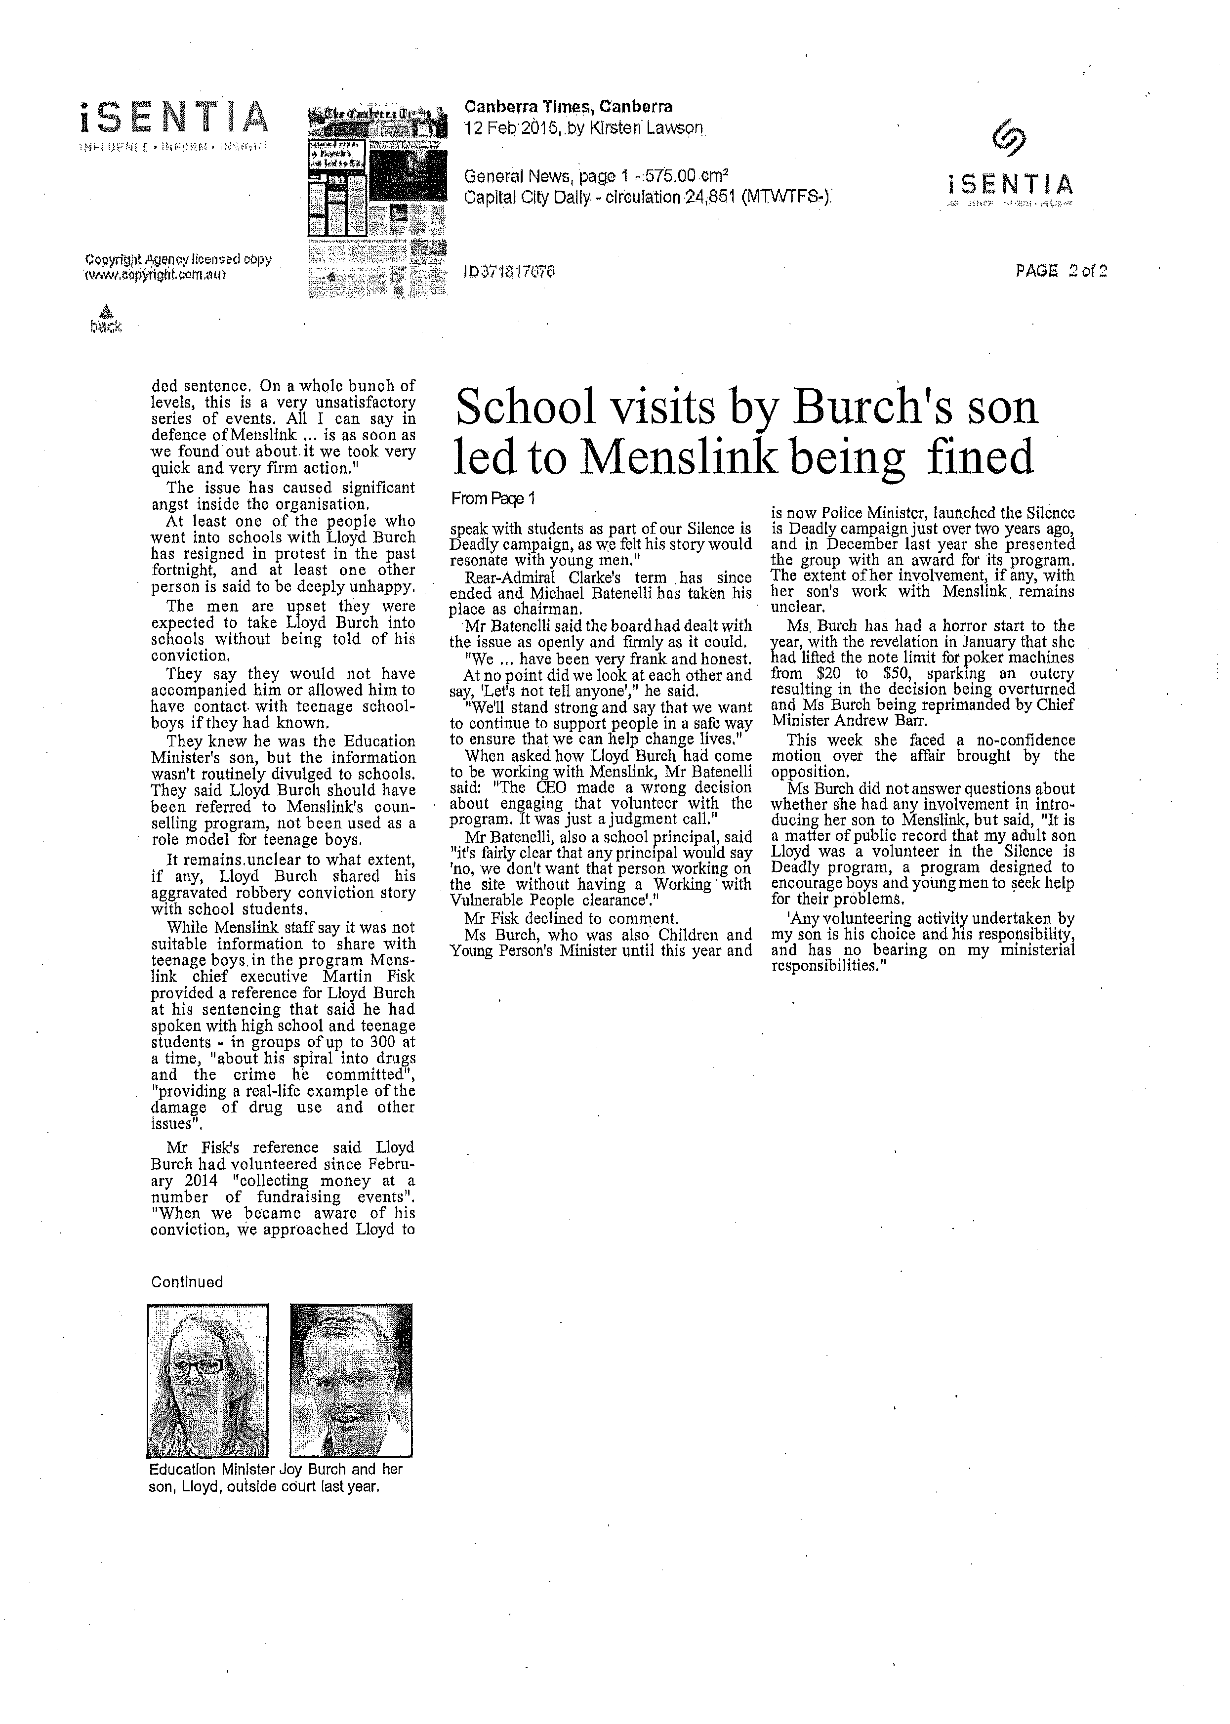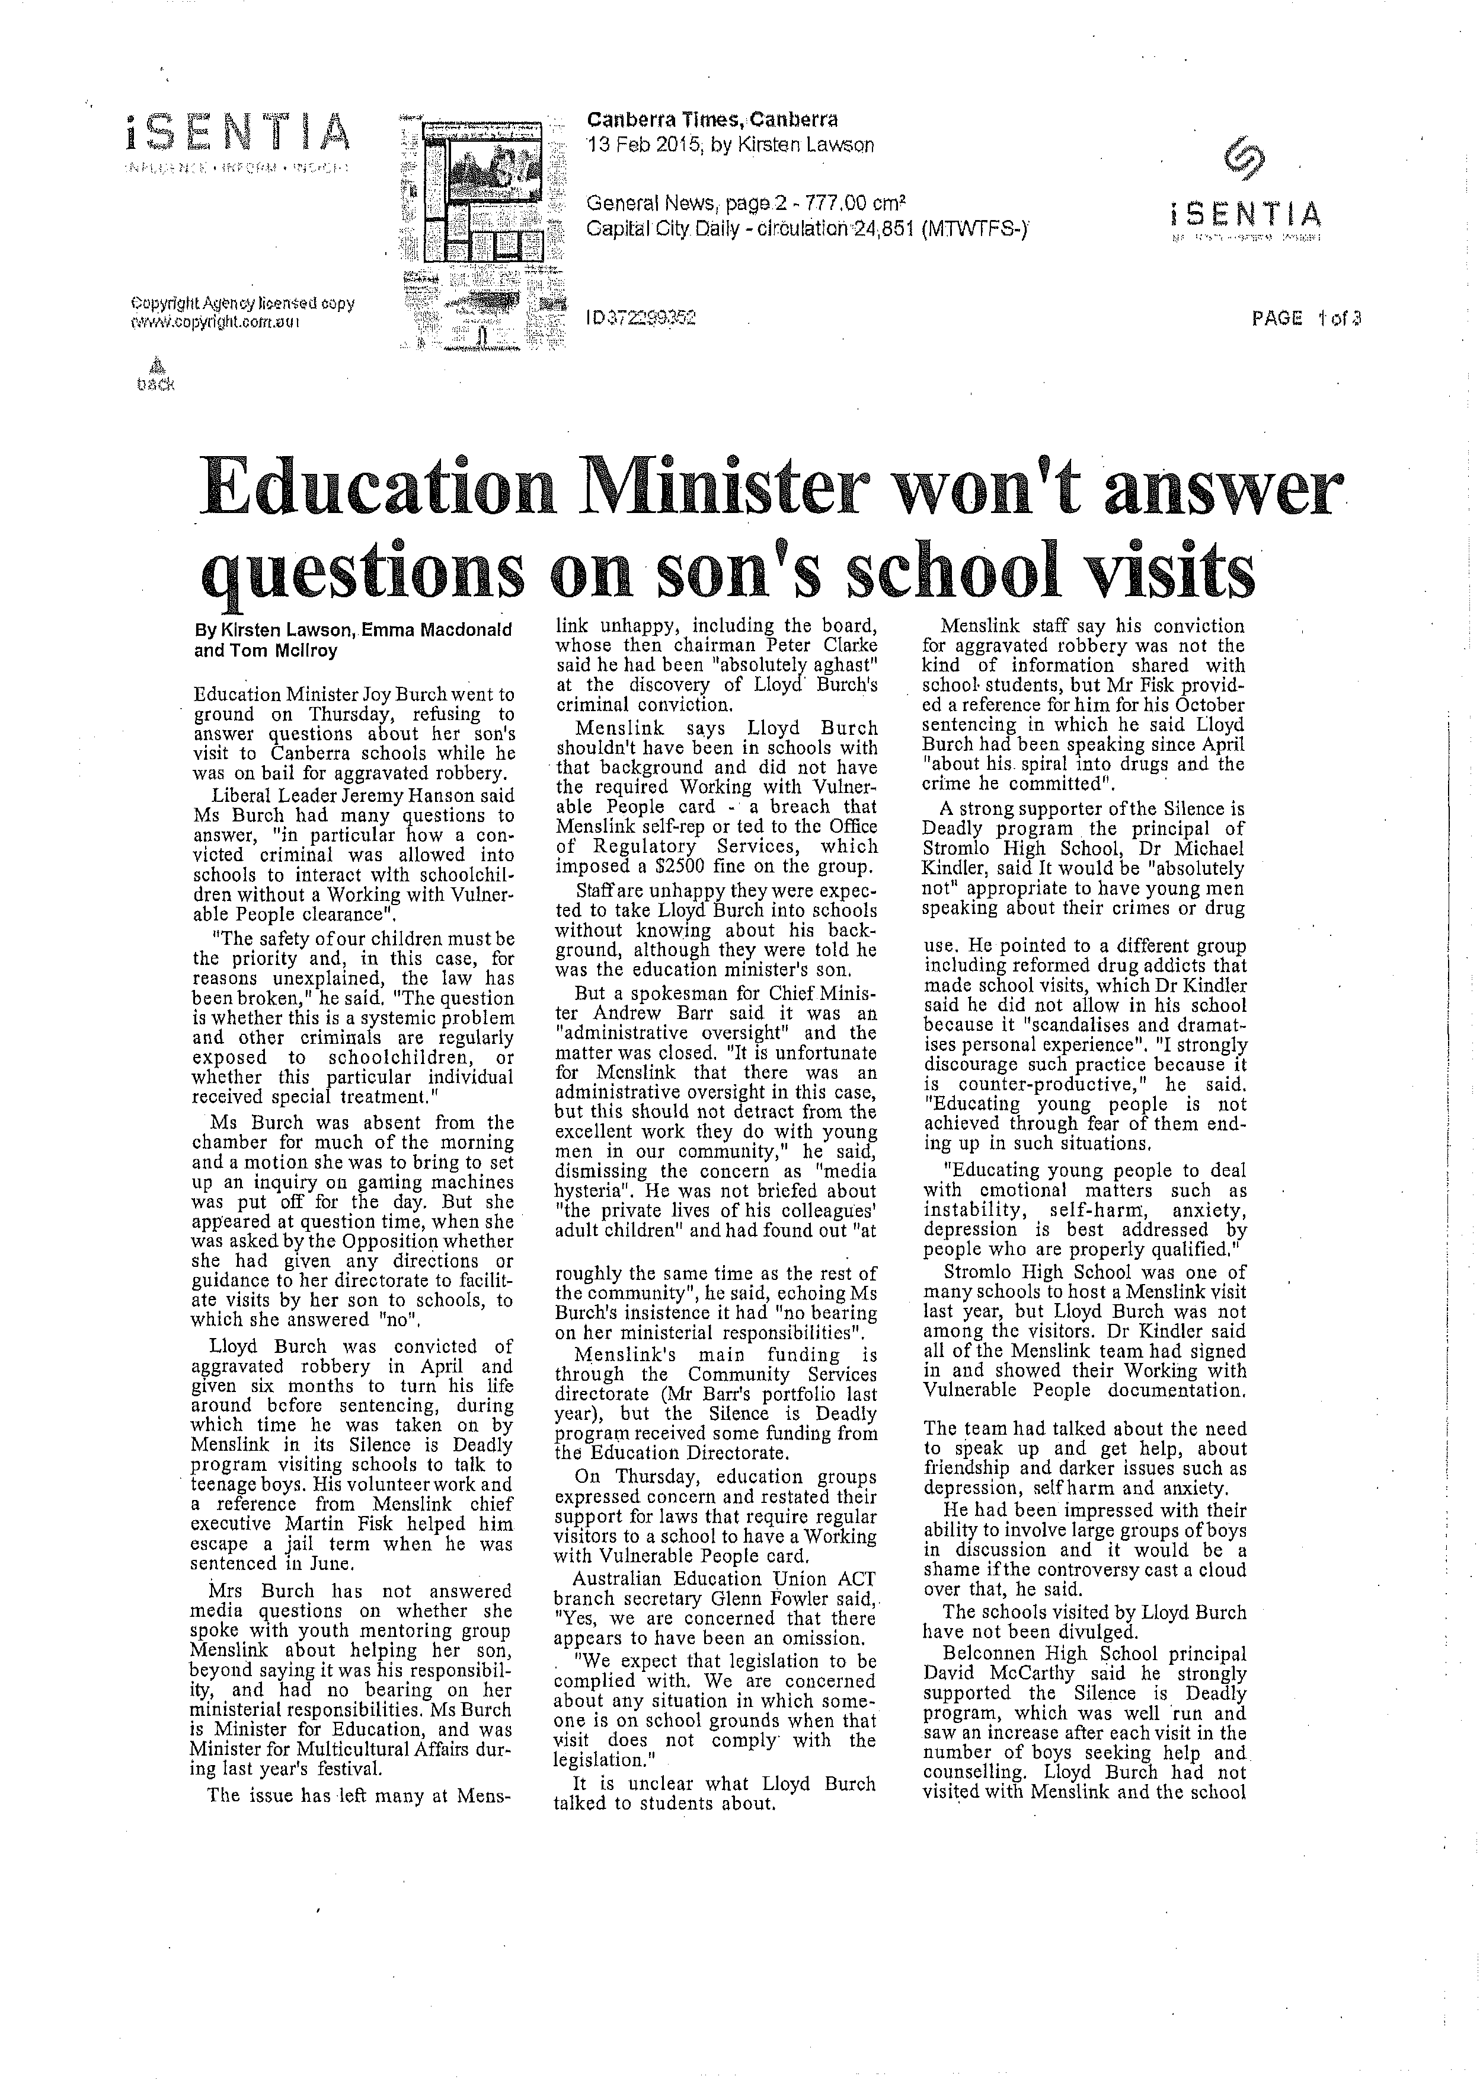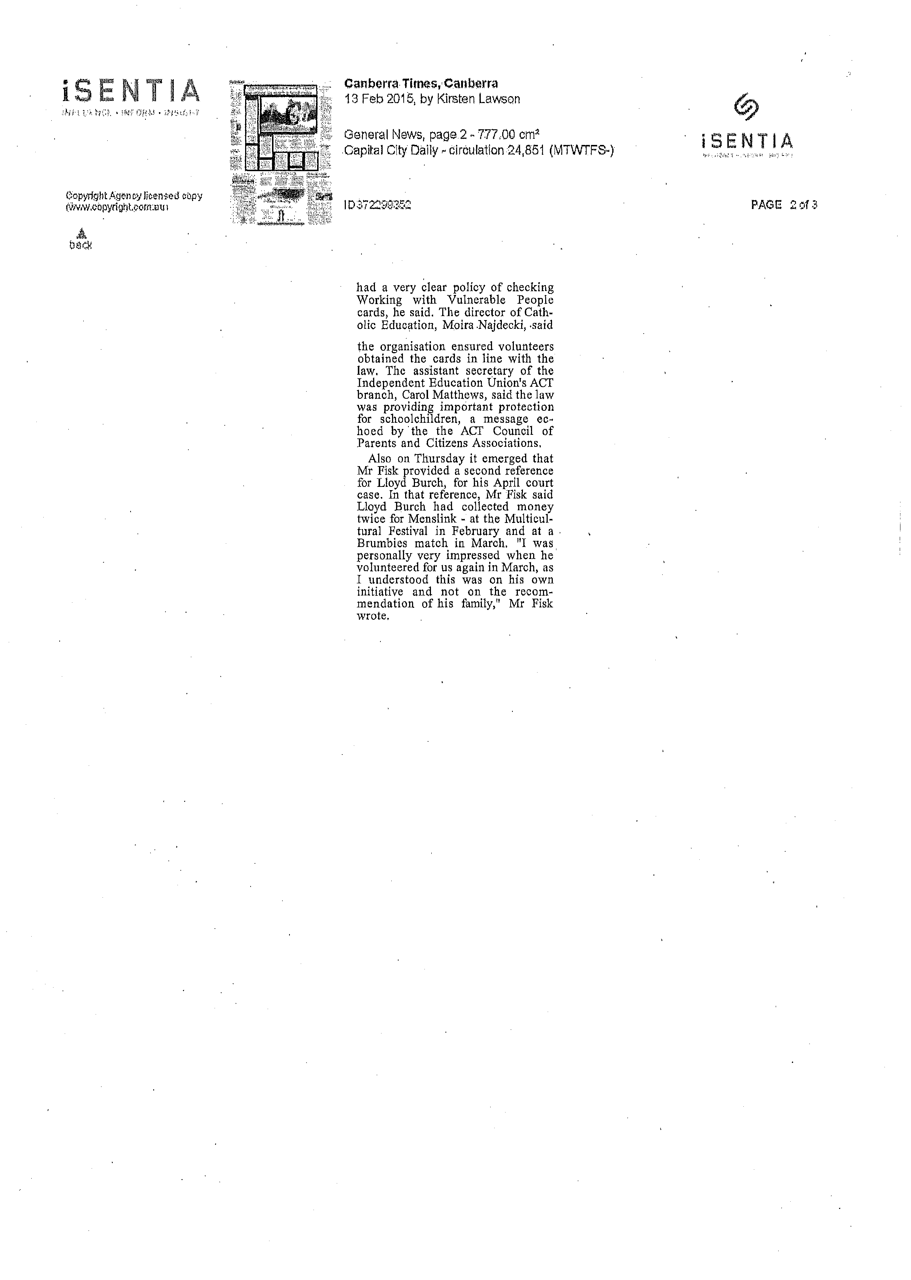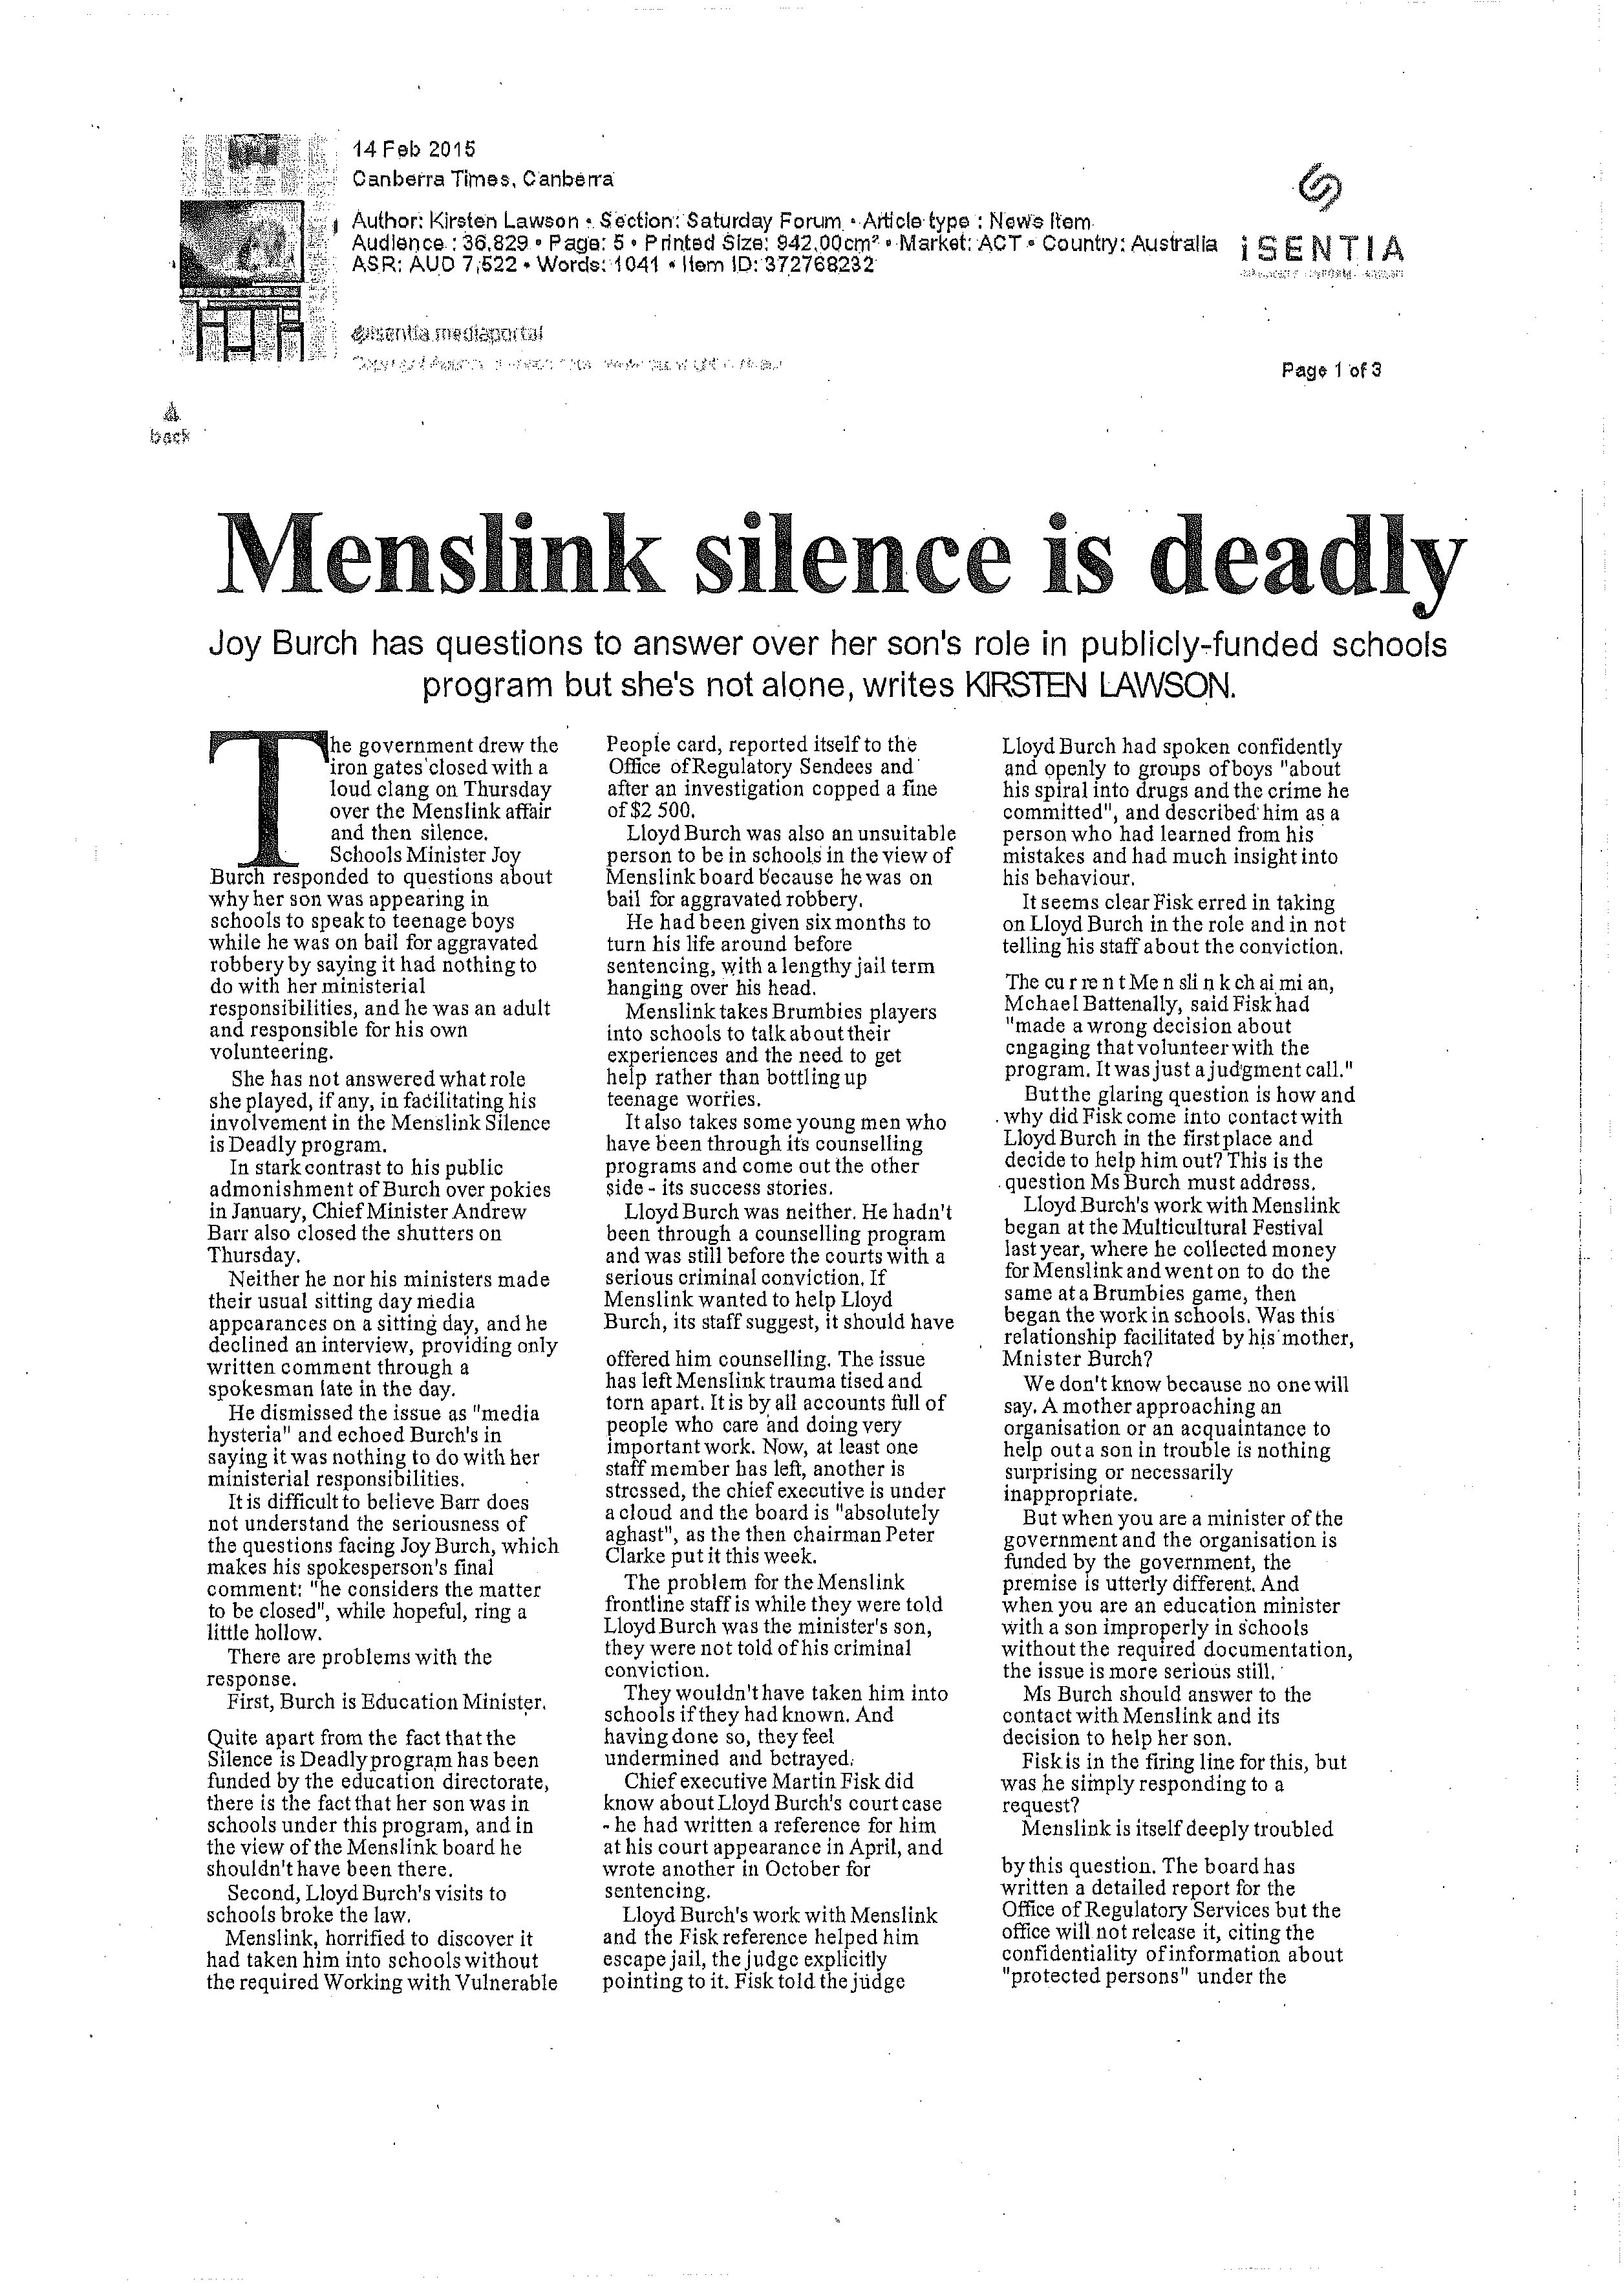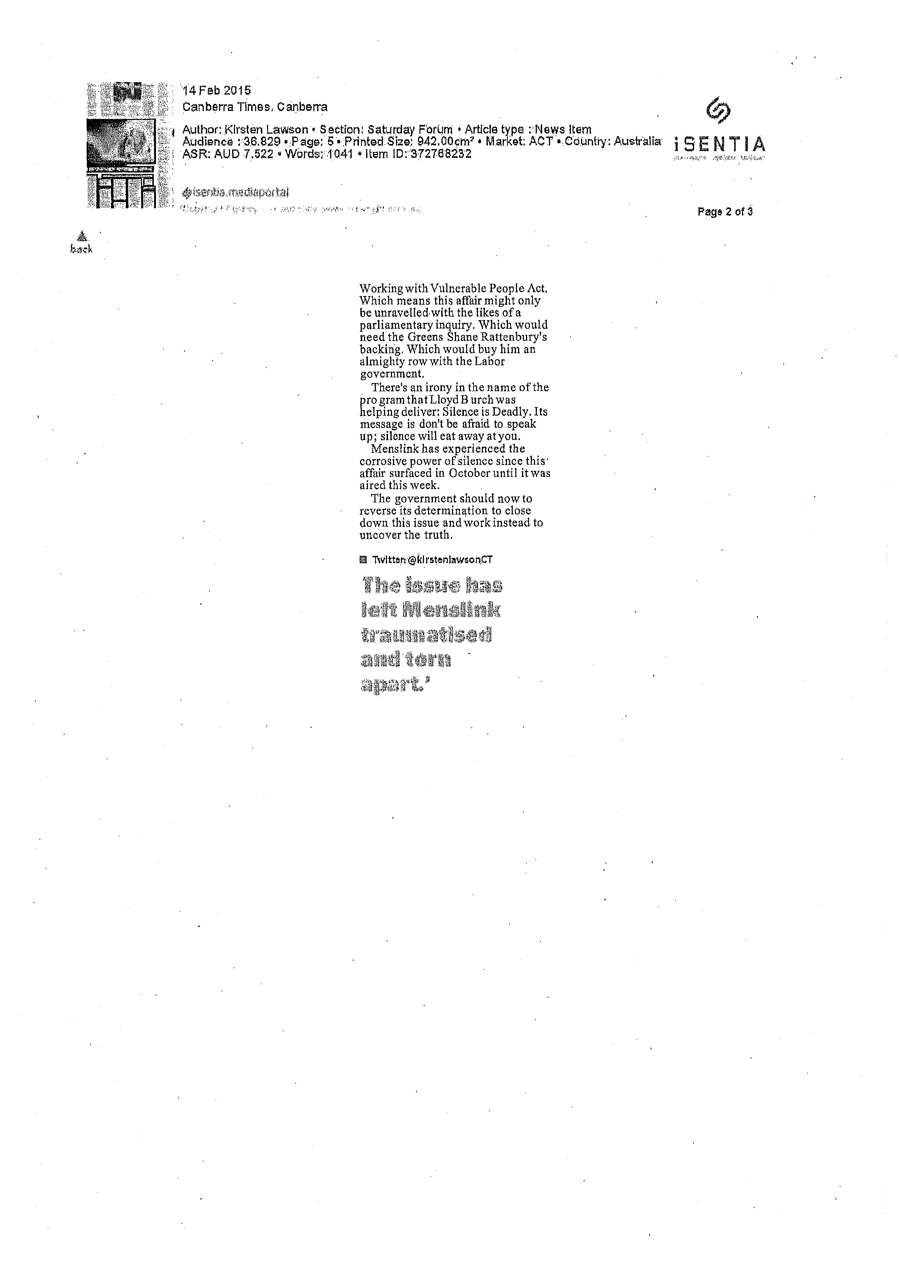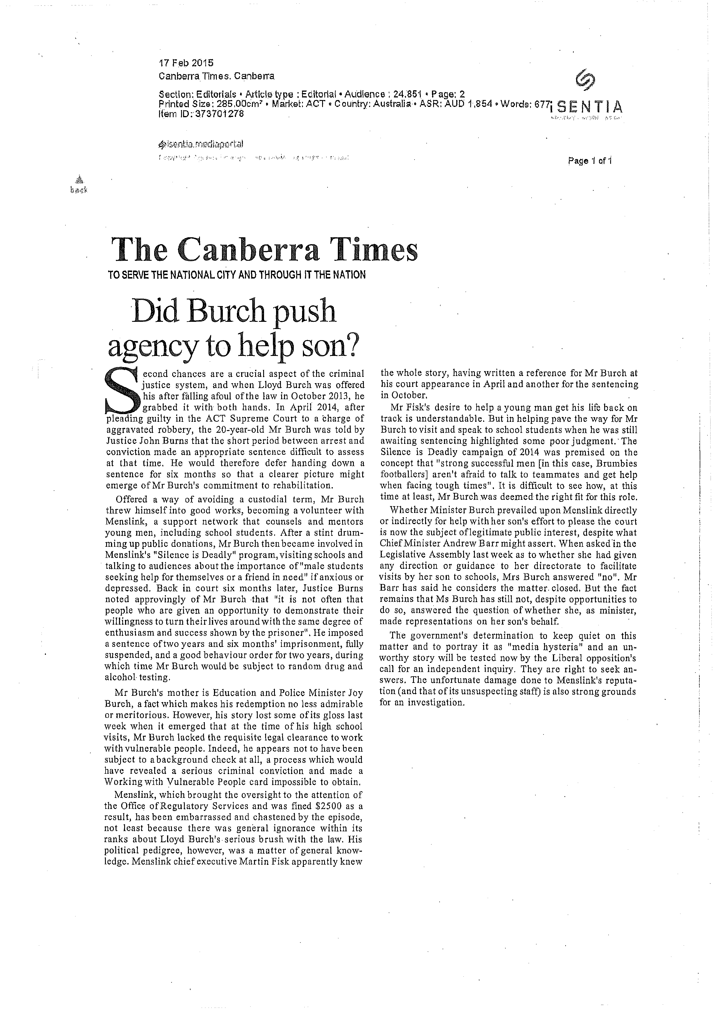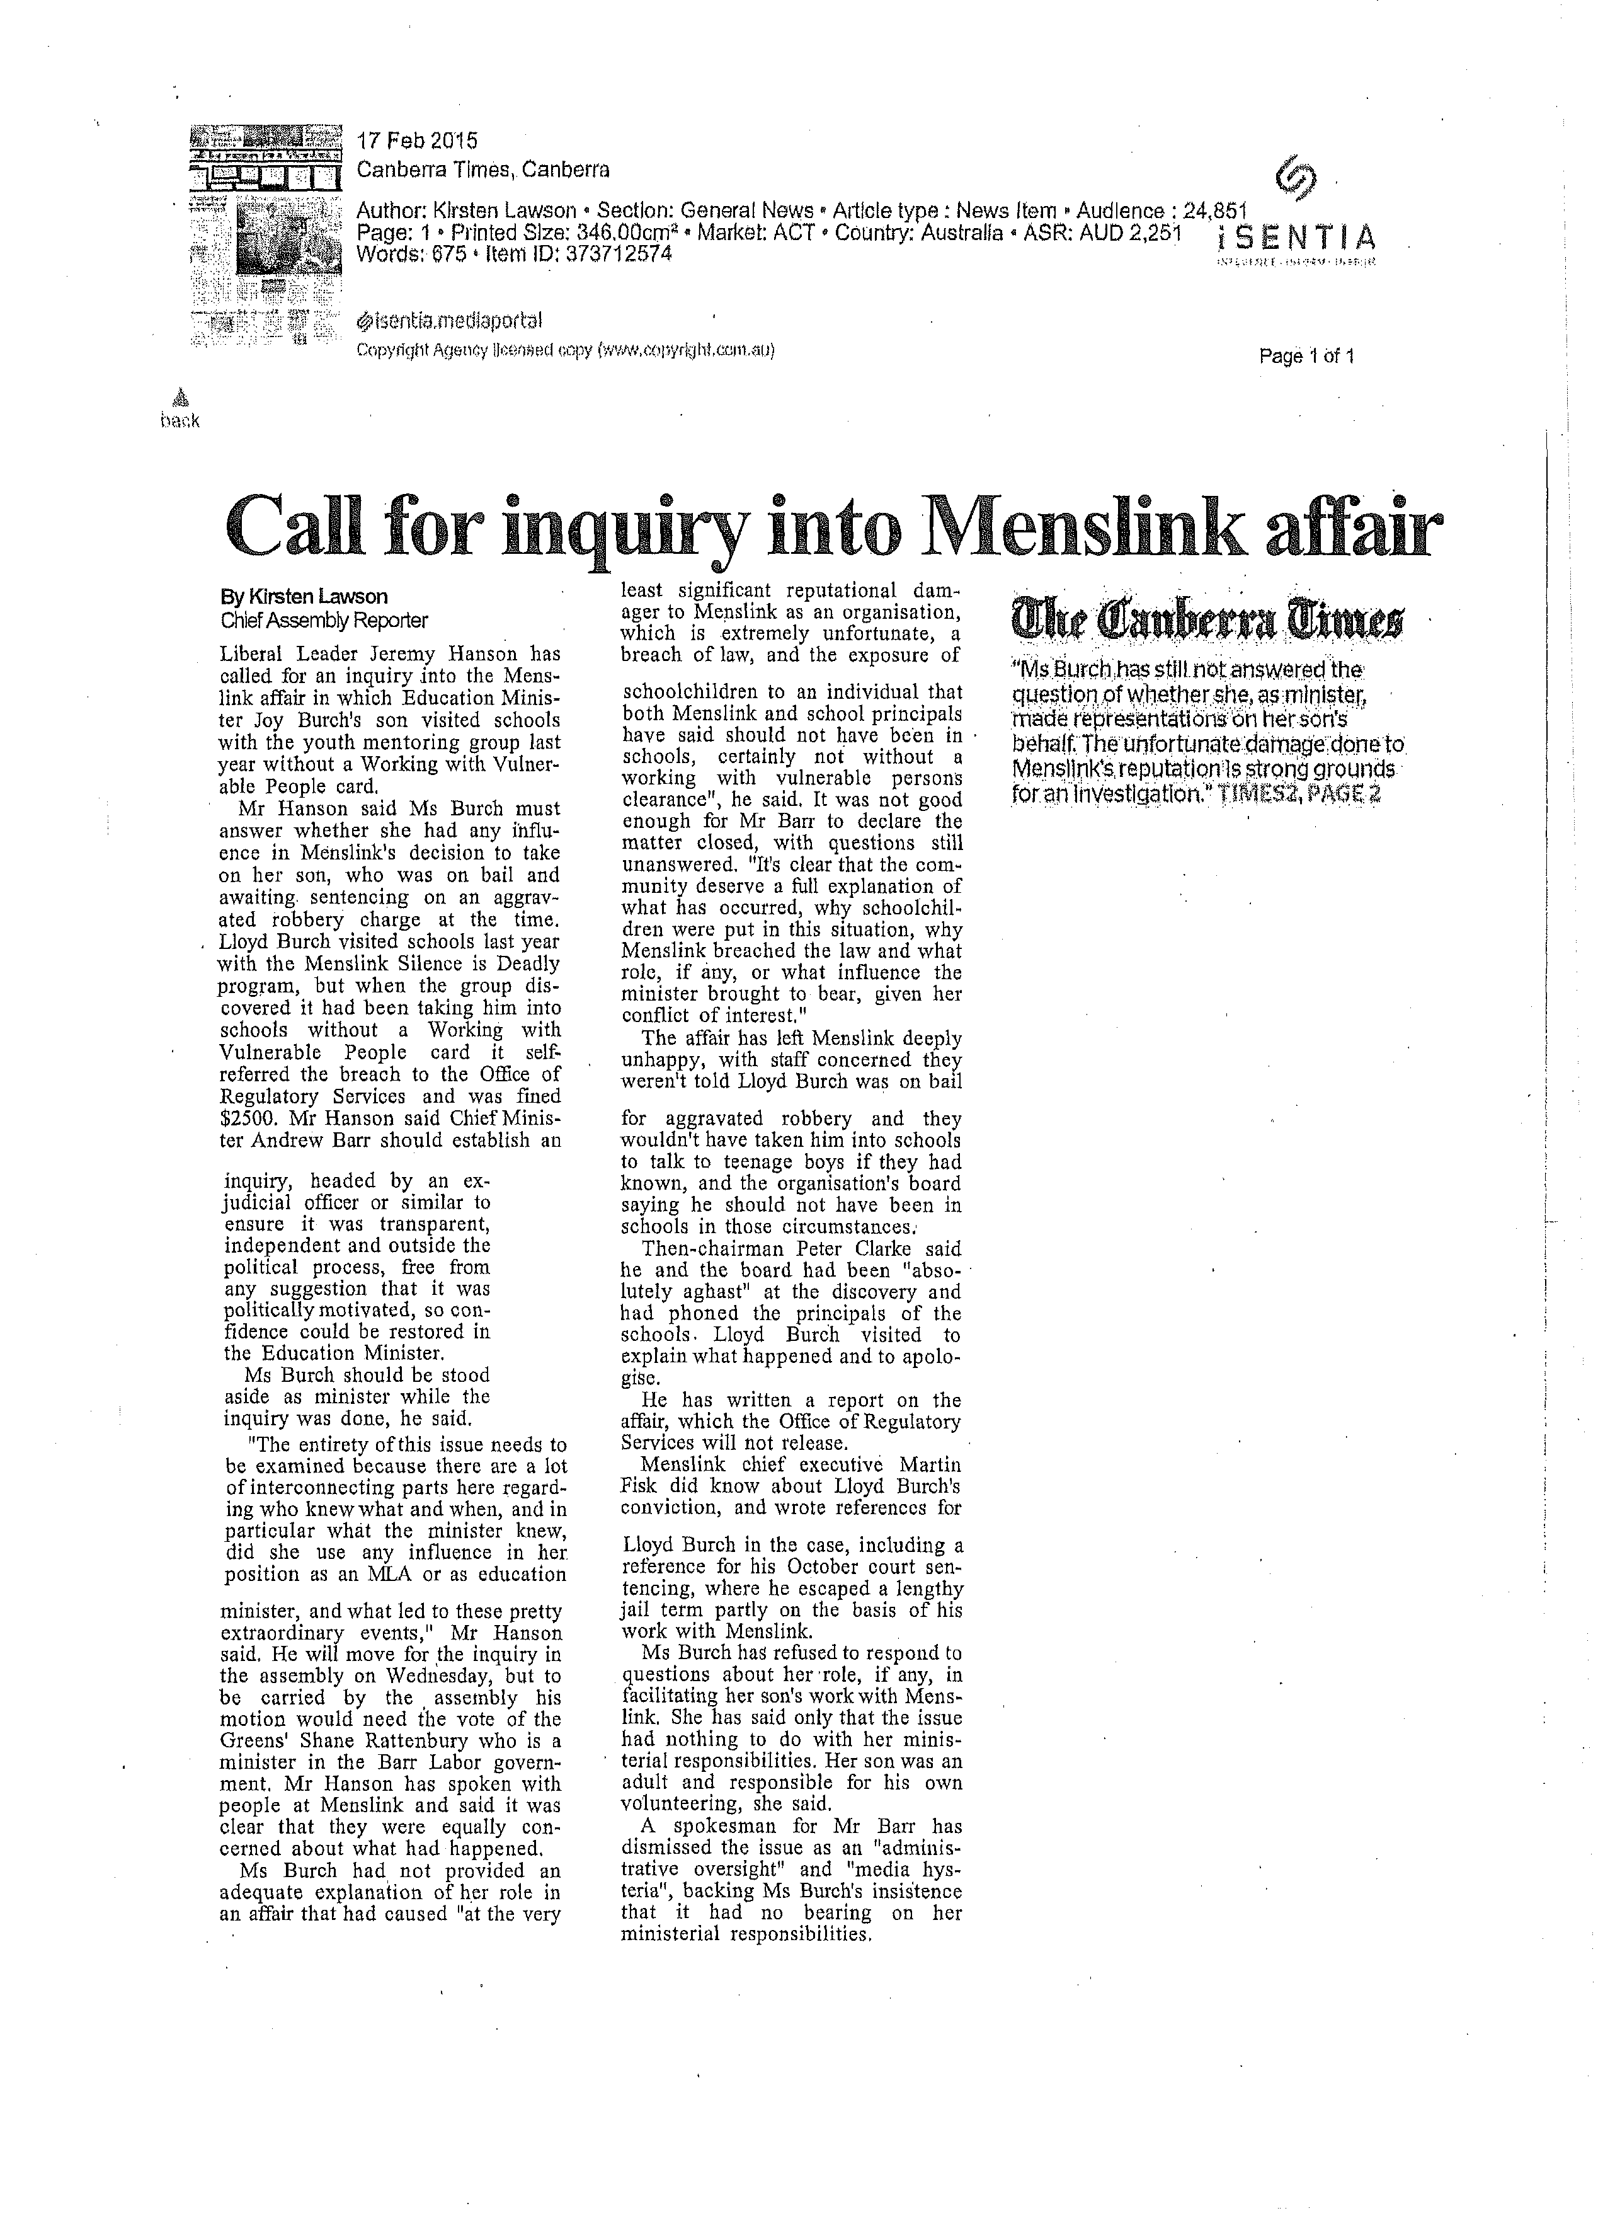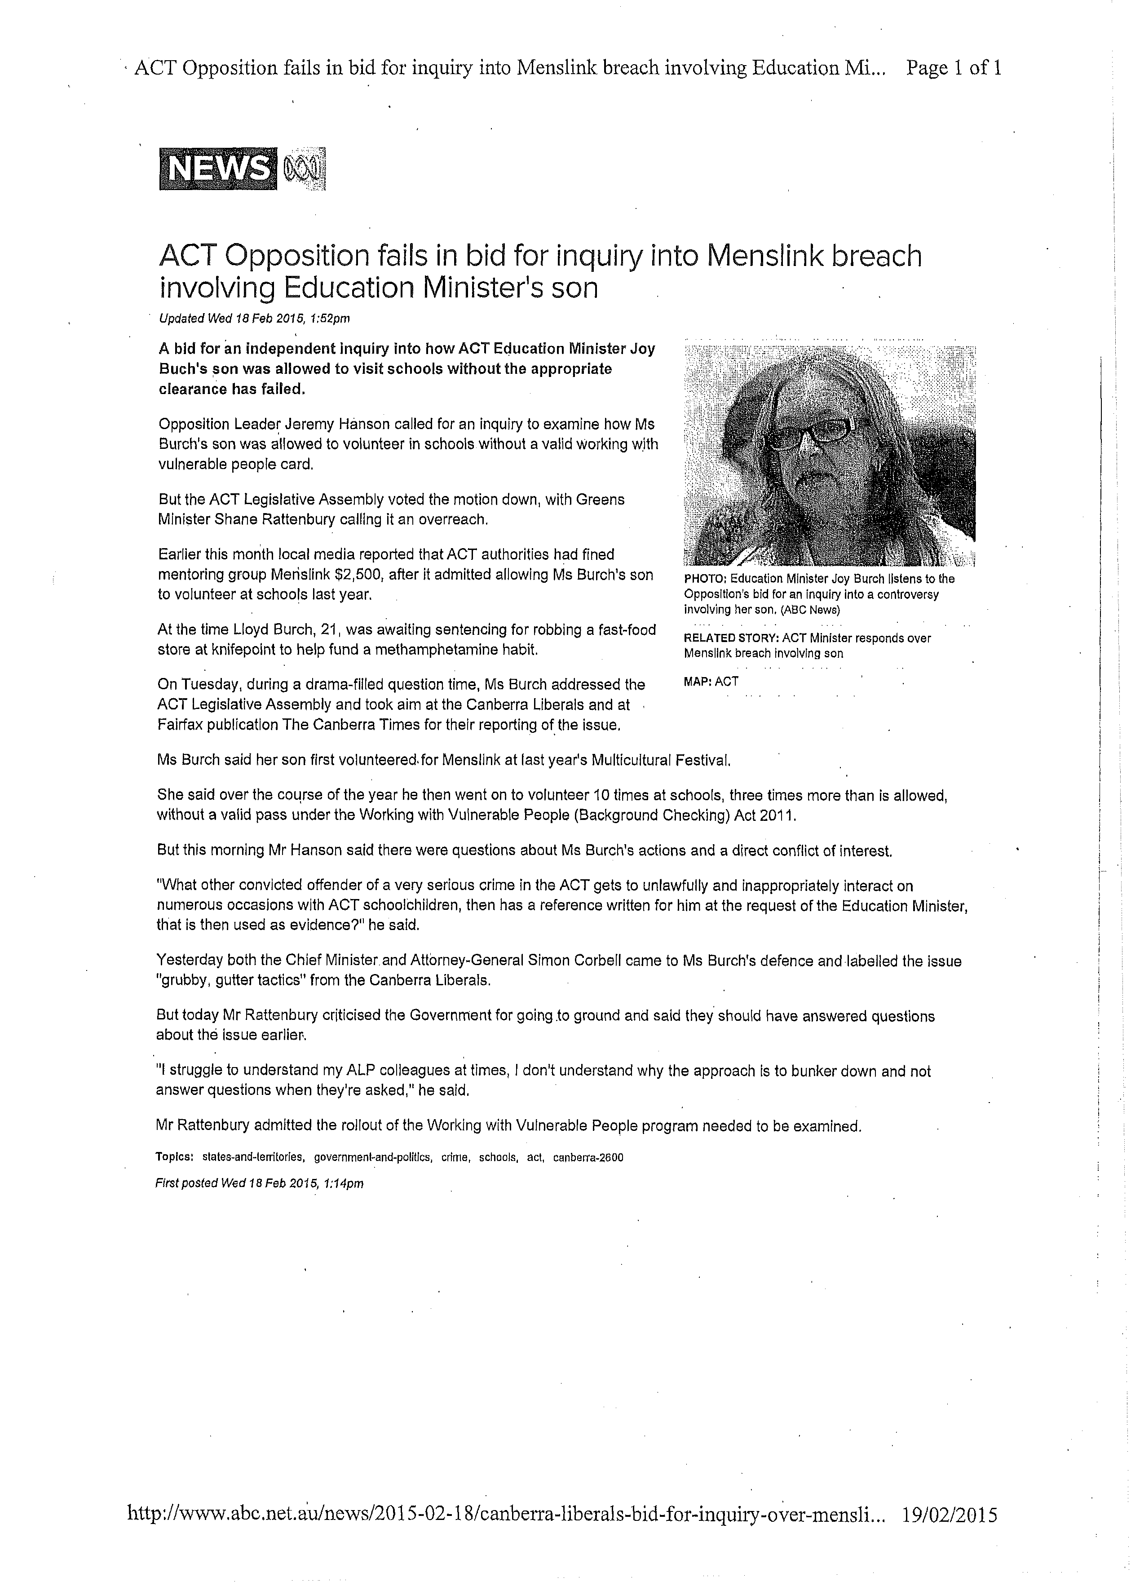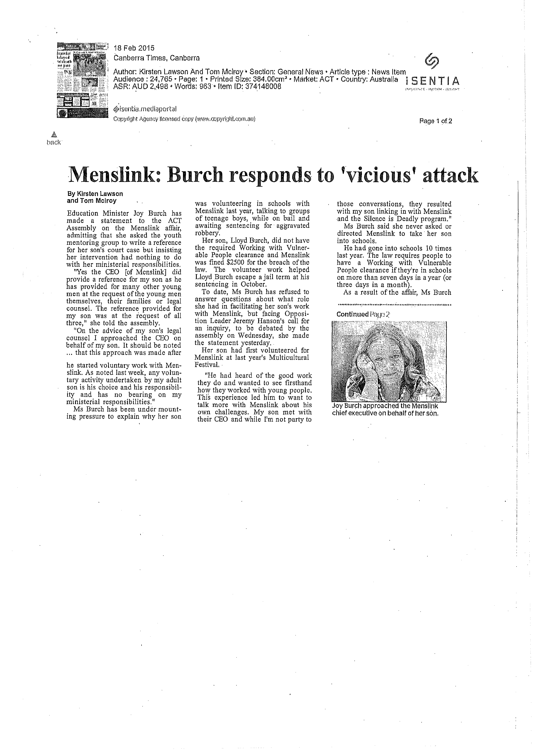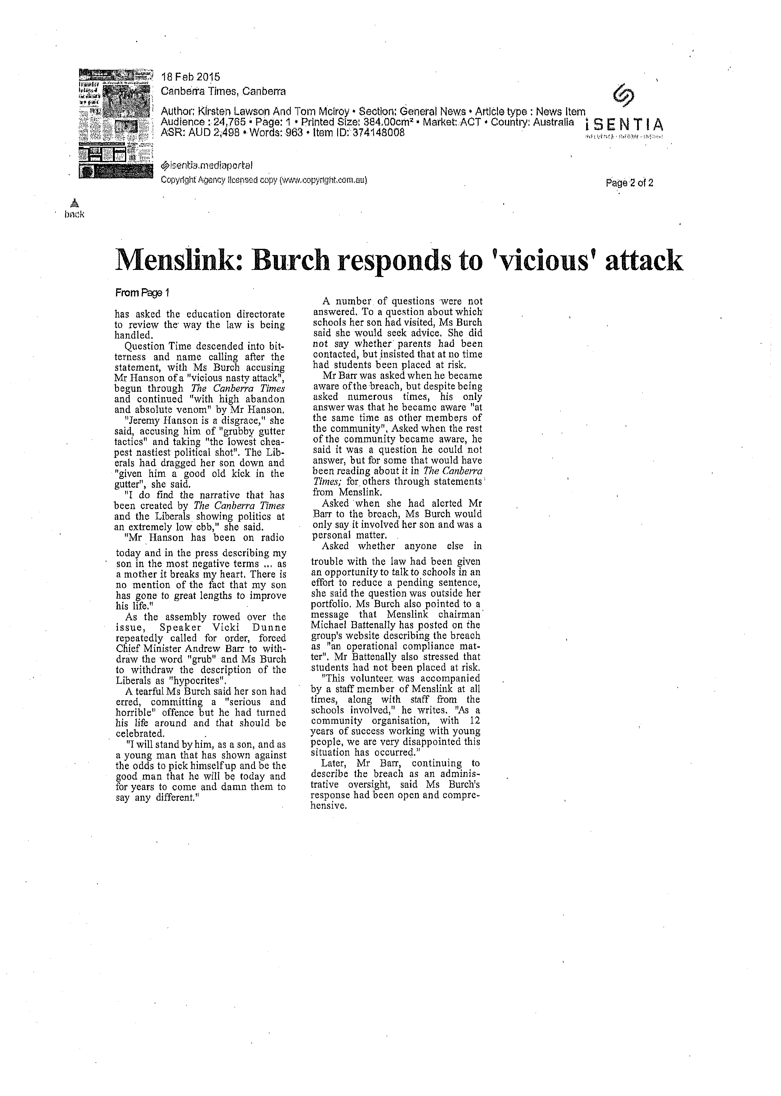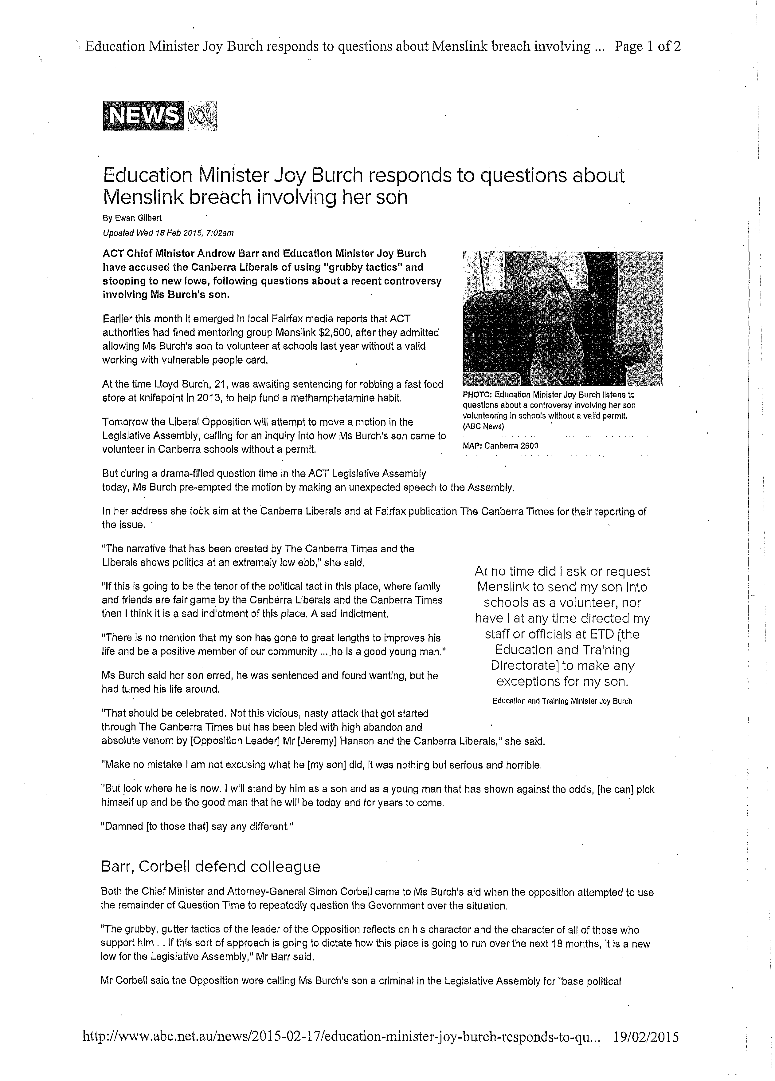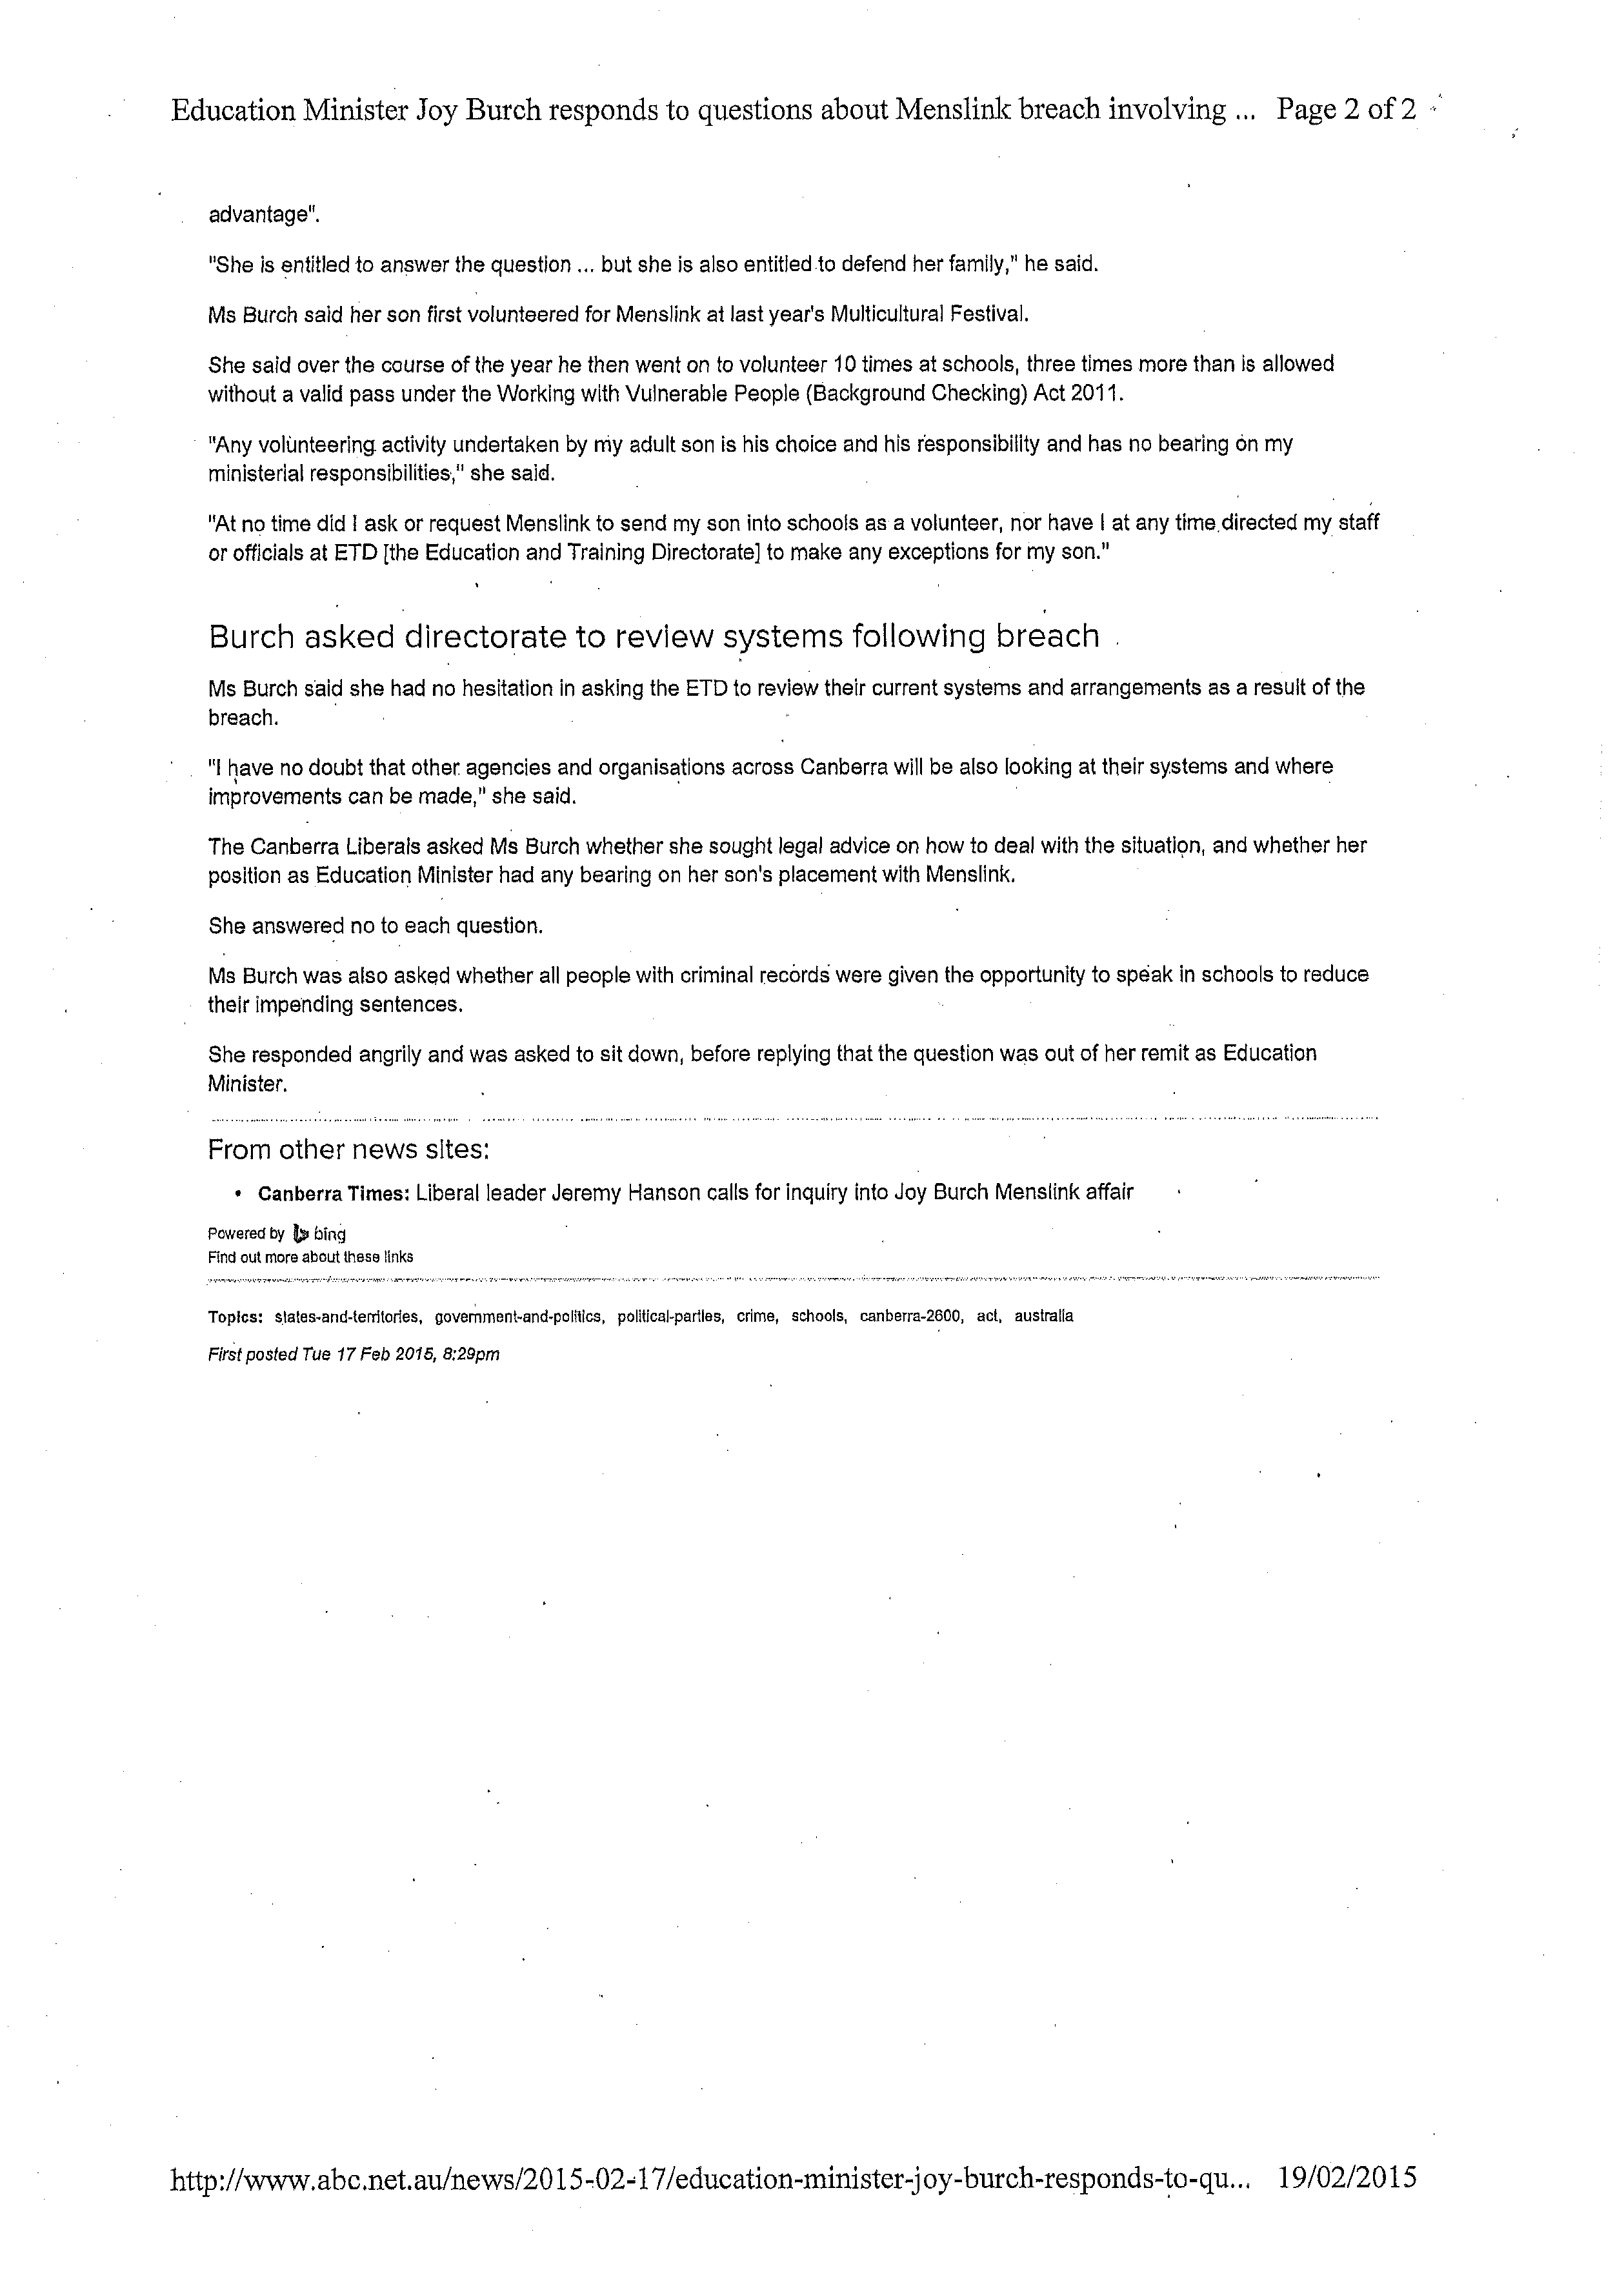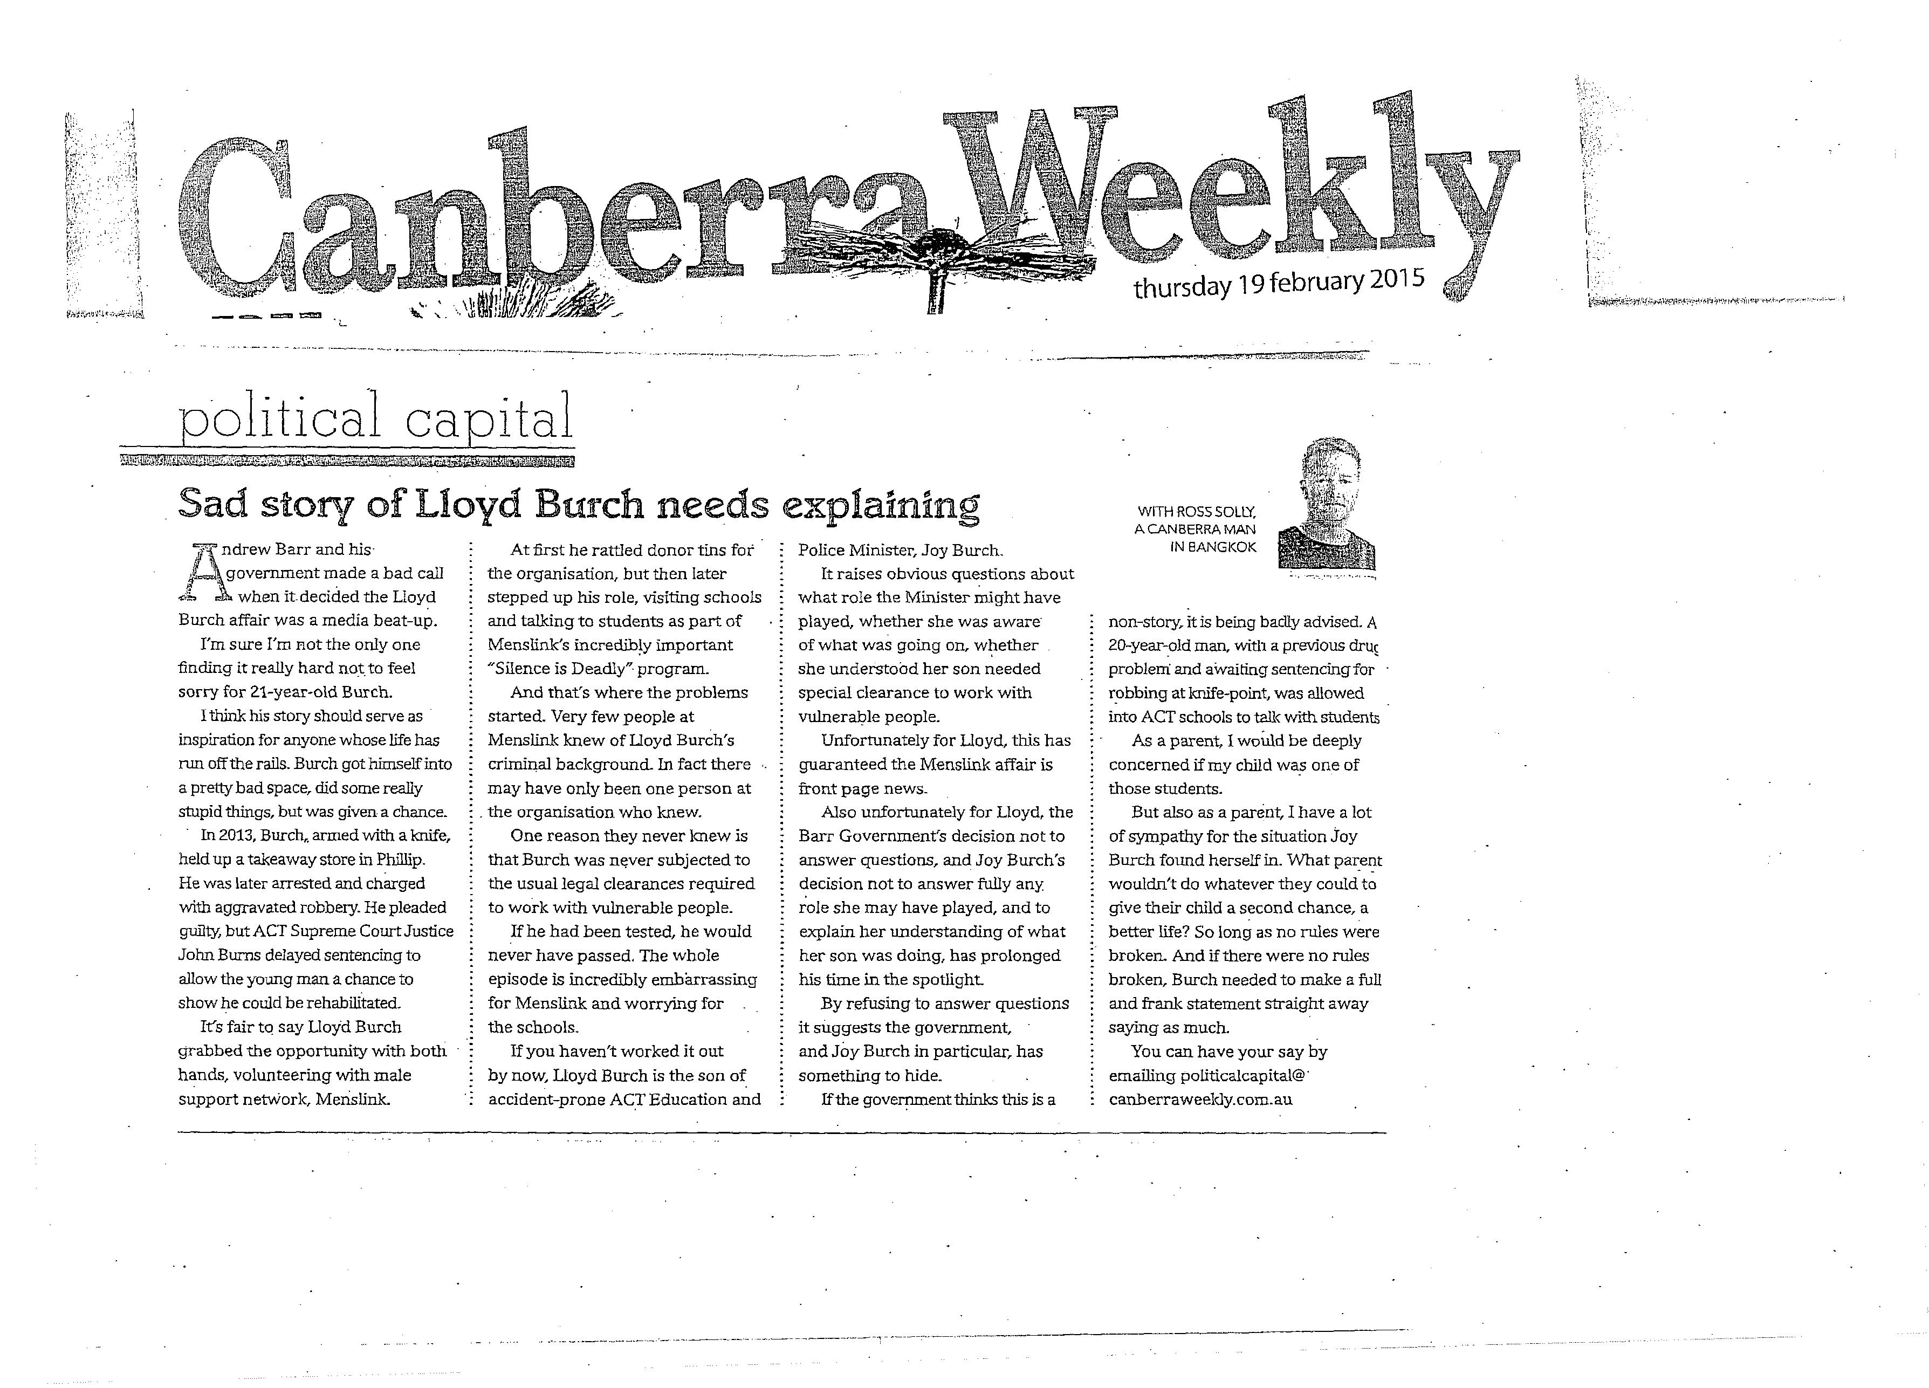
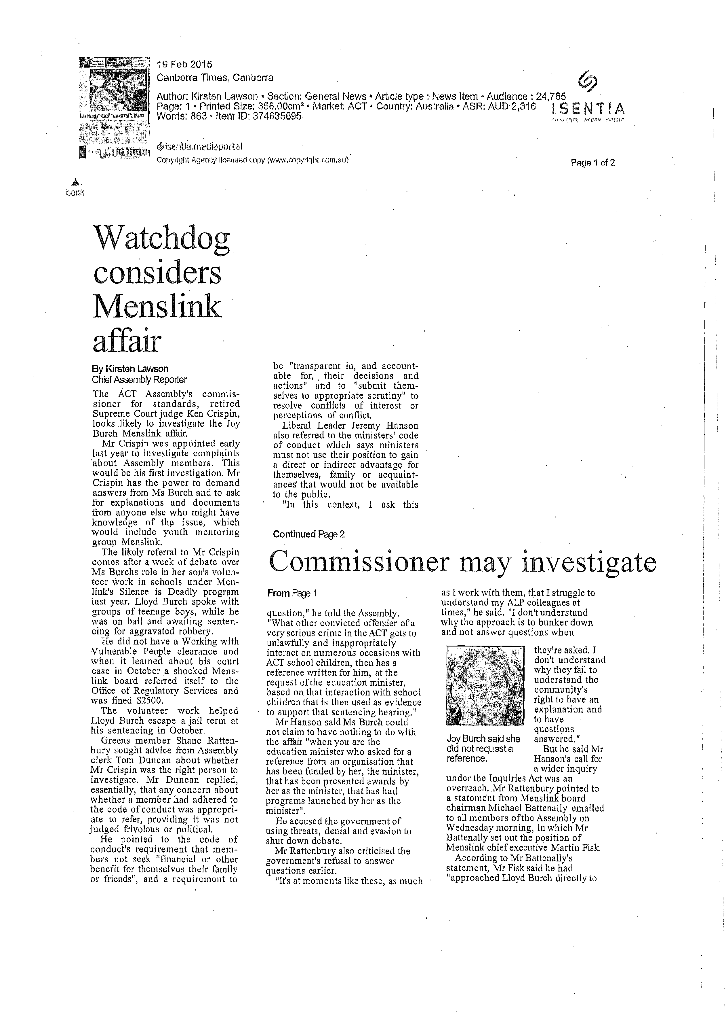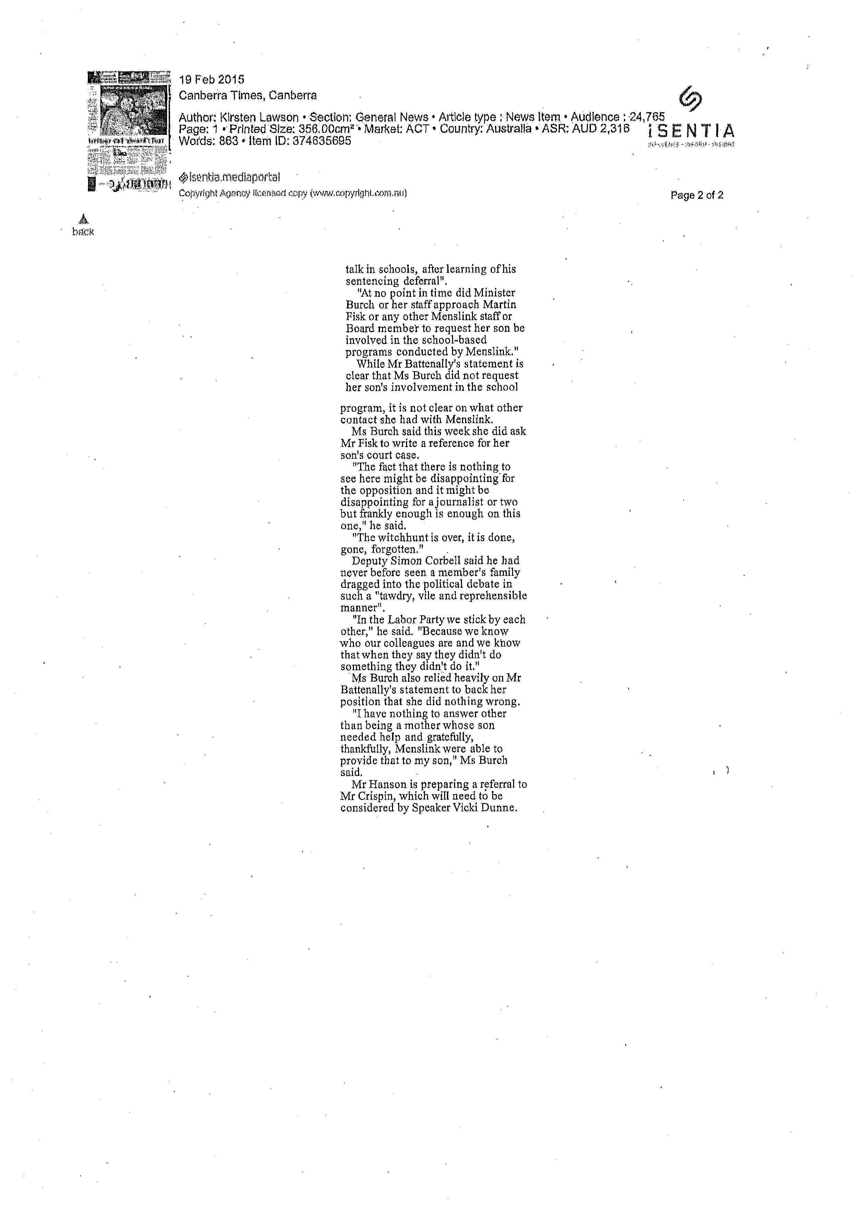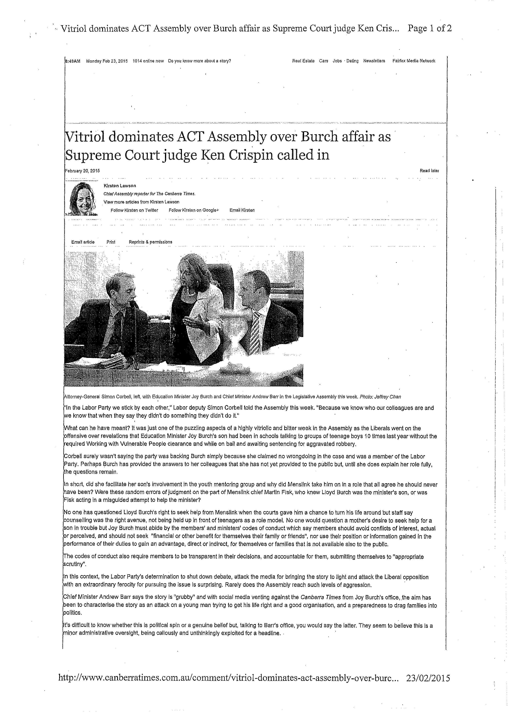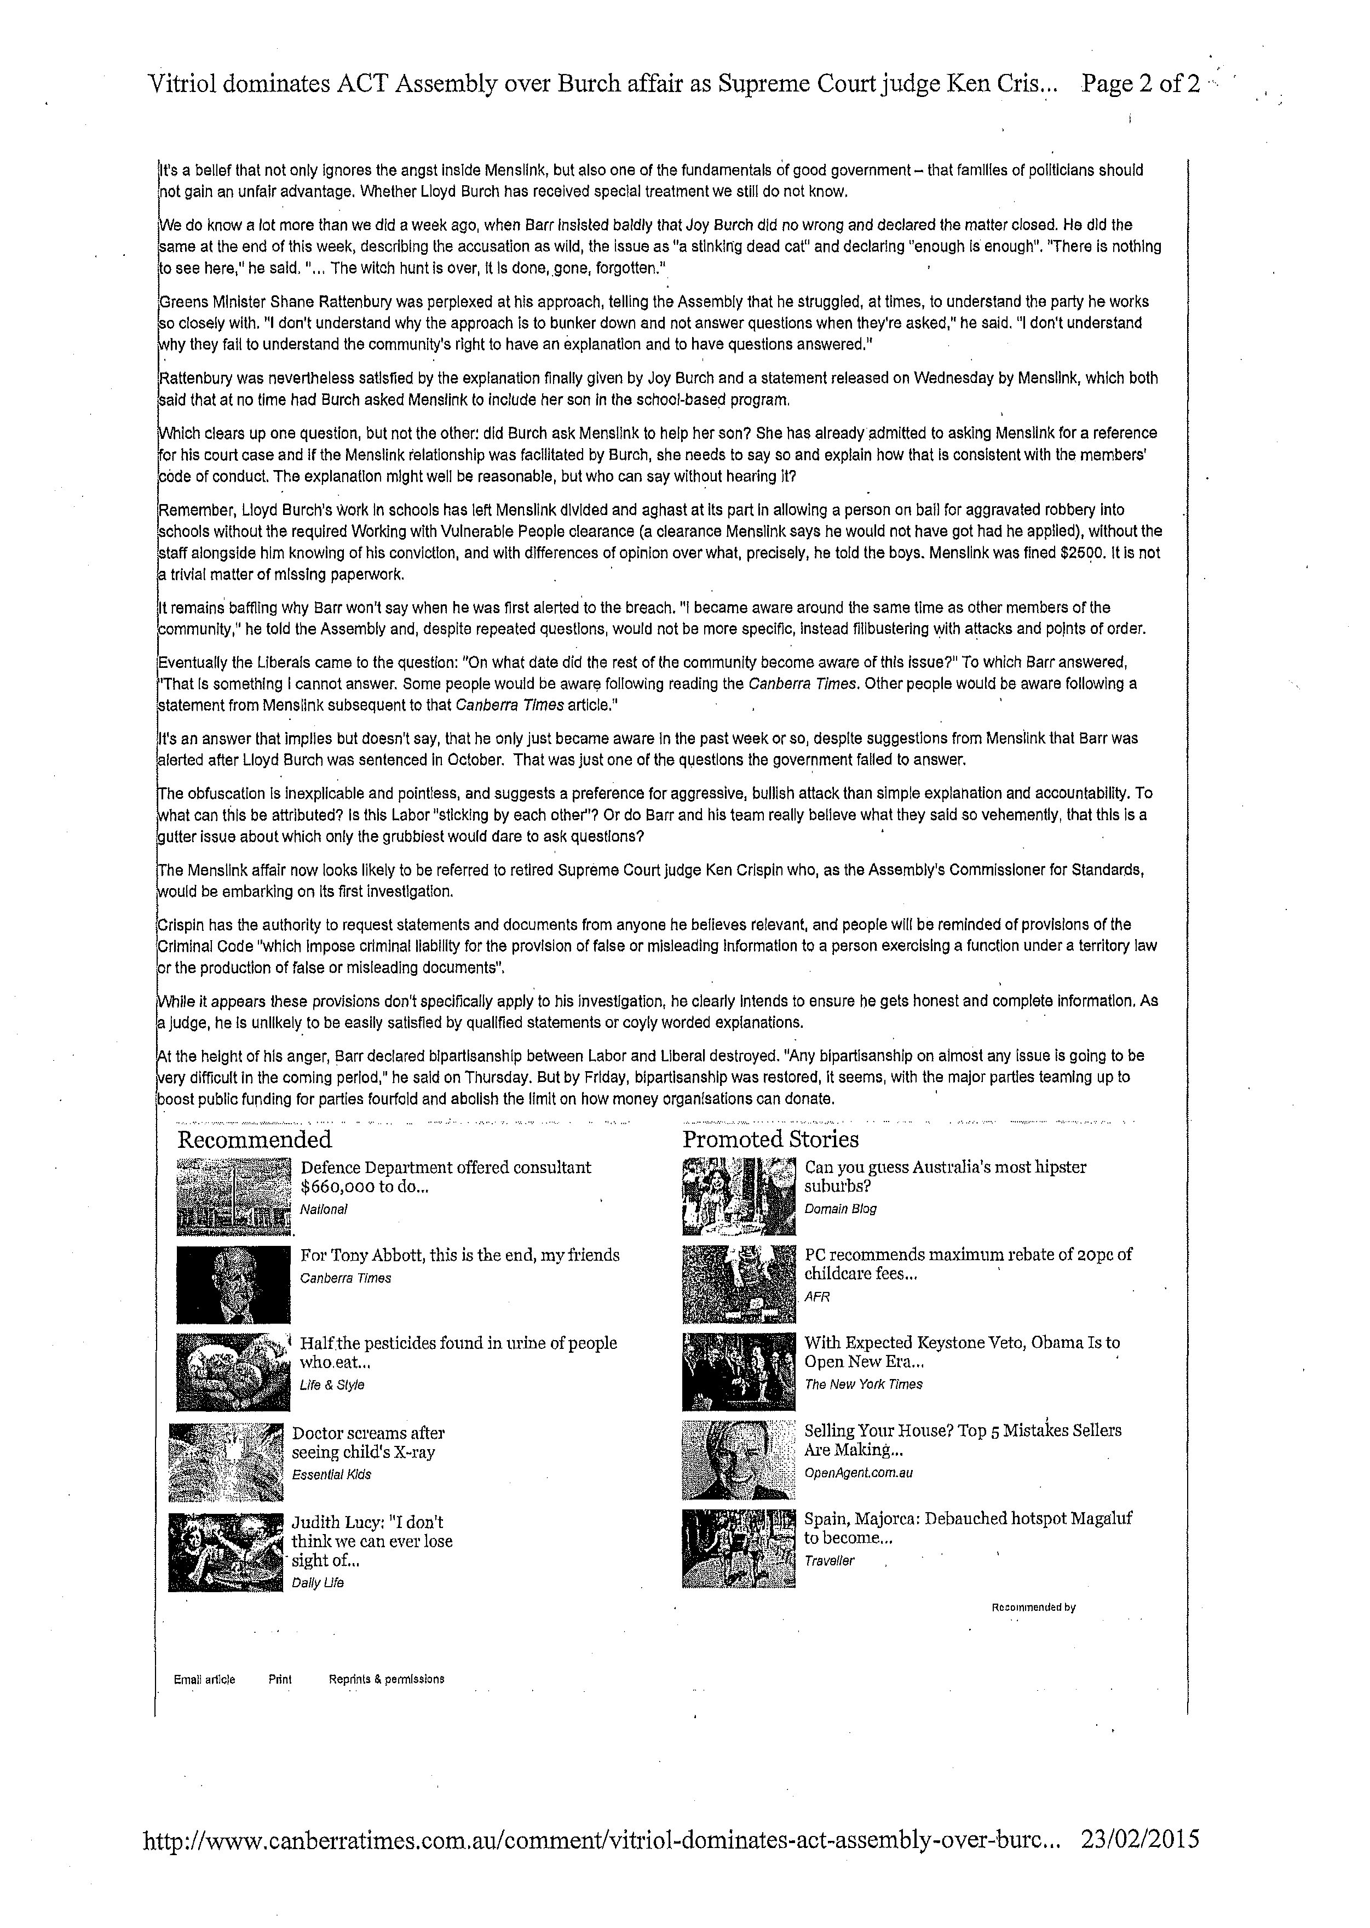

              - Letter to the Commissioner of Standards from the Speaker, dated 26 February 2015

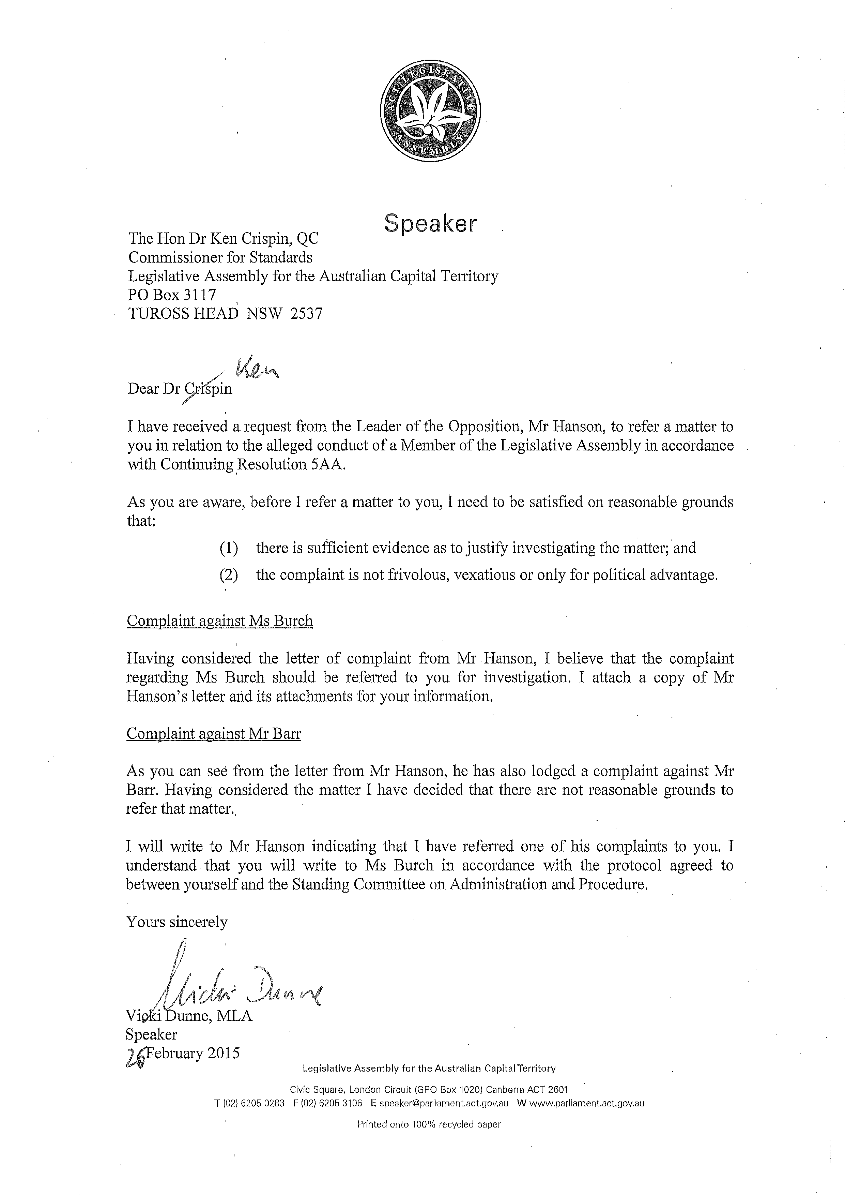
              - The Conduct of Ms Burch MLA—Report by The Hon Dr Ken Crispin QC, dated 28 May 2015.

REPORT INTO A COMPLAINT AGAINST MS JOY BURCH MLA

K. J. Crispin QC
Commissioner for Standards
Legislative Assembly for the Australian Capital Territory
28 May 2015
CONTENTS

Background 3
The Complaint 5
The Code of Conduct 5
The nature of the investigation 6
The conduct of the investigation 7
Mr Burch’s involvement with Menslink 10
The school visits 11
The need for registration 12
The Minister’s involvement 14
The direct evidence 15
The role of Mr Fisk 16
Should the Minister have intervened to stop the visits? 21
The suggested need to ensure statutory compliance 21
Her son’s conviction 23
The references 24
Did the Minister make due disclosure? 26
Issues of confidentiality 28
Conclusion 29

APPENDICES

Letter from the Commissioner to the Minister 4 Mar 2015
Letter from the Commissioner to Mr Fisk 4 Mar 2015
Letter from the Commissioner to the Leader of the Opposition 4 Mar 2015
Letter from the Leader of the Opposition to the Commissioner 13 Mar 2015
Submission from Mr Fisk 20 Mar 2015 Letter from Commissioner to Mr Roberts 4 Apr 2015
Submission from Mr Roberts incl earlier complaint to Menslink Board 17 Apr 2015
Submission on behalf of the Minister 17 Apr 2015
Further letter from Leader of the Opposition to the Commissioner 29 Apr 2015
Further submission on behalf of the Minister 1 May 2015
Brief from Menslink

REPORT INTO A COMPLAINT AGAINST MS JOY BURCH MLA

BACKGROUND

- On 12 February 2015 the Canberra Times reported that the youth mentoring organisation, Menslink, had been fined $2,500 for allowing Mr Lloyd Burch to enter a number of high schools without a Working with Vulnerable People Registration Card (‘WWVP Card’). This had occurred as part of Menslink’s ‘Silence is Deadly’ program which is intended to encourage young men to speak about personal problems and hence reduce the incidence of suicide. Mr Burch had then been on bail and awaiting sentencing on a charge of aggravated robbery to which he had pleaded guilty on 9 April 2014.

- Mr Burch is the son of Ms Joy Burch MLA (‘the Minister’) who at all relevant times was the ACT Minister for Education and Training and held several other portfolios.

- Menslink, is a name used by Men’s Link Incorporated, a charitable association with the avowed mission of promoting ‘the value, well-being and social participation of men, in particular young men, by providing appropriate and professional services with outreach activities’.

- The article in the Canberra Times went on to reveal that when the case was again before the court in October, 2014 the judge, who had earlier given Mr Burch ‘a chance to turn his life around’, had proceeded to impose a suspended sentence. In doing so, he noted that Mr Burch had gone beyond compliance with the ‘deferred sentence order’ and worked in schools with Menslink, where he had ‘shared his experiences with the deterioration of his life through drug abuse with students’. Rear Admiral Peter Clarke, who then chaired the board of Menslink was quoted as saying that he and the other members of the Board had been ‘absolutely aghast’ at the discovery of Mr Burch’s conviction.

- The judgment of Justice Burns confirms that on 9 April 2014 he convicted Mr Burch of an offence of aggravated robbery and imposed a deferred sentence order requiring Mr Burch to again appear in the Supreme Court for sentencing. He was released on bail subject to the following conditions:

(a) that he was to reside at a nominated address which was his parents’ address;

(b) that he was to abstain from the consumption of alcohol and illicit substances;

(c) that he was to accept the supervision of ACT Adult Corrections and to obey all lawful directions of officers of that service, including any directions to attend counselling or treatment for substance abuse or mental health issues;

(d) that he was to undergo random urinalysis as directed by Corrective Services;

(e) that he was to provide a sample of his breath when requested by members of the police; and

(f) that he was not to approach within 100 metres of the Ali Baba restaurant in Phillip in the Australian Capital Territory (ACT), where the offence occurred.

- When the hearing resumed on 23 October 2014 Justice Burns sentenced Mr Burch to a term of two years and six months’ imprisonment, which was wholly suspended, and imposed a good behaviour order for a period of two years, subject to certain conditions. In explaining the reasons for the sentence, Justice Burns said that:

2. The material which has now been placed before me demonstrates that the prisoner has complied with all of the requirements of the Deferred Sentence Order which I imposed in April. He has indeed gone beyond the requirements of that Order. He has attended Menslink, a charity that supports young men in the ACT, and has participated in a program at schools provided by Menslink in which he has shared his experiences with the deterioration of his life through drug abuse with students at those schools. The material that I have from Menslink speaks of the fact that this has proved to be remarkably effective in getting the message across to the students that have been addressed by the prisoner.

3. He has also attended Directions ACT in relation to substance abuse. He has ceased drug use, as has been demonstrated by random urinalysis. His parents have noticed a dramatic change in his presentation and his attitude, and I accept they are in the best position to judge that matter. I also note that he is studying and that he plans to complete his electrical apprenticeship and then to undertake an engineering course at university.

4. It is not often that people who are given an opportunity to demonstrate their
willingness to turn their lives around, in the way the prisoner was given an opportunity on this occasion, respond with the same degree of enthusiasm and success as the present prisoner. He must, of course, keep very clearly at the forefront of his mind that this is only the beginning and that he must maintain the commitment which he has demonstrated so far. It is very easy, indeed all too easy, to slip back into old habits. However, I think that I can now have some confidence that the prisoner has turned a corner in his life, to use a cliché which is sometimes misused in these courts, and that it is unlikely that he will reoffend.

- Mr Burch wrote to the Office of Regulatory Services on 12 December 2014 explaining his involvement with Menslink.

- Whilst Mr Burch’s activities are obviously relevant to the issues I am required to examine, they are not the focus of my investigation and any findings I make concerning his conduct should not be seen as involving any view about his conduct or character. I am concerned only with the complaint against his mother.

- Subsequent press articles suggested that the Minister had failed to explain her son’s role in the ‘Silence is Deadly’ program and raised questions whether she had exerted any influence over Menslink or otherwise facilitated his involvement. Questions were also asked about the circumstances in which the Chief Executive Officer of Menslink, Mr Martin Fisk, had provided references for Mr Burch in April and September last year.

THE COMPLAINT

- The complaint was contained in a letter from the Leader of the Opposition, Mr Jeremy Hanson CSC MLA, to the Speaker of the Legislative Assembly, Ms Vicki Dunne MLA dated 23 February 2015. Copies of various media reports were enclosed. The letter included a further complaint against another Member of the Assembly but that was not referred to me by the Speaker and for present purposes must be disregarded.

- The complaint against the Minister was understandably expressed in broad terms. It raised a number of general issues, including the extent, if any, to which she may have influenced Menslink to help her son and her knowledge of his visits to ACT schools and of any breaches of the relevant legislation. In essence, it alleged that:

Without excluding breaches of the criminal code or more extensive breaches of the Code of Conduct, it appears that sections 3, 5, 9 and 10 of the Code of Conduct have been breached.

- The complaint was referred to me by the Speaker by letter dated 26 February 2015.

THE CODE OF CONDUCT

- The Code of Conduct for all Members of the Legislative Assembly of the Australian Capital Territory (‘the Code of Conduct’) contains a succinct statement of agreed principles intended to guide the conduct of Members. The principles to which the Leader of the Opposition referred in the complaint are as follows:

(3) Members should always act in the public interest, make decisions and choices on merit, and not seek to gain financial or other benefit for themselves, their family or friends.

(5) Members should be transparent in, and accountable for, their decisions and actions, should avoid or appropriately resolve any actual or reasonably perceived conflicts of interest and should submit themselves to appropriate scrutiny.

(9) Members should promote and support these principles by leadership and example, in order to maintain and support public trust and confidence in the integrity of the Assembly and the conduct by its Members of public business.

Consistent with the above principles, Members further undertake that they should:

(10) Actively seek to prevent any conflict of interest, or the perception of such a conflict, arising between their duties as a Member and their personal affairs and interests, take all reasonable steps to resolve any such conflict or perception of a conflict that does arise …
- There are other potentially relevant sections including section (1) that records the perhaps self-evident but nonetheless fundamental principle that Members of the Assembly should at all times act with integrity, honesty and diligence.

THE NATURE OF THE INVESTIGATION

- Since this is the first occasion upon which a Commissioner for Standards has dealt with a complaint of this kind in the Australian Capital Territory, it might be appropriate for me to make some observations about the nature of the investigation I am required to undertake.

- The role of the Commissioner is limited to investigating the matters referred to him or her by the Speaker and reporting to the Standing Committee on Administration and Procedure (‘the Committee’). It is for the Committee to determine whether the complaint has been substantiated in any respect and, if so, what consequences should ensue.

- The investigation is inquisitorial rather than judicial in nature. Hence the Commissioner is obliged to initiate inquiries and actively try to establish the relevant facts, unlike a judge who generally hears only the evidence that the opposing parties choose to present. The scope of the investigation may also be somewhat more elastic than that of a trial since there are no pleadings of the kind used in civil cases to identify and narrow the range of issues before the hearing. The possibility of further issues emerging as the investigation proceeds cannot be wholly excluded, though the investigation must obviously remain focussed on the complaint. The Commissioner cannot pursue unrelated questions that emerge from the material examined, even if interesting and of potential public importance.

- As I have no adjudicative role, any issues about the standard of proof that should be applied in relation to complaints of this nature are ultimately matters for the Committee. However, since my report is intended to assist the Committee, I have taken the view that I should record my own impressions of the evidence and express my own opinion as to whether it is capable of substantiating any aspects of the complaint.

- In legal proceedings a matter is said to be substantiated only when the party with the onus of proving the relevant facts has established them to the required legal standard. Since I am not hearing a legal action, but merely enquiring into what may have occurred, neither the Leader of the Opposition nor anyone else bears an onus of proving anything. On the other hand, the very concept of substantiation involves the proposition that the relevant matter has been established to some level of satisfaction. The approach usually followed in cases involving suggested breaches of non-criminal codes of conduct is to adopt the so-called ‘civil’ standard of proof on the balance of probabilities, though the strength of the evidence necessary to establish the relevant facts even to that standard may vary according to the nature of what is alleged. As Dixon J. commented in Briginshaw v. Briginshaw ((7) (1938) 60 CLR, at p 362 “the seriousness of an allegation made, the inherent unlikelihood of an occurrence of a given description, or the gravity of the consequences flowing from a particular finding are considerations which must affect the answer to the question whether the issue has been proved.’ (See also Neat Holdings Pty Ltd v Karajan Holdings Pty Ltd [1992] HCA 66 Mason C.J., Brennan, Deanery and Gaudron JJ at paragraph 2).

- Of course, the Committee is free to determine the relevant issues as it seems fit but, in the absence of some indication that it intends to adopt a more stringent standard, I have assumed that it is likely to adopt the usual approach taken in relation to such matters. Accordingly, I have borne in mind the need to consider whether evidence revealed by the investigation would be likely to be accepted by the Committee as substantiating any aspect of the complaint to that standard.

THE CONDUCT OF THE INVESTIGATION

- The investigation was conducted in accordance with the protocol adopted by the Committee on 24 March 2015. The protocol notes that:

It is the Commissioner’s intention to rely upon written material and not to hold any face to face discussions or otherwise receive oral evidence unless such a course proves necessary for the fair and satisfactory completion of a particular investigation.

- In the interests of transparency, I have annexed copies of all of the relevant documentation received during the course of the investigation.

- Having regard to the broad nature of the complaint, I took the view that it was necessary to identify some potential issues, if only to ensure that submissions had a common focus and covered all or most of the matters likely to be relevant. Hence, whilst those contacted were advised that they were free to make any submissions they saw fit, they were also asked to address the following issues:

  - The circumstances in which the Minister’s son, Mr Lloyd Burch, came to visit a number of schools, including some conducted by the ACT Education and Training Directorate and falling within her portfolio as Minister for Education on various occasions last year.

  - When those visits occurred.

  - Whether, Mr Burch had a legal obligation to become registered under the Working with Vulnerable People (Background Checking) Act 2011 (‘the Act’) before engaging in a ‘regulated activity’ such as visiting schools of this nature.

  - If so, whether at the time of some or all of those visits the Minister knew that registration was required by the Act.

  - Whether at the time of some or all of those visits she was aware that her son had not been registered under the Act.

  - Whether those visits were facilitated by Mr Fisk or some other person holding a position of authority with Menslink.

  - Whether the Minister asked Mr Fisk or any other person associated with that group to arrange such visits or did anything else to facilitate them.

  - Whether, by doing so, she was complicit in an offence against the Act.

  - When she first became aware that such visits were to occur or were occurring.

  - Whether she took any action upon becoming aware that the visits may have involved breaches of the Act and, if so, what action.

  - Whether, irrespective of any statutory requirement, it was inappropriate for her son to be permitted to visit government schools whilst he was on bail for a serious criminal charge.

  - Whether she at at any time consulted the ACT Ethics and Integrity Advisor or any other person about the propriety of such visits and, if so, whether she followed any advice that she may have been given.

  - Whether she asked Mr Fisk to provide references for her son and, if so, the time when each such request was made.

  - The suggested inconsistency between statements attributed to her in your complaint, namely the visits ‘were entirely between Menslink and my son’ and ‘I approached the CEO on behalf of my son’.

  - What, if any, explanations she gave to the Assembly and the adequacy of those explanations.

- On 4 March I wrote to the Minister advising her of the complaint and inviting her to submit a written response to the complaint by the close of business on 25 March 2015. The letter specified the issues that I had identified as being potentially relevant. I also wrote to Mr Fisk, advising him of the complaint, identifying certain issues on which I thought he may be able to shed some light and asking him to provide any relevant information. A further letter was sent to the Leader of the Opposition advising him that I had written to the Minister, mentioning the issues I had identified as potentially relevant and inviting him to provide me with any further information that he thought might be relevant.

- The Leader of the Opposition responded by letter dated 13 March 2015, indicating that the issues I had identified appeared to be consistent with the questions that had been asked in the public domain and that he believed had not been satisfactorily answered. He also provided some extracts from Hansard.

- The Minister responded by letter dated 17 March advising me that she had sought legal advice and might need an extension of time to submit written responses to the complaint.

- Mr Fisk responded by letter dated 20 March 2015.

- On 24 March I received a letter from Mr Paul Vane-Tempest, a partner in the legal firm Ashurst Australia, informing me that the firm now acted for the Minister and requesting an extension of time for the provision of a written submission until 13 April 2015. I acceded to that request and also to a subsequent request for a further extension until 19 April 2015.

- I was subsequently informed that another officer of Menslink, Mr Neale Roberts, wished to make a submission concerning the complaint and wrote to him by letter dated 4 April 2015.

- On 17 April 2015 I received a letter from Ashurst Australia containing detailed submissions on behalf of the Minister and enclosing various documents.

- On the same day, I received an email from Mr Roberts enclosing a written submission to me and a copy of an earlier complaint he had made to the Board of Menslink. I sent a copy of those documents to Ashurst Australia to provide an opportunity for further submissions to be made on the Minister’s behalf in reply to any of the issues Mr Roberts had raised.

- On 19 April I sent a copy of the submissions that had been made on the Minister’s behalf to the Leader of the Opposition to give him the opportunity of commenting on them. He replied with another short submission on 29 April 2015.

- Further submissions were duly received from Ashurst Australia on 1 May 2014 relating to an issue raised by Mr Roberts who had said that Mr Fisk had been contacted, apparently by someone from the Minister for Women’s office and invited to submit a late nomination by Menslink for a ‘Partners in Prevention’ award. Mr Roberts said that Menslink won the award two days after the nomination was submitted and it was presented by the Minister. In the further submissions made on her behalf, the Minister denied the implicit allegation that she or someone in her office had suggested that Menslink should apply for that or any other award and explained that the ‘Partners in Prevention’ awards are facilitated by the Office of Women within the Community Services Department. The award was apparently presented in December 2014, well after Mr Burch had been sentenced, and Mr Roberts’ understanding of the invitation appears to have been dependent upon at least third hand hearsay. The issue is not directly relevant to the complaint I am required to investigate and the Leader of the Opposition did not refer to it in his response to Mr Roberts’ submissions. In the circumstances, I took the view that the issue did not warrant further investigation.

- On 1 May 2015 the Leader of the Opposition informed me that an investigation into the circumstances in which Mr Burch had been permitted to visit schools with Menslink staff had been conducted by Rear Admiral Clarke and that he had prepared a report which had been provided to the Office of Regulatory Services but not otherwise released. I immediately requested a copy of the report but Mr Michael Battenally, who had replaced Rear Admiral Clarke as chair of the board, indicated that he was concerned about the possibility of the document being publicly disclosed and an exchange of emails and some discussion by telephone ensued. A copy of the report, or ‘brief’ as the document was described by Rear Admiral Clarke, was finally received on 14 May. The brief has been slightly redacted to omit the names of some staff members.

- The sentencing remarks of Justice Burns and the Menslink rules and manual are available online.

- Viewed overall, the evidence provided by the various submissions I have received seems to disclose the relevant facts with reasonably clarity. There is no evidence to suggest that the Minister had any direct contact with anyone associated with Menslink other than Mr Fisk concerning her son’s involvement with that organisation and, since no relevant and substantial factual disputes emerged, it has proved unnecessary to hold face to face discussions or receive oral evidence.

- A draft report was sent to Ashurst Australia on 20 May 2015, a response was received on 27 May 2015 and comments made on behalf of the Minister have been duly considered.

MR BURCH’S INVOLVEMENT WITH MENSLINK

- The Minister’s submissions explain that she had discussed her son’s predicament with him during the course of his involvement with the criminal justice system and that she had encouraged him to become involved with Menslink as she thought this would offer him hope and support. She had known Mr Fisk in a professional capacity since 2011 and had attended several functions organised by Menslink, including one on 5 December 2012 at which she launched the ‘Silence is Deadly’ program.

- Her son accompanied her to the Multicultural Festival in February 2014 and proceeded to collect money for Menslink. It was also at this function that he first met Mr Fisk.

- Mr Burch again collected money for Menslink at a Rugby match in March 2014.

- Mr Fisk provided a reference for him on 7 April 2014, mentioning the support he had displayed in collecting money on those occasions and indicating that Menslink was willing to provide counselling and support for him.

- In his submission, Mr Fisk said that he contacted Mr Burch again after reading of his conviction in a report published in the Canberra Times. He subsequently discussed the ‘Silence is Deadly’ program with him at a meeting on 28 April 2014.

- This program addresses the apparent reluctance of young men to seek help when they experience emotional problems and other difficulties. It involves school visits by counsellors, sportsmen and young men who have themselves battled with personal problems and volunteered to speak about their experiences in the hope of helping others. The Menslink website suggests that young men suffer from depression and anxiety at about the same rate as young women but are less willing discuss to their problems. This reticence means that the problems often remain unaddressed and hence expose young men to greater risk of suicide.

- Mr Fisk said in his submission that where possible, Menslink uses men with ‘lived experience’ as this has proven most effective in delivering Menslink’s key messages to students. He asked Mr Burch to take part in the school visits because he believed that his story would resonate with male students and help them avoid making poor life choices. He also thought that it would give him an opportunity to pay his debt to the community and help him ‘turn his life around’. Mr Burch agreed to become a volunteer. Arrangements were subsequently made for Mr Burch to participate in a number of visits to schools in the ACT and to speak to various groups of students.

- Mr Fisk was clearly impressed with Mr Burch’s conduct and on 1 September 2014 he wrote a second reference for him.

THE SCHOOL VISITS

- Mr Fisk candidly conceded that each of the subsequent school visits was facilitated by him or others acting with his full knowledge. Mr Roberts agreed that the visits were facilitated by Mr Fisk and added that he had included Mr Burch on invitation lists to attend schools when booking sessions for the ‘Silence is Deadly’ program without knowing that he had been convicted of a serious offence and lacked a WWVP Card.

- There is no evidence to suggest that the Minister had any involvement in the arrangements for her son to attend the individual schools.

- Mr Fisk offered to provide details of the Menslink staff members who attended on each of these occasions. Since there had been no suggestion that the Minister had ever spoken to any of them and no issue had been raised about anything that occurred during those visits other than Mr Burch’s presence, I took the view that this was unnecessary.

- Mr Fisk provided a list indicating that Mr Burch had participated in visits to the following schools on the dates specified:

14 May 2014 Canberra High School
28 May 2014 Blue Gum Community School
5 June 2014 Lanyon High School
13 June 2014 Queanbeyan High School
18 June 2014 Amaroo High School
2 July 2014 Carolyn Chisholm High School
23 July 2014 Daramalan College
30 July 2014 Namadgi School
30 July 2014 Mary MacKillop College
20 August 2014 John Paul II College
28 October 2014 St Edmunds College

- Queanbeyan High School is, of course, located in NSW but the other ten schools are within the ACT.

- In his submission, Mr Roberts referred to the visits to Daramalan College on 23 July and Mary Mackillop College on 30 July, but suggested that Mr Burch had also visited Canberra Grammar School on 13 August and Erindale College on 24 September. He did not mention a visit to John Paul II College but said that he was aware of a visit to St Edmunds College in November 2014. He understood that there had been ten such visits in all.

- I am unable to resolve these discrepancies with any real confidence, though it is possible that Mr Fisk was unaware of the visits to Daramalan College and Mary Mackillop College and, conversely that Mr Roberts was unaware of the visit to John Paul College. For present purposes it is sufficient to note that there seems to have been at least ten visits to ACT schools.

THE NEED FOR REGISTRATION

- WWVP Cards are issued under section 49 of the Working with Vulnerable People (Background Checking) Act) 2011 (’the Act’) to all who become registered under section 41. The real question is whether Mr Burch was required to be registered.

- The Act has been subject to some amendment since initially enacted but at all relevant times section 12 provided that a person was required to be registered to engage in a ‘regulated activity.’ That term that was defined to include any activity or service mentioned in schedule 1 and paragraph 1.4 of that schedule provided that:

(1) An activity or service is a regulated activity if the activity is conducted, or the service is provided, as part of a child education service.

(2) In this section:
child education service—

(a) means a service for which the main purpose is to provide education and care for children; and

(b) includes—

(i) a school or other educational institution, whether or not operated by or on behalf of the Territory; and

(ii) a school-crossing service.
school means a preschool, primary school, high school or secondary college.

- Accordingly, the visits made to schools by Mr Burch were ‘regulated activities’ and the requirements for registration applied.

- It is an offence to engage in regulated activities in breach of the requirements for registration (see section 13 of the Act).

- Mr Roberts was critical of Menslink for making public statements to the effect that an administrative error had led to Mr Burch being allowed to enter schools on more than 7 occasions in a 12 month period. He maintained that it was clear from the legislation that he had required a Card to enter a school even once. I have no reason to doubt that he believed this to be true. However, the Act does provide some exceptions to the general requirement for registration. In particular, a person is not required to be registered if engaged in the relevant activity (other than an overnight camp for children) for not more than 3 days in any 4-week period or 7 days in any 12-month period [see section 12(2)(b)].

- Accordingly, no offence would have been committed had Mr Burch made no more than seven visits to schools in the ACT without being registered. Unfortunately, that was not the case. Since there were at least ten visits to ACT schools, registration was clearly required.

- In his letter of 12 December 2014 Mr Burch said that he had not been deliberately avoiding the ‘checking requirements’ that must be met for registration and offered the following explanation:

Shortly after I started volunteering with Menslink for the Silence is Deadly program Menslink provided me with Working with Vulnerable People Check guidelines and forms. At this point I didn’t know how often I was going to be asked to attend a school visit and didn’t really expect to be asked very often. I also thought that given the short period of time I was at a school and that I was at all times supervised that I fell within the category of not needing a Working with Vulnerable People card.

He added that he had not kept track of the number of visits he had made to schools and that he had not fully understood the requirements.

- Of course, neither a misunderstanding of the legal requirements nor a failure to keep track of the number of visits undertaken offer any defence to charges under section 13 of the Act. Hence, it seems clear that he committed at least three breaches of the Act by repeatedly engaging in a regulated activity without being registered.

- In making this observation, I would not wish to be taken to be suggesting that he bore the sole or even predominant responsibility for these breaches. He was a young man, struggling with serious personal problems and the prospect of being sent to prison, and he was participating in the visits as part of a well established community program run by people whom he would have been entitled to assume were well aware of the legal requirements governing entry to schools. The board of Menslink rightly accepted responsibility for their complicity in these breaches of the Act by reporting the matter to the Office of Regulatory Services and subsequently paying the fine. His visits should have been duly recorded and there should have been a system in place to ensure that neither he nor any other volunteer were permitted to continue in circumstances involving an offence under the Act.

- I should also note that there has been no suggestion that Mr Burch was guilty of any misconduct during the school visits. On the contrary, Mr Fisk said that his behaviour had been ‘exemplary’ and that he had treated staff, fellow volunteers and students with respect.

THE MINISTER’S INVOLVEMENT

- It has not been suggested that the Minister’s decision to encourage her son to become involved with Menslink itself involved any breach of her ethical obligations and in my opinion no such allegation could have been sustained. There is nothing in the Code of Conduct to suggest that Members of the Assembly should withhold parental advice or encouragement to seek to seek access to rehabilitation or mentoring services available to other members of the community.

- The main issue raised by the complaint is whether she went beyond the provision of that advice and influenced Mr Fisk or others associated with Menslink to include her son in visits to schools when she knew that other young men in a similar situation would probably have been excluded and/or that his participation was likely to involve breaches of the Act.

The direct evidence

- The Minister maintains that neither she nor her staff approached Mr Fisk or any other representative of Menslink to suggest that her son be involved in school based programs. She insists that the relevant arrangements were made by Mr Fisk on his own initiative and followed discussions with her son to which she had not been party.

- Her evidence to this effect is supported by Mr Fisk whose submission includes the statement that:

Ms Burch did not ask me or anyone at Menslink (staff or volunteer) to facilitate the school visits. Mr Burch’s school visits were initiated and organised solely by Menslink and not at the request of Ms Burch.

- Her evidence is also consistent with the account given by her son in his letter of 14 December 2014 to the Office of Regulatory Services. The weight that should be given to this evidence may be limited by the family relationship and his own involvement in the relevant events, though the letter was written before any public controversy emerged about any role that his mother may have played in the arrangements. Mr Burch confirmed that Mr Fisk approached him about being involved with school visits as part of the ‘Silence is Deadly’ program and said that he had been honoured to be asked . He had thought that his own experiences of depression, substance abuse and antisocial behaviour and of working through these problems with the support of others might offer some ‘peer insight’ for the students.

- The Minister’s evidence also gains some support from the ‘community message’ issued by Mr Battenally on 17 February 2015, which stated that ‘at no point in time did Minister Burch or her staff approach Martin Fisk or any other Menslink staff or Board member to request her son be involved in the school-based programs conducted by Menslink.’ This information may have been provided by Mr Fisk but it is not only consistent with his evidence but also with that of the Minister and the account given by her son in his letter to the Office of Regulatory Services.

- No cogent evidence to the contrary has emerged and there is nothing inherently improbable in the Minister’s account of the relevant events.

- It was suggested that there was some inconsistency between two of the statements made by the Minister in explaining the relevant events, namely the visits ‘were entirely between Menslink and my son’ and ‘I approached the CEO on behalf of my son’. However, it is clear from the Hansard records that, in recounting the fact that she had ‘approached the CEO on behalf of my son’, she had not been referring to some overture she had made about the school visits but to an approach she had made to Mr Fisk in April 2014 in order to obtain the first of the references.

- Some suggestion that the Minister may have been complicit in the arrangements has been raised, at least by implication, by comments made by Mr Roberts. In his complaint to the board of Menslink, Mr Roberts said the Minister was ‘open to allegations of conflict of interest by asking Menslink to intervene.’ he added that: ‘It would be very destructive if a narrative was written by the Canberra Times drawing links from the Education minister, to the Menslink CEO, and then to her son being allowed into schools to talk when other offenders would be excluded’

- His concern about the potential impact of adverse press reports on the reputation and work of Menslink may be entirely understandable. However, Mr Roberts did not commence employment with Menslink until 2014 and, when asked whether the Minister had asked him or anyone associated with Menslink to arrange such visits or had done anything else to facilitate them, he said simply: ‘Ms Burch has never had contact with me.’ Hence, the suggestion that the Minister had asked Menslink to make the arrangements seems to have been based on assumption rather than any actual knowledge of what occurred. The suggestion was not repeated in the submission he subsequently provided at my request.

The role of Mr Fisk

- Mr Fisk obviously played a pivotal role in the events that gave rise to the complaint. He seems to have made all of the relevant decisions on Menslink’s behalf. He made or effectively authorised the relevant arrangements, wrote both of the references relied upon by Mr Burch in the sentencing proceedings and, as previously mentioned, seems to have been the only Menslink representative to have had any relevant discussions with the Minister.

- Both Mr Roberts’ submission and his earlier complaint to the Menslink board contain trenchant criticism of Mr Fisk’s actions in accepting Mr Burch into the ‘Silence is Deadly’ program and arranging for him to visit schools when he not only lacked a WWVP Card but had been convicted of aggravated robbery and was awaiting sentencing. Mr Roberts suggests that Mr Burch received exceptional treatment because he was the Minister’s son. He also maintains that Mr Fisk breached the Act, breached Menslink’s own protocols, kept staff in the dark and provided false information in the second of the references prepared for the court.

- I should stress that I am neither required nor entitled to make any judgments about the wisdom or propriety of Mr Fink’s conduct, save to the extent to which it might cast light on issues relating to the complaint against the Minister.

- However, the Leader of the Opposition has submitted that the allegations made by Mr Roberts cast Mr Fisk’s version of events in a doubtful light and that the matters he has raised may undermine the weight that should be given to other statements made by Menslink. This submission obviously requires due consideration. It is also necessary to consider whether any inferences about the the role of the Minister should be drawn from his conduct.

- These issues must be approached with caution. Since I am not dealing with a complaint against Mr Fisk, he has not been asked to make submissions in his own defence and, in the absence of a full oral hearing in which they could be fairly tested, it would be wrong to assume that all of the allegations now raised against him are well founded.

- The brief prepared by Rear Admiral Clarke reveals that Mr Fisk was found to have knowingly breached the drug and alcohol policy stated in the Menslink Manual by not raising Mr Burch’s participation with the board. The report explains that the board had ‘restricted the use of volunteers with a history of drug and alcohol abuse’ and cited paragraph 7.8.1 of the Manual. However, that paragraph refers to ‘drug or alcohol use (or former use) by a board member, executive staff, patrons or other high profile people whose name may be associated with Menslink’. It may be noted that whilst this paragraph covers patrons, it does not extend even to non executive staff, let alone volunteers. It seems to be directed towards any involvement with prominent people whose drug taking or drinking might tarnish Menslink’s reputation, not to young men who have formerly used drugs or alcohol and subsequently volunteered to help others avoid similar mistakes. However, it is not my role to review the Board’s conclusions and this was not the only adverse finding. The Board was also critical of his judgment, knowledge of the Act and apparent lack of remorse. It also complained that he had exposed Menslink and others to prosecution.

- On the other hand, the brief recorded some favourable observations , including:

The board accepted that (Mr Fisk) believed he had acted in good faith for the benefit of Men’s Link and the rehabilitation of Mr Burch

The board’s risk assessment revealed no adverse impact of Mr Burch’s involvement in the Silence is Deadly programme other than the exposure of Men’s Link, (Mr Fisk), Mr Burch and possible (sic), other Men’s Link staff to prosecution.

- Mr Roberts seems to feel that these findings were insufficient. Whilst I have no reason to doubt the sincerity of his indignation and distress at what occurred, it does seem likely that his present attitude towards Mr Fisk may be at least partially attributable to a fundamental difference of view about the manner in which Menslink should respond to young offenders like Mr Burch. In his complaint to the board, Mr Roberts said that he objected to Mr Fisk’s ‘forgiving nature’ in view of the seriousness and nature of Mr Burch’s crime. Whilst conceding that there was a case for Menslink to rehabilitate young men who had committed crimes, he said that there was a difference between Mr Burch and someone who had already served his sentence and was seeking to redeem himself and contribute to the community. He accepted that Mr Burch could have been permitted to engage in counselling or to serve Menslink in some capacity involving no contact with young men, but expressed the opinion that ‘we should not use the resources of Menslink to reduce the punishment of a crime before the courts’. Mr Roberts , who had formerly been an Australian Federal Police chaplain, seemed to see this as an important moral principle. Mr Fisk clearly had very a different view.

- Mr Roberts’ apparent concern about community bodies being used by offenders seeking unwarranted leniency should not be wholly discounted. Anyone involved in drug or alcohol rehabilitation who is approached by someone on bail for a serious offence needs to be alert to the risk of being manipulated for forensic purposes. On the other hand, I must say that I agree with Mr Fisk’ apparent view that it is desirable for mentoring organisations like Menslink to assist people struggling with drug, alcohol or mental health problems, even when they are still awaiting sentence. In my view it would be quite wrong to deny people prompt treatment and help merely because the proceedings pending against them have not been finally resolved. To do so would not enhance the sentencing process but merely deprive the judge of potentially important evidence about the offenders’ commitment to rehabilitation or propensity to lapse into recidivism. In fact, courts regularly adopt the practice followed by Justice Burns in April last year of deferring sentencing for some period to give an offender the opportunity to demonstrate that there is some realistic prospect of rehabilitation. This practice, sometimes known as the ‘carrot and stick’ approach, presents a drug dependent, alcoholic or in some cases mentally ill offender with a stark choice. The offender may agree to undertake or accept a regimen of treatment or rehabilitation stipulated by the court or face a substantial term of imprisonment. The prospect of imprisonment continues to hang over the offender’s head like the sword of Damocles and in some cases this practice merely delays an offender’s arrival at the prison gates, but there are many cases in which it is surprisingly effective.

- In any event, Mr Roberts indicated that he had been so distressed by the approach taken by Mr Fisk that he had been obliged to take time off from work on three occasions due to ‘mental health issues’ and still found it difficult to work with him. Strong feelings may be a mark of the depth of one’s convictions, but they may also have the capacity to mislead and, perhaps, to attribute mala fides to others when the adverse perceptions one has formed may actually reflect some misunderstanding by one or both parties. There are some indications that at least some of his grievances against Mr Fisk could have arisen in this manner. For example:

- His statement that ‘it is clear in the legislation’ that Mr Burch needed a WWVP card to enter even one school seems to have reflected his misunderstanding of the relevant provisions. Mr Roberts may have gained this impression from paragraph 6 of the Menslink Manual but it was nonetheless incorrect, as was the accompanying assertion that Mr Fisk ‘knew of this fact.’

- Whilst Mr Roberts complained of staff being deliberately kept in the dark about Mr Burch’s background, he also mentioned that Mr Fisk had said, ‘on more than one occasion, that he was assisting Mr Burch with a court matter’. Whilst Mr Roberts may have expected him to reveal any further information that was relevant, Mr Fisk may have assumed that, if he had not known what the court matter was about, he would have asked.

- After noting that Mr Fisk had informed the court that Mr Burch had used his sessions in the schools to speak of his drug use and violence, Mr Roberts stated that ‘this simply did not occur’. However, as previously mentioned, Mr Roberts did not commence work with Menslink until late July, when six of the eleven school visits recorded by Mr Fisk had already occurred, and he referred to only two of the other five in his own list of the schools visited. Accordingly, it seems likely that he was not present on at least nine of the eleven occasions (including the one in Queanbeyan) on which Mr Burch had presumably spoken. Mr Roberts may have accepted things that others had told him or assumed that Mr Burch had always followed the same theme, but in the absence of further evidence, I would not be willing to assume that Mr Fisk had knowingly included false information in his reference.

- The proposition that the judge had taken the view that ‘without the assistance of Menslink Mr Burch would probably be in gaol’ seems to have been overstated. Justice Burns did speak with evident approval of Mr Burch’s involvement with Menslink, but he also took into account the fact that Mr Burch had attended Directions ACT, ceased using drugs, changed his attitude and started studying. The judgement also makes it clear that other sentencing options, including periodic detention, had been precluded by the fact that Mr Burch had been involved in an accident and had two fractured legs.

- Some of Mr Roberts’ assumptions, such as the belief that the resources of Menslink would not have been used for Burch’s rehabilitation if he ‘had not been the son of an influential person’ may have also been unduly cynical. The ‘Strategy” section of the Menslink Manual begins with the statement that ‘Menslink provides mentoring and face-to-face counselling services to young men aged 12-25 years of age’ and, after mentioning some types of ‘challenges’ it may be unable to adequately address, continues: ‘Regardless of this, Menslink will always attempt to assist any young man in need …’

- Of course, none of these observations suggest that Mr Roberts’ complaints were not made honestly. On the contrary, he seems to be a person of real conviction who was genuinely aggrieved at what he saw as flagrant breaches of Menslink’s legal obligations and ethical standards.

- On the other hand, I am not persuaded that Mr Fisk, who even Mr Roberts described as an ‘upstanding member of the community’, should be regarded as devoid of credibility merely because these allegations have been made against him. It has not been suggested that he stood to make any personal gain by his actions and I can see no reason to doubt that he was motivated by genuine concern for a young man in obvious need of mentoring and help. As the CEO of Menslink, he must bear substantial responsibility for the breaches of the Act that occurred, but the evidence does not establish that this was attributable to anything more sinister than a failure to ensure that an adequate system was established and followed to prevent any such breaches.

- The material provided by Mr Roberts does not contain any evidence capable of supporting an inference that the Minister intentionally influenced Mr Fisk to involve her son in school visits. He does claim that Mr Fisk told him that Mr Burch was the son of the Minister of Education and explained he had told him this so that he would not make any derogatory remarks about her at school. Mr Roberts says that he found this both strange and an offence to his professionalism. It can sometimes be difficult to know what inferences should be drawn from words alone and I cannot discount the possibility that there may have been something in Mr Fisk’s accompanying tone or demeanour that led Mr Roberts to construe this statement as strange and offensive, but at face value it does not seem remarkable. Not everyone suppresses political biases when making judgments about others and this conversation apparently occurred during Mr Robert’s first week with Menslink. Mr Fisk was not asked for his version of the conversation but even if it occurred as Mr Roberts apparently recalls, it may have reflected nothing more than a desire to avoid embarrassment or unintended offence.

- Of course, Mr Fisk may well have been sensitive to the fact that Mr Burch was the Minister’s son, but the evidence does not support an inference that he consciously departed from from his duty in order to impress the Minister. It is also difficult to imagine that Mr Fisk could have expected her to have been pleased by having her son permitted to breach the Act and hence commit even relatively minor offences whilst awaiting sentencing in the Supreme Court.

- The possibility that his initial decision to involve Mr Burch in the ‘Silence is Deadly’ program may have been influenced, in part, by a desire to please the Minister cannot be so readily dismissed, but even this has not been established. There was no obvious reason for him to have rejected an approach from any young man in Mr Burch’s position and no evidence to suggest that the Minister did or said anything in an attempt to influence him to give her son preference in some way.

- Had any conflict emerged in the accounts given by Mr Roberts and Mr Fisk that seemed likely to have a substantial bearing on the outcome of the complaint against the Minister, I would have arranged for an oral hearing so that the reliability of the competing versions could have been more effectively assessed and appropriate findings made. However, that did not occur. Mr Roberts acknowledged that he had had no personal contact with the Minister and, whatever the merits of his complaints against Mr Fisk, the adverse assumptions he made concerning the Minister have not been shown to be well founded.

- Viewed overall, the evidence concerning Mr Fisk’s role and conduct provides no real grounds for an inference that the Minister did anything to encourage or facilitate her son’s visits to the schools or the breaches of the Act.

SHOULD THE MINISTER HAVE INTERVENED TO STOP THE VISITS?

- The Minister concedes that she became aware of the visits when her son told her about the experience of visiting the first school and said that Menslink had invited him to visit others. She said that he had been enthusiastic about forming new relationships and the faith Mr Fisk had shown in him.

- Mr Fisk has also said that he met the Minister at a number of social events during the period in which her son was involved with the ‘Silence is Deadly’ program and that he had told her that he was doing well but had not provided any details of the schools he had visited.

- The fact that she became aware of her son’s participation in the school visits so early in the period of his involvement with Menslink may raise questions about whether she then had a duty to intervene in some way.

The suggested need to ensure statutory compliance

- The Leader of the Opposition has suggested that once she became aware of her son’s visits to ACT schools she should have disclosed the full extent of his activities and taken steps to ensure that the relevant legislation and guidelines were complied with. He maintains that she committed a breach of her duties by ‘turning a blind eye’ when she had ‘actual and on-going knowledge of his activities’. This is a serious allegation which, if sustained, would warrant a conclusion that she had contravened sections (3), (5), (9) and (10) of the Code of Conduct.

- Of course, the Minister was denied the benefit of hindsight that can so easily be brought to bear on issues of this kind and it is necessary to consider what she must have known or suspected at the time. Any finding that she should have anticipated future breaches of the Act would require evidence that she was not only aware of the relevant statutory requirements but also that she knew her son had not complied with them and that he intended to persevere with the visits beyond the number permitted without registration.

- The Minister concedes that she knew the Act provided for a scheme of registration and was generally aware that the requirement was dependent upon the number and frequency of visits. However, she maintains that she was unaware of the number of visits her son had undertaken at any given time and hence unaware that registration was required.

- Mr Fisk confirmed that he had never had any discussion with the Minister concerning the need for her son to be registered.

- The requirements of the Act are of obvious importance to the safety of children in schools and, as the Minister for Education and Training, I would have expected her to have had a good general knowledge of its requirements. However, she is not a lawyer and education is not her only portfolio. Furthermore, the only relevant gaps in her claimed knowledge of the applicable provisions apparently related to such details as the precise scope of the exception for occasional visits by people who were unregistered. In the circumstances I see no reason to doubt that her knowledge of the Act was as she has stated.

- The Minister acknowledges that she knew her son had been provided with registration forms but says that she assumed that this process was being managed or supervised by Menslink. Since he was a participant in a community based program run by the a reputable charitable organisation which routinely arranged for volunteers to be involved in school visits, this does not seem to have been an unreasonable assumption.

- It should also be remembered that her son was still in a precarious legal position. He had already pleaded guilty to aggravated robbery, an offence that usually leads to a substantial term of imprisonment, and had still not been sentenced. One would have expected her to have reacted with alarm if she had suspected that his participation in the school visits was likely to involve the commission of further offences, however minor, whilst he was on bail. The fact that she apparently responded with equanimity to the news of his participation suggests that she had not realised that there had been any prospect of that occurring.

- It could be contended that she should have questioned her son more closely about his understanding of the need for registration, made further enquiries to ascertain the number of visits permitted by the statutory exception and taken some action to ensure that they were not exceeded. Such a contention would obviously need to be supported by evidence that the Minister had had at least some foresight of the likelihood that Mr Fisk and other Menslink staff would fail to ensure due compliance with the requirements of the Act. There is no evidence that she was adverted to such a likelihood. On the contrary, I think she was entitled to assume that Mr Fisk and other members of the Menslink staff were well aware of the statutory requirements for registration and had an established system in place to ensure due compliance with the prevailing statutory requirements. The evidence does not reveal anything that should have alerted her to some risk that Menslink staff would be unaware of the need for her son to be registered or that he would otherwise find himself in breach of the Act.

- The Minister she did not at any time consult the ACT Ethics and Integrity Adviser about the visits, but in August 2014 she did inform the Director General of the ACT Education and Training Directorate that her son was ‘volunteering with Menslink and may visit schools.’ She asked her to let her know if any concerns were raised. Of course, she could have raised the matter with her much earlier, but there was no apparent obligation for her to have done so and, when the Director General was informed, she indicated that no concerns had been raised by anyone.

- Of course, the Minister would have had a duty to intervene urgently if she had known her son was continuing to visit schools in breach of the statutory requirement for registration. However, she said that she first became aware of the apparent breaches of the Act when she met Rear Admiral Clarke on 12 November 2014 who apparently gave her some explanation of what had occurred and told her that Menslink would be notifying the Office of Regulatory Service of the non compliance.

- Upon learning of the breaches she told her son about this conversation and asked him to cooperate fully with the Office of Regulatory Services. He also undertook not to visit any more schools until the matter was resolved to the satisfaction of the relevant authorities.

- Viewed overall, the evidence does not reveal that the Minister had any reason to anticipate the breaches of the statutory requirements that occurred or any basis for concluding that she failed in her duty by not actively intervening to prevent them.

Her son’s conviction

- Another question that could be asked is whether, irrespective of whether any law was likely to be broken, the Minister should have done something to prevent her son from entering schools when he had been convicted and was on bail pending sentencing for a serious criminal offence. Even if she had been unable to persuade him to abstain from such visits, as the Minister for Education and Training she could presumably have given directions that would have prevented him from entering government schools and she could have arranged for her staff to contact the Catholic Education Office and other bodies responsible for the conduct of private schools to convey her views.

- This question really involves two issues. The first is an issue of policy: should people with a history of drug or alcohol abuse and/or criminal records be permitted to come into schools for the purpose of participating in programs like the ‘Silence is Deadly' program that are intended to address problems of that kind? The second is an issue of personal responsibility: did the Minister breach her duty by failing to prevent her son from doing so?

- Opinions may differ sharply about the first of these issues. Mr Roberts was clearly appalled at what occurred and still maintains that Mr Fisk should not have permitted it. Many people would agree with him. Some would assume that the entry of anyone recently convicted of an offence involving violence might jeopardise the physical safety of students. Others might be concerned that permitting such a person to talk to young and perhaps impressionable male students about drug abuse might have unintended consequences. On the other hand, Mr Fisk and no doubt others would argue that if depressed, uncommunicative and perhaps potentially suicidal male teenagers respond to anyone, it is likely to be someone who has experienced similar problems, gone down some of the destructive paths that may loom before them and begun to emerge to find hope. Perhaps fortunately, this is not an issue I am required to resolve. I am concerned only with the propriety of the Minister’s conduct.

- Nonetheless, the issues are not unrelated. A person who takes the same view as Mr Roberts may readily conclude that the Minister had a duty to do all that she could to prevent her son’s participation in school visits, whilst one who takes the same view as Mr Fisk might take the view that any such intervention would have been quite inappropriate. It is not my role to determine what policy the Minister should have adopted or even whether she should have adopted any policy at all rather than leaving such matters to be determined by principals or others responsible for individual schools. Hence, in my opinion, it would be inappropriate to attempt to resolve this aspect of the complaint by reference to an assumption the Minister had a general duty to prevent organisations like Menslink from undertaking any programs in schools when they involved young men with alcohol abuse or previous convictions.

- Of course, the Minister has an overriding duty to act in the public interest (see section 3 of the Code of Conduct) and the absence of such a general duty would not absolve anyone in her position from the need to intervene if she formed a view that the involvement of a particular person was likely to give rise to an unacceptable level of risk. However, there is no evidence to suggest that she formed such a view.

- Mr Burch had obviously committed a serious offence, but his arrest and subsequent court appearances, including the appearance before Justice Burns on 9 April 2014, seem to have led to a substantial change in attitude. He had been assessed by Mr Fisk as suitable for the program. He was also on bail at the time of all of the visits except the one to St Edmunds College which occurred after he had been sentenced and would have known that any further misconduct would have been likely to result in him being sent to prison. It is also significant that he was accompanied by a Menslink staff member during the course of each visit and that staff from the schools also attended the sessions. In these circumstances, I do not think that the Minister should be taken to have formed a view that there was an unacceptable risk that he might engage in some unacceptable behaviour that could not be managed by members of the Menslink staff accustomed to dealing with troubled young men.

- In my opinion, the evidence does not establish that the Minister committed any breach of the principles expressed in the Code of Conduct either by failing to intervene in order to prevent from her son visiting ACT schools or to ensure that such visits did not involve any breach of the Act.

THE REFERENCES

- There is some uncertainty as to how the references came to be written. The Minister says that she is unable to recall whether she approached Mr Fisk about the first reference in April or whether it had been done by her son or his lawyers, but she says that she did approach him about the second reference in September. On the other hand, Mr Fisk says that it was the Minister who had asked him to provide the first reference and that he had written the second reference on his own initiative. I can see no reason to suspect that either the Minister or Mr Fisk were less than candid in attempting to recall what had happened. On either version, the Minister clearly approached Mr Fisk to ask him to provide one of the references for her son and any doubt as to whether that occurred in April or September would not appear to have any substantial impact on the issue raised by the complaint. However, I am inclined to think that Mr Fisk’s memory may be more accurate as he had had to actually write the references and his account of the events revealed no suggestion of any doubt about the accuracy of his recollection.

- There has been no suggestion that the Minister attempted to influence Mr Fisk in relation to the contents of either of the references and the only issue that arises is whether the Minister acted in breach of any of the principles expressed in the Code of Conduct by asking Mr Fisk to provide it.

- In response to this suggestion, she maintains that she contacted Mr Fisk not as the Minister for Education and Training, but in a private capacity as the mother of a young man in obvious need of help and on the advice of his lawyer. As the Leader of the Opposition has suggested, section 3 of the Code of Conduct does not recognise a distinction between benefits sought as a Member and benefits sought as a parent or in some other capacity. The last clause of this section simply states that Members should ‘not seek to gain financial or other benefit for themselves, their family or friends.’

- Nonetheless, the intended scope of this section is by no means clear. If the last clause were to be construed literally and in isolation, its unequivocal terms would effectively prevent Members from engaging in many of the normal activities of life, such as borrowing the proverbial cup of sugar or asking a neighbour to mind a child for short period. I am sure that was not intended. Whilst it may be unnecessary for me to attempt to define the limits of this principle’s potential application, I think this part of the section must be construed by reference to the duty expressed in the earlier part requiring Members to act in the public interest and make decisions and choices on merit. Construed in this manner, I think the section requires Members not to seek financial or other benefits in any circumstances related to the office they hold and/or the duties they are required to undertake. The principle would extend to requests or overtures made in the realisation that those providing the benefits would be likely to expect something in return, whether a discrete quid pro quo of some kind, a more favourable attitude towards their interests in a continuing commercial relationship with the ACT government or merely a kindly disposition towards them in case some situation occurred in which a sympathetic approach by someone in the Member’s position might be useful.

- Of course, even if that construction were to be adopted, it might still be difficult to know exactly where to draw the line. In the present case, whilst Mr Fisk would have understood that the Minister’s request for a reference involved a plea for help from a concerned mother, he would also have remained conscious of the fact that she was the Minister for Education and Training and the evidence suggests that she had previously been supportive of the work of his employer, Menslink. In these circumstances, it could be suggested that she must have realised the Mr Fisk would or might expect something in return, if only some marginal increase in her level of goodwill towards Menslink and hence to the likelihood that it would continue to be treated favourably.

- Whilst that is conceivable the evidence does not establish that she adverted to such a possibility. In fact, it seems likely that she anticipated that Mr Fisk would be actuated only by concern for her son. As she well knew, he was the Chief Executive Officer of a charitable organisation with the avowed mission of promoting ‘the value, well-being and social participation of men, in particular young men’. There was no obvious reason for her to have supposed that he would not have been equally willing to help any other young men in similar situations.

- Whilst I am reluctant to trespass too far into areas more properly the domain of the Committee and/or the Ethics and Integrity Adviser, I should, perhaps, stress that section (3) does not encapsulate a precisely formulated legal rule but expresses an ethical principle and that it is part of an overall code of conduct that must be applied within the social context in which Members live and raise their families. Consequently, it may be quite inappropriate to interpret it an overly technical manner and apply it without regard for the practical implications. In a city like Canberra it will not always be possible for Members to wholly avoid seeking help from people who might conceivably be influenced by the public office they hold. Members who seek advice from government departments, treatment from the staff of public hospitals or even assistance from non-government organisations like Menslink may sometimes realise that they could receive favourable treatment by reason of the offices they hold (though, of course, there may also be occasions when they may fear an opposite response). Yet it would be wholly impracticable to insist that they should withdraw from any such situations. In my opinion, the section should be seen as reflecting the general requirement to act with honesty and integrity and it should be applied in a manner dictated by common sense and community standards.

- In the present case, I have no doubt that the Minister was entitled to approach Mr Fisk to ask him to provide a reference for her son. In my view the request did not contravene the principle expressed in section (3) of the Code of Conduct or otherwise involve any breach of her ethical obligations.

DID THE MINISTER FAIL TO MAKE DUE DISCLOSURE?

- The complaint also suggests that the Minister breached her duty by failing to make a timely disclosure of the relevant events in order to dispel any perceived conflict of interest that had arisen from the school visits undertaken by her son in breach of the Act whilst she held office as Minister for Education and Training.

- Ethical requirements concerning real or apparent conflicts of interest are usually expressed in terms that require those bound by them to avoid any situations in which such conflicts are likely to arise; not to require ex post facto statements, whether in the hope of dispelling adverse perceptions already formed or pre-empting any such perceptions before the news leaks out. A formulation of that kind may be found in section 10 of the Code of Conduct which requires Members ‘to actively seek to prevent any conflict of interest, or the perception of such a conflict, arising between their duties as a Member and their personal affairs and interests’. However, the duties expressed in section (5) go much further than formulations of that kind. They require Members to avoid or ‘appropriately resolve’ any actual or reasonably perceived conflicts of interest and to ‘submit themselves to appropriate scrutiny.’

- In the present case, there seem to be real issues as to when such a conflict of interest may have arisen and what the Minister may have been required to do in order to expose herself to the requisite scrutiny.

- In my opinion, the evidence does not reveal any real or apparent conflict of interest at the time the Minister first became aware of her son’s participation in the school visits. No breach of the Act had then occurred and the evidence does not reveal anything that should have alerted her to any risk that Menslink might fail to ensure due compliance. She had launched the ‘Silence is Deadly’ program in December 2012, well before her son became involved in it, and presumably saw it as a valid means of helping male secondary students deal with their problems and perhaps avoid suicide. Mr Fisk apparently believed that Mr Burch’s involvement would be beneficial to such students and there is no reason to doubt that his mother shared that view.

- Of course, a clear conflict of interest emerged once she became aware that some of the visits had involved breaches of the Act. In my view, she was then obliged to ensure that the appropriate authorities were informed. As previously mentioned, she had special responsibilities as Minister for Education and Training and the breaches had occurred during the course of programs conducted by an organisation that had apparently received government funding and enjoyed a continuing relationship with many schools. On the other hand, such a disclosure could have resulted in the prosecution of her son. However, Rear Admiral Clarke, who told her of the breaches, immediately resolved this conflict by announcing that he intended to inform the Office of Regulatory Services and proceeding to do so. I think she was entitled to accept that his report would be sufficient, especially since he was ‘self-reporting’ offences for which the organisation whose board he chaired bore legal and moral responsibility.

- Whilst section (5) does require Members to be ‘transparent’ in their actions, it does not impose a general duty for Members to make spontaneous public disclosures and when the relevant issues involve breaches of the law likely to give rise to prosecutions there are usually sound reasons for them to decline to do so. There are some cases in which the public interest may require public disclosure and it may be argued that apparent breaches of statutory obligations by the son of a Minister fall into this category. However, even in cases of that nature, the relevant Minister may be obliged to take into account a range of competing considerations before deciding where the path of duty lies.

- In the present case, the beaches of the Act constituted relatively minor offences, the reaction of Rear Admiral Clarke made it clear that there was unlikely to be any opportunity for them to be repeated and the Minister had no reason to believe that they would not be dealt with by the Office of Regulatory services in an appropriate manner. It may also be argued that, given her son’s involvement, any public statement by the Minister may have given rise to further perceptions of a conflict of interest and perhaps even been seen as an attempt to influence any decision by the Office of Regulatory Services concerning his potential prosecution. There is obviously scope for debate about whether she was right to simply abstain from public comment and permit any resultant legal proceedings to take their course, but I am unable to conclude that she committed any breach of ethics by doing so.

- Any public perception of a conflictive interest seems to have arisen when the relevant events were revealed by the press articles in February 2015. In my opinion, it then became incumbent upon the Minister to resolve the perceived conflict and submit herself to ‘public scrutiny’ in repletion to the relevant events.

- The precise nature and extent of the response required by the duty in section (5) may vary according to the circumstances but, in the absence of some countervailing factor such as a genuine need to protect some public interest by maintaining due confidentiality, it will almost invariably require them to at least provide clear answers to any questions they may reasonably be asked in the Assembly. In the present case, I think the Minister was obliged to provide such a full and candid explanation to the Assembly once it was sought. She complied with this requirement when she gave a detailed explanation to the Legislative Assembly on 17 February 2015 and subsequently answered questions. She also addressed some of the relevant issues during a debate on the following day.

- She also cooperated fully with the investigation as required by section 17 of the Code of Conduct. I do not believe that the section required her to do more.

- There may be situations in which the general duty to act in the public interest will require a Member to offer a full a frank explanation on his or her own initiative. However, the section does not, in my opinion, impose a general requirement for Members who have not been guilty of any misconduct to provide pre-emptive explanations in case the finger of suspicion may come to fall upon them at some time in the future.

ISSUES OF CONFIDENTIALITY

- Mr Battenally has requested that the contents of the brief prepared by Rear Admiral Clarke remain confidential and that every effort be made to avoid embarrassing the Board of Menslink or the Chief Executive Officer, Mr Fisk. Mr Fisk also made a request for the material he provided to be treated confidentially in view of the media attention the issue had already generated and the need for the staff of Menslink to concentrate on helping young men in the community. Whilst I understand these concerns, especially in the light of the allegations made against Mr Fisk by Mr Roberts, I concluded that it was for the Committee to determine whether the whole or any part of this report should be publicly released and, if so, whether the names of any of those mentioned should be redacted.

CONCLUSION

- The complaint raised potentially serious issues about the conduct of the Minister who holds high offices in the Australian Capital Territory. In my opinion, there was sufficient evidence to warrant referral of the matter for an independent investigation. However, that investigation has now been completed and, after examining the issues raised, I have formed the view that no breach of the Minister’s duty has been substantiated.

- I recommend that the complaint be dismissed.

K. J. Crispin QC
Commissioner for Standards
28 May 2015

