Standing Committee on Education and Community Inclusion

Inquiry into the Future of School Infrastructure in the ACT

About the committee

Establishing resolution
The Assembly established the Standing Committee on Education and Community Inclusion on 2 December 2020.
The committee is responsible for the following areas:

- Aboriginal and Torres Strait Islander Affairs
- Disability
- Early Childhood Development
- Education
- LGBTIQ+
- Multicultural Affairs
- Seniors
- Skills
- Sport and Recreation
- Veterans
- Women (including the Office for Women)
- Youth Affairs

You can read the full establishing resolution on our website.

Committee members
Mr Michael Pettersson MLA, Chair
Miss Laura Nuttall MLA, Deputy Chair (from 5 December 2023)
Mr Johnathan Davis MLA, Deputy Chair (to 12 November 2023)
Ms Nicole Lawder MLA

Secretariat
Ms Katie Langham, Committee Secretary (from 6 November 2023)
Dr Adele Chynoweth OAM, Committee Secretary (until 29 September 2023)
Ms Anna Hough, Assistant Secretary (from 4 September 2023)
Mr Peter Materne, Assistant Secretary (until 1 September 2023)
Mr Dikshes Patel, Administrative Assistant

Contact us
Mail Standing Committee on Education and Community Inclusion
Legislative Assembly for the Australian Capital Territory
GPO Box 1020
CANBERRA ACT 2601
Phone (02) 6207 5498
Email LACommitteeECI@parliament.act.gov.au
Website parliament.act.gov.au/parliamentary-business/in-committees

About this inquiry
Under standing order 216, standing committees can self-initiate an inquiry into any subject area it is given responsibility for by the establishing resolution. The Standing Committee on Education and Community Inclusion resolved to conduct an inquiry into the future of school infrastructure in the ACT on 6 December 2022.
The committee informed the Assembly of its intention to conduct this inquiry on 5 May 2002, when tabling the report of its previous inquiry, Report No. 3—Management of ACT School Infrastructure.

Terms of Reference
On 6 December 2022, the Standing Committee on Education and Community Inclusion resolved to inquire into and report on the future of ACT school infrastructure, with particular reference to:
- access to safe and healthy schools, including distance (travel to school);
- age-appropriate learning and recreation spaces;
- consideration of the external environment, including climate awareness;
- the learning interactions between teachers, spaces and pedagogy, including scheduling/timetabling of access to spaces;
- cross-cultural impact;
- context for students from varying income backgrounds (class analysis);
- use of technology;
- optimal school size;
- synergies with the wider community; and,
- long-term planning and demographic change.

Contents
About the committee i
Establishing resolution i
Committee members i
Secretariat i
Contact us i
About this inquiry ii
Terms of Reference ii
Acronyms & Abbreviations v
Recommendations vi
1. Introduction 1
Questions taken on notice 1
Acknowledgements 1
2. Reviews of ACT school infrastructure 3
Current inquiry 4
3. Planning for the future 5
Overview 5
Equitable infrastructure 6
Centralised building services 8
Community considerations 9
Population growth 9
Optimal school sizes 10
Diversity data 12
Planning schools as community infrastructure 12
4. Designing for the future 15
Education Directorate Infrastructure Specifications 15
Design process 15
Consultation 15
Climate change 17
Flexibility 18
Vertical schools 20
Outdoor space 24
Inclusion and cultural integrity 25
Inclusion 25
Cultural integrity 27
Technology 29
Technology for teachers 29
Software 30
5. Safe and healthy schools 33
Student and staff safety 33
Psychosocial safety 34
School amenities 35
Air quality and temperature control 35
Toilets 35
Staff rooms 36
Travel, roads and parking 37
6. Funding considerations 39
System-wide funding 39
Demand and decision-making 40
Appendix A: Submissions 43
Appendix B: Witnesses 44
Tuesday, 8 August 2023 44
Appendix C: Questions Taken on Notice 45
Questions Taken on Notice 45
Appendix D: Gender distribution of witnesses 46

Acronyms & Abbreviations
Acronym or Abbreviation | Long form
AAEE | Australian Association for Environmental Education
ACT | Australian Capital Territory
ADHD | Attention Deficit Hyperactivity Disorder
AEU | Australian Education Union
AGA | A Gender Agenda
AGPPA | Australian Government Primary Principals Association
EDIS | Education Directorate Infrastructure Specification
MLA | Member of the Legislative Assembly
NSW | New South Wales
OECD | Organisation for Economic Co-operation and Development
P&C | Parents’ and Citizens’ Association
PIA | Planning Institute of Australia
PSIRP | Public Schools Infrastructure Renewal Program
PSIU | Public School Infrastructure Upgrades
SA | South Australia
STEP | Student Transition and Estimation Projection (STEP) model
SOA | School Operational Allowance
Vic. | Victoria
YAC | Youth Advisory Council

Recommendations
Recommendation 1
The committee recommends that the ACT Government, when responding to this report, provide updates on the actions taken against each of the recommendations it accepted in the Government Response to Report No. 3 of the Standing Committee on Education and Community Inclusion – Management of ACT School Infrastructure.
Recommendation 2
The committee recommends that the ACT Government prioritise equity in public school infrastructure by:
• finalising the minimum property quality standards for all ACT public school sites;
• auditing all school infrastructure against these standards;
• setting out a schedule for improvement until all sites reach minimum standards; and
• reporting progress against these standards in annual reports.
Recommendation 3
The committee recommends that the ACT Government review school infrastructure funding allocations to ensure the infrastructure needs identified by the process outlined at Recommendation 2 are met.
Recommendation 4
The committee recommends that the ACT Government review processes for major works in schools, including centralising school infrastructure building services, to ensure equity and lower school leader workload.
Recommendation 5
The committee recommends that the ACT Government develop a school capacity formula that more accurately represents usage of schools and responds to existing crowding issues accordingly.
Recommendation 6
The committee recommends that the ACT Government outline targets or maximum school sizes for future construction.
Recommendation 7
The committee recommends that the ACT Government ensure that young people are consulted as part of the design process for new public schools and major works at existing public schools.
Recommendation 8
The committee recommends that the ACT Government, when required, construct vertical schools in the ACT, giving consideration to relevant health and safety considerations.

Recommendation 9
The committee recommends that the ACT Government revise the design guidelines for recreational spaces in public schools to ensure that they are gender sensitive.
Recommendation 10
The committee recommends that the ACT Government set tree canopy targets for each public school campus.
Recommendation 11
The committee recommends that the ACT Government commit to fully funding the infrastructure upgrades deemed necessary by the Inclusive Education: A Disability Inclusion Strategy for ACT Public Schools 2024–2034, through a discrete and centrally funded program, including developing a schedule for updates to ensure that every school site has the capacity for inclusion.
Recommendation 12
The committee recommends that the ACT Government ensure that disability inclusion and accessibility considerations are incorporated into the design and construction of all new school infrastructure in the ACT.
Recommendation 13
The committee recommends that the ACT Government ensure that the hardware provided in schools meets basic teaching and learning needs.
Recommendation 14
The committee recommends that the ACT Government ensure that adequate and timely technical support is provided for the digital infrastructure used in schools.
Recommendation 15
The committee recommends that the ACT Government ensure adequate consultation ahead of major ICT changes in schools, and adequate training is provided when new ICT infrastructure is introduced.
Recommendation 16
The committee recommends that the ACT Government evaluate information management systems used in schools to ensure they enhance learning and do not increase workload.
Recommendation 17
The committee recommends that the ACT Government ensure that the ICT systems used for teaching, learning and administration across schools recognise the affirmed name and gender of students.

Recommendation 18
The committee recommends that the ACT Government ensure teacher and student safety in ACT public schools by centrally funding infrastructure works to reduce violence risk.
Recommendation 19
The committee recommends that the ACT Government consider the psychological and cultural safety of students and staff as part of the design processes when planning new schools or major works at existing schools and seek to prevent harm and promote wellbeing.
Recommendation 20
The committee recommends that the ACT Government develop and implement long term air quality plans and ensure adequate heating and cooling in ACT public schools.
Recommendation 21
The committee recommends that the ACT Government improve essential ACT public school facilities, such as the inclusion of unisex toilets and amenities.
Recommendation 22
The committee recommends that the ACT Government ensure all school staff are provided with adequate accommodations and facilities to support teachers to effectively plan and deliver quality education.
Recommendation 23
The committee recommends that the ACT Government prioritise active travel, public transport access, road safety, and adequate parking when planning new schools or major works at existing schools.
Recommendation 24
The committee recommends that the ACT Government improve public school planning and maintenance systems by reforming budget processes within the Education Directorate so that all repairs, maintenance, upgrades, and new builds are funded centrally, rather than from within school budgets.
Recommendation 25
The committee recommends that the ACT Government ensure that system-wide education reforms are accompanied by system-wide resourcing for any school infrastructure implications.
Recommendation 26
The committee recommends that the ACT Government better publicise school infrastructure processes to ensure transparency around decision-making on major works at public schools.

Introduction
  - At a private meeting on 6 December 2022, the Standing Committee on Education and Community Inclusion (the committee) resolved to conduct an inquiry.
  - A media release advising the public of the inquiry and inviting submissions was published the same day. A subsequent media release was published on 14 March 2023 advising that the deadline for submissions had been extended.
  - The committee received 18 submissions from individuals and organisations, listed at Appendix A.
  - On 8 August 2023, the committee conducted a public hearing. Witnesses who appeared at the hearing are listed at Appendix B.
  - The committee conducted site tours at 10 schools across the ACT, New South Wales (NSW), South Australia (SA), and Victoria (Vic.) between 16 May and 13 June 2023.

Questions taken on notice
  - Two questions were taken on notice, listed at Appendix C.

Acknowledgements
  - The committee thanks everyone who contributed to this inquiry by attending the public hearing and making submissions. The committee also appreciates members of the ACT Youth Advisory Council taking time to share their views.
  - In particular, the committee thanks the principals, staff (and in some cases, architects) of Adelaide Botanic High School (SA), Adelaide High School (SA), Aldinga Payinthi College (SA), Cranbrook Senior School (NSW), Evelyn Scott School (ACT), Inner Sydney High School (NSW), Murrumbateman Public School (NSW), Prahran High School (Vic.), Richmond High School (Vic.), and Throsby School (ACT), who generously provided informative tours of their schools.

Reviews of ACT school infrastructure
  - School infrastructure in the ACT has been the subject of two reviews in recent years, by the ACT Auditor-General in 2019 and this committee between 2021 and 2022.
  - The ACT Auditor-General’s 2019 performance audit examined the maintenance of infrastructure in ACT Government schools. In this report, the Auditor-General concluded that while the Education Directorate’s (the directorate’s) framework for the management of school infrastructure assets is ‘sound’, the implementation of that framework ‘is hampered by poor supporting systems and processes.’ In particular, the report noted ‘the lack of asset management objectives for school infrastructure assets, operational asset management planning and building condition data’.
  - The Auditor-General made eight recommendations in relation to the maintenance of ACT Government school infrastructure. In its response to the report, the directorate welcomed the audit and ‘look(ed) forward to progressing key issues identified...’
  - The directorate reported in its Annual Report 2022–23 that it had implemented five of the Auditor-General’s recommendations, with work progressing to implement another two. The directorate’s Annual Report 2021–22 listed one recommendation, Recommendation 7, as no longer required.
  - On 2 February 2021, the committee resolved to inquire into the management of school infrastructure in the ACT, with a particular focus on the management of school infrastructure assets and hazardous materials in schools. The committee also considered issues such as future school infrastructure needs, building inclusive schools, and community access to school facilities.
  - On 5 May 2022, the committee released its report Inquiry into the Management of ACT School Infrastructure, making 35 recommendations. In its response to the report, the ACT Government:
    - agreed to 22 recommendations;
    - agreed in principle to eight recommendations; and
    - noted five recommendations.
  - In its Annual Report 2022–23, the directorate lists the implementation of 23 of the 30 agreed recommendations as complete and seven as in progress.
  - While the committee acknowledges the significant work undertaken in response to these previous reviews, evidence was received during this inquiry speaking to many previous review recommendations. The committee considers this may be due, in part, to a lack of clarity about the specific actions undertaken to address previous recommendations made by the Auditor-General and this committee.
Recommendation
The committee recommends that the ACT Government, when responding to this report, provide updates on the actions taken against each of the recommendations it accepted in the Government Response to Report No. 3 of the Standing Committee on Education and Community Inclusion – Management of ACT School Infrastructure.

Current inquiry
  - This inquiry builds on the previous work outlined above, taking a future-focused approach. It will examine how best to plan and design ACT Government school infrastructure to meet the needs of students, staff, and the ACT community over the coming decades.
  - Where evidence received by the committee raised concerns with current processes, the committee has examined these with the view to how they may improve the foundation for future planning or design of school infrastructure.

Planning for the future

Overview
  - The Education Directorate (the directorate) is responsible for managing and maintaining the ACT public school asset portfolio, which includes 91 schools catering for over 50,000 students across more than 100 sites.
  - Planning for maintenance and modernisation of ACT public schools is guided by several documents, including the:
- ACT Infrastructure Plan (Education Update) – a comprehensive multi-decade plan for school infrastructure within the ACT.
- Strategic Asset Management Framework – outlines school infrastructure asset management.
- Set Up for Success Strategy – a 10-year strategy for government and community early childhood education and care providers in the ACT.
- Future of Education Strategy – a 10-year strategy guiding all parts of the ACT education system to support and deliver excellence and equity in educational outcomes.
  - The impact of population growth in the ACT is also a key driver for planning and delivery of future school infrastructure. The directorate undertakes a ‘regional approach to planning’ informed by ongoing enrolment forecasting and modelling in collaboration with the ANU School of Demography.
  - The directorate manages three main infrastructure activities: Major Projects; Public School Infrastructure Upgrades (PSIU); and Repairs and Maintenance.
  - Schools receive funding through the School Operational Allocation (SOA) to meet educational administration costs, including minor maintenance. Schools also undertake other maintenance/minor capital upgrades with partial reimbursement from Infrastructure and Capital Works and the school’s petty cash.

Equitable infrastructure
  - ACT public school infrastructure continues to be highly diverse in terms of the provision of facilities across school sites; age and condition of infrastructure; and classroom designs and the teaching styles they enable. This is particularly evident for older schools, where the ability to alter classroom designs is limited by the existing building layout and construction.
  - This difference in infrastructure does not automatically result in lower quality teaching outcomes. Mrs Wendy Cave, Secretary of the Australian Government Primary Principals Association (AGPPA) and Principal of Ainslie Public School, stressed the importance of teachers, noting ‘[q]uality outcomes will happen for students when they are in the hands of quality expert teachers.’
  - The Minister for Education and Youth Affairs, Ms Yvette Berry MLA, advised that teachers in the ACT work flexibly to provide quality outcomes for students within different infrastructure environments:
Having fit-for-purpose and modern facilities can lead to some really great flexible learning opportunities, but that can also be the case in some of the older infrastructure in some of our older schools where teachers use spaces differently so they can allow for flexible educational experience while managing the various limitations those older school environments might pose.
  - Mr David Matthews, Executive Group Manager, Business Services, ACT Education Directorate said the directorate’s program of infrastructure upgrades seeks to enhance the ‘magic’ produced by teachers wherever possible.
  - In addition to variation in the age of buildings, school infrastructure design within the ACT reflects individual community needs and values. The committee heard the importance of maintaining a view of these when considering future school infrastructure. See Chapter 4: Designing for the future, for further discussion.
  - While the design of facilities will inevitably differ between schools, there are universal needs and expectations that all schools have regarding comfort, safety, and ease of use for teaching and learning. For example, the committee heard some Parent and Citizen Associations (P&Cs) continue to report concerns regarding a lack of effective heating and cooling within their schools.
  - Minimum property quality standards across ACT public schools support greater equity and inform planning for future infrastructure needs. In its submission, the ACT Branch of the Australian Education Union (AEU ACT) advised:
Equity is not just achieved through resource allocation, it is achieved through effective planning that places equity at the core of its objectives. Without a comprehensive set of minimum property quality standards and regular assessments against those standards, the Education Directorate is not able to know where there are problems in its asset portfolio, how much it would cost to fix those problems, and where there are significant upgrades needed.
  - The ACT Auditor-General recommended in the 2019 report that the directorate implement property quality standards across ACT public schools. In its 2022–23 annual report, the directorate reported that a template has been developed and ‘is being refined to ensure schools can appropriately implement required standards.’
  - While the committee is pleased to see progress against this recommendation, evidence received during this inquiry supports responsibility for implementing new standards sitting with the directorate, rather than individual schools. This includes planning, funding, and implementing necessary works to ensure standards are met.
Recommendation
The committee recommends that the ACT Government prioritise equity in public school infrastructure by:
- finalising the minimum property quality standards for all ACT public school sites;
- auditing all school infrastructure against these standards;
- setting out a schedule for improvement until all sites reach minimum standards; and
- reporting progress against these standards in annual reports.

Recommendation
The committee recommends that the ACT Government review school infrastructure funding allocations to ensure the infrastructure needs identified by the process outlined at Recommendation 2 are met.

Centralised building services
  - Responsibility for upgrades and maintenance of ACT school infrastructure assets is split between the directorate, which is responsible for overall management of the asset portfolio, major works and upgrades; and individual schools, which manage minor maintenance and some other capital works.
  - The committee understands this system intends to provide greater autonomy for schools in how their resources and funding are allocated. However, evidence received during this inquiry suggests it may also have unintended impacts for school leaders, in particular school principals.
  - School principals advised the committee they needed to allocate a significant proportion of their time to building services issues. Principals also reported stress arising from being responsible for deciding which aspects of infrastructure maintenance could be fixed within their school budget and which could not. In some instances it was reported P&Cs were undertaking fundraising to supplement funding.
  - The AEU ACT, suggested a better investment of education funding would be to provide building services to schools as a service, rather than making those services the school’s responsibility.
  - The committee received several submissions supporting centralised building services, noting this would reduce the administrative work of school principals, providing greater opportunity for them to apply their educational expertise to leading and teaching.
  - Given the unique circumstances of each school and community, the committee is of the view that involvement of school leadership and staff remains important when planning for modern and effective school infrastructure. As the Australian Primary Principal’s Association explained:
Increasingly, building service officers, business managers and principals are needing to do more of the planning and implementation of projects. Centralisation of these roles and responsibilities requires consideration, whilst balancing the reality that school staff carry knowledge and direct experience of the needs of their schools as communities.
  - The AEU ACT gave evidence to the committee that there had been some movement towards centralising building services to schools ‘as a result of enterprise bargaining on the schoolteachers agreement and some other agreements.’
Recommendation
The committee recommends that the ACT Government review processes for major works in schools, including centralising school infrastructure building services, to ensure equity and lower school leader workload.

Community considerations

Population growth
  - Population growth and demographic change are key components of the ACT Government’s approach to planning future school infrastructure needs.
  - As outlined in the committee’s previous report on school infrastrcture, the directorate uses a combination of modelling and forecasting to plan and determine future school infrastructure needs across the ACT:
Demographic analysis and enrolment forecasting is conducted in collaboration with the Australian National University’s School of Demography and uses the Student Transition Estimation Projection (STEP) model to predict student movements from preschool to Year 12. STEP takes account of factors such as enrolment policy, school capacity changes within regions, trend changes and a range of demographic assumptions.
  - School enrolment forecasts are complemented by projected school capacity and analysis of classroom utilisation. This supports planning for future upgrades and school developments, as well as adhering to class size limits as per the ACT Public Sector Education Directorate (Teaching Staff) Enterprise Agreement.
  - Classroom capacity is determined by multiplying the total number of classrooms by an average number of students considered in relation to the directorate’s Class Size Policy.
  - For high demand schools, the directorate begins monitoring facility utilisation room by room when the school reaches 80 percent capacity. Closer monitoring of enrolment projections occurs when the school reaches 85 percent capacity.
  - Despite this, the committee heard that school capacity continues to be of concern to stakeholders.
  - The ACT Council of Parents & Citizens Associations identified capacity issues as a key concern raised by members, providing the example of playground equipment access being rostered to accommodate the number of students.
  - The AEU ACT expressed concerns about the formula used to calculate school capacity, noting schools which were technically ‘under capacity’ according to the formula nevertheless reported issues with overcrowding.
  - In its submission, the AEU ACT suggested adjusting the capacity calculation to build on the current formula which considers current and projected enrolment of students with disability and likely infrastructure needs; usage and desired usage of specialist facilities and non-teaching spaces; as well as the physical area footprint of each classroom.
  - The capacity calculations undertaken by the Victorian School Building Authority were given as an example where built capacity and site capacity are considered in determining the infrastructure needs of schools.
Recommendation
The committee recommends that the ACT develop a school capacity formula that more accurately represents usage of schools and responds to existing crowding issues accordingly.

Optimal school sizes
  - There are no requirements for minimum and maximum school sizes across ACT public schools.
  - The Education Directorate Infrastructure Specifications (EDIS) includes recommended school sizes ranging from average long term enrolment figures (over 15–25 years) of:
- 585 to 975 students for pre-school to Year 6 schools, depending on the number of pre-school sessions at the school;
- an optimum of 600 students and maximum of 800 students for a high school; and
- an optimum of 800 students and maximum of 1,100 students for a college.
  - While suggesting the above as preferred school sizes, the directorate noted that an important consideration is also how available space within schools is used.
  - Some submitters agreed that the optimal school size will vary based on the demand and specific characteristics of individual schools.
  - International research evidence on the effects of school size on student outcomes indicates that smaller schools may be beneficial at the primary school level, while the impact of school size at the secondary level appears to be mixed. A 2014 literature review on the impact of school sizes by the Organisation for Economic Co-operation and Development (OECD) found students experienced positives and negatives from both large and small schools. The OECD review concluded there was no ‘one-size-fits-all’ solution or single optimal school size.
  - The ACT Council of Parents & Citizens Associations submitted schools of all sizes could deliver positive learning outcomes for students, and what was more important was that schools have ‘infrastructure that meets the needs of the number of students at the school.’ Their submission went on to state that:
Planning for new schools and increases to existing schools’ capacity has been an ongoing concern for P&Cs, parents and families over recent years. Council remains concerned that the ACT Government’s commitment to building new schools, and expanding others is too slow and places an unreasonable capacity pressure on existing schools.
  - The committee is aware transportable classrooms continue to be required for some schools to keep pace with population growth and is of the view imposing firmer targets for maximum school sizes could go some way towards addressing these capacity pressure issues in the future.
Recommendation
The committee recommends that the ACT Government outline targets or maximum school sizes for future construction.

Diversity data
  - In addition to population growth, submitters raised the importance of considering diversity data when undertaking long-term school infrastructure planning. Two examples provided to the committee were gender diversity and disability data.
  - A Gender Agenda (AGA) submitted ‘there is a growing population of young people who identify as trans and gender diverse.’ This is supported by an increase in people accessing AGA youth services over the previous 12 months, as well as comparison surveys conducted by La Trobe University, which showed the number of young people identifying as either trans or non-binary grew by approximately 24 percent between 2010 and 2021.
  - Based on this data, AGA argued future planning and design should ensure appropriate school infrastructure recognises ‘young people who are currently not adequately accommodated in school design.’ Examples provided to the committee included non-binary toilet facilities and software that recognises people’s preferred name and gender.
  - The AEU ACT recommended ‘projections of disability and diagnosis over the next few decades’ may assist in planning for future infrastructure needs, such as ‘quiet withdrawal rooms and sensory gardens.’
  - The Inclusive Education Strategy 2024-2034 discusses the use of enrolment forecasting data and information about children and young people with disability to inform workforce planning to ‘proactively meet needs.’
  - The committee acknowledges there may be limitations on the availability and use of diversity data, however considers the use of this data, where appropriate, may better inform future planning for inclusive school infrastructure across the ACT.

Planning schools as community infrastructure
  - Schools are intrinsic to the communities they serve, holding ‘a strong emotional investment’ to those that attend and live near them.
  - Planning the development of new school infrastructure, and management of under-utilised existing school infrastructure, should consider opportunities to retain that connection to the community while providing the opportunity to repurpose facilities.
  - In its submission for the inquiry, the Planning Institute of Australia (PIA) advised schools are often located on land zoned ‘Community Facility’ providing for broader community use beyond education.
  - To deliver greater benefit for the community, PIA advised ‘schools should not be seen as buildings, but as facilities for a range of organisations with networks of connections.’
  - The ACT Government noted the importance of schools serving as community hubs. In addition to schools hosting events that involve the wider community, such as fetes and fundraisers, local community groups hire school halls, sporting facilities and meeting rooms. Schools also serve an important role in providing access to social and support services for students from varying income backgrounds.
  - In their joint submission, Badminton ACT and Capital Juniors Badminton Club emphasised the importance of access to school halls and gyms for community and sporting groups, noting that schools could in some cases provide specific sporting facilities that were difficult to access elsewhere in the ACT. Another example the committee noted during one of its site visits was the use of facilities at Evelyn Scott School by a Canberra roller derby team.
  - Adopting a ‘community hubs’ approach to planning and funding schools will help maintain community connections while providing flexibility in the event of underutilisation. The AGPPA stated:
Demographic changes are a reality, and school facilities are significant assets…AGPPA supports repurposing school infrastructure whilst retaining ownership in context of fluctuating enrolment…This could help to mitigate the risks to student learning outcomes and staff wellbeing, as well as minimising the substantial costs of establishing new schools.
  - PIA raised processes within New South Wales (NSW) as an example that directly supports shared use of school infrastructure.
  - The NSW State Environmental Planning Policy (Transport and Infrastructure) 2021 requires consideration of whether proposed school developments support shared community use. PIA also reported circumstances where revenue from community hire of certain school facilities in the NSW had been reinvested to supplement infrastructure upgrades.
  - With appropriate governance and asset considerations, the committee considers school infrastructure could provide greater benefits for the ACT community, along with additional revenue possibilities for schools.

Designing for the future

Education Directorate Infrastructure Specifications
  - The design of public school infrastructure in the ACT is guided by the Education Directorate Infrastructure Specifications (EDIS). The EDIS is a set of specifications set out in a suite of documents that guide projects and form the basis of building contracts.
  - The overarching principles of the EDIS include education principles, design principles for education facilities, school design, universal design principles, cultural integrity, sustainable design principles, and architectural, urban planning and master planning principles.
  - The EDIS principles are used to inform the construction and development of ACT public school infrastructure projects. These include the building of new school infrastructure as well as major upgrades to existing school infrastructure.

Design process

Consultation
  - Significant and wide-ranging consultation within school communities and with the broader community is an important element of school infrastructure design. Government should seek input from school leaders, teachers, and other school staff, students, parents, education specialists, and local communities to design schools that will meet the ACT’s needs now and into the future.

Education
  - Engaging with education specialists during the design process can provide valuable insights and help ensure that school infrastructure is optimised for teaching and learning needs. These can be internal experts with a comprehensive understanding of individual schools, external consultants with expertise in pedagogy, or both.
  - The ACT Branch of the Australian Education Union (AEU ACT) provided the example of the recent redevelopment of Belconnen High School, where the school’s former principal was closely involved in the design process. During its site visit to Evelyn Scott School the committee heard that the school’s founding principal had significant input into the school’s design. Involving school leaders in this way enabled detailed knowledge of the schools’ needs to be built into the new designs.
  - During its site visit to Cranbrook Senior School in Sydney, committee members heard that the architecture firm who designed the school’s new buildings, Architectus, also employs an educational consultant. Their role is to serve as the bridge between the design team and the school, and to ensure that teaching and learning considerations are embedded into the design process.

Communities
  - School communities and the ACT community more broadly also provide important input into school infrastructure design. The Australian Government Primary Principals Association (AGPPA) emphasised the ‘strong emotional investment’ communities have in their schools, and the significance of school assets for local communities.
  - Mrs Wendy Cave, Secretary of the Australian Government Primary Principals Association (AGPPA) and Principal of Ainslie Public School, spoke to the importance of principals bringing the community on the journey of school infrastructure changes:
We have experience of working with communities around change in pedagogy—why we are teaching the way that we are teaching. The facilities are the same—understanding why we need to do what we are doing. Design is clever at this time—in working with communities to understand what it is that they value, how we give a nod to those things, and how we sustain and provide some continuity through the changing and developing infrastructure.

Children
  - Submitters and witnesses to the inquiry, and the ACT Youth Advisory Council (YAC), emphasised the importance of consulting with children and young people about their school infrastructure.
  - The Children and Young People Commissioner highlighted the importance of proper consultation to ensure the right to education under the United Nations Convention of the Rights of the Child:
Due to the far-reaching impact of education, it is essential that plans for the future of school infrastructure in the ACT are viewed through the broad lens of the best interests of the child’ . This can only be determined by properly consulting children and young people themselves.
  - Mrs Kiran Bir Sethi, who established the Riverside Education Foundation in India, spoke to the committee of her experience consulting students when establishing the foundation. At Riverside School, ‘[i]t was more the children who became the clients for the architect’ saying they wanted the school to feel like a home, to have flexible spaces, including outdoor spaces, and to have a sense of transparency, safety and community. ‘Kids see themselves as not just consumers of this place but as caretakers of the school … you build a space and it becomes a teacher,’ Mrs Bir Sethi explained.
  - In the ACT context, the committee heard examples of recent positive consultation with children and young people about their school infrastructure, including:
- Kingsford Smith School, where University of Canberra landscape architecture students partnered with school students to co-design one of the school courtyards, to create ‘a new space that is vibrant, innovative and fun.’
- Gender diverse students at Amaroo School were consulted about their preferred term for inclusive toilets and bathrooms at school (‘all gender’). The students wanted a term that was inclusive, in their words ‘respectful of the whole community’, and could help educate their school community on gender diversity.
  - These examples demonstrate the opportunities for effective school infrastructure design through the proactive consultation with ACT children and young people. Such consultation allows children and young people to input to the facilities they will use at their school and should be embedded into the design process.
Recommendation
The committee recommends that the ACT Government ensure that young people are consulted as part of the design process for new public schools and major works at existing public schools.

Climate change
  - The committee’s previous report considered the impact of climate change, and the environmental sustainability of ACT public school infrastructure and facilities. The committee was of the view that ‘a more systematic approach to sustainability urgently needs to be applied to school infrastructure’ in the ACT.
  - The ACT Climate Change Council emphasised the impact extreme weather events such as heatwaves, droughts, storms and bushfires are likely to have on the Territory in coming decades, and the importance of being prepared for these eventualities. This could include by providing climate-safe shelters and refuges on school campuses.
  - The Green Building Council of Australia’s (GBCA) submission to the inquiry stated that ‘safe and healthy schools should also be environmentally friendly schools’. GBCA added that the ‘ACT Government is a leader in Australia for its commitment to sustainable, net zero outcomes.’
  - Currently in the ACT, sustainable design principles are incorporated into the EDIS. Climate awareness and adaptation within Education Directorate assets are also managed via the EDU Strategic Asset Management Framework and Operation Asset Management Plan. New and upgraded schools in the ACT use solar panels to generate power, while all new ACT public schools are fully electric, running on renewable energy sources. Throsby School, which opened in 2022, is the ACT’s third zero-emission operation school.

Flexibility
  - Flexibility enables new buildings to keep pace with changing teaching and learning needs in schools, and with new technologies, now and into the future. Ensuring flexibility in school infrastructure is a fundamental part of the EDIS.
  - In its submission to the committee, the ACT Government advised that flexibility of learning space design is a key consideration, with, for example, movable walls or classrooms with a range of different spaces facilitating different subjects and different types of learning. Flexible learning spaces can also enable teachers to undertake ‘team teaching’ and switch between larger and smaller group instruction more easily.
  - Examples of flexible learning space design viewed by the committee during its site visits included:
- Evelyn Scott School which includes no load bearing walls in the middle of buildings and a focus on acoustics and moveable furniture;
- Throsby School, where ‘learning bleachers’ leading to the library are also used as breakout spaces for teaching and learning; and
- Adelaide Botanic High School, where most areas have sinks to allow them to change between a laboratory, kitchen or art spaces (see Figure 1).
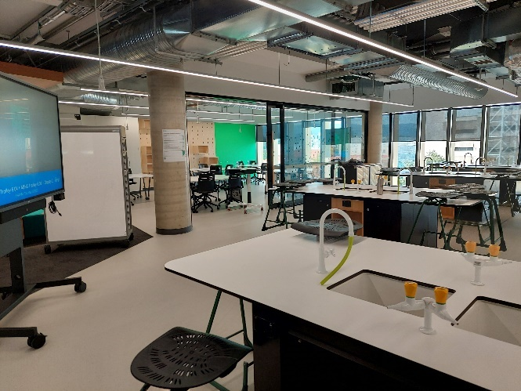
Figure 1: Inclusion of sinks at Adelaide Botanic High School supports students to move between a science laboratory and classroom, allowing two classes to use effectively the space at the same time.
  - Witnesses and submitters had mixed views on the best classroom layouts to support student learning.
  - The ACT YAC told the committee that its members were enthusiastic about open plan learning spaces, which they viewed as more modern and better for facilitating group discussion than classrooms with more traditional designs.
  - On the contrary, Ms Lorraine Taylor, Principal, Primary, at Silverstream School in New Zealand, stated that ‘the academic data for reading, writing and mathematics across New Zealand currently indicated that [open-plan learning spaces have] resulted in lower achievement.’
  - In response to the Covid-19 pandemic, the Silverstream School added glass dividing doors to its open plan classrooms, and have retained the dividers as they had reduced classroom noise and distractions and been particularly helpful to students who ‘have ADHD, are neurodiverse or have autism spectrum disorder.’
  - In its submission the ACT Government cited international comparative research which found that the optimal physical learning environment was neither fully enclosed nor fully open, but one where:
Walls between adjoining classrooms and the breakout space are flexible, allowing for the entire learning environment to become one larger space, whilst also retaining the ability to close it down into traditional classrooms.
  - Given the differing views on open plan learning spaces, and the varying needs of classes, teachers, and students, building flexibility into classroom design would appear to be an appropriate way of ensuring current and future needs can be met. One option for consideration could be the classroom refurbishments at Belconnen High School, which included flexible design and the use of glass dividers between learning spaces.

Vertical schools
  - Vertical schools, defined here as schools exceeding three stories in height, are becoming more common in the inner urban areas of larger Australian cities, generally as a solution to space constraints on existing school sites.
  - While there are currently no vertical schools in the ACT, some submitters argued building vertical schools in the ACT, particularly in town centres, may be necessary in the future to ensure optimal use of land as the population expands. Greater Canberra pointed to Belconnen Town Centre as an example of where vertical schools could effectively address density issues.
  - The committee visited six vertical schools during its inquiry:
- Cranbrook School (Bellevue Hill, NSW), where the senior school includes a new building with five levels.
- Inner Sydney High School (Surry Hills, NSW), which has 14 levels, including two basement levels.
- Prahran High School (Prahan, Vic.), which has four levels.
- Richmond High School (Richmond, Vic.), which has four levels.
- Adelaide Botanic High School (Adelaide, SA), which has seven levels and a basement level.
- Adelaide High School (Adelaide, SA), which includes a building with four levels.
  - During these visits and in evidence received during the inquiry, the committee heard vertical schools present both opportunities and challenges for school infrastructure planning and design.

Opportunities
  - Vertical schools include innovative features to make most of the limited space available. Some of the features raised during the committee’s site visits included:
- Incorporation of flexible learning spaces, resulting in innovative teaching practices such as team teaching.
- Clever uses of indoor space, often involving using the same spaces in multiple ways. For example, stairways doubling as seating for learning or for audience spaces (see Figure 2).
- Creative uses of outdoor spaces such as rooftops to provide recreation areas for students.
- Use of space-saving storage solutions (see Figure 3).
- Inclusion of noise-dampening features, given the importance of acoustics in vertical schools.
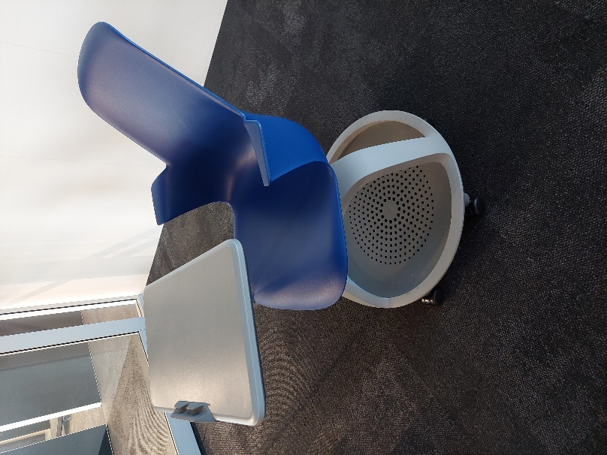
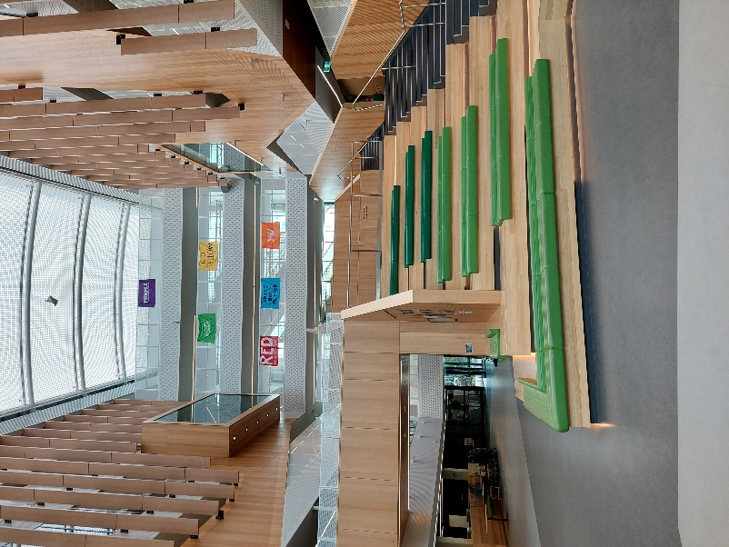
- Close connections with the surrounding community and sharing of facilities in both directions (the community using the school’s facilities and the school using nearby community facilities).
Figure 3: Student bag storage is incorporated into the classroom furniture design at Inner Sydney High School.
Figure 2: The Atrium at Adelaide Botanic High School serves a dual purpose as a breakout learning space.
  - Speaking to this final point, Ms Gweneth Leigh from the University of Canberra gave the example of a vertical secondary school in an urban area of South Australia where the inner-city location and design of the school enabled it to ‘really become a communal space where students … had permission to engage with the surrounding areas, as well as being a community resource.’
  - This feature was demonstrated to the committee during its site visits to Adelaide Botanic High School (SA) and Inner Sydney High School (NSW). Students at both schools are able to access neighbouring community land during school hours. The aquatic facilities at Cranbrook Senior School are also hired out to the community, providing a revenue resource outside school hours.

Challenges
  - Common challenges of vertical schools that were raised during the committee’s site visits included:
- Limited outdoor space. Some vertical schools had access to adjoining large outdoor spaces, while others had to transport students to parks or ovals.
- Limited access to facilities such as halls, gymnasiums and performing arts spaces.
- Lack of storage space.
- Lack of private areas for students and teachers.
- Safety issues relating to building height and line of sight issues.
- Minimal or no staff parking, which could be an issue when recruiting staff.
- Limited ability to accommodate all students in a single area for school assemblies and events.
  - ACT YAC members spoke to the committee about concerns they held about the potential introduction of vertical schools in the ACT, in particular the lack of outdoor space, and safety issues.
  - While some vertical schools utilise roof spaces to provide additional outdoor breakout areas for students (see Figure 4), the committee is aware of instances where vertical schools have had to regularly hire community sporting facilities to undertake physical education due to limited space to house these facilities on the school campus. As an alternative, some schools had opted to have a school sporting campus separate to the main school facilities.
  - Any consideration of vertical school design should seek to optimise availability of outdoor and physical education spaces, including the use of basement levels.
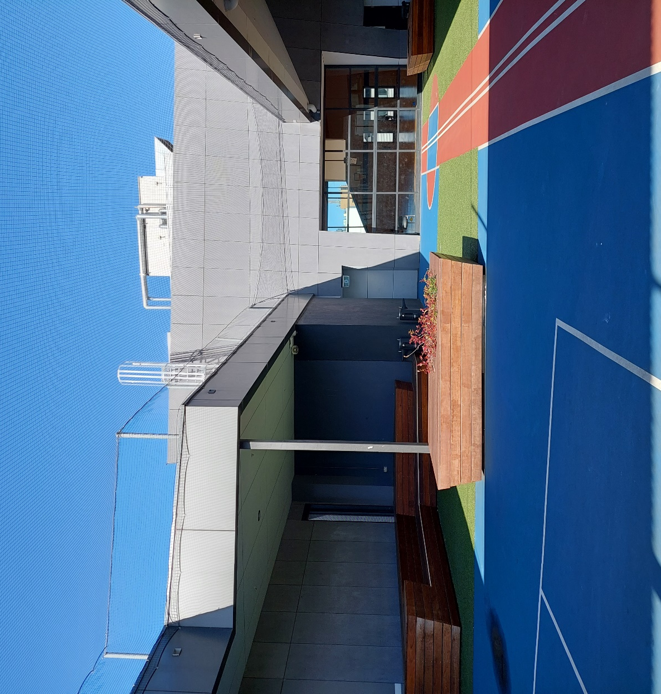
Figure 4: Outdoor breakout space at Prahran High School, Melbourne (Vic.) provides fully netted area for student safety and to contain sporting equipment.

Future of vertical schools in the ACT
  - In her evidence to the committee, the Minister advised that while there were currently no plans for vertical public schools in the ACT, the directorate is keeping a watching brief on the approaches being taken in other jurisdictions.
Recommendation
The committee recommends that the ACT Government, when required, construct vertical schools in the ACT, giving consideration to relevant health and safety considerations.

Outdoor space
  - The outdoor spaces in ACT public schools include courtyards, playgrounds, seating areas, shaded spaces, and formal active sporting spaces.
  - Ms Leigh told the committee that ‘[o]ver the years, schoolyard spaces have not evolved at the same rate, in terms of following pedagogy and practice, as our school buildings. … They have kind of been left behind.’
  - Ms Leigh advised that many students found outdoor spaces at their schools stressful rather than calming, and that this could be a missed opportunity to provide spaces that could enhance student wellbeing. Female secondary school students, in particular, reported that outdoor spaces were not meeting their needs and that this was negatively affecting their wellbeing.
  - Having conducted an ideas competition consulting students about what they would like to see in their outdoor spaces at school, Ms Leigh found students wanted places to gather, places to sit, gardens they could look after, and a sense of community and safety. Secondary school students need more ‘restorative spaces’ where they can relax and relieve mental fatigue.
  - As well as their use as recreational spaces, outdoor areas are increasingly being used as learning spaces. Learning in outdoor environments has been shown to have significant educational advantages for children and young people. In its submission, the ACT Chapter of the Australian Association for Environmental Education (AAEE) pointed out that nature play areas could be designed to benefit all age groups, not only younger children. The AAEE encouraged the use of local endemic species, including pollinator-friendly gardens.
  - ACT YAC members told the committee they valued outdoor learning spaces, including shaded areas, central areas where students can congregate, and areas such as kitchen gardens and chicken coops. ACT YAC members emphasised that it was valuable for all students to be able to access the latter types of areas, not only for those students studying subjects such as agriculture.
  - In addition to the more formal outdoor spaces at schools, the trees in school playgrounds provide shade for students and improve the energy efficiency of buildings. These trees also contribute to the overall tree canopy in the ACT, reducing heat island effects. The ACT Climate Change Council recommended that the ACT Government improve the tree canopy around schools.
Recommendation
The committee recommends that the ACT Government revise the design guidelines for recreational spaces in public schools to ensure that they are gender sensitive.
Recommendation
The committee recommends that the ACT Government set tree canopy targets for each public school campus.

Inclusion and cultural integrity
  - During the inquiry, the committee heard about the importance of ensuring accessibility and cultural integrity in ACT public schools.

Inclusion
  - Ensuring the inclusion of all students will need to be a central consideration in the development of future school infrastructure in the ACT. The Strategic Plan 2022–25 notes the directorate’s focus on creating an education system that is ‘equitable and inclusive’, and ‘where all children and young people are supported to learn, thrive, have agency, participate and achieve.’
  - It is important to have a broad definition of inclusion. Inclusive Education: A Disability Inclusion Strategy for ACT Public Schools 2024–2034 applies to ‘all children and young people who require additional support and adjustments to access learning’ and notes that all types of ‘diversity are valued and celebrated at ACT public schools’. The strategy, released in December 2023, aims to ensure that all students ‘can access a quality education designed to meet their needs at their local school.’
  - Universal design principles emphasising inclusion are incorporated into the development of new schools. Examples of inclusive design viewed by the committee during its site visits included sensory gardens, as well as the use of specific furnishings and classroom layouts to support students with auditory sensitivities (see Figures 5 and 6).
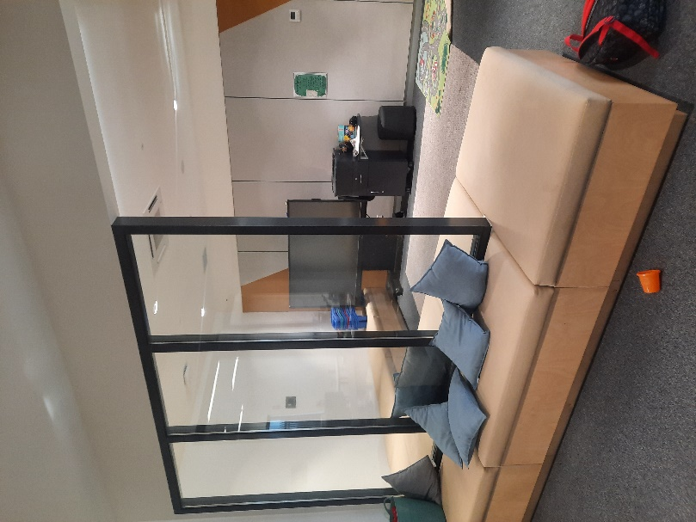
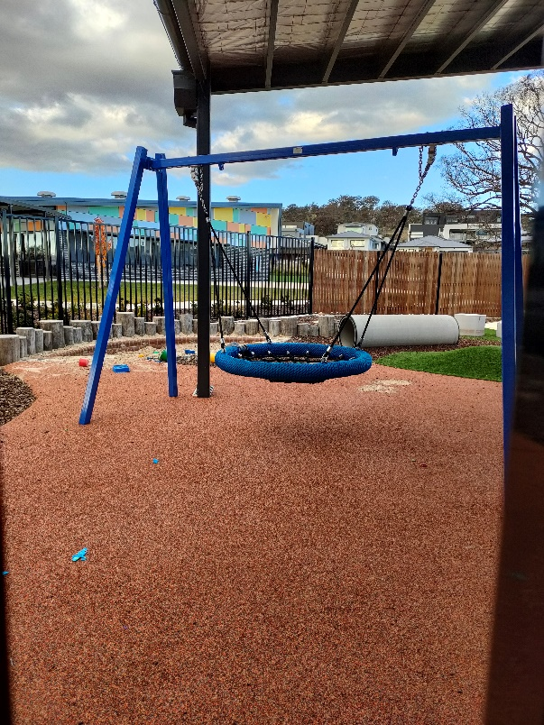
  - In addition, the EDIS includes a focus on inclusive toilets and bathrooms to meet the access needs of students with disability and to make provision for gender diverse students. The 2022-23 ACT Budget included $4.1 million of additional funding for projects to improve the accessibility of indoor and outdoor spaces at public schools.
Figure 6: Soft furnishings used in breakout space at Evelyn Scott School.
Figure 5: Sensory garden at Throsby School.
  - In their evidence to the committee, the AEU ACT stated the ACT’s older schools were not built at a time when we think about inclusiveness in education the way we do now, which can make it difficult to provide an inclusive environment at older school sites. Upgrades are needed to ensure that all ACT public schools, regardless of the age of the school, can cater appropriately to all students. In their submission, which was supported by Advocacy for Inclusion, the ACT Council of Social Service (ACTCOSS) stated that ‘too many schools are inaccessible in the ACT.’
  - ACTCOSS’s argued that future decisions concerning school infrastructure in the ACT need to foreground the immediate needs of ‘students with disabilities and Aboriginal and Torres Strait Islander students.’ ACTCOSS contended that those students ‘are currently not benefiting equitably from improvements made in areas of inclusion, student agency and wellbeing.’
Recommendation
The committee recommends that the ACT Government commit to fully funding the infrastructure upgrades deemed necessary by the Inclusive Education: A Disability Inclusion Strategy for ACT Public Schools 2024–2034, through a discrete and centrally funded program, including developing a schedule for updates to ensure that every school site has the capacity for inclusion.
Recommendation
The committee recommends that the ACT Government ensure that disability inclusion and accessibility considerations are incorporated into the design and construction of all new school infrastructure in the ACT.

Cultural integrity
  - Cultural integrity and other cultural considerations are key aspects of the EDIS. This can include incorporating ‘the culture and inclusion of the connection to the local Ngunnawal Country in the design.’
  - The February 2022 Census of ACT public schools found that 25.9 percent of ACT public school students identified as speaking a language other than English at home. The August 2022 Census of ACT public schools found that 4.2 percent of students enrolled at ACT public schools were Aboriginal and Torres Strait Islander students.
  - Given the cultural diversity of the ACT, the provision of cultural spaces in schools is an important consideration. While multi-faith rooms to be used for prayer or other religious observance are available at all ACT public schools, other ‘flexible cultural spaces’ also have the potential to benefit students from all backgrounds.
  - Ms Taylor told the committee how cultural integrity was factored into the design of her school. The Silverstream School actively works to ensure that ‘the play equipment is not all Eurocentric in nature and that it has Te Ao Maori context’ and that ‘the school itself reflects the various cultures of the people in the room’.
  - Mrs Cave told the committee that cultural integrity and diversity can be incorporated into the design features of schools in ways that help students to learn more about those concepts:
We teach our children about cultural integrity, and we value diversity—so, diverse entry points for children to come into ways of learning and places for learning as well. These are all contemporary challenges and opportunities that teachers are grappling with, and there is such a great link with this inquiry.
  - The members of the ACT YAC agreed, telling the committee they would like to see, for example, more artworks by First Nations artists on ACT school campuses. The AAEE, noted in its submission that outdoor learning spaces, in particular, allow students to discover more about First Nations culture.
  - An example of cultural integrity in school infrastructure can be seen Evelyn Scott School, with the school named after First Nation’s woman and reconciliation advocate Dr Evelyn Scott, and a mural created by local Ngunnawal artist Lynnice Church being a prominent feature on the school grounds.
  - The committee also saw the incorporation of Aboriginal story telling in the design of outdoor spaces at the Murrumbateman Public School, following consultation with local Ngunnawal elders (see Figure 7).
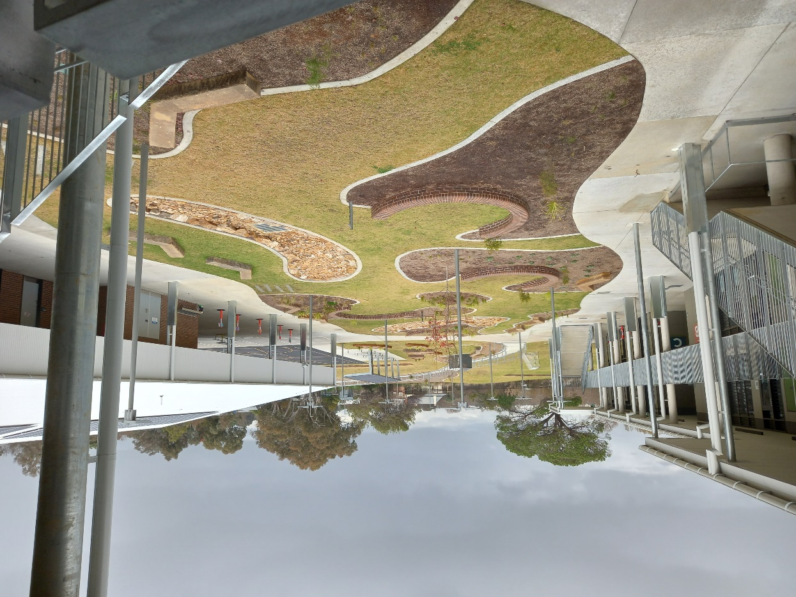
Figure 7: The garden area at Murrumbateman Public School was designed to include Aboriginal storytelling as a key element of the school.

Technology
  - The directorate aims to deliver the systems ‘essential to support children and young people in an increasingly digital world’, in line with the commitments set out in the ACT Government’s 2020 Future of Education Strategy and 2020 ACT Government Digital Strategy. This includes the provision of wireless internet, desktop computers, audiovisual display screens, data projectors, videoconferencing capability, and software.
  - In addition, the ACT Government’s Future of Education — Digital Access and Equity Program provides access to personal computing devices to all ACT public school students in Years 7 to 12. Shared devices are provided to primary school students. This program enables schools students from all income backgrounds to access the personal devices needed for their education.
  - While it acknowledges the investment to ensure all students can access to devices for their education, the committee is aware of concerns relating to the technology support provided to teachers and the impacts of technology systems on some students.

Technology for teachers
  - In its submission and evidence at the public hearing, the AEU ACT raised concerns around the digital infrastructure used to support teachers in ACT public schools. This relates to both the funding and provision of resources, as well as the software used in a school setting.
  - The committee heard that there is a lack of redundancy factored into the number of devices, and IT support services provided to schools when teaching devices fail. MrPatrick Judge, Secretary, AEU ACT, told the committee there were also ‘gaps’ when it came to providing devices to relief teachers:
It is not clear to us how a casual relief teacher can be provided with a device, despite the commitment to do so, unless they have a longstanding relationship with the school, where it is known that they will keep coming back. When they are provided those devices, they are often provided with a student device, which is not appropriate. It is about the provision of the basic tools to do the job…We require those hardware devices to do our jobs. It is not up to scratch.
  - The committee understands that the in-built relief teacher model recommended in the 2022 Teacher Shortage Taskforce Report will go some way to addressing the issue of equipping relief teachers quickly each morning.
  - However, concerns remain among schools that teachers may not have access to prompt ICT support and/or appropriate devices to support effective teaching, including replacement devices, display screens and audio equipment.
Recommendation
The committee recommends that the ACT Government ensure that the hardware provided in schools meets basic teaching and learning needs.
Recommendation
The committee recommends that the ACT Government ensure that adequate and timely technical support is provided for the digital infrastructure used in schools.

Software
  - In addition to hardware, technology infrastructure in schools requires effective and modern software and platforms. Digital infrastructure and software should seek to enhance innovative teaching, while reducing the administrative burden on teachers.
  - The AEU ACT reported ongoing issues with members having access to systems that are fit-for-purpose and do not require duplication:
To provide a really clear example of that, the systems for reporting incidents involving students and safety incidents involving staff do not talk to each other. There is a duplication of work that would be easily resolved by having one system or, alternatively, something that speaks to both of those systems in relation to those incidents. That is a problem that we have known about for some years now.
  - It was put to the committee that future technology needs in ACT schools would be best provided for by implementing changes to existing arrangements, including by ensuring:
- comprehensive consultation and user testing with school staff ahead of the provision of new hardware and software;
- adequate training for school staff following the introduction of new hardware and software, and adequate ongoing technical support;
- minimising the number of different platforms staff need to interact with daily and ensuring platforms communicate with each other where possible;
- focusing on procuring ICT platforms that reduce, rather than add to, the workload of school staff.
  - ICT systems may also have broader impacts on students that can sometimes be disregarded or overlooked. In its submission, A Gender Agenda (AGA) raised concerns that the technology used in ACT public schools does not always recognise and use the preferred name and gender of students. This has flow on effects for online learning environments and can cause distress to the students who are affected:
Social affirmation of a young person’s gender identity is protective for the mental health of young trans and gender diverse people. Therefore, ensuring that school technological infrastructure can consistently reflect and affirm a young person’s gender and name will support young people to access and thrive in the school environment. Sadly, this is reliant at the moment on individual school policies and bounded by limitations in the technology used by schools.
  - The AGA called for ‘system-wide policies and technologies regarding the use of affirming names and gender markers within school.’ Ensuring preferred names are reflected across all technologies (administrative and teaching platforms) will help reduce the likelihood of accidental ‘dead-naming and mis-gendering.’
Recommendation
The committee recommends that the ACT Government ensure adequate consultation ahead of major ICT changes in schools, and adequate training is provided when new ICT infrastructure is introduced.
Recommendation
The committee recommends that the ACT Government evaluate information management systems used in schools to ensure they enhance learning and do not increase workload.
Recommendation
The committee recommends that the ACT Government ensure that the ICT systems used for teaching, learning and administration across schools recognise the affirmed name and gender of students.

Safe and healthy schools

Student and staff safety
  - The need for all students and staff to feel safe at school was a recurring theme in the committee’s inquiry.
  - The ACT Branch of the Australian Education Union (AEU ACT) emphasised the importance of funding infrastructure that will help reduce the occupational violence experienced by teachers, principals, and other school staff. Minimising the risk of such incidents occurring is part of the Education Directorate’s responsibilities as an employer under the Work Health and Safety Act 2011.
  - As outlined in the previous chapter, the committee is aware of reports that the online systems for reporting safety incidents involving students and those involving teachers do not connect.
  - School infrastructure can be designed to increase the safety of both staff and students by focusing on maximising visibility. In her work with schools internationally, Mrs Kiran Bir Sethi found that students were particularly concerned about their safety and about bullying. In relation to bullying on the school campus, students were primarily worried about being bullied in playgrounds, the corners of buildings, bathrooms and corridors – that is, in places where there is less visibility.
  - Learning spaces with high visibility, such as glass walls, have been shown to improve safety in the learning environment. Ms Lorraine Taylor, Principal of Silverstream School in New Zealand, told the committee that the addition of sliding glass door separating some of the classroom spaces in the school contributed to an environment that was ‘calmer’ and quieter’.
  - In the ACT context, the recently refurbished classrooms at Belconnen High School were highlighted to the committee as an example of how the use of glass adds multiple lines of between classrooms, benefiting the safety and management of classrooms. Among other benefits, this allows teachers to seek assistance quickly and easily from colleagues where needed in emergency situations.
  - Conversely, during the committee’s site visits to vertical schools, committee members heard that the reduced sight lines in those buildings created additional safety and security issues.
Recommendation
The committee recommends that the ACT Government ensure teacher and student safety in ACT public schools by centrally funding infrastructure works to reduce violence risk.

Psychosocial safety
  - In addition to physical safety, safety in schools encompasses psychosocial and cultural safety.
  - The committee heard that school infrastructure can contribute to promoting psychological safety and cultural safety for both adults and children and young people. This can be done by designing buildings to optimise staff and student safety, as well as by incorporating separate indoor and outdoor sensory spaces where students can de-stress and relax.
  - In their submission A Gender Agenda (AGA) expressed concerns about the psychosocial safety of trans, gender diverse and intersex students, including at ACT public schools. Young people and their families have told AGA of their experiences of ‘transphobia, a lack of safe facilities, and a lack of consistent affirmation and support within the school environment.’ These experiences can affect young people’s mental health and school attendance.
  - The AGA pointed to access to ‘safe and affirming’ bathroom and change room facilities and physical and psychosocial safety within the classroom and playground environments as some of the key improvements needed for trans, gender diverse and intersex school students.
Recommendation
The committee recommends that the ACT Government consider the psychological and cultural safety of students and staff as part of the design processes when planning new schools or major works at existing schools and seek to prevent harm and promote wellbeing.

School amenities

Air quality and temperature control
  - The 2019–20 bushfire season and the Covid-19 pandemic saw an increasing emphasis on air quality, including in schools. While this matter was examined in the committee’s previous inquiry, submitters continued to draw the committee’s attention to the need for an ongoing plan for air quality in ACT public schools.
  - The AEU ACT stated in its submission that their members regularly call to express their concerns about the temperatures in their classrooms being at unsafe levels in summer and winter, raising work health and safety issues. The ACT Youth Advisory Council (YAC) also emphasised the importance of air purification, and good ventilation, heating, and cooling in schools during their meeting with the committee.
  - The ACT Government advised construction of new and upgraded schools seeks to be sustainable and includes positioning of buildings ‘to maximise natural daylight and fresh air’ while use of ‘[d]ouble glazing and insulation support thermal comfort and reduce energy consumption.’ The Education Directorate (the directorate) also stated in its annual report that $8 million will be spent in 2023–24 as part of the Delivering Energy-Efficient Heating Upgrades for ACT Public Schools initiative.
Recommendation
The committee recommends that the ACT Government develop and implement long term air quality plans and ensure adequate heating and cooling in ACT public schools.

Toilets
  - A number of submitters highlighted that many school toilet blocks are not fit for purpose. This has implications for student health and human rights. The ACT Council of Parents & Citizens Associations submission noted that P&Cs have also identified insufficient numbers of toilets as an issue at schools.
  - Some submitters drew attention to the need for more safe bathroom facilities for trans, gender diverse and intersex students. In her submission, Ms Anna Haiblen suggested a solution that is ‘increasingly common in Scandinavia’, in which students are able to access a row of individual toilet stalls which are unisex and are each equipped with a toilet, sink, soap and hand dryer, providing a private space that can be accessed without any requirement to identify as any particular gender (see Figure 8). This could be one solution for consideration in the ACT context.
During its site visits, the committee saw examples where schools have included toilet facilities that are exclusively gender-neutral or a mixture of gendered and gender-neutral.

Figure 8: Example of unisex toilet facilities proposed by Ms Anna Haiblen in her submission to the inquiry [Source: Anna Haiblen, Submission 16].
Recommendation
The committee recommends that the ACT Government improve essential ACT public school facilities, such as the inclusion of unisex toilets and amenities.

Staff rooms
  - The AEU ACT noted that facilities for staff, and particularly for school assistants, could be inadequate, which could make it difficult for staff to effectively complete their work.
  - Examples of staff facilities provided to the committee varied, with some schools providing staff work areas that are private, semi-private (using partial glass dividing walls), or open to learning spaces.
  - While there is no ‘one-size-fits-all’ approach for staff rooms, the committee understands the facilities available to staff may impact recruitment and retention of teachers and should be openly communicated to any prospective staff.
Recommendation
The committee recommends that the ACT Government ensure all school staff are provided with adequate accommodations and facilities to support teachers to effectively plan and deliver quality education.

Travel, roads and parking
  - The ACT Government encourages active travel to and from ACT schools and emphasises traffic and parking safety in the vicinity of schools.
  - The ACT Council of Parents & Citizens Associations noted in their submission that safe travel to school continues to be a key concern of P&Cs in the ACT. They advocated for more bike storage facilities at schools, as well as better parking and traffic management at and around schools.
  - The ACT Council of Social Service (ACTCOSS) advocated for free public transport across the ACT, including for school students. The ACT YAC is also supportive of free public transport for school students. Such an initiative would reduce financial pressures on low-income families associated with school attendance, as well as encouraging all families to use public transport rather than private cars.
  - Greater Canberra argued in their submission that the ACT’s public transport and active transport networks need to be better integrated with its school system.
Recommendation
The committee recommends that the ACT Government prioritise active travel, public transport access, road safety, and adequate parking when planning new schools or major works at existing schools.

Funding considerations
  - During its inquiry, the committee heard concerns regarding funding allocation for school infrastructure upgrades and major works and the implications for planning for future school needs. Similar concerns were raised during the committee’s previous inquiry into the management of school infrastructure.

System-wide funding
  - The Education Directorate (the directorate) funds school infrastructure through three main funding streams:
- major projects, which includes the construction of new schools as well large-scale expansions or modernisations of existing school sites;
- Public Schools Infrastructure Upgrades (PSIU), which incorporates upgrades such as renovations to classrooms, new fit-outs, accessibility improvements, and safety and security improvements; and
- repairs and maintenance, comprising day-to-day maintenance of school buildings and the management of hazardous materials.
  - In the 2022–23 financial year, the ACT Government allocated over $600 million to school infrastructure investment over four years to 2025–26. $100 million will be spent over four years from 2021 to 2025 under the Public School Infrastructure Renewal Program (PSRIP), an annual program of capital upgrades focused on improving existing school infrastructure.
  - The committee was advised that the directorate has also implemented initiatives focussing on specific types of improvements to school infrastructure, such as roof repairs and heating and cooling systems.
  - Funding allocated to investment in building new schools in the ACT is separate, and amounted to approximately $500 million over the four years to 2025–26.
  - In their submission the ACT Branch of the Australian Education Union argued that the decentralised nature of funding for ACT school infrastructure and building services reduced efficiency and placed too much pressure and responsibility for school infrastructure on school leaders.
Recommendation
The committee recommends that the ACT Government improve public school planning and maintenance systems by reforming budget processes within the Education Directorate so that all repairs, maintenance, upgrades, and new builds are funded centrally, rather than from within school budgets.
  - Funding allocations should also consider the future school infrastructure implications associated with legislative reforms.
  - The Period Products and Facilities (Access) Act 2023 was provided to the committee as an example of legislative reform which would require infrastructure upgrades across schools to ensure compliance with access arrangements.
  - While it is not clear whether funding has been allocated to support infrastructure changes required under this Act, the committee was advised that infrastructure upgrades required to implement previous legislative reforms had been unfunded (or funding had been delayed). In these instances, schools were required to ‘find the money in their [School Operational Allocation] SOA.
Recommendation
The committee recommends that the ACT Government ensure that system-wide education reforms are accompanied by system-wide resourcing for any school infrastructure implications.

Demand and decision-making
  - A common theme throughout the evidence provided to the committee was the desire for greater clarity and transparency around long-term plans and decisions regarding infrastructure works across ACT schools.
  - The directorate regularly updates details of medium and long-term infrastructure, investment and demand management on its website and engages with community stakeholders regarding school planning.
  - In addition, the ACT Infrastructure Plan 2019 Education Update provides a comprehensive view of priority school infrastructure investment over multiple decades. This was updated last year, taking into account updated demography data.
  - While the ACT Infrastructure Plan provides detail of priority works, detail on capital works funded under the PSIRP is not included as funding under this program is allocated annually.
  - There is a high demand for funding under the PSIRP, with over 300 individual project applications received from 73 individual schools for funding in 2023–24. Project applications were assessed for eligibility and prioritised using the Project Prioritisation Tool, with 51 individual projects receiving support for funding in 2023–24.
  - The directorate reports on PSIRP expenditure in its annual report each year, however the total number of applications received and the matrix against which applications are assessed and prioritised do not appear to be publicly available.
  - Greater transparency around the demand and decision-making process for school infrastructure works may enhance community understandings of the medium and long-term plans across the ACT. As Mrs Wendy Cave, Principal of Ainslie Public School and Secretary of the Australian Government Primary Principals Association, told the committee, effectively engaging communities in these conversations builds trust and a sense of shared ownership.
Recommendation
The committee recommends that the ACT Government better publicise school infrastructure processes to ensure transparency around decision-making on major works at public schools.

Mr Michael Pettersson MLA
Chair, Standing Committee on Education and Community Inclusion
March 2024

Appendix A: Submissions
No. | Submission by | Received | Published
1 | ACT Council of Parents & Citizens Associations | 15/03/2023 | 14/04/2023
2 | Green Building Council of Australia | 17/03/2023 | 14/04/2023
3 | A Gender Agenda | 17/03/2023 | 14/04/2023
4 | ACT Climate Change Council | 22/03/2023 | 14/04/2023
5 | ACT Government | 29/03/2023 | 14/04/2023
6 | Children and Young People Commissioner | 30/03/2023 | 14/04/2023
7 | Association of Independent Schools of the ACT | 30/03/2023 | 14/04/2023
8 | Australian Association of Environmental Education | 30/03/2023 | 14/04/2023
9 | Ms Gweneth Leigh, University of Canberra | 31/03/2023 | 14/04/2023
10 | Badminton ACT and Capital Juniors Badminton Club | 31/03/2023 | 14/04/2023
11 | ACT Council of Social Service Inc. | 31/03/2023 | 14/04/2023
12 | Lyneham Primary School Board | 31/03/2023 | 14/04/2023
13 | Planning Institute of Australia ACT | 31/03/2023 | 14/04/2023
14 | Greater Canberra | 31/03/2023 | 14/04/2023
15 | Molonglo Valley Community Forum | 31/03/2023 | 14/04/2023
16 | Anna Haiblen | 31/03/2023 | 14/04/2023
17 | Australian Government Primary Principal Association | 10/04/2023 | 14/04/2023
18 | Australian Education Union ACT | 12/04/2023 | 14/04/2023

Appendix B: Witnesses

Tuesday, 8 August 2023
Ms Lorraine Taylor, Principal – Primary, Silverstream School
Mrs Kiran Bir Sethi, Founder and Director, The Riverside Education Foundation
Ms Gweneth Leigh, Academic and Consultant Landscape Architect, University of Australia

ACT Branch of the Australian Education Union
- Mr Patrick Judge, Branch Secretary
- Dr Bianca Hennessy, Research and Policy Officer

Australian Government Primary Principal Association
- Mrs Wendy Cave, Secretary; Principal, Ainslie Public School

Australian Association of Environmental Education
- Ms Vivienne Pearce OAM, Vice-President
- Mrs Julia Landford, Vice-President; Founding Director, NatureArt Lab

ACT Government
- Ms Yvette Berry MLA, Minister for Education and Youth Affairs
- Ms Katy Haire, Director-General, Education Directorate
- Ms Jane Simmons, Deputy Director-General, Education Directorate
- Mr David Matthews, Executive Group Manager, Business Services, Education Directorate

Appendix C: Questions Taken on Notice

Questions Taken on Notice
No. | Date | Asked of | Subject | Response received
1 | 08/08/2023 | Minister Berry | Demand on school infrastructure spending | 31/08/2023
2 | DD/MM/YY | Minister Berry | Capacity constraints | 28/11/2023

Appendix D: Gender distribution of witnesses
Beginning in April 2023, in response to an audit by the Commonwealth Parliamentary Association, committees are collecting information on the gender of witnesses. The aim is to determine whether committee inquiries are meeting the needs, and allowing the participation of, a range of genders in the community. Participation is voluntary and there are no set responses.
Gender indication | Total
Female | 7
Male | 1
Non-binary | 0
Gender neutral | 0
No data | 4

Mr Michael Pettersson MLA (Chair, Standing Committee on Education and Community Inclusion), ‘Education and Community Inclusion — Standing Committee’, Assembly Hansard, 5 May 2022, p 1263.
ACT Auditor-General, Maintenance of ACT Government School Infrastructure: Report No. 11/2019, ACT Audit Office, 2019, p 1.
ACT Auditor-General, Maintenance of ACT Government School Infrastructure: Report No. 11/2019, ACT Audit Office, 2019, p 2.
ACT Auditor-General, Maintenance of ACT Government School Infrastructure: Report No. 11/2019, ACT Audit Office, 2019, pp 6–7.
ACT Auditor-General, Maintenance of ACT Government School Infrastructure: Report No. 11/2019, ACT Audit Office, 2019, p 8.
ACT Education Directorate, Annual Report 2022-23, September 2023, pp 123-125. The two recommendations listed as ‘in progress’ were Recommendation 2 (property quality standards), and Recommendation 3 (operational asset management plans).
ACT Education Directorate, Annual Report 2021-22, September 2022, Table 20.
Standing Committee on Education and Community Inclusion, Inquiry into the Management of ACT School Infrastructure, ACT Legislative Assembly, 5 May 2022.
ACT Legislative Assembly, Tenth Assembly, Report No. 3 of the Standing Committee on Education and Community Inclusion: Management of School Infrastructure, Government Response, presented 15 September 2022.
ACT Education Directorate, Annual Report 2022-23, September 2023, pp 158-169.
ACT Council of Parents & Citizens Associations, Submission 1; Australian Education Union, ACT Branch, Submission 1.
ACT Government, Submission 5, p 3.
ACT Government, Submission 5, pp 3, 33, and 42.
ACT Government, Submission 5, pp 39–40.
ACT Education Directorate, Annual Report 2022–23, p 329.
The ACT Education Directorate Annual Report 2022–23, states that Major Projects includes the ‘construction of new schools and major works to existing sites such as capacity expansions or modernisations of existing schools.’
The ACT Education Directorate Annual Report 2022–23 describes Public School Infrastructure Upgrades as incorporating ‘improvements and upgrades to schools such classroom renovations, disability access requirements, and safety and security improvements.’
The ACT Education Directorate’s Annual Report 2022–23 notes Repairs and Maintenance ‘support schools in compliance with key asset obligations, management of preventative maintenance contracts, response coordination for critical reactive asset-related events and hazardous materials management.’
ACT Education Directorate, Annual Report 2022–23, p 125.
ACT Education Directorate, Annual Report 2022–23, p 125.
See, for example, Australian Education Union (AEU), Submission 18, pp 5–7; Australian Government Primary Principals Association, Submission 17, pp [2]–[3]; ACT Council of Parents and Citizens Associations, Submission 1, pp [8]–[9]; Lyneham Primary School Board, Submission 12, pp [3]–[4].
ACT Council of Parents & Citizens Associations, Submission 1, pp [8]-[9]; Australian Education Union (ACT Branch), Submission 18, pp 5–6.
Mrs Wendy Cave, Secretary, Australian Government Primary Principals Association, Committee Hansard, 8 August 2023, p 30.
Ms Yvette Berry MLA, Minister for Education and Youth Affairs, Committee Hansard, 8 August 2023, p 41.
Mr David Matthews, Executive Group Manager, Business Services, ACT Education Directorate, Committee Hansard, 8 August 2023, p 42.
Mrs Wendy Cave, Secretary, Australian Government Primary Principals Association, Committee Hansard, 8 August 2023, p 29.
Mrs Wendy Cave, Secretary, Australian Government Primary Principals Association, Committee Hansard, 8 August 2023, p 29; Australian Education Union, Submission 18, p 5.
ACT Council of Parents and Citizens Associations, Submission 1, p 9.
Australian Education Union, Submission 18, p 5.
Australian Education Union, Submission 18, p 6.
ACT Auditor-General, Report No. 11/2019 Maintenance of ACT Government School Infrastructure, p 7.
ACT Education Directorate, Annual Report 2022–23, p 123.
ACT Council of Parents and Citizens Association Associations, Submission 1, p 4; Australian Government Primary Principals Association, Submission 17, p 6; Australian Education Union ACT, Submission 18, p 7.
Mr David Matthews, Executive Group Manager, Business Services, ACT Education Directorate, Committee Hansard, 8 August 2023, pp 42–44.
ACT Education Directorate, Annual Report 2022–23, p 123.
Mrs Wendy Cave, Secretary, Australian Government Primary Principals Association, Committee Hansard, 8 August 2023, p 31.
Australian Education Union (AEU), Submission 18, p 9.
Australian Education Union ACT Branch, Submission 18, p 6.
Mr Patrick Judge, ACT Branch Secretary, Australian Education Union, Committee Hansard, 8 August 2023, p 18.
Australian Education Union, Submission 18, pp 9-10. Australian Government Primary Principals Association, Submission 17, p [5]. ACT Council of Parents and Citizens Associations, Submission 1, p 9.
Australian Government Primary Principals Association, Submission 17, p [5].
Mrs Wendy Cave, Secretary, Australian Government Primary Principals Association, Committee Hansard, 8 August 2023, p 29.
Mr Patrick Judge, Branch Secretary, ACT Branch, Australian Education Union (AEU), Committee Hansard, 8 August 2023, pp 17–18.
ACT Government, Submission 5, p 39.
ACT Legislative Assembly, Standing Committee on Education and Community Inclusion, Report No 3, Managing ACT School Infrastructure, May 2022, p 4.
ACT Government, Submission 5, p 36.
ACT Government, Submission 5, p 36.
ACT Government, Submission 5, p 37.
ACT Council of Parents & Citizens Association, Submission 1, p [7].
Australian Education Union (AEU), Submission 18, p 23.
Australian Education Union, Submission 18, pp 24-25; Victorian Department of Education, Capacity and Area Allocation, 3 November 2023, https://www2.education.vic.gov.au/pal/capacity-and-area-allocation/advice (accessed 5 January 2023).
ACT Government, Submission 5, p 35.
The EDIS notes the size and configuration of primary schools is dependent on maximum class sizes; guaranteed placement for students at a school within their Priority Enrolment Area; and research and current ACT data for student outcomes.
ACT Government, Submission 5, pp 35–36.
ACT Government, Submission 5, p 35.
Australian Government Primary Principals Association, Submission 17, p [4]; Association of Independent Schools of the ACT, Submission 7, p [5].
European Expert Network on Economics of Education study, referenced in Trevor Cobbold, ‘School Size Matters’, Save Our Schools (SOS) Australia, 17 October 2015.
New South Wales Government, Centre for Education Statistics and Evaluation, Literature review: School assets and student outcomes, 2015, p 10.
New South Wales Government, Centre for Education Statistics and Evaluation, Literature review: School assets and student outcomes, 2015, p 10.
ACT Council of Parents and Citizens Associations, Submission 1, p [10].
The committee was advised during its Inquiry into Annual and Financial Reports 2022-23 that four transportable classrooms have been delivered to Gungahlin College to address ongoing capacity concerns at the school. See Ms Yvette Berry MLA, Minister for Education and Youth Affairs, Committee Hansard, 16 November 2023, p 59.
A Gender Agenda, Submission 3; Australian Education Union, Submission 18.
A Gender Agenda, Submission 3, p [4].
A Gender Agenda, Submission 3, p [4].
Australian Education Union, Submission 18, p 13-14.
ACT Education Directorate, Inclusive Education Strategy 2024-2034, p 15.
Australian Government Public Principals Association, Submission 17, p [4].
Australian Government Public Principals Association, Submission 17, p [4].
Planning Institute of Australia, Submission 13, p 2.
Planning Institute of Australia, Submission 13, p 2.
ACT Government, Submission 5, p 2.
Badminton ACT and Capital Juniors Badminton Club, Submission 10.
Australian Government Primary Principals Association, Submission 17, p [4].
State Environmental Planning Policy (Transport and Infrastructure) 2021 (NSW), s 3.36 (6)(a).
Planning Institute of Australia, Submission 13, p 3.
ACT Government, Submission 5, p 6.
ACT Government, Submission 5, p 6.
ACT Government, Submission 5, p 4.
See, for example, Children and Young People Commissioner, Submission 6, Australian Education Union (AEU), Submission 18.
Australian Education Union (AEU), Submission 18, p 21.
Australian Education Union (AEU), Submission 18, p 21.
Australian Government Primary Principals Association, Submission 17, p 5.
Mrs Wendy Cave, Secretary, Australian Government Primary Principals Association, Committee Hansard, 8 August 2023, p 31.
See, for example, Children and Young People Commissioner, Submission 6; Mrs Kiran Bir Sethi, Founder and Director, The Riverside Education Foundation, India, Committee Hansard, 8 August 2023, p 9 and p 11; Ms Gweneth Leigh, Academic and Consultant Landscape Architect, University of Canberra, Committee Hansard, 8 August 2023, p 23.
Children and Young People Commissioner, Submission 6, p 1.
Ms Gweneth Leigh, Academic and Consultant Landscape Architect, University of Canberra Committee Hansard, 8 August 2023, p 23.
Mrs Kiran Bir Sethi, Founder and Director, The Riverside Education Foundation, India, Committee Hansard, 8 August 2023, p 11.
Mrs Kiran Bir Sethi, Founder and Director, The Riverside Education Foundation, India, Committee Hansard, 8 August 2023, p 11.
ACT Government, Submission 005, p 20.
ACT Government, Submission 5, p 13.
ACT Government, Submission 5, p 13.
Standing Committee on Education and Community Inclusion, Inquiry into the Management of ACT School Infrastructure, ACT Legislative Assembly, 5 May 2022, pp 19-24.
Standing Committee on Education and Community Inclusion, Inquiry into the Management of ACT School Infrastructure, ACT Legislative Assembly, 5 May 2022, p 23.
ACT Climate Change Council, Submission 4, p 2.
ACT Climate Change Council, Submission 4, p 3.
Green Building Council of Australia, Submission 2, p 2.
Green Building Council of Australia, Submission 2, p 3.
ACT Government, Submission 5, p 6.
ACT Government, Submission 5, p 6.
ACT Government, Submission 5, p 6.
ACT Government, Submission 5, p 6.
ACT Government, Submission 5, p 6.
ACT Government, Submission 5, p 23.
ACT Government, Submission 5, p 14.
Legislative Assembly for the ACT, Standing Committee on Education and Community Inclusion, Inquiry into the Future of School Infrastructure in the ACT, Consultation with the ACT Youth Advisory Council, 5 September 2023.
Ms Lorraine Taylor, Principal — Primary, Silverstream School, Committee Hansard, 8 August 2023, p 2.
Dovey and Fisher, 2014, cited in ACT Government, Submission 5, p 25.
Australian Education Union, Submission 18, pp 19–20.
MS Yvette Berry, Minister for Education and Youth Affairs, Committee Hansard, 8 August 2023, pp 46–47.
See Greater Canberra, Submission 14; Molonglo Valley Community Forum, Submission 15.
Ms Gweneth Leigh, Academic and Consultant Landscape Architect, University of Canberra, Committee Hansard, 8 August 2023, p 25.
Legislative Assembly for the ACT, Standing Committee on Education and Community Inclusion, Inquiry into the Future of School Infrastructure in the ACT, Consultation with the ACT Youth Advisory Council, 5 September 2023.
Mr David Matthews, Executive Group Manager, Business Services, ACT Education Directorate, Committee Hansard, 8 August 2023, p 48.
ACT Government, Submission 005, p 19.
Ms Gweneth Leigh, Academic and Consultant Landscape Architect, University of Canberra, Committee Hansard, 8 August 2023, p 23.
Ms Gweneth Leigh, Academic and Consultant Landscape Architect, University of Canberra, Committee Hansard, 8 August 2023, p 23.
Ms Gweneth Leigh, Academic and Consultant Landscape Architect, University of Canberra, Committee Hansard, 8 August 2023, p 26.
Ms Gweneth Leigh, Academic and Consultant Landscape Architect, University of Canberra, Committee Hansard, 8 August 2023, p 23.
Ms Gweneth Leigh, Academic and Consultant Landscape Architect, University of Canberra, Committee Hansard, 8 August 2023, p 25.
Mrs Julia Landford, Founding Director, NatureArt Lab; Vice-President, Australian Association for Environmental Education, Committee Hansard, 8 August 2023, p 36.
Australian Association for Environmental Education (AAEE), ACT Chapter, Submission 8, p 2.
Australian Association for Environmental Education (AAEE), ACT Chapter, Submission 8, p 2.
Legislative Assembly for the ACT, Standing Committee on Education and Community Inclusion, Inquiry into the Future of School Infrastructure in the ACT, Consultation with the ACT Youth Advisory Council, 5 September 2023.
ACT Climate Change Council, Submission 4, p 2.
ACT Climate Change Council, Submission 4, p 3.
ACT Government, Submission 5, p 3.
ACT Government, Inclusive Education: A Disability Inclusion Strategy for ACT Public Schools 2024-2034, 2023, p 4.
Ms Yvette Berry MLA, ‘Strengthening inclusion across ACT public schools’, media release, 5 December 2023.
ACT Government, Submission 5, p 11.
ACT Government, Submission 5, p 12.
ACT Government, Submission 5, p 11.
Mr Patrick Judge, Branch Secretary, ACT Branch, Australian Education Union (AEU), Committee Hansard, 8 August 2023, p 17.
ACT Council of Social Service, Submission 11, p 2.
ACT Council of Social Service, Submission 11, p 1.
ACT Government, Submission 5, p 6.
ACT Government, Submission 5, p 7.
ACT Government, Submission 5, p 27.
ACT Government, Submission 5, p 27.
ACT Government, Submission 5, p 30.
Australian Government Primary Principals Association (AGPPA), Submission 17, p 4.
Ms Lorraine Taylor, Principal, Silverstream School, New Zealand, Committee Hansard, 8 August 2023, p 8.
Mrs Wendy Cave, Principal, Ainslie Public School, Committee Hansard, 8 August 2023, p 32.
Legislative Assembly for the ACT, Standing Committee on Education and Community Inclusion, Inquiry into the Future of School Infrastructure in the ACT, Consultation with the ACT Youth Advisory Council, 5 September 2023.
Australian Association for Environmental Education (AAEE), ACT Chapter, Submission 8, p 4.
ACT Government, Submission 5, p 20.
ACT Government, Submission 5, p 21–22.
ACT Government, Submission 5, p 21–22.
Mr Patrick Judge, ACT Branch Secretary, Australian Education Union, Committee Hansard, 8 August 2023, pp 20–21.
Mr Patrick Judge, ACT Branch Secretary, Australian Education Union, Committee Hansard, 8 August 2023, p 21.
ACT Education Directorate, Teacher Shortage Taskforce Report, 2022, p 20; Dr Bianca Hennessy, Research and Policy Officer, Australian Education Union ACT, Committee Hansard, 8 August 2023, p 21.
Australian Education Union (AEU), Submission 18, p 26.
Mr Patrick Judge, ACT Branch Secretary, Australian Education Union, Committee Hansard, 8 August 2023, p 21.
Australian Education Union, Submission 18¸pp 25–26
A Gender Agenda, Submission 3, p 3.
A Gender Agenda, Submission 3, p 3.
See, for example, Children and Young People Commissioner, Submission 6, p 1; Mrs Kiran Bir Sethi, Riverside Foundation, Committee Hansard, 8 August 2023, p 14; A Gender Agenda, Submission 3, p [4]; ACT Council of Social Services, Submission 11, p 1.
Work Health and Safety Act 2011.
Mr Patrick Judge, ACT Branch Secretary, Australian Education Union, Committee Hansard, 8 August 2023, p 21.
Mrs Kiran Bir Sethi, Riverside Foundation, Committee Hansard, 8 August 2023, p 14.
ACT Government, Submission 5, p 24.
Ms Lorraine Taylor, Principal, Silverstream School, New Zealand, Committee Hansard, 8 August 2023, p 2.
Australian Education Union (AEU), Submission 18, p 20.
See, for example, Australian Education Union (AEU), Submission 18; Children and Young People Commissioner, Submission 6; Legislative Assembly for the ACT, Standing Committee on Education and Community Inclusion, Inquiry into the Future of School Infrastructure in the ACT, Consultation with the ACT Youth Advisory Council, 5 September 2023.
Australian Education Union (AEU), Submission 18, p 17.
Children and Young People Commissioner, Submission 6, p4.
A Gender Agenda (AGA), Submission 3, pp 1-3.
A Gender Agenda (AGA), Submission 3, p 2.
A Gender Agenda (AGA), Submission 3, p 2.
A Gender Agenda (AGA), Submission 3, p 2.
Australian Education Union (AEU), Submission 18, p 18.
See, for example, ACT Council of Parents and Citizens Associations, Submission 1; Australian Education Union (AEU), Submission 18.
Legislative Assembly for the ACT, Standing Committee on Education and Community Inclusion, Inquiry into the Future of School Infrastructure in the ACT, Consultation with the ACT Youth Advisory Council, 5 September 2023.
ACT Government, Submission 5, p 33.
ACT Education Directorate, Annual Report 2022–23, p 168.
See, for example, Australian Education Union (AEU, Submission 18, p 18
See, for example, Australian Education Union (AEU), Submission 18, p 18.
ACT Council of Parents and Citizens Associations, Submission 1, p 8.
See, for example, A Gender Agenda, Submission 3, p 3, Ms Anna Haiblen, Submission 16.
Ms Anna Haiblen, Submission 16, p 1.
Australian Education Union (AEU), Submission 18, p 19.
ACT Government, Submission 5, p 11.
ACT Council of Parents and Citizens Associations, Submission 1, p 10.
ACT Council of Parents and Citizens Associations, Submission 1, p 10.
ACT Council of Social Service (ACTCOSS), Submission 11, p 1.
Legislative Assembly for the ACT, Standing Committee on Education and Community Inclusion, Inquiry into the Future of School Infrastructure in the ACT, Consultation with the ACT Youth Advisory Council, 5 September 2023.
Greater Canberra, Submission 14, p 4.
See, for example, Australian Education Union (AEU), Submission 18.
ACT Legislative Assembly, Standing Committee on Education and Community Inclusion, Report No 3, Managing ACT School Infrastructure, May 2022, p 41.
ACT Government, Submission 12, p 15.
ACT Government, Submission 6, p 8.
Mr David Matthews, Executive Group Manager, Business Services, Education Directorate, Committee Hansard, 8 August 2023, p 42.
Mr David Matthews, Executive Group Manager, Business Services, Education Directorate, Committee Hansard, 8 August 2023, p 42.
Australian Education Union (AEU), Submission 18, p 11–12.
Australian Education Union, Submission 18, pp 11–12.
Australian Education Union, Submission 18, p 12.
See, for example, ACT Council of Parents and Citizens Associations, Submission 1; Australian Education Union, Submission 18.
ACT Government, Education Directorate, ‘The Future of Education: An ACT Education Strategy for the Next Ten Years’.
ACT Government, Submission 5, p 42.
ACT Government, Education Directorate, ‘The Future of Education: An ACT Education Strategy for the Next Ten Years’.
Expanding and Upgrading Schools for our Growing City - Education (act.gov.au)
ACT Government, Response to Question Taken on Notice 1, p 1.
Ms Katy Haire, Director-General, ACT Education Directorate, Committee Hansard, 8 August 2023, p 46.
Mrs Wendy Cave, Principal, Ainslie Public School, and Secretary, Australian Government Primary Principals Association (AGPPA), Committee Hansard, 8 August 2023, p 31.

