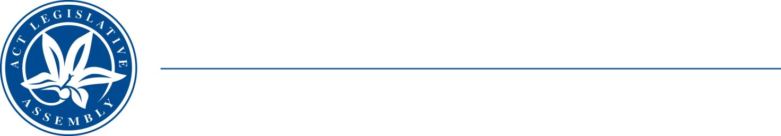
QoN No. 22
Committee Support
LEGISLATIVE ASSEMBLY
FOR THE AUSTRALIAN CAPITAL TERRITORY
Standing Committee on Education and Community Inclusion

Inquiry into Annual and Financial Reports 2021-2022

ANSWER TO QUESTION ON NOTICE

Asked by Elizabeth Kikkert MLA: To ask the Minister for Early Childhood Development

Reference: Early Childhood Development, CSD Annual Report 2022, pp. 87–88

In relation to: Program Stats at Child and Family Centres

- During the reporting year, how many clients at each CFC participated in a) Bringing Up Great Kids, b) Cool Little Kids, c) Tuning into Kids, d) Learn, Giggle and Grow, e) Parents as Teachers, f) POPPY, g) Circles of Security, h) Koori Girls, i) Koori Boys, and any other programs not listed?
- Does Koori Boys serve the same ages as Koori Girls

MINISTER: The answer to the Member’s question is as follows:–

- Based on the data available, the table below provides the number Child and Family Centre Group Programs and registrations for the period – 1 July 2021- 30 June 2022:

Please note registrations for groups have been tallied across the three Child and Family Centres.

Group Program | Registrations
Bringing Up Great Kids - Parenting program | Nil
Cool Little Kids - Parenting program | 10
Tuning into Kids - Parenting program | 38
Learn, Giggle, Grow - Supported playgroup | 225
POPPY - Supported playgroup | 79
Circle of Security - Parenting program | 124
Cool Kids - Supported playgroup | 13
Mindful Motherhood - Parenting program | 30
Project Dust (dance group) - Supported playgroup | 14
Multicultural Playgroup - Supported playgroup | 171
Koori Boys - Supported playgroup | 74
Koori Girls - Supported playgroup | 53
Strong Women’s - Parenting program | 57
Atfaal - Supported playgroup | 50
Parents as Teachers cases | 39

This is a total of 1015 registrations across the three centres.

- The Koori Boys and Girls groups are delivered to First Nations children of primary school age. There are occasions when slightly older children (who have been part of the group) will continue to attend post primary school age.

Approved for circulation to the Standing Committee on Education and Community Inclusion

Signature: Date:

By the Minister for Early Childhood Development, Yvette Berry MLA

