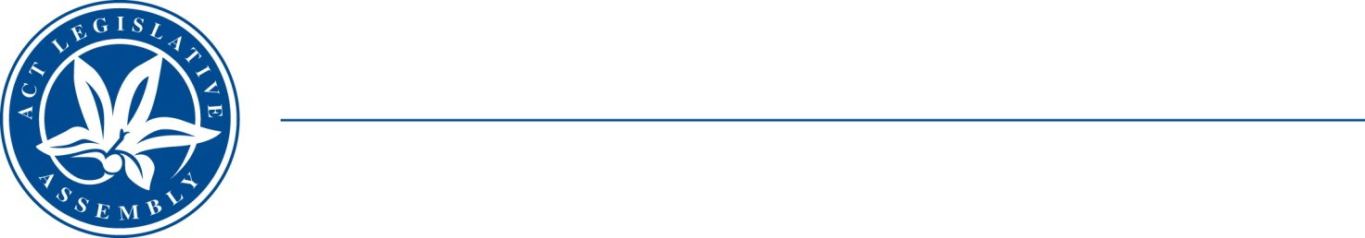
QoN No. 13
Committee Support
LEGISLATIVE ASSEMBLY
FOR THE AUSTRALIAN CAPITAL TERRITORY
Standing Committee on Education and Community Inclusion

Inquiry into Annual and Financial Reports 2021-2022

ANSWER TO QUESTION ON NOTICE

Asked by Elizabeth Kikkert MLA: To ask the Minister for Education and Youth Affairs

Reference: Youth Affairs, CSD Annual Report 2022, p. 56

In relation to: Youth Engagement – Future Directions

1. Why are the ‘future directions’ for youth engagement on p. 56 of the annual report merely things the government has been doing in this space for several years?

2. When was the last time that the ACT Government introduced a new program into the Youth Engagement portfolio, and what was it?

MINISTER Berry: The answer to the Member’s question is as follows:–

- Community Services Directorate (CSD) delivers a number of programs and initiatives under Youth Engagement Portfolio. The Future Directions section identifies key deliverables in the Youth Engagement portfolio that are planned for future delivery. These include the ACT Youth Advisory Council Workplan, Young Canberra Citizen of the Year Awards and the ACT Youth Assembly.

CSD delivers the following programs under the Youth Engagement portfolio:
  - Youth InterACT Scholarships
  - Youth InterACT Grant Program
  - Youth Grant Program
  - Youth Week
  - ACT Youth Advisory Council
  - ACT Youth Assembly
  - Young Canberra Citizen of the Year

These programs are focused on supporting young people and young people led priorities. The ACT Youth Assembly (the Assembly) held every 2 years, provides a platform for young Canberrans to engage in a dialogue with the ACT Government and to share ideas on how to advance the agenda for youth issues. The outcomes of Assembly set the priorities of the ACT Youth Advisory Council work plan and direction of key deliverables in the Youth Engagement portfolio.

- The Youth Engagement programs and the ACT Youth Advisory Council work program is focused on young people led priorities. For example, in 2021, ACT Youth Advisory Council identified consent as a critical issue for young people.

The ACT Youth Advisory Council partnered with Sexual Health and Family Planning ACT to develop a consent brochure to raise awareness and provide young people with accurate information on consent. The brochure is available at: https://www.communityservices.act.gov.au/youth/youth-advisory-council

Approved for circulation to the Standing Committee on Education and Community Inclusion

Signature: Date:

By the Minister for Education and Youth Affairs, Yvette Berry MLA

