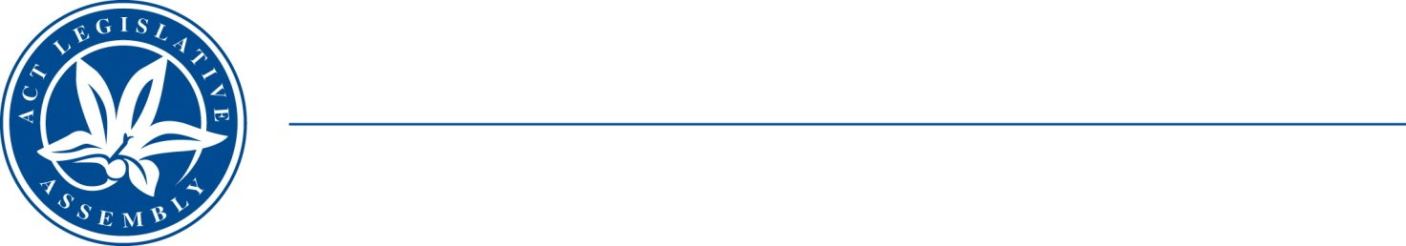
QoN No. 23
Committee Support
LEGISLATIVE ASSEMBLY
FOR THE AUSTRALIAN CAPITAL TERRITORY
Standing Committee on Health and Community Wellbeing

Inquiry into Annual and Financial Reports 2021-2022

ANSWER TO QUESTION ON NOTICE

Asked by MS LEANNE CASTLEY MLA:

Reference: Hearing on 1 November 2022, Annual Report of CHS

In relation to: Page 132, CHS annual report 2021-22

- Why are you reducing the amount of medical imaging equipment in the hospital?
- Are any machines due to expire or out of order that need replacing right now in the hospital?
- There has only been $73,000 spent so far, why is there such a low spend and priority for this project?
- Oncology patients have contacted my office about lengthy waits for imaging services at Canberra Hospital, what is the current median wait time in days for outpatient imaging services?
- How many patients are on the wait list for outpatient imaging?
- Is it faster if the patient is an inpatient? What is the median wait time in days for inpatients?
- How many patients are on wait lists for medical imaging as an inpatient?
- Are wait times for other medical imaging increasing? if so, what area and how many patients are on the wait list?

MINISTER STEPHEN-SMITH MLA: The answer to the Member’s question is as follows:–
- There are no plans to reduce the amount of medical imaging equipment located and operated in Canberra Hospital. There are several active projects for the replacement of vital equipment such as computer tomography (CT) scanners, magnetic resonance imaging (MRI) scanners and Nuclear Medicine equipment. There is also an active project adding a CT, x-ray unit and ultrasound (U/S) scanner to the Weston Creek Community Health Centre, to provide more access to imaging services for outpatients.
CHS has progressed with the design of an MRI bunker upgrade at the Canberra Hospital. The remaining expenditure allocated to the provision of More public medical imaging services for Canberra Hospital will be spent on the MRI replacement project between March and December 2023. This will include infrastructure work, installation and commissioning of a 3T MRI.
Median wait times in days for outpatient imaging at TCH is 80 days, with an outpatient waiting list as at 24 October 2022 of 2380 patients that are either currently awaiting scans or those with scans needed at a pre-determined future date.
Inpatients are triaged as a clinical priority and services are completed within a median turnaround time of 1 day. There is currently no waitlist for TCH inpatient imaging services.
There are no other areas in Medical Imaging that have increasing wait times at present.

Approved for circulation to the Standing Committee on Health and Community Wellbeing

Signature: Date:
By the Minister for Health, Rachel Stephen-Smith MLA

