Select Committee on Privileges 2022

Imposition of a prohibition notice by WorkSafe ACT

About the committee

Establishing resolution
At its meeting on Monday, 15 August 2022, the Assembly passed the following resolution:
“That:
- pursuant to standing order 276, a Select Committee on Privileges 2022 be established to examine whether there has been a breach of privilege relating to the actions of the Work Health and Safety Commissioner and any other person, and whether they have improperly interfered with the free exercise of the authority of the Select Committee on Estimates 2022-23 or breached any other privileges of the Assembly;

- the Committee also examine the alleged breach of privilege raised by the Select Committee on Estimates 2022-2023 in relation to a possible interference in the work of the Committee by a Minister (amended 21 September 2022);

- the Privileges Committee shall report back to the Assembly by the last sitting in 2022 (amended 21 September 2022); and

- the Committee shall be composed of:
(a) Mr Pettersson MLA;
(b) Mr Hanson MLA; and
(c) Ms Clay MLA.”

Committee members
Mr Jeremy Hanson CSC MLA, Chair
Ms Jo Clay MLA, Deputy Chair
Mr Michael Pettersson MLA

Secretariat
Mr Max Kiermaier, Committee Secretary
Ms Lydia Chung, Administrative Assistant
Mr Nick Byrne, Committee Support

Contact us
Mail Select Committee on Privilege 2022
Legislative Assembly for the Australian Capital Territory
GPO Box 1020
CANBERRA ACT 2601
Phone (02) 6207 2301
Email LAcommitteePrivileges2022@parliament.act.gov.au
Website parliament.act.gov.au/parliamentary-business/in-committees

Contents
About the committee i
Establishing resolution i
Committee members i
Secretariat i
Contact us i
Acronyms v
Findings and Recommendations vi
1. Background to the privileges of the Legislative Assembly 1
Contempt 2
Separation of powers 3
Exclusive cognisance 3
2. Background to the Inquiry 6
Estimates Committee and Manager of Government Business 6
WorkSafe ACT and the Legislative Assembly 8
Estimates Committee and Manager of Government Business - continued 13
3. Conduct of the inquiry 15
Public hearings 15
4. Findings and Recommendations 19
Imposition of a prohibition notice 21
WorkSafe ACT 22
Manager of Government Business 24
Misrepresentation of committee proceedings 27
Other findings and recommendations 28
5. Legal and other matters 32
Legality of the prohibition notices 32
Definitional issues 33
Who has control over the activity? 34
Section 2.23 of the Work Health and Safety Act 34
Service of processes in the precincts on a sitting day 35
Section 164(2)(c) of the Work Health and Safety Act 36
Concluding remarks 36
Appendix A: Submissions and correspondence 37
Appendix B: Witnesses 40
24 October 2022 40
25 October 2022 40
Appendix C: Prohibition notice issued 12 August 2022 41
Appendix D: Prohibition notice issued 15 August 2022 44

Acronyms
Acronym | Long form
Estimates Committee | Select Committee on Estimates 2022-2023
McGee | McGee, Parliamentary Practice in New Zealand, 4th ed
May | Erskine May: Parliamentary Practice, 25th edition
Odgers | Odgers’ Australian Senate Practice, 14th edition
OLA | Office of the Legislative Assembly
Pettifer | Pettifer, House of Representatives Practice, 7th edition
Privileges Committee | Select Committee on Privileges 2022
WHS Act | Work Health and Safety Act 2011 (ACT)
WHS Commissioner | Work Health and Safety Commissioner

Findings and recommendations
Finding 1
The Committee finds that the first WorkSafe ACT prohibition notice improperly interfered with the free exercise of the Assembly and its committees and therefore was a breach of the privileges of the Assembly by WorkSafe ACT.
Finding 2
The Committee finds that the second WorkSafe ACT prohibition notice may have improperly interfered with the free exercise of the Assembly or a committee of its authority but, as a breach of privilege has been found on the first prohibition notice, the Committee did not consider it necessary to make a further finding.
Finding 3
The Committee finds that the phone call and email from the Minister's office for advice, which WorkSafe ACT considered to be a complaint, was open to the perception of intentionally influencing WorkSafe's actions. However, it did not, of itself, interfere with a committee and therefore is not a breach of privilege.
Finding 4
The Committee notes with concern the Estimates Committee’s reports of the ongoing actions of the Minister in the possible interference of that Committee, but finds that it did not meet the standard of breaching privilege.
Recommendation 1
The Committee recommends that WorkSafe ACT develop a memorandum of understanding with the Assembly on how it will exercise its regulatory functions within the Assembly precincts, acknowledging the parliamentary privilege issues engaged.
Recommendation 2
The Committee recommends that no further action be taken with WorkSafe ACT.
Recommendation 3
The Committee recommends that the Work Health and Safety Act 2011 be amended to:
(1) provide clarity that the Assembly is a workplace; and
(2) provide that nothing in the Act:
(a) abrogates or derogates from the powers, privileges and immunities of the Legislative Assembly, its committees or its members; or
(b) gives an inspector or any other person the power to prohibit the proceedings of the Assembly or its committees.
Recommendation 4
The Committee recommends that the Government draws the matters raised in this report in particular, to the attention of regulatory bodies in the ACT who potentially may have cause to interact with the Legislative Assembly in future and, more broadly, to the wider ACT Public Service.
Recommendation 5
The Committee recommends that all Ministers take care in their interactions with independent regulators, so they are not open to the perception of improperly influencing or directing a particular investigation or regulatory action.
Recommendation 6
The Committee recommends that all Ministers ensure that they and their offices keep appropriate written records of significant matters.
Recommendation 7
The Committee recommends that Ministers should take care to provide accurate information to the media and the public, particularly on key matters that could risk the reputation of the Assembly or the Government.
Recommendation 8
The Committee recommends that in the next review of the Latimer House principles, the Speaker refer:
(1) for assessment the Executive’s compliance with the objectives enunciated in the principles, particularly in its relationship with the Legislative Assembly; and
(2) to the Standing Committee on Administration and Procedure whether Continuing Resolution 8A requires amendment or re-affirmation to accentuate the independence of the legislature from Executive interference, in terms similar to the motion passed by the Senate.
Recommendation 9
The Committee recommends that Continuing Resolution 5 relating to the code of conduct for all Members of the Legislative Assembly for the Australian Capital Territory be amended to make clear that Members, in carrying out their responsibilities, have a duty to act in way that does not unreasonably place the health, safety and wellbeing of others at risk.
Recommendation 10
The Committee recommends that the powers of a committee of the Assembly to compel:
(1) documents pertaining to that committee or a member of that committee; and
(2) the identity of a person whose identity is otherwise protected under law;
be considered as part of the ongoing review into standing orders.

Background to the privileges of the Legislative Assembly
  - The powers and privileges of the ACT Legislative Assembly derive from the Australian Capital Territory (Self Government) Act 1988 (Cth) which states at section 24 that:
Powers, privileges and immunities of Assembly
- In this section:
powers includes privileges and immunities, but does not include legislative powers.
- Without limiting the generality of section 22 {ie, the power to make laws], the Assembly may also make laws: [emphasis added}
(a) declaring the powers of the Assembly and of its members and committees, but so that the powers so declared do not exceed the powers for the time being of the House of Representatives
(b) providing for the manner in which powers so declared may be exercised or upheld.
- Until the Assembly makes a law with respect to its powers, the Assembly and its members and committees have the same powers as the powers for the time being of the House of Representatives.
- Nothing in this section empowers the Assembly to imprison or fine a person.
  - The Assembly has not made a law under this section. Thus, the powers and immunities of the Assembly are the same as those of the House of Representatives, with the exception that it has no power to imprison or fine a person who might be found to be in contempt of the Assembly or its committees.
  - The powers of the Assembly include those necessary to assert and to protect its privileges. The privileges of the Legislative Assembly comprise those immunities and powers necessary for the conduct of the business of the legislature. Immunities are exemptions from the ordinary law which enable Members to carry out their duties. Arguably the best known of these is the exemption from the laws of defamation or libel regarding the proceedings of the Assembly and its committees. This is considered essential for the protection of Members’ (and witnesses’) freedom of speech in the Assembly. Section 14 of the Parliamentary Privileges Act 1987 (Cth) lists other immunities, such as immunity from attending court and freedom from arrest (in civil matters) within imminent meetings of the House or its committees.
  - Section 16 of that Act provides a definition of what constitutes “proceedings in Parliament”, which is:
“all words spoken and acts done in the course of, or for the purposes of or incidental to, the transacting of the business of a House or of a committee, and, without limiting the generality of the foregoing, includes:
(a) the giving of evidence before a House or a committee, and evidence so given;
(b) the presentation or submission of a document to a House or a committee;
(c) the preparation of a document for purposes of or incidental to the transacting of any such business; and
(d) the formulation, making or publication of a document, including a report, by or pursuant to an order of a House or a committee and the document so formulated, made or published.”.
  - All persons participating in “proceedings” as defined above are covered by “privilege”.
  - Thus, proceedings in Parliament not only refer to its meetings and those of its committees, but also the evidence of witnesses before committees and documents prepared by third parties for use by Members in the course of their parliamentary duties.

Contempt
  - The powers of the Assembly to examine and, if necessary, to punish, contempts are analogous to that of the courts to punish contempts of court, and reflect the need of a legislature “to protect themselves from acts which directly or indirectly impede them in the performance of their functions.” They are the powers necessary to enable the institution and its members to discharge their responsibilities. Note that “the power [to punish contempts] does not depend on the acts judged and punished being violations of particular immunities”.
  - While Parliaments have great freedom and flexibility to judge matters of privilege and contempt, the Parliamentary Privileges Act 1987 and the proceedings of the Commonwealth Parliament provide relevant guidance. Significantly, under “what amounts to a statutory definition”, contempt of Parliament is qualified in the Parliamentary Privileges Act 1987 at section 4:
Essential element of offences
4. Conduct (including the use of words) does not constitute an offence against a House unless it amounts, or is intended or likely to amount, to an improper interference with the free exercise by a House or a committee of its authority or functions, or with the free performance by a member of a member’s duties as a member.”.
  - Consequently, the Houses of the Commonwealth Parliament, while treating contempt seriously have tended to exercise their powers “with great circumspection”. The Senate Privileges Committee has generally confined its investigations to “serious matters potentially involving significant obstruction of the Senate…” and “… now regards a culpable intention on the part of the person concerned as essential for the establishment of contempt.”. Similarly, the practice of the House of Representatives is to “exercise or invoke its powers in respect of matters of contempt and privilege sparingly...” and “…the Joint Select Committee on Parliamentary Privilege recommended the adoption by the House of a policy of restraint in these matters. Although this recommendation has not been formally adopted by the House, the Committee of Privileges and Speakers have had regard to the policy.”
  - In determining whether a charge of contempt can be sustained, many jurisdictions have adopted the civil law test of “on the balance of probabilities”, but one of a high degree of probability.
  - It is reasonable to conclude from the above that for an action to constitute a finding of contempt it should include (a) an improper interference with the free exercise by a committee of its authority or functions; and (b) an intention by the person responsible for the action to improperly interfere with the free performance of a committee’s responsibilities. [emphasis added]

Separation of powers
  - The notion of “Separation of powers” is a fundamental tenet of a democratic society. Under the notion, the branches of government are separated, each with independent powers and responsibilities, so that the powers of one branch are not in conflict with those of the other branches. Typically, the three branches are a legislature, an executive, and a judiciary. The intention is to prevent the concentration of power in any one branch.
  - The notion finds embodiment in the Australian Constitution through discrete Chapters – Chapter I - The Parliament, Chapter II – The Executive Government and Chapter III – The Judicature. The Australian Capital Territory (Self-Government) Act 1988 envisages a similar structure – Parts III and IV – Legislative Assembly, Part V – The Executive and Part VA – The Judiciary, with each Part detailing the powers of the particular branch.

Exclusive cognisance
  - At its simplest, “exclusive cognisance” refers to the notion that a Parliament is immune from outside interference in relation to activities “within its four walls”, be that interference from the Executive, the Courts or, in the case of bicameral parliaments, the other Chamber.
  - Section 15 of the Parliamentary Privileges Act 1987 makes clear that laws prevailing in the ACT apply to the Commonwealth Parliament, and so by extension, to the Legislative Assembly. Thus, a tension is created between the exclusive cognisance right of the legislatures to go about their business unhindered by external bodies and the applicability of statute law. While there may be little doubt that serious criminal acts would not find shelter behind the notion of exclusive cognisance, other actions are less clear.
  - Historically, the notion of exclusive cognisance was wide ranging and applied to a host of activities within the parliamentary precincts. It had been long held in the UK that "whatever matter arises concerning either house of parliament, ought to be examined, discussed, and adjudged in that house to which it relates, and not elsewhere".
  - Over time, however, the concept has narrowed. The UK Parliament’s Joint Committee on Parliamentary Privilege in 2013 recognised that:
“The possibility of tension between parliamentary privilege and the rule of law means that Parliament's claim to exclusive cognisance should be strictly limited to those areas where immunity from normal legal oversight is necessary in order to safeguard the effective functioning of Parliament. It is agreed that immunity applies to that core work itself, to things said or done as part of proceedings in either Chamber or in a select committee of either House—the "proceedings in Parliament" whose immunity from challenge is enshrined in Article 9.”
  - The committee goes on to observe that “Both the courts and committees have in recent years adopted a test based on a "necessary connection" to proceedings, in assessing whether or not privilege extends to certain activities.”.
  - The committee further observes that “the Supreme Court of Canada went so far as to elevate this approach into a ‘doctrine of necessity’”:
"If the existence and scope of a privilege have not been authoritatively established, the court will be required to test the claim against the doctrine of necessity—the foundation of all parliamentary privilege. In such a case, in order to sustain a claim of privilege, the assembly ... must show that the sphere of activity for which privilege is claimed is so closely and directly connected with the fulfilment by the assembly or its members of their functions as a legislative and deliberative body, including the assembly's work in holding the government to account, that outside interference would undermine the level of autonomy required to enable the assembly and its members to do their legislative work with dignity and efficiency".
  - In other words, in order to sustain a claim of exclusive cognisance, there needs to be a clear and direct link to the core business of parliament.

Background to the Inquiry

Estimates Committee and Manager of Government Business
  - On 2 August 2022, the Budget bills for the 2022-2023 financial year were introduced into the Assembly, comprising of the Appropriation Bill 2022-2023 and a separate Appropriation (Office of the Legislative Assembly) Bill 2022-2023, the latter in recognition of the Assembly’s independence from the Executive.
  - As per previous practice, the bills were referred to a Select Committee on Estimates 2022-2023, established to examine the bills through a series of public hearings commonly referred to as Estimates.
  - The Estimates Committee approached the Manager of Government Business with a view to establishing a timetable for the proposed hearings, which it wished to resume as face-to-face hearings following the two previous years being conducted virtually due to COVID-19 issues. In correspondence to the Minister, dated 4 August, the committee advised that it believed that current COVID arrangements in the Assembly would be sufficient, including social distancing, cleaning seats and desks between witnesses, and hand sanitisers. Witnesses would also be free to wear masks in the building. Further, if a witness had a health condition making them vulnerable to COVID-19, then suitable arrangements could be made for them, including the ability to appear remotely.
  - The Minister responded on 8 August, seeking further advice on how social distancing would be implemented and querying the impact that cleaning desks between witnesses would have on the timeliness of hearings. His suggestion was for a hybrid arrangement to be put in place so that witnesses and officials had the choice to either attend in person or virtually depending on their personal preferences. The adoption of such arrangements would assist the Government, the Public Service and the Assembly to discharge obligations under the Work Health and Safety Act 2011 to provide a safe workplace and take steps to mitigate risks for employees and those with whom they interact.
  - The committee responded on 11 August, stating:
The Committee views COVID safety practices as a high priority and has asked the Secretariat to ensure appropriate measures have been put in place. This includes availability of hand sanitiser, disinfectant wipes and face masks, social distancing and a cleaner in the room to insure efficiency in cleaning between sessions/witnesses.
A number of rooms/spaces have been made available to facilitate social distancing with maximum numbers clearly labelled:
- In the Prince Edward Island room, up to five witnesses can be seated at the table, with 13 seats in the gallery;
- There are 18 seats in the Kiribati Room and a TV for viewing proceedings; and
- There are three seats and standing room in the waiting area with a TV for viewing proceedings.
While Webex Boards were installed last week, staff are still testing and being trained in their use and this represents risks of disruption to proceedings. Overall, the Committee has decided that hearings will be face to face where possible to provide effective scrutiny of the budget. The boards will be used as an exception where required, such as for witnesses isolating due to COVID-19 or vulnerable to COVID-19. Priority is to be placed on Ministers and most senior officials to be in the Prince Edward Island room.
  - Later that day, the Minister re-iterated his desire for hybrid hearings, saying:
Hybrid attendance is warranted to permit those staff who are required to attend to choose whether they attend in person or virtually to support ongoing COVID-smart arrangements given current rates of community transmission and the uncertainty of the current situation…A hybrid offering of Budget Estimates Hearings will prevent crowding and enhance physical distancing for those attending face-to-face and reduce the burden on those staff required to implement COVID-smart controls during proceedings, such as through increased cleaning protocols of desks and equipment between staff attending the committee….By failing to offer our staff the option to attend hearings virtually, we are excluding valued and diverse members of our workforce who may be exposed to serious risk when attending due to their personal health status, the personal health status of their loved ones, or due to their own exposure to COVID-19, from participating in the hearings…The transmission of COVID-19 is considered a foreseeable risk during the pandemic which requires employers to implement targeted risk management strategies to eliminate or reduce the risk of infection including through measures such as hybrid attendance.
  - On 12 August, the Committee replied, repeating its commitment to put into effect COVID-safe practices at hearings. It also sought advice from the Minister on what he regarded as a suitable hybrid model, and why the Assembly building would not provide a safe environment for ACT Government officials. Should the committee not regard the Minister’s hybrid model proposal feasible, it would expect attendance in line with the Speaker’s COVID building update advice, provided to all building occupants on 2 August, and re-iterated that all efforts would be put in place to ensure a safe environment for witnesses.
  - Later that day, the Minister replied, acknowledging that the Committee was “giving high priority to the safety of all involved in the hearing process”. He suggested that:
Ministers will be presumed to attend in person, noting that this still carries significant risk to their own health and does not account for those who may be vulnerable, have family members who are vulnerable, or those who have caring responsibilities. I ask that the Committee acknowledge this risk and consult with members on its risk assessment, as is required under workplace safety duties.
All ACT Public Service employees and independent statutory office holders will attend virtually unless they elect to attend in person.
Attendees must be able to choose the safest method of appearance without requiring them to disclose private health information to the Committee.
  - The Committee responded that it was considering the Minister’s letter.

WorkSafe ACT and the Legislative Assembly

First visit to the Assembly – 12 August 2022
  - On Thursday, 11 August, the WHS Commissioner received a phone call expressing concern over a “lack of dial-in for Estimates”, “no risk assessment” and “no consultation”. A subsequent follow-up email from Minister Gentleman’s office refers to the Estimates Committee purportedly insisting on all witnesses appearing in person. The WHS Commissioner undertook to refer the matter to the compliance and enforcement team, which she did that evening.
  - On the morning of Friday, 12 August, the complainant was advised that a response would be forthcoming and in a later call, further information was sought. After an internal meeting, the complaint was referred to two WorkSafe ACT inspectors.
  - Calls were placed to the Assembly, including to the Clerk, inquiring about the control measures in place and what risk assessment had been undertaken regarding the Estimates hearings. The Clerk indicated to WorkSafe ACT that parliamentary privilege issues were being engaged.
  - WorkSafe ACT then advised the Minister’s office of the requirements of a person conducting a business or undertaking under the Work Health and Safety Act, and the options available to it to ensure compliance.
  - From their notes, the two inspectors from WorkSafe ACT arrived at the Assembly at 1:56 pm where they were met by the Manager, Security and Building Services and the Clerk of the Legislative Assembly.
  - In its submission, OLA reports the ensuing interaction as follows:
The inspectors proceeded to demand the production of certain documents from the Clerk.
The Clerk provided the inspectors with a copy of a draft revision of the Assembly’s COVID Safe Plan… that the Speaker had provided to the Standing Committee on Administration and Procedure at its meeting of 1 August 2022 for its consideration.
The plan contains a series of detailed risk assessments and associated controls relating to a wide range of activities that take place in the Assembly precincts.
The inspectors were particularly interested in the proceedings of the Select Committee on Estimates 2022-2023 and how it intended to undertake its public hearings program. The Clerk explained that he did not have any authority over the proceedings of the committee and nor was he authorised to speak with any third-party about what the committee’s internal deliberations might have entailed.
During the inspection, the inspectors purported to require that the Clerk make members of the estimates committee available to the inspectors in order to question them.
It is understood that being finished with their meetings for the day, two of the MLAs on the estimates committee had left the precincts already and that only one of its members remained.
On being advised of this, the inspectors reprimanded the Clerk for ‘permitting’ the other two MLAs to leave the precincts….
Throughout the course of the Clerk’s interactions with the inspectors, he had emphasised on several occasions that parliamentary privilege was potentially enlivened by the sorts of demands that were being made and the prospect that had been conveyed by the inspectors that they could shut down the work of the committee if they were not satisfied that certain risk assessments and consultations with ‘affected workers’ had been performed. The matters raised by the Clerk did not appear to be of concern to the inspectors.
On a number of occasions, and in response to queries about consultations with ‘affected workers’ and risk assessments, the Clerk attempted to draw the inspectors’ attention to the Assembly’s COVID Safe Plan and the risk assessments contained in it. It was unclear whether the inspectors did, in fact, examine the plan in any detail.
  - Notes of one of the inspectors made available to the Privileges Committee confirm reference being made to the Parliamentary Privileges Act. They also indicate that at 14:38 pm a 15-minute call was made to her supervisor, noted as “update + advice”.
  - The remaining committee member then met with the inspectors, and at 15:40 the inspectorsʻ notes show that a prohibition notice was verbally issued to that member. At approximately 6 pm, a written prohibition notice was issued to the Speaker, with copies to the Clerk and the committee member.
  - The prohibition notice prohibited the Assembly from:
“Undertaking any hearings or committee meetings… until a risk assessment has been undertaken, adequate control measures are implemented in line with the Hierarchy of Control, and consultation has been undertaken with all affected workers”.
  - The notice stated that the Legislative Assembly had contravened section 19 of the Work Health and Safety Act, the basis for the inspectorʻs belief being:
Section 19 states- A person conducting a business or undertaking must ensure, so far as is reasonably practicable, the health and safety of workers engaged, or caused to be engaged, by the person and workers whose activities in carrying out work are influenced or directed by the person, while the workers are at work in the business or undertaking. The Select Committee on Estimates 2022-23 (the Committee) has not undertaken a risk assessment in relation to the planned activity 'Estimates 2022-23 Hearings' and has not consulted, so far as is reasonably practicable, with workers who carry out work for the business or undertaking who are, or are likely to be, directly affected by the activity. Workers have been directed to attend this planned activity face-to-face only, without alternative options being provided that are readily available to control and eliminate the risk.
The Legislative Assembly of the Australian Capital Territory has not identified reasonably foreseeable risks in the workplace, or implemented adequate control measures in relation to potential or known risks. The risk is transmission of a biological hazard in the workplace, being Covid-19, without consideration of eliminating the risk (in line with the Hierarchy of Controls) in preventing contraction of the disease which could cause serious injury or death.
  - To remedy the contravention, the Assembly was required to:
1 Undertake a risk assessment in relation to face-to-face hearings or committee meetings at the Legislative Assembly of the Australian Capital Territory.
2 Develop and implement adequate control measures in line with the Hierarchy of Control pursuant to regulation 36 of the Work Health and Safety Regulation 2011.
3 Consult with all workers who are, or are likely to be, directly affected by the activity; and
4 Provide evidence of the risk assessment, control measures, and consultation process having been undertaken.

Second visit to the Assembly – 15 August 2022
  - The Speaker wrote to the WHS Commissioner early on 15 August – a sitting day - expressing concern over the prohibition notice, its impact on the Assembly conducting its core scrutiny and accountability functions, the separation of powers doctrine between the Legislature and the Executive, and the exclusive cognisance of the Assembly to exercise control over its own proceedings. The Speaker requested that the notice be withdrawn, else she would consider taking action in the Supreme Court to have it set aside. She also pointed out that there were some issues with the terms of the notice.
  - The same inspectors, plus a third, revisited the Assembly at around 9:35 am.
  - The OLA submission states:
The inspectors advised that they were there to ascertain if any further action had been taken by the Speaker in relation to the prohibition notice, viz whether the matters set out [to remedy the prohibition] had been attended to.
The three inspectors met with the Clerk, staff of the Office and a senior member of the Speaker’s staff. At the meeting, the Clerk and parliamentary officials reiterated that issues of parliamentary privilege and possible contempt of the Assembly were enlivened by the serving of the prohibition notice in terms that purported to prevent all of the Assembly’s committees from meeting or conducting hearings.
The Clerk sought to draw the attention of the inspectors to the wording in the notice that was regarded as being particularly problematic. However, the inspectors indicated that they had not brought a copy of the notice with them.
The inspectors indicated that all of these considerations were not pertinent to their function in attending the Assembly precincts and that such matters would need to be dealt with elsewhere.
The inspectors indicated that there had been ‘some confusion’ as to the scope of the prohibition notice in that it was claimed that the notice was not intended to prevent all meetings and hearings of Assembly committees, only those that took place in-person. Assembly officials pointed out that the terms of the notice were clear and did not make any such distinction. It was also pointed out to the inspectors that, in any event, a notice that purported only to restrict in-person meetings would still engage the Assembly’s privileges. The inspectors said words to the effect that this was not a matter for them to consider.
The Clerk asked whether, given the issues associated with parliamentary privilege, the inspectors had sought legal advice prior to the issuing of the prohibition notice. The inspectors indicated that they had not sought legal advice but had consulted with their supervisor.
The Clerk indicated that he had provided a copy of the Assembly’s COVID Safe Plan to the inspectors on the afternoon of Friday 12 August 2022 and that a number of specific risk assessments were contained in that document, including those relating to the conduct of committee proceedings and the way in which consultations were conducted. The inspectors advised that they did not bring a copy of COVID Safe Plan with them.
The Clerk, staff of the Office and the Speaker’s senior staff member observed that the COVID Safe Plan and the risk assessments in the plan had been endorsed by the Office, the Speaker, the Standing Committee on Administration and Procedure and the Assembly’s Health and Safety Committee, all of which had been consulted. Inspectors were queried as to whether those arrangements were not considered as being adequate in satisfying various duties under the Act and/or the matters alluded to in the prohibition notice.
Inspectors indicated that assessing the adequacy of controls was a matter for individual ‘businesses’ but that they had formed the view that a number of steps had not been taken to properly assess possible hazards and that there was a requirement to consult with ‘affected workers’.
On several occasions, it was put directly to the inspectors whether they had read through the assessments within the COVID Safe Plan. On each occasion, the inspectors declined to answer that question, instead stating words to the effect that they had ‘read through the COVID Safe Plan’—they would not be drawn on whether they had specifically examined the risk assessments, or the consultation arrangements contemplated in the document and whether or not they were considered adequate.
The inspectors took issue with the plan being in a draft form (with March 2022 being the last time that the plan had been formally endorsed). It was pointed out to inspectors that the plan remained with draft revisions in place from July as it had been presented to the Standing Committee on Administration and Procedure on 1 August 2022, party whips (who sit on the committee) had been asked by the Speaker at that meeting to consult with their party room colleagues and that that process had not concluded.
  - The inspectors indicated that the prohibition notice would be withdrawn, and a new notice issued in line with the intent of the original notice.
  - Subsequently, a new prohibition notice was issued preventing the Assembly:
Conducting committee hearings… at which participants attend in person, until a risk assessment has been undertaken, adequate control measures are implemented in line with the Hierarchy of Control, and consultation has been undertaken with all affected workers and others.
  - The new prohibition notice expanded on the original, citing:
Inspectors requested evidence of a risk assessment being undertaken in relation to the planned activity 'Estimates 2022-23 Hearings', from both the Deputy Chair of the Committee, as well as the Clerk of the Legislative Assembly. Neither persons could provide a copy of a risk assessment, or demonstrate knowledge of a risk assessment having been conducted in relation to the planned activity. Further, the Clerk of the Legislative Assembly could not demonstrate knowledge of a risk assessment having been conducted generally in relation to hearings and/or committee's undertaken at the Legislative Assembly of the Australian Capital Territory, stating that it's up to each committee, which are run differently and independently.
Inspectors requested evidence of consultation being undertaken in relation to the planned activity 'Estimates 2022-23 Hearings' from the Deputy Chair of the Committee, who advised that consultation occurred through letters that were sent out to Ministers in relation to the activity. When Inspectors reviewed a copy of the supplied letters, it was identified that the letters did not capture the nature of consultation in line with section 48 of the Work Health and Safety Act 2011.
A review of the current Risk Register provided by the workplace as part of the overarching COVID-Safe Plan- 10th Assembly' document identified that the document provided is in draft-state, with the previous version/approval being considered by the WHS committee on 8 March 2022. Further review of the section 'Exposure risks-committee hearings/meetings' fails to demonstrate that the risk has been adequately assessed, or confirm that the Hierarchy of Control has been applied.
  - The new notice also added “(or participants)” to the third requirement to be met to remedy the contravention.

Third visit to the Assembly – 19 August 2022
  - A separate group of inspectors returned to the Assembly on Friday, 19 August and were generally satisfied with the control and other measures that were in place. They sought and were given assurances that potential witnesses had been consulted, and that any associated feedback had been considered.
  - Later that morning the prohibition notice was lifted.

Estimates Committee and Manager of Government Business - continued
  - Minister Gentleman was invited to a meeting with the Estimates Committee on 16 August 2022, along with Dr Damien West, Deputy Director-General of the Chief Minister, Treasury and Economic Development Directorate.
  - The Estimates Committee reports as follows:
At the meeting, Minister Gentleman and Dr West proposed that the Estimates Committee could meet the requirements of the Prohibition Notice by consulting with officials through the Minister. Dr West could then consult with Directors-General who could then propose a small number of their staff to attend who would also be consulted on the Estimates Committee’s risk assessment for hearings. Minister Gentleman would also manage the consultation with Ministers. Once the Speaker and Committee believed they had met the requirements of the Prohibition Notice, then the Speaker could apply to WorkSafe ACT for the notice to be lifted.
The Estimates Committee then thanked the Minister and Dr West and stated that they would consider the proposal….
The Estimates Committee also resolved at the meeting on 16 August 2022 that each member would informally advise party leaders of its proposed arrangements for hearings.
  - Significantly, the Estimates Committee maintains:
However, before the Estimates Committee was able to formally respond to the proposal, or liaise with party leaders, Minister Gentleman sent a letter to the Estimates Committee incorrectly stating that the proposed arrangement was agreed to and that the model was that only Ministers, Directors-General, and Deputy Directors-General (as needed) would appear in person. The Estimates Committee notes that this was circulated to some staff of members of the Assembly. The Minister pre-empted the decision by the Committee by suggesting the proposed hybrid model was agreed to, disregarded the Estimates Committee’s efforts to negotiate in good faith, provided factually incorrect and misleading information, and divulged confidential committee proceedings.
As advised in the original submission, the Estimates Committee viewed Minister Gentleman as acting with contempt towards the Estimates Committee in issuing the letter on 16 August 2022 containing false statements that there was an agreement when in fact there wasn’t.
The Estimates Committee then had to conduct a further private meeting that day to discuss Minister Gentleman’s letter, and issue another public statement correcting the record.
On 17 August 2022, Minister Gentleman made misleading statements in the media …that 40 witnesses would be in one room for the hearings. The Estimates Committee provided information on room limits to Mr Gentleman making it clear that this would not be the case. Also, during the interview Mr Gentleman misrepresented the COVID situation in the ACT by stating record cases when in fact cases were declining.

Conduct of the inquiry
  - After having been granted precedence by the Speaker, a motion was carried in the Assembly on 15 August to establish a Select Committee on Privileges 2022 with terms of reference to investigate the actions of the WHS Commissioner and any other person in regard to the issuing of the prohibition notice. The terms were amended on 21 September to include the actions of the Manager of Government Business in allegedly misreporting committee proceedings, and to extend the reporting date of the Committee.
  - The Committee met on 16 August and resolved to invite submissions from the following persons and entities considered to be able to contribute to the inquiry:
          - Madam Speaker;
          - The Clerk;
          - The WHS Commissioner;
          - The Minister for Industrial Relations and Workplace Safety;
          - The Select Committee on Estimates 2022-2023;
          - OLA’s Work Health and Safety Committee;
          - Assembly Health and Safety Representatives and
          - The CPSU.
  - With the exception of the Minister and the CPSU, all submitted responses. OLA’s Work Health and Safety Committee responded on behalf of all the Health and Safety representatives.
  - Following the further reference to the committee on 21 September, the Minister and the Estimates Committee were again invited to submit responses. The Estimates Committee provided a response.
  - All submissions and correspondence received were authorised for publication on the Committee’s website, as was legal advice obtained by the Speaker and the WHS Commissioner and provided to the Committee.

Public hearings
  - Public hearings were held on 24 and 25 October. A brief summary of the main issues that arose are recorded below.

Work Health and Safety Commissioner
  - The WHS Commissioner outlined to the Committee her actions in response to the two prohibition notices. Regarding the first notice, following the receipt of the Speaker’s letter on 15 August, she became concerned that the notice was too broad in that it prevented all committees from operating. As a result, she directed that WorkSafe officials attend the Assembly and withdraw the notice. As to the second prohibition notice, the WHS Commissioner advised that she sought legal advice regarding the wording of the notice relating to the activity to be prohibited.
  - The WHS Commissioner confirmed that the approach to her was made by Minister Gentleman’s office. She regarded it as a complaint and forwarded it on for others to investigate, although she did later acknowledge that the approach was for advice. She also makes it clear that she did not regard the approach as a direction which would be in contravention of the WHS Act.
  - The complaint was referred to her officials to deal with “in the usual way”.
  - Details of a significant threat to the welfare of WorkSafe staff were also given. In a later submission to the Committee, the WHS Commissioner provided details of the contact she had had with the Minister’s office on this threat.

Select Committee on Estimates 2022-23
  - In his opening statement, the Chair of the Estimates Committee referred to the costs the action had brought about, namely, the reputational costs to the Assembly by giving the impression that the Assembly had a careless approach to COVID safety, the delay to the examination of the Territory Budget, the impact it had on a committee of the Assembly freely exercising its authority, and the administrative costs to reschedule hearings.
  - The Estimates Committee outlined its reasoning for wanting to conduct hearings as much as possible face-to-face, while doing so under COVID-safe precautions. It cited problems with the Webex system, and the greater ability to hear and understand questions when meeting in person. This, it believed, would achieve a more effective and efficient scrutiny of the Budget. It also noted that out of eight other Australian jurisdictions, six held their Estimates hearings solely in person while two conducted them as hybrid meetings.
  - When questioned why it sought to obtain details of the complaint, the Committee stated that it wanted a better understanding of what the complaint was about, the nature of what the serous risk in the Prohibition Notice was, and how it could be addressed. As far as the Committee was aware, its hearings were to be conducted under the COVID safe measures extant in the building. The Committee said that it did not presume it was from the Minister’s office.

Madam Speaker and the Office of the Legislative Assembly
  - Madam Speaker re-iterated her belief that the actions of WorkSafe were an executive overreach into the affairs of the Assembly, and that the Assembly was a safe workplace employing safe work practices.
  - The Clerk stated that when he first met with the inspectors that he was puzzled as to what was the immediate and imminent exposure to a hazard that the inspectors were trying to deal with, given that public hearings and other activities had been held in the building for several months prior to this inspection. He commented that the inspectors had been fixated on the fact that the Assembly’s COVID plan had a March date, when the plan is constantly updated and just the previous week, it had been circulated to all members of the Administration and Procedure Committee for consultation with all Members.
  - In their meeting with the inspectors, the Clerk spent some time explaining how the committees of the Assembly operated independently, and that neither he, nor the Speaker, were responsible for the operation of the Estimates Committee.
  - The Speaker commented on how she found it necessary, in concert with the Clerk, to make a public statement to counter the reputational damage caused by inaccurate statements being made in the media by the Minister concerning the existence of COVID safe measures which had been in operation in the Assembly for the past two years.

Manager of Government Business
  - The Minister stressed that the approaches made by his office to the WHS Commissioner were to seek advice following concerns expressed by senior public servants and other Ministerial Officers. There was no complaint. Nor was there any interference with, or direction to, the WHS Commissioner.
  - The Minister stated that given all of the ACT Government’s functions had been conducted either remotely or via a hybrid model, he thought it odd that the Estimates Committee would ask that people appear in person. The Minister observed that an outbreak could have serious business continuity consequences for the public service.
  - Each time he met with the Estimates Committee, the Minister said he was offering assistance in order for the estimates hearings to go forward.
  - The Committee asked during hearings why the Minister had made comments to the media. The media comment was “concerns were raised by our public service to me that we would see 40 people in one room in a confined space and I was very concerned about these numbers in a confined space.” The Committee asked the Minister about this, given that committee hearings are conducted in a posted COVID-safe manner with maximum room numbers of 18 and 21 and the Minister knew this, having attended hearings throughout the pandemic and having seen the COVID-safe plan and the room numbers posted on room doors. The Minister said that he was passing on the concerns of public servants. When pressed as to why he did not explain to those public servants that that was not how hearings would be conducted, the Minister said “I was simply relaying the concerns that were put to my office.”.
  - The Minister also said during hearings that he had responded to the media question because of media releases and backgrounding issued by the Speaker. Subsequently, the Speaker wrote to the Privileges Committee placing on record that she had not put out a media release or backgrounded journalists at the time of the Minister’s media interview, as alleged by the Minister. It was only after that interview that the Speaker issued her media release. The Minister conceded that he had been in error, to which the Speaker said she was satisfied with his response.

Findings and Recommendations
  - Under its terms of reference, the Committee has been charged by the Assembly to report on the privileges issues relating to (a) the actions of the WHS Commissioner and any other person, and whether they have improperly interfered with the free exercise of the authority of the Select Committee on Estimates 2022-23 or breached any other privileges of the Assembly, and (b) a possible interference in the work of the Estimates Committee by a Minister.
  - To give some context, it may be helpful first to provide background regarding parliamentary privilege and how it is employed in the Westminster system of responsible government enjoyed throughout Australia, and the ACT in particular.
  - It has been long regarded as a fundamental principle that for good government the executive, legislative and judicial functions are separated. Parliamentary privilege is a means through which the legislature can assert this separation and refers to those immunities and powers regarded as necessary for the independent conduct of the business of the legislature.
  - The concept is well articulated in Parliamentary Practice in New Zealand:
Parliamentary privilege has been justified in law on the grounds that a legislature must enjoy freedom from control by the Crown and the courts (an aspect of the constitutional separation of powers); that it must possess certain powers to facilitate the carrying out of its functions; and that it, its members and others participating in its proceedings must enjoy certain immunities for the legislature to discharge its functions effectively. The privileges that a legislature enjoys are not an end in themselves; they form part of a constitutional expression of parliamentary autonomy and are a means to achieving an end—an effectively functioning legislature able to operate in the public interest. Parliamentary privilege may override other generally accepted legal rights in certain circumstances, which can at times lead to tensions. However, Parliament’s exception to the general application of the law has, over time, become a fundamental constitutional principle, which is itself part of the general law.
  - Section 49 of the Australian Constitution endows the Commonwealth Parliament with its parliamentary privileges. Those same privileges (with a couple of exceptions relating to penalties) are also enjoyed by the Legislative Assembly via section 24 of the Self-Government Act.
  - Where a parliament wishes to abrogate its privileges, it must do so through express statutory provision. As stated in New South Wales Legislative Council Practice:
It is well established that the privileges of parliaments generally at common law are not affected by a statutory provision unless the provision alters the common law of privilege by express words or by ‘necessary implication’, and that the presumption against alteration of the common law of privilege by necessary implication is very strong.
The founding authority for this position is the 1870 decision of the House of Lords in Duke of Newcastle v Morris, in which the Lord Chancellor, Lord Hatherley, observed:
It seems to me that a more sound and reasonable interpretation of such an Act of Parliament would be, that the privilege which had been established by Common Law and recognised on many occasions by Act of Parliament, should be held to be a continuous privilege not abrogated or struck at unless by express words in the statute …
Similarly, in 2002 in the Queensland Supreme Court decision of Criminal Justice Commission v Parliamentary Criminal Justice Commissioner, McPherson JA affirmed ‘the general interpretive rule that express words (or, as would probably now be said, unmistakable and unambiguous language) are required to abrogate a parliamentary privilege.’.
  - The position was also stated in a joint opinion of the then Commonwealth Attorney-General and Solicitor-General in 1985:
Whatever may be the constitutional position, it is clear that parliamentary privilege is considered to be so valuable and essential to the workings of responsible government that express words in a statute are necessary before it may be taken away .......... In the case of the Parliament of the Commonwealth, s. 49 of the Constitution requires an express declaration.
  - It is noteworthy that express words abrogating parliamentary privilege can been found in a limited number of ACT statutes. For instance, the Public Interest Disclosure Act at section 35 states that it is not a contempt to make a disclosure regarding a Member. Similarly, section 7 of the Evidence Act and section 178 of the Integrity Commission Act provide for parliamentary privilege to be taken to be waived for MLAs’ declarations of interests.
  - The Work Health and Safety Act contains no such express words. Thus, parliamentary privilege is enlivened.
  - Of significance to this matter is the fact that though an action committed against a legislature may be considered lawful, it nonetheless can be regarded as a breach of privilege. This issue was highlighted in a recent case in the Senate involving CCTV surveillance of senators. The Department of Parliamentary Services had argued that its actions were lawful and approved. The Senate Privileges Committee rejected that argument:
The argument is inconsistent with well-established principles about the powers, privileges and immunities of the parliament, and the manner in which they constrain administrative action. An act which is otherwise “lawful” or “proper” or “authorised” may nevertheless amount to a contempt. A sound formulation of that advice, to which the committee has referred many times, is that:
In establishing whether a contempt has been committed, the matters to be examined are the tendency, effect and intention of the act in question, not the lawfulness of the act or whether there is otherwise a legal right to perform the act.
  - The Assembly was endowed with parliamentary privilege powers when it was established under the Self Government Act. As such it has the powers and obligations to protect and use those powers as any other Westminster Parliament. As noted in May:
The House will proceed against those who obstruct Members in the discharge of their responsibilities to the House or in their participation in its proceedings.

Imposition of a prohibition notice
  - The Committee was aided in its deliberations by the legal advice obtained by the Speaker and the WHS Commissioner. The advice provided by the Speaker was produced by Bret Walker AO SC and Jackson Wherrett and concluded:
It would be open to the Select Committee to conclude that the issuing of the prohibition notices amounted to a breach of parliamentary privilege. More particularly, it would be open to the Committee to find that the notices amounted to an improper interference with the free exercise by the Assembly or committee of its authority or functions, which is a privilege enjoyed by the Assembly by reason of s 24 of the Self-Government Act.
  - Legal advice provided by Saul Holt KC and Katharine Brown to the WHS Commissioner notably omitted reference to the first prohibition notice, observing:
Whether parliamentary privilege extends to decisions about the manner in which the Legislative Assembly holds its meetings (ie, in person or online) is a more finely balanced question. A reasonable argument could be made that given the relationship between parliamentary sovereignty and parliamentary privilege, the autonomy of Parliament to decide the manner in which it holds its hearings falls within the scope of the privilege.
On the other hand, it can be argued that the second notice in particular did not, on proper analysis, interfere with the privilege because it simply directed the manner in which the hearings were to be heard, but did not prevent them from occurring or seek to intervene in their content or conclusions. Online hearings are authorised by Parliament itself and so it can hardly be said that to do so interferes – in a real sense – with the exercise of the proper functions of Parliament.
On balance, we consider that the second notice did not breach privilege, but the matter cannot be said to be clear.

WorkSafe ACT
  - The first prohibition notice was issued prohibiting the Legislative Assembly from undertaking any hearings or committee meetings until certain conditions had been met. The Committee considers that it would be difficult to envisage a more egregious example of interference with the Assembly and its committees. To some extent this appears to have been recognised by WorkSafe ACT when it felt the need to withdraw the notice and issue a replacement.
  - It is hoped that the issues raised in this report serve as a reminder to ACT executive agencies that important constitutional and parliamentary principles may arise when engaging with the Legislative Assembly. Collaboration, negotiation and mutual respect should be key drivers in future interactions.
  - As noted by the President of the Australian Senate when commenting on COVID restrictions:
[t]hese problems may be largely avoided where the requisite action, in this case a response to the public health advice, is developed cooperatively by the institutions concerned. The approach taken during this public health crisis will doubtless set precedents that will be looked to in the future. We all know and, indeed, support the public health messages that outline the need for caution, as this pandemic will likely be with us for some time, but the national parliament is a critical part of government.
  - The Committee re-iterates that sentiment and believes that the situation would not have arisen had a set of protocols been established beforehand. It is noted that the Australian Federal Police have developed a memorandum of understanding with the Speaker on how the AFP may exercise its powers and functions within the Assembly precincts. The Committee sees the potential value of a similar MOU being established between WorkSafe ACT and the Speaker. Indeed, other regulatory agencies may see value in such an arrangement.
Recommendation
The Committee recommends that WorkSafe ACT develop a memorandum of understanding with the Assembly on how it will exercise its regulatory functions within the Assembly precincts, acknowledging the parliamentary privilege issues engaged.
  - In accordance with standing order 280(g), the Committee forwarded to the WHS Commissioner its draft findings on WorkSafe ACTʻs involvement in this matter. The Committee considered her response and authorised its publication.
  - In her response, the WHS Commissioner asserted that the Committeeʻs terms of reference required it to examine the conduct of individuals rather than WorkSafe ACT. The Committee rejects this narrow interpretation of its brief as a sanction on the Assembly made under the authority of WorkSafe ACT cannot realistically be divorced from the actions of officials purportedly acting under the authority of WorkSafe ACTʻs umbrella legislation.
  - The WHS Commissioner also maintains that the task of the Committee was to determine whether a contempt by any individual had occurred. The Committee’s terms of reference did not require it to determine whether a contempt had occurred, but whether there had been a breach of privilege. The Committee deliberately chose not to find any individual in contempt of the Assembly, as it had concluded that the actions were not taken with the intention of deliberately causing disruption to the operations of the Estimates Committee. Nonetheless, the Committee does not resile from its belief that, without there being clear and unambiguous statutory authority to do so, no entity outside of the Assembly should be capable of trespassing upon the exclusive cognisance of the Assembly or its committees to manage its own affairs.

Finding 1
  - The Committee finds that the first WorkSafe ACT prohibition notice improperly interfered with the free exercise of the Assembly and its committees and therefore was a breach of the privileges of the Assembly by WorkSafe ACT.

Finding 2
  - The Committee finds that the second WorkSafe ACT prohibition notice may have improperly interfered with the free exercise of the Assembly or a committee of its authority but, as a breach of privilege has been found on the first prohibition notice, the Committee did not consider it necessary to make a further finding.
Recommendation
The Committee recommends that no further action be taken with WorkSafe ACT.
  - In a supplementary submission to the Committee, the Speaker referred to the Commonwealth’s WHS Act and recent legislative action to remove any ambiguity that parliamentarians are officers of the Commonwealth for the purposes of the Act “in respect of the business or undertaking of the Commonwealth constitution by the provision by the Commonwealth of support for the functioning of the Parliament”. The Speaker noted that while there may be value in similarly amending the ACT WHS Act, such amendment should ensure that the powers, privileges or immunities of the Assembly, its committees or its members are not compromised.
  - The Committee endorses this view, and notes that a bill to achieve the above has now been introduced into the Assembly, and the Speaker has flagged that she has proposed moving amendments to protect the privileges of the Assembly.
Recommendation
The Committee recommends that the Work Health and Safety Act 2011 be amended to:
            - provide clarity that the Assembly is a workplace; and
            - provide that nothing in the Act:
              - abrogates or derogates from the powers, privileges and immunities of the Legislative Assembly, its committees or its members; or
              - gives an inspector or any other person the power to prohibit the proceedings of the Assembly or its committees.
Recommendation
The Committee recommends that the Government draws the matters raised in this report in particular, to the attention of regulatory bodies in the ACT who potentially may have cause to interact with the Legislative Assembly in future and, more broadly, to the wider ACT Public Service.

Manager of Government Business
  - The actions of Minister Gentleman were considered by the Committee, in the context of section (1) (the issuing of the prohibition notice) and the subsequent addition of section (2) (interference with the Estimates Committee) to its terms of reference.

Prohibition notice
  - The exchange of correspondence between the Minister and the Estimates Committee shows that the issue of the form that hearings would take was still being negotiated on Friday, 12 August. Yet, the evidence provided to this Committee shows that an approach was made from Minister Gentleman’s office directly to the WHS Commissioner through a phone call sometime on Thursday, 11 August, with a follow-up email sent at 4.31 pm.
  - Within 24 hours of the phone call, a prohibition notice was placed on the Legislative Assembly prohibiting the Assembly “undertaking any hearings or committee meetings”.
  - The Estimates Committee had written to Minister Gentleman on 11 August, advising of the COVID safe arrangements that would be in place. Email logs reveal that this advice was sent to the Minister’s office at 12.34 pm, yet neither the phone call to the WHS Commissioner later that afternoon, nor the follow-up email, make any reference to these proposed arrangements. Rather, the WHS Commissioner’s notes of the call reveal a “lack of dial-in for Estimates”, “no risk assessment” and “no consultation”, and an insistence by the Committee on all witnesses appearing in person.
  - The evidence suggests, therefore, that while the Estimates Committee and the Minister were still in negotiation over the form that hearings would take, the Minister’s office was “seeking advice” from the WHS Commissioner and making incomplete and misleading allegations regarding the COVID precautions that were proposed for the hearings.
  - At the public hearing, the Minister undertook to provide the Committee with a number of items, including the legal advice he had received. The Committee was disappointed with what was provided.
  - Firstly, the Minister declined to provide the legal advice he had obtained from the Solicitor-General, citing legal professional privilege claims. The Committee regrets that it does not have the benefit of this advice but respects the right to claim legal professional privilege.
  - Secondly, the Minister undertook to provide a full chronology and has not done so. The WHS Commissioner provided notes of phone calls on 11 August and 15 August with the Minister and his office. At the time at which the Committee received this information via written and verbal evidence, the Committee had not received any evidence at all from the Minister. During hearings, the Committee asked the Minister for notes of these calls and for any other evidence that he had not put to the Committee. The Minister undertook to provide these. The Minister submitted a chronology of events, but this chronology was incomplete as it only contained notes of letters and emails. It contained no details of any phone calls. This means that the Committee has an incomplete chronology and incomplete records from the Minister. The Committee does not have any certainty about what calls occurred between the WHS Commissioner and the Minister and Minister’s office and does not have any certainty about what occurred during those calls.
  - Thirdly, there is the absence of any details or notes of the alleged representations that had been made to the Minister from public servants and others expressing concerns over the proposed face-to-face hearings. The Minister several times referred to these approaches as the reason why his office had sought advice from the WHS Commissioner, and he undertook to check what documentary evidence he had and provide those details to the Committee. The Minister said ‘I will provide you with that information that the concerns were put to my office from senior public servants, that was what initiated the email... It was put to me that senior public servants and ministers had concerns about the safe operation of the estimates committee.’ The Minister further said that he was lodging the request for information to the WHS Commissioner on behalf of senior public servants who had voiced their concerns to the Minister.
  - Whether the WHS Commissioner initiated the investigation as a result of the Minister’s personal concerns or concerns lodged by the Minister on behalf of third parties is a significant point. The former could indicate that the Minister had directed an investigation, which is prohibited under the Act, and which could substantiate a breach of privilege. The latter is unusual but falls within the bounds of operational practice. The Minister subsequently advised the Committee that no file note or record had been taken and so none could be provided.
  - It is disappointing that no record was kept for a matter significant enough to cause a Minister to liaise directly and unusually with an independent Commissioner, particularly given the consequences of this encounter. It is also disappointing that the Minister has not provided a full chronology of events, including phone calls, despite undertaking to do so. This is unprofessional and it is not an appropriate way to operate for a sensitive, important and difficult matter. Records should be kept in future and should be provided to an investigating Committee and to any other authority that legitimately seeks them.

Finding 3
  - The Committee finds that the phone call and email from the Minister's office for advice, which WorkSafe ACT considered to be a complaint, was open to the perception of intentionally influencing WorkSafe's actions. However, it did not, of itself, interfere with a committee and therefore is not a breach of privilege. (See also the Committee’s comments on section 2.23 of Division 2.2.3 of the WHS Act in the following chapter).
  - However, the interaction serves as a timely reminder for caution to be exercised in such approaches.
  - The Minister’s media comments on the matter were concerning to the Committee, particularly his inaccurate statements about the COVID-safe arrangements that were in place in the Assembly and of which he would have been fully aware. As a consequence, there arose a perception in the public that the Assembly had been negligent in its approach to COVID, causing the Speaker and the Clerk to make statements to counter the perception.
Recommendation
The Committee recommends that all Ministers take care in their interactions with independent regulators, so they are not open to the perception of improperly influencing or directing a particular investigation or regulatory action.
Recommendation
The Committee recommends that all Ministers ensure that they and their offices keep appropriate written records of significant matters.
Recommendation
The Committee recommends that Ministers should take care to provide accurate information to the media and the public, particularly on key matters that could risk the reputation of the Assembly or the Government.

Misrepresentation of committee proceedings
  - Standing order 277(g) provides:
False reports of proceedings
A person shall not wilfully publish any false or misleading report of the proceedings of the Assembly or of a committee.
  - Following the imposition of the prohibition notices, Minister Gentleman and the Estimates Committee met on Tuesday, 16 August “with a view to coming to a mutually acceptable arrangement on the hybrid model in relation to witness attendance at the public hearings”.
  - As documented earlier, Minister Gentleman proposed a hybrid model which the Committee undertook to consider, but before it was able to do so, Minister Gentleman had circulated a letter to his ministerial colleagues that the Estimates Committee considered had incorrectly stated that the Committee had agreed to the proposal.
  - The Estimates Committee’s reaction and subsequent action is also documented earlier. It also maintained that:
Minister Gentleman’s interference undermines the Legislative Assembly’s proper process and the ability of Committees to make decision/exercise their rights. No member should speak on behalf of committee. This is also especially problematic if the advice is at odds with the Committee’s actual decisions.
The Estimates Committee is concerned about the impact that this has had on community confidence in parliamentary process and the ability for a committee to run effective hearings. As evidenced above, Minister Gentleman misled Ministers and misled the public in misrepresenting the Estimates Committee.
It has also impacted on workloads of the committee support staff and Estimates Committee members who have had to work extended hours due to the need to meet numerous times, consult with witnesses to respond to the prohibition notice requirements and correspond extensively with Minister Gentleman while preparing for the Estimates hearings and liaise with the WorkSafe ACT.
  - In response, Minister Gentleman said:
I simply wrote to my colleagues and advised them of the outcome of the meeting, which is that we had agreed on a hybrid model….
I am Manager of Government Business responsible for communicating with ministerial colleagues and we were at a point where those [Estimates] hearings had been delayed for quite some time. In that meeting, that point was put to me and this is one of the reasons why we offered to assist the committee as much as possible to go forward with their hearings.
  - When asked if the Estimates Committee had contacted him regarding the fact that an agreement had not been reached, the Minister replied “No”.

Finding 4
  - The Committee notes with concern the Estimates Committee’s reports of the ongoing actions of the Minister in the possible interference of that Committee, but finds that it did not meet the standard of breaching privilege.

Other findings and recommendations
  - All Members are required to affirm their commitment to the principles, obligations and aspirations of the Members’ code of conduct. Section 3 of the code requires Members to uphold the separation of powers and the rule of law.
  - While Ministers are drawn from the membership of the Assembly and therefore must too abide by the code, the Committee believes that insufficient gravitas is given to the fundamental separation of powers concept by being a passing reference in the code of conduct.
  - In his statement to the Senate cited above, the President remarked:
The right of those elected to attend and participate in parliament is an ancient one. For good reason the ability of others, including the executive, to restrict this has always been limited. The powers and immunities that enable and secure the work of the two Commonwealth houses belong to the houses themselves by constitutional design—a design which ensures that the Senate, in particular, can undertake its functions with an appropriate degree of independence. The ability to scrutinise the executive and participate in legislative activity is unarguably even more critical in times of crisis due to the extraordinary powers being delegated, granted and exercised by officials and the executive.
In the current pandemic, an important principle is at stake: notably, the ability of the executive or its officers, no matter the jurisdiction, to control attendance at parliament or constrain the work of members of parliament when it's directly related to parliamentary proceedings…
Principles not defended in difficult times are in effect mere customs or conveniences.
  - In response, the Leader of the Opposition in the Senate observed:
Put simply, parliamentary democracy needs a parliament. It’s not an optional extra.
  - In consequence, the Senate adopted a resolution, jointly moved by the Leader of the Government in the Senate and the Leader of the Opposition in the Senate, which, among other things:
[Recognised that] (i) the law of parliamentary privilege is intended to protect the ability of legislative houses, their members and committees, to exercise their authority and perform their duties without undue external interference; and (ii) the powers and immunities that enable and secure the work of the two Commonwealth houses belong to the houses themselves by constitutional design – a design which ensures that the Senate, in particular, can undertake its functions with an appropriate degree of independence; and…
Affirm[ed] the right of the Senate to determine its own meetings, and in particular…the scheduled Budget Estimates hearings
  - The Latimer House principles, endorsed and adopted by the Assembly in 2008 as Continuing Resolution 8A, contain, among others, provisions recognising the three branches of government and the independence of parliamentarians. The implementation of the principles in the ACT are reviewed every Assembly. The Committee sees merit in the next review examining whether the Executive is complying with the principles in its relationship with the Assembly and whether the Continuing Resolution should be amended and re-affirmed to ensure greater compliance.
Recommendation
The Committee recommends that in the next review of the Latimer House principles, the Speaker refer:
            - for assessment the Executive’s compliance with the objectives enunciated in the principles, particularly in its relationship with the Legislative Assembly; and
            - to the Standing Committee on Administration and Procedure whether Continuing Resolution 8A requires amendment or re-affirmation to accentuate the independence of the legislature from Executive interference, in terms similar to the motion passed by the Senate.
  - Members occupy a privileged place in the governance of the Territory. With that privilege comes a responsibility to act in a manner that does not jeopardise the health, safety and wellbeing of others, be they members of the public, Territory officials, other Members or staff. As such the Committee is of the view that that obligation be recognised in the Membersʻ code of conduct.
Recommendation
The Committee recommends that Continuing Resolution 5 relating to the code of conduct for all Members of the Legislative Assembly for the Australian Capital Territory be amended to make clear that Members, in carrying out their responsibilities, have a duty to act in way that does not unreasonably place the health, safety and wellbeing of others at risk.
  - Following the imposition of the prohibition notices, the Estimates Committee wrote to the WHS Commissioner seeking details of the complaint and complainant which had led to interference with its operations. The WHS Commissioner declined to provide the details, citing privacy restrictions in the WHS Act.
  - There is little doubt that an Assembly committee ultimately can formally seek such information, despite privacy or secrecy provisions being in a statute. As well, the WHS Act at s271(d) provides for disclosure to a “lawful authority…documents or the answering of questions”.
  - The issue of a committee compelling the production of certain information did cause the Privileges Committee to consider whether there are adequate boundaries in place when a committee exercises those powers of compulsion, particularly when there could be perceptions of a conflict of interest. For instance, should it be appropriate for a committee to compel the production of information when it, or some of its membership, are the subject of the matter requested? The Committee was also concerned that compelling information in certain circumstances could be counterproductive. Allowing a committee to require provision of the name of a person who has lodged a complaint or the name of a whistleblower may undermine legal protections otherwise afforded to those people. It may also have a chilling effect on people’s willingness to lodge complaints and provide information to authorities. The Committee believes that this aspect is worthy of further consideration.
Recommendation
The Committee recommends that the powers of a committee of the Assembly to compel:
            - documents pertaining to that committee or a member of that committee; and
            - the identity of a person whose identity is otherwise protected under law;
be considered as part of the ongoing review into standing orders.

Legal and other matters
  - The Committee’s brief from the Assembly was to consider and report on the privileges issues attaching to the actions of WorkSafe ACT and the Minister. Inevitably, however, other matters arose during the inquiry which the Committee believes deserve some exposure.
  - Most of the issues relate to the legality of the process and to definitions.

Legality of the prohibition notices
  - Legal advice provided to the Speaker maintains that the inspector who issued the prohibition notices did not have the power to do so. The advice argues that the Assembly is not a mere “workplace” undertaking “activities” as this overlooks the constitutional significance of the Legislative Assembly.
We strongly doubt that the Legislative Assembly falls within the definition of a “workplace” in the Work Health and Safety Act. The Assembly is clearly not a place where work is carried out for a business….
The Assembly is a constitutional institution responsible for making laws for the peace, order and good government of the Territory and for holding the Territory Executive to account. To describe those functions as a “task” or “enterprise” is, in our view, inapt.
Even if the Assembly is a “workplace”, in our opinion, the better view is that the conduct of parliamentary debates or committee proceedings are not “activities” within the meaning of the Work Health and Safety Act. Although the word “activities” is broad, we consider that it is highly unlikely that the Legislative Assembly, in using such a general word, intended to include its core constitutional functions such as that they would be capable of being shut down by an inspector appointed under the Act…
If the Assembly had intended that it would be treated as a workplace in the same way as any other workplace that exists within the Territory, it is likely that intention would have been made more clear in the legislation.
  - Legal advice obtained by WorkSafe ACT offered a contrary view:
In our opinion, narrowly construing the words of the Act by reference to the constitutional significance of the Legislative Assembly is the wrong approach… We think the better approach is to construe the Act as broadly as its terms permit, which would necessarily mean it applies, on its face, to the Legislative Assembly.
  - The opinion also recognised that statutes “should not be read to interfere with Parliamentary privilege absent clear words” and goes on to assert that this approach is not settled, quoting UK, Canadian and Australian cases. The Committee notes that those cases in the main dealt with parliamentary employee issues, and that contemporary claims of parliamentary privilege and the exclusive cognisance of parliaments must now demonstrate a direct link to parliamentary proceedings.

Definitional issues
  - The Speaker’s legal advice above at some length examines the impropriety of using terms such as “workplace”, “activity”, “business” and “undertaking” in relation to the constitutional role of the Assembly. Use of the term “worker” is also problematic.
  - The prohibition notices refer to “workers” in the following terms:
A person conducting a business or undertaking must ensure, so far as is reasonably practicable, the health and safety of workers engaged, or caused to be engaged, by the person and workers whose activities in carrying out work are influenced or directed by the person, while the workers are at work in the business or undertaking. The Select Committee on Estimates 2022-23 (the Committee) has not undertaken a risk assessment in relation to the planned activity 'Estimates 2022-23 Hearings' and has not consulted, so far as is reasonably practicable, with workers who carry out work for the business or undertaking who are, or are likely to be, directly affected by the activity. Workers have been directed to attend this planned activity face-to-face only, without alternative options being provided that are readily available to control and eliminate the risk.[emphasis added]
  - The notices assert that “workers” had been “directed to attend” the hearings. The Committee is not aware of the Estimates Committee issuing any summons for witnesses to appear before it. Rather, in line in the usual approach of Assembly committees (and standing order 264A), witnesses are invited to appear.
  - At the public hearing, in answering a question about whether Ministers and officials are individually directed by committees to attend, as opposed to via a Minister, the Minister referred to committee officials for estimates sending emails directly to public servants asking them to fill out witness lists. To clarify, the Clerk of the Assembly subsequently advised that once a committee has decided on who it wishes to invite to a public hearing, a committee would then write to each Minister (and/or statutory office holder) advising details of the proposed hearings. Additionally, departmental liaison officers are contacted asking to provide details of the officials who have been nominated by the Minister or directorate. This means that the Estimates Committee and Assembly are not directing any individual official to appear in the first instance. They provide a blank form and Ministers and directorates fill in the names of officials who will appear. These standard witness forms are used by Hansard, irrespective of whether a hearing is conducted virtually or face-to-face.

Who has control over the activity?
  - The written prohibition notices were served on the Speaker, presumably under the belief that the Speaker had control over the activity, i.e., the public hearings of the Estimates Committee. Such a belief is in error.
  - As the Clerk stated in his submission:
The Speaker cannot, on any conception, be regarded as ‘a person who has control over the activity’ (i.e. the proceedings of the Select Committee on Estimates 2022-2023 or over any other committee of the Legislative Assembly) as provided for at s 195 of the WHS Act. Nor can the Speaker be regarded as the person who ‘carries on’ the activity in the manner contemplated in the notices.
Each committee is delegated its powers and functions by the Assembly, by way of a resolution of the plenum. No power is conferred by the Speaker under the standing orders, or any other sources of law, in a way that could be construed giving the Speaker the capacity to exercise ‘control over the activity’ (that being the proceedings of an Assembly committee) as specified at s 195(1)(a)-(b).
  - The WHS Act refers to “Persons Conducting a Business or Undertaking” (PCBU) as having a number of obligations under the Act. Legal advice obtained by OLA in 2019 concludes that, in relation to the management of their individual offices, each MLA is a PCBU. Together with the Clerk, who has overall management responsibility for the Office of the Legislative Assembly, that equates to there being 26 PCBUs within the Assembly precincts, each with their own spheres of responsibility. It is difficult to envisage whether any one PCBU has overall control over the activities of a parliamentary committee.

Section 2.23 of the Work Health and Safety Act
  - Section 2.23 of Division 2.2.3 of the WHS Act, concerning the independence of the WHS Commissioner from ministerial and other direction, allows the Minister to give directions to the WHS Commissioner but only of a general nature and does not allow the Minister to direct the WHS Commissioner in relation to a particular investigation or particular regulatory action.
  - When questioned whether he was in breach of this section of the Act, the Minister insisted that he was not, stressing that he was requesting advice from the WHS Commissioner.
  - Regardless of the Minister’s assertions, the evidence is clear that the approaches to WorkSafe ACT by the Minister’s office actually were taken as a direct complaint by the WHS Commissioner and her inspectors.
  - As referred to earlier, the Committee urges that Ministers exercise caution with any phone calls, emails or interactions with regulatory bodies in future to ensure there is no possible perception that a direction on a particular investigation is being given.

Service of processes in the precincts on a sitting day
  - The second prohibition notice was served on the Speaker on a day when the Assembly was sitting (Monday 15 August 2022), contrary to standing order 277(f) which provides that:
Service of writs, etc
A person shall not serve or execute any criminal or civil process in the precincts of the Assembly on a day on which the Assembly meets except with the consent of the Assembly or of a person authorised by the Assembly to give such consent.
  - The Clerk of the Legislative Assembly, in a response to the Committee following his appearance at the public hearing noted the following.
The Joint Committee on Parliamentary Privilege 1998-99 of the UK Parliament noted in its report on this issue that:
Service of court documents such as writs and orders within the precincts of the House on a day when the house is sitting, but not otherwise, has long been regarded as a contempt, as tending to obstruct or impede the House in its functions. The main purpose of this rule nowadays is to protect members and others who attend either House from service within the House being used for publicity seeking purposes. Such activity would be an abuse of the precincts of Parliament.
The rule also applies in the Australian House of Representatives. At page 763 of House of Representatives Practice (7th Edn) it is noted:
May also cites in this category of contempt ‘serving or executing civil or criminal process within the precincts of either House while the House is sitting without obtaining the leave of the House’.[179] Parliament House is not considered to be an appropriate place in which to serve such documents and, for example, service, or attempted service, on a Member on a sitting day, or on a day on which a Member was to participate in a committee meeting, could be complained of as a contempt.
On 6 October 1922 a complaint was made that a summons had been served on a Member in the precincts of the House while the House was sitting.[180] The Attorney-General expressed the opinion that it was not desirable to proceed further in the case but that ‘those entrusted with the service of process of the Court should take steps to have summonses served in the ordinary way, as it is not a desirable practice that service should, under any circumstances, be made within the precincts of this House while the House is sitting….
While the second prohibition notice was an administrative rather than a court process, it nonetheless threatened sanction for noncompliance and enlivened the same principles discussed above.

Section 164(2)(c) of the Work Health and Safety Act
  - Section 164(2)(c) of the WHS Act requires an inspector, when entering a workplace under a power of entry, to advise any health and safety representative at the workplace of the visit.
  - Advice received from OLA’s Health and Safety Committee indicates that on the three separate occasions its inspectors entered the Assembly precincts, no representatives were informed.

Concluding remarks
  - Parliamentary privilege aside, the issues highlighted in this report demonstrate the complexities faced by regulatory bodies such as WorkSafe ACT when interacting with the Legislative Assembly. What may apply through a “one size fits all” template approach to a business with clear lines of responsibility, certainly cannot easily be applied to the Legislative Assembly.
  - The Legislative Assembly is not just another government agency. It has a unique and important constitutional role to play in the good governance of the Territory and as such has been endowed with the privileges of a parliament to protect and enhance its ability to scrutinise and hold to account the government of the day, free from external interference.
  - The Committee has recognised that these privileges are just that and must be exercised judiciously and with restraint. This report has shown that care and restraint must be taken by agencies of the government in exercising their duties and functions when applying those to the Assembly, so as to avoid transgressing parliamentary privileges, however unintentional that may be.
  - I commend the Committee’s report to the Assembly.
Jeremy Hanson CSC MLA
Chair
November 2022

Appendix A: Submissions and correspondence
No. | Submission by | Published
1 | OLA Health and Safety Committee | 6/9/22
1.1 | OLA Health and Safety Committee - Erratum | 20/9/22
2 | Select Committee on Estimates 2022-2023 | 6/9/22
2.1 | Select Committee on Estimates 2022-2023 - Supplementary - 10 October 2022 | 10/10/22
2.1a | Attachment A - Mr Gentleman to Mr Milligan - Estimates 12 August response | 10/10/22
2.1b | Attachment B - Invitation to Mr Gentleman to attend Committee private meeting | 10/10/22
2.1c | Attachment C - Minutes - Meeting 8 - (16 August 2022) - private meeting | 10/10/22
2.1d | Attachment D - Letter from Mr Gentleman | 10/10/22
2.1e | Attachment E - Media release - Committee statement | 10/10/22
2.1f | Attachment F - Email to third parties | 10/10/22
3 | Work Health and Safety Commissioner (WHS) | 6/9/22
3.1 | WHS - Chronology related to the Legislative Assembly - Jacqueline Agius | 6/9/22
3.2 | WHS - Timeline - Brooke Grey | 6/9/22
3.3 | WHS - Legislative Assembly Chronology of events - Ben Palmer | 6/9/22
3.4 | WHS - Timeline of events MOConnor | 6/9/22
3.5 | WHS - Chronology of events - Bob Alford | 6/9/22
3.6 | WHS - Supplementary | 24/10/22
3.6a | WHS - Attachment - Parliamentary privilege advice final | 24/10/22
3.7 | WHS – Threat to Office | 14/11/22
3.8 | WHS – Response to findings | 1/12/22
4 | Speaker, Legislative Assembly for the ACT | 6/9/22
4.01 | Attachment 01 | 6/9/22
4.02 | Attachment 02 | 6/9/22
4.03 | Attachment 03 | 6/9/22
4.04 | Attachment 04 | 6/9/22
4.05 | Attachment 05 | 6/9/22
4.06 | Attachment 06 | 6/9/22
4.07 | Attachment 07 | 6/9/22
4.08 | Attachment 08 | 6/9/22
4.09 | Attachment 09 | 6/9/22
4.10 | Attachment 10 | 6/9/22
4.11 | Attachment 11 | 6/9/22
4.12 | Attachment 12 | 6/9/22
4.13 | Attachment 13 | 6/9/22
4.14 | Attachment 14 | 6/9/22
4.15 | Attachment 15 | 6/9/22
4.16 | Attachment 16 | 6/9/22
4.17 | Attachment 17 | 6/9/22
4.18 | Attachment 18 | 6/9/22
4.19 | Attachment 19 | 6/9/22
4.20 | Attachment 20 | 6/9/22
4.21 | Attachment 21 | 6/9/22
4.22 | Attachment 22 | 6/9/22
4.23 | Attachment 23 | 6/9/22
4.24 | Attachment 24 | 6/9/22
4.25 | Attachment 25 | 6/9/22
4.26 | Attachment 26 | 6/9/22
4.27 | Attachment 27 | 6/9/22
4.28 | Attachment 28 | 6/9/22
4.3 | Speaker, Legislative Assembly for the ACT - Supplementary | 17/10/22
4.4 | Speaker, Legislative Assembly for the ACT - Supplementary | 31/10/22
4.5 | Legal Advice – Validity of prohibition notices | 10/10/22
4.6 | Speaker, Legislative Assembly for the ACT – Ministerʻs comments | 14/11/22
5 | Office of the Legislative Assembly (OLA) | 6/9/22
5.1 | Office of the Legislative Assembly (OLA) - Letter from Clerk | 6/9/22
5.2 | Attachment B - COVID Safe Plan (As provided to WorkSafe inspectors) | 6/9/22
5.3 | Attachment D - Risk assessment agreed by estimates committee and provided to WorkSafe | 6/9/22
5.4 | Office of the Legislative Assembly (OLA) - Follow-up from public hearing | 14/11/22
6 | Minister Gentleman - Provision of legal advice | 14/11/22
6.1 | Minister Gentleman – Response to Speakerʻs letter | 14/11/22
6.2 | Minister Gentleman—Chronology of events | 14/11/22

Appendix B: Witnesses

24 October 2022

Work Health and Safety Commissioner (WHS)
- Jacqueline Agius, WHS Commissioner
- Amanda Grey, Deputy WHS Commissioner

Select Committee on Estimates 2022-2023
- James Milligan MLA, Chair
- Andrew Braddock MLA, Deputy Chair

Madam Speaker, Legislative Assembly for the ACT
- Joy Burch MLA, Speaker

Office of the Legislative Assembly
- Tom Duncan, Clerk
- Rachel Turner, Executive Manager, Business Support

25 October 2022
- Mick Gentleman MLA, Minister for Industrial Relations and Workplace Safety

Appendix C: Prohibition notice issued 12 August 2022

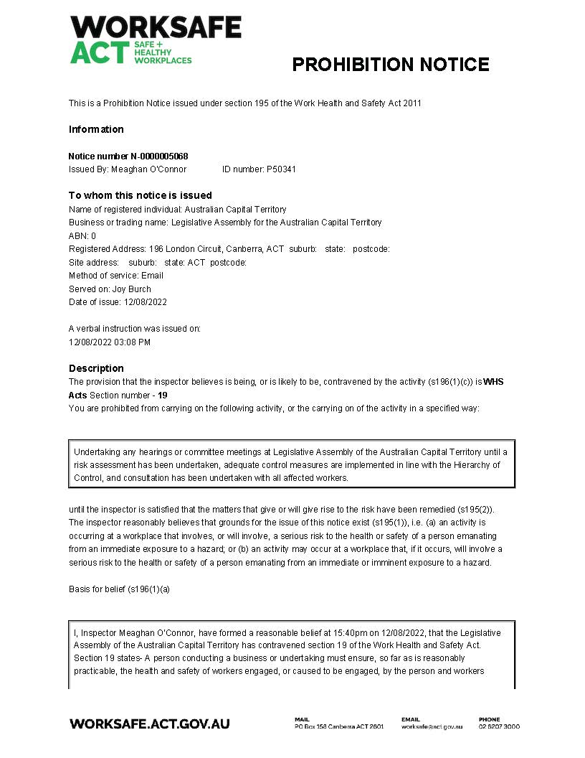
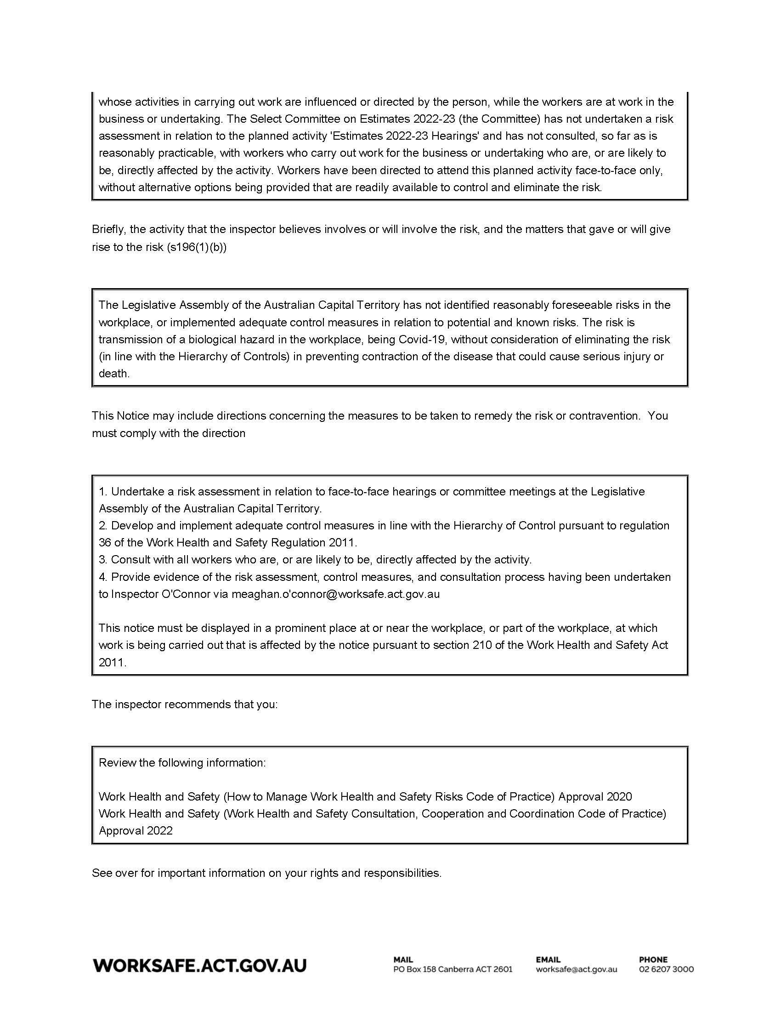

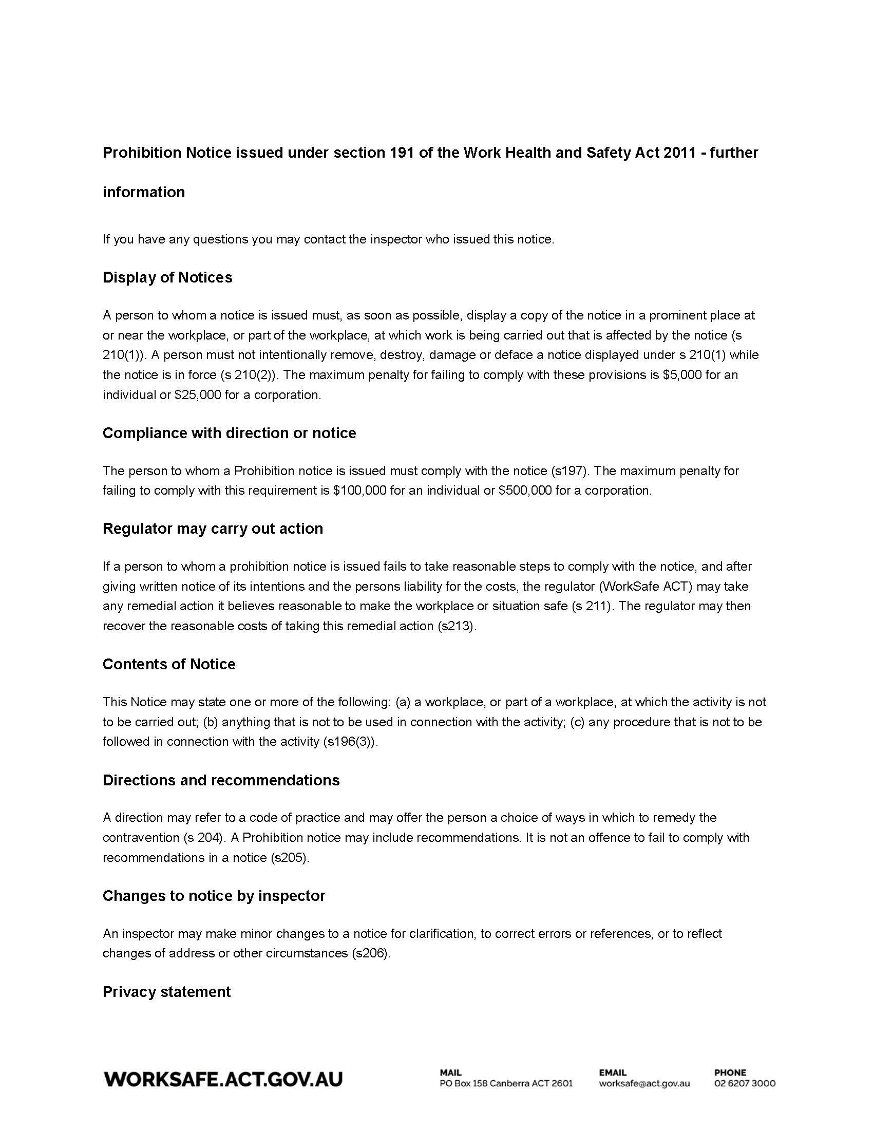
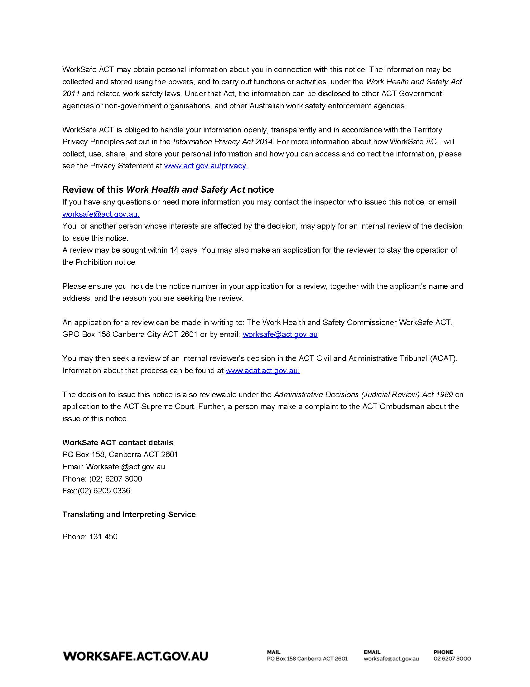

Appendix D: Prohibition notice issued 15 August 2022

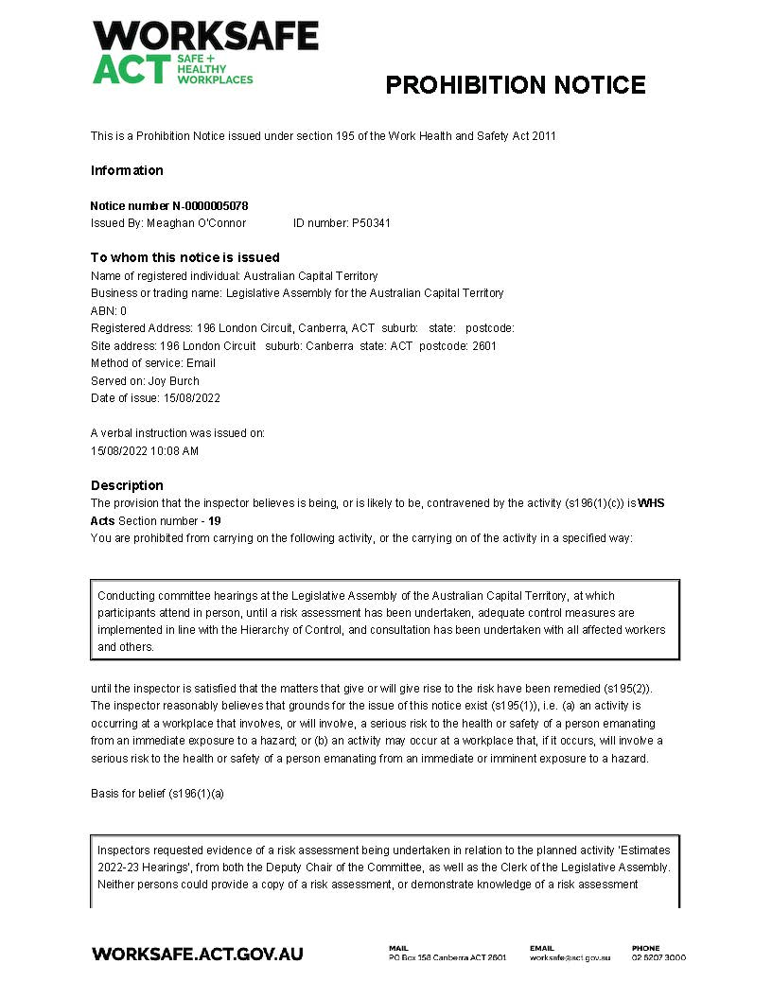

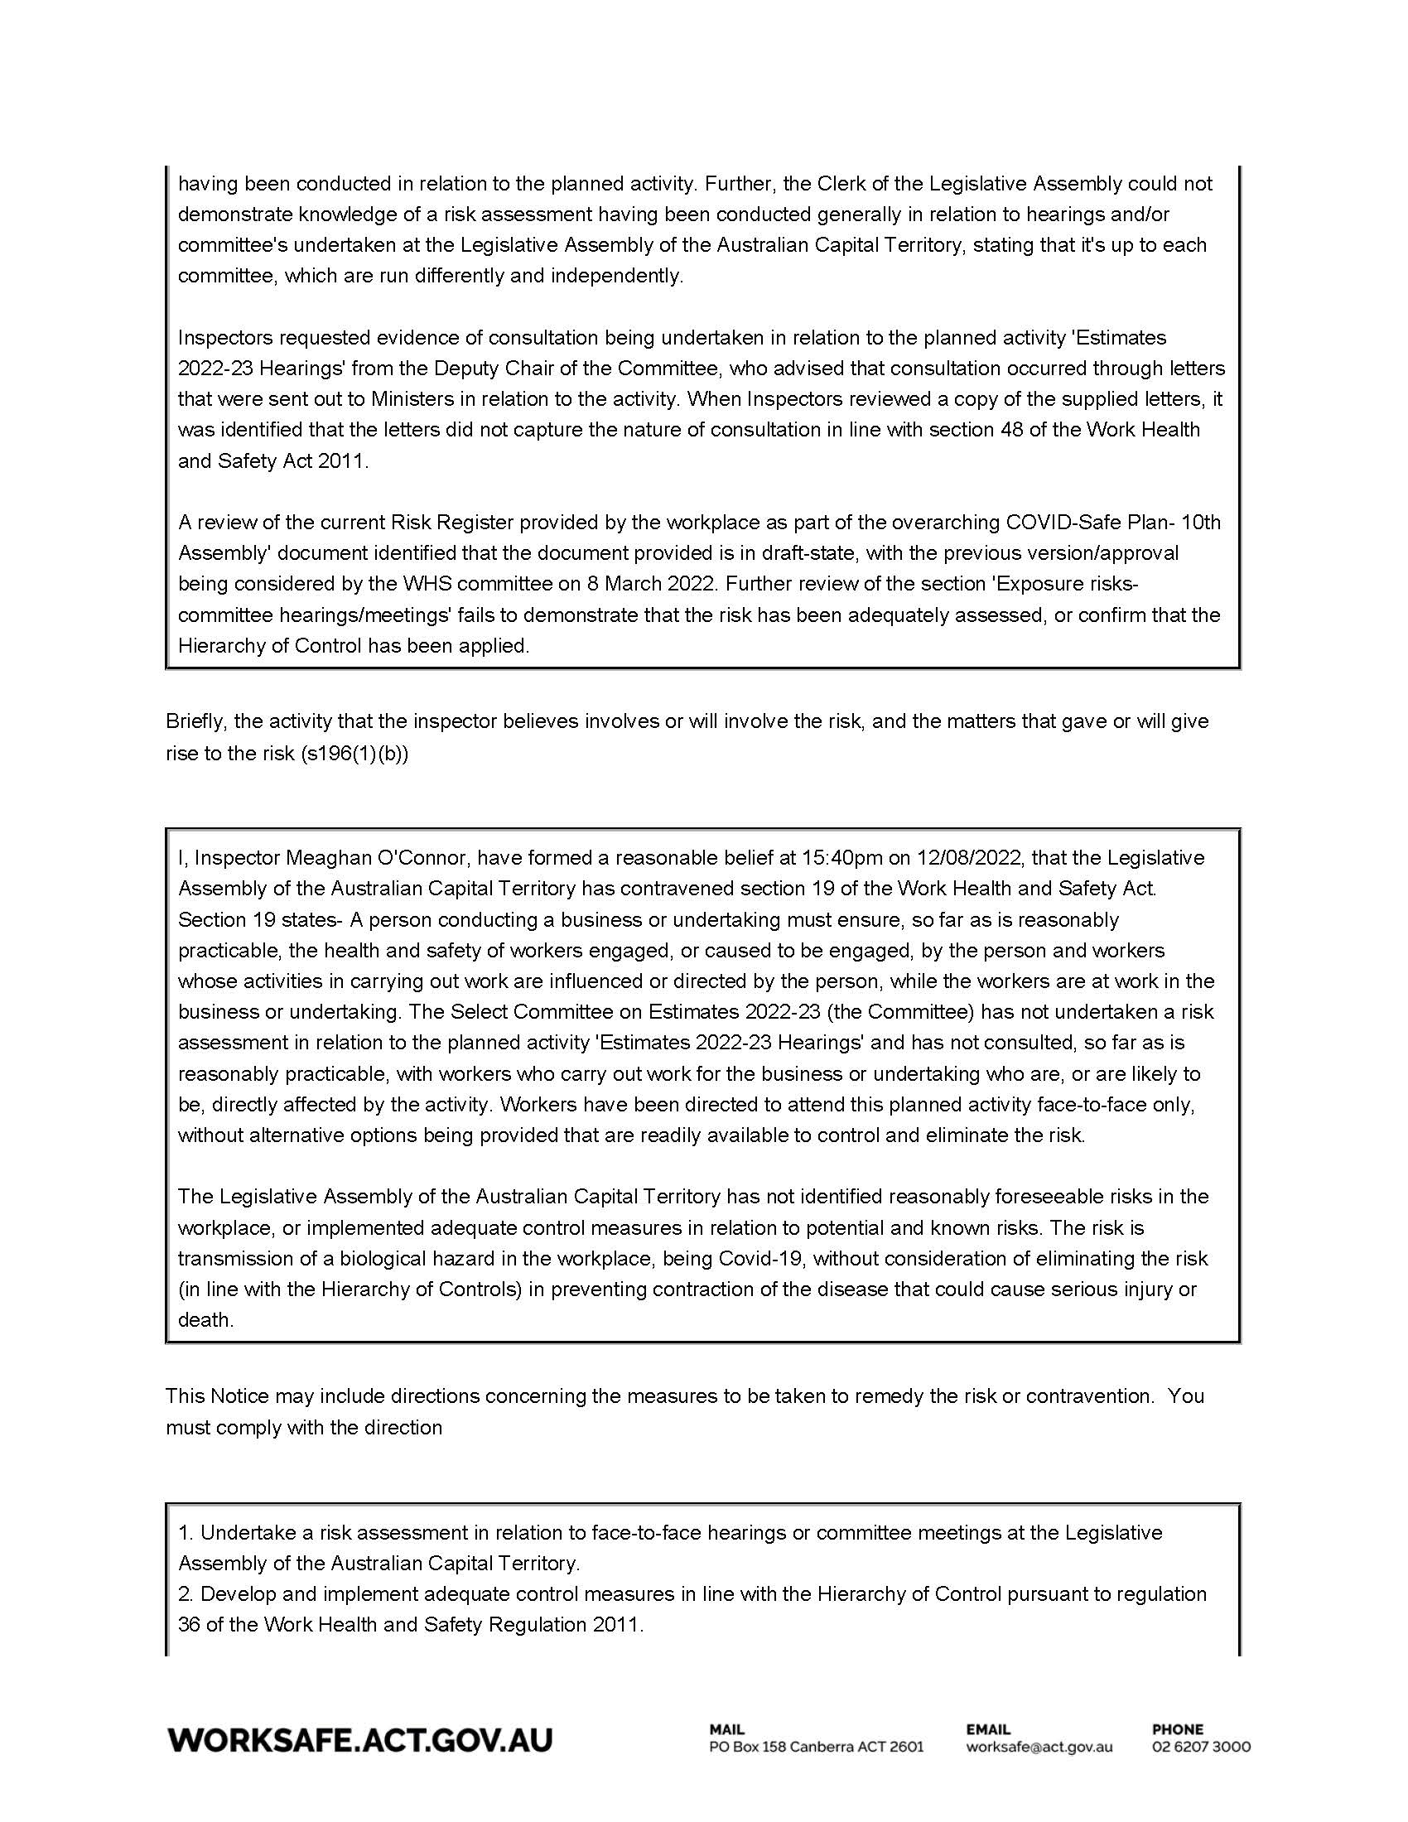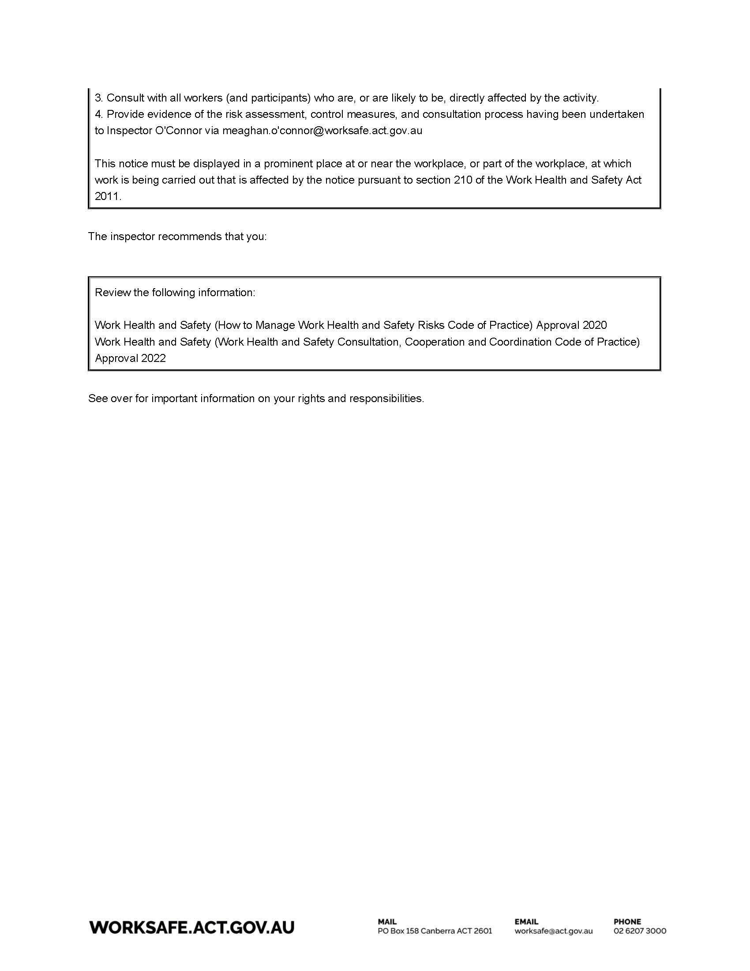

The privileges of the House of Representatives derive in turn from those of the British House of Commons as at 1901 via section 49 of the Australian Constitution.
Odgers’ Australian Senate Practice, 14th edition, p. 83.
Odgers’, op cit, p. 83.
Odgers’, op cit, p. 84.
Odgers’, op cit, p. 88.
Pettifer, House of Representatives Practice, 7th edition, p. 780.
For example, UK House of Commons, Commonwealth Parliament, New Zealand, Queensland, Victoria.
Sir William Blackstone, Commentaries on the Laws of England (1765), pages 58 to 59 , cited in Parliamentary Privilege - Joint Committee on Parliamentary Privilege https://publications.parliament.uk/pa/jt201314/jtselect/jtprivi/30/3004.htm.
Op cit, paragraph 20
Op cit, paragraph 21.
Op cit, paragraph 23.
Submission 2—Select Committee on Estimates 2022-2023.
Submission 2—Select Committee on Estimates 2022-2023.
Submission 2—Select Committee on Estimates 2022-2023, pp 9-10.
Submission 5—Office of the Legislative Assembly.
Submission 5—Office of the Legislative Assembly, pp 12-13.
Submission 2.1—Select Committee on Estimates 2022-2023 - Supplementary.
Select Committee on Privileges 2022 - ACT Legislative Assembly
McGee, Parliamentary Practice in New Zealand, 4th ed, page 706.
New South Wales Legislative Council Practice, 2nd ed, pp 171-172.
Cited in Odgers Senate Practice, 14 ed, p 69.
https://www.aph.gov.au/Parliamentary_Business/Committees/Senate/Privileges/Completed_inquiries/~/link.aspx?_id=2946091C6D154B518900CE1FAA185ED1&_z=z
Erskine May: Parliamentary Practice (25th ed), Ch 15.12.
Submission 4.5 - The validity of prohibition notices issued to the Legislative Assembly of the Australian Capital Territory—Joint opinion by Bret Walker and Jackson Wherrett, 4 October 2022 at 45.
Submission 3.6a - The interpretation of the Work Health and Safety Act 2011 (ACT)—Joint opinion by Saul Holt KC and Katharine Brown, 20 October 2022 at 53-55.
Senate Hansard, 24 August 2020, p 3706.
Submission 3.8 – Response to findings.
Work Health and Safety Act 2011 (Cth), s 242(3).
Submission 2 – Select Committee on Estimates 2022-2023.
Submission 2.1—Select Committee on Estimates 2022-2023 - Supplementary.
Transcript, 25 October 2022, p 66.
Continuing resolution 5 – Code of conduct for all members of the Legislative Assembly for the Australian Capital Territory, section 21.
Senate Hansard, 24 August 2020, pp 3705-3706.
Senate Journals, 3 September 2020, p 2298.
For a discussion see Odgers Senate Practice, (14th ed), pp 68-69.
Submission 4.5 - The validity of prohibition notices issued to the Legislative Assembly of the Australian Capital Territory—Joint opinion by Bret Walker and Jackson Wherrett, 4 October 2022 at 37.
Submission 3.6a - The interpretation of the Work Health and Safety Act 2011 (ACT)—Joint opinion by Saul Holt KC and Katharine Brown, 20 October 2022 at 11.
Submission 5 – Office of the Legislative Assembly, p 17.
Submission 4.3 – Speaker, Legislative Assembly for the ACT - Supplementary submission – Attachment A.
Joint Committee on Parliamentary Privilege, HC 214-I (1998-99 paragraph 334.
Submission 5.4 – Office of the Legislative Assembly – Follow-up from public hearing, p 2.

