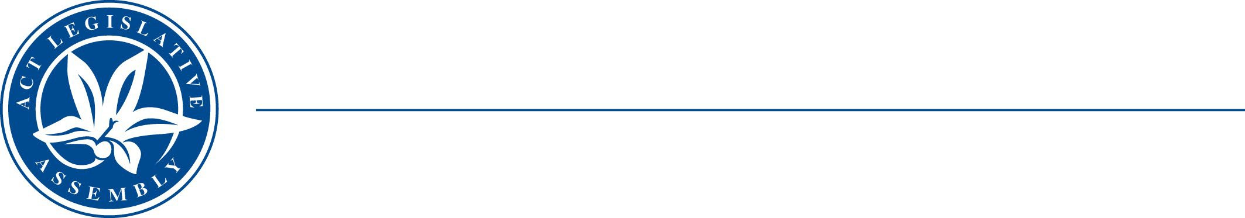
LE G I S LA TI V E A S S EM B LY
F O R T H E AU S T R A L I A N CA P I T A L T E R RI T O R Y

STANDING COMMITTEE ON JUSTICE AND COMMUNITY SAFETY
Mr Peter Cain MLA (Chair), Dr Marisa Paterson MLA (Deputy Chair), Mr Andrew Braddock MLA

MEDIA RELEASE
Hearing on Inquiry into new Terrorism Bill

Today the Standing Committee on Justice and Community Safety will hold a public hearing for the Inquiry into the Terrorism (Extraordinary Temporary Powers) Amendment Bill 2022.
The bill proposes to extend the Terrorism (Extraordinary Temporary Powers) Act 2006 for a further five years (to 19 November 2027), as it is due to expire on 19 November 2022.

Given that the Act has been in place since 2006 and extended several times, the Committee sees value in a public discussion about its impact on the community before a further extension.

Visitors are welcome to observe the proceedings, between 3.40pm to 4.30pm, in the Prince Edward Island Room at the Legislative Assembly building on London Circuit (COVID-Safe restrictions apply).

The public hearing will also be web streamed live from the Legislative Assembly website at ACT Legislative Assembly On Demand

Appearing at today’s hearing include the following witnesses:
- The Attorney-General
- Human Rights Commission

The hearing schedule is available at: Public hearings schedule - ACT Legislative Assembly

Monday 6 June 2022 STATEMENT ENDS.

For further information please contact:
Committee Chair, Mr Peter Cain MLA on (02) 6205 1927
Committee Secretary, Kathleen de Kleuver, on (02) 6207 0524 or at LACommitteeJCS@parliament.act.gov.au

