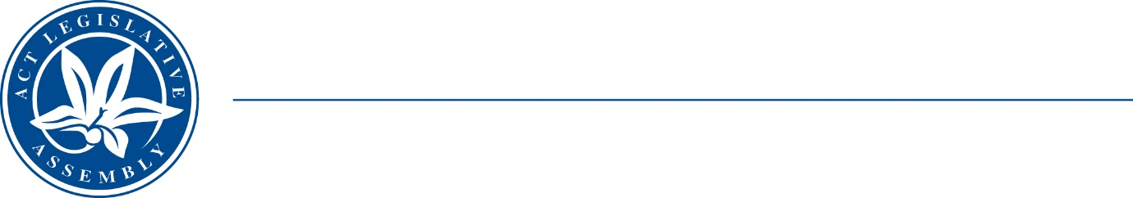
Standing Committee on Planning, Transport and City Services
Ms Jo Clay MLA (Chair), Ms Suzanne Orr MLA (Deputy Chair),
Mr Mark Parton MLA
Ms Caroline Le Couteur MLA

LEGISLATIVE ASSEMBLY
FOR THE AUSTRALIAN CAPITAL TERRITORY

MEDIA RELEASE

New inquiry into EV Vehicle Adoption in the ACT

A new Committee inquiry into electric vehicle adoption was announced in the Legislative Assembly today.

The Chair of the Standing Committee on Planning, Transport and City Services, Ms Jo Clay MLA, said “We are really pleased to open this inquiry into EV Adoption in the ACT. We really want to hear from a broad range of stakeholders to find out the challenges and opportunities for Canberrans who want to switch to EVs.

“We will be looking at eight topics in particular, including the issues and skills needed to expand EV uptake, changing infrastructure, planning, power needs, industry development opportunities, the application of ACT and Federal taxes and charges and transition assistance for people on low incomes.

“We look forward to hearing from as many people as possible about the barriers to uptake, possible incentives, ACT Government and private sector strategies and guidance on transport infrastructure needs and planning for Canberra.”

The Committee invites submissions from industry groups, peak bodies, think tanks, academics, economists, unions and members of the public.

The Terms of Reference for the inquiry are available on the Committee webpage.

Information about how to make a submission is available on the Assembly website.

Submissions are open until 6 August 2022.

Terms of Reference

That the Standing Committee on Planning, Transport and City Services inquire into barriers to EV uptake and solutions and incentives to encourage uptake in the Territory, including:
- Skills development needs to support an expanding EV uptake
- Industry development opportunities
- Planning laws and regulations and education and promotions in relation to charging infrastructure requirements in a variety of residential, public and commercial configurations and precincts
- ACT Government’s role in providing charging infrastructure
- Regional charging infrastructure and whether this is a barrier to local uptake, end-of-life battery disposal, and impact of EVs on ACT power supply requirements and vehicle-to-grid issues
- Application of Territory taxes and charges for EV purchases including registration charges.
- Federal taxes and charges for EV purchases, including import taxes
- Other Federal barriers to EV uptake, cost and availability of EVs, including fuel efficiency standards, impact of EV uptake on existing motor and service industry sectors including possible transition assistance, equity and just-transition issues for people on lower incomes.
Any other matter relevant to this issue.

1 June 2022
STATEMENT ENDS.

For further information please contact:
Committee Chair, Ms Jo Clay MLA on 0450 082 187
Committee Secretary, Martin Riordan on (02) 6205 0199 or at LACommittee -PTCS@parliament.act.gov.au

