
2021
Alistair Davey, Brett Kaufmann, Roger Fisher and Susan Antcliff
Pegasus Economics
February 2021
Review of the ACT Budget 2020-21

Pegasus Economics • www.pegasus-economics.com.au • PO Box 449 Jamison Centre, Macquarie ACT 2614
Pegasus Economics is a boutique economics and public policy consultancy firm that specialises in strategy and policy advice, economic analysis, trade practices, competition policy, regulatory instruments, accounting, financial management and organisation development.
This report has been commissioned by the ACT Legislative Assembly’s Standing Committee on Public Accounts to assist the Committee in its deliberations in relation to the 2019-20 ACT Budget.
The views and opinions expressed in this report are those of the authors.
For information on this report please contact:
Name: Dr Alistair Davey
Telephone: + 61 2 6100 4090
Mobile: 0422 211 110
Email: adavey@pegasus-economics.com.au

Photograph on the front cover is taken from the front cover of Australian Capital Territory Budget 2020-21: Driving Canberra's Recovery – Budget Outlook from the 2020-21 ACT Budget.

Table of Contents
Executive Summary vi
Overview vi
Limitation of Scope vii
Issues that may benefit from further investigation vii
1. Introduction 1
1.1 Introduction 1
1.2 Background 1
1.3 Purpose 1
1.4 Approach 1
1.5 Limitation of Scope 1
2. Economic Forecasts 3
2.1 Overview 3
2.2 ACT Final Demand 3
2.2.1 ACT Economy Public Sector Fiscal Stimulus During the COVID-19 Pandemic 8
2.3 Employment 10
2.4 Wage price index 11
2.5 Consumer price index 11
2.6 Population growth 12
3. Fiscal Position 13
3.1 Operating Statement - Headline Operating Balance 13
3.2 Medium term forecasts 15
3.3 Measures of the ACT Government’s balance sheet 16
3.4 Other fiscal indicators 17
3.5 Strategies for fiscal recovery 18
3.5 Conclusion 19
4. Revenue 20
4.1 Overview 20
4.2 Vertical fiscal imbalance 22
4.3 Tax reform 24
4.4 Dividends and Income Tax Equivalents 26
5. Expenditure 29
5.1 Overview 29
5.2 Expenses by function 30
5.3 Trends in Operating Expenses 30
5.4 New initiatives 31
6. Capital Works and Infrastructure 32
6.1 Overview 32
6.2 Capital Works Program 33
6.3 Public Private Partnerships 34
7. Assets and Liabilities 36
7.1 Overview 36
7.2 Net Debt 36
7.3 Net financial liabilities 38
7.4 Net worth 39
7.5 Superannuation 40
8. Risks 44
8.1 Overview 44
8.2 Risks to the economic outlook 44
8.3 Fiscal risks 45
9. Budget accounting, classification and valuation issues 46
9.1 Overview 46
9.2 Disclosure of Key Accounting Policies 46
9.3 Superannuation return adjustment 47
9.4 Superannuation liability valuation and service costs 48
9.5 Public Private Partnerships 49
9.6 Concessional Loans 51
Bibliography 52

Table 1: Current outcomes and economic estimates and forecasts in the 2020-21 ACT Budget, percentage change 3
Table 2: General Government Sector Headline Net Operating Balance 13
Table 3: General Government Sector Key Balance Sheet Measures 16
Table 4: General Government Sector Revenue 22
Table 5: Dividends from ACT Public Trading Enterprises 27
Table 6: Budget and forecast expenses, 2019-20, 2020-21 and 2021-22 to 2023-24 29
Table 7: Summary of investment and capital works program – 2020-21 to 2023-24 32
Table 8: Public Private Partnerships – Light Rail Stage 1 and Light Rail Stage 2 and 2A – Capital Expenditure Schedule 34
Table 9: Defined Benefit Superannuation Liability 41
Table 10: Defined Benefit Superannuation Liability Funding 42
Table 11: Impact of a 1 percentage point decrease in the discount rate on superannuation liability 48
Table 12: Impact of a 1 percentage point decrease in the discount rate on superannuation expense 49

Figure 1: Retail Turnover for the ACT Economy, March Quarter 2019 to the September Quarter 2020 ($ million, constant 2018-19 dollars) 4
Figure 2: Components of Final Demand for the New South Wales economy, year ended September 2020 5
Figure 3: Components of Final Demand for the ACT economy, year ended September 2020 5
Figure 4: Relative shares of ACT Final Demand – 1995-96 to 2019-20 6
Figure 5: ACT Final Demand and the contribution of the Commonwealth Government and Household Consumption – 1995-96 to 2019-20 ($ million, constant 2018-19 dollars) 7
Figure 6: Percentage Growth in ACT Final Demand, Commonwealth Expenditure and Household Consumption – 1996-97 to 2017-18 7
Figure 7: Quarterly Commonwealth Government and ACT Government Consumption and Investment Expenditure – June 2019 to September 2020 ($ million, constant 2018-19 dollars) 9
Figure 8: Percentage Increase in Commonwealth Government and ACT Government Consumption and Investment Expenditure – June 2019 to September 2020 9
Figure 9: ACT Employment – January 2010 to December 2020 (‘000) 10
Figure 10: Percentage Change in the ACT Wage Price Index for the Private and Public Sectors from Corresponding Quarter of Previous Year (Total hourly rates of pay excluding bonuses) – March quarter 2007 to September quarter 2020 11
Figure 11: Forecast returns to surplus ($ million) 16
Figure 12: Assets and Liabilities 17
Figure 13: Forecast ACT Budget Revenue in the 2019-20 ACT Budget and the 2020-21 ACT Budget – 2020-21 to 2023-24 ($’000) 20
Figure 14: Forecast ACT Budget Revenue for 2020-21 in the 2019-20 ACT Budget and the 2020-21 ACT Budget ($’000) 21
Figure 15: Percentage of ACT Government Revenue from Own-Source Taxation – 2019-20 to 2022-23 23
Figure 16: Percentage of Increased ACT Government Revenue Funded by the Commonwealth Government – 2020-21 to 2023-24 23
Figure 17: ACT Government Revenue from Commercial, Residential and Rural General Rates – 2019-20 to 2023-24 ($’000) 25
Figure 18: ACT Government Revenue from Residential Conveyances - 2019-20 to 2023-24 ($’000) 26
Figure 19: Forecast Revenue from Dividends and Income Tax Equivalent Payments from the 2019-20 ACT Budget, August 2020 Economic and Fiscal Update (EEU) and 2020-21 ACT Budget – 2020-21 to 2023-23 ($’000) 27
Figure 20: Forecast Revenue from Dividends from the Suburban Land Agency* and the City Renewal Authority and Tax Equivalent Payments from the 2019-20 ACT Budget, August 2020 Economic and Fiscal Update (EEU) and 2020-21 ACT Budget – 2020-21 ($’000) 28
Figure 21: Capital Works Program Forecasts – 2016-17 to 2023-24 ($’000) 34
Figure 22: Net debt as a proportion of Gross State Product – 2010-11 to 2023-24 (per cent) 37
Figure 23: Net financial liabilities as a proportion of Gross State Product – 2010-11 to 2023-24 (per cent) 39
Figure 24: Net worth as a proportion of Gross State Product – 2010-11 to 2023-24 (per cent) 40
Figure 25: Defined Benefit Superannuation Unfunded Liability and Investment Assets 42

Executive Summary

Overview
This report has been prepared by Pegasus Economics to assist the ACT Legislative Assembly’s Standing Committee on Public Accounts in its consideration and review of the 2020-21 ACT Budget. The draft report was required to be produced within six days of the presentation of the Budget to the Legislative Assembly. It is based on a desk-top review of the available documentation.
The Budget represents a measured and responsible approach to management of the impacts of the COVID-19 pandemic on the ACT economy.
Most of the ACT Budget economic forecasts for 2020-21 and 2021-22 appear to be reasonable. The major exception is growth in the consumer price index in both 2020-21 and 2021-22 that may be a little on the low side. The main source of fiscal stimulus to support the ACT economy during the COVID-19 pandemic came from the Commonwealth Government, while it is difficult to discern any evidence of a major stimulus provided by the ACT Government.
The Budget Papers present a headline net operating balance of -$603.1 million in 2020-21 and continuing deficits over the outyears. This represents an improvement relative to the August 2020 Economic and Fiscal Update but a significant deterioration in the fiscal outlook relative to the forecasts shown in previous Budgets. The Budget is now expected to be in deep deficit for the foreseeable future.
Indicators of the sustainability of the fiscal position such as net debt and net worth have deteriorated relative to previous Budgets. The budget deficit and levels of debt will require corrective action in the future, a point acknowledged in the Budget Papers by the ACT Government (2021, p. 53).
ACT Budget revenue in 2020-21 is expected to be almost $200 million lower than previously forecast at the time of the 2019-20 ACT Budget, falling from around $6.2 billion to around $6 billion, largely due to the decline in economic activity associated with the COVID-19 pandemic. While the ACT Government is gradually moving towards ameliorating the extent of vertical fiscal imbalance in future years through assuming greater responsibility for raising its own source taxation, it is still heavily dependent on the Commonwealth Government to fund increases in its revenue. The situation where the ACT Government is reliant on the Commonwealth to fund a significant proportion of its revenue increase contains an element of moral hazard and may provide an explanation for the relative inefficiency of the ACT Government in relation to the provision of public health and education services. One curious feature of the ACT Government’s tax reform is that with an expected buoyant ACT residential property market, residential conveyances are forecast to become an increasing tax base for the ACT Government over the years ahead. It appears incongruous for the ACT Government to be collecting more revenue from both residential conveyances and general rates when it is supposedly more than midway through its transition from transaction-based taxes to land-based taxes.
Expenses in 2020-21 are forecast to be around $400m higher than estimated at the time of the 2019-20 Budget and are expected to grow over the budget and forward estimates from $6.7 billion in 2020-21 to $7.1 billion in 2023-24. This is relatively modest in terms of historical rates of growth.
Growth in spending is driven mainly by new initiatives, most of which were announced in the August 2020 Economic and Fiscal Update.
New policy decisions will add some $298.7 million in expenses and $447.0 million in capital across the Budget and forward estimates. However, these amounts are partially offset by savings measures and other provisions.
The main areas of growth are in general public services, education and health.
The Budget includes the largest-ever infrastructure and capital works program across the Budget and forward years. The ACT Government will invest $4.3 billion in infrastructure and capital in the ACT over the next four years. $1.7 billion of the proposed program over the four years is in provisions, with detailed estimates not for publication. The key projects for 2020-21 include investments in health (SPIRE), new schools in Gungahlin, the big battery, road and bridge works in Molonglo, a new CIT campus for Woden, public housing renewal and Light Rail stage 2A. The peak year for infrastructure spending is 2021-22 ($1.3 billion), falling to $695 million in 2023-24; however, experience suggests new capital projects are likely to be proposed in future Budgets.
The Territory’s balance sheet is sound but has deteriorated over recent years. This decline has accelerated from 2019-20 due to the COVID-19 pandemic and other factors. Net worth is now in decline in absolute terms and as a proportion of Gross State Product (GSP) while net debt and net financial liabilities are rising. The Territory’s projected defined benefit superannuation liabilities are increasing slightly in nominal terms, but this is more than offset by projected increases in the Superannuation Provision Account. The unfunded superannuation liability is forecast to decline.
There are a number of risks and uncertainties attached to the Budget estimates. These include economic and fiscal risks. The Budget is based on assumptions about the future level of Commonwealth spending in the ACT and about the level of Commonwealth Government grants to the ACT that have some attached risk. The speed and strength of the recovery from the COVID-19 pandemic will have a significant bearing on the fiscal outlook.
Valuation effects, accounting treatments and timing issues continue to have large impacts on the budget aggregates and on the reported budget balance.

Limitation of Scope
In performing its role in assisting the ACT Legislative Assembly’s Standing Committee on Public Accounts in its review of the 2020-21 Budget, Pegasus relies on the details contained in the Budget Papers, our independent research and analysis and other sources.
Access to Treasury officials was limited. Pegasus attended the Budget lock-up, which involved a curtailed virtual presentation and question and answer session, with a brief presentation from the Chief Minister’s office. The Chief Minister did not attend and instead the session was chaired by the Deputy Under Treasurer. Pegasus presented a list of written questions to both the Chief Minister’s Office and the Deputy Under Treasurer. Those questions remain unanswered.
The level of detail ordinarily contained in the Budget Papers was not evident for 2020-21.
These matters have limited Pegasus’ ability to perform a full and complete review.

Issues that may benefit from further investigation
- Details and timing of the Government’s strategy for restoring the fiscal position and reducing net debt levels.
- The nature and reasons for the technical adjustments to revenue and expenses since the August 2020 Economic and Fiscal Update.
- Information on the ACT Government’s policy on dividends payable by ACT Public Trading Enterprises and any parameters that are set.
- The processes for reporting usage of the Capital Works Reserve, including:
    - criteria established to assess claims on the reserve
    - authority to approve such claims
    - Assembly assurance over the usage of the appropriation.
- How far into the future the planning timeframe for the capital works program extends.
- An explanation of the large fluctuation in reported levels of net financial liabilities between 2018-19 and 2020-21. Was this a valuation effect in 2019-20 or a real change in the level of liabilities? Is the data comparable across years?
- There are a number of issues in relation to the non-disclosure of key accounting policies and assumptions and key balance sheet items, including:
    - Was AASB 1049 adopted as the basis of accounting and presentation in preparing the budget financial statements?
    - Why, unlike other Australian jurisdictions, are the bases of accounting, key accounting policies and a disaggregation of key assets and liabilities not disclosed in notes accompanying the financial statement?
- The accounting treatment in the Budget for Public Private Partnerships, including:
    - Why has AASB 1059 Service Concession Arrangements: Grantors not been adopted for the Light Rail Stage 1 and the Law Courts PPP projects, particularly given it was adopted by NSW in its budget forward years and fully by Victoria?
    - Why has AASB 1059 not been adopted in respect to the Budget forward years?
    - Why has IPSASB 32 not been adopted?
    - What would be the impact on the Budget balances had AASB 1059 been adopted?
- The dollar impact on reported levels of net debt from 2019-20 arising from the impact of changes to AASB 16 Leases.

1. Introduction
This draft report has been prepared by Pegasus Economics to assist the ACT Legislative Assembly’s Standing Committee on Public Accounts in its consideration and review of the 2020-21 ACT Budget. The draft report was required to be produced within 6 days of the presentation of the Budget to the Assembly. It is based on a desk-top review of the available documentation. There has been limited opportunity to consult with the ACT Treasury.

1.1 Introduction
This report has been prepared for the ACT Legislative Assembly’s Standing Committee on Public Accounts to assist the Committee in its deliberations in relation to the 2020-21 ACT Budget.

1.2 Background
Pegasus Economics (Pegasus) was engaged by the Standing Committee on Public Accounts on 27 January 2021 to assist the Committee in its assessment of the 2020-21 ACT Budget. Pegasus was required to prepare a draft report on the Budget within six days of its presentation to the Assembly and to be available as required to assist the Committee in its subsequent deliberations.

1.3 Purpose
This report has been produced to assist the Standing Committee on Public Accounts in its consideration of the 2020-21 Budget.
The report does not provide a complete or comprehensive summary of the 2020-21 Budget, nor does it attempt to provide an assessment of the appropriateness of the individual spending, revenue and investment decisions reflected in the document.
Rather, the report seeks to explicate elements of the Budget and points to areas that the Committee may wish to explore or to seek further information in its consideration of the Budget.

1.4 Approach
The range of matters covered in this report relates to subjects raised by Committee members at a meeting with Pegasus consultants on Wednesday 3 February 2021.
The report is based on a desk-top review of the ACT Budget documentation presented to the Assembly on Tuesday 9 February 2021. We have also consulted other documentation in the public domain including Commonwealth Government Budget Papers, previous ACT Budget documents, reports of the ACT Auditor-General, various Ministerial statements, Departmental reports and other research literature.

1.5 Limitation of Scope
As indicated above, Pegasus Economics has been engaged to assist the ACT Legislative Assembly’s Standing Committee on Public Accounts in its review of the 2020-21 Budget. In performing this role Pegasus relies on the details contained in the Budget Papers, some access to Treasury officials, our independent research and analysis and other sources.
The level of detail ordinarily contained in the Budget Papers was not evident for 2020-21. It was not possible, for example, for Pegasus to form a view about the nature of many of the technical adjustments to the Budget figures or to follow some transactions through the documents provided.
In light of COVID-19 pandemic restrictions, the Budget lock-up was a curtailed virtual presentation and question and answer session, with a brief presentation from the Chief Minister’s office. The Chief Minister did not attend and instead the session was chaired by the Deputy Under Treasurer. As permitted, Pegasus presented a list of written questions to both the Chief Minister’s Office and the Deputy Under Treasurer. Those questions remain unanswered.
These matters have limited Pegasus’ ability to perform a full and complete review.

2. Economic Forecasts
Most of the ACT Budget economic forecasts for 2020-21 and 2021-22 appear reasonable. The major exception is growth in the consumer price index in both 2020-21 and 2021-22, which appears to be a little on the low side. The main source of fiscal stimulus to support the ACT economy during the COVID-19 pandemic came from the Commonwealth Government, while it is difficult to discern any evidence of a major stimulus provided by the ACT Government.

2.1 Overview
A summary of current economic trends alongside the economic estimates and forecasts contained in the 2020-21 ACT Budget are provided in Table 1 below.
Table 1: Current outcomes and economic estimates and forecasts in the 2020-21 ACT Budget, percentage change
Indicator | Current outcomes to the end of September 2020¹ | ACT Budget 2020-21 estimates | ACT Budget 2021-22 forecasts
State Final Demand² | 3.1 | 3¼ | 2¼
Employment³ | 3.2 | 4 | ½
Wage Price Index⁴ | 1.4 | 1½ | 1¾
Consumer Price Index⁵ | 1.1 | 3 | 1¼
Population | 1.1 | ¼ | ¼
1. Year to the end of September 2020 and through the year unless otherwise stated.
2. In year average seasonally adjusted terms.
3. Through the year to the end of December 2020 in seasonally adjusted terms.
4. Through the year to the end of September 2020.
5. Through the year to the end of December 2020.
6. Through the year to the end of June 2020.
Sources: ACT Government (2021), Australian Bureau of Statistics (ABS) (2020, 2020d, 2021, 2021a).

2.2 ACT Final Demand
The best and most immediate indicator of economic activity within the ACT is final demand. Estimates of gross state product (GSP) are only published annually with a significant time delay following the end of the financial year and quarterly estimates are not available. Because there is no timely way to get a gauge on GSP, it will not be considered further.
The most recent national accounts released by the Australian Bureau of Statistics (ABS) (Australian Bureau of Statistics, 2020) relates to the September quarter 2020. ACT final demand contracted by 1.7 per cent in June quarter 2020 as parts of the economy were shut down due to the COVID-19 pandemic, driven by an 11.8 per cent fall in household consumption. However, ACT final demand partially recovered during the September quarter 2020 growing by 2.0 per cent, with household consumption growing by 8.7 per cent during the quarter.
Growth in final demand for the year ending September 2020 was 3.1 per cent, which is consistent with the Budget estimate for an increase in ACT final demand of 3¼ per cent for 2020-21 assuming the recent strength observed in household consumption continues.
The available evidence suggests that household consumption in the ACT has now more than recovered from its COVID-19 pandemic induced slump. In the December quarter 2020, retail turnover (that makes up just over one third of household consumption), was 8.6 per cent higher (in seasonally adjusted terms) than it was during December quarter 2019. Retail turnover for the ACT economy is outlined in Figure 1 below.
Figure 1: Retail Turnover for the ACT Economy, March Quarter 2019 to the September Quarter 2020 ($ million, constant 2018-19 dollars)
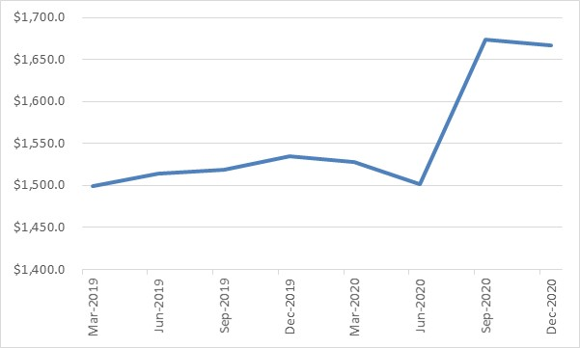
Source: ABS (2021b).
Pegasus has no reason to query the forecasts of ACT final demand of growth of 3¼ per cent in 2020-21, moderating to 2¼ per cent in 2021-22.
Economic forecasting in a modern mixed economy is usually focused on the largest components of economic activity, which are generally composed of household consumption and private investment. This can be seen in Figure 2 below that presents the four main components of the New South Wales (NSW) economy.

Figure 2: Components of Final Demand for the New South Wales economy, year ended September 2020
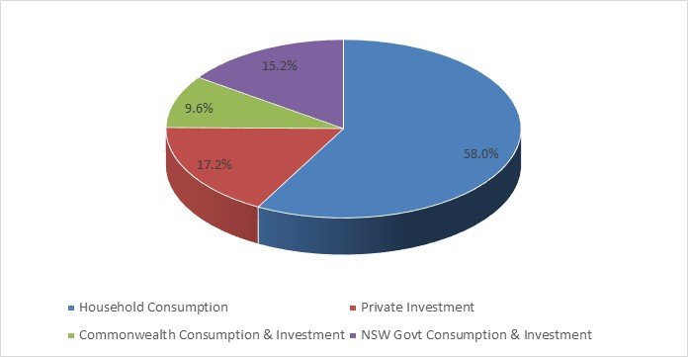
Source: ABS (2020).
However, the ACT, as the seat of the Commonwealth Government, is heavily dependent on the consumption and investment decisions of the Commonwealth Government.
In the year to the end of September 2020, the Commonwealth represented 43.8 per cent of total demand in the ACT economy, compared to household consumption that made up 34.9 per cent, private investment of 11.2 per cent, and 10.2 per cent for the ACT Government as illustrated in Figure 33 below.
Figure 3: Components of Final Demand for the ACT economy, year ended September 2020
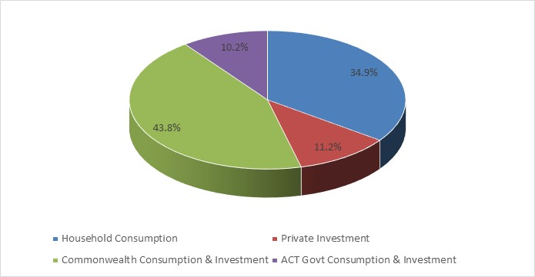
Source: ABS (2020).
The historical relative shares of ACT final demand are provided in Figure 4 below.

Figure 4: Relative shares of ACT Final Demand – 1995-96 to 2019-20
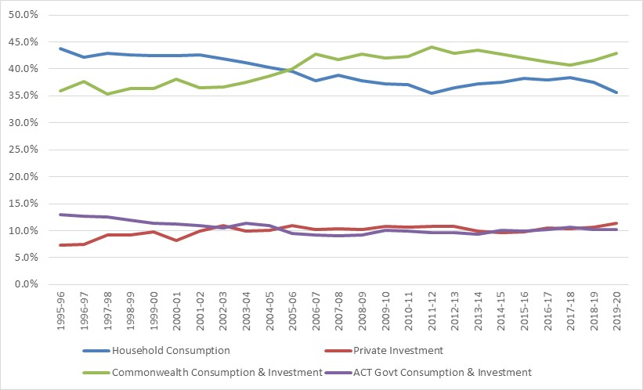
Source: ABS (2020; 2020a).
Household consumption was the largest component of ACT final demand up until 2005-06 when it was overtaken by the Commonwealth Government. The contribution of the ACT Government to final demand has been hovering at around 10 per cent on average since 2010-11, while private investment has stabilised at around 10½ per cent on average over the same period. Overall, there is no evidence to suggest there has been a dramatic shift in the drivers of ACT final demand over recent years, with the combined public sector (composed of both the Commonwealth Government and the ACT Government) still accounting for in excess of 50 per cent of final demand.
There is a close relationship between ACT final demand, Commonwealth Government expenditure and household consumption, as outlined in Figure 5 below, as well as between growth in ACT final demand and the growth of Commonwealth Government expenditure and household consumption, as outlined in Figure 6.

Figure 5: ACT Final Demand and the contribution of the Commonwealth Government and Household Consumption – 1995-96 to 2019-20 ($ million, constant 2018-19 dollars)
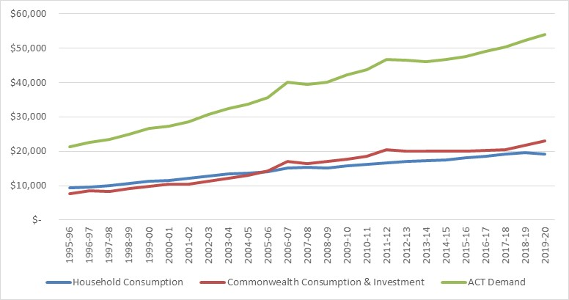
Sources: ABS (2020).
Figure 6: Percentage Growth in ACT Final Demand, Commonwealth Expenditure and Household Consumption – 1996-97 to 2017-18
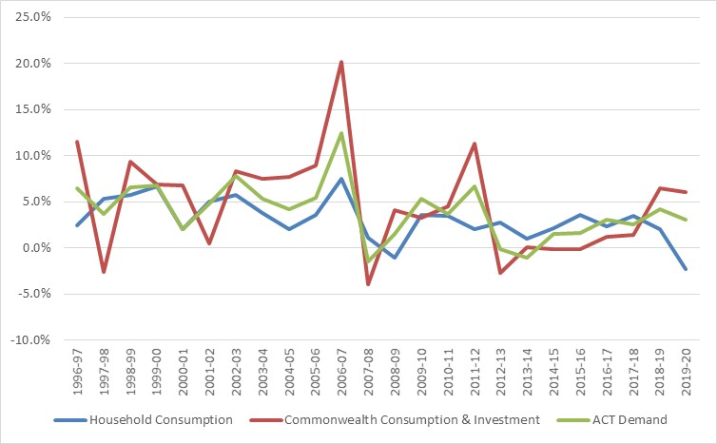
Sources: ABS (2020).
The ACT Budget papers previously contained projections for ACT final demand that converged back towards a long-run trend rate of growth in excess of 3 per cent in the out years (ACT Government, 2019, p. 12). According to the ACT Government (2021, p. 17):
The ACT Budget normally adopts a technical assumption for the final year of growth to reflect a return to average growth …
Pegasus had previously expressed reservations as to whether it was feasible to assume that ACT final demand would eventually return to long-run trend growth in excess of 3 per cent (Davey & Fisher, 2017, p. 6).
The ACT Government (2021, p. 17) has now decided to incorporate the impact of historically low population growth rather than adopting the assumption of a return to long-term growth. As such, Pegasus is much more comfortable with the long-term projections for growth in ACT final demand presented in the ACT Budget. These projections have a much more solid foundation than reversion to a historical trend that may not be realised.

2.2.1 ACT Economy Public Sector Fiscal Stimulus During the COVID-19 Pandemic
The ACT Government makes a number of claims in the Budget Papers about its role in supporting the ACT economy through the COVID pandemic.
According to the ACT Government:
Supported by effective health and economic policies locally and nationally, the ACT economy has emerged from the COVID-19 pandemic in a stronger position than previously expected, with economic growth of 2.4 per cent [in gross state product] in 2019-20. (ACT Government, 2021, p. 8)
and
The recent performance of the ACT economy has been stronger than expected at the time of the August 2020 EFU. This positive outcome reflects the combination of our highly effective public health response to the COVID-19 pandemic, the substantial economic policy actions locally and nationally and our resilient business and community sectors. In addition, our secure public sector base has provided a significant economic buffer, offsetting the significant declines in private sector activity. (ACT Government, 2021, p. 13)
The available evidence suggests the main source of fiscal stimulus to support the ACT economy during the COVID-19 pandemic came from the Commonwealth Government. It is difficult to discern evidence of any major stimulus provided to the ACT economy by the ACT Government.
In the 2019 calendar year, prior to any impact associated COVID-19, the ACT Government’s share of the ACT economy was 10.2 per cent. In the year to September 2020, incorporating three quarters impacted by the COVID-19 pandemic, the ACT Government’s share of the ACT economy was still sitting at 10.2 per cent.
Examination of quarterly public sector consumption and investment expenditure and growth rates reveals that ACT Government spending appears relatively flat overall and oscillates significantly between quarters, but quarterly growth never rises above 2.2 per cent. ACT Government spending actually contracted by 3.4 per cent during the September quarter 2020. On the other hand, Commonwealth Government spending increased significantly during the March and June quarters in 2020. This is outlined in Figures 7 and 8 below.

Figure 7: Quarterly Commonwealth Government and ACT Government Consumption and Investment Expenditure – June 2019 to September 2020 ($ million, constant 2018-19 dollars)
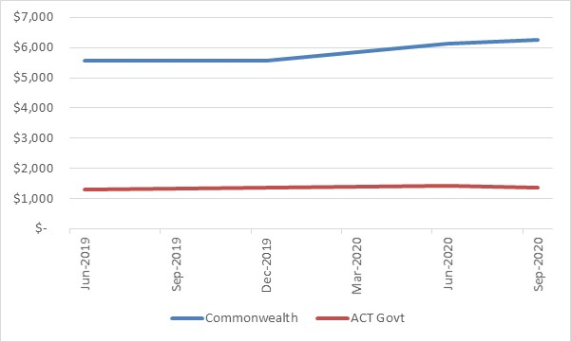
Source: ABS (2020).
Figure 8: Percentage Increase in Commonwealth Government and ACT Government Consumption and Investment Expenditure – June 2019 to September 2020
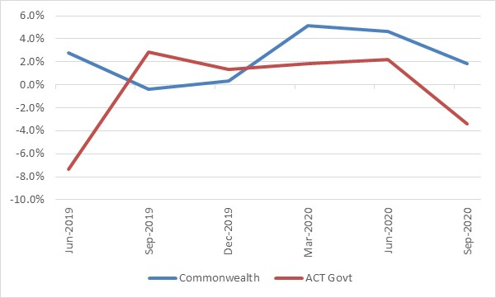
Source: ABS (2020).
The traditional theory of fiscal federalism lays out a general normative framework for the assignment of functions to different levels of government and the appropriate fiscal instruments for carrying out these functions (Oates, 1999, p. 1121). That theory suggests that responsibility for economic stabilisation, and thus fiscal stimulus when required, should reside with the central government. According to one of the leading proponents of this theory, distinguished American economist Wallace E. Oates (1972, p. 30):
The case for having the central government assume primary responsibility for the stabilisation function appears, therefore, to rest on a firm economic foundation … local government cannot use conventional stabilization tools to much effect and must instead rely mainly on beggar-thy-neighbor policies, which from a national standpoint are likely to produce far from the desired results. The central government, on the other hand, is free to adopt monetary policies and fiscal programs involving deficit finance; consequently, the stabilisation problem must be resolved primarily at the central government level.
While there isn’t anything necessarily wrong with the approach taken by the ACT Government, by the same token perhaps it shouldn’t be trying to take some credit for an economic stimulus that it didn’t really contribute all that much towards.

2.3 Employment
Employment growth through the year to the end of December 2020 for the ACT was running at 3.2 per cent in both original and seasonally adjusted terms (Australian Bureau of Statistics, 2021a). While the ACT lost just over 10,000 jobs during April and May 2020 at the height of the COVID-19 pandemic, the available evidence suggests those jobs have now been recovered.
In the 2020-21 ACT Budget, the ACT Government is estimating employment growth of 4 per cent in 2020-21, followed by employment growth of just ½ per cent in 2021-22. As the economic recovery from the COVID-19 pandemic is underway, the forecast of employment growth of 4 per cent in 2020-21 appears reasonable. The lower forecast for 2012-22 also appears reasonable given the significant reduction in population growth in 2020-21 driven by a decline in net overseas immigration (ACT Government, 2021, p. 8).
The level of employment in both original and seasonally adjusted terms for the ACT is provided in Figure 9 below.
Figure 9: ACT Employment – January 2010 to December 2020 (‘000)
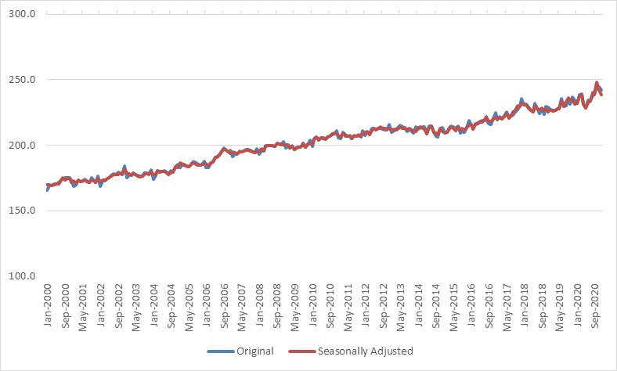
Source: ABS (2021a).

2.4 Wage price index
The Wage Price Index (WPI) is currently running at 1.4 per cent through the year to the end of the September quarter 2020 (Australian Bureau of Statistics, 2020d), which is consistent with the ACT Budget estimate of 1½ per cent for 2020-21.
Since 2013, wages growth in the private sector has generally outstripped that recorded within the public sector within the ACT as outlined in Figure 1010 below.
Figure 10: Percentage Change in the ACT Wage Price Index for the Private and Public Sectors from Corresponding Quarter of Previous Year (Total hourly rates of pay excluding bonuses) – March quarter 2007 to September quarter 2020
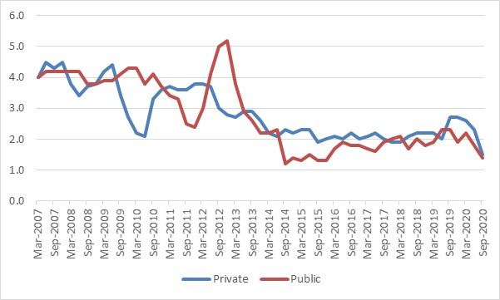
Source: ABS (2020d).
In November 2020 the Commonwealth Government announced a new wages policy for its public servants (Moreton, 2020). Under this policy, the Commonwealth removed its 2 per cent wages cap and will now cap future wage adjustments for Commonwealth public servants to wage adjustments in the private sector.
Given the widespread imposition of wage freezes and ongoing excess capacity in the labour market nationwide, wage growth in the private sector for Australia is anticipated to remain modest for some time (ACT Government, 2021, p. 33). On this basis, forecasts and projections for wages growth in the vicinity of 2 per cent and under appear reasonable.

2.5 Consumer price index
The Consumer Price Index (CPI) percentage change through the year to the end of the December quarter 2020 for Canberra was 1.1 per cent (Australian Bureau of Statistics, 2021). The ACT Government (2021) is forecasting the CPI will increase by 3 per cent through the year to the end of June 2021, before moderating to 1¼ per cent in 2021-22.
On face value the CPI forecast for 2020-21 may appear to be too high, especially as the Commonwealth Government (2020, p. 19) is forecasting growth in the CPI nationally of only 2¼ per cent in 2020-21. However, the forecast is being driven by the large fall in the CPI for Canberra in the June quarter 2020, when it fell by 2.3 per cent for the quarter during the height of the COVID-19 pandemic when childcare was free for most of the quarter (ACT Government, 2021, p. 34).
The 3 per cent forecast arguably falls into the category of a statistical anomaly and taking a year average result may provide a better indication of actual consumer price inflation. This is acknowledged by the ACT Government (2021, p. 34) when it comments:
For indexation purposes, a rate of 1½ per cent for 2020-21 is being used, which looks through the significant fall (-2.3 per cent) in Canberra’s CPI in the June quarter 2020 …
If anything, the 3 per cent forecast for 2020-21 may actually be on low side as it requires some modest reduction in the CPI in the March and June quarters 2021 to actually be achieved.
While the CPI forecast of 1¼ per cent growth for the ACT in 2021-22 does not appear unreasonable, Pegasus suspects that it may actually be ½ per cent on the low side. This is on the basis that forecasts for the ACT should probably be around ¼ per cent higher than national forecasts for the CPI that are currently for growth of around 1½ per cent in 2021-22 (Commonwealth of Australia, 2020, p. 19). Pegasus has previously suggested that ACT Government policies and practices may have locked in slightly higher inflation for the ACT than experienced in the other capital cities through tax reform and inefficient service delivery (Davey & Fisher, 2017, p. 11).

2.6 Population growth
There is no quarter of population data currently available so far for the 2020-21 financial year. With the exception of 2020-21, the population forecasts and projections contained in the ACT Budget are consistent with those produced by the Commonwealth Government Centre for Population (2020). However, the Centre for Population (2020) is forecasting negative population growth of 0.3 per cent in 2020-21, that would be consistent with a population growth forecast of –¼ per cent in 2020-21, whereas the ACT Government has forecast population growth of ¼ per cent for 2020-21. This small difference is unlikely to have a material impact on any of the other ACT Budget economic forecasts for 2020-21.

3. Fiscal Position
The Budget Papers present a headline net operating balance of $603.1 million in 2020-21 and continuing deficits over the outyears. This represents an improvement relative to the August 2020 Economic and Fiscal Update but a significant deterioration in the fiscal outlook relative to the forecasts shown in previous Budgets. The Budget is now expected to be in deep deficit for the foreseeable future.
Indicators of the sustainability of the fiscal position such as net debt and net worth have deteriorated relative to previous Budgets.
The Government is well positioned to meet its immediate financial obligations. However, the current trajectory cannot be sustained indefinitely. The ACT Government will need at some point to develop strategies to restore its fiscal position and reduce debt levels.

3.1 Operating Statement - Headline Operating Balance
The Budget Papers present a headline net operating balance of -$603.1 million in 2020-21 and reducing deficits over the outyears. The reported deficit is reduced by the superannuation adjustment.
Table 2: General Government Sector Headline Net Operating Balance
Empty Cell | 2019-20  Audited Outcome | 2020-21  Budget | 2021-22  Estimate | 2022-23  Estimate | 2023-24  Estimate
Empty Cell | $m | $m | $m | $m | $m
Revenue | 5,604.9 | 5,981.1 | 6, 171.9 | 6,330.5 | 6,560.1
Expenses | -6, 517.6 | -6,749.7 | -6,839.1 | -6,941.8 | -7,148.2
Superannuation return adjustment | 231.5 | 165.6 | 192.4 | 205.3 | 219.0
HEADLINE NET OPERATING BALANCE | -681.1 | -603.1 | -474.7 | -406.0 | -369.1
Source: ACT Government (2021, p. 46)
Forecasts for the headline net operating balance show a significant deterioration in the fiscal outlook relative to the forecasts shown in previous Budgets. The headline net operating balance is now expected to be in deficit across all of the Budget and forward years.
There is some improvement against the forecasts shown in the August 2020 Economic and Fiscal Update at around the worst period of the COVID-19 pandemic in Australia but the Budget is now expected to be in deep deficit for the foreseeable future.
The deterioration in the fiscal position has been driven by changes in the economy.
Since the 2019-20 Budget, changes in revenue forecasts driven the underlying economic parameters have added almost $1 billion to the deficit across 2020-21 and 2021-22 while policy decisions have only added around $260 million across these two years.
Changes in the expense forecasts since the last Budget have been driven by discretionary policy changes but their overall impact on the Budget has been relatively minor. Forecast expenses of $6.7 billion in 2020-21 represent an increase of $232.1 million, or 3.6 per cent, over the 2019-20 audited outcome but growth in expenses over the budget and forward years represent an annual growth rate of only 2.7 per cent.
To be fair, all Australian jurisdictions have reported a decline in their fiscal positions, and the relative deterioration in the ACT Government’s position is within the range of expected outcomes reported by other governments (ACT Government, 2021, pp201-204).
There are questions, however, about how the basis on which the reported fiscal position has been constructed. While the ACT Government states that the financial statements included in the Budget papers are consistent with the requirements of the Uniform Presentation Framework agreed by the Heads of Treasury (ACT Government, 2021, p.6), considerable discretion has been exercised in the inclusion of certain transactions in the reported fiscal position.
Reporting on the basis of a headline net operating balance is unique to the ACT. Other jurisdictions generally report a net operating balance that is constructed on a different basis.
The concept of a superannuation return adjustment is not part of the Uniform Presentation Framework. There are issues about whether the net operating balance should be adjusted for superannuation returns and the way this adjustment has been calculated. We estimate that the use of the projected long-term investment return rather than the valuation discount rate in the superannuation return adjustment reduces the headline net operating balance by around $75 million. Comments on the superannuation return adjustment are provided in section 9 of this report.
The ACT Budget also appears to have adopted some accounting policies that are different from those applied in other jurisdictions for comparable transactions. It is unclear to what extent these practices may have impacted on the reported headline net operating balance. A discussion of accounting and classification issues in the Budget is provided at section 9 of this report.
The reported headline net operating balance across the Budget and forward years rely to an unusual extent on contributed assets and dividends and taxation payments from Public Trading Enterprises. Overall, the contribution to the budget in the form of dividends and tax equivalent payments from the ACT Public Trading Enterprises over the next four years far exceeds the consolidated net operating balance for these entities (ACT Government, 2021, pp.156, 243).
The Budget estimate for dividends and tax equivalent payments from the Suburban Land Agency and City Renewal Authority are forecast to increase from $99 million in 2019-20 to $438 million in 2020-21. Dividends for these agencies fall away to $14 million in 2022-23. This reflects a bring forward of land sales to the Budget year (ACT Government, 2021, p.157).
There is a doubling in the estimate of gains from contributed assets in 2021-22 over the 2020-21 Budget associated with the expectation of increased land sales in 2020-21 (ACT Government, 2021, p.157). Revenue from contributed assets reflects the transfer of infrastructure assets such as roads and sewerage associated with land development.
These estimates point to the significance of the land sales program and other economic flows in supporting the ACT Government’s fiscal position over the next few years.
The Committee should be aware the Budget Outlook discloses (ACT Government, 2021 p. 47) a series of technical adjustments to both revenue and expenses since the since the August 2020 Economic and Fiscal Update. The adjustments affect the Budget year and each of the forward years. In respect to 2020-21, adjustments to revenue totalled $406.1 million, primarily relating to dividends and tax equivalents. Technical adjustments to expenses in 2020-21 totalled $ 7.6 million, the more material of which relate to Commonwealth grant expense and other technical adjustments.
The Committee is encouraged to explore with the ACT Government, the underlying nature of, and reasons for these adjustments.

3.2 Medium term forecasts
The ACT Government now expects that its fiscal position will remain in deficit across the Budget and forward years and that gross debt is expected to increase over the next four years (ACT Government, 2021, p.53).
Expenses are forecast to continue to outpace the government's revenue over the Budget and forward years, despite significant increases in rates, taxes, fees and charges and increases in Commonwealth grants over recent years.
The August 2020 Economic and Fiscal Update set out a range of policies and programs developed in response to the COVID-19 pandemic. However, measures to support the Canberra pandemic through the pandemic have not been the primary driver of the deterioration in the Government’s medium-term fiscal position. Rather, the decline in the fiscal outlook reflects structural weaknesses in the ACT Budget that have been exacerbated by the dampening of economic activity precipitated by the COVID pandemic. To the extent that increased land sales have been driven by stimulus measures, as implied by the ACT Government (2021, p.155), those transactions have had significant positive impacts on the medium-term fiscal outlook.
The ACT Government has indicated that it recognises the importance of restoring public finances and reducing net debt (ACT Government, 2021, p.53). It is clear however that the Government considers that the task of restoring public finances should be pursued after the impact of COVID has passed (ACT Government, p.52).
In our view, that is a sensible strategy. We would however point to the challenges that will be involved in restoring public finances given the forecast fiscal outlook.
A return to surplus had been announced and deferred in successive budgets between 2012-13 and 2017-18 and then again in 2019-20.
Figure 11 compares the predicted trajectory of the fiscal balance presented in successive Budget Papers since 2010-11.

Figure 11: Forecast returns to surplus ($ million)
Sources: ACT Government (2011, 2012, 2013, 2014, 2015, 2016, 2017, 2018a, 2019, 2021)
Figure 11 shows that over successive Budgets, forecast surpluses have tended to recede in time.
A return to surplus for the ACT Government will require favourable economic circumstances and considerable fiscal discipline over a long period of time.

3.3 Measures of the ACT Government’s balance sheet
The strength of the Government’s finances over the medium term can be assessed in terms of measures of net debt, net financial liabilities and net worth.
Table 3 presents these key balance sheet measures for the Budget and forward years. More detailed definitions of these measures and a discussion of longer-term trends is set out in section 7 of this report.
Table 3: General Government Sector Key Balance Sheet Measures
 | 2019-20  Outcome | 2020-21  Budget | 2021-22  Estimate | 2022-23  Estimate | 2023-24  Estimate
 | $m | $m | $m | $m | $m
Net debt (excluding super) | 3,296.7 | 4,665.0 | 5,960.6 | 6,926.7 | 7,658.6
Net financial liabilities | 12,003.2 | 9,301.8 | 10,559.7 | 11,744.9 | 12,670.2
Net worth | 13,030.3 | 16,628.9 | 15,971.4 | 15,343.1 | 14,837.2
Source: ACT Government (2021, pp. 191, 192).
Table 3 shows a weakening of the financial position forecast in the 2019-20 Budget and a deterioration in the key balance sheet measures over time.
The ACT Government’s forecast net worth for 2020-21 is higher than the 2019-20 estimated outcome, but for 2020-21 is 5.3 per cent lower than forecast in the 2019-20 Budget and net worth is now forecast to fall across the forward estimates.
Net financial liabilities have grown substantially since last year’s Budget and continue to deteriorate into the out-years. Net financial liabilities in the forward years are now forecast to be between 35 and 47 per cent worse than forecast in the 2019-20 Budget.
Net debt is also expected to be higher over the Budget and forward years than expected in the 2019-20 Budget, and the level of net debt is forecast to grow rapidly over the forward estimates. By 2023-24, net debt is forecast to be more than double the level forecast in the 2019-20 Budget.
The deterioration in these measures is largely a consequence of the economic and financial impact of the COVID-19 pandemic on the superannuation investment fund but other factors have also contributed, including structural imbalances in the ACT Government’s Budget.
Measures will be required in the future to return the ACT Budget to a stronger financial position.
In previous years the ACT Government has published the previous year’s Budget estimate alongside the estimated outcome and Budget estimates. This helped readers gain an understanding of movements in aggregates over time. While the information can be obtained from other sources, the withdrawal of this information from the Budget presentation represents a loss in transparency.
Figure 12 illustrates changes in net debt, net financial liabilities and net worth over time.
Figure 12: Assets and Liabilities

Source: ACT Government (2011, 2012, 2013, 2014, 2015, 2016, 2017, 2018a, 2019, 2021).
Note: From 2019-20, net debt includes the impact of accounting changes in relation to the treatment of leases. The ACT Government has indicated that for this reason net debt from 2019-20 is not directrly comparable to prior years.
Figure 12 shows clearly that over the Budget and forward years net debt and net financial liabilities are growing while net worth is falling. Taken together, these trends represent a weakening of the ACT Government’s medium-term financial position.

3.4 Other fiscal indicators
It would be desirable if future Budgets were to provide additional measures of the Territory’s capacity to meet its obligations.
Additional measures of the Territory’s financial position are also available.
In financial audits, the ACT Auditor-General has employed measures such as:
- Assets to liabilities coverage;
- Short term assets to short term liabilities coverage; and
- Financial assets to liabilities coverage (ACT Auditor-General, 2015, pp. 12-13).
The benefit of these measures is that they provide an indication of the Territory’s capacity to meet its obligations over the short and medium-term.
As part of this review, Pegasus undertook analysis of the capacity of the General Government sector to meets its financial obligations using similar ratios.
The coverage of assets to liabilities falls over the Budget and forward years from about 1.8 times in 2020-21 to about 1.6 times in 2023-24.
The ratio of short-term assets to short term liabilities also deteriorates over the Budget and forward years.
Financial assets are forecast to exceed net financial liabilities by 1.9 times in 2020-21 but this is lower than the 2019-20 outcome and the ratio reduces over time, to approximately 1.5 times in 2023-24.
This analysis reinforces the suggestion that the ACT Government’s financial position is deteriorating over the medium term.
Cash flows from operating activities and investments for policy purposes are forecast to be negative in all but one of the Budget and forward years.
An overall General Government cash deficit of $1.1 billion and negative net cash from operations of $219.8 million have been forecast for 2020-21. Overall, the ACT Government’s cash position in 2020-21 has deteriorated compared to the audited outcome for 2019-20.
These positions generally improve over the forward years, with the cash deficit reducing across each of the forward years. Similarly, net cash from operations is forecast to be positive across each of the out years.
The ACT Government will be able to meet its immediate obligations over the Budget and forward estimates period but the current fiscal trajectory is not sustainable over the long-term.
It would be useful if in future budgets the ACT Government could supplement the information already provided by presenting information on movements in these ratios over time. In particular, it would be useful if future Budget papers were to provide information to allow for a reliable identification of short-term assets and short-term liabilities.

3.5 Strategies for fiscal recovery
The ACT Government has indicated that it is committed to restoring public finances, after the impact of COVID has passed, by systematically reducing debt over the long term (ACT Government, 2021, p.52). The Government has no however articulated strategy or a timeframe for the return to surplus.
The ACT Government has in the past relied on taxation increases, land revenues and population related Commonwealth grants to maintain its fiscal position.
At least for the medium-term, the ACT Government expects economic activity and population growth to remain below trend levels. In our report on the 2019-20 Budget, Pegasus (Davey, Kaufmann, Bartos, & Antcliff, 2019) indicated that the then planned return to surplus rested on a number of assumptions: the Australian economy continuing to grow at around 3 per cent per annum (2.75 per cent in 2019-20); ongoing Commonwealth payments in a range of areas currently covered by specific purpose payments; continuing population growth and associated land releases; continuing high levels of exports of education services. We indicated that in our view the balance of risks to these assumptions was negative. In the event, the ACT Government’s 2020-21 economic assumptions suggest that a conjunction of circumstances such as these is unlikely to recur in the medium-term.
The achievement of an operating surplus in the medium-term would require an increase in revenue and a moderation of the ACT Government’s own spending in future years. Maintaining revenue levels will be a challenge in an environment of lower economic growth and investment uncertainty. It would also require the ACT Government to address a number of challenges in the planned transition from transaction-based taxes to land-based taxes.
Continued restraint on expenses will be difficult to achieve given the need for COVID-19 pandemic related measures and supports. A large component of public spending is “locked in” to the extent that it consists of payments which are not discretionary and which a future ACT Government is obliged to meet. Around a half of the ACT Budget consists of salaries, superannuation and other employee related costs. These costs are difficult to move in the short term. Another 10 per cent of the Budget consists of non-discretionary depreciation and amortisation and interest payments. The amount of lock-in limits the scope for governments to change the structure of their budgets even in the medium term.
There will also be pressure for new spending. History suggests governments will introduce new programs, or be faced with pressures on existing programs, which will require additional expenses in future Budgets. To some extent, these pressures will be unavoidable if the ACT Government is to achieve its objective of supporting the ACT economy to survive and recover from the COVID-19 pandemic. Without a strategy to offset these pressures with savings in other parts of the Budget, it is difficult to see a return to surplus as a realistic prospect.
These and other risks to the fiscal outlook are set out in section 7 of this report.

3.5 Conclusion
The Budget forecasts show a much weaker financial position than the Territory has experienced for some time. The headline net operating balance is now expected to be in deficit across all of the Budget and forward years.
There is little doubt that the Government will be able to meet its immediate financial obligations. However, the current trajectory cannot be sustained indefinitely. The ACT Government will need at some point to develop strategies to restore its fiscal position and reduce its levels of debt.

4. Revenue
ACT Budget revenue in 2020-21 is expected to be almost $200 million lower than forecast at the time of the 2019-20 ACT Budget, falling from around $6.2 billion to around $6 billion. This is largely due to the decline in economic activity associated with the COVID-19 pandemic.
Revenue is forecast to grown over the Budget and forward estimates period from $6.0 billion in 2020-21 to $6.6 billion in 2023-24. Revenue growth over the Budget and forward years largely reflects growth in higher ACT own-source taxation, increased GST revenues and increases in Commonwealth grants. A large growth in dividends and tax equivalent payments is forecast for 2020-21.
While the ACT Government is gradually moving towards assuming greater responsibility for raising its own source taxation, it is still heavily dependent on the Commonwealth Government to fund increases in its revenue.
One feature of the ACT Government’s tax reform is that with an expected buoyant ACT residential property market, residential conveyances will become an increasing tax base for the ACT Government over the years ahead.

4.1 Overview
ACT Budget revenue in 2020-21 is expected to be almost $181 million lower than previously forecast at the time of the 2019-20 ACT Budget, falling from $6,162 million to $5,981 million. In the three years to 2022-23, ACT Budget revenue is now expected to be almost $1.2 billion lower than previously forecast at the time of the 2019-20 ACT Budget. This is outlined in Figure 13 below.
Figure 13: Forecast ACT Budget Revenue in the 2019-20 ACT Budget and the 2020-21 ACT Budget – 2020-21 to 2023-24 ($’000)
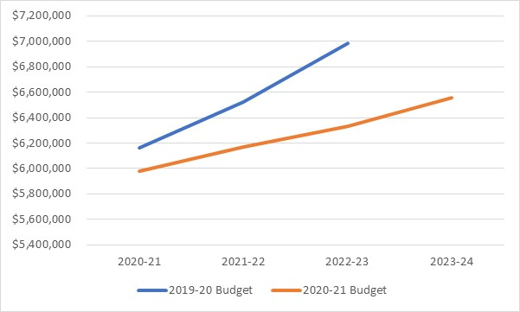
Source: ACT Government (2019, p. 226; 2021, p. 138).
The largest contributors to the loss of forecast revenue in 2020-21 have come from:
- a $253.8 million reduction in GST revenue
- a $191.3 million reduction in own-source taxation.
The fall in revenue for these items is largely associated with the decline in economic activity associated with the COVID-19 pandemic.
Lower revenue from these sources has been partially offset by:
- increased revenue from Commonwealth grants of $108.2 million
- increased revenue from dividends and income tax equivalents of $96.7 million
- increased revenue from investments of $59.1 million.
A comparison of revenue forecasts for 2020-21 from the 2019-20 ACT Budget and the 2020-21 ACT Budget is provided in Figure 14 below.
Figure 14: Forecast ACT Budget Revenue for 2020-21 in the 2019-20 ACT Budget and the 2020-21 ACT Budget ($’000)
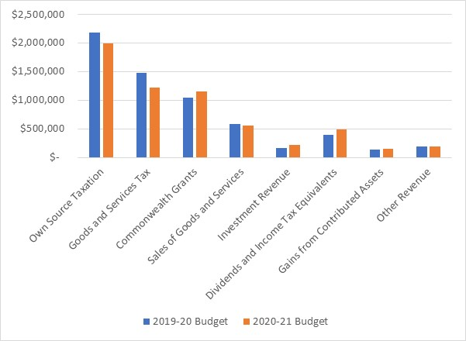Source: ACT Government (2019, p. 226; 2021, p. 138)
For 2021-22, forecast revenue is expected to increase by $191 million from $5,981 in 2020-21 to $6,172 million in 2021-22.
The main sources of revenue over the Budget and forward years are summarised in Table 4 below.

Table 4: General Government Sector Revenue
Empty Cell | 2019-20  Audited Outcome | 2020-21  Budget |  | 2021-22  Estimate | 2022-23  Estimate | 2023-24  Estimate
Empty Cell | $’000 | $’000 |  | $’000 | $’000 | $’000
Own Source Taxation | 1,949,207 | 1,987,230 |  | 2,156,238 | 2,269,753 | 2,390,173
Goods and Services Tax | 1,239,910 | 1,221,537 |  | 1,300,627 | 1,380,095 | 1,441,559
Commonwealth Grants | 1,123,497 | 1,158,195 |  | 1,244,883 | 1,240,798 | 1,273,534
Sales of Goods and Services | 546,992 | 561,693 |  | 602,108 | 621,838 | 636,926
Investment Revenue | 234,986 | 218,819 |  | 235,565 | 243,930 | 252,194
Dividends and Income Tax Equivalents | 157,661 | 486,739 |  | 216,301 | 127,083 | 206,342
Gains from Contributed Assets | 182,098 | 156,997 |  | 220,470 | 242,834 | 156,091
Other Revenue | 170,596 | 189,866 |  | 195,682 | 204,178 | 203,315
Total | 5,604,947 | 5,981,076 | 6,171,874 |  | 6,330,509 | 6,560,134
Source: ACT Government (2021, p. 136).
Revenue growth over the Budget and forward years largely reflects growth in higher ACT own-source taxation, increased GST revenues and increases in Commonwealth grants. One item that stands out as unusual is the significant increase in dividends and income tax equivalents in 2020-21, that is discussed further below.

4.2 Vertical fiscal imbalance
Vertical fiscal imbalance refers to circumstances in which one level of government spends less than it collects in taxes and charges, while other levels of government spend more than they raise from taxes and charges. In Australia, sub-national governments typically spend more than they collect in revenue and rely on transfers from higher levels of government to finance part of the revenue shortfall. It is widely perceived that the heavy reliance of state and local governments on transfers from above undercuts incentives for responsible fiscal decision-making (Oates, 1999, p. 1143).
The degree to which a sub-national government would be held accountable for the revenues at its disposal would increase with the extent of financing through taxes and charges imposed on constituents by that government. Ideally, taxation and charging effort by the sub-national government would be closely matched to revenue requirements. Sub-national taxes should at least be large enough to impose a noticeable burden on constituents.
A ‘hard budget constraint’ is one under which the sub-national government may only increase or decrease spending by increasing or decreasing revenues in a way that they are publicly responsible for (Bird & Smart, 2010, p. 78), where decisions to expand expenditure programs are made with regard to the political and economic costs of raising the revenue to meet them.
In the event that it is not possible to completely overcome the problem of vertical fiscal imbalance, the importance of sub-national governments having responsibility at the margin for raising their own revenues has also been strongly emphasised in the literature (Bahl & Bird, 2008, p. 8; Oates, 2008, p. 326). In this case, decisions to expand government expenditure programs would be made having full regard to the additional political and economic costs of raising the revenue. The critical requirement is that, regardless of the form of sub-national taxation, sub-national governments should control the effective tax rate at the margin (Bird & Smart, 2010, p. 78).
Over the course of the forward estimates, the ACT Government is gradually moving towards ameliorating the extent of vertical fiscal imbalance in future years through assuming greater responsibility for raising its own source taxation at the margin as outlined in Figure 15 below through increasing the percentage of its revenue that it raises through from own-source taxation.
Figure 15: Percentage of ACT Government Revenue from Own-Source Taxation – 2019-20 to 2022-23
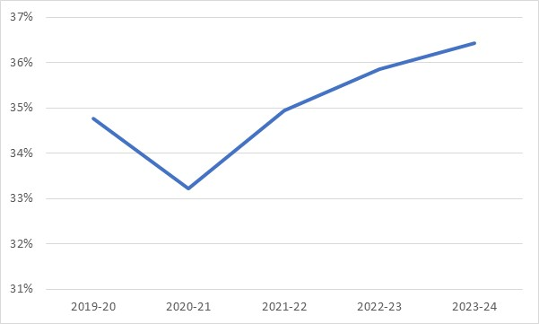
Source: ACT Government (2021, p. 136)
On the other hand, it also appears the ACT Government will remain heavily dependent on the Commonwealth Government through GST tax revenue and Commonwealth Government grants in the forward estimates to fund increases in its revenue and may escape the incentives and discipline imposed by a hard budget constraint. The percentage of increased ACT Government revenue being funded by the Commonwealth Government is outlined in Figure 16 below.
Figure 16: Percentage of Increased ACT Government Revenue Funded by the Commonwealth Government – 2020-21 to 2023-24
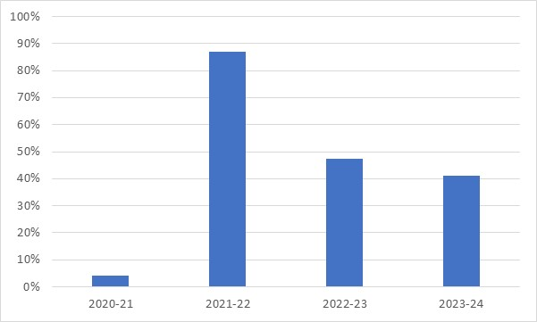
Sources: ACT Government (2021, p. 136).
The situation where the ACT Government is reliant on the Commonwealth Government to fund a significant proportion of its revenue increase contains an element of moral hazard. Moral hazard occurs in any situation in which one person makes the decision about how much risk to take, while someone else bears the cost if things go badly’ (Krugman, 2009, p. 63). Moral hazard infers a disposition on the part of individuals or organisations to engage in riskier behaviour, than they otherwise would, because of a tacit assumption that someone else will bear the costs and consequences if the incurred risk turns out badly (Wolf, 1999, p. 60). The inadequate control of moral hazards often leads to socially excessive risk taking (Dowd, 2009, p. 143).
Pegasus (Davey & Fisher, 2017, p. 17) has previously suggested that the lack of a hard budget constraint on the ACT may explain the relative inefficiency of the ACT Government in relation to the provision of public health and education services. The move towards a hard budget constraint for the ACT Government would provide an incentive to ensure that it pays much greater attention to the cost and relative efficiency of the services that it provides.

4.3 Tax reform
In the 2012-13 Budget, the ACT Government committed itself to rebalancing its tax base through an ongoing process of gradually reducing and eventually eliminating various taxes on conveyances (sometimes referred to as stamp duty on the sale of land for residential and commercial purposes) over a 20-year period and replacing the shortfall through an increase in the general rates system and has already abolished taxes on insurance premiums. In relation to Conveyance Duty the ACT Government (2012, p. 46) commented at the time:
The Government will abolish Conveyance Duty over a 20-year period. Over the next five years, tax rates will be progressively reduced to phase out Conveyance Duty in the longer term.
The reduction in the marginal tax rate will focus on the lower tax brackets. …
The tax brackets and reduced tax rates will be applicable to both residential and commercial sector transactions.
In relation to general rates, the ACT Government (2012, p. 47) commented at the time:
The Government will improve the progressivity of the General Rates system with the introduction of a number of tax brackets and increasing marginal tax rates.
The phasing out of stamp duties and the phasing in of the new general rates system over the course of 20 years will be implemented through a series of four separate stages to avoid a shock to the property market and to enable the change to be revenue neutral (Reardon & Hopkins, 2018, p. 4). Stage 3 of the tax reform will commence from 2021-22 and go until 2025-26 and see average rates increase by 3.75 per cent per annum (ACT Government, 2021, p. 139).
Consistent with the objectives of tax reform, revenue from general rates is expected to increase over future years, as outlined in Figure 17 below.

Figure 17: ACT Government Revenue from Commercial, Residential and Rural General Rates – 2019-20 to 2023-24 ($’000)
Source: ACT Government (2021, p. 137).
The report entitled Australia’s Future Tax System: Report to the Treasurer (Henry, Harmer, Piggott, Ridout, & Smith, 2010a, p. 473), more commonly known as the Henry Tax Review, was of the view that stamp duty on conveyancing discouraged people from changing their housing to better suit their requirements because of the high transaction costs imposed by stamp duty for doing so:
Ideally, there would be no role for any stamp duties, including conveyancing stamp duties, in a modern Australian tax system. Recognising the revenue needs of the States, the removal of stamp duty should be achieved through a switch to more efficient taxes, such as those on broad consumption or land bases. (Henry, Harmer, Piggott, Ridout, & Smith, 2010, p. 263)
One curious feature of the ACT Government’s tax reform is that with an expected buoyant ACT residential property market, residential conveyances will become an increasing tax base for the ACT Government over the years ahead. According to the ACT Government (2021, p. 142), this will reflect higher house prices and higher transaction volumes. This is outlined in Figure 18 below.

Figure 18: ACT Government Revenue from Residential Conveyances - 2019-20 to 2023-24 ($’000)
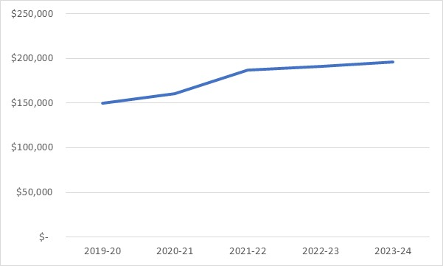
Source: ACT Government (2021, p. 137).
It appears rather incongruous for the ACT Government to be collecting more revenue from both residential conveyances and general rates while it is supposedly more than midway through its tax reform of abolishing residential conveyances altogether. The current ACT Government’s approach to its tax reform risks undermining the main efficiency benefits associated with the policy measure, namely encouraging people to change their housing to better suit their requirements.
The approach foreshadowed by the NSW Government (2020) of charging annual property tax for those who elect not to pay residential stamp duty may be a faster way to achieve the desired tax reform for the ACT Government and would be worth further consideration. Adopted for the ACT’s purposes, such a policy would impose higher residential general rates on those who chose not to pay residential conveyances on a residential property purchase.

4.4 Dividends and Income Tax Equivalents
Total dividends in 2020-21 are expected to be $332.0 million, an increase of $215.6 million from the audited outcome for 2019-20 Budget. Dividends are expected to decrease in 2021-22 to $149.2 million and then to $79.0 million in 2022-23 and then increase to $135.6 million in 2023-24. The large increase in dividends in 2020-21 is largely the result of a bring forward of land sales under the Indicative Land Release Program. Further details of these transactions are provided below.

Table 5: Dividends from ACT Public Trading Enterprises
Empty Cell | 2019-20 | 2020-21 | 2021-22 | 2022-23 | 2023-24
Empty Cell | Est. Outcome | Budget | Estimate | Estimate | Estimate
Empty Cell | $'000 | $'000 | $'000 | $'000 | $'000
Dividends | Empty Cell | Empty Cell | Empty Cell | Empty Cell | Empty Cell
Dividends – Icon Water | 51.278 | 42,390 | 49,957 | 64,170 | 70,650
Dividends – CIT Solutions |  | 500 | 500 | 500 | 500
Dividends – City Renewal Authority and Suburban Land Agency | 65,183 | 289,140 | 98,746 | 14,377 | 64,411
Total Dividends | 116,461 | 332,030 | 149,203 | 79,047 | 135,561
Source: ACT Government (2020, p. 156).
Tax equivalent revenue is forecast in 2020-21 to be $154.7 million, a substantial increase on the forecast of $99.6 million for 2020-21 contained in the 2019-20 ACT Budget. It is noted that the forecasts tapper off significantly across the 2021-22 and 2022-23 years but increase again in 2023-24.
Since the 2019-20 ACT Budget (ACT Government, 2019, p. 250) and the August 2020 Economic and Fiscal Update (EEU) (ACT Government, 2020, p. 126), forecast revenue from dividends and income tax equivalent payments have dramatically increased in the 2020-21 ACT Budget (ACT Government, 2021, p. 156) for 2020-21. This is outlined in Figure 19 below.
Figure 19: Forecast Revenue from Dividends and Income Tax Equivalent Payments from the 2019-20 ACT Budget, August 2020 Economic and Fiscal Update (EEU) and 2020-21 ACT Budget – 2020-21 to 2023-23 ($’000)
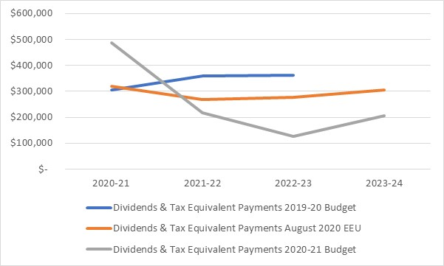Sources: ACT Government (2019, p. 250; 2020, p.126; 2021, p. 156).
The major driver and change in relation to dividends and income tax equivalent payments for 2020-21 has been the surge in dividends from the Suburban Land Agency as well as an increase in tax equivalent payments from this same public authority. This is outlined in Figure 20 below.
Figure 20: Forecast Revenue from Dividends from the Suburban Land Agency* and the City Renewal Authority and Tax Equivalent Payments from the 2019-20 ACT Budget, August 2020 Economic and Fiscal Update (EEU) and 2020-21 ACT Budget – 2020-21 ($’000)
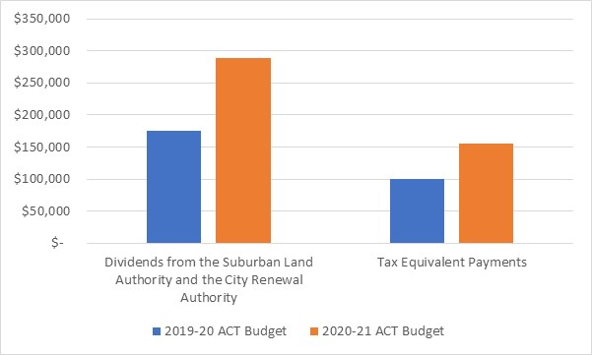
Sources: ACT Government (2019, p. 250; 2021, p. 156).
* It is understood that most of the increase in dividends relate to the Suburban Land Authority (SLA), although the ACT Government has provided a separate figure for the SLA.
The forecast dividend from the Suburban Land Authority in 2020-21 between the 2019-20 ACT Budget (ACT Government, 2019, p. 250) and the August 2020 EEU (ACT Government, 2020, p. 126) was little changed, rising slightly from $142.8 million to $143.8. However, the ACT Government (2020, p. 150) did foreshadow in the August 2020 EEU that if market conditions improved, that it would adjust the forward land release program to reflect that improvement.
The Suburban Land Agency’s dividends and income tax equivalents are now expected to be $438.5 million in 2020-21 (ACT Government, 2021, p. 155). This is largely the result of a significant bring forward of land sales by the Suburban Land Agency (ACT Government, 2021, p. 134). The forecasts also reflect a stronger than expected housing market (ACT Government, 2021, p. 45).
The available evidence suggests that the Canberra residential property remains extremely buoyant, with Canberra residential property prices rising 5 per cent to the end of the September quarter 2020 (Australian Bureau of Statistics, 2020c), and auction clearance rates for Canberra running in excess of 90 per cent, the highest rate amongst capital cities in the country (Harling, 2021).
More generally, there is a case for greater transparency in the presentation and explanation of the flows expected from dividends. In this regard, the ACT Government’s policy in respect to dividends is unclear.

5. Expenditure
Expenses are forecast to grow over the Budget and forward estimates from $6.7 billion in 2020-21 to $7.1 billion in 2023-24. This is relatively modest in terms of historical rates of growth.
Growth in spending is driven mainly by new initiatives, most of which were announced in the August 2020 Economic and Fiscal Update.
The main areas of growth are in general public services, education and health.
New policy decisions will add some $298.7 million in expenses and $447.0 million in capital across the Budget and forward estimates. However, these amounts are partially offset by savings measures and other provisions.

5.1 Overview
The Budget is forecast expenses of $6.7 billion in 2020-21 represent an increase of $232.1 million, or 3.6 per cent, over the audited 2019-20 outcome of $6.5 billion.
Table 6 sets out the forecasts for aggregate expenses for the budget and forward years.
Table 6: Budget and forecast expenses, 2019-20, 2020-21 and 2021-22 to 2023-24
 | 2019-20  Outcome | 2020-21  Budget | 2021-22  Estimate | 2022-23  Estimate | 2023-24  Estimate
 | $m | $m | $m | $m | $m
Expenses | -6,517.6 | -6,749.7 | -6,839.1 | -6,941.8 | -7,148.2
Source: ACT Government (2021, p. 41).
Table 6 shows that expenses are expected to grow over the Budget and forward estimates period to $7.1 billion in 2023-24. This represents growth of 9.7 per cent over the audited 2019-20 outcome, or an average rate of 2.4 per cent per annum growth to 2023-24. This is a relatively modest rate of growth compared with the growth in expenses experienced in recent years.
The main reasons for the change in the forecast level of expenses relative to the last Budget include the effect of changes of new initiatives and, to a much lesser extent, changes in underlying volume and price parameters. New initiatives were partially offset in the Budget year by the effect of parameter changes. Measures announced in the 2019-20 Budget Review and the August 2020 Economic and Fiscal Update added some $400 million to the 2020-21 Budget forecasts.
By contrast, discretionary decisions since the August 2020 Economic and Fiscal Update add around $100 million in net terms to the 2020-21 Budget. New initiatives in the current Budget include:
- Funding to support the public health response to COVID-19
- Various energy transition measures, including the Big Battery
- Extension of John Gorton Drive
- New school construction in Taylor
- Assistance for the higher education and tourism sectors
- Additional funding for housing and homelessness services and a range of Aboriginal and Torres Strait Islander programs.
In gross terms, new policy decisions total $298.7 million in expenses and $447.0 million in capital across the Budget and forward estimates (ACT Government, 2021, p.57). However, these amounts are partially offset by existing provisions and savings.

5.2 Expenses by function
The Budget Papers include a classification of expenses by the functions, or socioeconomic objectives, that general government units aim to achieve through various kinds of outlays. This classification is intended to allow trends in government outlays on particular functions or purposes to be examined over time (International Monetary Fund, p. 75).
In the ACT, General Government Sector expenses are dominated by spending on health, general public services and education. Together, these functions account for around 67 per cent of all government expenses in the 2020-21 Budget.
The major areas of growth in expenses over the Budget and forward estimates relative to the 2019-20 outcome are also in general public services, education and health. This is consistent with traditional patterns of spending in the ACT. Perhaps surprisingly, the Government proposes to reduce spending in dollar terms over the forward estimates on environmental protection and on recreation, culture and religion relative to the 2019-20 outcome.

5.3 Trends in Operating Expenses
Expenses can also be described in terms of the economic type or purpose of the payment.
Expenses in the General Government Sector are dominated by salaries, superannuation and other employee related expenses. Salaries and employee expenses are forecast in the Budget to grow by 2 per cent between 2019-20 and 2020-21 and by 4 per cent between 2019-20 and 2023-24.
Depreciation and amortisation expenses are forecast to grow by $32.4 million, or 7 per cent, in 2020-21 compared to the 2019-20 audited outcome. This mainly reflects the completion of fit-out and commencement of leases for government office blocks and other capital investments.
Interest expenses are forecast to decrease by $4.5 million, or 2 per cent, in 2020-21 from the audited outcome mainly due to lower interest costs on outstanding borrowings. Lower interest rates will ease the pressure on the Government’s fiscal position. However, it should be noted that interest expenses are projected to increase over the Budget and forward years from $214.7 million in the 2019-20 outcome to $275.7 million in 2023-24. This represents an increase of 28.4 per cent. The growth in interest payments is a direct consequence of the move into deficit. In the last year in which the ACT Budget was in surplus, the interest expense was less than $200 million.
Supplies and services are forecast to increase in 2020-21 by $149.4 million or 14 per cent compared to 2019-20. This category of expenses includes supplies, repairs and maintenance and payments for ACT Policing. The increase is largely due to the health response to the COVID-19 pandemic and some re-profiling of initiatives.
Other operating expenses are forecast to fall by $78.0 million, or 22 per cent in the 2020-21 compared with the 2019-20 audited outcome. The decrease is due to the write off of assets in 2019-20 and a lower number of participants entering the Lifetime Care and Support Scheme in 2020-21.
This discussion illustrates the extent to which ACT Budget expenses are “locked in” to the extent that they are made up of payments which are to a large extent not discretionary. Employee related expenses represent a half of total expenses. These costs are difficult to move in the short to medium-term. Depreciation and amortisation expenses represent another 7 per cent of the total Interest and are largely driven by past capital expenditure. Interest payments are a first call for government spending because if a government does not meet these payments as they fall due it will lose the confidence of financial markets. Other categories of expenditure are discretionary in a technical sense but as they are more directly related to the level of services provided to the community, there are practical constraints on the extent to which payments can be reduced in the short to medium term. It would be harmful, and probably counter-productive, for example, to seek to reduce COVID-19 related expenditure until the pandemic has passed. The amount of lock-in limits the scope for governments to influence the level of public expenditure and the broader fiscal position in the short to medium term.

5.4 New initiatives
There are fewer new expense initiatives in the 2020-21 Budget than in recent previous Budgets (around 100, compared with about 165 in 2019-20 and almost 200 in 2018-19). However, a large number of COVID related measures were announced in the August 2020 Economic and Fiscal Update.
The new policy measures are intended to reflect the Government’s strategy of providing immediate responses to COVID and to invest in infrastructure that will support economic growth in the longer-term while at the same time providing improvements in the delivery of programs and services.
Some of the more significant expense related new policy initiatives include:
- A net $10 million in 2021-22 to support the response to the COVID emergency to be implemented through a cost sharing arrangement with the Commonwealth. Additional support in 2020-21 for Canberra Health Services of $60 million was provided in the August 2020 Economic and Fiscal Update.
- A number of measures at a net cost of $2.7 million in 2020-21 to support jobs in the tertiary education and research sectors.
- Expenses of $7.9 million in 2020-21, as a component of $22.4 million over the Budget and forward years, to support the transition to solar power and electric energy.
- Funding of $1.9 million in 2021-22 to support the installation of 50 publicly accessible charging stations for zero emission vehicles.
- Allocation of $15 million in 2020-21 to undertake detailed design work for the construction of large-scale battery storage system capacity across the ACT. Construction is expected to commence in 2022-23.
- Funding of $1.5 million in 2020-21, as part of $4.9 million over the Budget and forward years, to support implementation of the Our Booris, Our Way review.
- A number of measures to support road and transport infrastructure improvements in the ACT.
It should be noted that funding for some of these measures was provided for in the August 2020 Economic and Fiscal Update.

6. Capital Works and Infrastructure
The Budget includes the largest-ever infrastructure and capital works program across the Budget and forward years. The ACT Government will invest $4.3 billion in infrastructure and capital in the ACT over the next four years. $1.7 billion of the proposed program over the four years is in provisions, with detailed estimates not for publication.
The key projects for 2020-21 include investments in health (SPIRE), new schools in Gungahlin, the big battery, road and bridge works in Molonglo, a new CIT campus for Woden, public housing renewal and Light Rail stage 2A. The peak year for infrastructure spending is $1.3 billion in 2021-22), falling to $695 million in 2023-24; however, experience suggests new capital projects are likely to be added to the forward years in future Budgets.

6.1 Overview
The Budget Papers indicate that the ACT Government (2021, p. 177) intends to invest $4.3 billion in infrastructure in the ACT over the next four years to 2023-24.
Table 7 below summarises the capital works and investment program.
Table 7: Summary of investment and capital works program – 2020-21 to 2023-24
 | 2020-21 | 2021-22 | 2022-23 | 2023-24
 | Allocation | Allocation | Allocation | Allocation
 | $’000 | $’000 | $’000 | $’000
New Capital Works | 155,916 | 252,932 | 217,378 | 154,977
Works-in-Progress | 668,614 | 538,800 | 263,587 | 74,614
TOTAL | 824,530 | 791,732 | 480,965 | 229,591
Infrastructure Investment Provisions | 1,278 | 434,953 | 596,052 | 694,850
Better Infrastructure Fund | 87,713 | 60,422 | 63,480 | 65,066
TOTAL INFRASTRUCTURE INVESTMENT INCLUDING PROVISIONS | 913,521 | 1,287,107 | 1,113,487 | 989,507
Source: ACT Government (2021, p. 177).
In 2019 the ACT Government amended the Financial Management Act 1996 to introduce a new mechanism, the Capital Works Reserve, to allow agencies to manage their capital program by advancing funds during the financial year should their capital appropriation be exceeded. Funds drawn from the Reserve will be deducted from the forward estimates for the project(s) concerned in later years. The 2020-21 Budget has allocated $150 million for this Reserve, with a corresponding reduction of $150 million in the 2021-22forward estimates. The Treasurer has to provide the Legislative Assembly with a reconciliation of any amounts approved for payment from the Reserve (under section 26 of the Financial Management Act 1996).

6.2 Capital Works Program
The Capital Works Program forms the largest component of the Infrastructure Investment Program, with funding of $912,243 million in 2020-21 and $1.7 billion over the four years to 2023-24. This includes:
- $155.9 million in 2020-21 and $625.3 million over four years for new capital works
- $668.6 million in 2020-21 and $877.0 million over four years for works-in-progress
- $87.7 million in 2020.21 and $188.9 million over four years for the Better Infrastructure Fund.
In 2019 a new Capital Works Reserve of was established under the Financial Management Act 1996. The reserve permits agencies with multi-year budget allocations for capital works to advance their capital works program during the financial year and draw on the reserve should existing appropriation be exhausted. The ACT Government has indicated it will provide the Assembly with details as part of its quarterly reporting processes. Essentially, the reserve is an appropriation mechanism allowing flexibility for agencies to advance capital projects by bringing forward subsequent funding allocations. At this stage the reserve is only available during the Budget year. The Reserve for the Budget year is $150 million, which is then cleared in 2021-22.
As consistent with our previous recommendation, the Committee may wish to investigate the operation, including processes for reporting usage of the reserve. In particular, given this arrangement is an appropriation mechanism, Pegasus is of the view the Assembly requires a level of control and assurance over the proper use of this mechanism to ensure appropriate accountability and transparency over the use of funds. In this regard, Pegasus strongly suggests it explores with the ACT Government and officials:
- Criteria established to assess claims on the reserve
- Authority to approve such claims
- Assurance over the usage of the appropriation.
In regard to the latter, the Committee may wish to approach the Auditor-General to review the usage of the Reserve.
Unlike previous year budgets, which tended to ratchet up the capital works program forecasts across the budget and the forward years, the 2020-21 Budget forecasts are generally consistent across years. The 2019-20 Budget forecast funding of $3 billion over the then four years. The 2020-21 Budget forecasts a total funding envelope for the capital works program of $4.3 billion. It is noted, however, the funding tappers off across the last two out years. The ratcheting up of the capital works program forecasts in the last five ACT Budgets is outlined in Figure 21 below.

Figure 21: Capital Works Program Forecasts – 2016-17 to 2023-24 ($’000)
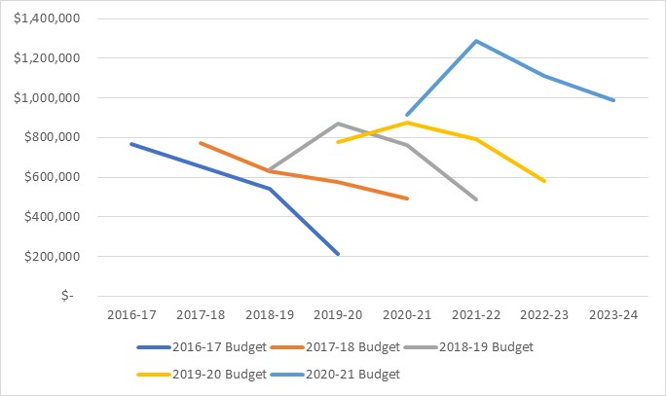
Source: ACT Government (2016, p. 210; 2017, p. 194; 2018a, p. 202, 2019, p. 197, 2021. p. 177).
One consistent pattern in the forward estimates for capital works program forecasts is the eventual decrease in spending across the forward years that is never actually realised. The Committee might wish to inquire of officials how far into the future the planning timeframe for the capital works program extends.
It should be noted, however, the Infrastructure Provisions increase substantially across the four forward years with a total funding envelope of $1.7 billion.

6.3 Public Private Partnerships
The infrastructure program outlined in the Budget includes capital components of the ACT’s major public private partnership, Light Rail Stages 1, 2 and 2A.
The investment associated with these projects is set out in the Table 8 below.
Table 8: Public Private Partnerships – Light Rail Stage 1 and Light Rail Stage 2 and 2A – Capital Expenditure Schedule
Project | 2020-21  Forecast  $’000 | 2021-22  Forecast  $’000 | 2022-23  Forecast  $’000 | 2023-24  Forecast  $’000 | Total  $’000
Light Rail Stage 1 | 12,022 | 1,514 | 0 | 0 | 13,536
Light Rail Stage 2 and 2A | 28,732 | 1,798 | 0 | 0 | 30,530
Total | 40,754 | 3,312 | 0 | 0 | 44,066
Source: ACT Government (2021a, p. 9).
The infrastructure program includes the capital components of the ACT’s major ongoing public private partnership; Light Rail Stages 1,2 and 2A. The Light Rail Stage 1 project is nearing completion with the new Mitchell stop expected to be delivered by June 2021. Consequently, it should be noted that Light Rail Stage 1 has been transferred from General Government to the Public Trading Enterprises sector.
Comments on the accounting treatment of the Territory’s Public Private leasing arrangements are provided in section 9.
It is noted the construction phase of the ACT Law Court Facilities Public Private Partnership is complete with the ongoing operating costs accounted for in the Budget and forward years.

7. Assets and Liabilities
The Territory’s balance sheet is sound but has deteriorated over recent years. This decline has accelerated from 2019-20 due to the COVID-19 pandemic and other factors. Net worth is now in decline in absolute terms and as a proportion of Gross State Product (GSP) while net debt and net financial liabilities are rising. The Territory’s projected defined benefit superannuation liabilities are increasing slightly in nominal terms, but this is more than offset by projected increases in the Superannuation Provision Account. The unfunded superannuation liability is forecast to decline.

7.1 Overview
The Budget Papers indicate a general deterioration in the ACT Government’s assets and liabilities.

7.2 Net Debt
Net debt is a key balance sheet measure in the Government Finance Statistics framework and in the Uniform Presentation Framework agreed by Treasurers in all Australian jurisdictions as the standard for presentation of information in budget papers.
It represents the sum of deposits held, advances received and borrowings less the sum of cash and deposits, advances paid, investments, loans and placements. The measure of net debt employed by the ACT Budget Papers excludes super liabilities.
The Territory’s debt position has deteriorated significantly since 2010-11, when General Government sector cash reserves and investments were some $735.9 million higher than gross debt liabilities (ACT Government, 2018a, p. 399).
The level of net debt rises is forecast to continue to grow over the Budget and forward estimates; more than doubling by 2023-24 relative to the estimated outcome for 2019-20.
The ACT Government acknowledges that the ratio of net debt to GSP is a broad indicator of a jurisdiction’s ability to meet its debt obligations and its medium term financial sustainability (ACT Government, 2021 ,p. 203). Figure 22 illustrates the growth in net debt since 2010-11 as a proportion of the Gross State Product (GSP).

Figure 22: Net debt as a proportion of Gross State Product – 2010-11 to 2023-24 (per cent)
Sources: ABS (2020a), ACT Government (2011, 2012, 2013, 2014, 2015, 2016, 2017, 2018a, 2019, 2021).
Note: From 2019-20, net debt includes the impact of accounting changes in relation to the treatment of leases. The ACT Government has indicated that for this reason net debt from 2019-20 is not directrly comparable to prior years.
Figure 22 shows that the ACT Government’s net debt has grown fairly steadily over the past decade as a proportion of the Territory’s economy.
The large increase in net debt to GSP in 2015-16 was related to the loan provided by the Commonwealth to support the Asbestos Eradication Scheme and a provision for the Light Rail project. The subsequent reduction in net debt reflected the effect of decisions to procure the Light Rail through a PPP, which removed the requirement to debt fund the capital cost of the project (ACT Government, 2015, p. 251; ACT Government, 2016, p. 288).
However, apart from that adjustment, the ratio of net debt to GSP has continued to grow up to 2023-24.
It is possible that changes to the budget treatment of Public Private Partnerships from 2021 foreshadowed in the Budget will add to pressures on the ACT Government’s reported debt position (ACT Government, 2021, pp. 277-278).
The ACT Government will need to raise additional borrowings to fund its expanded levels of debt. The Budget Papers indicate that the ACT Government (2021, p. 199) expects to raise some $7.0 billion in borrowings and loans to fund its activities over the Budget and forward years.
All Australian States and Territories have reported increases in the ratio of net debt to GSP over the Budget and forward years in their 2020-21 Budget Papers (ACT Government, 2021, p. 204). This reflects the expansionary fiscal response to the COVID-19 pandemic pursued across all Australian jurisdictions.
A short-term increase in net debt can be a sensible response to adverse economic shocks. However, high levels of continuing debt are undesirable as they impose debt servicing costs and can reduce future budget flexibility.
Australian interest rates are currently at historical lows. While interest rates remain low, the ACT’s net debt will be manageable. If, however, interest rates were to rise in future years the ACT would be faced with higher public debt interest bills and the Budget would come under significant stress.
The ACT Government’s net debt is only partially a consequence of its response to the COVID-19 pandemic. As Figure 22 shows, the Territory’s net debt as a proportion of GSP has grown steadily over the past decade.
It is of some concern that the Budget Papers do not indicate any long-term strategy for paying down the stock of accumulated debt.

7.3 Net financial liabilities
Net financial liabilities provide a broad measure of the General Government sector’s financial obligations to others.
Net financial liabilities are calculated as total liabilities (including net debt and superannuation liabilities) less financial assets (such as cash reserves and investments), excluding the value of equity held by the General Government sector in public corporations. Changes in net financial liabilities are therefore influenced by variations in the net debt figures discussed in the previous section.
The Territory’s net financial liabilities have grown substantially since the 2019-20 Budget and continue to deteriorate into the out-years. Net financial liabilities are estimated to be some $1.5 billion higher in 2020-21 than forecast in the 2019-20 Budget and $2.5 billion (or 31 per cent) higher for 2021-22 and $3.7 billion (or 47 per cent) higher for 2022-23 forecast in the 2019-20 Budget.
While the Budget Papers do not explain the increases in forecast growth in the ratio of net financial liabilities to GSP over the Budget and forward years in any detail, the growth appears to have been driven by increases in net debt discussed in the previous section and lease liabilities associated with the Light Rail and ACT Law Courts Facilities.
The ratio of net financial liabilities to GSP provides an indicator of the sustainability of a jurisdiction’s debt (ACT Government, 2015, p. 252). The ACT Government has indicated that it is desirable that the ratio of net financial liabilities to GSP should remain broadly stable over time while maintaining sustainable levels of borrowings (ACT Government, 2015, p. 252; ACT Government 2019, p.295).
Figure 23 below illustrates the growth in net financial liabilities since 2010-11 as a proportion of GSP.

Figure 23: Net financial liabilities as a proportion of Gross State Product – 2010-11 to 2023-24 (per cent)

Sources: ABS (2020a), ACT Government (2011, 2012, 2013, 2014, 2015, 2016, 2017, 2018a, 2019, 2021).
Figure 23 shows that while there has been some fluctuation in the ratio of net financial liabilities to GSP over time, the ratio has risen fairly steadily since 2010-11.
A spike in 2015-16 was related to a higher forecast superannuation liability and capital provisions to account for some capital projects that were subsequently procured through a PPP (ACT Government, 2016, p. 289). A second spike in 2019-20 largely reflected growth in the superannuation liability, higher borrowings and the effect of operating leases coming onto the balance sheet as a result of changes in accounting standards (ACT Government, 2019, p.295).
Continued growth in the ratio of net financial liabilities to GSP is not desirable in terms of the sustainability of the ACT Government’s debt. The ACT Government has in the past argued that its borrowings should be looked at in the context of a growing economy and budget, rather than as absolute figures in isolation (ACT Government, 2019, p.295). Figure 23 shows that the Territory’s financial liabilities are now growing slightly faster than the Territory’s capacity to support them. This can be maintained while interest rates are low and there is some confidence of future growth in the economy but, at some point, the ACT Government will need to develop strategies to achieve its previously articulated principle that the ratio of net financial liabilities to GSP should be broadly stable over time.

7.4 Net worth
Net worth is an economic measure of wealth that reflects the value of all financial and non-financial assets (such as land, plant and equipment) less liabilities, including superannuation liabilities.
This indicator is often regarded as the best measure of the sustainability and inter-generational equity of a jurisdiction’s fiscal position (e.g. Rowles, 1992; AARF, 1995; JCPA, 1995a; Mellor, 1996, cited in Robinson, 1996).

The ACT Government’s net worth is positive but the forecast figure for net worth for 2020-21 is 5.3 per cent lower than forecast in the 2019-20 Budget and net worth is forecast to decrease in absolute terms across the forward estimates.
Figure 24 illustrates the change in net worth as a proportion of GSP since 2010-11.
Figure 24: Net worth as a proportion of Gross State Product – 2010-11 to 2023-24 (per cent)
Sources: ABS (2020a), ACT Government (2011, 2012, 2013, 2014, 2015, 2016, 2017, 2018a, 2019, 2021).
Figure 24 shows a fairly consistent long-term decline in the ACT Government’s net worth expressed as a proportion of GSP. The ACT Government’s net worth has fallen from around 60 per cent of GSP in 2010-11 to just over 31 per cent in 2019-20 and is forecast to fall to 30 per cent by 2023-24. In nominal terms, net worth in 2023-24 is forecast to be lower than it was in 2010-11.
While the Territory maintains a positive net worth, this measure has been on a long-term decline since 2010-11 and in the absence of corrective measures to improve the value of the ACT Government’s assets or reduce liabilities, the ratio might be expected to continue to fall.

7.5 Superannuation
The ACT continues to carry a significant liability associated with the superannuation entitlements of past and present employees who are members of the Commonwealth defined benefit superannuation schemes, the Commonwealth Superannuation Scheme (CSS) and the Public Sector Superannuation Scheme (PSS).
Approximately 6,600 current full-time employees are members of these schemes. In addition, the ACT Government has liabilities in the two schemes in relation to a further 28,800 former ACT Government employees. Both the CSS and PSS schemes are closed to new members. Since 1 July 2005, new employees have had access to defined contribution scheme arrangements under which the ACT Government makes fortnightly payments to each employee’s designated superannuation fund (ACT Government, 2019, p 298).
Table 9 below sets out the most recent estimation of the Territory’s superannuation liability.
Table 9: Defined Benefit Superannuation Liability
 | 2019-20  Actual  $’000 | 2020-21  Budget  $’000 | 2021-22  Estimate  $’000 | 2022-23  Estimate  $’000 | 2023-24  Estimate  $’000
Opening liability | 11,771,324 | 12,053,516 | 8,281,129 | 8,506,561 | 8,716,078
Service cost | 278,234 | 268,995 | 142,657 | 136,386 | 130,505
Interest cost | 228,635 | 210,537 | 413,132 | 423,600 | 433,282
Benefit payments | -282,062 | -308,993 | -330,357 | -350,469 | -371,001
Actuarial (Gain)/Loss¹ | 57,385 | -3,942,926 | - | - | -
Closing liability | 12,053,516 | 8,281,129 | 8,506,561 | 8,716,078 | 8,908,864
Source: ACT Government (2021, p. 194).
Table 9 shows that the Territory’s defined benefit superannuation liability is estimated to grow to approximately $8.9 billion by 30 June 2024. The current estimates of the superannuation liability are virtually unchanged from those forecast last year.
The service cost associated with the accrual of employee superannuation benefits is forecast to decrease over time as ACT employee members leave the schemes through resignation or retirement. However, the interest cost (due to the unwinding of the discount rate as past benefits accrued by ACT employee members come closer to payment) is forecast to increase reflecting the increase in the estimated liability.
These calculations depend critically on the discount rate used to calculate the present value of superannuation payments in future years and other assumptions regarding future salary growth, pension indexation, crediting rates and exit rates from the scheme. These assumptions are reviewed on a triennial basis by the actuaries advising the Commonwealth Government, with the next full actuarial review reporting on the liability as at 30 June 2020 due to be published later this year.
The minimal changes in the estimated liability and service cost reflect the fact that the updates between the triennial reviews only take account of changes in the membership data, which, for closed schemes, tend to have a minor impact.
The large reduction between the opening and closing liability in the estimated 2020-21 outcome is due to the reversion to the long-term discount rate in the calculation of the estimated superannuation liability at the end of the financial year.
The ACT Government has chosen to contribute funds to a Superannuation Provision Account with the objective of extinguishing the Territory’s unfunded defined benefit superannuation liability by 2030. The unfunded superannuation liability, representing the difference between the superannuation liability and investment assets, is shown in Table 10 below.
Table 10: Defined Benefit Superannuation Liability Funding
 | 2019-20  Actual  $’000 | 2020-21  Budget  $’000 | 2021-22  Estimate  $’000 | 2022-23  Estimate  $’000 | 2023-24  Estimate  $’000
Superannuation Liability¹ | 12,053,516 | 8,281,129 | 8,506,561 | 8,716,078 | 8,908,864
Investments | 4,322,383 | 4,841,155 | 5,161,633 | 5,503,663 | 5,868,696
Unfunded Liability | 7,731,133 | 3,439,974 | 3,344,928 | 3,212,415 | 3,040,168
Funding Percentage | 36% | 58% | 61% | 63% | 66%
Source: (ACT Government, 2021, p. 196). The estimated liability is as at 30 June of the financial year and is calculated using the long term discount rate of 5 per cent per annum for 2020-21 and future years. The actual liability as at 30 June 2020 has been calculated using a discount rate of 1.7 per cent per annum.
The low funding percentage for 2019-20 is a function of the valuation interest rate used. On a constant interest rate basis, the unfunded superannuation liability has been declining in absolute terms for some years and is expected to continue to decline over the forward estimates period. This information is illustrated in Figure 25.
Figure 25: Defined Benefit Superannuation Unfunded Liability and Investment Assets
Source: (ACT Government, 2021, p. 209 for the estimate of the total defined benefit liability as at 30 June 2020 on the long term discount rate, p. 196 for all other estimates).
The actual return on investments in the Superannuation Provision Account for 2019-20 was considerably lower than anticipated in the 2019-20 ACT Budget. The 2020-21 Budget is very optimistic about investment returns for the budget year, assuming a nominal return of 12 per cent for the year. As a result, by 30 June 2021 assets are projected to exceed the estimates included in the 2019-20 Budget. A nominal investment return of 6.75 per cent per annum is assumed for the outyears. This is described as CPI plus 4.75 per cent.
The investment return assumption is above the midpoint of the range mandated for the Commonwealth Government’s Future Fund. Given the risks to the Australian and global economy, there must be some question as to whether this target can be met in the short to medium term. Without a significant increase in investment returns or additional contributions, the ACT Government seems unlikely to achieve its goal of full funding of the superannuation liability by 2030.
Despite these reservations, there is no indication that the ACT Government will have any difficulties in meeting its unfunded superannuation obligations, which will emerge as a requirement to meet benefit payments over a period of more than 50 years. The projections of benefit payments are virtually unchanged from the 2019-20 Budget.

8. Risks
There are a number of risks and uncertainties attached to the Budget estimates. These include economic and fiscal risks. The Budget is based on assumptions about the future level of Commonwealth spending in the ACT and about the level of Commonwealth Government grants to the ACT that have some attached risk. The speed and strength of the recovery from the COVID pandemic will have a significant bearing on the fiscal outlook. Previous sections have also pointed to the sensitivity of the Budget aggregates to technical assumptions including those related to the rate used to measure the present value of superannuation payments in future years.

8.1 Overview
The Budget Papers provide a statement of the risks attached to the outlook over the Budget and out years in Appendix I (ACT Government, 2021, pp. 291-296).
However, the Budget Papers do not generally quantify the sensitivity of the Budget aggregates on a number of important risk factors.

8.2 Risks to the economic outlook
Not surprisingly, the Budget Papers focus on the risks to the ACT economic outlook posed by the continuing impact associated with the COVID-19 pandemic (ACT Government, 2021, p. 291). The Budget Papers highlight that ongoing uncertainty could see households retain high levels of saving, in turn exerting downward pressure on consumption growth, with adverse flow-on effects for business investment and the ACT economy in general.
The ACT Government notes that any reimposition of restrictions in response to further outbreaks or delays in the rollout of vaccines globally and in Australia would present a downside risk to the baseline revenue estimates. The Government estimates that downside risks could potentially reduce the Territory’s baseline revenue estimates from payroll and land taxes, residential conveyance duty and motor vehicle registrations by up to $220 million over the budget and forward estimates period compared to the baseline scenario (ACT Government, 2021, p. 292).
The Budget Papers also highlight two risks posed to the ACT economy by the Commonwealth Government, namely:
- the decentralisation agenda, whereby all Commonwealth Government departments and agencies have undertaken a thorough assessment of their functions to identify opportunities to locate appropriate functions and staff closer to communities and relieve the pressure on capital cities (Commonwealth of Australia, 2019, p. 11).
- maintaining the Efficiency Dividend for most Commonwealth Government entities at the 2018-19 level of 2.0 per cent for a further two years before stepping down to 1.5 per cent in 2021-22 and returning to the base rate of 1.0 per cent from 1 July 2022 (Commonwealth of Australia, 2019a, p. 50).
Another risk to the economic outlook that it not remarked upon in the statement of risks is the risk of a downturn in the housing market (including residential construction), although some of the triggers for a downturn are acknowledged in the Budget papers such as the end of the Commonwealth Government’s HomeBuilder Program and low ACT population growth (ACT Government, 2021, p. 31). A downturn in the residential housing market also has implications for ACT Government revenue from lower residential conveyances, lower residential general rates, lower dividends from the Suburban Land Authority and lower levels of contributed assets.

8.3 Fiscal risks
The major fiscal risk to the ACT is Commonwealth funding. In addition to the economic risks discussed in the previous section, there are risks in relation to specific purpose payments and national partnership agreement payments.
Over the short to medium term, the fiscal outlook will be heavily dependent on the progress of the COVID pandemic and the speed and strength of any post COVID recovery.
The reimposition of restrictions in response to further COVID-19 outbreaks or delays in the rollout of vaccines globally pose a risk to the baseline revenue estimates (ACT Government, 2021, p. 292). These downside risks could potentially reduce the ACT Budget revenue from payroll and land taxes, residential conveyance duty and motor vehicle registrations by up to $220 million over the budget and forward years.
Population growth is a major driver of the ACT economy. The impact on the current outlook of the reduced population movements into the ACT has been offset to some extent by a compensatory reduction in movements of the ACT to other States and overseas. It is unclear at this stage what migration patterns might emerge post COVID. The attractiveness of the ACT as a destination for foreign students will depend on a range of factors. On a worst-case scenario, domestic movements of ACT residents could resume in advance of any significant in-flow of international students.
The current fiscal outlook is heavily dependent on a significant bring-forward of land releases. The Budget estimate for dividends and tax equivalent payments from the Suburban Land Agency and City Renewal Authority are forecast to increase from $99 million in 2019-20 to $438 million in 2020-21. In addition, there is a doubling in the estimate of gains from contributed assets in 2021-22 over the 2020-21 Budget associated with the expectation of increased land sales in 2020-21 (ACT Government, 2021, p.157). Revenue from contributed assets reflects the transfer of infrastructure assets such as roads and sewerage associated with land development.
Any significant downturn in the housing market, associated with lower than expected population movements or general economic uncertainty, would have an impact on the demand for new land releases and the revenue flows estimated by the ACT Government over the Budget and forward years.
Uncertainties around the investment climate in coming years would have a material impact on the budget aggregates. The Budget papers show that a 0.25 per cent increase in borrowing rates would add some $18 million to the cost of the Government’s borrowings in 2023-24, though there would also be an off-setting benefit in terms of returns on the ACT Government’s deposits. A 1 per cent decrease in investment returns would reduce earnings in the Superannuation Provision Account by $48 million in 2012-22 and $61 million in 2023-24.

9. Budget accounting, classification and valuation issues
Valuation effects, accounting treatments and timing issues continue to have large impacts on the budget aggregates and on the reported budget balance.

9.1 Overview
The 2020-21 Budget reflects decisions on a number of accounting, classification and valuation issues.
The following sections provide comment on the budget accounting and classification issues that have material impacts on the Budget aggregates and how they are presented.

9.2 Disclosure of Key Accounting Policies
The Budget financial statements, including the budget deficit, and associated tables, are presented in Chapter 4 of the principal Budget Paper (ACT Government, 2021). Section 4.1 relates to the General Government Sector (GGS) and Appendix D includes the financial statements for the ACT’s Public Trading Enterprises. The GGS statements are titled “GFS/GAAP HARMONISED FINANCIAL STATEMENTS” suggesting that Australian Accounting Standards Board (2012) accounting standard AASB 1049 Whole of Government and General Government Sector Financial Reporting has been adopted as the key basis for the preparation of the statements. The presentation format of the statements suggests this is the case. AASB 1049, which forms the basis for the Australian Heads of Treasuries Uniform Presentation Framework, requires compliance with all other applicable accounting standards in the preparation of the statements.
Unlike several other Australian jurisdictions, including the Commonwealth, the basis of accounting and the key accounting policies and assumptions adopted in preparing the statements, except in respect to Public Private Partnerships and Concessional Loans, Appendix G, have not been disclosed. In addition, and whilst key revenue streams and key expenses are detailed at sub-section 3.1, there is no disclosure of key assets such as investments and loans, investments in other public sector entities, and produced and non-produced property plant and equipment, nor key liabilities such as advances received, borrowings, superannuation and employee benefits.
Although some of these items, such as liabilities associated with Public Private Partnership arrangements, are described elsewhere in the Budget Papers, typically the financial statements would be accompanied by a series of notes, describing the accounting policies and assumptions adopted and providing a breakdown of key financial statement items. By way of comparison, some other jurisdictions include a statement of the basis of accounting adopted, significant accounting policies and forecast assumptions and include disclosure of the likely impact of new or amended accounting standards applicable in the future.
Such an approach enhances accountability and transparency for the user/s of the statements.
The Committee may wish to explore with officials a number of issues in relation to the non-disclosure of key accounting policies and assumptions and key balance sheet items. These include:
- Was AASB 1049 adopted as the basis of accounting and presentation in preparing the budget financial statements?
- Why, unlike other Australian jurisdictions, are the bases of accounting, key accounting policies and a disaggregation of key assets and liabilities not disclosed in notes accompanying the financial statement?

9.3 Superannuation return adjustment
As has been the case since 2006-07, the presentation of the headline net operating balance for 2019-20 includes an adjustment for long-term expected superannuation investment earnings.
The Government has argued in the past that a superannuation return adjustment is necessary because, although the Government Finance Statistics (GFS) reporting framework requires the inclusion of superannuation interest costs and other superannuation expenses in the operating balance, it only allows for interest income and dividends to be included as a transactional revenue item in the net operating balance, ignoring the capital growth on the assets in the Superannuation Provision Account (ACT Government, 2016, p. 42).
There is an argument for allowing an offset to the reported interest cost to recognise the fact that the Government is holding assets in the Superannuation Provision Account to meet superannuation liabilities. The combination of an unfunded liability partially offset by assets in the Account can be considered analogous to a partially funded superannuation scheme. In reporting the interest costs for a partially funded superannuation scheme, the assets of the scheme would be netted off the gross liability and the interest cost would arise only on the unfunded component of the liability. This effectively allows for fund assets to earn a rate of return equal to the discount rate. In the context of the ACT arrangements, the assets in the Account do not directly reduce the unfunded superannuation liability and the ACT Government must report the interest cost on the total unfunded liability, without any recognition of the assets that are held against this liability. In calculating the superannuation return adjustment, however, the ACT Government uses a projected total investment return that is greater than the discount rate used to value the liability. This has the effect of improving the Headline Net Operating Balance beyond the position that would be reported for a partially funded superannuation scheme with the same level of funding. In the Budget year, the use of the projected long-term investment return rather than the valuation discount rate reduces the headline net operating balance by around $75 million.
The ACT Government’s response to the Pegasus report on the 2019-20 ACT Budget described the process used to calculate the superannuation return adjustment in more detail (ACT Government, 2019a, pp. 14-16). This has allowed the figures to be replicated. However, some issues of concern remain.
The CPI assumption used for the purpose of calculating the nominal investment return is 2 per cent per annum (the inflation assumption adopted in the most recent triennial valuation of the liabilities) and differs from the rates set out in Table 1.2.1. It would be helpful to explain the rationale for the adoption of the 2 per cent assumption and provide an assurance that the estimates of investment income included in Budget Statements B for CMTEDD (ACT Government, 2021, p. 303) have been calculated on the same basis.
The Budget Papers note that over the past 24 years (1996-97 to 2019-20), the Superannuation Provision Account portfolio has generated a real investment return (above the CPI) of 5.2 per cent per annum (ACT Government, 2021, p. 197). However, this has been a period of historically high investment returns. The current return objective of CPI plus 4.75 percentage is slightly higher than the mid-point of the current Future Fund mandate. The benchmark return for the Future Fund is a long-term average return of at least the Consumer Price Index (CPI) plus 4 to 5 percentage points per annum (Commonwealth of Australia, 2017a). Given the economic uncertainties outlined earlier, a more conservative approach by the ACT Government would appear to be warranted.
While the superannuation return adjustment is calculated assuming a constant total investment return on the Account over the Budget and forward year, the return assumption adopted in projecting the assets of the Account over the Budget year is 12.1 per cent of the opening balance (ACT Government, 2021, p. 198). Higher than average returns might be expected following the downturn associated with COVID. However, there are questions about the plausibility of a 2021 forecast that is some $80 million more than the pre-COVID 2019-20 Budget forecast. The higher the estimated balance in the Account, the greater the superannuation return adjustment in future years and the greater the benefit for the headline fiscal balance.
The Committee should note that the return assumption in this adjustment has the potential to materially shift the budget aggregates and that variations in investment returns from the Territory’s Superannuation Provision Account can by themselves be significant enough to swing the balance from surplus to deficit.

9.4 Superannuation liability valuation and service costs
The discount rate used to calculate the present value of the Territory’s superannuation liability has a significant impact on the estimated value of the superannuation liability and related superannuation expenses.
It is also important to note that the Budget forecasts for the superannuation liability and associated expenses are calculated using a different discount rate from that used in reporting for the Territory’s financial statements. The Budget forecasts use a long-term discount rate while for financial reporting the prevailing Government bond rate is used.
The long-term discount rate utilised in the 2019-20 Budget of 5 per cent per annum has been retained for the 2020-21 Budget. This rate is consistent with the long-term discount rate used by the Commonwealth Government to estimate the liability valuation for its own defined benefit employer superannuation liabilities (ACT Government, 2021, p. 196).
Reporting at the end of the financial year in the financial statements is required under the Australian Accounting Standards (AASB 119) to be prepared on the basis of the yield on a suitable Commonwealth Government bond. The liability valuation at 30 June 2020 utilised a discount rate assumption of 1.73 per cent (ACT Government, 2021, p. 196).
Commonwealth Government bond rates remain close to zero with no indication that there will be any substantial increase in the short term. It would, therefore, be expected that the reported superannuation liability as at 30 June 2021 will, as in 2020, be considerably higher than the figure forecast in the Budget Papers.
Table J.6 in the Appendices to the Budget Outlook indicates that a 1 per cent decrease in the discount rate from the long-term budget assumption of 5 per cent would increase the estimated liability by almost $1.5 billion (ACT Government, 2021, p. 301).
Table 11: Impact of a 1 percentage point decrease in the discount rate on superannuation liability
 | 2020-21 | 2021-22 | 2022-23 | 2023-24
 | $’000 | $’000 | $’000 | $’000
Superannuation Liability | 1,457,200 | 1,472,414 | 1,483,438 | 1,490,352
Source: ACT Government (2021, p. 303)
The lower discount rate will also have an impact on the service cost, which would be expected to be somewhat higher, with an offsetting reduction in the interest cost. Based on the figures reported in the Budget Outlook (ACT Government, 2021, p. 303), the net effect of these adjustments to the service and interest costs is a small increase in the superannuation expense as shown in Table 12 below. This contrasts with the 2019-20 Budget where the net effect was a small decrease in the superannuation expense. It is not clear why the impact has reversed. However, the changes in the superannuation expense are not material in the context of the overall liability.
Table 12: Impact of a 1 percentage point decrease in the discount rate on superannuation expense
 | 2020-21 | 2021-22 | 2022-23 | 2023-24
 | $’000 | $’000 | $’000 | $’000
Superannuation Expense | 19,634 | 15,473 | 11,511 | 7,686
Source: (ACT Government, 2021, p. 303)
The application of a higher discount rate to the Budget estimate of the Territory’s superannuation liabilities will generally have the effect of decreasing the estimate of the superannuation liability and service costs. There is thus a trade-off between achieving consistency between Budget and forward year figures and the need for a subsequent revision of the estimates when the final outcome for the year is known.
Further discussion of the impact of the changes in the superannuation liability are provided in section 7.5 on superannuation liabilities and section 3.3 on balance sheet measures of the fiscal position.

9.5 Public Private Partnerships
The ACT Government (2021, pp. 277-278) is currently engaged in two Public Private Partnerships (PPP) projects: the ACT Law Courts Facilities, and Light Rail Stage 1.
The Committee would be aware that the ACT Government has adopted an accounting policy for these projects that results in their being accounted for as leases on a risk and rewards approach (ACT Government, 2019, p. 349). The treatment of these projects as leases impacts on the way they are described in the Budget.
The value of the leased assets, and the corresponding lease liabilities, are recognised in the balance sheet at the commencement of the lease term, which will be when the assets are ready for the provision of services. The ACT Government’s initial direct costs are capitalised when incurred and will be added to the final lease assets at the commencement of the lease term.
It is noted that Light Rail-Stage 1 commenced services on 20 April 2019 and that lease assets, liabilities, maintenance costs and service payments have been accounted for in the Budget financial statements for the Budget and forward years.
At the end of the construction contracts, the infrastructure will become ACT assets. This is taken to mean that once the projects are operational, the infrastructure is owned by the Territory. It is noted that Light Rail – Stage 1 is operational.
Appendix G also indicates that similar to other Australian jurisdictions, a United Kingdom accounting standard and application note has been adopted (ACT Government, 2021, p. 277). This particular standard treats such arrangements as leases. Appendix G acknowledges the existence of Australia’s new leases accounting standard, AASB 16 Leases, indicating the existing treatment complies with the new leases accounting arrangements (ACT Government, 2021, p. 277).
In 2011 the International Public Sector Accounting Standards Board (IPSASB) (2011) issued IPSAS 32 – Service Concession Arrangements: Grantor. This standard established the accounting for PPP arrangements from the grantor’s (government’s) perspective. In terms of the hierarchy of accounting policies, this standard is relevant.
In July 2017 the Australian Accounting Standards Board (AASB) (2017) issued AASB 1059 Service Concession Arrangements: Grantor. AASB 1059 is based on IPSASB 32. In October 2018 the AASB (2018) issued an amendment standard that deferred the commencement of AASB 1059 from 1 January 2019 to 1 January 2020. Specifically, AASB 1059 applies to reporting years commencing on or after this new date. This change is reflected at Appendix G, indicating that AASB 1059 will be implemented in the preparation of the 2021-22 Budget.
AASB 1059 has not been applied to the Budget and forward years, despite being applicable. The Committee should note that other jurisdictions with major PPP arrangements, particularly NSW and Victoria, adopted AASB 1059 in the preparation of their respective 2020-21 budgets. NSW, whilst not adopting AASB 1059 in the 2020-21 budget year, did adopt the standard in each of the forward years. Victoria became the first state to fully adopt AASB 1059 from 1 July 2019 and has now applied it on a full retrospective basis as outlined by the Victorian Auditor-General (2020, p. 25).
The statement in Appendix G that the ACT Government’s approach is consistent with other jurisdictions is, therefore, not correct.
AASB 1059 does not treat PPP arrangements as leases, but instead, requires the assets and liabilities to be recognised in the balance sheet and valued at current replacement cost, when the government gains control of these assets and liabilities, generally taken to be when the project becomes operational. Any intangible assets such as intellectual property rights, must be included in the aggregate of project assets.
The critical issue is which accounting treatment, leases, AASB 1059 or an approach similar to AASB 1059, appropriately reflects the substance of the transaction.
In terms of the accounting policy hierarchy in choosing the most appropriate accounting treatments, and as AASB 1049 appears to have been adopted which, as indicated above, requires the application of all other accounting standards, it would in our view have been appropriate to adopt AASB 1059. This approach more faithfully reflects the substance of the transactions. This is particularly so in respect to the Light Rail Stage 1 project, given that the project became operational on 20 April 2019. That is, the Light Rail Stage 1 project assets, liabilities and cash flows were controlled by the ACT Government from that date.
Had AASB 1059 been adopted, the impact on the budget balances is uncertain.
The Committee may wish to explore with officials a number of issues in relation to the accounting treatment in the Budget for Public Private Partnerships. These include:
- Why has AASB 1059 Service Concession Arrangements: Grantors not been adopted for the Light Rail Stage 1 and the Law Courts PPP projects, particularly given it was adopted by NSW in its budget forward years and fully by Victoria?
- Why has AASB 1059 not been adopted in respect to the Budget forward years?
- Why has IPSASB 32 not been adopted?
- What would be the impact on the Budget balances had AASB 1059 been adopted?
The Committee should note these are complex issues and Pegasus is available should clarification in private, be required.

9.6 Concessional Loans
Concessional loans are arrangements where a lender, typically a government, provides a loan facility on terms and conditions more favorable than the prevailing market. Concessions can include lower or zero interest rates, interest free periods, and/or an extended maturity term. Appendix G indicates the ACT Government (2021, p. 280) is providing concessional loans pursuant to its Sustainable Household Scheme.
The accounting treatment outlined accords with the applicable accounting standard AASB 9 Financial Instruments.

Bibliography
ACT Government. (2012). Australian Capital Territory Budget 2012-13 Budget Paper No. 3: Budget Overview. Canberra.
ACT Government. (2013). Australian Capital Territory Budget 2013‐14 Budget Paper No. 3. Canberra.
ACT Government. (2014). Australian Capital Territory Budget 2014-15 Budget Paper No. 3. Canberra.
ACT Government. (2015). Australian Capital Territory Budget 2015-16 - Budget Paper No. 3 Budget Outlook. Canberra.
ACT Government. (2016). Australian Capital Territory Budget 2016-17 for Canberra - Budget Paper 3: Budget Outlook. Canberra.
ACT Government. (2018). Australian Capital Territory Budget 2017-18 Budget Review. Canberra.
ACT Government. (2018a). Australian Capital Territory Budget 2018-19 - Budget Paper 3: Budget Outlook. Canberra.
ACT Government. (2019). Australian Capital Territory Budget 2019-20 Building for the Future - Budget Paper 3: Budget Outlook. Canberra.
ACT Government. (2019a). Government Response to the Pegasus Economics report Review of the ACT Budget 2019-20. Canberra.
ACT Government. (2020). August 2020 Economic and Fiscal Update. Canberra.
ACT Government. (2021). Australian Capital Territory Budget 2020-21: Driving Canberra's Recovery - Budget Outlook. Canberra.
ACT Government. (2021a). Australian Capital Territory Budget 2020-21: Driving Canberra's Recovery - Budget Statement I Major Projects Canberra. Canberra.
Australian Accounting Research Foundation (AARF). (1995). Financial Reporting by Government, Exposure Draft 62. Melbourne.
Australian Accounting Standards Board. (2010). AASB 9 - Financial Instruments. Melbourne.
Australian Accounting Standards Board. (2012). AASB 1049 - Whole of Government and General Government Sector Financial Reporting. Melbourne.
Australian Accounting Standards Board. (2016). AASB 16 - Leases. Melbourne.
Australian Accounting Standards Board. (2017). AASB 1059 Service Concession Arrangements: Grantor. Melbourne.
Australian Accounting Standards Board. (2018). AASB 2018-5 Amendments to Australian Accounting Standards – Deferral of AASB 1059. Melbourne.
Australian Bureau of Statistics. (2020). Australian National Accounts: National Income, Expenditure and Product, September 2020. Canberra.
Australian Bureau of Statistics. (2020a). Australian National Accounts: State Accounts, 2019-2020. Canberra.
Australian Bureau of Statistics. (2020b). National, State and Territory Population June 2020. Canberra.
Australian Bureau of Statistics. (2020c). Residential Property Price Indexes: Eight Capital Cities September 2020. Canberra.
Australian Bureau of Statistics. (2020d). Wage Price Index, Australia, September 2020. Canberra.
Australian Bureau of Statistics. (2021). Consumer Price Index, Australia, December 2020 - ABS Cat no. 6401.0. Canberra.
Australian Bureau of Statistics. (2021a). Labour Force, Australia, December 2020. Canberra.
Australian Bureau of Statistics. (2021b). Retail Trade, Australia - December 2020. Canberra.
Australian Public Service Commission. (2018). Remuneration - the Government's wages policy explained. Retrieved from Australian Public Service Commission: https://www.apsc.gov.au/remuneration-governments-wages-policy-explained
Bahl, R., & Bird, R. (2008). Subnational Taxes in Developing Countries: The Way Forward. Public Budgeting & Finance, 28(4), 1-25.
Bird, R., & Smart, M. (2010). Assigning State Taxes in a Federal Country. In M. Institute, Australia's Future Tax and Transfer Policy Conference : proceedings of a conference (pp. 72-94). Canberra: Commonwealth of Australia.
Blanchard, O., Charouaqui, J., Hagemann, R. P., & Sartor, N. (1990). The Sustainability of Fiscal Policy: New Answers to an Old Question. OECD Economic Studies(15 Autumn).
Centre for Population. (2020). Population Statement. Canberra: Commonwealth of Australia.
Commonwealth of Australia. (2017a). Retrieved from Future Fund Investment Mandate Direction 2017: https://www.legislation.gov.au/Details/F2017L00597
Commonwealth of Australia. (2018a). Regional Australia – A Stronger Economy Delivering Stronger Regions 2018-19. Canberra: Department of Infrastructure, Regional Development and Cities.
Commonwealth of Australia. (2019). Building Stronger Regional Communities. Canberra.
Commonwealth of Australia. (2019a). Mid-Year Economic and Fiscal Outlook 2019-20. Canberra.
Commonwealth of Australia. (2020). Mid-Year Economic and Fiscal Outlook 2020-21 - December 2020. Canberra.
CoreLogic. (2019). Housing downturn losing steam as the pace of declining home values continues to reduce in May. National Media Release.
Davey, A., & Fisher, R. (2017). Review of the ACT Budget 2017-18. Canberra.
Davey, A., Kaufmann, B., Bartos, S., & Antcliff, S. (2019). Review of the ACT Budget 2019-20. Canberra: Pegasus Economics.
Dowd, K. (2009). Moral Hazard and the Financial Crisis. Cato Journal, 29, 141-166.
Harling, J. (2021, February 8). Preliminary clearance rate improves as volumes rise across the combined capitals. Retrieved from CoreLogic: https://www.corelogic.com.au/news/preliminary-clearance-rate-improves-volumes-rise-across-combined-capitals
Henry, K., Harmer, J., Piggott, J., Ridout, H., & Smith, G. (2010). Australia's Future Tax System: Report to the Treasurer, Detailed Analysis Volume 1. Canberra: Commonwealth of Australia.
Henry, K., Harmer, J., Piggott, J., Ridout, H., & Smith, G. (2010a). Australia's Future Tax System: Report to the Treasurer, Detailed Analysis Volume 2. Canberra: Commonwealth of Australia.
International Monetary Fund. (n.d.). Government Finance Manual.
International Public Sector Accounting Standards Board. (2011). IPSAS 32 - Service Concession Arrangements: Grantor. London.
Joint Committee of Public Accounts (JCPA). (1995). Accrual Accounting-a Cultural Change. Parliament of the Commonwealth of Australia.
Kornai, J., Maskin, E., & Roland, G. (2003). Understanding the Soft Budget Constraint. Journal of Economic Literature, 41, 1095–1136.
Krugman, P. (2009). The Return of Depression Economics and the Crisis of 2008. New York: W.W. Norton Company Limited.
Liberal Party of Australia. (2019). Our Plan to Deliver Budget Surpluses Without Increasing Taxes.
Mellor, T. (1996). Why Governments Should Produce Balance Sheets. Australian Journal of Public Administration, 55, 78-81.
Moreton, B. (2020). New wages policy for Commonwealth Public Servants and a review of performance bonus arrangements for senior executives. Press Release by the Assistant Minister to the Prime Minister and Cabinet, Assistant Minister to the Minister for the Public Service, and Assistant Minister for Electoral Matters, 13 November.
Nash, F. (2017). Coalition begins decentralisation process. Media Release by the Minister for Regional Development and the Minister for Local Government and Territories, 19 April.
NSW Government. (2020). Consultation Paper:: Buying in NSW, Building a Future. Sydney.
Oates, W. E. (1972). Fiscal Federalism. New York: Harcourt Brace Jovanovich.
Oates, W. E. (1999). An Essay on Fiscal Federalism. Journal of Economic Literature, 37, 1120-1149.
Oates, W. E. (2008). On The Evolution of Fiscal Federalism: Theory and Institutions. National Tax Journal, LXI, 313-334.
Reardon, T., & Hopkins, D. (2018, February 15). Analysis ACT Tax reform Initiative. HIA National Outlook: A quarterly update on the housing & renovation industry - Summer Edition 2018, pp. 4-11.
Robinson, M. (1996). Public Sector Net Worth: Is it Worth Measuring? Department of the Parliamentary Library.
Rowles, T. (1992). Financial Reporting of Infrastructure and Heritage Assets by Public Sector Entities. Melbourne: AARF Discussion Paper No. 17.
Victorian Auditor-General. (2020). Auditor-General’s Report on the Annual Financial Report of the State of Victoria: 2019-20. Melbourne: Victorian Government Printer.
Wolf, C. (1999). Financial Crises and the Challenge of “Moral Hazard”. Society, 35(5), 60-62.

See ABS (2020b).
Definitions and further discussion of the application of these measures are provided in section 7 of this report.
Net debt takes account of gross debt liabilities, which include market and Commonwealth borrowings, and liabilities such as those associated with the impact of public private partnerships such as the Light Rail project, as well as financial assets, such as cash, deposits and investments.
The ACT Government’s net financial liabilities were forecast as $7.3 billion in 2019-20 in the 2019-20 ACT Budget. The actual outcome for 2019-20 is reported in the Budget Papers as $12.0 billion, an increase of almost $5 billion, in 2019-20 and are then forecast to fall to a little over $9 billion in 2020-21. The reasons for these large fluctuations are not clear but it is possible that the difference between the Budget and outcome for 2019-20 reflect changes in discount rates applied to the superannuation liability in 2019-20. If this is the case, the figures are not directly comparable across these years. The Committee should seek clarification of the reason for these variations from the ACT Government.
See Australian Accounting Standards Board (2016).
See ACT Government (2021, p. 277).
See Australian Accounting Standards Board (2010).

