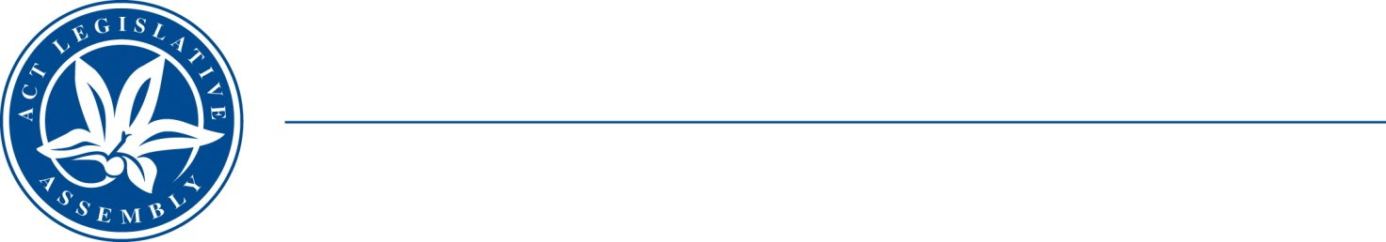
Standing Committee on Health and Community Wellbeing
Mr Johnathan Davis MLA (Chair), Mrs Elizabeth Kikkert MLA (Deputy Chair), Mr Michael Pettersson MLA

LEGISLATIVE ASSEMBLY
FOR THE AUSTRALIAN CAPITAL TERRITORY

INVITATION FOR SUBMISSIONS

Inquiry and review into alcohol, tobacco and other drug harm reduction policy and programs provided in the ACT and an evaluation of future options.
On 9 February 2021, the Standing Committee on Health and Community Wellbeing resolved to inquire into and report on the following matters by the end of 2021:

The Committee’s terms of reference are to inquire into the following matters:

- All matters raised by the petition referred to the Committee on 9 February 2021 In particular, the petitioners, request the Assembly to call upon ACT Government to conduct a thorough inquiry into the alcohol, tobacco and other drug service sector, including prevention/early intervention services and pathways as well as treatment/rehabilitation services, both for persons on Drug and Alcohol Treatment Orders and those voluntarily seeking help, to:
- identity current strength and weaknesses;
- access current and future demands; and
- recommend service and funding models that will better meet people’s needs

The petitions are at https://www.parliament.act.gov.au/__data/assets/pdf_file/0005/1700654/Petitions-3-21-and-24-20-final.pdf

Concurrently with its inquiry into the matters raised in a) above, the Standing Committee will also inquire into and report on the following matters:

- The health and other social impacts of current policy, legislative, and criminal justice approaches to alcohol, tobacco, and other drug use in the ACT.
- The adequacy and implementation of the ACT Government’s current funding commitments to support drug treatment and other harm reduction services, including funding for community-based and community-controlled organisations.
- The availability and access to best practice drug education to enable and support prevention, early intervention, and community safety.
- The benefits and challenges of establishing a clinically supervised drug consumption site in the ACT.
- The issues and policy challenges (if any) for the ACT arising from the Australian Government’s alcohol, tobacco, and other drug use policy frameworks and commonwealth legislation.
- Best practice policy approaches and responses being undertaken in other jurisdictions, including internationally, to reduce alcohol, tobacco, and other drug harm.
- Other opportunities for the ACT to explore innovative responses to reducing harm.
- The impact and proposed evaluation of the ACT Drug Strategy Action Plan 2018-2021.
- Any other related matters.

Details for submissions

Written submissions are invited by c.o.b. Friday, 7 May 2021.

- All Canberrans are invited to have their say on this important matter.
- The Committee’s terms of reference are available on the Legislative Assembly website at: https://www.parliament.act.gov.au/__data/assets/pdf_file/0007/1700719/ToR-HCW-Tobacco,-alcohol-and-other-drugs-programs-final.pdf
- Information about how to make a submission is available at: www.parliament.act.gov.au/in-committees/Getting-involved.

For further information please contact the Committee Secretary, Andrew Snedden on (02) 62050199 or at LACommitteeHCW@parliament.act.gov.au

11 February 2021

