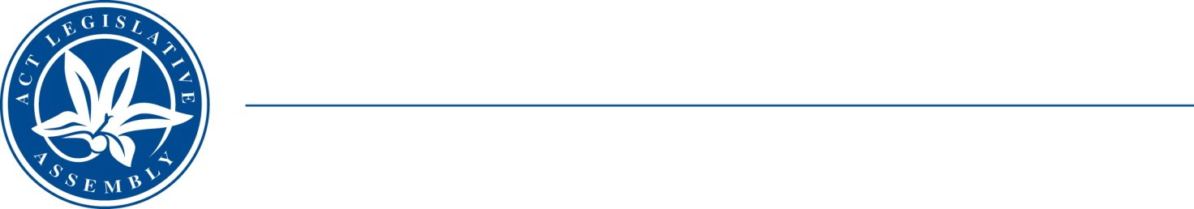
QoN No. 27
Committee Support
LEGISLATIVE ASSEMBLY
FOR THE AUSTRALIAN CAPITAL TERRITORY
Standing Committee on Health and Community Wellbeing

Inquiry into Annual and Financial Reports 2021-2022

ANSWER TO QUESTION ON NOTICE

Asked by MS CASTLEY MLA:

Reference: Hearing on 1 November 2022, Annual Report of CHS

In relation to: Page 246 ACT Health annual report 2021-22

On page 246 Grants and Purchased Services are 24% over budget.

The accompanying note says this is due to higher-than-expected Cross Border Health receipts being passed on as well as multiple prior year reconciliations being completed.

- How much did ACT pay NSW in 2021-22 for patient transfers through Cross Border payments?
- How much did NSW pay the ACT in 2021-22 for patient transfers through Cross Border payments?
- What is included in the new bilateral cross border agreement to 2025?
  - What period did the last agreement cover?

MS STEPHEN-SMITH MLA: The answer to the Member’s question is as follows:–

- The cross border payment made by the ACT to NSW for ACT residents treated in NSW for 2021-22 was $25.2 million. This payment did not include the cost to transfer ACT residents to NSW for treatment.
- The cross border payment made by NSW to the ACT for NSW residents treated in the ACT for 2021-22 was $127.2 million. This payment did not include the cost to transfer NSW residents to the ACT for treatment.
- A cross border bilateral agreement between the ACT and NSW is currently being finalised. The last agreement covered the period 2016-17 to 2019-20.

Approved for circulation to the Standing Committee on Health and Community Wellbeing

Signature: Date:

By the Minister for Health, Rachel Stephen-Smith MLA

