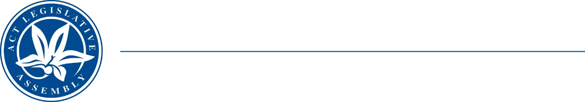
Standing Committee on Planning, Transport and City Services
Ms Jo Clay MLA (Chair), Ms Suzanne Orr MLA (Deputy Chair),
Mr Mark Parton MLA
Ms Caroline Le Couteur MLA

LEGISLATIVE ASSEMBLY
FOR THE AUSTRALIAN CAPITAL TERRITORY

MEDIA RELEASE

Public Hearing into the Property Developers Bill 2023

Today, Thursday 7 March, the ACT Legislative Assembly’s Standing Committee on Planning, Transport and City services will hold a public hearing for its inquiry into the Property Developers Bill 2023.

The Committee Chair, Ms Jo Clay MLA, said, ‘We have received written submissions from industry stakeholders, peak bodies, community organisations, the legal community and the public. Some of these strongly support the proposals in the Bill and offer suggestions for strengthening them. Other submitters raised concerns about the potential for increased regulatory and cost burden for property developers, and its flow on effects.’

‘Property Developers play a significant role in the future of our city and region, and it is important that the issues raised by this Bill are properly explored,’ Ms Clay said. ‘We look forward to hearing from submitters to the inquiry, as well as the Minister for Sustainable Building and Construction at the hearing.’

Members of the public are welcome to attend the hearing in the Prince Edward Island Room of the Legislative Assembly from 9.20 am to 3.20 pm on 7 March 2024. Proceedings will also be live streamed on the Assembly website.

The Bill itself functions as the terms of reference for the inquiry and is available on the Committee website.

7 March 2024
STATEMENT ENDS.

For further information please contact:
Committee Chair, Ms Jo Clay MLA on (02) 6205 0131
Committee Secretary, James Bunce on (02) 6205 0199 or at LACommitteePTCS@parliament.act.gov.au

