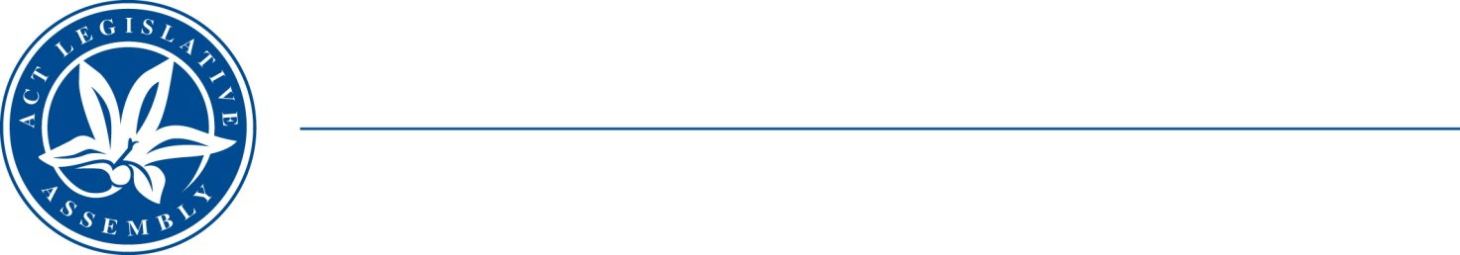
QoN No. 12
Committee Support
LEGISLATIVE ASSEMBLY
FOR THE AUSTRALIAN CAPITAL TERRITORY
Standing Committee on Education and Community Inclusion

Inquiry into Annual and Financial Reports 2021-2022

ANSWER TO QUESTION ON NOTICE

Asked by Elizabeth Kikkert MLA: To ask the Minister for Education and Youth Affairs:

Ref: Youth Affairs, CSD Annual Report 2022, p. 52
In relation to: Youth Advisory Council

1. Considering that the annual report lists 17 topics for government-initiated ‘engagement activities and consultations’ with the Youth Advisory council, what were the topics for the five that were community initiated?

2. Does the Youth Advisory Council include at least one CALD member and at least one Indigenous member, and is that always the case?

Minister Berry: The answer to the Member’s question is as follows:–

- The 5 Community-initiated ‘engagement activities and consultations’ with the Youth Advisory Council were:

- Young People and Care Project, conducted by Australian National University;
- Legal Aid ACT pilot program in ACT Public Colleges, conducted by Legal Aid ACT;
- Safe Response Toolkit Peer Review, A Toolkit for Sexual Violence Victim-Survivors and Their Supporters (SRT), conducted by The STOP Campaign;
- Right care, First time, where you live, Brain and Mind Centre, conducted by University of Sydney; and
- Youth Suicide Prevention Research Youth Suicide Prevention Promoting youth help-seeking with innovative technology, conducted by Australian National University.

- Council has a membership of up to 15 young people and is reflective of the diversity of young people residing in the ACT, including one young person who is Aboriginal; 3 young people from a culturally linguistically and diverse background; 2 young people with disability; different genders; and young people who identify as a members of the LGBTIQA+ community.

The diversity of Council is always considered when recruiting new members.

Approved for circulation to the Standing Committee on Education and Community Inclusion

Signature: Date:

By the Minister for Education and Youth Affairs, Yvette Berry MLA

