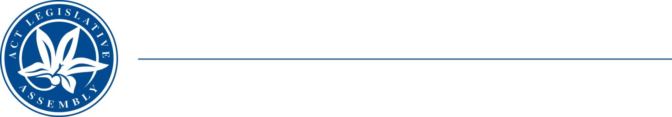
QToN No. 11
Committee Support
LEGISLATIVE ASSEMBLY
FOR THE AUSTRALIAN CAPITAL TERRITORY
Standing Committee on Health and Community Wellbeing

Inquiry into Annual and Financial Reports 2021-2022

ANSWER TO QUESTION TAKEN ON NOTICE

Asked by MR JOHNATHAN DAVIS MLA on 1 November 2022: MS CATHIE O’NEILL took on notice the following question(s):

Reference: Hansard uncorrected proof transcript 1 November 2022 Page 44

In relation to:

Oral Health Services:
- How many consumers have presented to CHS Emergency Department for dental issues in the last year data?
- What investments were made over the last 12 months to provide free or low cost dental services, particularly with preventative dental services to community?
- Have any representations been made to the incoming Federal Health Minister regarding public dental services?

MINISTER STEPHEN-SMITH MLA: The answer to the Member’s question is as follows:–
- There were 502 presentations to the Canberra Hospital Emergency Department due to dental concerns from 1 November 2021 to 31 October 2022. This includes all dental concerns and is not specific to services that could be provided by the Oral Health Services program and may include data regarding consumers who are not eligible for the Oral Health Services program. It is not feasible to provide the number of individual consumers as the collation of this information would require a considerable diversion of resources and cannot be undertaken in the timeframe.
- The overall budget for the Canberra Health Services Oral Health Services program was $12.8 million for 2021-22. This budget provides for a range of urgent and preventative dental and other oral health services treatments to eligible clients. A breakdown of how much funding was allocated to preventative dental services cannot be provided as activity data is not currently collected in this manner.
- Yes. On 15 June 2022, I wrote to the Australian Government Minister for Health noting that the previous government’s move to funding public dental services on a year-by-year basis was not a sustainable way of operating a public health service. I welcomed the continuing commitment by the current Australian Government to support the work of the National Dental Reform Working Group established by the Health Chief Executives Forum, which aims to develop a long-term strategy for dental policy and funding for reformed public dental services.

Approved for circulation to the Standing Committee on Health and Community Wellbeing

Signature: Date:

By the Minister for Health, Ms Rachel Stephen-Smith MLA

