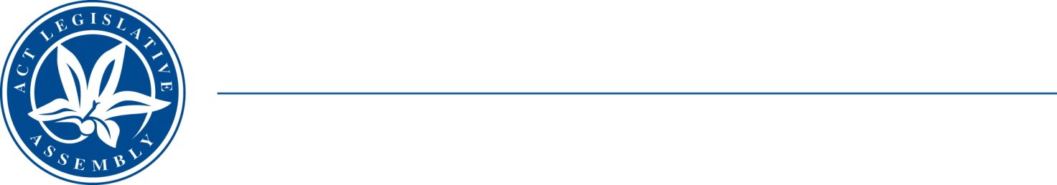
QoN No. 21
Committee Support
LEGISLATIVE ASSEMBLY
FOR THE AUSTRALIAN CAPITAL TERRITORY
Standing Committee on Health and Community Wellbeing

Inquiry into Annual and Financial Reports 2021-2022

ANSWER TO QUESTION ON NOTICE

Asked by MS LEANNE CASTLEY MLA:

Reference: Hearing on 1 November 2022, Annual Report of CHS

In relation to: page 100 CHS annual report

Legal expenses and Settlements increased from 2.3 million to 3.2 million between 2021-22.

- How many legal cases against CHS were closed during 2020-21?
- How many legal cases were open on July 1 2021?
- How many legal cases were open on July 1 2022?
- What were the main reasons for legal proceedings being opened against CHS?
- Does this table include all payments made by CHS for legal cases/representation or court legal fees? If not, why and why is the full cost to CHS for legal court proceedings against the organisation?

MINISTER STEPHEN-SMITH MLA: The answer to the Member’s question is as follows:
- 90 legal claims were closed during 2020-21. This includes all claims finalised by way of settlement, judgement or closed due to the claim not being progressed.
- As of 1 July 2021, CHS managed 149 open legal claims.
- As of 1 July 2022, CHS managed 164 open legal claims.
- Allegations in legal proceedings predominately related to medical negligence.
- No. The Territory is represented in all matters by the ACT Government Solicitor (ACTGS). The costs of representation and compensation are met from existing ACTGS resourcing, through the Territory’s insurance arrangements with ACT Insurance Authority (ACTIA) for insured claims and from CHS’ budget for all other matters.
Therefore, the Legal Expense and Settlements line within the table includes:
- payment of insurance excesses on settled medical negligence and public liability claims,
- accounting recognition of resources received free of charge relating to general legal advice provided by ACTGS, and
- legal costs and settlements relating to industrial relations investigations and claims.

Approved for circulation to the Standing Committee on Health and Community Wellbeing

Signature: Date:

By the Minster for Health, Rachel Stephen-Smith MLA

