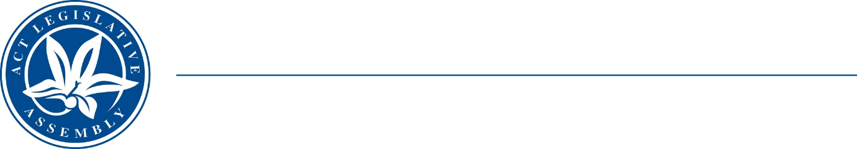
Standing Committee on Economy and Gender and Economic Equality
Ms Leanne Castley MLA (Chair), Ms Suzanne Orr MLA (Deputy Chair),
Mr Johnathan Davis MLA
Ms Caroline Le Couteur MLA

LEGISLATIVE ASSEMBLY
FOR THE AUSTRALIAN CAPITAL TERRITORY

Media Release

Summary of survey responses

Inquiry into the future of the working week
The ACT Legislative Assembly’s Standing Committee on Economy and Gender and Economic Equality (the Committee) has published the results of its survey into opinions towards alternative options to the standard five-day work week.
The survey was open from July to December 2022 and received just over a thousand (1,155) responses. It questioned respondent’s attitudes towards a four-day work week, associated changes to pay and conditions, and other flexible work arrangements.
The response was overwhelming in favour of a shortened work week. 86% of respondents rated themselves as very supportive of four-day work week, and 78% supported a model in which there was no change to pay or conditions.
The results of the public survey can be found on the Committee website under the ‘Other Documents’ tab.
STATEMENT ENDS—2 May 2023
–––––––––––––––––––––––––––––––––––––––––––––––––––––––––––––––––––––––––––––––––––––––––
contacts: | Ms Leanne Castley MLA  (for comment on the inquiry) | Committee Chair | (02) 620 50283
contacts: | Ms Sophie Milne  (for further information) | Committee Secretary | (02) 620 50435

