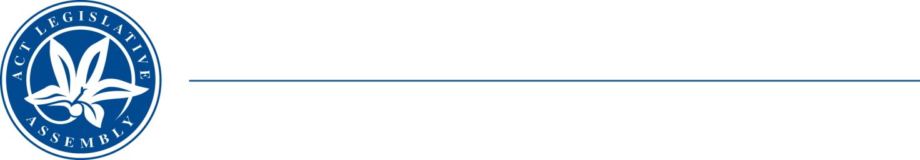
QToN No. 92
Committee Support
LEGISLATIVE ASSEMBLY
FOR THE AUSTRALIAN CAPITAL TERRITORY
Standing Committee on Health and Community Wellbeing

Inquiry into Annual and Financial Reports 2021-2022

ANSWER TO QUESTION TAKEN ON NOTICE

Asked by JONATHAN DAVIS MLA on 1 November 2022: MR DAVE PEFFER took on notice the following question(s):

Reference: Hansard uncorrected proof transcript 9 November 2022 Page 125

In relation to:

What actions and what impacts we are looking at around intern prescribing?

MS EMMA DAVIDSON MLA: The answer to the Member’s question is as follows:–

The legislation related to intern prescribing (the Medicines, Poisons and Therapeutic Goods Regulation 2008) is undergoing amendment to allow interns to prescribe medications for use external to Canberra Health Services’ facilities.

This will align the prescribing rights of interns in the ACT to those present in other states and territories.

Approved for circulation to the Standing Committee on Health and Community Wellbeing

Signature: Date:

By the Minister for Mental Health, Ms Emma Davidson MLA

