
QoN No. 26
Committee Support
LEGISLATIVE ASSEMBLY
FOR THE AUSTRALIAN CAPITAL TERRITORY
Standing Committee on Health and Community Wellbeing

Inquiry into Annual and Financial Reports 2021-2022

ANSWER TO QUESTION ON NOTICE

Asked by MS LEANNE CASTLEY MLA:

Reference: Hearing on 1 November 2022, Annual Report of CHS

In relation to: Page 131, 132 CHS Annual report 2021-22

The expansion of the women’s and children hospital which is due to be complete next year in September. The total expenditure to date is just over 50% of what is budgeted.
- Will the project be complete by September 2023?
- What wards and facilities are still under construction and what has been complete?

The Clinical Services and inpatient unit design and infrastructure expansion reduced the value for this project from around 41 million to 27 million.
- Why was the clinical services project reduced by such a significant amount?
- What is the Clinical services and inpatient design project?
- Is the design being implemented? If not, why?
- Was this project outsourced?
  - Which company won the tender and what was their total cost?

MINISTER STEPHEN-SMITH MLA: The answer to the Member’s question is as follows:
Centenary Hospital for Women and Children (CHWC) Expansion Project:
- The CHWC Expansion Project is on track for completion in September 2023.
- The program summary is provided in the table below.

Item | Service | Construction Completion Date
1 | Paediatric High Care Unit | October 2020
2 | Administration Building | July 2021
3 | Maternity Assessment Unit | October 2022
4 | Gynaecology Procedure Suite | October 2022
5 | Clinical Administration, Teaching and Education Spaces | December 2022
6 | Antenatal Ward & Early Pregnancy Assessment Unit | February 2023
7 | Adolescent Unit & Adolescent Mental Health Day Service | June 2023
8 | Neonatology Special Care Nursery | September 2023
Clinical Services Design:
- Funding for the project has not reduced. The original project budget was $40.8 million. It contained several separate components, with the main Emergency Department (ED) and Paediatric Streaming Expansion component representing $26.9 million that is reported against expenditure of $26.3 million as of 30 June 2022.
The balance of the original funding was redistributed to other projects as noted in the relevant budget papers from 2016-17, please see the below.

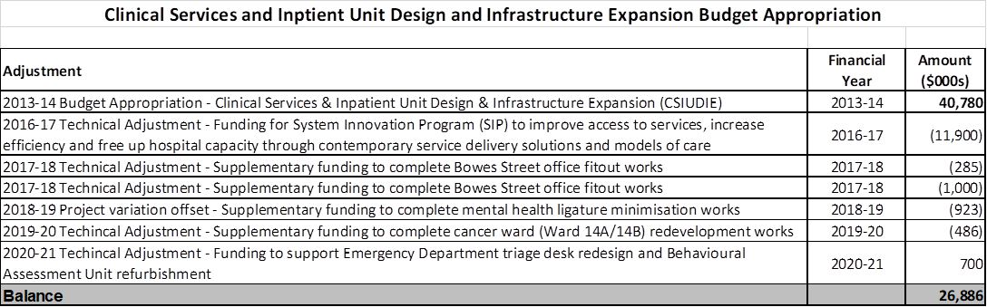

- In 2013-14, the ACT Government provided $40.8 million under the Clinical Services and Inpatient Unit and Infrastructure Expansion (CSIUDIE) project to:
- Prepare a Proof of Concept and forward design for major clinical buildings at the Canberra Hospital;
- Expand the ED on finalisation of the proof of concept; and
- Provide a paediatric service in the ED at Canberra Hospital.
The POC and forward design scope for major clinical buildings was not progressed following a revaluation by government in 2015. The Canberra Hospital Master Plan is now the guiding document for Canberra Hospital infrastructure development. Subsequent work in this area culminated in the development of the Canberra Hospital Expansion which is currently under construction and due for completion in 2024.
    - In December 2016, the project delivered an expanded emergency department with an extra 1,000 square metres of refurbished space, including 21 treatment areas (an increase from 54 to 75), a dedicated parent’s room, triage assessment bay and clinical forensic medical service. The expansion also delivered dedicated paediatric treatment areas, three new ambulance bays and a sub-acute area for treating patients with less-serious injuries.
- Yes.
  - In August 2015, a contract for the main ED and PSE component was awarded to ISIS Group Australia Pty Ltd (now Shape Australia Pty Ltd) with a contract amount of $20.2 million (including GST). The final contract cost was $21.7 million (including GST).

Approved for circulation to the Standing Committee on Health and Community Wellbeing

Signature: Date:

By the Minister for Health, Rachel Stephen-Smith MLA

