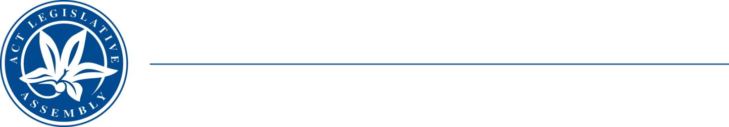
QoN No. 20
Committee Support
LEGISLATIVE ASSEMBLY
FOR THE AUSTRALIAN CAPITAL TERRITORY
Standing Committee on Health and Community Wellbeing

Inquiry into Annual and Financial Reports 2021-2022

ANSWER TO QUESTION ON NOTICE

Asked by MS LEANNE CASTLEY MLA:

Reference: Hearing on 1 November 2022, Annual Report of CHS

In relation to: Page 146, CHS annual report 2021-22 Output 1.1 - Cardiology

In relation to the QTON about the Johns review could the Minister also explain CHSFOI21-22.27 page 3 reveals that more than 40 cardiology staff and stake holders were interviewed.

- How many staff and stakeholders were interviewed by Barbara Deegan?
- How many staff and stakeholder were interviewed for both the Johns review and the Deegan review?
- How many of the staff interviewed for the (a) John's (b) Deegan reviews were executives/directors/managers of the department?

MINISTER STEPHEN-SMITH MLA: The answer to the Member’s question is as follows:
- 18.
- There were 40 interviewees for the Johns review. Of the 18 who participated in the Deegan Review, 11 were also interviewed for the Johns Review.
- Refer to the following table:

 | Johns report | Deegan report
Executive interviewees | 2* | 0
Director interviewees | 5 | 1
Manager interviewees | 3 | 3
*Includes GM National Capital Private Hospital

Approved for circulation to the Standing Committee on Health and Community Wellbeing

Signature: Date:

By the Minister for Health, Rachel Stephen-Smith MLA

