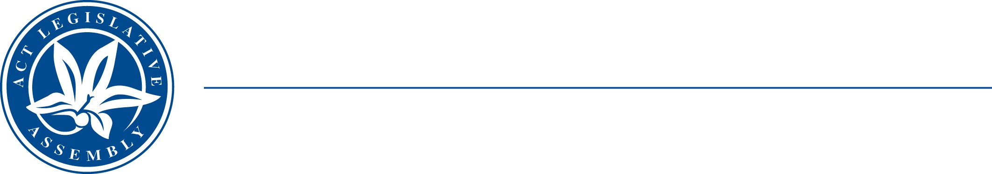
LEGISLATIVE ASSEMBLY
FOR THE AUSTRALIAN CAPITAL TERRITORY

STANDING COMMITTEE ON EDUCATION AND COMMUNITY INCLUSION
Mr Michael Pettersson MLA (Chair), Mr Johnathan Davis MLA (Deputy Chair), Ms Nicole Lawder MLA

MEDIA RELEASE
New inquiry into skateboarding and skate parks in the ACT

The Chair of the Assembly’s Education and Inclusion Committee, Michael Pettersson, today announced that the Committee would start an inquiry into skateboarding and skate parks.

Assembly Members have recently presented petitions to the Assembly supporting further investment in skate parks in the ACT.

The inquiry’s terms of reference include:

- accessibility of skateboarding and skate parks across the community;
- skateboarder safety and welfare;
- skate parks, including planning and maintenance;
- skateboarding and skate park history; and
- the relationship with other cultural activities, e.g., music and visual art.

Full terms of reference are available at the Committee’s website.

Mr Pettersson said that “Skateboarding and skate parks allow people to have fun. But there is evidence that skateboarding and skate parks also give people a great way to socialise and develop networks to support them elsewhere in their lives.”

“The Committee wants to get feedback from people on what skateboarding and skate parks mean to them and to see how the ACT Government can improve facilities and other resources.”

The Committee is conducting an online survey and calling for submissions, which close on 23 June 2023. Information on how to make a submission and access to the survey is also available at Committee’s website.
Online survey link
The Committee will be available for a stand-up media conference at 12.00 noon on Thursday, 11 May 2023.
10 May 2023
STATEMENT ENDS.

For further information please contact:
Committee Chair, Mr Michael Pettersson MLA, on (02) 6205 0051
The Committee Secretary on (02) 6207 5498 or at LACommitteeECI@parliament.act.gov.au.

