Management of ACT Cemeteries
Standing Committee on Environment and Transport and City Services
November 2017
Report 4

Committee membership

Suzanne Orr MLA Chair

Steve Doszpot MLA Deputy Chair (until 25 November 2017)

Tara Cheyne MLA

Mark Parton MLA

Secretariat

Andrew Snedden Secretary

Lydia Chung Administrative Assistant

Contact information

Telephone 02 6205 0199

Post GPO Box 1020, CANBERRA ACT 2601

Email committees@parliament.act.gov.au

Website www.parliament.act.gov.au

Resolution of appointment

The Legislative Assembly for the ACT appointed the Standing Committee on Environment and Transport and City Services (ETCS) on 13 December 2016.

Specifically the resolution establishing the Standing Committees of the 9th Assembly, as it relates to the Standing Committee on ETCS states:

- The following general purpose standing committees be established and each committee inquire into and report on matters referred to it by the Assembly or matters that are considered by the committee to be of concern to the community:

.....

(c) a Standing Committee on Environment and Transport and City Services to examine matters related to city and transport services, public infrastructure, heritage, and sport and recreation and matters related to all aspects of climate change policy and programs, water and energy policy and programs, provision of water and energy services, conservation, environment and ecological sustainability;

Terms of reference

The Committee is to inquire into the management of cemeteries in the ACT with particular reference to:

1. Current burial and cremation practices in the ACT, including;
- Current and anticipated community and regional demand for burial, cremation and any other interment or memorial practices in the ACT,
- Current and anticipated capacity of existing ACT cemeteries,
- Land management/land use and maintenance relating to ACT cemeteries including the identification of potential future sites,
- Tenure;

2. The funding model for ACT cemeteries, including:
- Initial and ongoing expenditure for burial, cremation, interment and memorial practices,
- Current funding sources for burial, cremation, interment and memorial practices,
- Cost-effectiveness and future viability of the current funding model,
- Comparative analysis with funding models used in other jurisdictions,
- The role of the private sector;

3. The governance model for ACT cemeteries, including;

a. Legislative requirements and current governance structures,

b. The cost-effectiveness of existing structures,

c. Comparative analysis with governance models in other jurisdictions, and

4. Any other relevant matter.

5. The Committee will present its report to the Assembly by the last sitting day for 2017

Table of contents
Committee membership i
Secretariat i
Contact information i
Resolution of appointment ii
Terms of reference iii
Recommendations vii
1 Introduction 1
2 Current cemetery and cremation arrangements in the ACT 3
Cemetery arrangements in the ACT 3
Cremation arrangements in the ACT 5
Current burial and cremation practices in the ACT 5
3 Changes in burial, cremation, interment and memorial practices in the ACT 7
Burial and cremation trends 7
Implications of changes in funeral practice 9
Natural Burial 11
Committee comment 11
4 Current funding arrangements and sources for ACT cemeteries 13
Introduction 13
Current business model – ACT Cemeteries Authority 13
Committee Comment 15
5 Current and future capacity of ACT cemeteries 19
Introduction 19
Committee comment 23
Southern Memorial Park 24
Committee Comment 25

6 Future funding capacity and tenure rights 27
Tenure – the Authority’s view 27
Committee Comment 31
7 Legislative requirements and governance model 33
Committee comment 33
8 Conclusion 35
Acknowledgments 35
Appendix A Submission 37
Appendix B Hearings 39
Appendix C Plan for Extension to the Woden Cemetery 41
Appendix D Plan for Southern Memorial Park 45

Recommendations
Recommendation 1
3.24 The Committee recommends the Government, in view of the diversification in burial and interment preferences in the ACT, ensure that the development and construction of a second crematorium in Canberra be considered a high priority.
Recommendation 2
3.25 The Committee recommends the Government continue to monitor community preferences across a range of burial, cremation and interment practices and where possible make provision for emerging or alternative practices.
Recommendation 3
4.20 The Committee recommends the management and operation of ACT cemeteries continue to be performed by the ACT Cemeteries Authority.
Recommendation 4
4.21 The Committee recommends the management and operation of any future cemeteries or crematorium or any other interment facility be performed by the ACT Cemeteries Authority.
Recommendation 5
5.24 The Committee recommends the Government reconsiders the planned extension of the Woden Cemetery in light of changes in planning for the Woden Town Centre and the views held by the local community.
Recommendation 6
5.32 The Committee recommends that the Government agree to proceed with the current plans for the Southern Memorial Park and work with the ACT Cemeteries Authority to establish the facility as a matter of urgent priority.
Recommendation 7
6.23 The Committee recommends that a review of the Cemeteries and Crematoria Act 2003 be undertaken to ascertain the feasibility and financial basis for adopting a renewable tenure scheme to replace the prevailing tenure provisions applying to ACT cemeteries.

Recommendation 8
6.24 The Committee recommends that any review conducted in accordance with Recommendation 7 should seek to clarify the current definition of perpetuity, and examine the introduction of a renewable tenure regime with some form of increments and renewals allowed.
Recommendation 9
6.25 The Committee recommends that any review conducted in accordance with Recommendation 7 should also include “for perpetuity” as a tenure option.
Recommendation 10
6.26 The Committee recommends that any changes to tenure practices arising from the review conducted in accordance with Recommendation 7 are applied only to future burial sales and are not applied retrospectively to existing plot sites.
Recommendation 11
6.27 The Committee recommends that an actuarial analysis of tenure options be undertaken as part of the review recommended in recommendation 7 to assess how best a renewable tenure scheme regime be structured to enable the ACT Cemeteries Authority to meet its financial liabilities over the long-term.
Recommendation 12
7.7 The Committee recommends that where a recommendation made in this Report is adopted, that all aspects of the Cemeteries and Crematoria Act 2003 relating to that matter be given specific review in light of the Cemeteries and Crematoria Act 2003 enabling the Authority to implement the relevant reform.

Introduction
          - 0 The Standing Committee self-referred an inquiry into the management of cemeteries and related facilities in the ACT on 26 July 2017. The Committee resolved to conduct this inquiry and present its report by the end of 2017.
          - In accordance with normal practice, the Committee commenced its inquiry by publication of its terms of reference, and notification to the Assembly of the commencement of the inquiry on 4 August 2017.
          - The Committee’s terms of reference set out in detail matters the Committee decided should be the subject of inquiry and report.
Conduct of the inquiry
          - Under its resolution of appointment, the Committee is empowered to examine matters which are the responsibility of the ACT Public Cemeteries Authority and the Transport Canberra and City Services Directorate. The Committee conducted this inquiry under that responsibility.
          - In accordance with established practice, the Committee advertised its inquiry on the Assembly Committees’ website and invited written submissions be lodged with the Committee by Friday, 1 September 2017.
Submissions
          - The Committee also wrote to stakeholders including groups, individuals and organisations it considered likely to be interested in the Committee’s inquiry seeking their views. The Committee also invited views from all major religious denominations in the ACT and from all businesses involved in the ACT funeral and cremation professions. The Minister for Transport and City Services and the ACT Public Cemeteries Authority were both invited to address the matters to make a submission addressing the terms of reference.
          - The Committee considered submissions received by the end of the period allowed for lodgement of submissions, and, following consideration of those submissions, allowed a further period to lodge a submission to the inquiry.
          - The Committee received 11 submissions, all of which are accessible and may be downloaded from the Committee’s website and are listed in Appendix A.
Public hearings
          - Public hearings were held on 5, 11, 18 and 23 October 2017. Witnesses who appeared before the Committee are listed at Appendix B. Transcripts of these hearings can be accessed and downloaded from the Committee inquiry homepage.
          - The Committee met on 27 November 2017 to discuss the Chair’s draft report which was adopted on 27 November 2017.
Structure of the report
          - The Committee’s report is in eight chapters:
Chapter 1 – Introduction and conduct of the inquiry
Chapter 2 – Current cemetery and cremation arrangements and practices in the ACT
Chapter 3 - Changes in burial, cremation, interment, and memorial practices
Chapter 4 - Current funding arrangements and sources for burial, cremation, interment and memorial practices in the ACT
Chapter 5 –Current and future capacity of ACT Cemeteries
Chapter 6 – Tenure issues
Chapter 7 – Legislative requirements governance model for ACT cemeteries
Chapter 8 – Conclusion

Current cemetery and cremation arrangements in the ACT
Cemetery arrangements in the ACT
          - Current cemetery and cremation practices in the ACT are in accord with practices followed in all Australian jurisdictions. These practices are generally that following a death, a family usually engages a funeral director from a choice of service providers in the ACT. The family typically chooses between burial and cremation in accordance with the wishes of the deceased person, the family or common practice.
          - All aspects of cemetery and cremation arrangements and practices in the ACT are governed by the provisions of the Cemeteries and Crematoria Act 2003 (the Act). The Act (section 6) provides the Minister (currently the Minister for City Services) to approve codes of practice in relation to the operation of cemeteries and crematoria in the ACT. The current Code of Practice (the Code) was made in 2007 and establishes a comprehensive code of practice for all cemeteries and crematoria in the ACT. The Code deals with all aspects of cemetery arrangements, burials, upkeep and services in cemeteries and crematoria, standards and codes for all aspects of coffin and other accoutrements and other standards.
          - Under current requirements in the Act, following burial or interment in a cemetery or crematoria, the right of burial or interment lasts into perpetuity, effectively meaning the burial plot belongs to the family forever. If a person pre-purchases a right of burial or interment and then does not use that right within 60 years, then the operator of the cemetery or crematoria may revoke the right in a way that is consistent with the Code.
          - Part 3 of the Act establishes the ACT Public Cemeteries Authority (the Authority) to efficiently and effectively manage public cemeteries and crematoria. The Authority is a self-funded body and receives the majority of its revenue from burials, reservations and returns earned on invested funds. Responsibility for all earth burials in the ACT is held by the Authority.
          - Under the Act Part3. S28A

The functions of the cemeteries authority are to effectively and efficiently manage public cemeteries and crematoria for which the authority has been appointed as the operator by the Minister.
          - The Authority describes its key purposes as being:

…to ensure the equitable availability of interment options, and maintain burial capacity in the medium to long term for the ACT community. The Authority strives to operate as an efficient government business with a strong customer service focus. Underpinning the services offered, the Authority has adopted operating practices that safeguard the environment and the health and safety of employees and visitors.
          - The Authority manages three cemeteries in Canberra, located at Gungahlin, Hall and Woden. All aspects of cemetery administration and planning come within the Authority’s responsibilities.
          - The Authority also has the responsibility under the Act for establishing and administering a Perpetual Care Trust for each cemetery. The Authority described the operation of each Perpetual Care Trust as follows:

Each Trust comprises two parts, one for current maintenance and one for future maintenance (the Reserve), that are intended to provide for maintenance of each site perpetuity. The Minister (Part 2 Division 2.2 Section 11 of the Act) sets a percentage of burial income that must be paid into each fund. The arrangements for all percentages were reviewed in 2016-17, with new percentages introduced on 1 July 2017.
          - The Authority currently provides a ‘wide variety of monumental and lawn options, natural burials, informal and formal memorial gardens for the memorialisation of ashes, and vault and mausoleum services.’
Cremation arrangements in the ACT
          - The Authority does not manage a crematorium in the ACT. There is one crematorium operating currently in the ACT, Norwood Park Crematorium (Norwood). The Managing Director of Norwood, Stephen Beer, told the Committee that the crematorium operates, with the Authority, as the only two organisations authorised under the Act providing for the cremation and interment of disposal of ashes.
Current burial and cremation practices in the ACT
          - The Committee has received evidence from submissions and in discussions with witnesses that both the Authority and Norwood offer a matrix of current burial and cremation services, together with a wide range of memorialisation and other similar services commonly practiced in all Australian jurisdictions.
          - These services provide for the burial traditions and rituals for a current list of seventeen religious denominations and includes non-religious burial and cremation practices.
          - Examples of these services are provided to the funeral directors and the community. These practices are common to other jurisdictions in Australia (depending on the size of the community involved) and are provided for in the Code under the Act, as described in paragraph 2.4.

Changes in burial, cremation, interment and memorial practices in the ACT
Burial and cremation trends
          - One of the regular themes throughout the inquiry was the need for choice in interment methods. A number of submissions and testimonies touched on various interment options and accepted that different groups had different ways of interning their loved ones, and that we should endeavour to offer as many opportunities as possible.
          - In his testimony, Father Julian Wellspring representing, the Catholic Archdiocese of Canberra and Goulburn said:

I think it would be important that Southern Memorial Park actually provided … the full gamut of options for dealing with a body, including things like natural burial, things like a lawn cemetery, things like a monumental burial, things like cremation, and then places for interring ashes. The whole gamut. It needs to think this through, because we are in a society where … death for many people is very foreign. People grieve very individually. And we need to, in a pluralistic society, provide these options.

…

Again I keep thinking about how does disruptive technology affect the world of the cemetery? I mean, digital memorialisation of people, what possibilities are there for the new cemetery?

…

But you know, streaming services of services as well to other parts of the country, all these kinds of things that I think should be built into the new facilities and be possible. But certainly, yes, we are getting more requests for, you know, use of what I call multimedia world when it comes to memorialisation in our services, in all that.
          - The Committee received consistent evidence that data and experience reflects a trend across Australia of a movement away from burial toward cremation. The Authority noted in its submission that:

Statistics sourced from Australian Bureau of Statistics (ABS) and Canberra Cemeteries indicate that there is a general community preference trending away from burial, towards cremation.

A significantly higher percentage of people are now choosing cremation over burial at a ratio of about 75:25 in the ACT, which is continuing to grow. This is the case for most Australian jurisdictions. NSW cremation to burial ratio is 67:33 overall, with Central Coast and Hunter ratios closer to 80:20. It is noted however, that communities that are further away from metropolitan jurisdictions generally have higher burial rates.
          - In addition, the total number of deaths has increased in the ACT over the last 15 years while the number of burials has only increased marginally. This trend – highlighted by the Authority - emphasises the change in practices, demand and choice has considerable ramifications for the future activities of cemeteries and crematoria.
          - There is one crematorium in the ACT - Norwood - which provides cremation and memorialisation services to a current population of 400,000. By comparison, there are 49 crematoria in NSW which is the equivalent of 1 crematorium per 155,000 population. The cremation rate (as compared with burial) in the ACT is now approximately 75%.
          - Stephen Beer from Norwood confirmed a trend from burial to cremation. Mr Beer also noted that cultural changes in Australian society has resulted in a number of cultural and religious communities having cremation as their required funeral rituals.
          - The Committee heard evidence from a member of the Authority, Mr Kanti Jinna, who also provided the Committee with detail on the importance of cremation as a funeral rite, in the case of his example, for the Hindu, Sikh and Jain communities:

The needs of the community have been increasing, especially in the past decade or two, because of the number of people who have been coming to live in Canberra. There has also been an overall increase in the community where people have preferred to be cremated rather than interred. The current availability is in a sense not fully functionally available to people of the Hindu, the Sikh and the Jain communities. Because it has been a traditional crematorium it does not have the types of facilities that are looked for—that are required—by the people.
        - and:

Certain rituals are where people need to go into the crematorium. The eldest child of any of these three communities has to be present and participate in the actual cremation. It could be in a variety of ways. Now technologically it is available through pressing a button, but previously it was lighting the fire. There is also the provision of people needing to view just before the cremation. At the moment there are other facilities where viewing can be done, but traditionally it is viewed just before the body is cremated. Then post the cremation there are really no facilities at the moment where the ashes can be interred. In fact, it is illegal the way it is required to be interred at the moment. There is no real provision that has been made for any of these communities to be able to do that. So many people are sending their ashes away.
          - In his evidence to the Committee, Father Wellspring noted that the trend is clear and often results from basic economic decisions:

Indeed, my experience would be that, as with many decisions in life, the decision about a funeral will often come down to economics and what can be afforded, and a cremation is much cheaper in Canberra today than a burial. Our fees for burial are not insignificant. I know there are a variety of reasons for that. Cremation is certainly an option that I would say is popular, not only with our community but more generally in the society in which we live and probably will continue to be so.
          - In view of the clear trend toward cremation as a matter of choice, the Authority provided this comment in its submissions:

Crematoriums attached to cemeteries are as much about using space not suitable for normal burial (in ashes memorial gardens and the like) as they are about performing a cremation service.
Implications of changes in funeral practice
          - Evidence received by the Committee makes it apparent that, with a growing trend to cremation services, and with Norwood having an effective monopoly in the ACT on those services, that demand – particularly for cemetery burial interment – will continue to change, with implications for the Authority and for the development in the future of ACT cemeteries as they have developed to the present.
          - A number of comments directed at the best approach to addressing this change and trend were put to the committee.
          - Father Wellspring directed some comments on cremation practices in the ACT as they derived from his experience with Norwood, with some observations that the facilities and approach taken by Norwood did not – in his view - provide comparative best level facilities when compared to facilities elsewhere. The Committee took the comments as observations on how Norwood might be ‘improved’ as a venue for funeral services.
          - Mr Beer from Norwood contested Father Wellspring’s comments and observations, and provided comment to the Committee on the readiness and proposals by Norwood to invest in upgraded and larger facilities.
          - There was considerable support for action to recognise this trend in practice. The Chair of the Authority, Stephen Bartos, told the Committee that a second crematorium – while not a matter for the Authority – would have desirable results:

That has to be a government decision, a minister’s decision, taking into account the views of the community. Probably the best way to describe it is that the Canberra community, particularly the families of deceased loved ones, would be better served if there were a second crematorium. There is clearly demand for it. There would be better services provided to the Canberra community were there a second crematorium.
          - Mr Beer from Norwood had no objection to the proposal and noted that if a second crematorium were built, Norwood may well choose to apply to manage and run the facility - although not being in a position to fund such a development.
          - The Authority highlighted the practical result of the trend and change in this way:

The community trends… demonstrate a strong need for additional crematoria capacity and places for the memorialisation of ashes. The Authority is also cognisant of future demands for new services at cemeteries, such as virtual memorials, augmented reality applications, live streaming and digital access to cemeteries and cemetery services will increase in the future.
Natural Burial
          - The prevailing practice for natural burials, which is followed in the ACT by the Authority is: …the act of returning a body as naturally as possible to the earth. To achieve this, we recommend that the body not be embalmed or cremated, but instead buried in a simple casket or shroud, in a protected green space.
          - The Authority has allocated spaces and a precinct at Gungahlin Cemetery for natural burials, and provided detailed advice of natural burial processes, practices and requirements for the cemetery. This service includes a means of recording the location of burials (as no headstones or memorials are utilised).
          - There have been 14 natural burials recorded for Gungahlin cemetery since the introduction of a natural burial choice in November 2015.
Committee comment
          - The Committee suggests that whatever form the expanded cemetery capacity takes, that provision be made to allow for the “full gamut” as Fr Wellspring put it (paragraph 3.2). In reference to recommendation 3 below, the Southern Memorial Park should be pursued and every effort should be made to offer the full range of services expected by the community.
          - The Committee notes that the important change to funeral and other practices such as interment and memorialisation that have occurred in the ACT over the last 15 years, has been the trend to move quite quickly away from burials to cremations.
          - This trend has been highlighted by the Authority, and confirmed by other material considered by the Committee. The demand for cremation over burials has implications for the use and demand for space at cemeteries, as demand for burial plots will either stay the same or fall, and the possible implications for future cemetery development are now apparent and require some recognition.
          - The Committee considers that the change in funeral practices within the community be addressed in future cemetery planning.

          - The Committee recommends the Government, in view of the diversification in burial and interment preferences in the ACT, ensure that the development and construction of a second crematorium in Canberra be considered a high priority.

          - The Committee recommends the Government continue to monitor community preferences across a range of burial, cremation and interment practices and where possible make provision for emerging or alternative practices.

Current funding arrangements and sources for ACT cemeteries
Introduction
          - The Committee considers two of the matters in its terms of reference related to the current funding arrangements in this chapter: the current funding model for ACT cemeteries, and the cost-effectiveness and future viability of that model.
          - In its submission to the Committee, the Authority has provided the Committee with details of its funding model, the means by which these factors are measured, how funding is sourced and how the future trends in the costs of cemetery administration can be met.
Current business model – ACT Cemeteries Authority
          - The Authority provided details on central funding features in its current business model. These included:
          - Cemetery development – the Authority noted that:

The Authority is not necessarily responsible for the construction of cemeteries, but it is currently responsible for their ongoing development. In the current business model of the Authority, the full costs for the development of undeveloped parts of cemeteries are met by the Authority…with cost breakdown into areas of:
- activity as administration (including overheads and depreciation) 20%
- cost of sales (development and inventory) 15%
- maintenance (current and future) 45%
- burial 20%
          - Current funding - As noted earlier, the Authority is self-funded by levying fees for its services, which includes setting aside funds for future maintenance. These fees are set by the Minister with provision of a burial allotment and associated burial services being covered by a once-only fee. Other services, such as plaque and memorial memorials, may be purchased.
          - Inherited liability – the Authority has ‘legacy allotments’ which were purchased prior to 1993, and which are now an unfunded liability on the Authority books. The Authority points out the unfunded liability has been calculated by the Authority’s advisers at some $18.1 million in 2016. The Government has advised the Authority this unfunded liability is not the responsibility of the Authority. The Authority also noted, in this context, that:

The development and management of a crematorium by the Authority could significantly address the current levels of inherited liability. This would be in line with cemeteries managed by other jurisdictions across Australia.
          - Benchmarking – the Authority provided the Committee with advice that, in the course of normal benchmarking, it benchmarks its fees every two years. A fee survey conducted by the Authority’s advisers show them to be within range for similar cemetery administrators in other jurisdictions. The Authority does note that it had also received advice that the Perpetual Care Review carried out had recommended the Authority raise fees by some 24%.
    - Cost Effectiveness and future viability of the current Cemeteries Authority Funding model
          - One matter the Committee considered could be sought from this inquiry is the overall effectiveness of the Authority going forward in an environment of considerable change in its operational and statutory roles.
          - In relation to the overall cost-effectiveness of the Authority, the Committee notes that the Authority submissions itself considers its current operating practices, for the provision of services are cost effective.
          - It noted that:

Benchmarking of maintenance costs documented in the Perpetual Care Review by KPMG found that considering the climatic conditions in the ACT, the Authority was in the range of similar cemeteries. However, this is becoming more difficult over time due to the reducing number of consumers being buried and increasing costs of more fully developed cemeteries. This means the costs of maintaining burial sites at the three ACT cemeteries are growing, while revenue and options to improve revenue declines on a relative basis.
          - The Committee discusses in Chapter 6 matters related to the question of tenure of sites in ACT cemeteries, and has made some recommendations on those issues.
          - A related issue, and one of current and future concern as a cost-effectiveness issues, is the case of the funding of the Perpetual Care Trusts funded from tenure fees. The Authority noted that the model is difficult to apply and leaves the Authority ‘somewhat vulnerable to reviews of percentages’. This comment and advice is, in context:

It is difficult to apply and leaves the Authority somewhat vulnerable to reviews of percentages. The risk exists that at any given review (reviews are required by the Act every five years) the situation may see a return to previous high levels of required contributions to Perpetual Care Trusts reserves.
          - The Authority made two other points to the Committee which entail a response by the Authority to the current cost-effectiveness of its operation:
          - Comparative measures of ACT Authority funding models with other jurisdictions – The Authority highlights the fact that, whilst similar in level, the difference between the ACT and other Jurisdictions (particularly NSW and Victoria) is that those jurisdictions have enacted legislative change to allow aggregation of larger trusts to allow a wide range of services.
          - Role of the private sector – The authority has provided some detail of involvement of the private sector in cemeteries ownership and administration, but notes that the overwhelming majority of other jurisdictions in Australia maintain trust or authority cemeteries models. The Committee noted also that a 2014 study (the Deloitte survey) recommends against that option. The Authority also advised the Committee that:

The [Deloitte] review also notes that privatisation would leave little capability for contributions to offset the inherited liability. Additionally, private operators demonstrated little appetite for taking on the legacy of perpetual care.
Committee Comment
          - The Committee considers that, based on the evidence before it, contracting out part or all of the management or operations of cemeteries is not in the public’s interest. The Committee arrives at this decision largely for two reasons. Firstly there is no evidence, testimony nor comparison with another jurisdiction that suggests there is anything to be gained from this action. Secondly, as the Authority notes:

Even if private cemeteries come into operation the ACT Government will always retain the responsibility for long term maintenance.
          - To ensure the financial viability of the Authority in meeting this long term liability, it is essential it retains control of those aspects of the interment process that can deliver a return above cost.
          - The Committee has also reviewed matters raised by its terms of reference in relation to the current funding model and cost effectiveness of the Authority. The Committee notes in Chapter 7 that the Authority has proposed a review of its legislation and other matters, and the Committee discussion in Chapter 7 focusses on that overall proposition.
          - In relation to funding and cost effectiveness factors – dealt with above – the Authority has proposed the following:
The risk exists that at any given review (reviews are required by the Act every five years) the situation may see a return to previous high levels of required contributions to Perpetual Care Trusts reserves. The Authority believes reform is required to avoid service reductions or increased costs. This reform should include:
- Business model reform, in particular the ability to operate a crematorium to:
  - meet changing community needs and choice; and
  - Provide a financially sustainable complement to the existing burial business.
- Legislative reform including:
- a move to renewable tenure;
- a review of the Perpetual Care Trusts financial model;
- a clarification of administrative arrangements for the Authority to make the principles for operation clearer and to provide the Authority’s Board with an appropriate level of governance autonomy to manage the Authority to achieve its objectives;
- updated investment mandate to provide flexibility to match investment options with the long-term nature of the activities needing to be funded; and
- A review of the independent status of the Authority compared to bringing the management of cemeteries into an ACT Government directorate as a business unit.

          - The Committee recommends the management and operation of ACT cemeteries continue to be performed by the ACT Cemeteries Authority.

          - The Committee recommends the management and operation of any future cemeteries or crematorium or any other interment facility be performed by the ACT Cemeteries Authority.

Current and future capacity of ACT cemeteries
Introduction
          - The capacity of ACT cemeteries is calculated according to a range of variable issues. The Committee notes advice from the Authority that these factors include:

… Environmental issues, layout, topography, percentage of curtilage (non-burial spaces such as lawn borders and gardens) and prosed styles of disposition of remains.
          - In its submission, the Authority also advised that the two major cemeteries, Woden and Gungahlin have been estimated to have capacity as:

The Authority estimates that based on current take-up rates and available space in the ACT, Gungahlin Cemetery has about 25 years of life and Woden Cemetery approximately 18 months. The Hall Cemetery while servicing a niche market is too small to have any real impact on the overall capacity.
          - In table form, the operational life of each of Gungahlin and Woden Cemeteries is shown as:
The estimated capacity in years for each site is shown in the table below:
Years to Capacity
 | Gungahlin | Woden Mausoleum | Woden Cemetery | Hall
Total Sites | 26,985 | 765 | 20,652 | 913
Unsold Sites | 15,487 | 430 | 4,888 | 11
Percent Sites not used | 57% | 56% | 24% | 1%
Estimated Capacity Year | 2070 | 2039 | 2038 | 2017
          - The question of cemetery capacity is of particular importance in making decisions on the future development of cemetery facilities (which require lead time and realistic assessment of site uptake factors).
          - The Committee discusses these matters below. The Committee does not have any comment to make on Gungahlin Cemetery, other than to note that renewable tenure may result in it not ever reaching capacity and that all indicators are that its capacity is more than adequate for current uses.
    - Woden cemetery
          - The Committee also notes reports from the Authority have consistently noted the estimates of limits on cemetery capacity at Gungahlin and Woden over the last several years. For instance, the Authority’s annual report for 2016-17 notes, as two of its priorities for the year:
- Develop strategic Master Plans for Gungahlin and Woden Cemeteries.
- Extend the Woden Cemetery.
          - The Authority also noted that one matter recorded in ‘The Year in Review’ category was:

Work commenced to extend the Woden Cemetery to ensure that burial space would continue for South Canberra.
          - The planning to provide extra space for burials at the Woden Cemetery has been a clear priority for the Authority. With support from the local community in its 2015 consultation, it is clear the Authority planned to move ahead with the Woden expansion, providing an additional 10 to 15 year’s capacity in south Canberra. The Committee notes this planned extension of the Woden Cemetery is not supported by the Woden Community Council and is now in contrast to the future direction of the Woden Town Centre.
          - The Committee received a number of submissions from individuals who put the views variously that the expansion of Woden Cemetery was a short-term solution, that the extension would mean the loss of part of the Edison Park green space surrounding the cemetery, and that any lack of capacity at Woden Cemetery should be taken up by the proposed Southern Memorial Park planned for Long Gully Lane, Hume.
          - A sketch plan for the planned extension of Woden Cemetery is at Appendix C of this report.
          - In evidence to the Committee, the Minister for City Services, Meegan Fitzharris MLA, told the Committee that planning for the cemetery extension is proceeding as follows:

I have said this year—given that the government has made a number of significant commitments around the Woden Town Centre and taking into account feedback from the community about the expansion of Woden—we are reconsidering that. That process is underway, and I am not able to say anything more about that at this stage.
          - In expansion of the Minister’s point, the Chair of the Authority advised the Committee that, in light of the Minister’s advice to the Committee:

As the Minister has indicated, any changes to the cemeteries actually do take a while, because they involve capital works and the lead time is reasonably long. Well before anything was done in relation to Woden, the Authority Board was careful to ensure that there was extensive community consultation.

As the Minister has indicated, the initial community consultation was pretty favourable to the idea of the expansion of Woden. But we acknowledge and accept that personalities change, pressures on community councils change, views might change over time. We acknowledge that that has happened in the interim and that is something that we have to take into account in our planning.

Woden Cemetery, unlike Gungahlin, just because of the way it was set up in the 1930s, is divided into different denominational areas for Catholics, Protestants, Islamic, Jewish et cetera, but the major faiths, as represented in the Canberra population, are the ones that are going to be running out of space soonest and they will be running out effectively by the end of next year.

It does not mean entirely that burials stop, because there are a number of plots at Woden that have been pre-sold. The owners of the plots are not yet deceased. They are available for burial at that time.
          - The Committee notes that a consistent concern raised about the need to expand the Woden Cemetery is that its closure – and resulting transfer of all burials and interments to Gungahlin Cemetery - would result in families and the community who needed to travel to the cemetery where a deceased is interred would involve considerable travel. This would result in residents of South Canberra, Woden, Weston Creek and Tuggeranong being placed at a relative social disadvantage which may be overcome by the Woden Cemetery extension.
          - The Woden Valley Community Council (WVCC) and Weston Creek Community Council (WCCC) both made submissions to the Committee which queried the proposal for cemetery extension and stated a preference against expanding Woden Cemetery, given the likely impact on current green space use which may result. Both councils also considered that development of the Southern Memorial Park would remove the need for the extension of Woden Cemetery.
          - In discussions with the Committee, Fiona Carrick of the WVCC noted that:

This significant loss of open green space should not be approved unless analysis is undertaken to determine the demographics, the forecast population of the area and the future requirement for open spaces.

In order to meet the needs of the community, the Woden Valley Community Council seeks retention of three hectares in Edison Park and improved lighting and connectivity in the area to facilitate pedestrian and cyclist access to the town centre. The cemetery, unfortunately, can be a scary place at night, so it should not be expanded into an urban area that people will be passing to access the town centre.

The loss of precious open green spaces for community activity is a permanent appropriation of Edison Park to meet a short-term need for cemetery services and cannot be reversed. To meet the burial needs of the community the Woden Valley Community Council advocates a funding commitment from the ACT Government to develop a new cemetery in the south of Canberra.
          - Tom Anderson from the of the WCCC supported this view:

With what is happening and what is going to happen in the future in the centre of Woden, they need all the green space they can get to cater for the large increase in people that is coming. It is going to be dramatic for the town centre with the numbers that are going to be there. There is not a lot of green space, and I think that three hectares should be kept to support the people that are there. A lot of facilities have gone in recent times; I will not go through them all but they have gone, and the green space is vital for the people there. I also support the need to look for a new cemetery in the south of Canberra.
          - Both Ms Carrick and Mr Anderson put other views to the Committee, including from Father Wellspring, that the need for extension of Woden Cemetery may be confirmed as a business case, but that demonstrably it would be better if further expansion of the cemetery be foregone if the Southern Memorial Park were to be developed in the foreseeable future.
          - In the interim, Ms Carrick suggested it was acceptable for people in South Canberra to rely on Gungahlin.

(W) Hen Woden Cemetery was closed … quite a number of people from the south were buried in the Gungahlin Cemetery. We all go over there to the crematorium because it is (the only) crematorium. I know a lot of people from the south are buried in Gungahlin.

…

Ideally, you want your loved ones to stay close, but the situation would have to be managed.
          - The submission and discussion from the Authority also emphasised that tenure considerations (discussed by the Committee in Chapter 6) are a particular area of concern to the Authority and do have a bearing on how decisions have been made regarding an extension of Woden Cemetery.
Committee comment
          - The Committee has set out the advice received form the Authority and the Minister of the present position regarding the extension of Woden Cemetery. The Committee notes that questions of capacity at Woden Cemetery are quite imminent, with evidence that burial sites will be taken up by the end of 2018.
          - In addition, the Committee notes that the current position regarding planning issues in the Woden Town Centre environs – including the cemetery – are being re-examined, and may need some time to resolve.
          - As a result, it appears to the Committee that development of the Woden Cemetery extension should not proceed.
          - The Committee’s recommendation recognises these factors and, the Committee believes, will ensure that matters currently of concern to both the Authority and Woden citizens and all users of the Edison Park greenspace area kept in mind.

          - The Committee recommends the Government reconsiders the planned extension of the Woden Cemetery in light of changes in planning for the Woden Town Centre and the views held by the local community.
Southern Memorial Park
          - The proposal to develop and build a new cemetery, burial, interment and crematorium facility at a site on Long Gully Lane, Hume was made some time ago. This facility will be the Southern Memorial Park. A sketch plan for the Southern Memorial Park is at Appendix D of this report.
          - The Authority submission describes the Southern Memorial Park as follows:

The ACT Government is considering the proposed 70 hectare green field site for the Southern Memorial Park that would provide cemetery capacity for at least 100 years. The Southern Memorial Park would provide both burial and interment options. If the Southern Memorial Park is constructed, and assuming that Woden burials would transfer to this new site, the Gungahlin Cemetery capacity would increase to 40 years. Additional capacity at Gungahlin is also possible through the adoption of more efficient grave spacing, reduction of forest buffers zones and smaller garden areas. There is little flexibility at Woden due to heritage status and tight grave spacing of the site.

An additional crematorium at Southern Memorial Park would provide cremation facilities for the southern region of the ACT.
          - A more detailed picture of the current Authority planning for the Southern Memorial Park was given by the Chair of the Authority during discussions with the Committee:

There is a site available around Hume. Currently it is used on occasion for horse riding and so on, but it is a large, more or less bushland site, and that has been earmarked for a potential Southern Memorial Park for a long time. There is a master plan for that site which includes all of the things you would expect for a cemetery: the roadworks, car parking and so on. The master plan also includes provision for building a new memorial hall and provision for a crematorium on that site. That master plan is still pretty much valid for that site; it could still go ahead. We have been advised by our accountants that the longer it takes to move to construction of a Southern Memorial Park the more likely it is that we will have to write down the value of that planning in our books and think about doing new planning. But for the moment the plan remains valid.
          - In terms of the desirability and shape of the Southern Memorial Park, the Authority Chair advised that:

Southern Memorial Park is essentially a project that could go ahead should funding be available, but we are all aware of the pressures on the ACT budget and the priorities. From the Authority’s perspective we are keen to meet the needs of all of the Canberra community and, therefore, the needs of people living on the south side as well as the north. Gungahlin could, to an extent, meet those needs. But if someone lives way south in Lanyon—for example, the former Chair of our Board actually did the trip on public transport and it took more than three hours—it is a six-hour trip to visit your loved ones if you are reliant on public transport. From the perspective of the Authority Board, that suggests that if we are to meet the needs of the bereaved in the south of Canberra it is really desirable to do one or the other: establish a new memorial park or a Woden expansion.
          - Other discussions held by the Committee on the Southern Memorial Park, and evidence heard, was to the effect that the development of Southern Memorial Park was certainly a major undertaking for the Authority, but that its development was understood to be underway, and that the Southern Memorial Park was definitely going ahead.
Committee Comment
          - The Committee considers that the development of the Southern Memorial Park offers Canberra a major modern memorial park type development with contemporary facilities for burial, cremation and interment, designed to accommodate the varied needs of a diversifying community.
          - The Committee considers the ACT Government should prioritise progressing the current proposal for the Southern Memorial Park. The Committee considers the ACT Government should progress the development and implementation of the Southern Memorial Park in a manner that ensures South Canberra and Gungahlin Cemetery are least affected by the exhaustion of capacity at Woden Cemetery.

          - The Committee recommends that the Government agree to proceed with the current plans for the Southern Memorial Park and work with the ACT Cemeteries Authority to establish the facility as a matter of urgent priority.

Future funding capacity and tenure rights
          - A central question for the future funding of the Authority is that of the term of tenure on a burial plot. Tenure is defined as the duration (in years) of exclusive right of burial or interment of ashes. In general, at the end of the tenure period, the burial rights (or control) over an allotment lapse and return to the relevant cemetery authority.
          - The question of tenure of gravesites is a matter of concern and, depending on what approach is adopted in the future (for unsold burial sites) the Authority’s business model and the funding of the Perpetual Care Trusts will be affected.
          - The Act currently defines ‘perpetuity’ as ‘forever’, subject to an allotment being used within 60 years of the date of its purchase. Tenure of graves is dealt with in the Act (Section 8, Division 2.1 and Part Two).
Tenure – the Authority’s view
          - The Authority submission to the Committee is as follows:

Under current arrangements in the ACT, families can recycle graves for their own use. This is an informal option that can be utilised by families. It is potentially very expensive and utilises current guidelines relating to exhumation of bodies. In the medium to long term this would require the “lift and deepen” process including associated codes of practice and in-house procedures by cemeteries.
          - The Committee was also provided, as part of the Authority’s submission, with a study of tenure provisions in all jurisdictions in Australia.
          - The study was considered by the Authority in 2015. The study is detailed and comprises a survey of current tenure practices and regulation in Australia and overseas. A table of comparative approaches to tenure is an attachment to the briefing document on renewable tenure, which is an attachment the Authority’s submission. The table highlights the fact that cemetery administrations in a number of states have moved away from a perpetual tenure model.
          - The tenure brief addresses major concerns that would be raised in the community for personal, religious and other reasons, should renewable tenure be considered.
          - The Authority’s submission to the Committee addressed the question of tenure in some detail, but specifically stated its belief that the ACT Government should investigate a renewable tenure regime as the most financially sustainable model for achieving funding of the Authority’s business model.
          - The Authority stated that:

The Authority believes that perpetual tenure will lead to unmanageable provisioning for the Perpetual Care Trusts, where the financial reserves required to maintain burial grounds in perpetuity would render the Authority’s business model unsustainable. The Authority also believes that the retention of perpetual tenure will inevitably lead to unavailability of burial land in the city precincts.
          - In evidence, the Chair of the Authority, Stephen Bartos provided the Authority view in some detail:

In the ACT “tenure” is defined as forever. In some other jurisdictions, even where they claim to have perpetual tenure, it is defined as a fixed term, say, 99 years; whereas in the ACT it is much longer than 99 years. Forever is a very long time and provisioning for forever is extraordinarily difficult. In terms of financial viability, the Authority is very keen that there be some exploration with the community of the option of renewable tenure. It is one of those policy areas where, in terms of how we might implement it, there are potentially only winners and no losers in the sense that the proposition that the Authority Board would prefer to pursue would give people who wanted perpetual tenure and had the capacity to pay for it that option, whereas if people were to elect for a shorter period of tenure—renewable—then the costs for the person choosing that option would be lower.

Most European countries have much shorter tenure periods, as short as five years in some countries. In Australia most jurisdictions have moved to renewable tenure with varying degrees of success in implementation. I think South Australia implemented it in a way that we have learnt some lessons from. They announced it, and for many of the bereaved it was a surprise and an unwelcome surprise at that. We would want to do this with extensive consultation in a fairly mature and intelligent way.
          - In its submission, the Authority is sensitive to the need to actively engage various religious groups in approaching the topic of tenure with the community. The Committee notes the acceptance of the possibility of renewable tenure, as long as the option of perpetuity was still made available to those who valued it sufficiently.
          - In his testimony, Father Wellspring said:

The Catholic Church is very comfortable with people being buried or being cremated.

…

We would want to see the burial option in perpetuity remain in some way.

…

One of the things Christians have done is re-use graves, and there is often situations where somebody is buried, and then at a later point they are exhumed and the bones are crushed down and they are, if you like, interred, but a new burial takes place.
          - In response to Fr Wellspring’s comments, Mr Bartos said:

We were really heartened by the testimony you had from Father Wellspring from the Catholic community.

….

We think a number of things should be talked through with the community to ensure that people are comfortable with it and that people are assured that renewable tenure would be implemented in a way that respects the wishes of bereaved people and respects all of the different religious faiths concerned. But our belief is that moving to renewable tenure essentially gives Canberra people a greater range of options, some of which will be cheaper for the people who choose to go down that route and, therefore, it is meeting the needs of the community better.
          - The Minister told the Committee during evidence that tenure was an important consideration:

As you know, the government is aware of the longer term need for additional burial space in the ACT, particularly in South Canberra. We are closely considering community feedback regarding the importance of urban open space in Woden and will be considering future options including the Southern Memorial Park in this context. The government is aware of the requirements of the Cemeteries and Crematoria Act and the need for payments to be made toward a perpetual care fund for the future maintenance of our cemeteries. To put the current operations of the Authority on a sound footing I have, for the 2017-18 financial year, approved a reduction in the rate upon which these are calculated.
          - The Authority’s principal submission to the Committee is that a review of the Act is important for the Authority’s future for five main reasons:
- A shortage of land suitable for cemeteries within close proximity to communities;
- The cost of providing for maintenance of cemeteries for long periods of time, or forever, is a major issue with perpetual tenure. At present the Authority has a significant unfunded, inherited liability for burials that took place before 2003. Renewable tenure could reduce or eliminate this liability over time;
- Even if private cemeteries come into operation the ACT Government will always retain the responsibility for long term maintenance;
- Equitable geographic access to burials – due to the imminent full subscription of Woden Cemetery there will be increased pressure, at least in the short term, on Gungahlin Cemetery. The commencement of limited renewable tenure is imperative to increase the expected capacity of Gungahlin for the North Canberra area, and for effective use of the Southern Memorial Park; and
- Visitation – declining visitation rates in the modern era anecdotally support the notion that perpetual tenure is an outdated paradigm.
and

The Authority sees the need to reduce the period of reservation of exclusive right to allotment to a term of not more than 25 years, incorporating provision for a renewal option to be available. Further, the Authority does not support the introduction of renewable on a retrospective basis.
          - In the submission made by Peter Dinn of Tuscan Dinn, funeral directors, Mr Dinn observes:

Information on tenure needs to be clearly spelled out to families and funeral directors, to avoid confusion and discrepancies at a later date. Most ACT families would understand that plots are purchased perpetually.

In most regional and rural areas this is accepted practice and tradition. The arguments around land use management are harder to make for a place like the ACT with large amounts of land than for highly urbanised areas like Sydney and Melbourne.
Committee Comment
          - The Committee considers that, the considerable financial liability created by the current perpetual tenure regime is the first of several factors that should be addressed in relation to tenure.
          - The second factor, relates to the fact the introduction of renewable tenure could well ensure Gungahlin Cemetery and the proposed Southern Memorial Park meet anticipated demand for burial plots into the foreseeable future.
          - The Committee notes the summarised views of the Authority on this matter:

In summary, a review of the Cemeteries and Crematoria Act 2003 legislation could reduce current complication around Perpetual Care Trusts and tenure, and assess the legislative structure governing the Authority. The review should look at the definition of perpetuity, the introduction of a renewable tenure regime, with renewable options in 25-year increments and renewals allowed upon request. As part of the legislative review an actuarial analysis of benefits of tenure should also be undertaken. Perpetuity could be defined as 99 years.
          - The Committee supports such a review, but warns of the potential for confusion and ambiguity redefining perpetuity might create when the existing definition will remain in place for already allocated burial plots. Any recommendations from the review would need to address those issues the Authority concludes, correctly, in the Committee’s view, would be of concern to the community, including:
- A preference for remains of a family’s loved one(s) to not be disturbed;
- There are faiths that strongly support perpetual tenure;
- Limited tenure will drive up costs and drive down burial rates;
- Loss of graves and monuments of historical significance; and
- Genealogical research.
          - The Committee considers that the question of differentiating and planning for a tenure regime that is not in ‘perpetuity’ in favour of one with limited tenure period should be addressed.
          - The Committee supports the proposal for review advanced by the Authority during this inquiry and recommends that the courses of action the Authority proposes be adopted.

          - The Committee recommends that a review of the Cemeteries and Crematoria Act 2003 be undertaken to ascertain the feasibility and financial basis for adopting a renewable tenure scheme to replace the prevailing tenure provisions applying to ACT cemeteries.

          - The Committee recommends that any review conducted in accordance with Recommendation 7 should seek to clarify the current definition of perpetuity, and examine the introduction of a renewable tenure regime with some form of increments and renewals allowed.

          - The Committee recommends that any review conducted in accordance with Recommendation 7 should also include “for perpetuity” as a tenure option.

          - The Committee recommends that any changes to tenure practices arising from the review conducted in accordance with Recommendation 7 are applied only to future burial sales and are not applied retrospectively to existing plot sites.

          - The Committee recommends that an actuarial analysis of tenure options be undertaken as part of the review recommended in recommendation 7 to assess how best a renewable tenure scheme regime be structured to enable the ACT Cemeteries Authority to meet its financial liabilities over the long-term.

Legislative requirements and governance model
          - The Authority, its objectives and the way it conducts itself in meeting its obligations to the community and the ACT Government are all underpinned by the Act.
          - Throughout its submission the Authority references the need for reviewing the Act in line with any reform that might be actioned, as amendment to the Act will enable the Authority to undertake the actions necessary to ensure it can continue to meet the needs and standards of the ACT while also remaining financially viable.
          - Perhaps most pointedly, the Authority states in its submission:

The Authority believes that the current operating and legislative arrangements of the Authority do not underpin a financially sustainable environment in the medium or long term. The Authority believes that changes are necessary to provide a contemporary and sustainable service, which would also provide the community with affordable variety of funeral and burial choices. The Authority believes this should be considered through a legislative review as outlined, and a public consultation program on the revision of the current period of tenure (forever) to introduce a more sustainable and contemporary paradigm of renewable tenure.
          - In discussions with the Committee, the Minister noted that:

The government has, on a regular basis, reviewed the operating model for the management of cemeteries in the ACT. These reviews have found the need for an organisation that can readily adapt to community wants and needs and has a commercial focus. It is worth noting that an authority or trust model for large cemeteries is the current preference across most Australian jurisdictions, and the government will continue to review this model going forward.
Committee comment
          - The Committee considers the scope of this inquiry has proven to be comprehensive, having offered commentary and recommendations on the future planning of sites and for capacity requirements of cemeteries in the ACT, the governance model, the tenure regime and in turn, the financial model.
          - Given the need for any and all changes in policy direction the Authority takes to be reflected in the relevant section of the Act, the Committee recommends that changes to the Act be made in conjunction with any reform the Authority is undertaking.

          - The Committee recommends that where a recommendation made in this Report is adopted, that all aspects of the Cemeteries and Crematoria Act 2003 relating to that matter be given specific review in light of the Cemeteries and Crematoria Act 2003 enabling the Authority to implement the relevant reform.

Conclusion
          - 0The Committee has considered the matters in its terms of reference and has provided a report on matters raised with it by the ACT Cemeteries Authority, by the Government and by a number of submissions form interested parties and form Community Councils.
          - The Committee has made 12 Recommendations in the report.
Acknowledgments
          - The Committee thanks the contributors to the inquiry and those who made submissions and presented their views.
          - The Committee also thank the ACT Cemeteries Authority for its submission and for other assistance during the inquiry.
          - The Committee thanks the Minister for Transport and City Services and officers of her directorate for their assistance.

        - Suzanne Orr MLA
        - Chair
- November 2017

              - Submission
- Submission 01 - Woden Valley Community Council
- Submission 02 - Martin Miller
- Submission 03 - Peter Dinn
- Submission 04 - Catholic Archdiocese of Canberra and Goulburn
- Submission 05 - Weston Creek Community Council
- Submission 06 - John Kain
- Submission 07 - Ailsa Tony Lawton
- Submission 08 - Gary Shapcott
- Submission 09 - Emma Hawke
- Submission 10 - Lynne Bliss
- Submission 11 - ACT Public Cemeteries Authority

              - Hearings
Thursday 5 October 2017

WELLSPRING, FATHER JULIAN, Parish Priest, Catholic Archdiocese of Canberra and Goulburn
Wednesday 11 October 2017

ANDERSON, MR THOMAS, Chair, Weston Creek Community Council

CARRICK, MS FIONA, President, Woden Valley Community Council
Wednesday 18 October 2017

BARTOS, MR STEPHEN, Chair, ACT Public Cemeteries Authority

FITZHARRIS, MS MEEGAN, Minister for Health and Wellbeing, Minister for Transport and City Services and Minister for Higher Education, Training and Research

HORNE, MR HAMISH, Chief Executive Officer, ACT Public Cemeteries Authority

JINNA, MR KANTI LAL, member, ACT Public Cemeteries Authority and Hindu Council of Australia
Monday 23 October 2017

BEER, MR STEPHEN, Managing Director, Norwood Park Ltd

              - Plan for Extension to the Woden Cemetery

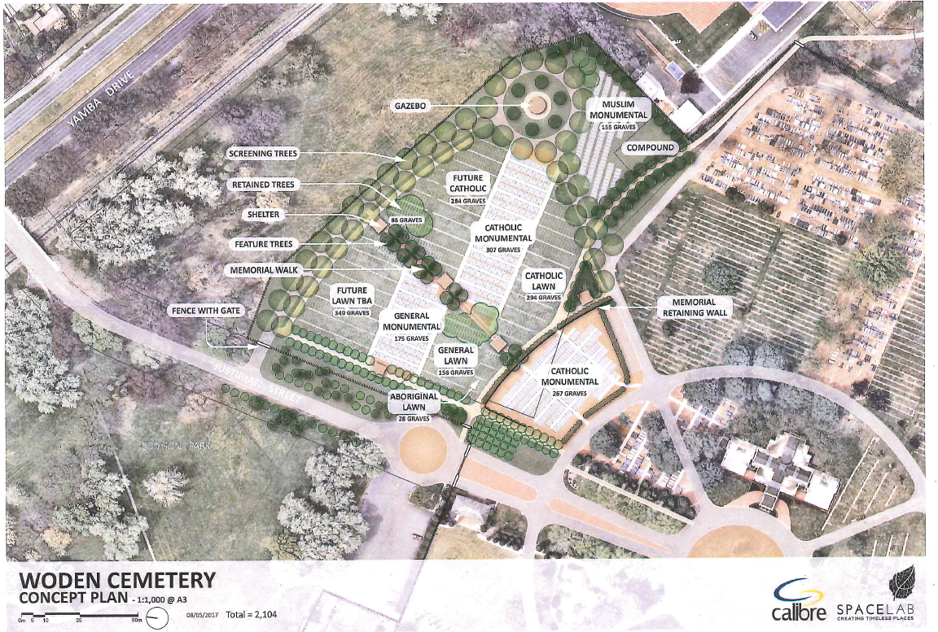

              - Plan for Southern Memorial Park

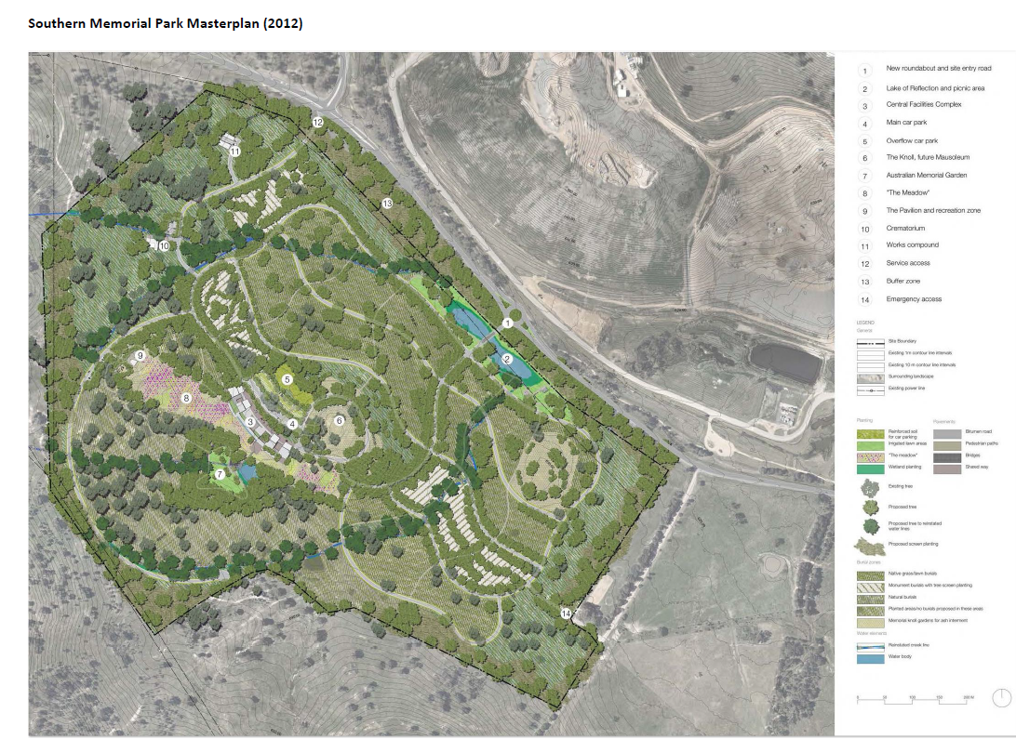

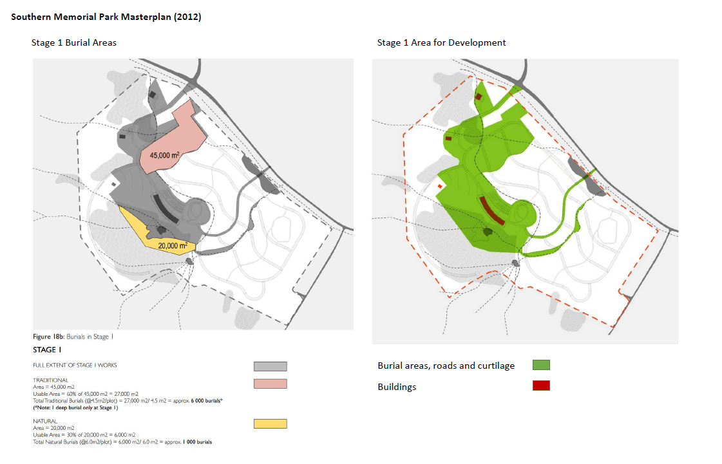

See, ACT Legislative Assembly, Minutes of Proceedings, 13 December 2016, p. 13.
See http://www.legislation.act.gov.au/di/2007-100/default.asp
Submission 11, ACT Cemeteries Authority, p.5.
Submission 11, ACT Cemeteries Authority, p.5
Submission 11, ACT Cemeteries Authority, p. 5
Submission 11, ACT Cemeteries Authority, p. 6.
Transcript of evidence, 23 October 2017, pp.43-4.
See, for example: http://www.canberracemeteries.com.au/canberra-cemeteries-home-page/forms-downloads; http://norwoodpark.com.au/
Transcript of evidence, 5 October 2017, p.9
Transcript of evidence, 5 October 2017, p. 15
Transcript of evidence, 5 October 2017, p. 15
Submission 11, ACT Cemeteries Authority, p. 7.
Transcript of evidence, 18 October 2017, p. 36.
Transcript of evidence, 18 October 2017, p. 36.
Transcript of evidence, 5 October 2017, pp. 5-6.
Submission 11, ACT Cemeteries Authority, p. 7
Transcript of evidence, 5 October 2017, p. 6
Transcript of evidence, 23 October 2017, p. 44.
Transcript of evidence, 18 October 2017, p. 35.
Transcript of evidence, 23 October 2017, p. 50.
Submission 11, ACT Cemeteries Authority, p. 7.
Submission 11, ACT Cemeteries Authority, p. 10.
Submission 11, ACT Cemeteries Authority, p. 11.
Submission 11, ACT Cemeteries Authority, p. 11
Submission 11, ACT Cemeteries Authority, p. 11; and see also Attachment C to that submission.
Submission 11, ACT Cemeteries Authority, p. 11
Submission 11, ACT Cemeteries Authority, p. 11.
Submission 11, ACT Cemeteries Authority, p. 12.
Transcript of evidence, 5 October 2017, p. 9
Submission 11, ACT Cemeteries Authority, pp. 11-12.
Submission 11, ACT Cemeteries Authority, p. 8.
Submission 11, ACT Cemeteries Authority, p. 8.
See: Attachment D, Submission 11, ACT Cemeteries Authority p. 1
ACT Government, Transport Canberra and City Services Directorate, Annual Report 2016-17 volume 2, ACT Public Cemeteries Authority, p. 11.
Op. Cit, p. 11.
Transcript of evidence, 18 October 2017, p. 26.
Transcript of evidence, 18 October 2017, pp. 26-27
See submission 1, Woden Valley Community Council, and submission 5, Western Creek Community Council
Transcript of evidence, 11 October 2017, pp. 14-15.
Transcript of evidence, 11 October 2017, p. 15.
Submission 4, Catholic Archdiocese of Canberra-Goulburn, p. 1
Transcript of evidence 11 October 2017, p. 18.
Transcript of evidence 11 October 2017, p. 18.
Transcript of evidence 18 October 2017, pp. 28-30.
Submission 11, ACT Cemeteries Authority, p. 8.
Transcript of evidence, 18 October 2017, pp. 28-29.
Transcript of evidence, 18 October 2017, pp. 28-29
Submission 11, ACT Cemeteries Authority, p. 9.
See: Attachment B, Submission 11, ACT Cemeteries Authority p. 15.
Submission 11, ACT Cemeteries Authority, p. 9.
Transcript of evidence, 5 October 2017, p. 7.
Transcript of evidence, 5 October 2017, p. 11.
Transcript of evidence, 5 October 2017, p. 12.
Transcript of evidence, 18 October 2017, p. 31.
Transcript of evidence, 18 October 2017, p. 25.
Submission 11, ACT Cemeteries Authority, p. 9.
Submission 11, ACT Cemeteries Authority, p. 10.
Submission 3, Peter Dinn, p. 3.
Submission 11, ACT Cemeteries Authority, p. 9.
Submission 11, ACT Cemeteries Authority, p. 12.
Transcript of evidence, 18 October 2017, p. 26.

