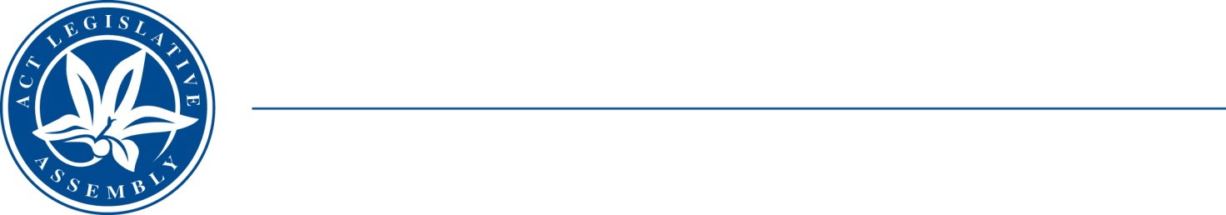
QToN No. 91
Committee Support
LEGISLATIVE ASSEMBLY
FOR THE AUSTRALIAN CAPITAL TERRITORY
Standing Committee on Health and Community Wellbeing

Inquiry into Annual and Financial Reports 2021-2022

ANSWER TO QUESTION TAKEN ON NOTICE

Asked by JONATHAN DAVIS MLA on 1 November 2022: MS EMMA DAVIDSON took on notice the following question(s):

Reference: Hansard uncorrected proof transcript 9 November 2022 Page 118

In relation to:

Do you know how many people have been turned away from the service in Canberra?

MS EMMA DAVIDSON MLA: The answer to the Member’s question is as follows:–

Southside Step Up Step Down (SUSD) (Garran) is operated by a non-government organisation STRIDE.

From 4 May 2021 to 8 August 2022, SUSD received 303 referrals and 82 referrals or 28 per cent were not accepted or closed.

Referrals were not accepted due to a variety of reasons, including risk assessment, clinical decision and appropriate care pathway planning, alternative care and treatment arrangements being utilised and the consumer choosing not to enter the program.

Approved for circulation to the Standing Committee on Health and Community Wellbeing

Signature: Date:

By the Minister for Mental Health, Ms Emma Davidson MLA

