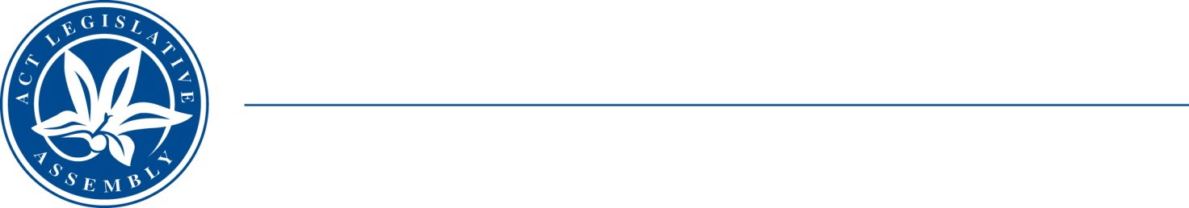
QToN No. 99
Standing Committee on Health and Community Wellbeing
Mr Johnathan Davis MLA (Chair), Mr James Milligan MLA (Deputy Chair), Dr Marisa Paterson MLA
LEGISLATIVE ASSEMBLY
FOR THE AUSTRALIAN CAPITAL TERRITORY
Standing Committee on Health and Community Wellbeing

Inquiry into Annual and Financial Reports 2021-2022

QUESTION TAKEN ON NOTICE

Asked by MR JOHNATHAN DAVIS MLA on 10 November 2022: MR GEOFF AIGNER took on notice the following question(s):

Reference: Hansard uncorrected proof transcript 10 November 2022, Page 183

In relation to: Eviction of tenant from ACT Housing property because of unneighbourly behaviour complaints

THE CHAIR: Have there been any instances in the last financial year where Housing ACT has had to evict a tenant because of unneighbourly behaviour complaints, not necessarily rent arrears or other issues, but specifically those sort of complaints?

Mr Aigner: We have had–I think it is also in the annual report, Mr Davis–six items have gotten to a stage where we were able to issue a warrant. Four of those were turned over at the last minute by ACAT. We were able to find some remediation. The two that remain, I think one of those was an antisocial behaviour issue, but I would need to check that.

THE CHAIR: Happy to take that on notice?

Mr Aigner: Yes.

Minister Vassarotti: The answer to the Member’s question is as follows:–

During the 2021/22 financial year there was one Tribunal order made for the termination of a public housing tenancy under section 48 of the Residential Tenancies Act due to anti-social behaviours.

The tenant abandoned the premises before the warrant was issued. This matter is represented in the Annual Report as the single matter where the tenant left after the Unconditional Termination and Possession order was granted.

Approved for circulation to the Standing Committee on Health and Community Wellbeing

Signature: Date:

By the Minister Homelessness and Housing Services, Minister Rebecca Vassarotti

