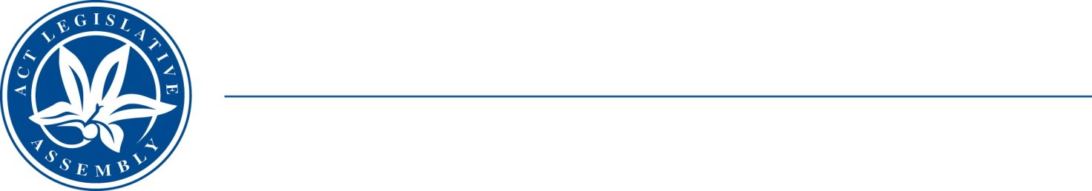
QToN No. 9
Committee Support
LEGISLATIVE ASSEMBLY
FOR THE AUSTRALIAN CAPITAL TERRITORY
Standing Committee on Health and Community Wellbeing

Inquiry into Annual and Financial Reports 2021-2022

ANSWER TO QUESTION TAKEN ON NOTICE

Asked by MS LEANNE CASTLEY MLA on 1 November 2022: MR DAVE PEFFER took on notice the following question(s):

Reference: Hansard uncorrected proof transcript 1 November 2022 Page 38

In relation to:

Is the UCH Hydrotherapy Pool fully subscribed every day?

MINISTER STEPHEN-SMITH MLA: The answer to the Member’s question is as follows:–
The University of Canberra Hospital (UCH) hydrotherapy pool is used by Canberra Health Services (CHS) during business hours (9:00am to 5:00pm, Monday to Friday).
The pool has been made available to non-government organisations such as Arthritis ACT and Water Wombats when it is not being used by CHS to provide further access to the pool for the community. This includes early mornings, lunch times, in the afternoon and evening and on Saturdays. A breakdown of how time is allocated is below.

User | Hours per week
CHS | 30.5
Arthritis ACT | 28
Water Wombats | 8

Approved for circulation to the Standing Committee on Health and Community Wellbeing

Signature: Date:

By the Minister for Health, Ms Rachel Stephen-Smith MLA

