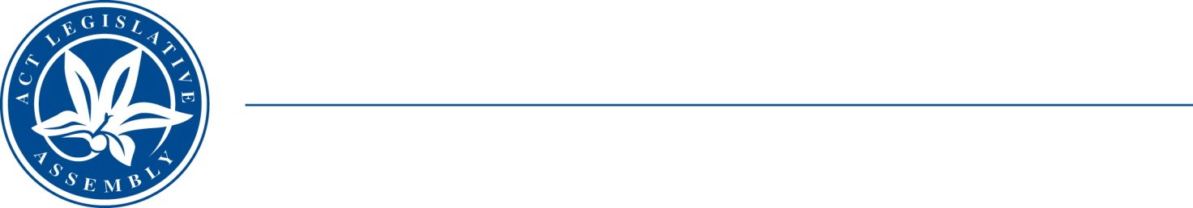
QToN No. 90
Committee Support
LEGISLATIVE ASSEMBLY
FOR THE AUSTRALIAN CAPITAL TERRITORY
Standing Committee on Health and Community Wellbeing

Inquiry into Annual and Financial Reports 2021-2022

ANSWER TO QUESTION TAKEN ON NOTICE

Asked by MR JONATHAN DAVIS MLA on 1 November 2022: MS KATIE MCKENZIE took on notice the following question(s):

Reference: Hansard uncorrected proof transcript 9 November 2022 Page 115

In relation to:

How many people have we supported in this program since it was established?

MINISTER EMMA DAVIDSON MLA: The answer to the Member’s question is as follows:

Southside Step Up Step Down (SUSD) is operated by a non-government organisation STRIDE.

From 4 May 2021 to 8 August 2022, SUSD received 303 referrals and 221 referrals were accepted or 72 per cent.

Approved for circulation to the Standing Committee on Health and Community Wellbeing

Signature: Date:

By the Minister for Mental Health, Ms Emma Davidson MLA

