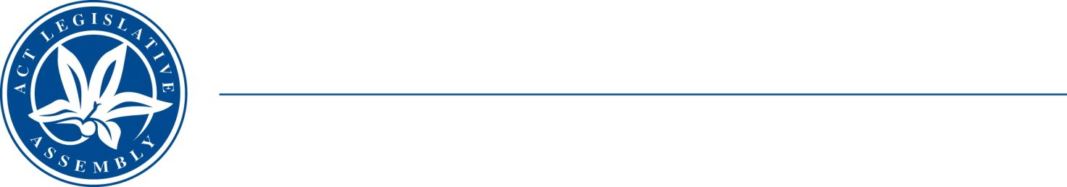
QToN No. 13
Committee Support
LEGISLATIVE ASSEMBLY
FOR THE AUSTRALIAN CAPITAL TERRITORY
Standing Committee on Health and Community Wellbeing

Inquiry into Annual and Financial Reports 2021-2022

ANSWER TO QUESTION TAKEN ON NOTICE

Asked by MS LEANNE CASTLEY MLA on 1 November 2022: MR DAVE PEFFER took on notice the following question(s):

Reference: Hansard uncorrected proof transcript 1 November 2022 Page 49

In relation to:

Workforce and junior doctors:
- Is there a shortfall of junior doctors in the hospital?

MINISTER STEPHEN-SMITH MLA: The answer to the Member’s question is as follows:–
The Canberra Hospital currently has a shortfall of 11 post graduate year one and two (PGY1/2) junior medical officers (JMO).
Six of these roles are filled and are awaiting the finalisation of processes by Department of Home Affairs and the Australian Health Practitioner Regulation Agency (AHPRA) for commencement. The remaining roles are subject to ongoing recruitment action.

Approved for circulation to the Standing Committee on Health and Community Wellbeing

Signature: Date:

By the Minister for Health, Ms Rachel Stephen-Smith MLA

