Standing Committee on Public Accounts and Administration
Inquiry into Public Sector (Closing the Gap) Legislation Amendment Bill 2025

About the committee

Establishing resolution
The Assembly established the Standing Committee on Public Accounts and Administration on 3 December 2024.
The Committee is responsible for the following areas:
- Accounts of the receipts and expenditure of the ACT and its authorities
- All reports of the Auditor-General which have been presented to the Assembly
- ACT Public Service
- Procurement Policy
- Insurance Policy
- Chief Digital Officer
- Digital and Data Strategy
- Finance
- Treasury (including taxation and revenue)
You can read the full establishing resolution on our website.

Committee members
Mr James Milligan MLA, Chair
Ms Fiona Carrick MLA, Deputy Chair
Ms Caitlin Tough MLA

Secretariat
Ms Sophie Milne, Committee Secretary
Ms Cherelyn Brearley, Assistant Secretary
Ms Kate Horgan, Assistant Secretary
Ms Mae Zhu, Administrative Officer

Contact us
Mail Standing Committee on Public Accounts and Administration
Legislative Assembly for the Australian Capital Territory
GPO Box 1020
CANBERRA ACT 2601
Phone (02) 6205 4053
Email LACommitteePAA@parliament.act.gov.au
Website parliament.act.gov.au/parliamentary-business/in-committees

About this inquiry
The Public Sector (Closing the Gap) Legislation Amendment Bill 2025 was presented in the Assembly on 26 June 2025 and referred to the Standing Committee on Public Accounts and Administration. Standing order 174 refers all bills presented to the Assembly to the relevant standing committee for inquiry. A Committee has three weeks from the date of presentation, or one week after the tabling of the relevant scrutiny report, whichever is later, to advise the Speaker on whether it will undertake an inquiry.
If the Committee does decide to undertake an inquiry, it must report within three months from the date of presentation of the bill, with the exception of bills presented in the last sitting period of a calendar year, in which case the Committee has four months to inquire and report.
The Committee decided to inquire into the bill on 1 September 2025. The reporting date was 25 September 2025.
Committees may seek an extension from the Assembly to the reporting date of a Bill inquiry. The Committee sought and was granted an extension for this inquiry on 3 September 2025, with the new reporting date being 25 November 2025.

Contents
About the committee i
Establishing resolution i
Committee members i
Secretariat i
Contact us ii
About this inquiry iii
Acronyms & Abbreviations vi
Recommendations vii
1. Introduction 1
Conduct of the Inquiry 1
Background 1
Closing the Gap 1
Partnership Agreement on Closing the Gap 2019-2029 1
National Agreement on Closing the Gap 2
Productivity commission review 3
ACT Aboriginal and Torres Strait Islander Agreement 2019-2028 5
ACT Aboriginal and Torres Strait Islander Elected Body (ATSIEB) 5
The Bill 5
Scrutiny Report 8 6
2. Recommendations 7
Committee Comment 8
Obligations on the public service 8
Committee Comment 9
Implementation 9
Committee Comment 10
Possible further amendments 10
Committee Comment 11
Post-implementation review 11
Committee Comment 12
3. Conclusion 13
Appendix A: Submissions 14
Appendix B: Witnesses 15
Thursday, 09 October 2025 15
Appendix C: Gender distribution of witnesses 16

Acronyms & Abbreviations
Acronym or Abbreviation | Long form
ACT | Australian Capital Territory
ACTPS | ACT Public Service
ALGA | Australian Local Government Association
ATSIEB | Aboriginal and Torres Strait Islander Elected Body
COAG | Council of Australian Governments
MLA | Member of the Legislative Assembly
SES | Senior Executive Service

Recommendations
Recommendation 1
The Committee recommends that the Assembly pass the Public Sector (Closing the Gap) Legislation Amendment Bill 2025 with amendments.
Recommendation 2
The Committee recommends that the Assembly pass the amendments, provided in Mr Emerson’s submission, that restrict the closing the gap principle obligation to SES members.
Recommendation 3
The Committee recommends that the Assembly pass an amendment to the Bill to change the commencement date to 1 July 2026.
Recommendation 4
The Committee recommends the Assembly consider supporting any further minor technical amendments to the Bill.
Recommendation 5
The Committee recommends a post-implementation review is undertaken twelve months after commencement to evaluate the effectiveness and consequences of the legislation.

Introduction

Conduct of the Inquiry
  - On 12 February 2025, the Committee resolved to conduct an inquiry into the Public Sector (Closing the Gap) Legislation Amendment Bill 2025 and called for submissions.
  - The Committee held a public hearing on 9 October 2025. The Committee heard evidence from witnesses listed in Appendix A. The transcript and video recordings are available on the Legislative Assembly website.
  - The Committee did not receive any questions on notice or questions taken on notice.
  - Statistics on the gender of witnesses, collected in response to an audit by the Commonwealth Parliamentary Association, are at Appendix C. The information is collected to determine whether committee inquiries are meeting the needs, and allowing the participation of, a range of genders in the community. Participation is voluntary and there are no set responses.
  - In this report, references to Committee Hansard are to proof transcripts of evidence. Page numbers may vary between proof and official transcripts.
  - The Committee wishes to acknowledge the traditional custodians of the lands which it meets on, the Ngunnawal people, and recognise any other people or families with connection to the lands of the ACT and region. We wish to acknowledge and respect their continuing culture and the contribution they make to the life of the city and this region.

Background

Closing the Gap
  - In 2007 and 2008, the Council of Australian Governments (COAG) formally agreed to ‘close the gap’ in key socio-economic indicators between Aboriginal and Torres Strait Islander peoples, and non-Aboriginal and Torres Strait Islander peoples. This included committing to targets such as closing the life expectancy gap within a generation and reducing the gap in areas such as early childhood education, mortality rates, and employment outcomes.
  - In 2019, a Coalition of Aboriginal and Torres Strait Islander Peak Organisations, also known as the Coalition of Peaks, was formed to work with COAG on a ‘refresh’ of closing the gap policy.

Partnership Agreement on Closing the Gap 2019-2029
  - In 2019, an agreement was signed between the Coalition of Aboriginal and Torres Strait Islander Peak Organisations, and the Council of Australian Governments, now known as National Cabinet, to share decision-making on closing the gap with Aboriginal and Torres Strait Islander community-controlled representatives. This included decisions on the design, implementation and monitoring of the Closing the Gap framework.

National Agreement on Closing the Gap
  - A new National Agreement on Closing the Gap (the National Agreement) was signed in 2020 by First Ministers of all Australian governments, the Lead Convener of the Coalition of Aboriginal and Torres Strait Islander Peak Organisations (the Coalition of Peaks) and the President of the Australian Local Government Association (ALGA).
  - It states:
15. The objective of this Agreement is to overcome the entrenched inequality faced by too many Aboriginal and Torres Strait Islander people so that their life outcomes are equal to all Australians.
16. The Parties commit to mobilising all avenues and opportunities available to them to meet the objective of this Agreement.
  - Parties to the National Agreement committed to the following four priority reforms:
- Formal partnerships and shared decision-making;
- Building the community-controlled sector;
- Transforming government organisations; and
- Shared access to data and information at a regional level.
  - Accountability to the National Review was outlined via the following mechanisms:
- A publicly accessible dashboard of data on the progress, to be maintained by the Productivity Commission;
- Annual reports by each party;
- A comprehensive review every three years, to be carried out by the Productivity Commission;
- Subsequent reviews in the 12 months after each Productivity Commission review, to be carried out in partnership with the Coalition of Peaks;
- Formal responses to the reviews; and
- An annual update.

Productivity commission review
  - The first Productivity Commission Review (the Review) was published in January 2024. The review analysed progress made against the four priority reforms; analysed progress against socio-economic commitments; and examined the factor affecting said progress.
  - The Review found that while there were ‘some pockets of good practice’, progress on implementing the priority reforms had been weak, and largely reflected a ‘business as usual’ approach:
The Productivity Commission’s first review of the Agreement shows that governments are not adequately delivering on this commitment.
  - The review made four over-arching recommendations which included numbered ‘essential actions’ for implementation.
  - The two essential actions which the Bill draws from are as follows:
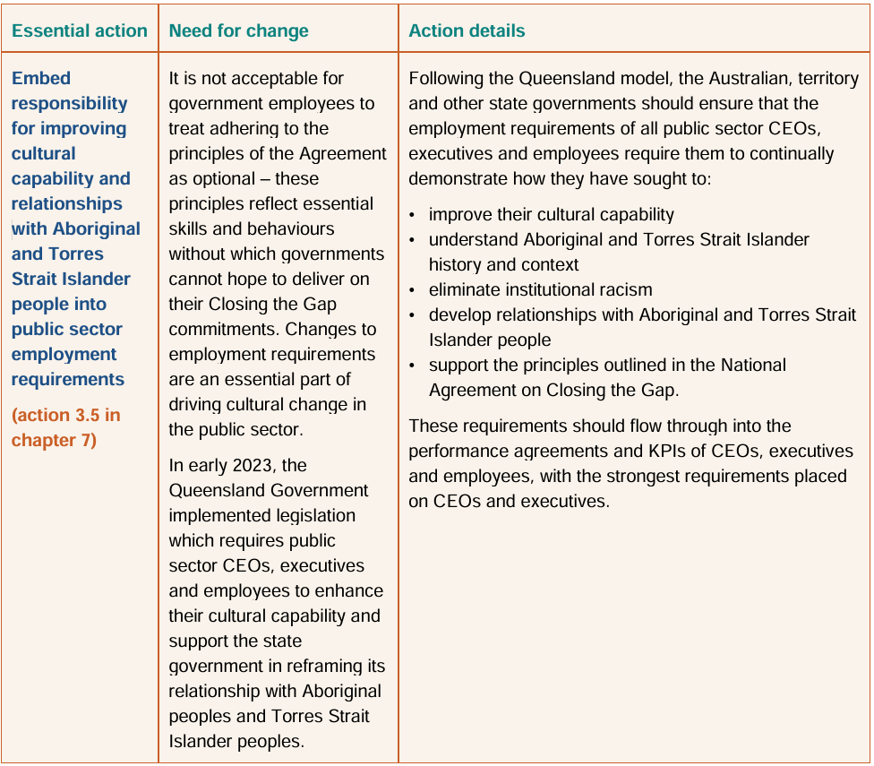
Figure 1: Essential action 3.5 (Australian Government Productivity Commission, Review of the National Agreement on Closing the Gap, Study report Volume 1, January 2024, p 21.)
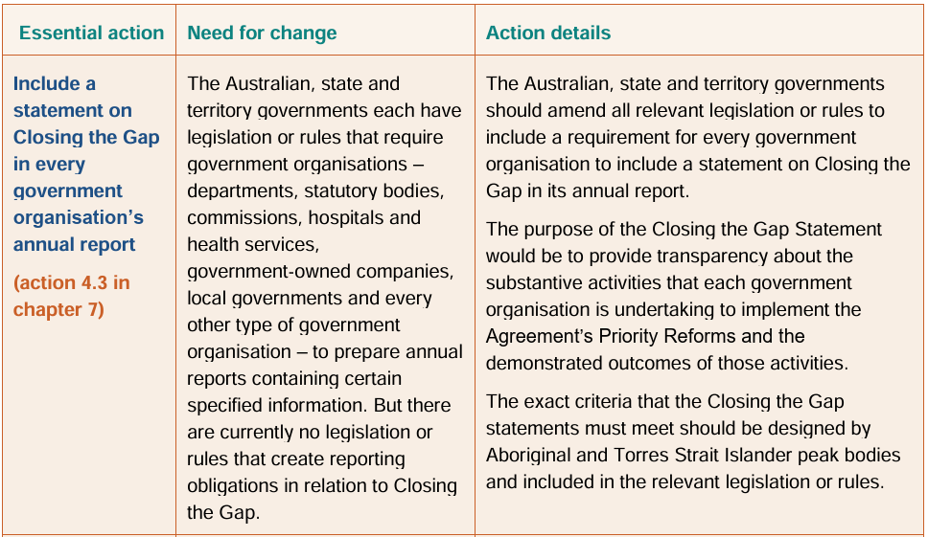
Figure 2: Essential action 3.5 (Australian Government Productivity Commission, Review of the National Agreement on Closing the Gap, Study report Volume 1, January 2024, p 21.)

ACT Aboriginal and Torres Strait Islander Agreement 2019-2028
  - As a signatory to the National Agreement, the ACT Government is committed to its objectives and priority reforms.
  - The ACT Aboriginal and Torres Strait Islander Agreement 2019-2028 (the ACT Agreement), which was co-signed by the ACT Government and the ACT’s Aboriginal and Torres Strait Islander Elected Body, ‘obligates the signatories to work together to enable equitable outcomes for Aboriginal and Torres Strait Islander peoples in the ACT.’ According to a 2024-25 Annual Impact Statement, the ACT Agreement ‘aligns with and helps deliver against [the Government’s] commitments under the National Agreement on Closing the Gap.’

ACT Aboriginal and Torres Strait Islander Elected Body (ATSIEB)
  - ATSIEB was established under the Aboriginal and Torres Strait Islander Elected Body Act 2008 to enshrine to right of Aboriginal and Torres Strait Islander people living in the ACT to participate in policy development in matters affecting them, in order to further their economic, social and cultural development.
  - Among its other functions, ATSIEB is legislated to ‘monitor and report on the effectiveness and accessibility of programs and services conducted by government agencies for Aboriginal and Torres Strait Islander people living in the ACT.’

The Bill
  - The Public Sector (Closing the Gap) Legislation Amendment Bill 2025 (the Bill) was introduced by Mr Thomas Emerson MLA on 26 June 2025.
  - The Bill seeks to amend the Annual Reports (Government Agencies) Act 2004 and the Public Sector Management Act 1994 to legislate ACT Government commitments under the National Agreement, specifically essential actions 3.5 and 4.3 of the Review
  - Essential action 3.5 recommends embedding responsibility for improving cultural capability and relationships with Aboriginal and Torres Strait Islander people into public sector employment requirements. Essential action 4.3 recommends including a statement on Closing the Gap in every government organisation’s annual report.
  - Part 2 of the Bill would implement essential action 4.3 by amending Part 2 of the Annual Reports (Government Agencies) Act 20004, which sets out requirements for Australian Capital Territory bodies to report on their operations during a reporting year. The Bill would insert new section 7E to require that annual reports prescribed by the Act contain ‘information about the measures taken by the reporting entity to implement the National Agreement on Closing the Gap,’ including specifics on measures to implement priority reforms and responses to recommendations from reviews of the National Agreement.
  - Part 3 of the Bill would implement essential action 3.5 by inserting the ‘closing the gap principle’ as a public sector principle in the Public Sector Management Act 1994. It also provides definitions of ‘Aboriginal and Torres Strait Islander cultural capability’, ‘closing the gap principle’, and ‘National Agreement on Closing the Gap’. This addition would have the effect of requiring all ACT public servants to do their jobs in accordance with the closing the gap principle, as well as the current best practice principle.

Scrutiny Report 8
  - Although the original Explanatory Statement to the Bill said that it would not materially limit any human rights, the Standing Committee on Legal Affairs (Legislative Scrutiny Role) found that it did impact on the right to work due to the ‘additional obligations on the work of a public servant’ which it would impose. The Scrutiny Committee drew this matter to the attention of the Assembly and asked Mr Emerson to respond.
  - In response, Mr Emerson provided an amended explanatory statement which explains the limitation and why it is reasonable and proportionate. The Scrutiny Committee was satisfied with the amended explanatory statement. Mr Emerson also provided it to this inquiry as an attachment to his submission.

Recommendations
  - Mr Emerson’s submission points to multiple critical reviews of governments’ actions on Closing the Gap:
Since the signing of the National Agreement, multiple reviews have criticised governments for failing to follow through on their Closing the Gap commitments, making recommendations for what governments need to do differently to implement their obligations under the Agreement.
  - His submission described the ACT Government’s progress on meeting the targets of the National Agreement as ‘mixed’ and says that Aboriginal and Torres Strait Islander people are over-represented in the ACT in areas such as children’s out-of-home care, youth detention, and adult incarceration.
  - The ACT Aboriginal and Torres Strait Islander Elected Boday (ATSIEB) also presented a negative view of the effects of the ACT’s Aboriginal and Torres Strait Islander Agreement 2019-2028 and its underlying Action Plans. They believe that the lack of positive outcomes comes from a lack of responsibility, of enforcement, or of consequences.
  - The ATSIEB submission also stated that due to the lack of accountability at the Government level, this work falls to their own organisation and communities:
The onus falls back on ATSIEB, our Aboriginal Community-Controlled Organisations and the community to continually highlight failures, rather than on government to prove success.
  - Mr Emerson explains that his Bill aims to implement essential actions 3.5 and 4.3 of the Productivity Commission’s Review as closely as possible to the format suggested by the review’s recommendations. This is to increase accountability within the work of the ACT government by requiring that public servants uphold the principle of Closing the Gap within their work and by requiring that government agencies report on their progress towards the targets of Closing the Gap in their annual reports.
  - Most submitters to this inquiry expressed support for the passage of the Bill, either in its current or some amended form.
  - The ACT Government also supports the principle and intent of the Bill but raised some concerns over its practical implementation.

Committee Comment
  - The Committee notes that one of the witnesses at the public hearing stated that he did not feel culturally safe in his current employment within the ACTPS. The Committee hopes that this Bill will work towards rectifying this issue across the ACTPS.
  - The Committee supports the Bill in principle but recommends that it be amended before being passed by the Assembly, as will be discussed below.
Recommendation
The Committee recommends that the Assembly pass the Public Sector (Closing the Gap) Legislation Amendment Bill 2025 with amendments.

Obligations on the public service
  - In its current form, the Bill obliges the entire ACT public service to do their work in accordance with the closing the gap principle. The Bill defines this principle as follows:
closing the gap principle—a public servant does the public servant’s job in accordance with the closing the gap principle if the public servant—
(a) demonstrates Aboriginal and Torres Strait Islander cultural capability; and
(b) works to develop the Aboriginal and Torres Strait Islander cultural capability of the administrative unit in which the public servant is employed; and
(c) implements the principles of the National Agreement on Closing the Gap, to the extent they relate to the public servant’s job and the administrative unit in which the public servant is employed; and
(d) promotes cultural safety (within the meaning of the National Agreement on Closing the Gap) for Aboriginal and Torres Strait Islander peoples; and
(e) works to eliminate institutional racism in the administrative unit in which the public servant is employed.
  - The ACT Government raised their concern that this would be too onerous a legislative requirement to be placed on every ACT public servant, especially given the varied nature of the ACTPS:
While acknowledging there should be an expectation that every public servant seeks to continually commit to a life-long journey of cultural capability, the Government does not consider it is reasonable to place this legal obligation on every public servant, from graduates, school cleaners and parking inspectors, to the SES in the Community Services Directorate.
  - In response to these concerns about the scope of the Bill, Mr Emerson MLA presented with his submission a proposed amendment which would restrict the obligation of the closing the gap principle to senior public servants, named the SES (Senior Executive Service).
  - The ACT Government submitted that this would be an appropriate amendment to the Bill’s requirement, noting that ‘a core function of the SES is to be responsible for leadership in the service, advance whole-of-government strategies, and promote and uphold the public sector values, principles and conduct, including by personal example.’
  - The ACT Government submission also notes that, in time, the obligation could potentially be placed on all levels of the public service, once industrial considerations that the obligations enliven are worked through.

Committee Comment
  - The Committee supports Mr Emerson’s amendment which would restrict the obligation of upholding the closing the gap principle to SES members.
Recommendation
The Committee recommends that the Assembly pass the amendments, provided in Mr Emerson’s submission, that restrict the closing the gap principle obligation to SES members.

Implementation
  - The Government submission raised concerns over the timing of the Bill, and suggested that its debate be delayed to allow time for more consultation with the ACT Aboriginal and Torres Strait Islander Elected Body, ACTPS (ACT Public Service) employees, unions, and the broader Aboriginal and Torres Strait Islander community. It also stated that the Government is already ‘actively taking steps to implement Essential Actions 3.5 and 4.3 in a considered and meaningful way.’
  - The Committee received evidence from the Aboriginal and Torres Strait Islander community that delaying the passage of the Bill would be harmful. Mr Maurice Walker, Chairperson of ATSIEB, stated at the public hearing that he would personally be in favour of the Bill being passed sooner, even with a delayed implementation date to allow time for consultation. However, he did not believe that the community would be happy for the implementation timeframe to extend beyond June 2026.
  - The submission from ATSIEB made a strong statement on the use of deferrals and delays in these processes:
Time has become a weaponised currency in the ACT Government’s slow response to the needs of Aboriginal and Torres Strait Islander peoples. Continued delays have nationally significant social and economic costs. Without time-bound targets, accountability mechanisms, or incentives to act, commitments risk remaining aspirational rather than operational. These delays contribute to systemic risk, weakening the effectiveness and credibility of public institutions over time.

Committee Comment
  - The Committee supports amending the commencement date of the bill to 1 July 2026.
Recommendation
The Committee recommends that the Assembly pass an amendment to the Bill to change the commencement date to 1 July 2026.

Possible further amendments
  - The ACT Government, in suggesting extra time for consideration of the Bill, raised some of the following technical issues.
  - One was that the requirement of the Bill for government agencies to report on progress towards Closing the Gap could duplicate similar obligations laid out in the annual reporting directions. These annual reports directions are made yearly in the form of a Notifiable Instrument, which is open for consultation by this Committee before it is tabled in the Assembly.
  - The current annual reports directions, which came into effect in May, require all reporting entities to report on annual progress under the ACT Aboriginal and Torres Strait Islander Agreement 2019 – 2028 (ACT Agreement) and the National Agreement on Closing the Gap (National Agreement) through the Impact Statement and through the ACT Annual Report for the National Closing the Gap Agreement coordinated by the Office of Aboriginal and Torres Strait Islander Affairs for the ACT Public Service. This reporting was optional for the 2023-24 year but is now a requirement for the 2024-25 period.
  - Another issue was that of definitions. The ACT Government submission argued that variable definitions for key terms (such as ‘racism’ and ‘systemic bias’) are already used across ACT legislation and policies, and should be harmonised before the Bill can come into effect.
  - The Minister for the Public Service, during the public hearing, also elaborated on some technical details regarding legislative drafting.

Committee Comment
  - The Committee supports any further minor amendments to the Bill which would address minor technical issues.
Recommendation
The Committee recommends the Assembly consider supporting any further minor technical amendments to the Bill.

Post-implementation review
  - During the public hearing, the Government highlighted the need for continuous improvement in building the cultural capacity of the ACTPS. The Head of Service pointed especially to the complexity of the tools and compliance framework which would be required to implement the amendment to the Public Sector Management Act.
  - Other witnesses raised questions about how the Bill would work in practice, and whether it could have unintended effects, or whether it needed to be strengthened to allow for a greater level of responsibility.
  - Ms Katrina Fanning, former chairperson of ATSIEB (who was appearing in a personal capacity), raised the possibility that if the closing the gap obligation was restricted to SES officers, they could still delegate the work to junior employees who may not have the required skill level or expertise.
  - Mr Walker called for greater accountability provisions in the Bill, saying:
If this bill is to mean anything, it must answer three simple questions. Who is responsible? What happens when they fail? How will the community know the truth?

Committee Comment
  - The Committee believes that a post-implementation review would be a useful mechanism to evaluate the effectiveness of the legislation.
Recommendation
The Committee recommends a post-implementation review is undertaken twelve months after commencement to evaluate the effectiveness and consequences of the legislation.

Conclusion
  - The Committee would like to express its thanks to all those who contributed submissions and attended as a witness at the public hearing.
  - The Committee has made five recommendations in the report.

Mr James Milligan MLA
Chair, Standing Committee on Public Accounts and Administration
October 2025

Appendix A: Submissions
No. | Submission by | Received | Published
01 | Sarah Ahmed | 12/09/25 | 29/09/25
02 | Name Withheld | 15/09/25 | 29/09/25
03 | Hepatitis ACT | 18/09/25 | 29/09/25
04 | ACT Council of Social Service (ACTCOSS) | 18/09/25 | 29/09/25
05 | Productivity Commission | 18/09/25 | 29/09/25
06 | Alcohol Tobacco & Other Drug Association ACT (ATODA) | 19/09/25 | 29/09/25
07 | Beryl Women Inc. | 19/09/25 | 29/09/25
08 | ACT Government | 19/09/25 | 29/09/25
09 | St Vincent de Paul Society Canberra/Goulburn | 19/09/25 | 29/09/25
10 | CATSINaM | 20/09/25 | 29/09/25
11 | Active Democracy Bean | 20/09/25 | 29/09/25
12 | Paula McGrady | 21/09/25 | 29/09/25
13 | ANTaR ACT | 21/09/25 | 29/09/25
14 | Our Booris, Our Way | 16/09/25 | 29/09/25
15 | Mr Thomas Emerson MLA | 22/09/25 | 29/09/25
16 | Aboriginal Community leaders | 22/09/25 | 29/09/25
17 | Ngambri (Kamberri) Cultural Group (Walgalu Speaking) Inc. | 25/09/25 | 29/09/25
18 | Aboriginal and Torres Strait Islander Elected Body (ATSIEB) | 30/09/25 | 09/10/25

Appendix B: Witnesses

Thursday, 09 October 2025

Minister
Ms Rachel Stephen-Smith, Minister for the Public Service

Individual
- Ms Katrina Fanning AO PSM

Aboriginal and Torres Strait Islander Elected Body
- Mr Maurice Walker, Chairperson

Chief Minister, Treasury and Economic Development Directorate
- Ms Kathy Leigh, Head of Service and Director-General
- Mr Michael Young, Acting Deputy Director General, Office of Industrial Relations and Workforce Strategy
- Ms Natalee George, Executive Branch Manager, Cultural Transformation Branch, Office of Industrial Relations and Workforce Strategy

Health and Community Services Directorate
- Mr Brendan Moyle, Executive Branch Manager, Strategic Policy

Sponsoring Member
- Mr Thomas Emerson MLA
- Ms Julie Tongs OAM, CEO, Winnunga Nimmityjah Aboriginal Health and Community Services
- Ms Paula McGrady, Former Deputy Chair, ACT Aboriginal and Torres Strait Islander Elected

Appendix C: Gender distribution of witnesses
Beginning in April 2023, in response to an audit by the Commonwealth Parliamentary Association, Committees are collecting information on the gender of witnesses. The aim is to determine whether committee inquiries are meeting the needs, and allowing the participation of, a range of genders in the community. Participation is voluntary and there are no set responses.
Gender indication | Total
Female | 6
Male | 4
Non-binary | 0
Gender neutral | 0
No data | 0

Commonwealth of Australia, Department of the Prime Minister and Cabinet, History of Closing the Gap, undated, https://www.closingthegap.gov.au/resources/history (accessed 14 October 2025).
Coalition of Peaks, Our Story, 2023, https://www.coalitionofpeaks.org.au/our-story (accessed 14 October 2025).
https://federation.gov.au/sites/default/files/about/agreements/partnership-agreement-on-closing-the-gap_0.pdf
Commonwealth of Australia, Department of the Prime Minister and Cabinet, History of Closing the Gap, undated, https://www.closingthegap.gov.au/resources/history (accessed 14 October 2025).
National Agreement 3 objectives and outcomes para 15
Commonwealth of Australia, Department of the Prime Minister and Cabinet, 6. Priority reform areas for joint national action, undated, https://www.closingthegap.gov.au/national-agreement/national-agreement-closing-the-gap/6-priority-reform-areas (accessed 14 October 2025).
Commonwealth of Australia, Department of the Prime Minister and Cabinet, 9. Being publicly accountable for our actions, undated, https://www.closingthegap.gov.au/national-agreement/national-agreement-closing-the-gap/9-being-publicly-accountable-our-actions (accessed 14 October 2025).
Australian Government Productivity Commission, Review of the National Agreement on Closing the Gap, Study report Volume 1, January 2024, p iv.
Australian Government Productivity Commission, Review of the National Agreement on Closing the Gap, Study report Volume 1, January 2024, p 3.
Australian Government Productivity Commission, Review of the National Agreement on Closing the Gap, Study report Volume 1, January 2024, pp 14-24.
Commonwealth of Australia, Department of the Prime Minister and Cabinet, 2. Formalities, undated, https://www.closingthegap.gov.au/national-agreement/national-agreement-closing-the-gap/2-formalities (accessed 14 October 2024).
ACT Government, ACT Aboriginal and Torres Strait Islander Agreement 2019-2028, undated, p 1.
ACT Government, ACT Aboriginal and Torres Strait Islander Agreement 2019-2028, ACT Annual Impact Statement 2024-25, undated, p 6.
Aboriginal and Torres Strait Islander Elected Body Act 2008, s 3.
Aboriginal and Torres Strait Islander Elected Body Act 2008, ss 8(g).
Public Sector (Closing the Gap) Legislation Amendment Bill 2025, Explanatory Statement, p 2.
Australian Government Productivity Commission, Review of the National Agreement on Closing the Gap, Study report Volume 1, January 2024, p 21.
Australian Government Productivity Commission, Review of the National Agreement on Closing the Gap, Study report Volume 1, January 2024, p 24.
Annual Reports (Government Agencies) Act 20004, Part 2.
Proposed section 7E, Public Sector (Closing the Gap) Amendment Bill 2025.
Proposed section 5, Public Sector (Closing the Gap) Amendment Bill 2025.
Proposed section 7, Public Sector (Closing the Gap) Amendment Bill 2025.
Public Sector (Closing the Gap) Legislation Amendment Bill 2025, Explanatory Statement, p 6.
Standing Committee on Legal Affairs (Legislative Scrutiny Role), Report 8, September 2025, p 10.
Standing Committee on Legal Affairs (Legislative Scrutiny Role), Report 10, September 2025, p 17.
Mr Thomas Emerson MLA, Submission 15, Attachment A.
Mr Emerson MLA, Submission 15, p 3.
Mr Emerson MLA, Submission 15, p 3.
ATSIEB, Submission 18, p 2.
ATSIEB, Submission 18, p 4.
Mr Emerson MLA, Submission 15, pp 5-6.
Sarah Ahmed, Submission 1; Hepatitis ACT, Submissions 3; ACTCOSS, Submission 4; Australian Government Productivity Commission, Submission 5; Alcohol Tobacco & Other Drug Association ACT, Submission 6; Beryl Women Inc, Submission 7; St Vincent de Paul Society Canberra/Goulburn, Submission 9; Active Democracy Bean, Submission 11; Paula McGrady, Submission 12; ANTaR ACT, Submission 13; Our Booris, Our Way, Submission 14; Aboriginal Community Leaders, Submission 16; Aboriginal and Torres Strait Isalnder Elected Boday; Submission 18.
ACT Government, Submission 8, p 2; Ms Rachel Stephen-Smith, Minster for the Public Service, Proof Committee Hansard, 9 October 2025, p 16.
Mr Brendan Moyle, Executive Branch Manager, Office for Aboriginal and Torres Strait Islander Affairs, Health and Community Services Directorate, Proof Committee Hansard, 9 October 2025, p 25.
Proposed section 8 (2), Public Sector (Closing the Gap) Amendment Bill 2025.
Proposed section 8 (4), Public Sector (Closing the Gap) Amendment Bill 2025.
ACT Government, Submission 8, p 4.
Mr Emerson MLA, Submission 15, Attachment B.
ACT Government, Submission 8, p 5.
ACT Government, Submission 8, p 6.
The Committee notes that Unions ACT and the CPSU were both invited to provide evidence to this inquiry, however neither made a submission nor requested to appear at the hearing.
ACT Government, Submission 8, p 2.
ATISEB, Submission 18, p 5; Aboriginal Community Leaders, Submission 16, pp 1-2.
Mr Maurice Walker, Chairperson, Aboriginal and Torres Strait Islander Elected Body (ATSIEB), Proof Committee Hansard, 9 October 2025, pp 14-15.
ATISEB, Submission 18, p 5.
ACT Government, Submission 8, p 3.
Annual Reports (Government Agencies) Directions 2025 (No 1), NI2025-240.
ACT Government, Submission 8, p 6.
Ms Rachel Stephen-Smith, Minister for the Public Service, Proof Committee Hansard, 9 October 2025, p 22.
Ms Kathy Leigh, Head of Service and Director-General, Chief Minister, Treasury and Economic Development Directorate (CMTEDD), Proof Committee Hansard, 9 October 2025, p 25.
Ms Leigh, CMTEDD, Proof Committee Hansard, 9 October 2025, p 24.
Ms Katrina Fanning AO PSM, Proof Committee Hansard, 9 October 2025, p 8.
Mr Walker, ATSIEB, Proof Committee Hansard, 9 October 2025, p 10.

