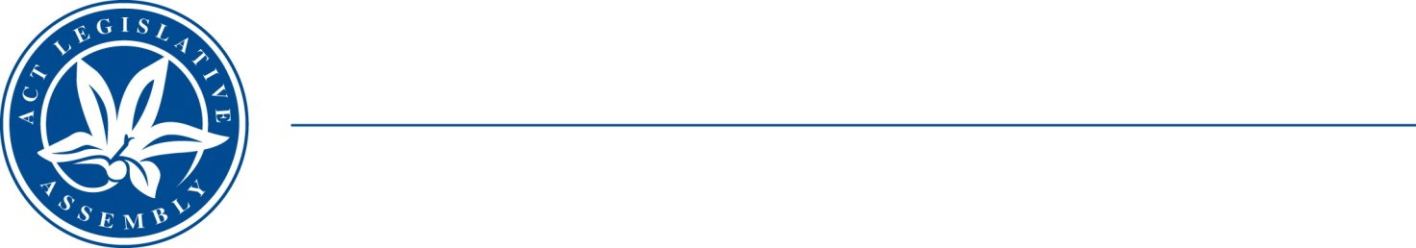
QToN No. 8
Committee Support
LEGISLATIVE ASSEMBLY
FOR THE AUSTRALIAN CAPITAL TERRITORY
Standing Committee on Health and Community Wellbeing

Inquiry into Annual and Financial Reports 2021-2022

ANSWER TO QUESTION TAKEN ON NOTICE

Asked by MR JAMES MILLIGAN MLA on 1 November 2022: MS LIZ LOPA took on notice the following question(s):

Reference: Hansard uncorrected proof transcript 1 November 2022 Page 38

In relation to:

The size and capacity of the new southside hydrotherapy pool.

MINISTER STEPHEN-SMITH MLA: The answer to the Member’s question is as follows:–

The ACT Government is developing a new public hydrotherapy pool at the Tuggeranong Lakeside Leisure Centre, Anketell St, Greenway. This hydrotherapy pool will be developed consistent with the Australasian Health Facility Guidelines.

Community consultation undertaken to date has focussed on the use of the Australasian Health Facility Guidelines as a standard, with some modifications to support ACT user lived experience. The capacity of this standard pool is 12 users and 2 staff. The final design process for the pool will include input from further user consultation.

Approved for circulation to the Standing Committee on Health and Community Wellbeing

Signature: Date:

By the Minister for Health, Ms Rachel Stephen-Smith MLA

