

Alistair Davey, Brett Kaufmann, Roger Fisher and Susan Antcliff
Pegasus Economics
July 2026
Review of the ACT Budget 2026-27

Pegasus Economics • www.pegasus-economics.com.au • PO Box 449 Jamison Centre, Macquarie ACT 2614
Pegasus Economics is a boutique economics and public policy consultancy firm that specialises in strategy and policy advice, economic analysis, trade practices, competition policy, regulatory instruments, accounting, financial management and organisation development.
This report has been commissioned by the ACT Legislative Assembly’s Select Committee on Estimates 2026-2027 to assist the Committee in its deliberations in relation to the 2026-27 ACT Budget.
The views and opinions expressed in this report are entirely those of the authors.
For information on this report please contact:
Name: Dr Alistair Davey
Mobile: 0422 211 110
Email: adavey@pegasus-economics.com.au

Table of Contents
Executive Summary vi
1 Introduction 1
1.1 Purpose 1
1.2 Approach 1
1.3 Limitation of scope 1
2 Economic Forecasts 2
2.1 Economic Overview 2
2.2 ACT Gross State Product and final demand 3
2.3 Employment 9
2.4 Wage price index 10
2.5 Consumer price index 10
2.6 Population growth 10
3 Fiscal Position 12
3.1 Operating Statement - Headline Operating Balance 12
3.2 Changes in the Headline Operating Balance since the last Budget 13
3.3 Medium term forecasts of the Headline Net Operating Balance 14
3.4 Cash Flow Statement 14
3.5 Balance sheet measures of the ACT Government’s financial position 15
3.6 Fiscal strategy 17
4 Revenue 19
4.1 Overview 19
4.2 Tax reform 21
4.3 Payroll Tax 24
4.4 Lease Variation Charge 25
4.5 Gambling Taxes 25
4.6 Dividends and income tax equivalents 26
4.7 Contributed assets 28
4.8 Cost of Living 29
5 Expenses 32
5.1 Overview 32
5.2 Reasons for growth 33
5.3 Expenses by function 34
5.4 Expenses by economic type 36
6 Infrastructure and Capital 41
6.1 Overview 41
6.2 Infrastructure Investment Program (IIP) – Key Elements 42
6.3 Capital Works Program – General Government 44
6.4 Asset Renewal Program 2026-27 45
6.5 Works-In-Progress 46
6.6 Infrastructure Canberra (iCBR) 46
6.7 Capital Works Reserve 46
6.8 Capital Works Program – Public Trading Enterprises 47
6.9 Public Private Partnership Arrangements 47
7 Assets and Liabilities 49
7.1 Overview 49
7.2 Net debt 49
7.3 Net financial liabilities 51
7.4 Net worth 52
7.5 Superannuation 53
8 Budget accounting, classification and valuation issues 58
8.1 Overview 58
8.2 Disclosure of financial statements and key accounting policies 58
8.3 Superannuation return adjustment 59
8.4 Superannuation liability valuation and service costs 59
8.5 Service Concession Arrangements 60
8.6 Acquisition of Calvary Public Hospital and Clare Holland House 61
8.7 Technical adjustments 61
8.8 Concessional loans 61
8.9 Financial Guarantee Contract Liability 61
9 Housing 63
9.1 Housing Approvals and Supply 63
9.2 Housing Affordability 65
9.3 Provision of Public Housing 68
10 References 70

Table 1: Current outcomes and economic estimates and forecasts in the 2026-27 ACT Budget, percentage change 2
Table 2: General Government Sector Headline Net Operating Balance 12
Table 3: General Government Sector Key Balance Sheet Measures 15
Table 4: Dividends and Tax Equivalents 27
Table 5: Estimated impact of increased ACT taxes and fees, and utility charges on households in 2026-27 by percentage of increase in disposable income 30
Table 6: Budget and forecast expenses 32
Table 7: Summary of Infrastructure Investment Program – 2025-26 to 2030-31 41

Figure 1: ACT GSP and Australian GDP – 2000-01 to 2024-25 ($‘000) 5
Figure 2: Components of Final Demand for the New South Wales and ACT economies, year ended March 2026 5
Figure 3: Relative shares of ACT Final Demand – 2013-14 to 2025-26* 6
Figure 4: Percentage of ACT Final Demand made up by the Public Sector (Commonwealth and ACT Government) – 2013-14 to 2025-26* 7
Figure 5: Number of Businesses Operating in the ACT – June 2015 to June 2025 8
Figure 6: Business Survival Rate for All Businesses Operating at 30 June 2021 8
Figure 7: Business Survival Rate for New Business Start-Ups in 2021-22 9
Figure 8: ACT Government and Centre for Population ACT Population Growth Forecasts: 2025-26 to 2029-30 11
Figure 9: Changes in the forecast 2026-27 Budget between the 2025-26 and 2026-27 Budgets 13
Figure 10: Forecast returns to surplus 14
Figure 11: Key balance sheet measures as a proportion of Gross State Product 16
Figure 12: ACT net debt as a proportion of GSP within the range of other States and Territories 17
Figure 13: Estimated ACT Budget Revenue in the 2024-25, 2025-26 and 2026-27 ACT Budgets 20
Figure 14: Revenue Estimated Outcome 2025-26 and Forecast 2026-27 21
Figure 15: Revenue from general rates and conveyances (GSP deflated), 2011-12 to 2029-30 (forecast) 22
Figure 16: Composition of ACT Government Own-Source Taxation Revenue 23
Figure 17: Gambling Taxes as a Proportion of Own-Source Revenue 26
Figure 18: Expense forecasts as a proportion of GSP – 2019-20 to 2026 -27 Budgets 33
Figure 19: Expenses by function, 2025-26 (est.) to 2029-30 35
Figure 20: Expenses by economic type – 2025-26 (est.) to 2029-30 36
Figure 21: Employee expenses showing average annual growth rates, 2016-17 (actual) to 2029-30 37
Figure 22: Interest expenses as a proportion of Gross State Product, 2014-15 (actual) to 2029-30 39
Figure 23: Interest expenses as a percentage of own source taxation revenue, 2016-17 (actual) to 2029-30 40
Figure 24: Capital Works Program Forecasts 45
Figure 25: Net debt as a proportion of Gross State Product 50
Figure 26: Annual growth in net debt and GSP, 2021-22(actual) to 2029-30 (forecast) 51
Figure 27: Net financial liabilities as a proportion of Gross State Product 52
Figure 28: Net worth as a proportion of Gross State Product 53
Figure 29: Estimated Defined Benefit Superannuation Liabilities 54
Figure 30: Estimated Defined Benefit Superannuation Flows 55
Figure 31: Defined Benefit Superannuation Unfunded Liability and Investment Assets 57
Figure 32: Total Number of Dwellings Approved in the ACT – 2011 to 2025 64
Figure 33: Mean Dwelling Price, States and Territories – September Quarter 2025 to March Quarter 2026 ($’000) 65
Figure 34: Median Rent per Week in Australian Capital Cities – March Quarter 2026 66
Figure 35: Portion of Income Required to Service a New Mortgage and Rent for a Dwelling in Australian Capital Cities – September 2025 67
Figure 36: ACT Population and the Provision of ACT Public Housing Dwellings 68

Executive Summary
Overview
The ACT’s fiscal position remains vulnerable. The budget is still in deficit and the promised return to an operating surplus has again been delayed by another year. Net debt continues to grow across the Budget and forward years. Interest payments on borrowings are increasing, reaching 11 percent of expenses and over 30 percent of own-source tax revenue by 2029-30.
The 2026 Budget takes some small steps towards fiscal repair. The budgeted operating cash position is now positive (after several years in deficit), the capital investment program has been wound back, and the ACT Government has set specific and measurable targets with timelines against which its progress toward an improved fiscal position can be measured.
While the ACT Government is on track to achieve its fiscal targets, it has a poor record in achieving its budget forecasts and there are some risks in the estimates. Achievement of the fiscal targets will require a level of expenditure management and financial discipline that has not been evident in the Budgets produced in recent years.
Economy
Public sector demand is expected to be the main engine of growth for the ACT economy in 2026-27. Since the onset of COVID-19, the ACT economy has become more dependent on public sector demand.
While most of the ACT Budget economic forecasts appear reasonable, forecasts for gross state product (GSP) and population growth appear to be on the optimistic side.
The forecasts for GSP assume the ACT economy will grow at a much faster pace than the national economy when compared to both the Commonwealth Government budget forecasts and the most recent growth forecasts from the Reserve Bank of Australia (RBA). Given risks in the outlook this forecast appears optimistic.
Fiscal Position
The Budget forecasts a headline net operating deficit of $323.4 million in 2026-27. The return to surplus previously forecast in last year’s Budget has been pushed back a year, to 2028-29.
After reporting operating cash deficits for three years in a row, the Budget forecasts an operating cash surplus for 2026-27 that increases to $842.9 million in 2029-30. The return to an operating cash surplus is two years later than forecast in the 2024-25 Budget.
The ACT balance sheet has deteriorated over time and remains vulnerable despite some improvement in forecasts for the outyears. Net debt is forecast to continue to grow across the Budget and forward years, reaching 17.3 percent of GSP by 2029-30. Net financial liabilities also increase across the Budget and forward years but fall slightly from 2028-29. Net worth continues to decline until 2028-29 and falls as a proportion of GSP through the Budget and forward estimates period.
The Budget sets out a fiscal strategy that includes specific, measurable targets and timelines. At this stage, the forecasts included in the Budget are consistent with the stated targets.
Revenue
Revenue is forecast to be $9.6 billion in 2026-27, almost $750 million higher than the expected outcome for 2025-26. Revenue rises over the forward years to $10.9 billion by 2029-30.
Policy decisions made by the ACT Government since the 2025-26 Budget are forecast to raise an additional $181.6 million from 2026-27 to 2029-30.
The ACT Government is in the process of rebalancing its tax base by progressively eliminating conveyance duties over a 20-year period and replacing the shortfall through an increase in the general rates system. Based on current policy settings, revenue from conveyance duties will still be around 10 percent of own-source revenue in 2029-30. In the absence of further decisions in relation to conveyance duties and general rates, then it is extremely unlikely the ACT Government will meet its original deadline of eliminating conveyance duties following 20 years of tax reform.
Revenue from payroll tax is forecast to increase from 29.7 percent of ACT Government own-source taxation revenue in 2025-26 to 33.3 percent by 2029-30 – an overall increase of 3.6 percentage points. This is in marked contrast to the percentage of ACT Government own-source taxation revenue expected to be collected from general rates over the same period that is actually flat at around 29 percent.
Expenses
Government expenditure continues to increase. Forecast expenses for 2026-27 of $10.2 billion are $554.4 million, or 5.7 percent, higher than the expected 2025-26 outcome. Growth in expenses has been driven by policy choices to undertake new spending and the interest expenses associated with continued growth in borrowings. Only moderate growth in the major expenditure areas of health and education has been forecast and forecasts for employee expenses are much lower than historical trends. There are risks around the achievement of these forecasts.
Interest expenses are now forecast to reach $811 million in 2026-27 and $1,217.5 million in 2029-30. The interest bill doubles between the 2025-26 outcome and the 2029-30 estimate.
Infrastructure and Capital
The Budget includes funding for a substantial major projects, infrastructure and capital works program across the Budget and forward years. The ACT Government intends to invest $1.1 billion in 2026-27 and approximately $5.1 billion out to 2030-31 relating to the General Government Sector. A further $2.4 billion of works relates to the Public Trading Enterprises. Key new investments include health, public housing, education, urban renewal, transport and roads, city and community and services, climate action and entertainment, arts and sport. The Infrastructure Plan is subject to review in 2026-27 to reflect changes to the capital program, which may give rise to changes to the current estimates.

Assets and Liabilities
The Budget forecasts continuing deterioration in the balance sheet until the final outyears when net worth improves slightly in nominal terms.
Net debt continues to grow through the Budget and forward years, reaching 17.3 percent of GSP.
Net financial liabilities also increase until 2028-29 but then fall slightly in 2029-30.
As a proportion of GSP net worth continues to decline through the Budget and forward estimates period.
The ACT continues to make progress in building a pool of assets to cover its superannuation liability and on present trends could be expected to achieve its fiscal target of fully funding the liability by 2035.
Housing
While the ACT Government’s target of 30,000 new homes by 2030 is consistent with long-run trends, it may be difficult to achieve based on more recent developments.
The available evidence supports claims by the ACT Government that the ACT is the most affordable jurisdiction to buy or rent a home. Two factors have contributed to improved housing affordability in the ACT. First, ACT residents enjoy the highest relative incomes across all States and Territories. Second, the overall value of dwellings in Canberra have fallen relative to the rest of the country. While overall housing affordability in Canberra has improved, there is also evidence to suggest that lower income households are still struggling.
Access to public housing in the ACT remains challenging. The stock of public housing in the ACT has not kept pace with ACT population growth and has remained largely stagnant since 2011 while the ACT resident population has grown by over 31.7 percent between 2011 and 2025. While the ACT Government’s budget investment in public housing is likely to increase the overall stock of public housing available in the ACT, the supply of public housing is unlikely to keep pace with growth in the ACT population.

Introduction

Purpose
This report has been produced to assist the Select Committee on Estimates in its consideration of the 2026-27 ACT Budget.
The purpose of the report is to identify major features of the Budget that the Committee may wish to explore in its consideration of the Budget. The report does not express any judgement on the appropriateness of individual decisions reflected in the document. The focus of the report is on explanation and elucidation of key features of the Budget, assessment of the reasonableness of assumptions, and the consistency and transparency of the presentation of the Budget aggregates.
Additional comment has been provided in the report on issues specifically identified by the Committee.

Approach
The report is based on a desk-top review of the ACT Budget documentation presented to the Assembly on Wednesday 10 June 2026. We have also consulted other documentation in the public domain including Commonwealth Government Budget Papers, the Budget Papers of other States and the Northern Territory, and economic statements, previous ACT Budget documents, reports of the ACT Auditor-General, various Ministerial statements, Departmental reports and other research literature.
The ACT Treasury was generous in providing assistance to help us gain a better understanding of the Budget numbers. Pegasus thanks the ACT Treasury officials for making this opportunity available to us at a busy time of the year, for their careful and considered answers to our questions and for their prompt responses. Information provided by ACT Treasury is noted in the text. Any errors or misunderstandings remain our own.
All numbers in the report are from the 2026 ACT Budget documents, unless otherwise indicated.

Limitation of scope
In preparing advice for the Select Committee, Pegasus has relied on details contained in the Budget Papers, our independent research and analysis and other public sources.
All budgets are subject to change as they are negotiated through the legislature. Rather than attempting to anticipate the outcome of these processes, this report relies on the Budget as presented by the Treasurer on 10 June.
A draft report was provided within 16 days of the presentation of the Budget to the Legislative Assembly and the final report was provided within 23 days of the Budget.

Economic Forecasts
Public sector demand is expected to be the main engine of growth for the ACT economy in 2026-27. Since the onset of COVID-19, the ACT economy has become more dependent on public sector demand.
While most of the ACT Budget economic forecasts appear reasonable, forecasts for gross state product (GSP) and population growth appear to be on the optimistic side.
Since 2000-01, ACT gross state product (GSP) has grown on average by slightly more than 1 percent per annum higher than Australian gross domestic product (GDP). The ACT Government’s forecasts for GSP assume the ACT economy will grow at a considerably faster pace than the national economy when compared to both the Commonwealth Government budget forecasts and the most recent growth forecasts from the Reserve Bank of Australia (RBA). This forecast appears optimistic given that the Budget Papers acknowledge that the risks in the economic outlook are weighted towards the downside in light of great uncertainty within the domestic and international economy.
The population forecasts and projections presented by the ACT Government are on the high side based on forecasts for the Commonwealth Government by the Centre for Population. Over the period to the end of 2029-30, the ACT Government is projecting the ACT will have a resident population that is almost 9,800 people larger than forecast by the Centre for Population.

Economic Overview
A summary of current economic trends alongside the economic estimates and forecasts contained in the 2026-27 ACT Budget are provided in Table 1 below.
Table 1: Current outcomes and economic estimates and forecasts in the 2026-27 ACT Budget, percentage change
Indicator | Current Outcomes | 2025-26 Estimate | 2026-27 Budget Forecast | 2027-28 Forecast | 2028-29 Projection | 2029-30 Projection
Gross State Product¹ |  | 3¼ | 3¼ | 3½ | 3¾ | 3¾
State Final Demand^{1,2} | 2.9 | 3 | 2¾ | 3 | 3 | 3
Employment^{3,4} | 1.7 | 2 | 1¾ | 1¾ | 1¾ | 1¾
Wage Price Index^{2,3} | 3.7 | 3½ | 3¼ | 3¼ | 3 | 3
Consumer Price Index^{2,3} | 3.7 | 4¾ | 2½ | 2½ | 2½ | 2½
Population^{3,5.6} | 1¼ | 1½ | 1¾ | 1¾ | 1¾ | 1¾
1. In year average terms.
2. Outcome to the end of March quarter 2026.
3. Through the year.
4. Outcome through the year for the three-month period ending May 2026.
5. Outcome to the end of December 2025.
6. The Australian Bureau of Statistics has rounded population growth for the ACT up to 1.3 percent, but it is actually 1.25 or 1¼ percent.
Sources: ACT Government (2026), Australian Bureau of Statistics (ABS) (2026, 2026c, 2026d, 2026e, 2026g).

ACT Gross State Product and final demand
Gross state product (GSP) is the equivalent of Gross Domestic Product (GDP) (national income) for a region of a national economy (Australian Bureau of Statistics, 2021b). However, GSP is only available on an annual basis (Li & Gao, 2021, p. 1).
For analysis of within year changes in 2025-26, state final demand offers the most readily available within-year indicator of economic activity within the ACT. State final demand differs from GSP in that it excludes international and interstate trade as well as the change in inventories but tracks closely to changes in GSP over time, as shown in Pegasus reports on previous ACT Budgets.
ACT final demand contracted by 0.6 percent in the March quarter 2026, driven primarily driven by a 10.4 percent fall in private sector investment.
Private sector investment fell by 10.4 percent in the March quarter 2026
In the year to the end of March 2026, overall private investment in dwellings has fallen by 6.3 percent, with investment in new and used dwellings down by 6.0 percent and investment in dwelling alternations and additions down by 7.6 percent. This suggests that the previous tightening of monetary policy through the raising of the official cash rate by the Reserve Bank of Australia (RBA) that occurred between May 2022 and November 2023 coupled with more recent rate rises in February and March this year has continued to have an adverse impact on dwelling investment in the ACT. However, the fall in dwelling investment has been more than offset by business investment that has grown by 6.8 percent in the year to the end of March 2026, leading to an overall increase of 1.5 percent in private sector investment in the year to the end of March 2026.
The ACT Government (2026, pp. 15-16) is forecasting private sector economic activity to remain subdued throughout 2026-27 but eventually bounce back in 2027-28. According to the ACT Government (ACT Government, 2026, p. 15), higher inflation will dampen household consumption in 2026-27 but strengthen from 2027-28 onwards supported by growth in real wages and employment. While the ACT Government (2026, p. 16) recognises that dwelling investment has been contracting and is likely to remain subdued in the near term during 2026-27, it forecasts that dwelling investment will eventually recover in 2027-28:
Dwelling investment is expected to be softer in the near term than previously forecast, reflecting the ongoing impact of higher building costs and interest rates through 2026‑27. Investment is then expected to strengthen from 2027‑28, supported by solid population growth, easing construction cost pressures and stabilising interest rates.
Although the factors the ACT Government outlines above in relation to dwelling investment appear reasonable, other factors that could contribute to ongoing subdued dwelling investment is the announced changes to negative gearing and capital gains tax treatment for dwelling investors announced in the Commonwealth Government’s 2026-27 Budget. According to one recent newspaper report:
The government’s proposed reforms to negative gearing and capital gains tax have triggered a 20 per cent fall in Westpac’s housing investor loan applications over the past three weeks, with the head of consumer banking Carolyn McCann warning there is widespread community concern about the changes. (Eyers, 2026)
While the ACT Government has overlooked the potential risk to dwelling investment from the Commonwealth Government’s proposed tax changes in its economic outlook, the ACT Government (2026, p. 169) has drawn attention to it in relation to revenue fromduties:
Commonwealth tax changes may also have implications for investment, in particular dwelling investment, which will have implications for duties revenue.
On the other hand, the ACT Government (2026, p. 16) is forecasting that public sector demand will remain robust.
Public sector demand is expected to be the main engine of growth for the ACT economy in 2026-27
Growth in final demand (in year average terms) for the year ending March 2026 was 2.9 percent, which is consistent with the Budget estimate for an increase in ACT final demand of 3 percent for 2025-26. On this basis, the estimate for final demand in 2025-26 appears reasonable.
The forecast for ACT final demand in 2026-27 is for an increase of 2¾ percent, rising to 3 percent in 2027-28. This is around half a percentage point above the Commonwealth Government (2026a, p. 62) budget forecast of growth in national final demand (gross national expenditure) of 2¼ percent in 2026-27 and 2½ percent in 2027-28. Since 2000-01, ACT final demand has averaged growth that is around 0.6 percent per annum higher than the growth in national final demand. On this basis, the ACT final demand forecasts for both 2026-27 and 2027-28 appear reasonable.
Forecasts for final demand appear to be reasonable
The ACT Government’s forecasts for GSP assume the ACT economy will grow by 3¼ percent in 2026-27 and by 3½ percent in 2027-28, suggesting the ACT economy will grow by 1½ percent in 2026-27 and by 1¼ percent in 2027-28 faster than the national economy as compared to the Commonwealth Government budget forecasts. The difference between the growth rate for the ACT economy with the national economy is even greater if one considers the most recent growth forecasts from the Reserve Bank of Australia (RBA) that are less buoyant than the Commonwealth Government’s growth forecasts, the ACT Budget is based on forecasts that the ACT economy will grow by 1.85 percent in 2026-27 and by 2.1 percent in 2027-28 higher than the national economy.
Since 2000-01, ACT GSP and Australian GDP have been highly correlated as can be seen in Figure 1 below. Over that same period, ACT GSP has grown on average by slightly more than 1 percent per annum higher than Australian GDP. Given the ACT Government (2026, p. 12) acknowledges that the risks in the economic outlook are weighted towards the downside in light of great uncertainty within the domestic and international economy, the forecasts for the ACT economy for GSP appear to be on the optimistic side.
Forecasts for GSP appear to be on the optimistic side

Figure 1: ACT GSP and Australian GDP – 2000-01 to 2024-25 ($‘000)
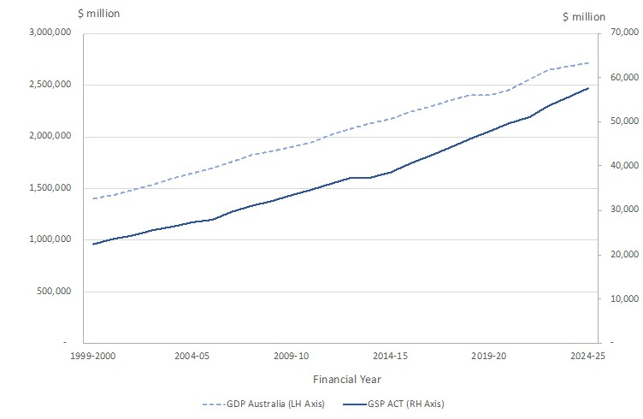
Source: ABS (2025)
The ACT is heavily dependent on the consumption and investment decisions of the Commonwealth Government. This can be seen in Figure 2 below, which compares the four main components of the New South Wales (NSW) and ACT economies.
Figure 2: Components of Final Demand for the New South Wales and ACT economies, year ended March 2026
- New South Wales | - ACT
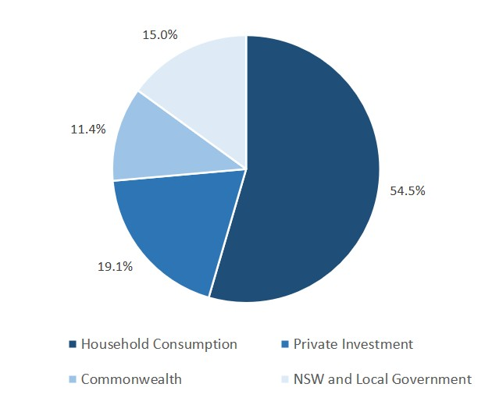 | 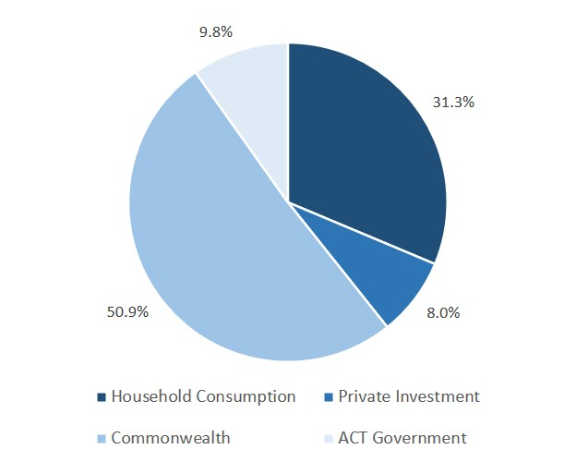
Source: ABS (2026).
In the year to the end of March 2026, the Commonwealth represented 50.9 percent of total demand in the ACT economy while household consumption represented 31.3 percent, private investment 8.0 percent, and 9.8 percent for the ACT Government.
The relative shares of ACT final demand are provided in Figure 3 below.
Figure 3: Relative shares of ACT Final Demand – 2013-14 to 2025-26*
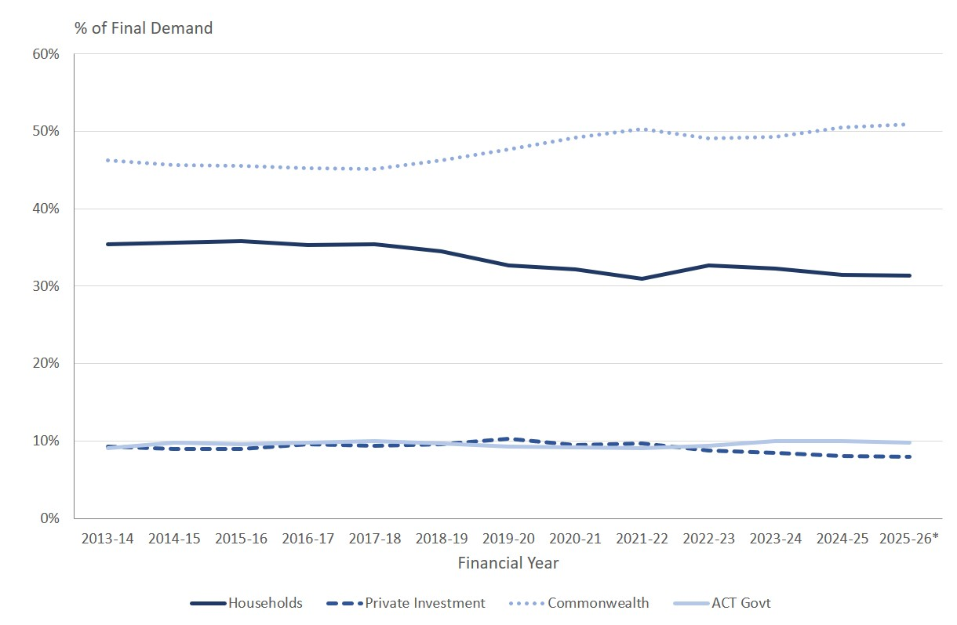
Source: ABS (2026).
* 2025-26 only includes the September and December quarters 2025, and the March quarter 2026.
Between 2019-20 and 2021-22 with the onset of COVID-19 pandemic, there was a contraction in household consumption that was largely offset by an expansion in expenditure by the Commonwealth Government. However, household consumption has not fully recovered back to its pre-COVID-19 pandemic levels and its relative contribution to the ACT economy has been trending downwards. There has also been a noticeable uptick in the relative contribution of the ACT Government to final demand, as private investment (composed of both dwelling and business investment) has declined as its relative contribution has also been trending downwards.
The ACT economy has become more reliant on the public sector since COVID-19
Since the onset of the economic disruption caused by the COVID-19 pandemic, the ACT economy has become less diverse and more dependent upon the public sector, with the Commonwealth and ACT Governments’ now accounting for around 61 percent of final demand, as compared to around 56 percent pre-COVID. This is shown in Figure 4 below.

Figure 4: Percentage of ACT Final Demand made up by the Public Sector (Commonwealth and ACT Government) – 2013-14 to 2025-26*
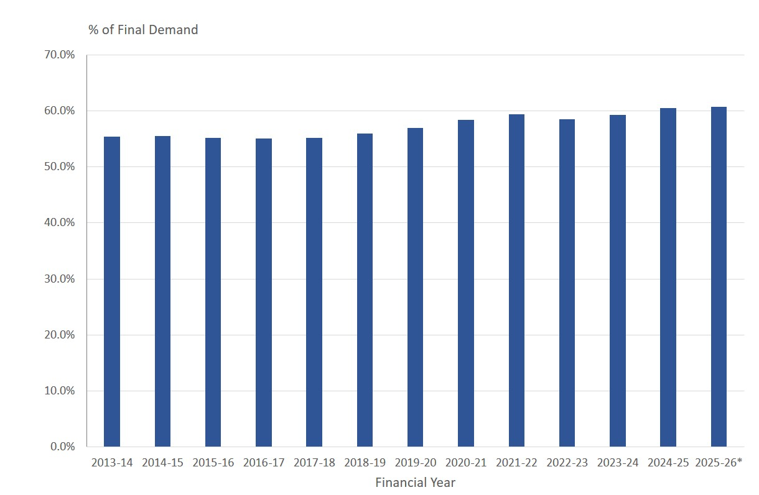
Source: ABS (2026).
* 2025-26 only includes the September and December quarters 2025, and the March quarter 2026.
The risk for the ACT economy in becoming increasingly dependent upon Commonwealth Government demand is that it leaves it vulnerable and exposed in the event of a contraction in Commonwealth Government spending, Commonwealth Government spending is currently at record levels outside of the COVID-19 pandemic and some sort of future fiscal consolidation on the part of the Commonwealth Government is not out of the question and poses a major risk to the health of the ACT economy.
2.2.1. Businesses in the ACT
Since emerging from the COVID-19 pandemic, the ACT enjoyed some of the strongest growth in new businesses in the country. In 2020-21 the number of new businesses operating in the ACT grew by 1,761 for a total of 31,479, an increase of 5.9 percent which was the largest percentage growth in any state/territory. In 2021-22 the number of new businesses operating in the ACT grew by 2,288 for a total of 33,767, an increase of 7.3 percent which was the second largest percentage growth in any state/territory. In 2022-23 the number of new businesses operating in the ACT grew by 1,289, an increase of 3.8 percent and the largest percentage growth in any state/territory. In 2023-24 the number of businesses operating in the ACT grew by 1,214, an increase of 3.5 percent and the equal largest percentage growth in any state/territory.
However, in 2024-25 the number of businesses operating in the ACT grew by 679, an increase of 1.9 percent, that was below the national average of 2.5 percent. This is shown in Figure 5 below.
Figure 5: Number of Businesses Operating in the ACT – June 2015 to June 2025
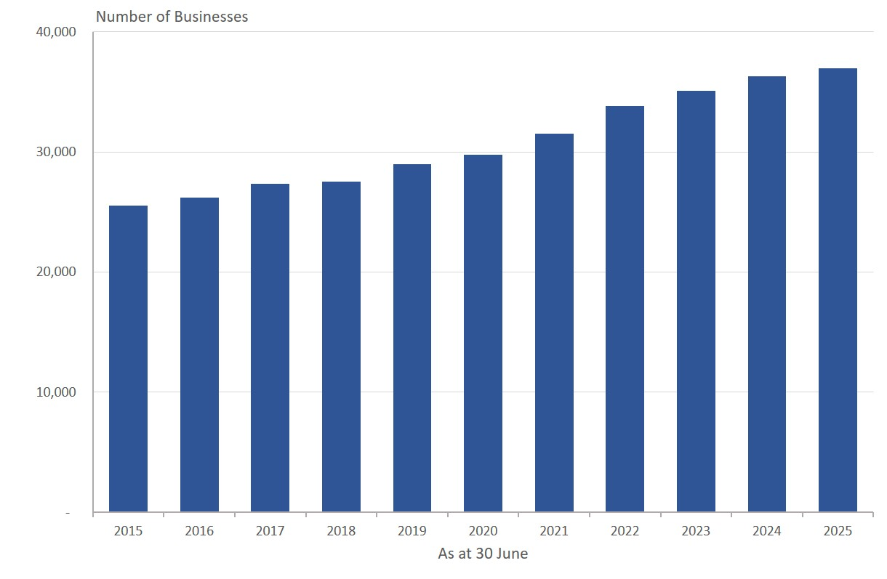
Source: ABS (2025a).
For all businesses that were operating as at 30 June 2021, the survival rate in the ACT is running slightly below the national average, as shown in Figure 6 below.
Figure 6: Business Survival Rate for All Businesses Operating at 30 June 2021
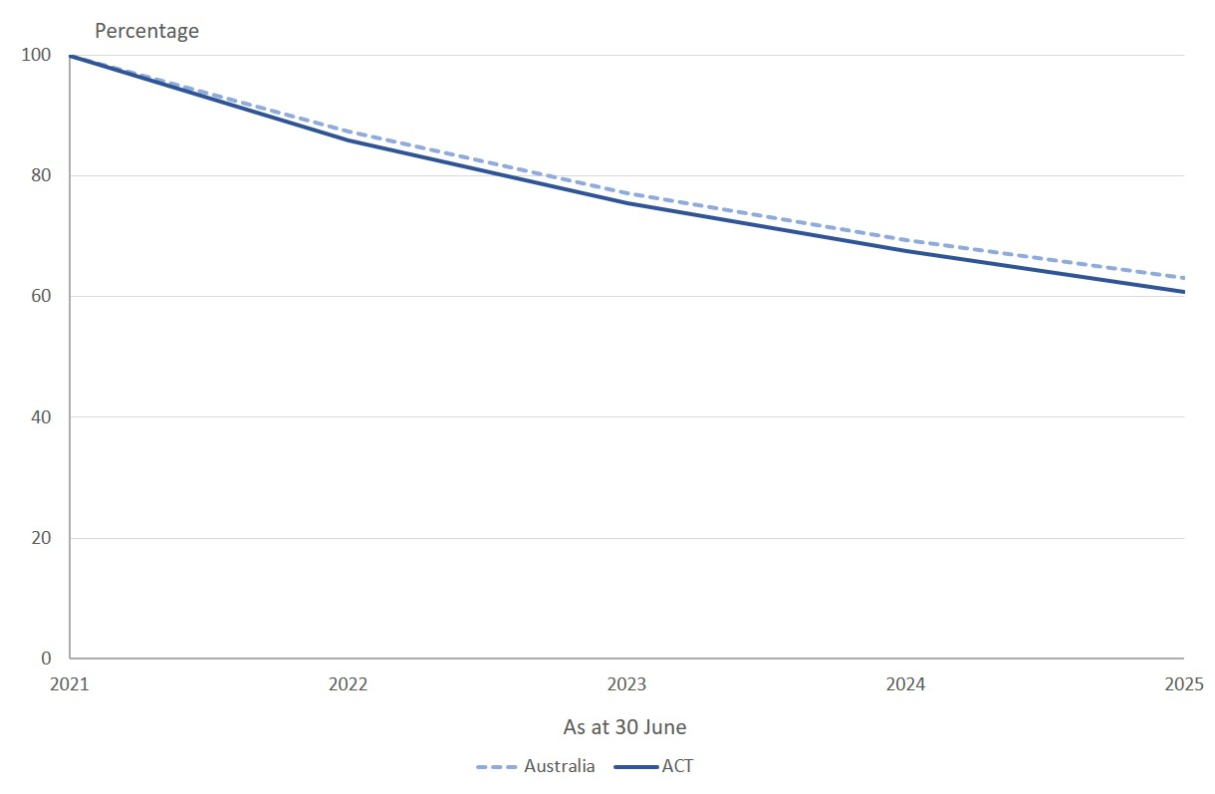
Source: ABS (2025a).
The survival rate for new business start-ups in 2020-21 in the ACT is also running slightly above than the national average. This is outlined in Figure 7 below.
Figure 7: Business Survival Rate for New Business Start-Ups in 2021-22
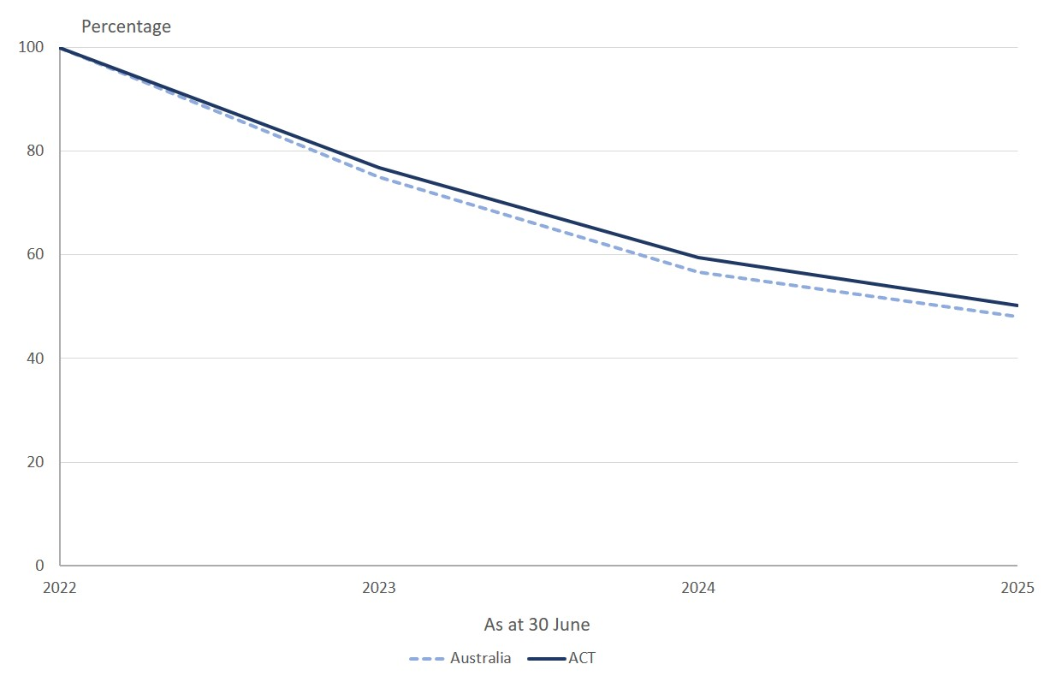
Source: ABS (2025a).
The available evidence suggests that conditions conducive for business survival in the ACT are similar to those prevailing across the rest of the country.

Employment
Employment growth through the year for the three-month period to the end of May 2026 for the ACT was running at 1.7 percent (Australian Bureau of Statistics, 2026d). In the three-month period to the end of May 2026, an additional 4,700 jobs had been added over the period for the previous year. This is running below the 2026-27 ACT Budget estimate for employment growth of 2 percent in 2025-26 (ACT Government, 2026).
In order to meet the Budget estimate of employment growth in 2025-26 of 2 percent there needs to be employment growth of 2,800 additional jobs added in June from the outcome for May 2026. On this basis, the employment growth estimate of 2 percent for 2025-26 is probably not going to be met.
In the 2026-27 ACT Budget, the ACT Government is forecasting a moderation in employment growth to 1¾ percent in both 2026-27 and 2027-28, with projections for growth of 1¾ percent in the out-years. In order to reach the Budget forecast of employment growth of 1¾ percent in 2026-27, something in the order of an additional 4,900 jobs will need to be added to ACT employment levels by the end of the June quarter 2027.
In light of only modest employment growth expected across the Commonwealth Government (2026, p. 165) civilian workforce of around 1,300 full-time equivalents expected during 2026-27 with only around a third of Commonwealth employees based in the ACT (Australian Public Service Commission, 2025, p. 29), and employment growth of less than around 400 full-time equivalents across the ACT Government agencies and business enterprises (ACT Government, 2026, p. 321), the bulk of employment growth will need to be made up from elsewhere.
While the employment growth forecast for 2026-27 doesn’t look unreasonable, it may be on the high side.

Wage price index
The Wage Price Index (WPI) was running at 3.7 percent through the year to the end of the March quarter 2026 (Australian Bureau of Statistics, 2026g), which is consistent with the ACT Budget estimate of 3½ percent growth in the WPI for 2025-26 (through the year to the end of June 2026). Through the year to the end of March 2026 in the private sector the WPI was running at 3.6 percent growth while for the public sector it was running at 3.7 percent growth.
The ACT Government (2026) is forecasting growth in the WPI of 3¼ percent for both 2026-27 and 2027-28, with projections of growth for the out-years of 3 percent in 2027-28 and 2028-29.
Forecasts for wages and CPI appear reasonable
The ACT Budget estimate and forecasts are consistent with the Commonwealth Government (2026a, p. 62) budget forecast of growth in the WPI for the nation in 2025-26 of 3¼ percent and 3½ percent growth in both 2026-27 and 2027-28. It is also consistent with the most recent enterprise bargaining pay offer by the Commonwealth Government across the entire Australian Public Service (APS) of a 3.4 percent pay increase as from March 2026 (Riordan, 2023). On this basis, forecasts for wages growth appear reasonable.

Consumer price index
The percentage change for in the Consumer Price Index (CPI) for Canberra through the year to the end of the March quarter 2026 was 3.7 percent (Australian Bureau of Statistics, 2026c). In the monthly CPI through the year ended April 2026, the CPI had risen to 4.0 percent. Given continuing price pressures arising from higher fuel prices due to the conflict in the Middle East and their pass through into higher transport costs and the prices of other goods and services, the ACT Government (2026) Budget estimate for growth in the CPI of 4¾ percent in 2025-26 is also consistent with the Commonwealth Government budget forecast for growth in the CPI of 5 percent in 2025-26 and the latest forecast by the RBA of 4.8 percent growth in the CPI in 2025-26 (Commonwealth of Australia, 2026a, p. 62; Reserve Bank of Australia, 2026, p. 4).
The ACT Government (2026) is forecasting CPI growth for Canberra to moderate to 2½ percent through the year to the end of June 2026 and remain at 2½ percent in 2027-28.
The ACT Budget forecasts for the CPI are consistent with the Commonwealth Government (2026a, p. 62) budget forecast for national CPI growth of 2½ percent for both 2026-27 and 2027-28. Similarly, the Reserve Bank of Australia (RBA) (2026, p. 4) is forecasting national CPI growth of 2.4 percent in 2026-27, rising slightly to 2.5 percent in 2027-28.
The ACT Budget CPI growth estimate for 2025-26 as well as the Canberra CPI forecast growth in 2026-27 and 2027-28 are reasonable in light of the Commonwealth Government and RBA forecasts.

Population growth
Population growth for the ACT is currently running at 1.25 percent (that has been rounded up to 1.3 percent) through the year to the end of December 2025 (Australian Bureau of Statistics, 2026e), which is 0.25 percent lower than the ACT Government (2026) Budget estimate for population growth of 1½ percent in 2025-26. It is also consistent with the latest Commonwealth Government population forecast for growth in the ACT of 1.3 percent during 2025-26 (Centre for Population, 2026).
The ACT Government (2026) is forecasting the ACT population to continue to grow at 1¾ percent in both 2025-26 and 2026-27, with the projections for ACT population growth also remaining at 1¾ percent in the out-years.
ACT forecasts for population growth are higher than Commonwealth government forecasts
The outlook for population growth presented by the ACT Government is generally significantly higher than those prepared for the Commonwealth Government by the Centre for Population (2026). The difference between ACT Government and the Centre for Population ACT population growth forecasts is outlined in Figure 8 below.
Figure 8: ACT Government and Centre for Population ACT Population Growth Forecasts: 2025-26 to 2029-30
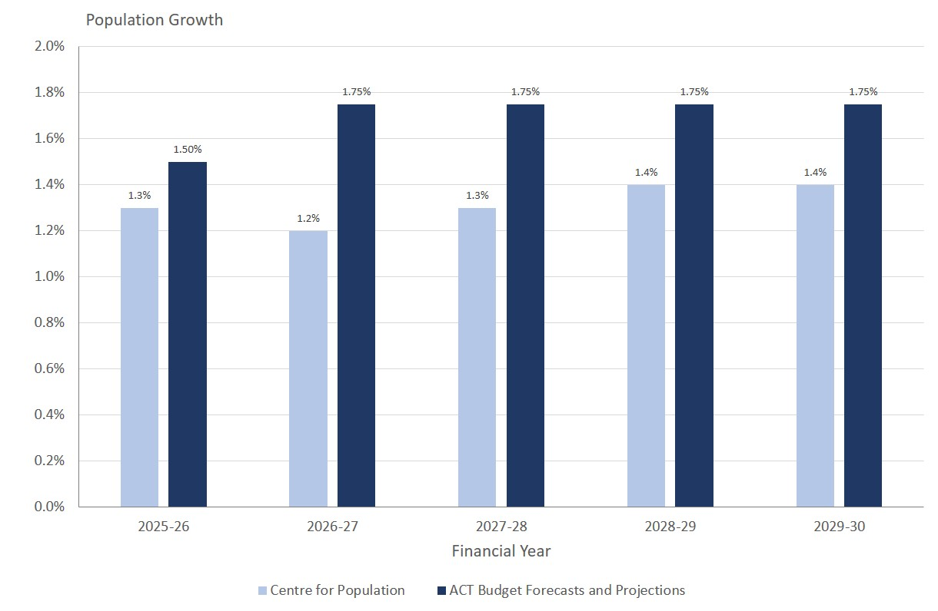
Sources: ACT Government (2026) and Centre for Population (2026).
Over the period to the end of 2029-30, the ACT Government is projecting the ACT will have a resident population that is almost 9,800 people larger than the Centre for Population.
While the population forecasts presented by the ACT Government may not be unreasonable, they are arguably on the high side based on forecasts from the Centre for Population.

Fiscal Position
The ACT’s fiscal position remains vulnerable despite some tentative steps toward budget repair. The Budget is still in deficit in 2026-27 and the return to surplus previously forecast in last year’s Budget has been pushed back another year, to 2028-29.
After reporting operating cash deficits for the past three years, the Budget forecasts an operating cash surplus for 2026-27 of $109.0 million in 2026-27 rising to $842.9 million in 2029-30. The return to an operating cash surplus is two years later than forecast in the 2024-25 Budget.
Net debt is forecast to continue to grow across the Budget and forward years, reaching 17.3 percent of GSP by 2029-30. Net financial liabilities also increase across the Budget and forward years but fall slightly from 2028-29. Net worth continues to decline until 2028-29 and falls as a proportion of GSP through the Budget and forward estimates period.
The Budget sets out a fiscal strategy that includes specific, measurable targets and timelines. Movement toward these targets should improve the credibility of the ACT Government’s fiscal position. At this early stage, the forecasts included in the Budget are consistent with the stated targets.

Operating Statement - Headline Operating Balance
The Budget Papers present a headline net operating deficit of $323.4 million in 2026-27, improving over the forward years to a surplus of $355.7 million by 2029-30.
Table 2: General Government Sector Headline Net Operating Balance
Empty Cell | 2025-26  Est. outcome | 2026-27 Budget | 2027-28 Estimate | 2028-29 Estimate | 2029-30 Estimate
Empty Cell | $m | $m | $m | $m | $m
Revenue | 8,846.1 | 9,595.7 | 10,090.1 | 10,734.5 | 10,921.1
Expenses | 9,653.2 | 10,207.6 | 10,421.6 | 10,824.6 | 10,925.1
Superannuation return adjustment | 305.4 | 288.5 | 310.5 | 334.2 | 359.7
HEADLINE NET OPERATING BALANCE | -501.7 | -323.4 | -20.9 | 244.2 | 355.7
The expected return to surplus in the Headline Net Operating Balance is a year later than forecast in the 2025-26 Budget and the 2025-26 Budget Review.
The ACT is unique in reporting its fiscal position in terms of the Headline Net Operating Balance. This measure is derived by including in the balance an estimate of expected returns from the Territory’s Superannuation Provision Account.
If the Superannuation Return Adjustment (SRA) is to be included in the headline net operating balance, it should not lead to a bias in outcomes. This would mean calculating the SRA on an assumption that the total return on the assets of the Superannuation Provision Account is identical to the long-term discount rate used in valuing the liability. In the Budget year, this would imply an SRA of $105 million. Use of the projected long-term investment return in the Budget instead of the long-term valuation discount rate of 5 percent per annum improves the reported fiscal position in 2026-27 by around $185 million.
On a net operating balance basis, which is closer to the fiscal measure used by other States, and which is the fiscal measure agreed by the Heads of State, Territory and Commonwealth Treasuries, the ACT deficit would be around $611.9 million in 2025-26 and would not return to surplus at any time in the forward estimates period (Table 4.1.1 of the 2026 Budget Outlook (ACT Government, 2026, p. 233)).
A more detailed discussion of accounting and classification issues in the Budget, including issues around the superannuation return adjustment, is provided at section 8 of this report.

Changes in the Headline Operating Balance since the last Budget
The Budget forecast for 2026-27 is worse than forecast in the 2025-26 Budget and the 2025-26 Budget Review.
Figure 9: Changes in the forecast 2026-27 Budget between the 2025-26 and 2026-27 Budgets
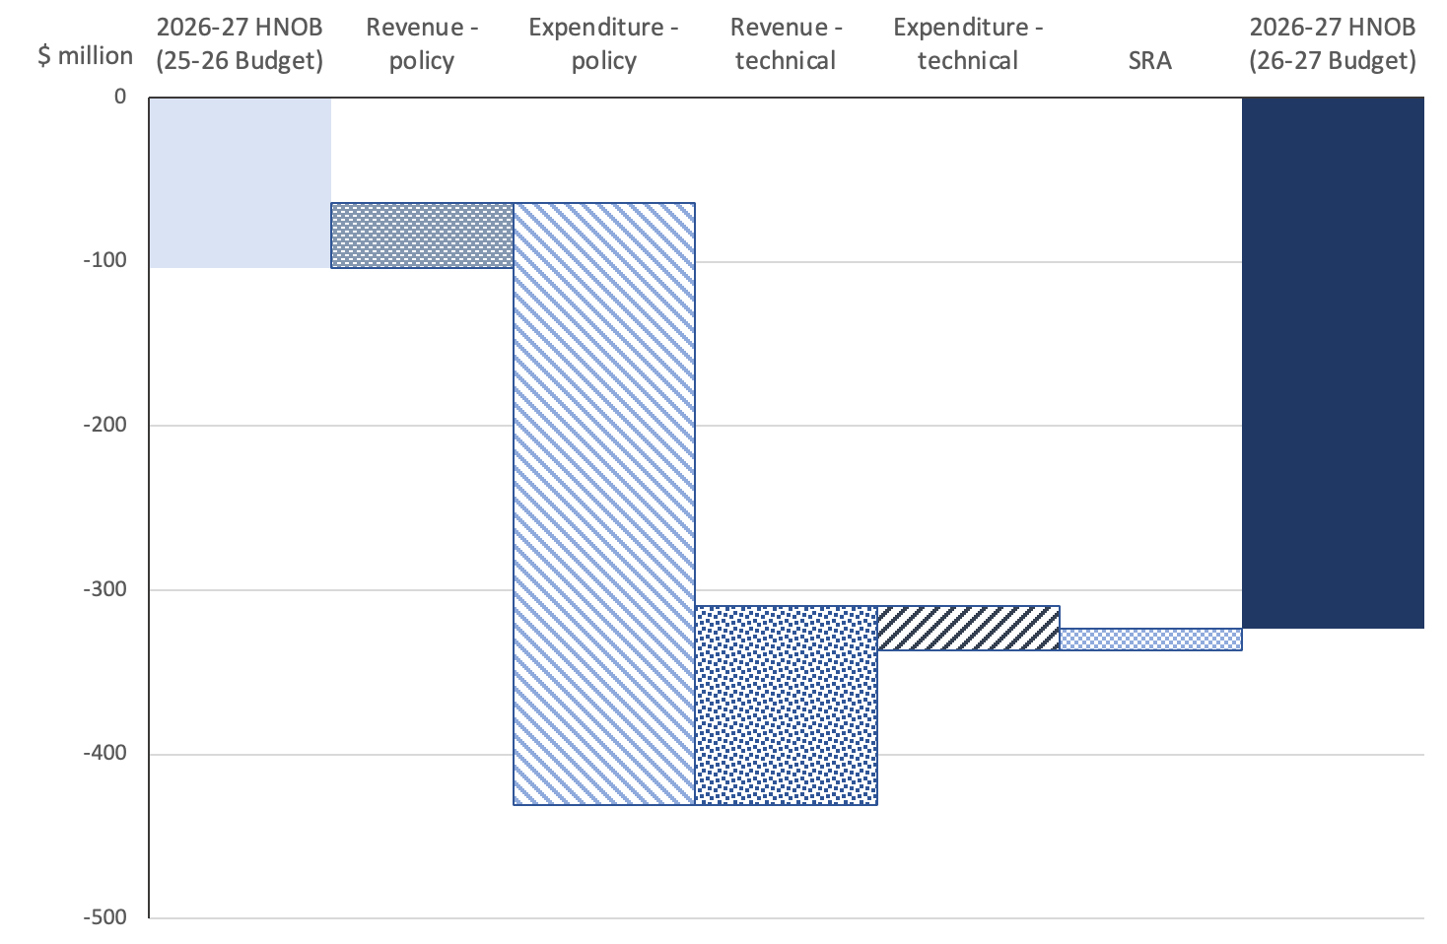
The deterioration in the 2026-27 Budget forecast is primarily the result of policy decisions to increase expenditure, offset to some extent by increases in revenue as a result of technical adjustments, and policy decisions including increases in general rates, partially off-set by measures such as removal of the Health Levy.
New spending initiatives include additional funding for public housing maintenance and repairs, public housing tenancy and homelessness services and for emergency services. Interest costs are also forecast to be higher due to the impact of borrowings.
Revenue forecasts for 2026-27 have increased because of increased Commonwealth grants for hospital services, adjustments to reflect anticipated increases in other Commonwealth funding, an increase in forecast investment earnings and revenue measures. These changes have been partially offset by expected reductions in returns from the Territory’s public trading enterprises, lower revenue from traffic infringements and reductions in expected revenue from payroll tax and conveyancing.

Medium term forecasts of the Headline Net Operating Balance
The medium-term outlook is also worse than forecast in recent Budgets.
The long-term trend in the ACT has been for successive Budgets to promise improved fiscal positions in the forward years only to set out progressively worse forecasts in subsequent Budgets. The post-pandemic Budgets in 2022 and 2023 were an exception to that trend but, as Figure 10 below shows, the three most recent Budgets have returned to the profiles forecast in earlier years, with forecasts in the Budget and forward years worse than previously estimated.
Figure 10: Forecast returns to surplus
This history raises questions about the credibility of the promised return to surplus.

Cash Flow Statement
The cash position is an important measure of the Territory’s fiscal settings. The Golden Rule of Budgeting is that over the economic cycle, governments should only borrow to invest and not to fund current spending. This implies that the cash operating position should be in balance over the economic cycle.
In the 2024-25 Budget, the ACT forecast General Government operating surpluses for 2024-25 and each of the forward years up to 2027-28. In the event, the ACT has reported cash operating deficits in each year between 2023-24 and 2025-26. The estimated outcome for 2025-26 of a $180.6 million deficit in the Net Operating Cash Balance is three times larger than the 2025-26 Budget forecast.
When announcing a reduction in the ACT’s long-term credit rating from AA+ to AA in September 2025, S&P Global Ratings, a ratings agency, indicated that the downgrade reflected delays in the ACT's return to a cash operating surplus.
Improvements in the cash position are forecast in the 2026-27 Budget and the forward years. The net operating position is forecast to increase from a surplus of $109.0 million in 2026-27 to $842.9 million in 2029-30. However, the forecast cash surplus is smaller in 2026-27 and 2028-29 than was forecast for those years in the 2025-26 Budget and the return to an operating cash surplus is one year later than forecast in the 2024-25 Budget.
The overall cash position, which includes cash investments in non-financial assets such as infrastructure and capital, is forecast to be in deficit of $607 million in 2025-26 and the following two outyears, only returning to surplus in 2029-30.
We understand that S&P Global Ratings also focuses on Total Territory net cash flows from operating activities. That is, the consolidated account including General Government and the Public Trading Enterprises. On a Total Territory basis, the ACT is forecast to move from a deficit in 2025-26 to a cash operating surplus across the Budget and forward years.

Balance sheet measures of the ACT Government’s financial position
The ACT has a strong balance sheet, but that position has deteriorated over time.
The strength of the ACT Government’s finances over the medium term can be assessed in terms of reported levels of net debt, net financial liabilities and net worth. Net debt and net financial liabilities provide an indication of the Territory’s indebtedness and financial obligations to others.
Table 3below presents movements in these measures for the Budget and forward years.
Table 3: General Government Sector Key Balance Sheet Measures
Empty Cell | 2025-26  Est. outcome | 2026-27 Budget | 2027-28 Estimate | 2028-29 Estimate | 2029-30 Estimate
Empty Cell | $m | $m | $m | $m | $m
Net Debt (excluding superannuation) | 11,089.5 | 12,483.4 | 13,143.7 | 13,841.1 | 14,069.2
Net Financial Liabilities | 16, 544.7 | 17,612.2 | 18,013.5 | 18,273.2 | 18,098.7
Net Worth | 19,787.6 | 19,361.1 | 19,213.0 | 19,262.6 | 19,480.8
Table 3 shows that the Territory’s financial position continues to deteriorate over the Budget and forward estimates until the last forward year when growth in net debt moderates, net financial liabilities fall slightly and net worth improves.
Expression of these measures as a proportion of Gross State Product provides an indication of their significance in terms of the size and growth of the Territory’s economy. Figure 11 shows the key balance sheet measures as a proportion of Gross State Product.
Figure 11: Key balance sheet measures as a proportion of Gross State Product
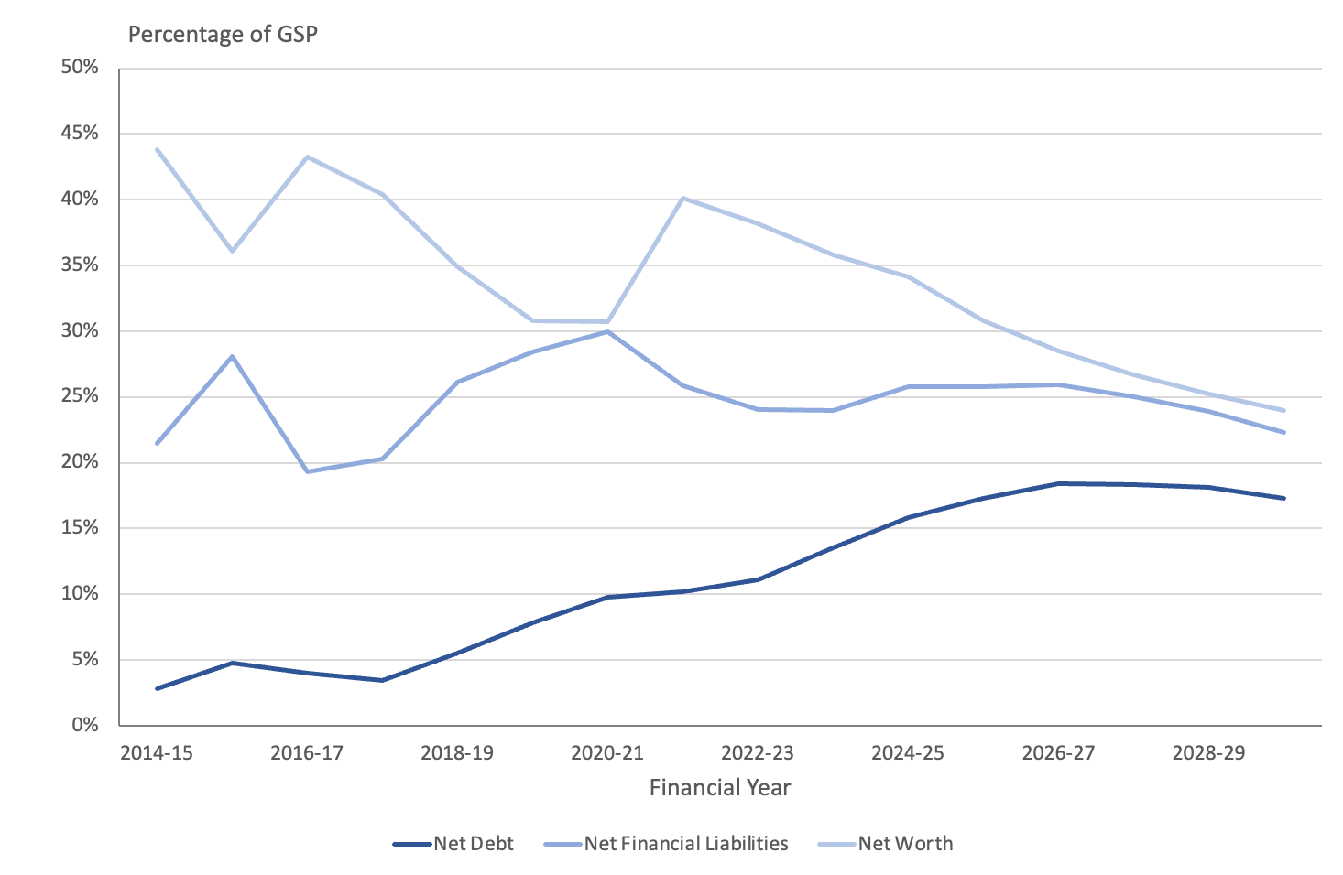
These measures can be subject to variations in the short term due to fluctuations in the economy and changes in the valuation of assets and liabilities. However, over the longer term they provide an indication of changes in the health of the Territory government’s key balance sheet. Figure 11 shows a long-term deterioration in the Territory balance sheet, moderating in the final forward years due mainly to a lower rate of growth in net debt and anticipated growth in the Territory economy.
The ACT’s net debt sits within the range of other Australian States and Territories. This is shown in Figure 12 below, where the upper bound is Victoria and the lower bound is WA.

Figure 12: ACT net debt as a proportion of GSP within the range of other States and Territories
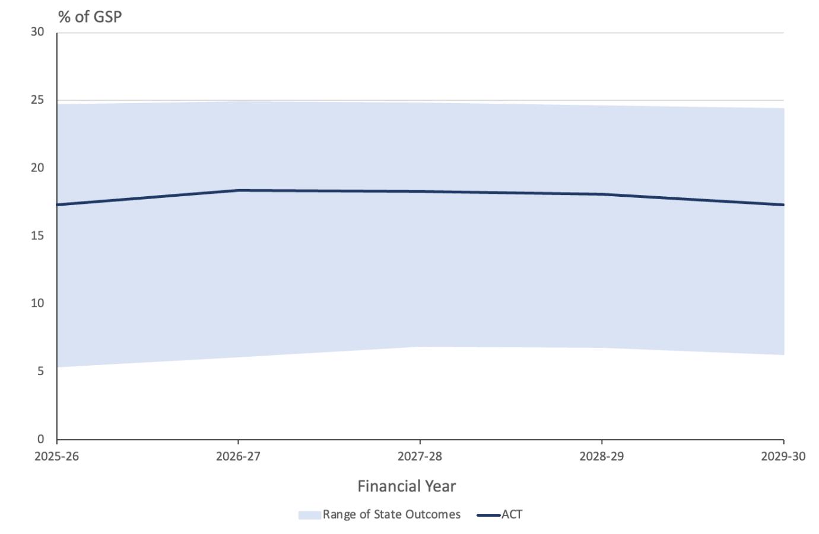
Figure 12 shows that the level of net debt as a proportion of GSP sits in the upper range: it is not as bad as Victoria and the Northern Territory but worse than NSW, Queensland, Tasmania and Western Australia. The ACT now shares with Victoria and Tasmania the lowest S&P Global Ratings debt rating of Australian States and Territories (the Northern Territory is not rated by S&P Global Ratings).
Comparison with other Australian States is not completely reassuring, however. According to S&P Global Ratings, Australian States and Territory governments are posting some of the largest budget deficits among sub-national governments in the developed world (van Onselen, 2024). In 2024 Victoria was reported as being the fourth-most-indebted state government from advanced economies outside the US in absolute dollar terms (Read, 2024).
While forecasts for the ACT’s balance sheet measures show some improvement in the final out years, these improvements depend heavily on government achieving the forecast return to surplus and consequent reductions in net debt.
Further discussion of the Budget forecasts for ACT assets and liabilities is provided in section 7 of this report.

Fiscal strategy
The Budget includes the statement of a fiscal strategy that is clearer, more detailed and more explicit than in previous years. It includes specific, measurable targets and timelines.
The targets include, in abbreviated form:
Fiscal measure | Target
HNOB | Return to surplus by 2029-30 and maintain surpluses beyond this point.
Operating cash | Return to surplus by 2028-29 and maintain surpluses beyond this point
Net debt | Not to exceed 19 percent of GSP in any year of the forward estimates period (to 2029-20) and to decline thereafter.
Superannuation liability | To be extinguished by 2035
Sustainable public finances | Infrastructure Investment Program does not exceed $1 billion from 2028-29; and growth in general government employment does not exceed growth in the ACT population.

Clarification of the Government’s medium-term strategy provides a basis against which future Budgets will be assessed. Movement toward these targets over the Budget and forward estimates will strengthen the Government’s fiscal position and build confidence in the credibility of future budgets. At this early stage, the ACT Government’s Budget forecasts are consistent with achievement of the announced targets.
Attainment of the targets will, however, be a challenge. The ACT has a poor record in achieving its budget forecasts. The return to HNOB surplus over the forward estimates has been forecast many times in the past, but rarely achieved. The Territory generally exceeds its own estimates for expenses. An earlier goal, set out in the 2006-07 Budget, of extinguishing the unfunded superannuation liability by 2030 that was repeated as recently as the 2018-19 Budget, was replaced in recent years with statements merely indicating a general intention to reduce the unfunded liability over time, or over the next decade.
The achievement of the ACT Government’s fiscal targets will require a level of fiscal discipline that has not been evident in the Budgets produced in recent years.

Revenue
Revenue is forecast to be $9.6 billion in 2026-27, almost $750 million higher than the expected outcome for 2025-26. Revenue rises over the forward years to $10.9 billion by 2029-30.
Policy decisions made by the ACT Government since the 2025-26 Budget are estimated to raise an additional $181.6 million from 2026-27 to 2029-30, although there is not a lot of transparency surrounding exactly what these policy decisions have been.
The ACT Government is in the process of rebalancing its tax base by reducing and eventually eliminating conveyance duties (stamp duty) over a 20-year period and replacing the shortfall through an increase in the general rates system. Based on current policy settings, revenue from conveyance duties will still be around 10 percent of own-source revenue in 2029-30 with supposedly only two more years following of revenue collection from this source to follow (2030-31 and 2031-32) if the ACT Government is to meet its original tax reform timetable. Annual increases in general rates in the order of few percentage points above the Wage Price Index (WPI) is not likely going to generate sufficient additional revenue to eliminate conveyance duties any time in the foreseeable future. Unless the ACT Government is going to announce some dramatic changes in forthcoming budgets in relation to both conveyance duties and general rates, then it is extremely unlikely the ACT Government will meet its original deadline of eliminating conveyance duties following 20 years of tax reform.
Revenue from payroll tax is forecast to increase from 29.7 percent of ACT Government own-source taxation revenue in 2025-26 to 33.3 percent by 2029-30 – an overall increase of 3.6 percentage points. This is in marked contrast to the percentage of ACT Government own-source taxation revenue expected to be collected from general rates over the same period that is actually flat at around 29 percent.
As part of its ‘Missing Middle’ housing reforms, the ACT Government (2026, p. 86) will provide a temporary 50 percent remission of the codified Lease Variation Charge (LVC) for developments in Suburban (RZ1) and Suburban Core (RZ2) zones to support the uptake of ‘missing middle’ housing developments.

Overview
ACT revenue is now forecast to be some $80.5 million lower in 2025-26 than previously forecast in the 2025-26 Budget (ACT Government, 2026, p. 169). The largest contributions to the change in ACT revenue in 2025-26 over the 2025-26 Budget forecasts have come from:
- Almost $73 million decrease in other revenue, mostly reflecting a reduction in revenue from fines and the profile of revenue associated with the Big Battery
- $57.6 million decrease in dividend and income tax equivalent income
- $51.9 million decrease in investment revenue
- $39.2 million decrease in general rates (almost 75 percent of which was due to changes in the final composition of the Health Levy)
- $32 million decrease in payroll tax receipts
- $31.3 million decrease in goods and services tax (GST) receipts
- $11.6 million decrease in contributed assets
These decreases were partially offset by increased revenue from:
- $116.4 million increase in sales of goods and services (most of which comes from higher cross-border health receipts)
- $54.9 million increase in Commonwealth Government grants
- $51.3 million increase in interest income
ACT Budget revenue is now estimated to be $160.3 million higher in 2026-27 than previously estimated in the 2025-26 Budget and higher in the out-years – by $303.1 million in 2027-28 and by $461 million in 2028-29. This is shown in Figure 13 below.
Figure 13: Estimated ACT Budget Revenue in the 2024-25, 2025-26 and 2026-27 ACT Budgets
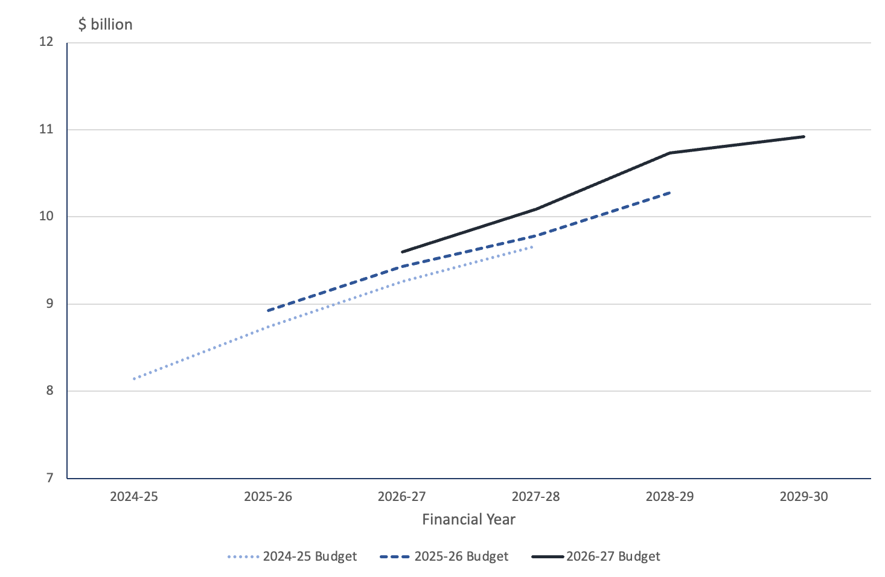
Revenue in 2026-27 is expected to be almost $750 million higher than for 2025-26
Since the 2025-26 Budget, the ACT Government (2026, p. 41) has made policy decisions that have increased revenue by $39.7 million in 2026-27, and by $181.6 million over the three years from 2026-27 to 2028-29. However, there is not a lot of transparency surrounding exactly what these policy decisions have been. Individual revenue policy decisions are provided in chapter 3.2 of Budget Outlook, but it is not clear how these decisions add up to the net change of $39.7 million since the last Budget.
In 2026-27, revenue is expected to increase by $749.6 million over the expected outcome for 2025-26 (ACT Government, 2026, p. 169). The largest contributors to the change in revenue over the expected outcome in 2025-26 will come from:
- a $301.9 million increase in own-source taxation
- a $82.8 million increase in other revenue
- a $82.4 increase in GST revenue
- a $82.3 million increase in interest revenue
- a $65.7 million increase in dividend and income tax equivalents
- a $62 million increase in Commonwealth Government grants
- a $50.6 million increase in investment revenue
- a $38 million increase from sales of goods and services from contracts with customers
- a $0.9 million increase in gains from contributed asset.
A comparison of the revenue estimated outcome for 2025-26 and the revenue estimate for 2026-27 is provided in Figure 14 below.
Figure 14: Revenue Estimated Outcome 2025-26 and Forecast 2026-27
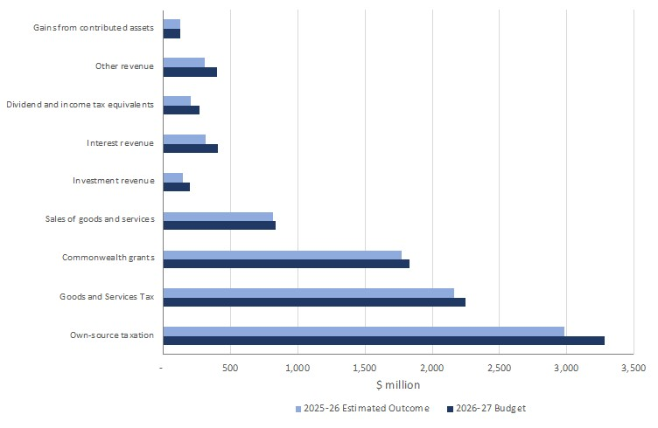

Tax reform
In the 2012-13 Budget, the ACT Government committed itself to improving the stability and predictability of its tax base through a process of gradually reducing and eventually eliminating transaction-based taxes like conveyance duties (stamp duties) over a 20-year period and replacing the shortfall through an increase in broad-based land taxes through the general rates system. The tax reform program is intended to be revenue neutral.
Tax reform is intended to replace conveyance duties with increases in general rates
The phasing out of stamp duties and the phasing in of the new general rates system over the course of 20 years is being implemented in four stages to avoid a shock to the property market and to enable the change to be revenue neutral (Reardon & Hopkins, 2018, p. 4). Based on tax reform commencing in 2012-13, this implies that stamp duties should be eliminated by 2032-33 with 2031-32 being the last year in which stamp duties are applied in the ACT.
According to the ACT Government (2026, p. 81), it has progressed tax reform by offsetting any general rates increase above wage price index (WPI) with reductions in conveyance duty. For the next financial year in 2026-27, the ACT Government is seeking to ensure that the average residential general rates bill (which includes general rates and levies) will not increase by more than 5 percent, and that the average increase in general rates for commercial properties is no greater than 8 percent.
Stage 3 of tax reform lasted from 2021-22 to 2025-26 (ACT Government, 2021a, p. 242). According to last year’s Budget, the ACT Government (2025a, p. 25) said:
The fourth stage of tax reform will begin in 2026-27, with the settings to be announced in the next Budget.
While there is no specific reference that we can find in relation to stage 4 of tax reform in this year’s Budget, the ACT Government (2026, p. 34) has indicated that:
In 2026-27, the Government will eliminate conveyance duty for all first homebuyers and expand existing concessions for pensioners, people with a disability and people buying off-the-plan units by removing the property price cap. The Government will continue tax reform, with the measures announced in each Budget.
When ACT Treasury were queried as to whether anything specific in relation to stage 4 of tax reform had been announced in the 2026-27 Budget, the reply we received was that the measures relating to conveyances were effectively part of the first instalment of stage 4 of tax reform. ACT Treasury also indicated that the future shape of stage 4 was the subject of further consideration by the ACT Government
The 2026-27 Budget continues the process of rebalancing of revenue over time. Figure 15 illustrates the real growth in revenue from general rates and the real decline in revenue from property since 2012-13 when the tax reform program started. This shows considerable progress toward the Government’s tax reform objective, although there is still some way to go before conveyance duties are completely replaced.
Figure 15: Revenue from general rates and conveyances (GSP deflated), 2011-12 to 2029-30 (forecast)
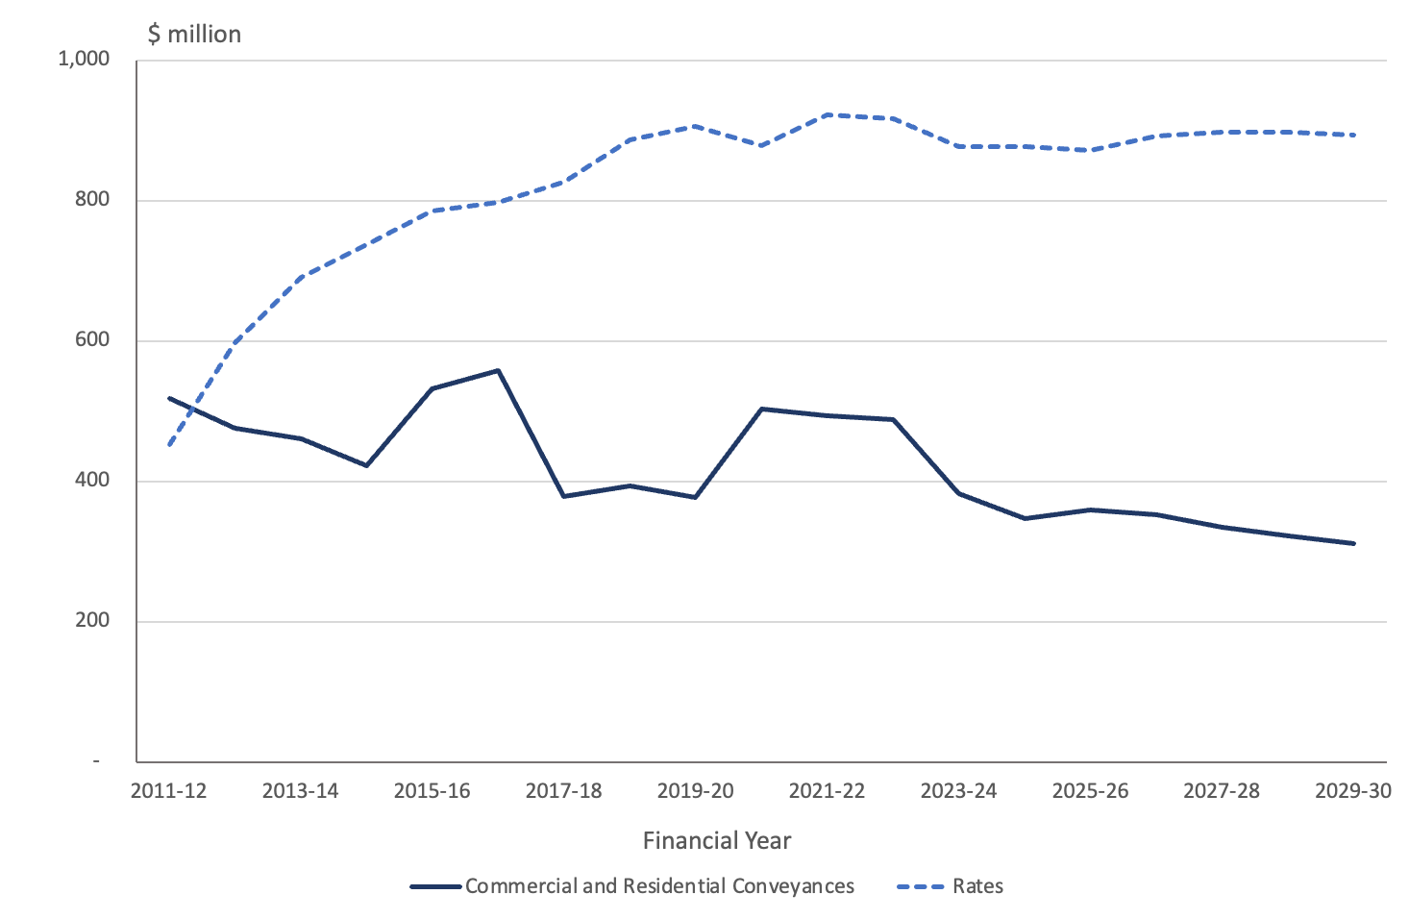
In last year’s Budget, the ACT Government (2025a, p. 36). said that it had taken deliberate steps that had slowed the rate of progress of tax reform, owing to the pressures felt in the community from COVID-19 and recent cost of living pressure on households.
The Budget indicates that revenues from conveyance duties as well as general rates are both expected to increase from 2026-27 onwards through into the out-years up to 2029-30. When expressed as a percentage of total own-source revenue, the share of conveyance duties is expected to decline from around 26 percent when the program started in 2012-13, to a current level of 12 percent in 2025-26, to 10 percent by 2029-30. Over the same period, the proportion of own-source revenue derived from general rates has increased from around 17 percent in 2012-13 to current level of around 29 percent in 2025-26.
Over the Budget and forward years, the rate of substitution of declining revenue from conveyance duties being made from an increasing revenue from general rates appears to have come to a complete stop as the percentage of total own-source revenue from general rates is forecast to remain flat at around 29 percent from 2025-26 onwards. This is shown in Figure 16 below.
Figure 16: Composition of ACT Government Own-Source Taxation Revenue
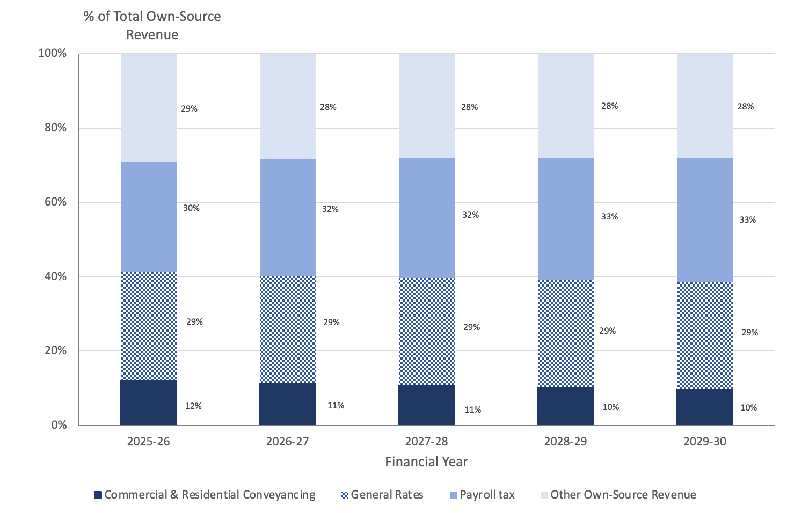
Source: ACT Government (2026, p. 170).
Based on current policy settings, revenue from conveyance duties will still be around 10 percent of own-source revenue in 2029-30 with supposedly only two more years following of revenue collection from this source to follow (2030-31 and 2031-32) if the ACT Government is to meet its original tax reform timetable. Prospective increases in general rates from 2030-31 to 2032-33 to fill the revenue void left by the elimination of conveyance duties will prove extremely challenging for the ACT Government. For example, in 2029-30 that is the last year of current forward estimates, revenue from general rates collections would have to increase by just under 35 percent to fully offset and replace the revenue collected from commercial and residential conveyance duties. On this basis, annual increases in general rates in the order of few percentage points above WPI is not likely to generate sufficient additional revenue to eliminate conveyance duties any time in the foreseeable future.
In the absence of further decisions, the ACT Government is unlikely to meet its timetable for tax reform
Unless the ACT Government is going to announce some dramatic changes in forthcoming budgets in relation to both conveyance duties and general rates, then it is extremely unlikely the ACT Government will meet its original deadline of eliminating conveyance duties following 20 years of tax reform.

Payroll Tax
Payroll tax is a tax levied on wages paid by employers to employees by State and Territory governments with a threshold set based on a wages bill Australia-wide. The tax is calculated based on wages paid or payable in relation to services performed in the ACT (ACT Government, 2026a, p. 12). The total taxable payroll includes wages and salaries, allowances, superannuation, fringe benefits and contractor payments.
Revenue from payroll tax is forecast to increase from 29.7 percent of ACT Government own-source taxation revenue in 2025-26 to 33.3 percent by 2029-30 – an overall increase of 3.6 percentage points. This is in marked contrast to the percentage of ACT Government own-source taxation revenue expected to be collected from general rates over the same period that is actually flat at around 29 percent (as discussed above).
The ACT Budget is increasingly reliant on payroll taxes
In 2026-27 the ACT will have the second highest tax-free threshold on an annual wages bill for the imposition of payroll tax of $1.75 million, behind the Northern Territory at $2 million. The high threshold for payroll tax in the ACT that was $2 million until 30 June 2026 ensured that an estimated 85 percent of businesses in the ACT were exempt in 2024-25, at an estimated cost $287.4 million in 2024-25 in foregone revenue (ACT Government, 2026a).
The ACT generally imposes some of the highest rates of payroll tax across the state and territory jurisdictions, commencing at 6.75 percent on an annual wages bill of between $1.75 to $50 million, all the way up to 8.75 percent on an annual wages bill above $150 million. The other states and territories generally impose a payroll tax of less than 6 percent on annual wages bills, except Victoria and Tasmania.
It has been observed the ACT’s payroll tax regime imposes a high rate of tax over a narrow base (Eslake, 2026, p. 74), that runs counter to the policy advice of the OECD (2010, p. 9) that:
In general, tax reforms that broaden tax bases and lower rates should reduce the extent to which tax systems distort work, investment and consumption decisions, increasing output and enabling improvements in social welfare.
Payroll tax is levied on employers. Because payroll taxes are generally levied on all components of employee remuneration, they are designed to tax the value-added from labour (Henry, Harmer, Piggott, Ridout, & Smith, 2009a, p. 293). As such, payroll taxes are similar to the labour component of Australia’s personal income tax as well as the goods and services tax — they all generate revenue by reducing the real return from working.
Business organisations often assert that payroll tax is an impost on business rather than a payment by workers (Freebairn, Stewart, & Liu, 2015, p. 14). However, the long-term incidence and distributional effects of a selective payroll tax are very different to the statutory incidence. The adjustment of the wage cost and of employment mean that most of the tax in a long run equilibrium is passed back to employees of both large and small businesses as a lower market wage than otherwise (or lower rate of wage increase over time). That is, all employees, including those employed by small business, bear most of the payroll tax levied on large business.
In policy advice provided to the Legislative Assembly Select Committee on the Fiscal Sustainability of the ACT, Saul Eslake (2026, p. 74) suggested that a sensible reform would be to lower both the maximum rate of payroll tax and the payroll tax-free threshold, either in such a way as to raise additional revenue if that were to be desired, or alternatively in a revenue-neutral way in order to procure a more efficient tax system and, potentially, to generate increased employment.

Lease Variation Charge
The Lease Variation Charge (LVC) is a charge applied when additional development rights are granted, such as building more dwellings or subdividing residential blocks.
As part of its ‘Missing Middle’ housing reforms (discussed further in section 9), the ACT Government (2026, p. 86) will provide a temporary 50 percent remission of the codified Lease Variation Charge (LVC) for developments in Suburban (RZ1) and Suburban Core (RZ2) zones to support the uptake of ‘missing middle’ housing developments. The remission will apply to eligible developments that have not paid or deferred their LVC prior to 10 June 2026, receive development approval before 30 June 2029, and complete construction by 31 December 2030. The ACT Government is also intending to review the LVC framework to ensure it remains fit for purpose with opportunities to simplify the framework, reduce the potential for disputes and improve certainty will be explored.
The housing construction industry has collectively been critical of the LVC, with the Housing Industry Association (HIA) (2026a, p. 4) arguing that:
The LVC is imposed at the point of regulatory permission, before feasibility is established and before housing is constructed. In practice, it functions as an upfront tax on development activity, increasing costs at the earliest and riskiest stage of a project. This suppresses marginal developments and places upward pressure on dwelling prices and rents.
In turn, the HIA (2026) has welcomed the proposed changes to the LVC announced in the Budget
The decision to halve the Lease Variation Charge (LVC) for Missing Middle housing projects was a particularly significant measure. HIA has consistently argued that the LVC acts as a tax on new housing supply which undermines the feasibility of housing projects.
We recognise that the Government has commenced a broader review of the LVC and welcome that process. In the meantime, halving the charge for Missing Middle developments is a significant step that will improve the feasibility of infill townhouse, terrace and low-rise multi-unit housing projects.

Gambling Taxes
In nominal terms, revenue collected from gambling taxes is steadily increasing from an expected outcome of around $88 million in 2025-26 to $93.6 million in 2029-30 at the end of the forward estimates. However, when considered as a proportion of own-source revenue, gambling taxes fall from a current level of 3.0 percent to 2.4 percent in 2029-30. This is shown in Figure 17 below.
Figure 17: Gambling Taxes as a Proportion of Own-Source Revenue
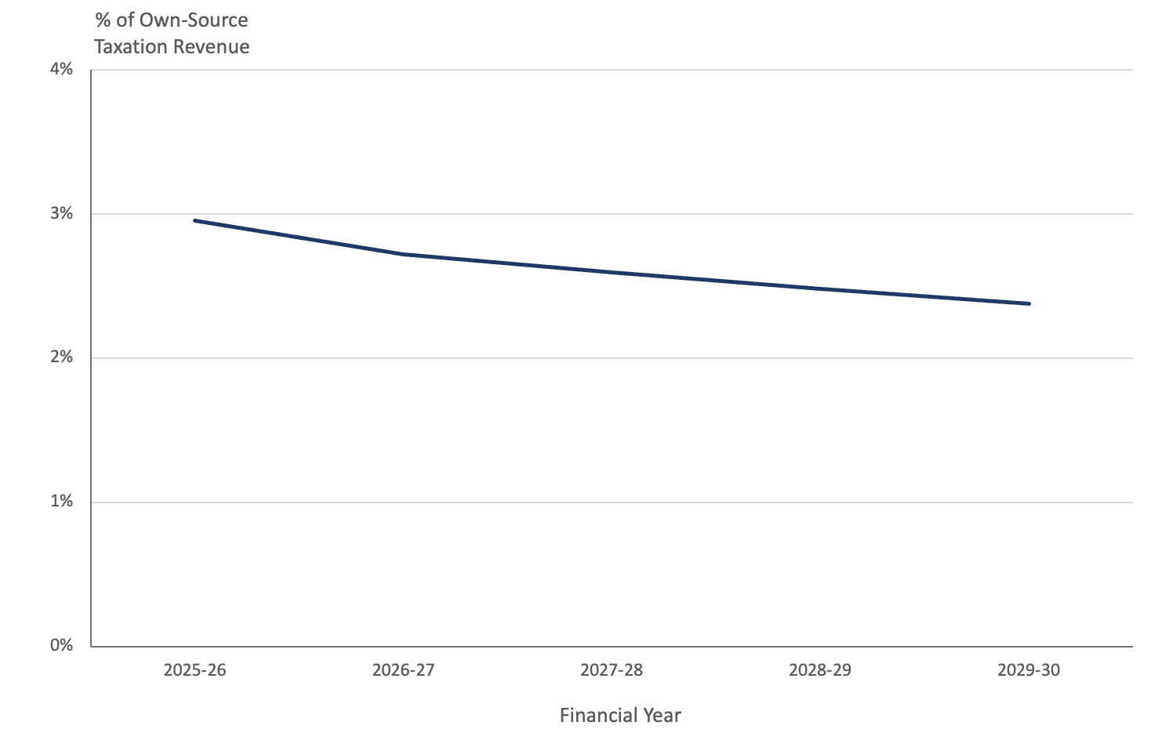
The forecasts for revenue from gambling taxes are noteworthy in the light of advice provided by Saul Eslake (2026, p. 75) to the Legislative Assembly Select Committee on the Fiscal Sustainability of the ACT:
A second revenue-raising option which the ACT could consider is to increase the revenue it collects from gambling taxes. ABS data indicate that the ACT collects less revenue per head of population from gambling taxes than any other jurisdiction except Western Australia …, largely because Canberrans spend less on gambling than any other Australians except Western Australians and Tasmanians. But combining that with data compiled by the Queensland Treasury suggests that the ACT collects a smaller percentage of what is spent on gambling by way of taxation revenue than any other jurisdiction except Western Australia.
Government restrictions on the supply of gambling services, implemented through licensing arrangements, mean that some gambling businesses can earn excess profits (economic rent) (Henry, Harmer, Piggott, Ridout, & Smith, 2009, p. 57). Economic rent is defined as an excess distribution to any factor in a production process above the amount required to draw the factor into the process or to sustain the current use of the factor. True economic rent can be collected by governments for the purpose of public finance without the adverse effect generally caused by taxes on production or consumption. The rationale for continuing to impose specific taxes on gambling is to capture any economic rents that have not been captured by licence fees (Henry, Harmer, Piggott, Ridout, & Smith, 2009, p. 57).

Dividends and income tax equivalents
Total dividend revenue in 2026-27 is forecast to be $174.9 million, an increase of $46.0 million over the 2025-26 Estimated Outcome. Dividends are forecast to reach $215.0 million in 2028-29 but fall to $129.1million in 2029-30.
Tax equivalent revenue is forecast to be $97.0 million in 2026-27, an increase of $19.6 million compared to the estimated outcome for 2025-26.
Details of these transactions are provided in Table 4 below.
Table 4: Dividends and Tax Equivalents
Empty Cell | 2025-26 | 2026-27 | 2027-28 | 2028-29 | 2029-30
Empty Cell | Est. Outcome | Budget | Estimate | Estimate | Estimate
Empty Cell | $'000 | $'000 | $'000 | $000 | $'000
Dividends | Empty Cell | Empty Cell | Empty Cell |  | Empty Cell
Dividends – Icon Water | 40,967 | 79,720 | 77,466 | 85,521 | 72,839
Dividends – CIT Solutions | 0 | 0 | 0 | 0 | 0
Dividends – Suburban Land Agency and City Renewal Authority | 87,903 | 95,176 | 98,084 | 131,426 | 56,296
Total Dividends | 128,870 | 174,896 | 175,550 | 214,947 | 129,135
Total Income Tax Equivalents | 77,350 | 96,982 | 66,213 | 112,231 | 32,064
Total Dividends and Tax Equivalents | 206,220 | 271,878 | 241,763 | 327,178 | 161,199
Table 4 shows growth in forecast dividends for ICON Water and the Suburban Land Agency (SLA) and City Renewal Authority (CRA) growing across the out-years to 2028-29, with a decline in 2029-30. This is a very different profile from the 2025-26 Budget forecasts, where dividends for Icon Water were expected to fall in 2028-29 and the combined dividends for SLA/CRA were forecast to dip in 2027-28.
Forecasts for dividends from SLA/CRA are much lower than forecast in the 2025-26 Budget for all years other than 2027-28. The Budget Outlook notes that SLA revenue has been impacted by higher interest rates and challenging market conditions. But no explanation is provided for the changes in forecast dividends for Icon Water compared with the 2025-26 Budget.
More information on reasons for changes in dividends in the forward years would increase budget transparency
Pegasus provided detailed comment on the Icon Water forecasts in the report on the 2024-25 Budget. It was noted in that report that the relatively low estimates reflected several one-off factors related to in-sourcing some functions and compensation for previous over-charging. The expectation at that time was that normal returns would be expected from 2025-26. This would appear to explain the step change in forecast dividends for Icon Water between 2025-26 and 2026-27, but not the decline in 2029-30.
The Budget Outlook explains that the reduction in the forecast dividend for the SLA from 2028-29 to 2029-30 reflects lower expected land sales revenue due the timing of land development projects and resulting land sales. Information provided by ACT Treasury on planned land sales and expected revenue from contributed assets is consistent with the expectation of lower levels of activity in the final out-year.
No explanation is provided in the Budget Outlook for the changes in forward estimates for Icon Water dividends.
It is difficult for a reader of the Budget to reconcile the forecast dividends with information available on operating results for the relevant bodies. While the Budget Outlook indicates that the ACT Government’s dividend policy requires businesses to return 100 percent of net profit after tax to the General Government sector, dividend forecasts in Table 3.5.12 are different from forecast estimates for net profit after tax for Icon Water, CRA and SLA in the Budget Statements. Reconciliation is made more difficult by the combination of SLA and CRA in the dividends Table 3.5.12 and the aggregation of all the public trading bodies in the contributed assets Table 3.5.13. It is not clear why the SLA and CRA have been combined in the Budget Outlook. The SLA and CRA are separate bodies and their accounts are reported separately in the Budget Statements.
Pegasus understands from the ACT Treasury that the difference between the dividends and net profit after tax for Icon Water is due to Icon Water dividends not including contributed/gifted assets. For SLA and CRA, the difference is mainly due to market gains on assets and for the CRA the difference also includes UNSW land transfers.
There are no direct dividend flows from ACTEW (ACTEW/AGL). ACTEW/AGL is a joint venture structure whereby each partner takes its share of any net profits and net assets. Those profits flowing to ACTEW are consolidated into ICON and are therefore included in ICON’s dividend flows.
We understand that the zero dividends from CIT Solutions reflects a decision to transition CIT Solutions into CIT and then to wind up the entity.
Given the size and volatility of revenue flows from dividends, the Budget contains surprisingly little information to assist a reader understand the underlying changes in the operations of the businesses that have generated the profits on which the dividends have been paid. More information on the components of dividend flows and the underlying reasons for change would aid budget transparency.

Contributed assets
The Budget forecasts revenue of $126.8 million from contributed assets in 2026-27, which is almost the same as the estimated outcome for 2025-26.
Revenue from gains from contributed assets are now expected to be substantially lower across the Budget and forward years than forecast in last year’s Budget.
The largest variations from last year’s Budget forecasts relate to Large-Scale Generation Certificates. Large-scale Generation Certificates are credits received for the generation of renewable electricity under the Commonwealth Government’s large-scale renewable energy target. Once created and recognised, LGCs can be sold, with the price determined by the market.
The Statement of Risks in the Budget Outlook indicates that spot prices for LGCs have declined, resulting in the supply of LGCs now exceeding demand, with oversupply likely to persist in 2026 through to the end of the Renewable Energy Target in 2030. This has had an adverse impact on the market price for the surrender of Large-scale Generation Certificates. (Changes in the volume and price of Large-scale Generation Certificates also impacts on the environment protection function in expenses.)
Other contributed assets mostly comprise assets transferred from the Public Trading Enterprises sector and external developers that relate to land release development. The bulk of the contributed assets in Table3.5.13 relate to activities by the SLA and Icon Water. Information provided by ACT Treasury shows that the forecasts for contributed assets peak in 2028-29, in line with forecasts for the cost of land sold by the SLA. In the 2025-26 Budget these gains had been expected to peak a year earlier, in 2027-28.
As with dividends, budget transparency would be enhanced if additional explanation were provided in the Budget Outlook for the considerable changes in forecasts of gains from contributed assets.

Cost of Living
The ACT Government (2026, pp. 151-160) addresses cost of living issues in its Cost of Living Statement contained in its Budget Outlook.
The ACT Government (2026, p. 155) indexes many of its fees and charges in line with the Wage Price Index (WPI). The ACT Government asserts this ensures taxes and fees keep pace with the cost of providing government services, while remaining fair and affordable for the ACT community. To the extent the WPI is generally higher than the Consumer Price Index (CPI), the ACT Government will be increasing the real financial burden it imposes through fees and charges upon ACT households.
While on average, ACT residents in the workforce should be able to offset ACT Government tax increases indexed to the WPI through wage and salary increases, ACT residents whose primary source of income is social security benefits indexed to the national CPI could be relatively worse-off in real terms. However, potentially offsetting this additional impost is the additional ACT Government (2026, p. 156) support that is provided for eligible households with cost-of-living pressures through the provision of a wide range of concessions to assist with living expenses such as general rates, conveyance duty, utility bills, driver licence fees, motor vehicle registration fees and public transport fares.
The Budget Outlook (ACT Government, 2026, pp. 158-159) provides nine ACT household scenarios on the impact of the ACT Government’s fees and charges and concessions. While eight of the nine scenarios outline situations where households are relatively better-off in terms of net disposable income following the application of ACT Government taxes and fees as well as concessions, this is entirely due to higher household disposable income rather than the ACT Government reducing its financial impost upon households.
While six of the nine scenarios are set up on an essentially like-for-like basis, the other three scenarios involve households that change their dwelling and the overall net results are driven by changes in conveyance duty and concessions as well as by general rates. In the household scenarios involving changes in dwellings, the households in each case qualify for the conveyance duty concession that may not necessarily always be the case the real-world. On that basis, perhaps the selection of a household scenario involving changes in dwellings could arguably be broadened to include those that will not necessarily qualify for the conveyance duty concession, such as pre-existing non-pensioner owner-occupiers seeking to purchase an already established dwelling.
For the six household scenarios provided on an essentially like-for-like basis, it is useful to determine the percentage of the increase in household disposable income from 2025-26 to 2026-27 that is accounted for by increased ACT Government taxes and fees and offset by concessions. The results are outlined in Table 5 below.

Table 5: Estimated impact of increased ACT taxes and fees, and utility charges on households in 2026-27 by percentage of increase in disposable income
Household Scenario | Disposable Income | Net Disposable Income After ACT Government Taxes and Fees and Concessions | Change in Net Disposable Income from 2025-26 to 2026-27 | Percentage of Increase in Disposable Income accounted for by changes in ACT Government Taxes and Fees and Concessions
1. Belconnen - Single, pensioner, in own unit, no car
2025-26 | $29,900 | $24,811
2026-27 | $31,200 | $25,744 | $933 | 28.2%
3. Banks - Single parent, first income quintile, in own house, 1 car, 1 child who catches the bus to school
2025-26 | $35,800 | $26,841
2026-27 | $37,000 | $27,511 | $670 | 44.2%
4. Cook - Single, fixed income retiree, in own house, 1 car
2025-26 | $65,300 | $56,300
2026-27 | $68,100 | $58,509 | $2,208 | 21.1%
5. Kingston - Single, second income quintile, in own unit, no car
2025-26 | $61,200 | $52,898
2026-27 | $63,200 | $54,204 | $1,306 | 34.7%
8. Ainslie - Couple, fourth income quintile, in own house, 2 cars,
1 school child and 1 tertiary student who catch the bus
2025-26 | $210,100 | $193,392
2026-27 | $217,000 | $199,220 | $5,828 | 15.5%
9. Forrest - Couple, fifth income quintile, in own house, 2 cars, 2 children who catch the bus to school
2025-26 | $311,900 | $285,759
2026-27 | $322,000 | $293,075 | $7,316 | 27.6%
Based on Table 5 above, it appears the Banks single parent who is on the second lowest income amongst the six like-for-like household scenarios has the largest proportion of their increased disposable income taken by increases in ACT Government taxes and fees, followed by the Kingston single income household on the third lowest income. On the other hand, the Belconnen single pensioner on the lowest income has been shielded from increases in ACT Government taxes and fees to some degree by various ACT Government concessions.

Expenses
Forecast expenses for 2026-27 of $10.2 billion are $554.4 million or 5.7 percent higher than the expected 2025-26 outcome and 4.0 percent higher than forecast in last year’s budget.
Growth in expenses has been driven by policy choices to undertake new spending and the interest expenses associated with continued growth in borrowings.
Overall, only moderate growth has been forecast in the major expenditure areas of health and education. Growth in employee expenses is also forecast to be much lower than historical trends. However, there are risks in these areas that may make achievement of the forecasts challenging.
Interest payments represent a large and growing proportion of the ACT budget. Interest expenses are now forecast to reach $811 million in 2026-27 and $1,217.5 million in 2029-30. The interest bill doubles between the 2025-26 outcome and the 2029-30 estimate. This represents annual average growth over the Budget and forward years of 23.5 percent.

Overview
Forecast expenses for 2026-27 of $10.2 billion are $554.4 million or 5.7 percent higher than the expected 2025-26 outcome and $394.4 million or 4.0 percent higher than forecast in last year’s budget.
Table 6 sets out the forecasts for aggregate expenses for the budget and forward years.
Table 6: Budget and forecast expenses
Empty Cell | 2025-26  Est. outcome | 2026-27 Budget | 2027-28 Estimate | 2028-29 Estimate | 2029-30 Estimate
Empty Cell | $m | $m | $m | $m | $m
Expenses | 9,653.2 | 10,207.6 | 10,421.6 | 10,824.6 | 10,925.1
The forecasts show growth over the period on the estimated outcome for 2025-26 of 13.1 percent, or an annual growth rate of 3.1 percent. This is higher than the rate of growth forecast in last year’s Budget but is close to the assumptions for inflation and population growth in the Budget.
Expenses are growing at about the rate of inflation and population growth
Figure 18 shows expense forecasts as a proportion of GSP. The chart shows that expenses are forecast to decline over the Budget and forward years as a proportion of GSP. However, the chart also shows that in recent years forecasts of reductions in expenditure as a proportion of GSP have not been achieved.
Figure 18: Expense forecasts as a proportion of GSP – 2019-20 to 2026 -27 Budgets
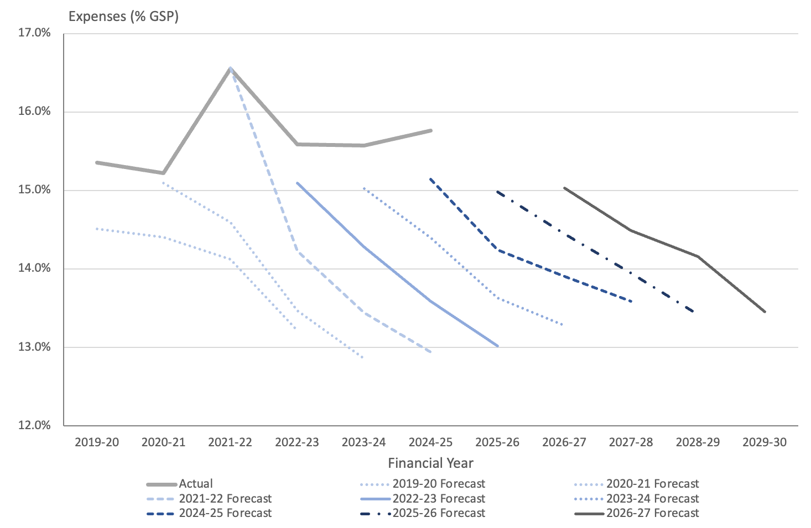
In each year, the ACT Budget has presented relatively modest forecasts for expenses that have been revised upwards in each successive set of Budget forecasts. In practice, expenses have generally grown faster than GSP and faster than forecast.
The Territory has a poor record in meeting forecasts for expenses
While forecasts of GSP can be influenced by many factors that might influence these ratios, forward estimates for expenses show a familiar pattern when expressed in simple dollar terms.
Based on this experience, and the discussion in following sections of this report, in the absence of concerted measures to restrain expenditure growth, estimates for expenses in the forward years might be expected to be higher in future years than forecast in the current Budget, both in absolute terms and as a proportion of GSP, unless the ACT Government has more success than it has achieved in the past, in restraining expenditure growth.

Reasons for growth
Growth in forecast expenses since the last Budget and the 2025-26 Budget Review is primarily the result of policy decisions to initiate new spending and the interest expenses associated with continued growth in borrowings, offset slightly by some technical adjustments.
The major contributions to the growth in expenses involve funding for housing, transport and municipal services and education. These include:
- public housing maintenance and repairs funding ($214.5. million over four years)
- public transport ($70.7 million over four years)
- modernising traffic and parking systems ($72.9 million over four years)
- support for public schools ($61.0 million over four years)
- support for community housing ($39.2 million over four years)
- public housing tenancy and homelessness services ($16.9 million over four years).
Other new initiatives include:
- city services ($30.7 million over four years)
- corporate services for Infrastructure Canberra and Digital Canberra ($30.5 million over four years)
- more frontline paramedics ($26.0 million over four years)
- essential prosecution services ($18.4 million over four years).
Interest costs are also forecast to be higher due to the impact of borrowings.
Growth in expenses is being driven by discretionary policy choices
Additional comment on growth in expenses by function is provided in subsection 5.3 below.
Many of the new initiatives have capital components. In addition, some housing initiatives announced in the Budget are outside the General Government sector. New capital investments in the Budget are discussed in section 6 of this report.
The new policy announced in this Budget has been partly offset. Expense offsets and savings in the Wellbeing statement total around $799.0. million over four years, though these figures include already provisioned funding, which would not normally be considered a saving against the budget balance.

Expenses by function
The Budget Papers include a presentation of expenses by the functions through which governments seek to achieve their objectives. This classification is widely employed in international financial reporting systems and allows trends in government outlays on functions or purposes to be compared between jurisdictions and over time.
In the ACT, General Government expenses are dominated by spending on health, education and general public services (which includes interest). Together, these functions account for around 70 percent of all government expenses as outlined in Figure 19 below.
Figure 19: Expenses by function, 2025-26 (est.) to 2029-30
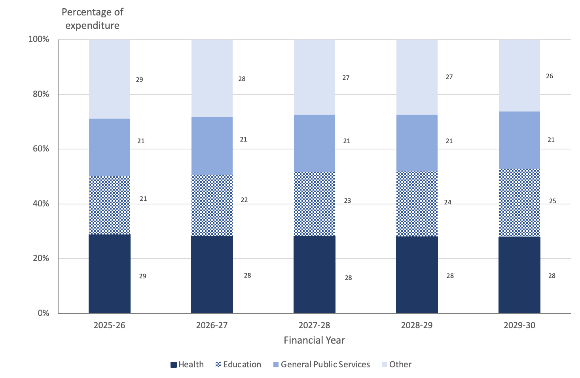
Note: This chart is drawn from Table 4.2.6 of the Budget Outlook which shows General Government expenses by function. This data does not include some government spending on housing, which in the ACT is also provided through the Public Trading Enterprises sector.
The Health function shows modest annual growth of 2.2 percent over the Budget and forward years, which is roughly in line with expected cost increases, but this is after an uplift of about 10 percent across each of the Budget and forward years announced in the 2025-26 Budget, and the forecasts are higher for each year than predicted last year. The Statement of Risks indicates that there is a possibility of further cost increases in this function given the ongoing nature of some of the challenges facing health service delivery. Assumptions have also been made in the Budget about future levels of additional assistance for public hospitals that might be provided in the future by the Commonwealth.
The Education function is also forecast to experience relatively modest annual growth of 2.7 percent between 2025-26 and 2029-30. This forecast may be difficult to achieve if costs increase faster than assumed in the Budget or if there is growth in the school age population. The Statement of Risks points to increased costs of meeting demand within ACT public schools. While additional funding to support public schools has been provided in the Budget, the Statement of Risks indicates that the outcomes of the ACT Public School System Resourcing Review may require additional funding in future years.
Readers need to be aware that Table 3.4.1 of the Budget Outlook does not fully account for the ACT Government’s expenses on housing. Information in Table 3.4.1 is consistent with the GFS general government framework. Under that framework, some housing services are reported as part of the social protection function. (The government provides a detailed breakdown of expenses by function that includes these expenses in Table 4.2.6 of the Budget Outlook.) In addition, many housing services in the ACT are provided by Housing ACT, which operates as a public non-financial institution outside the general government sector.
General public services are expected to grow by 7.7 percent annually over the Budget and forward years. This is mostly due to growth in public debt transactions (chiefly interest payments), which are forecast to increase from an estimated outcome of $586.6 million in 2025-26 to 1,204.8 million in 2029-30.
Further comment on interest expenses is provided in subsection 5.4 immediately below.

Expenses by economic type
Expenses can also be described in terms of the type or nature of the payment.
Expenses by type for the ACT Government are dominated by salaries, superannuation and other employee related expenses, representing almost half of total expenses, as shown in Figure 20 below.
Figure 20: Expenses by economic type – 2025-26 (est.) to 2029-30
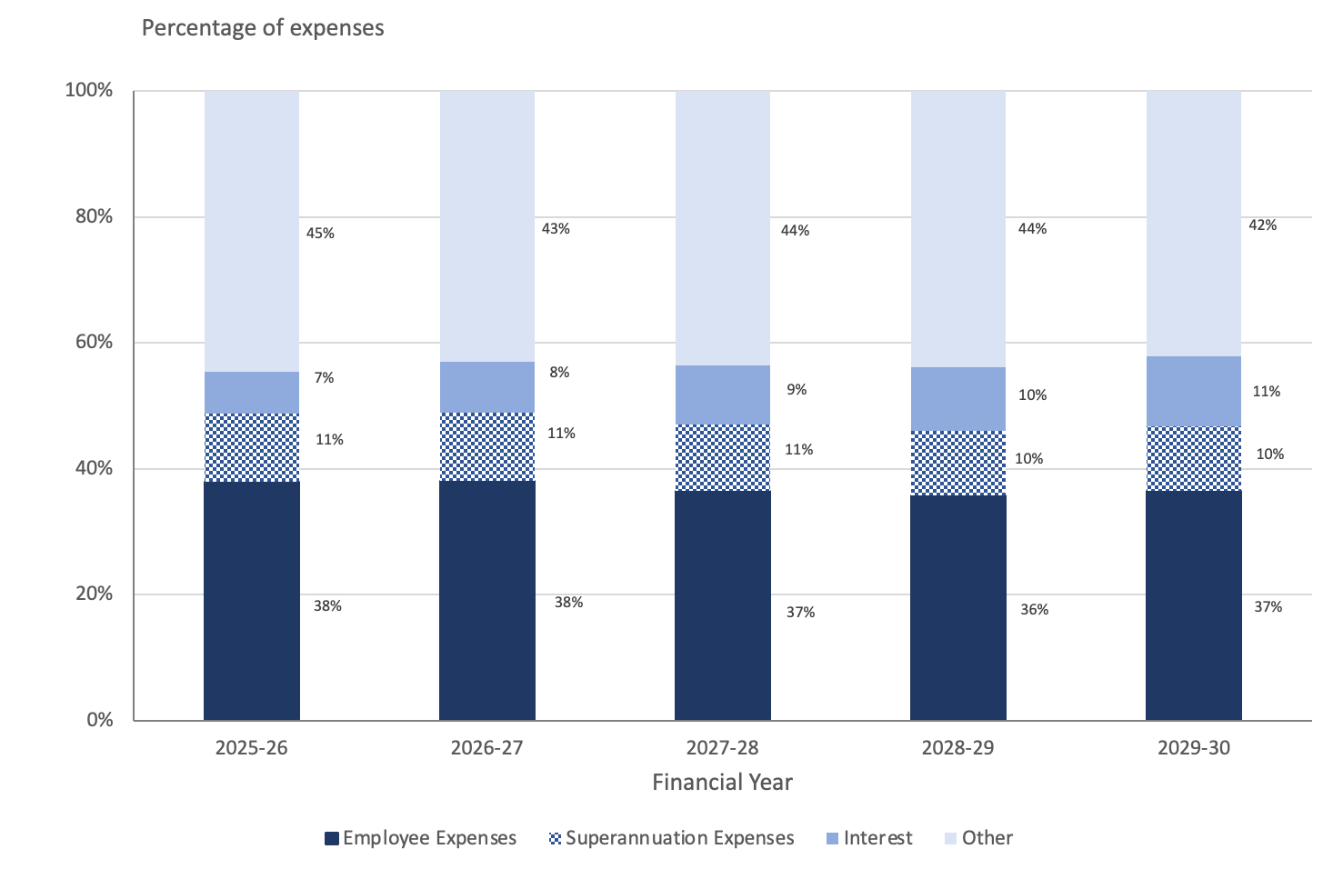
Employee expenses
Employee expenses are the largest single component of ACT Government expenditure, representing around 40 percent of the total. This means that the Budget and forward year forecasts for expenses will be driven to a large extent by decisions in relation to employee expenses. This is particularly the case given that many other areas of expenditure, such as interest payments, superannuation obligations and contractual commitments, are effectively locked in.
In 2026-27, employee expenses are forecast to grow by 6.0 percent over the expected outcome for 2025-26. This is lower than forecast for the same period last year, but higher than forecast for the Budget and forward years. The forecast 2.1 percent average annual growth rate is lower than the consumer price index assumption in the Budget of about 2½ percent and therefore represents a reduction in real terms.
Achievement of these forecasts will be a challenge for the ACT Government. As shown in Figure 21 below, employee expenses have risen steadily over the past decade, with a compound annual growth rate of 6.2 percent in the years from 2016-17 to 2022-23 and a compound annual growth rate of 9.7 percent between 2022-23 and 2025-26. In comparison with these historical growth rates, the Budget is forecasting that compound annual growth rate across the Budget and forward years will fall to 2.1 percent.
Figure 21: Employee expenses showing average annual growth rates, 2016-17 (actual) to 2029-30
The growth in expenses over this period are the result of various wage agreements across the years and growth in public service numbers. Data from previous budgets shows that the full-time equivalent staff numbers have increased from 25,879 in 2022-23 to an estimated 29,883 in 2025-26. This represents a compound annual growth rate of 4.9 percent, about half the overall rate of growth in employee expenses.
The forecast growth rate of 2.1 percent across the Budget and forward years is consistent with the fiscal target of ensuring that growth in general government employment does not exceed growth in the ACT population. However, achievement of this target will require a turn-around from almost 10 percent annual growth to 2 percent annual growth over a very few years. Year on year growth of 6 percent in 2026-27 is forecast to fall to less than 2 percent year on year growth by 2028-29.
Public service employment numbers are notoriously sticky on the way down. Salary increases are locked in by wage agreements and reductions in staffing are governed by employment arrangements that involve lengthy and potentially costly processes. The Budget papers are not clear about how the forecast reduction in employee expenses will be achieved. Only one new measure - a fund to assist agencies with voluntary redundancies - explicitly addresses whole of government expenditure reform. That measure is forecast to add to expenses in the first three years and only generate savings in 2029-20. The expected savings of $27 million in 2029-30 represent less than 1 percent of employee expenses in that year. Offsets are identified for other new policy measures but information on how these offsets will be achieved is not always provided.
Further information on strategies for achieving the forecast reductions in employee expenses, and their effect on front-line services, would aid in assessment of the robustness of these forecasts.
Interest expenses
Interest expenses are the fastest growing area of public expenditure with an annual average growth over the Budget and forward years of 17.6 percent. Interest expenses are now forecast to reach $811 million in 2026-27 and $1,217.5 million in 2029-30. The interest bill approximately doubles between the 2025-26 outcome and the 2029-30 estimate.
Interest costs are the fastest growing area of Government expenditure
Interest expenses include the cost of borrowings to service debt incurred to finance ongoing deficits and investments, interest on Commonwealth and other loans, and the interest costs associated with public private partnerships and service concessions. But the largest, and the fastest growing component, relates to the cost of servicing the public debt.
It can be useful to look at interest payments as a proportion of the Gross State Product for the ACT. This measure provides an indication of how much of the Territory’s total economic output is required just to pay the interest on its borrowings, providing a clear picture of long-term fiscal sustainability.
The Territory’s interest expense has grown as a share of GSP over the past decade, in line with growth in the Territory’s debt and other liabilities. Figure 22 below shows that interest expenses are forecast to almost triple as a share of GSP over this period, with much of this growth occurring since 2020-21.
By 2029-30, interest payments are forecast to total reach $1,217.5 million, or 11.1 percent of total expenses, and approximately 1.5 percent of GSP. Figure 22 below shows that the ACT Government’s interest bill represents a measurable and growing burden on the ACT economy.
Figure 22: Interest expenses as a proportion of Gross State Product, 2014-15 (actual) to 2029-30
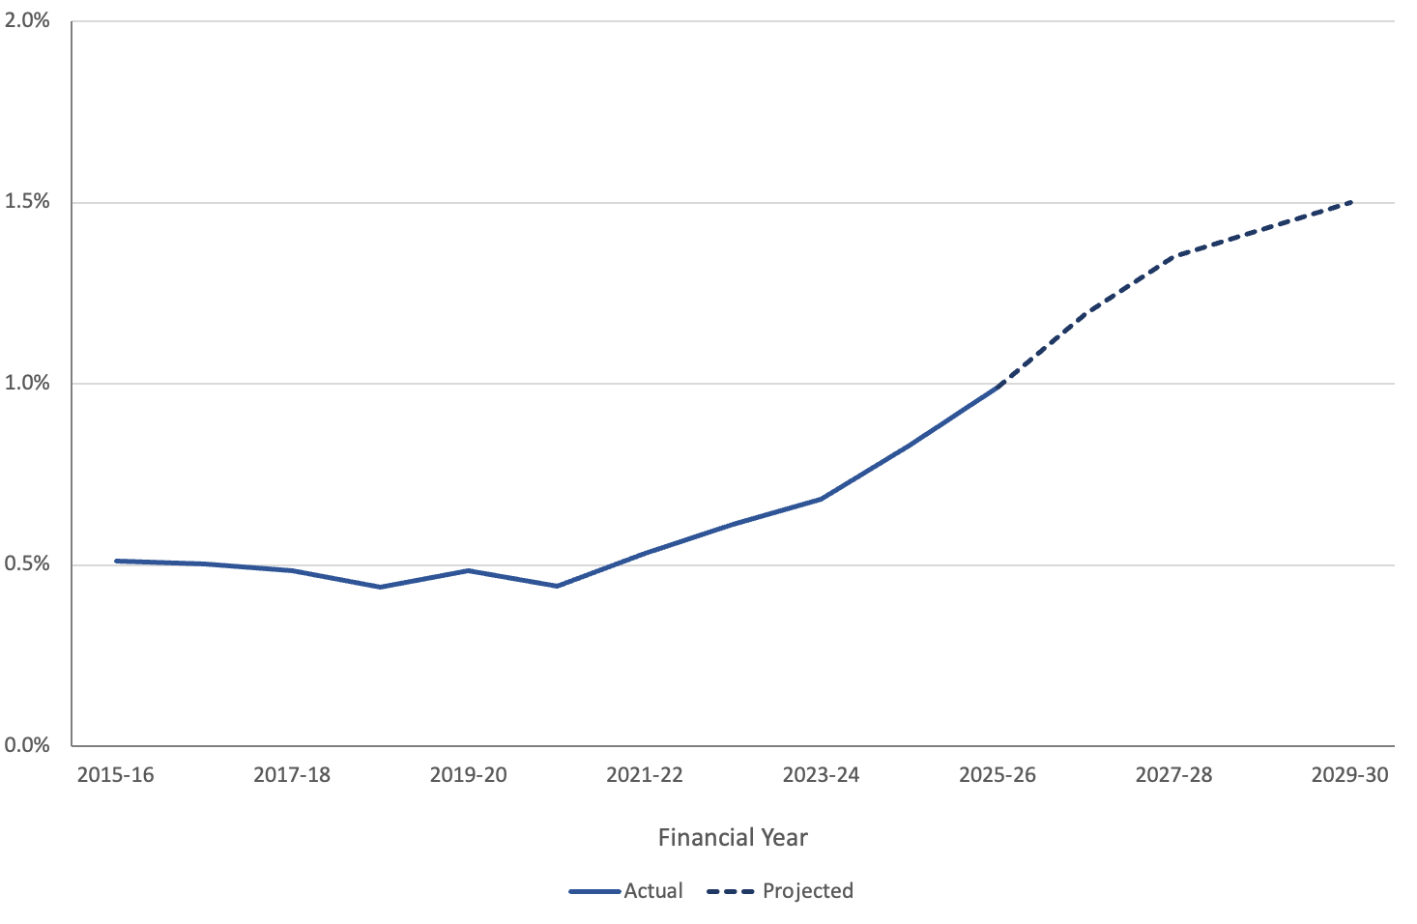
Another way to consider the growth of interest expenses in the ACT Budget is to consider how much of the Territory’s own-source tax revenue is required to meet interest obligations on government debt. This provides an indication of the government’s ability to meet its interest obligations from its own taxation efforts or, from the perspective of the taxpayer, how much of the taxes paid to the government are directed to interest payments on public debt rather than public services.
Figure 23: Interest expenses as a percentage of own source taxation revenue, 2016-17 (actual) to 2029-30
Figure 23 above shows that the interest expense as a proportion of own source taxation revenue has grown from around 10 percent in 2016-17 to a forecast of more than 30 percent in 2029-30. In other words, about a third of the taxes collected by the ACT Government in 2029-30 are expected to be diverted to interest payments on government borrowings.
Interest expenses represent a smaller, but still significant, proportion of total revenue, growing from a little over 5 percent in 2016-17 to just under 20 percent in 2029-30. However, this figure includes grants from the Commonwealth Government over which the ACT Government has little direct control and which it cannot ensure will be available to meet its debt obligations. Both measures are useful but the ratio of interest to own-source revenue highlights a government's direct capacity to service its debt using the revenues it controls.
High interest obligations divert funds that might otherwise be spent on health, education and other services. The interest bill also limits future budget flexibility. A large outstanding debt burden leaves the ACT less able to respond to future shocks in the form of pandemics, natural disasters or global uncertainty.

Infrastructure and Capital
The Budget includes funding for substantial major projects, infrastructure and capital works program across the Budget and forward years through the Infrastructure Investment Program, and the overarching 2024 revised ACT Infrastructure Plan. The program is over five years out to 2030-31. The ACT Government intends to invest $1.1 billion in 2026-27 and approximately $5.1 billion out to 2030-31 relating to the General Government Sector. A further $2.4 billion of works relates to the Public Trading Enterprises.
Key new investments include health, public housing, education, urban renewal, transport and roads, city and community and services, climate action and entertainment, arts and sport.
The Infrastructure Plan is subject to review in 2026-27 to reflect changes to the capital program, which may give rise to changes to the current estimates.

Overview
The Budget Papers indicate that the ACT Government (2026 p. 203) intends to invest $5.1 billion in infrastructure in the ACT over the next five years to 2030-31 in respect to the General Government Sector (GGS), and a further $2.4 billion for the Public Trading Enterprise Sector (PTE). Table 7 below summarises the infrastructure, capital works and investment program.
Table 7: Summary of Infrastructure Investment Program – 2025-26 to 2030-31
 | 2026-27 Allocation | 2027-28 Allocation | 2028-29 Allocation | 2029-30 Allocation | 2030-31 Allocation
 | $’000 | $’000 | $’000 | $’000 | $’000
New Capital Works | 184,718 | 232,486 | 120,494 | 22,374 | 42,492
Asset Renewal Program | 95,665 | 113,032 | 116,033 | 94,572 | 93,217
Works-in-progress | 1,451,889 | 1,196,468 | 372,105 | 393,850 | 287,326
Central Capital Provisions | 30,033 | 165,190 | 209,667 | 228,009 | 93,200
Other Provisions | -400,000 | -37,893 | -36,842 | -42,531 | 238,762
Total GGS Capital Works Program (including provisions) | 1,362,305 | 1,669,283 | 781,457 | 696,274 | 754,997
Capital Delivery Provision | -275,000 | -200,000 | 135,000 | 50,000 | 75,000
Total Capital Program Forecasts (including provisions) | 1,087,305 | 1,469,283 | 916,457 | 746,274 | 829,997
Public Trading Enterprises | 560,466 | 543,564 | 473,963 | 501,936 | 324,715
Total GGS and PTE Capital Program Forecasts (including provisions) | 1,647,771 | 2,012,847 | 1,390,420 | 1,248,210 | 1,154,712
Source: Table 3.7.1 (ACT Government, 2026, pp. 210-211)
The Budget Papers indicate the ACT Government is moving from a peak investment program to a more sustainable infrastructure program. The key focus will be on integrating existing infrastructure, improving asset utilisation and targeting areas of highest need. The ACT Government indicates the construction market is constrained, particularly in respect to contractor availability, labour shortages, supply chain volatility and competition from interstate infrastructure pipelines, causing upward pressure on project costs and delivery timelines.
The estimated reduction in the general government total capital works program (including provisions) for the years 2026-27 to 2029-30 compared with forecasts in the 2025-26 Budget for the same years is around $300 million.
As a consequence, the capital program will:
- Prioritise the delivery and completion of existing projects;
- Sequence future major projects to avoid excessive concurrency;
- Smooth the pipeline of infrastructure investment to support industry capacity; and
- Stage or delay major projects to focus on key priority areas including housing and health infrastructure.
Pegasus notes recent ACT Government announcements and public commentary indicated several projects will not proceed such as the new joint emergency services facility for Gungahlin – Casey and a new public health facility in Gungahlin – Casey. The ACT Government also announced the existing Monaro highway works – in progress would be completed but further stages have been deferred. Additionally, the extent of the planned upgrades of the Kippax, Coolaman Court and Calwell shopping precincts is not clear. The ACT Treasury has advised that the Kingston Arts Precinct project is being staged with early works, including parking and artist housing being prioritised, whilst the main buildings have been deferred.
The Capital Works Program includes savings adjustments, particularly in respect to the Asset Renewal Program of $202 million, whereby this amount is returned to the Budget reducing funding to agencies across the forward years. ACT Treasury has indicated this adjustment does not specifically remove or defer projects, rather, agencies are required to re-sequence planned assets renewal works to better align with historical delivery performance. Agencies retain discretion to allocate the reduced funding pool to projects that meet guidelines.
The ACT Treasury has advised that a comprehensive list of projects cancelled, deferred, or otherwise adjusted, as a consequence of reductions in the total infrastructure spend will not be available until the 2026-27 Budget Review.

Infrastructure Investment Program (IIP) – Key Elements
The IIP relies on ongoing Commonwealth funding, including planning and construction of Light Rail Stages 2A and 2B, a new Convention and Entertainment Centre and a new Aquatic Centre for Commonwealth Park. The Commonwealth also contributes to housing initiatives.
In summary, key elements of the IIP are (ACT Government, 2026, pp. 206-209):
Health Infrastructure:
- Delivering a new Northside hospital, including a new Clinical Services building (as announced, a 10 year project);
- Progressing the development of the Watson health precinct, including alcohol and other drug rehabilitation services through the Ted Noffs foundation;
- Purpose-built mental health and alcohol and other drug treatment facilities replacing the Gawanggal Mental Health Unit and Arcadia House;
- The new Inner South Health Centre and the new South Tuggeranong Health Centre; and
- Continue the redevelopment of the Canberra hospital.
Housing, land release and city planning:
The ACT Government intends to continue to expand the public housing portfolio to at least 13,200 homes and support an additional 5,000 public, community and affordable rental dwellings by 2030. This includes a target of 1,000 property renewals and 400 net additional public housing dwellings by June 2027 and at least 55 new social housing dwellings under the Commonwealth’s Social Housing Accelerator Program.
- 450 public housing dwellings with 252 supported by the Commonwealth’s Housing Australia Future Fund;
- 800 new affordable rental homes through the Affordable Housing Project Fund;
- Support the Commonwealth to increase housing supply for first home byers;
- Increased investment in repairs and maintenance of existing public housing stock, including insourcing maintenance services;
- Progressing the duplication of William Hovell drive, between John Gorton drive and Drake Brockman drive;
- Upgrading Drake Brockman drive; and
- Completing the construction of the John Gorton drive bridge.
Entertainment, arts and sports:
- Delivering playing fields in Taylor, and progressing the Stromlo Forest Park playing fields;
- Expanding the Belconnen Belconnen Basketball Stadium;
- Upgrades to Canberra Stadium;
- Redevelopment of the Canberra Theatre Centre;
- Progressing the National Convention and Entertainment Centre and the Canberra Aquatic Centre;
- Upgrades to community sporting facilities;
- Upgrades and repairs to acquatic facilities in Gungahlin, Erindale, Lakeside and Stromlo; and
- Upgrades to Exhibition Park.
Pegasus notes that a number of these projects have been in the plan for several years.
Education:
- Construction of a second college in Gungahlin;
- Construction of stage 2 of Strathnairn primary school including early childhood services;
- Stage 2 of the Whitlam school and Garren primary school projects and upgrades to Fraser primary school and Melba secondary school;
- Upgrades to school and TAFE and CIT infrastructure across Central Canberra;
- Complete the CIT campus in Woden; and
- Replacing 32 gas furnaces with electric reverse cycle appliances across a number of schools;
- Continuing establishment of a TAFE electric vehicles Centre of Excellence; and
- Supporting the UNSW City campus project.
Again, Pegasus notes that a number of these projects have been in the plan for several years.
Transport:
- Delivering Light Rail Stage 2A;
- Planning and Design of Light Rail Stage 2B;
- An active travel route from Hall to Gold Creek;
- Road upgrades to Athllon drive, Monaro highway, and Haydon, William Hovell, and John Gorton drives;
- Design of the Belconnen to City transitway; and
- Progressing the Garden City cycleway.
Climate action, energy and environment:
- Upgrades to bushfire risk reduction at Mugga Lane, planning and design of two new landfill cells, and deliver a Materials Recovery Facility;
- Improve water efficiency across the ACT;
- Upgrade Hall Village stormwater network; and
- Continue the electrification of gas asset replacement across ACT Government buildings funding

Capital Works Program – General Government
The Capital Works Program forms the largest component of the Infrastructure Investment Plan, with funding of $1.4 billion in 2026-27 and $3.7 billion over the five years to 2030-31. This includes:
- $185 million in 2026-27 and $603 million over five years for new capital works
- $1.5 billion in 2026-27 and $3.7 billion over five years for works-in-progress
- $96 million in 2026-27 and $476 million over five years for the Asset Renewal Program, and
- $726 million over five years for Central Capital Provisions.
The forecast capital spend increases over 2026-27 and 2027-28 and then drops significantly in 2028-29 and 2029-30, with a slight increase in 2030-31. On the experience of previous years, the forecast spending in 2030-31 could be expected to be revised in the future, particularly given the plan’s review scheduled for 2026-27.
Trends in capital works program forecasts in the last five ACT Budgets are outlined in Figure 24 below.

Figure 24: Capital Works Program Forecasts
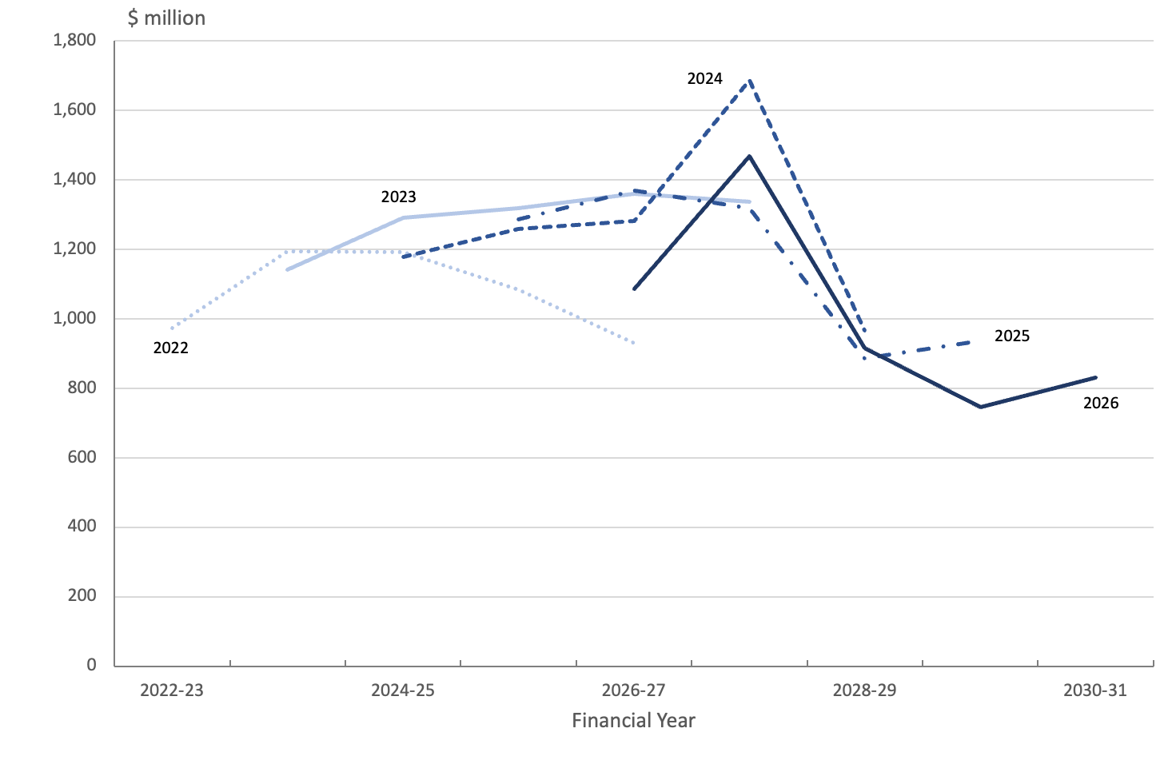
Source: ACT Budget Papers
Infrastructure Provisions increase substantially across the 2027-28 to 2029-30 forward years and tapper off in 2030-2031 with a total funding envelope of $727 million (Central Capital Provisions). The Central Capital Provisions sets aside funding for significant capital works projects for which budgets are yet to be settled, or which are commercially sensitive, including unallocated funding for the General Works Provision.
The Capital Delivery Provision is applied to the total GGS Capital Works Program and re-profiles the investment program across the plan and has a net zero impact over the six years to 2031-32.

Asset Renewal Program 2026-27
A total of $96 million is provided for in 2026-27 and a total funding envelope to 2030-31 of $476 million (ACT Government, 2026, p. 210). The purpose of the program is to maintain and/or existing infrastructure assets.
Key activities include (ACT Government, 2026, pp. 261-265):
- Canberra and North Canberra Hospital $19.2 million;
- Venues $8.4 million;
- Technology $23 million;
- Cultural Facilities $1,6 million;
- Education $13,4 million; and
- Infrastructure Canberra $7.6 million.

Works-In-Progress
A total of $1.5 billion is allocated for 2026-27 and a total of $3.7 billion across the five years. In summary, key components for 2026-27 include (ACT Government, 2026, pp. 267-277):
- Canberra Health services, $99.6 million, including Northside Hospital transition of $2.2 million;
- Chief Minister, Treasury and Economic Development, $33 million;
- City and Environment l, $282 million;
- Digital Canberra, $46.4 million;
- Education, $83 million;
- Health and Community Services, 15.2 million;
- Housing ACT, $199 million;
- Infrastructure Canberra, $2.8 billion; and
- Justice, $21 million.
Key projects include Light Rail phases 2A and 2B, Canberra Hospital expansion, Northside hospital development, Healthcare services, Monaro highway, school upgrades and community facilities, public/social housing and the Canberra Theatre Centre redevelopment.

Infrastructure Canberra (iCBR)
iCBR was established in 2024 and supersedes Major Projects Canberra. iCBR is responsible for delivering the Government’s infrastructure program including health, civil, transport and education capital projects and the Housing ACT capital works program. It is also responsible for the management and maintenance of most of the Government’s property portfolio.
Major projects include: upgrades to public buildings, Canberra Theatre expansion, managing construction of Light Rail Stage 2A, progressing Light Rail Stage 2B to Woden, Canberra hospital expansion and planning for the new Northside Hospital, Athllon drive duplication and other major road duplications, new and upgrades to ACT schools, public housing and electrification of Government and other gas assets.
It appears that many of these projects are re-phased from previous Budgets.

Capital Works Reserve
In 2019 the ACT Government amended the Financial Management Act 1996 to introduce a new mechanism, the Capital Works Reserve, to allow agencies with multi-year allocations to manage their capital program by advancing funds during the financial year should their capital appropriation be exceeded. Essentially a capital works advance allows funds to be drawn from the Reserve which are deducted from the forward estimates for the project(s) concerned in later years. The 2026-27 Budget has allocated $272 million to the Reserve, with unused funds lapsing at the end of the financial year.
Directorates wishing to drawdown on the Reserve must seek the Treasurer’s approval, with ACT Treasury centrally controlling applications. The Treasurer is required to provide the Legislative Assembly with a reconciliation of any amounts approved for payment from the Reserve (under section 26 of the Financial Management Act 1996).
ACT Treasury has confirmed the Reserve is rarely accessed.

Capital Works Program – Public Trading Enterprises
The Public Trading Enterprises (PTEs) capital works program is outside the Budget as each entity funds their projects from own-sourced revenue, borrowings or funding from the Government. The PTEs will undertake new works totalling $560 million in 2026-27 and $2.4 billion over the five years to 2030-31.
Both the City Renewal Authority and Housing ACT will also receive additional amounts from the Budget. City Renewal Authority receives $39.1 million and $47.6 million across the five year program. ACT Housing receives $266.3 million and a total of $647.2 million from the Budget.
New works are projected in 2026-27 totalling $560.5 million and a total of $2.4 billion across the five years to 2030-31 (ACT Government, 2026, p. 216). The programs include:
- Cemeteries and Crematoria Authority, $0.6 million in 2026-27 and $2.8 million over five years;
- City Renewal Authority, $8.0 million in 2026-27 and $22.4 million over five years;
- Housing ACT, $69.3 million in 2026-27;
- Icon Water, $299 million in 2026-27 and $1.6 billion over five years; and
- Suburban Land Agency, $183.6 million in 2026-27 and $704.3 million over five years.

Public Private Partnership Arrangements
The ACT Government is engaged in three Public Private Partnership (PPP) arrangements, Light Rail, ACT Housing Assistance Program and the New Recycling Facility. A typical PPP involves a number of parties, a government, a third party constructor/operator and a third party financier/s. The third party entities usually act as a consortium. A project will normally consist of three phases, planning and design, construction and operation.
PPP arrangements have been a feature of off-balance sheet asset and infrastructure generation and financing by Australian governments for over 30 years, with toll roads being a classic example. There is a specific accounting standard that sets out the accounting rules for each phase of the project (see subsection 8.5 below). A typical partnership will continue for 25 years, during which the asset is constructed and then operated by the consortium with revenue generated from the asset being retained by the consortium. During this period the government pays the consortium to operate the asset (similar to a lease arrangement), with the asset/s transferring to the government at the expiry of the contract period.
Light Rail
Stage 1, Gungahlin to Alinga Street, is complete and operational. The operator is Canberra Metro, a private consortium, including John Holland construction. Metro staff are employed by Canberra Metro, and the rolling stock and other assets are owned and used by the consortium. Revenue generated is retained by the consortium. The assets will revert to ACT ownership at the expiry of the contract period. Currently, the contract runs through to 2039.
Stage 2A, Alinga Street to Commonwealth Park, is in construction phase. The agreement for the operation and maintenance of Stage 2A rolled into existing contracts and runs for a 20-year period.
Stage 2B, to Woden, is in planning and design phase.
ACT Housing Asset Assistance Program (HAAP)
The HAAP arrangements are long term leases between the Government and Community Housing Providers to provide affordable housing solutions and specialist homelessness services to vulnerable citizens.
The initial contract term usually operates for a fixed three-year term, with options for three and four year extensions, capped to a maximum of 10 years.
New Recycling Facility (NRF)
The Government entered into a contract with Veolia Environmental Services (Australia) in January 2025, for the financing, design, construction, commissioning, operation and maintenance of a new recycling facility in Hume. The facility is expected to be operating in 2026, with the contract running until April 2048.

Assets and Liabilities
The Budget forecasts a continuing deterioration in the balance sheet until the final outyears.
From being a net creditor at the beginning of the last decade, the ACT now carries a substantial and growing debt burden. Net debt continues to grow through the Budget and forward years, reaching 17.3 percent of GSP.
Net financial liabilities also increase until 2028-29 but then fall slightly in 2029-30.
Net worth declines until 2028-29 when it improves slightly in nominal terms. As a proportion of GSP net worth falls through the Budget and forward estimates period.
The ACT continues to make progress in building a pool of assets to cover its superannuation liability and on present trends could be expected to achieve its fiscal target of fully funding the liability by 2035.

Overview
The ACT balance sheet has been deteriorating over recent years. Net debt is again forecast to rise over the Budget and forward estimates. Net financial liabilities are also forecast to rise until experiencing a slight decline between 2028-29 and 2029-30. Net worth is forecast to fall in absolute terms until 2027-28 and to grow slightly in nominal terms over the final two out-years.

Net debt
Net debt represents the sum of deposits held, advances received and borrowings less the sum of cash and deposits, advances paid, investments, loans and placements but excludes super liabilities.
The ACT’s net debt continues to increase over the Budget and forward estimates period. The Budget forecast for net debt in 2026-27 is slightly lower than forecast in the 2025-26 Budget but there is still an upward trend over the forward estimates. The slight fall relative to the 2025-26 Budget is due to higher cash and deposits and lower borrowing requirements due to changes in the Infrastructure Investment Program.
Net debt continues to grow across the forward estimates
In absolute terms, net debt in 2029-30 is forecast to be approximately 50 percent higher than the estimated debt in 2025-26 and eight times higher than in 2015-16. The ACT had no public debt as recently as 2011-12.
The ratio of net debt to GSP is a broad indicator of a jurisdiction’s ability to meet its debt obligations and its medium-term financial sustainability. The Budget Papers forecast continued growth in this indicator, in line with the trend over the past decade, until 2028-29 when the ratio falls slightly. This reflects growth in GSP rather than a decline in net debt. Net debt is forecast to reach 17.3 percent of GSP in 2029-30, which is within the 19 percent target set by the Government’s fiscal strategy.
Figure 25 illustrates the growth in net debt since 2013-14 as a percentage of Gross State Product (GSP).
Figure 25: Net debt as a proportion of Gross State Product
Note: From 2019-20, net debt includes the impact of accounting changes in relation to the treatment of leases. The ACT Government has indicated that for this reason net debt from 2019-20 is not directly comparable to prior years.
While there have been some technical adjustments and other transactions related to the Asbestos Eradication Scheme in 2015-16, and the treatment of leases in 2015-16 and 2019-20, growth in debt over the period has been driven by persistent ACT Government deficits and a large infrastructure program. The 2026-27 Budget has adopted a new accounting standard, AASB 17 Insurance Contracts. This standard impacts the way the Lifetime Care and Support Scheme liabilities are treated. The overall budget impact at this stage is expected to be immaterial.
Growth in public debt as a proportion of GSP is forecast to moderate in the later out-years. This is the result of forecast growth in GSP in those years being higher than forecast growth in public debt. Figure 26 below shows the annual growth in net debt compared with growth in GSP.
Figure 26: Annual growth in net debt and GSP, 2021-22(actual) to 2029-30 (forecast)
Figure 26 shows that actual annual growth in net debt has been much higher than growth in GSP over recent years, and is forecast to remain higher until 2027-28. Beyond 2027-28, net debt is still expected to grow year on year, but at a lower rate than GSP.
A short-term increase in net debt can be a sensible response to adverse economic shocks, such as the COVID-19 pandemic, and can be justified when investing in future wealth generating assets. However, continuing high levels of debt impose costs on the Budget that constrain choices to invest in other areas and can reduce future budget flexibility.

Net financial liabilities
Net financial liabilities is a broader measure than net debt as it includes liabilities other than borrowings, such as unfunded superannuation and long service leave entitlements, and includes financial assets held by the government but excludes the value of equity held in public corporations. Changes in net financial liabilities are therefore influenced by variations in the net debt figures discussed above.
The Territory’s net financial liabilities are forecast to increase across the Budget and forward years until falling slightly from 2028-29. ACT Treasury has advised that the fall in net financial liabilities between 2028-29 and 2029-30 mainly relates to the growth in superannuation related investment assets. This also accounts for the difference in the trends for net debt and net financial liabilities in the final outyears, as superannuation is excluded from net debt.
Net financial liabilities improve in the last year of the forward estimates
The growth in net financial liabilities over the period is mainly due to increasing levels of net debt.
Figure 27 below illustrates the growth in net financial liabilities as a proportion of GSP since 2011-12.

Figure 27: Net financial liabilities as a proportion of Gross State Product
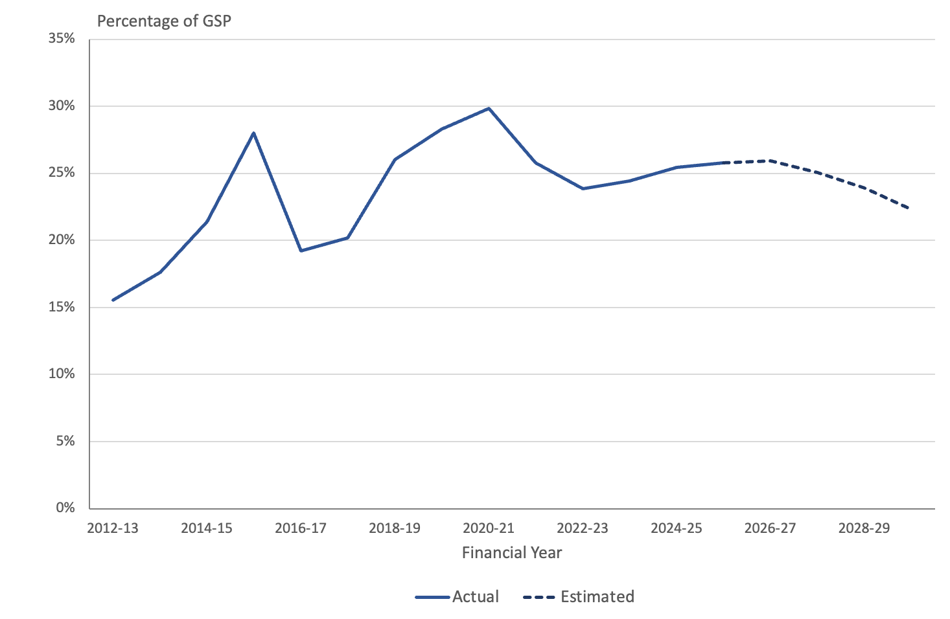
While there has been some fluctuation in the ratio of net financial liabilities to GSP over time, the overall trend over the last decade has been upwards. Relative to GSP, net financial liabilities are forecast to rise gradually over the period to 2026-27 and then decline slightly across the forward years.

Net worth
Net worth is an economic measure of wealth that reflects the value of all financial and non-financial assets (such as land, plant and equipment) less liabilities, including superannuation liabilities.
This indicator is often regarded as the best measure of the sustainability and inter-generational equity of a jurisdiction’s fiscal position.
Changes in net worth since 2011-12 mirror the experience for net financial liabilities. That is, when liabilities decrease, as occurred in 2021-22, net worth increases and vice versa. In nominal dollar terms net worth grew from $13.8 billion in 2011-12 to $20.9 billion in 2023-24 but is forecast to fall to $19.2 billion in 2027-28 before growing slightly in 2028-29 and 2029-30.
The decline in net worth is forecast to be reversed from 2027-28
Relative to GSP, however, there has been a downward trend, as shown in Figure 28 below.
Figure 28: Net worth as a proportion of Gross State Product
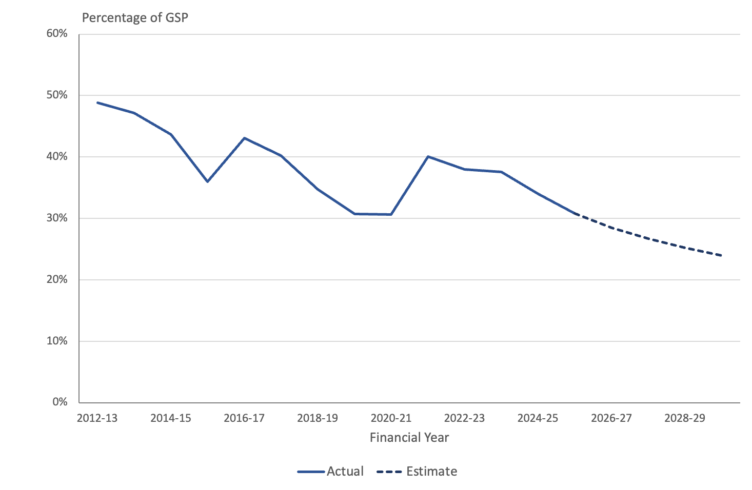
The ratio of net worth to GSP has been falling for over a decade, from around 50 percent of GSP in 2012-13 to about a third in 2024-25 and is forecast to be slightly less than a quarter of GSP in 2029-30.
In the absence of corrective measures to improve the value of the Territory’s assets, or further reduce liabilities, that trend could be expected to continue.

Superannuation
For new employees since 2005, the Government has made fortnightly payments to each employee’s designated superannuation fund under a defined contribution arrangement. There are no associated unfunded liabilities for these employees. However, the ACT continues to carry a significant liability associated with the superannuation entitlements of past and present employees who are members of the Commonwealth’s now closed defined benefit superannuation schemes, the Commonwealth Superannuation Scheme (CSS) and the Public Sector Superannuation Scheme (PSS). The CSS was closed to new members in 1990 and the PSS scheme in 2005.
Approximately 4,450 employees as at 30 June 2025 were members of these schemes, a reduction of around 250 over 2024-25. In addition, the ACT has liabilities in the two schemes in relation to a further 29,600 former ACT Government employees, including around 18,000 pensioners. Total membership has fallen by only around 600 over 2024-25, reflecting the long-tailed nature of defined benefit pension schemes.
The Territory’s estimated defined benefit superannuation liability depends critically upon the discount rate used to calculate the present value of superannuation payments in future years and its relativity to the other financial assumptions regarding future salary growth, pension indexation and crediting rates. Demographic assumptions regarding exit rates and mortality will also impact on the estimated liability. For financial statement reporting, the discount rate is prescribed under the accounting standards (AASB 119) to be the market yield on Government bonds on the reporting date. This changes from year to year and leads to volatility in the estimated liability.
For the Budget estimates, however, financial assumptions have been unchanged since the 2023-24 Budget, which means that changes in the liability reflect deviations in actual experience from the assumptions previously adopted as well as changes in assumptions regarding future outcomes that take account of those changes in experience.
Over 95 percent of the estimated CSS liability of $2.8 billion relates to pensions in payment. This component of the liability is very sensitive to pension indexation rates, which in turn rely on growth in the CPI. Over the past three years, the CPI has grown faster than the long-term assumption of 2.5 percent per annum adopted in projecting the liability, averaging 3.4 percent per annum. This has led to an increase in the estimated liability. The PSS liability now constitutes around three quarters of the total liability and, for the PSS pensions currently in payment and the employer funded component of the deferred benefit, there is a similar exposure to inflation risk. For current employees, the more significant risk is salary growth. For example, higher than anticipated salary growth over 2024-25 added almost $100 million to the liability as at 30 June 2025. The investment earnings rate achieved on the funded component of PSS benefits for current employees and Figure 29 shows the estimated superannuation liability for the Budget year and out-years from each of the last four Budgets. The liability increased by around 10 percent between the 2023-34 and 2024-25 Budgets, primarily as a result of the spike in inflation over 2022 and 2023. Over the subsequent years inflation moderated leading to progressively smaller increases in the liability. The liability projections in the current Budget are just 0.6% higher than those from the 2025-26 Budget, but do not take account of the increase in inflation over 2025-26 which resulted in indexation of 4.1 percent rather than the 2.5 percent assumed for valuation purposes.
Furthermore, the latest Reserve Bank outlook noted that inflationary pressures were elevated prior to the outbreak of hostilities in the Middle East and that these pressures have been exacerbated by the disruptions in global trade caused by the conflict. It therefore seems likely that pension indexation increases will again be higher than the valuation assumption of 2.5 percent per annum over the next year or two leading to an increase in the liability over and above the current projections.
Figure 29: Estimated Defined Benefit Superannuation Liabilities
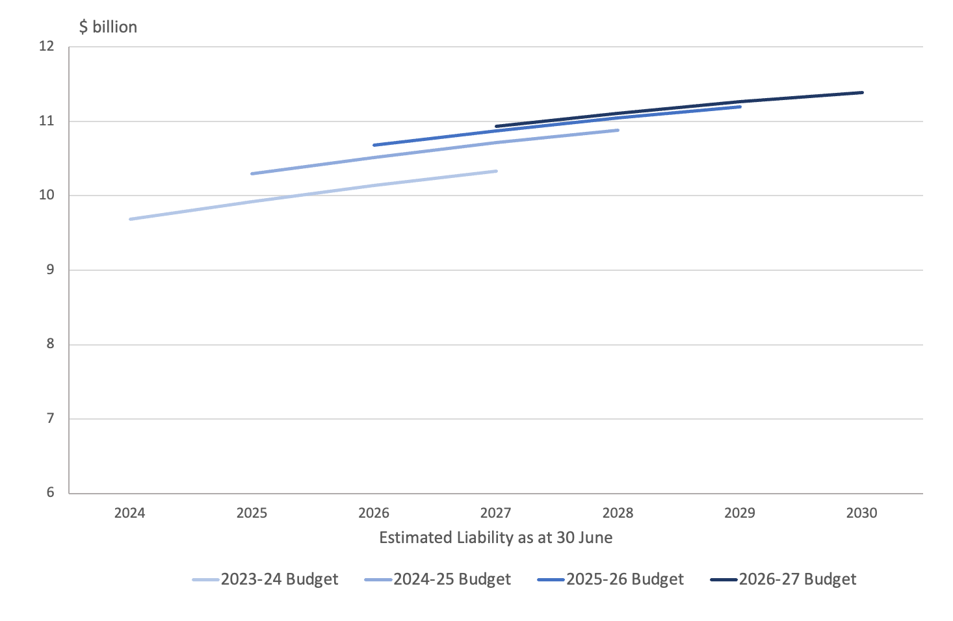
Source: ACT Budget Papers
There are three flows associated with the superannuation liability. The projected service cost represents the additional liability arising from employee service during the year. This cost is gradually reducing as the number of members still in employment declines. The interest cost takes account of the fact that the accrued benefits that make up the liability are now one year closer to payment and also leads to an increase in the liability. Benefit payments cover the cost of paying beneficiaries and reduce the total liability. Benefit payments are expected to increase in nominal terms for the next twenty years before starting to fall as the pensioner population declines. The projections of these three flows are shown in Figure 30.
Figure 30: Estimated Defined Benefit Superannuation Flows
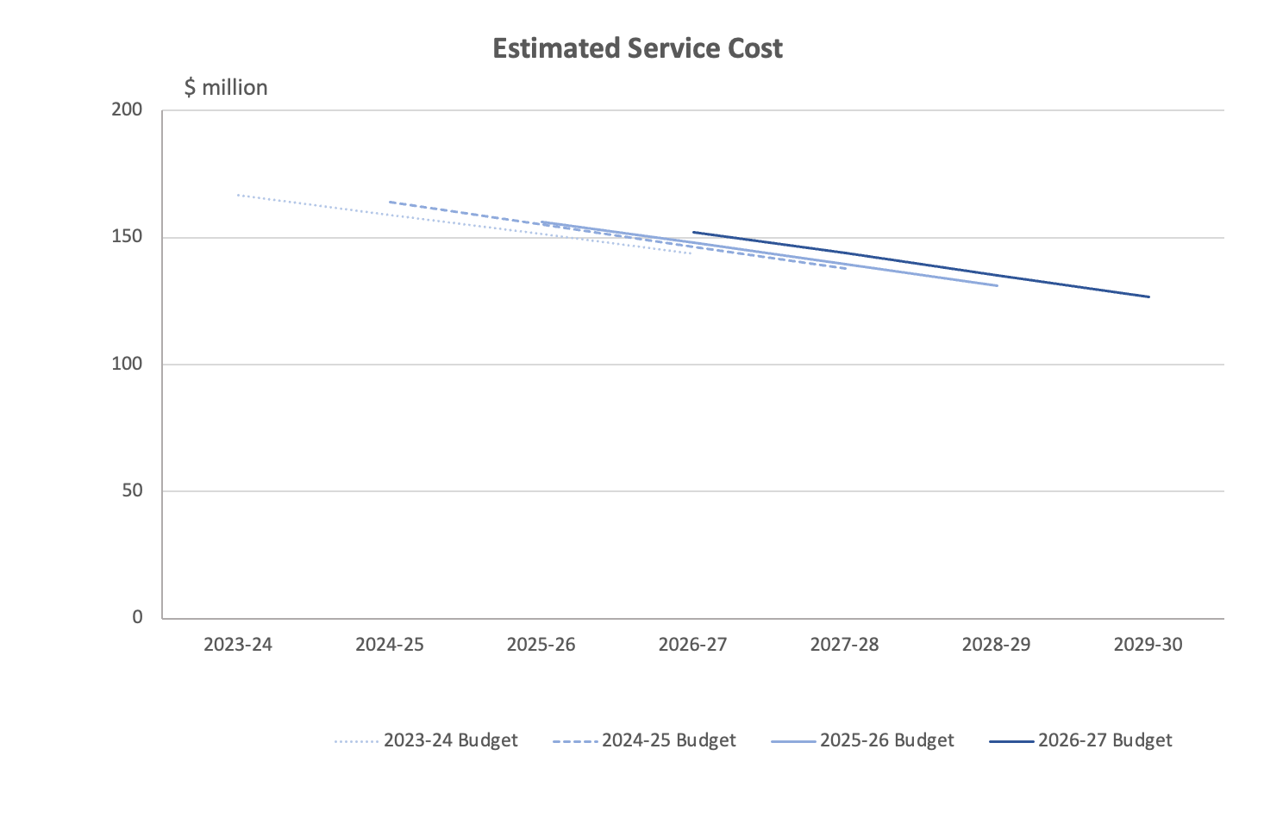
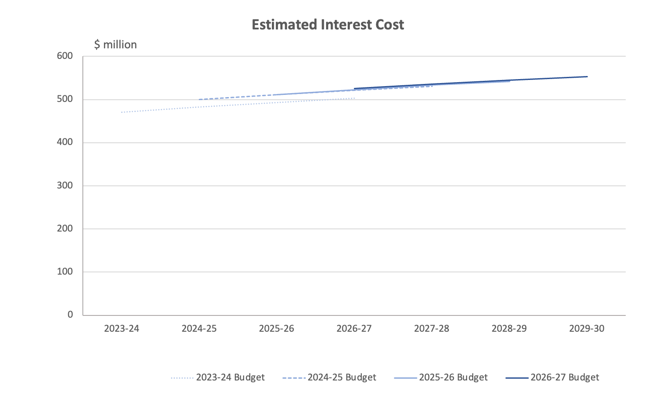
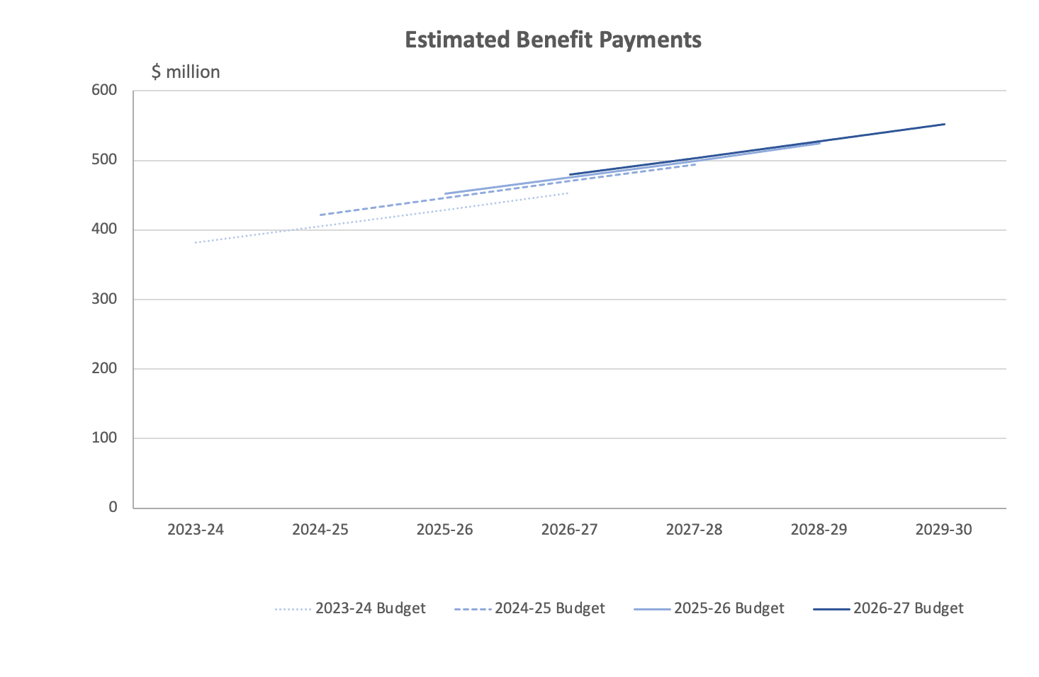
Source: ACT Budget Papers
It can be seen that all three of these measures have been stable over successive Budgets. The impact of the higher than anticipated inflation is visible in the increase in projected benefit payments between the 2023-24 and 2024-25 Budgets, but is minor in the context of overall superannuation liabilities.
The ACT Government established a Superannuation Provision Account in 1991 as a vehicle for accumulating funds to meet the Territory’s unfunded defined benefit superannuation liability. As at 30 June 2026, the assets in the Account are estimated to cover 68% of the total superannuation liability and this proportion is expected to increase over the forward years as shown in Figure 31.

Figure 31: Defined Benefit Superannuation Unfunded Liability and Investment Assets
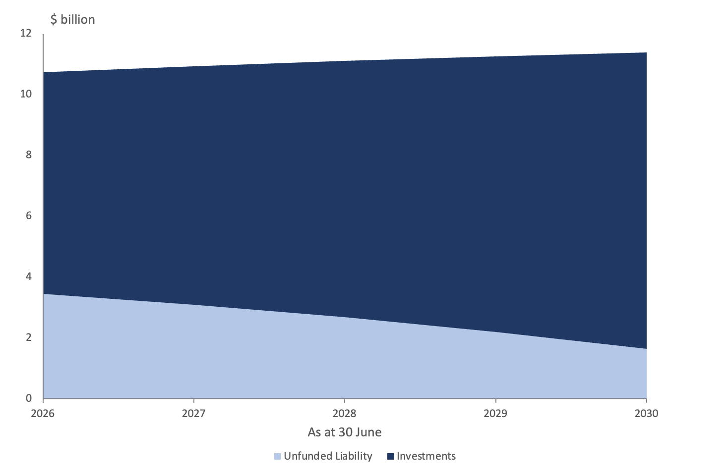
Source: ACT Budget Papers
The original intention when the Account was established was to achieve 90% coverage of liability by 2040. In the 2006-07 Budget, the then Government strengthened the commitment to achieving full funding by 2030. This goal was reiterated by successive Governments over the following decade and a half, but no additional cash injections have been made to the Account since 2016. As a result, it became increasingly apparent that full funding was unlikely to be achieved within the designated timeframe. In the current Budget, the Government has revised its funding goal and committed to full funding by 2035.
Based on the existing trends in investment performance and, assuming that benefit payments continue to be funded from the Budget rather than the Account, we estimate that assets will be sufficient to cover the unfunded liability (estimated using the long-term financial assumptions) by 2033.
Furthermore, there is no indication that the ACT will have any difficulties in meeting its unfunded superannuation obligations, which will emerge as a requirement to meet benefit payments over a period of more than 50 years.

Budget accounting, classification and valuation issues
Valuation effects, accounting treatments and timing issues continue to have large impacts on the budget aggregates and on the reported Budget balance.

Overview
The 2026-27 Budget reflects decisions on a number of accounting, classification and valuation issues.
The following sections provide comment on the budget accounting and classification issues that have material impacts on the Budget aggregates and how they are presented.

Disclosure of financial statements and key accounting policies
The Budget financial statements, including the budget deficit, and associated notes and tables, are presented in Chapter 4 of the Budget Outlook (ACT Government, 2026, pp. 233-247). Section 4.1 relates to the General Government Sector (GGS) and Appendix D includes the consolidated financial statements for the ACT’s Public Trading Enterprises. Appendix E includes the Total Territory Consolidated Financial Statements which provides an accounting consolidation of the GGS and the Public Trading Enterprises.
The Notes to the GGS Financial Statements – Basis of preparation (ACT Government, 2026, pp. 240-247) outlines the GGS statements have been prepared on an accrual accounting basis and accord with the Australian Accounting Standards Board accounting standard AASB 1049 Whole of Government and General Government Sector Financial Reporting. AASB 1049, which forms the basis for the Australian Heads of Treasuries Uniform Presentation Framework (UPF), requires compliance with all other applicable accounting standards in the preparation of the statements.
In accordance with generally accepted budget reporting principles, the notes set out disaggregated financial details of key expenses, assets and liabilities. Disaggregated key revenue items is disclosed in Chapter 3.5 Revenue of the Budget Outlook. This level of disclosure represents an improvement in transparency compared to the Budgets in prior years.
The Committee should note the Headline Net Operating Balance, (Table 4.1.4, ACT Government, 2006, pp. 238-239), diverges from the UPF Net Operating Balance as it includes long-term superannuation investment earnings (ACT Government, 2026, p. 241).
Section 4.2 – “OTHER GGS STATEMENTS” provides details and a further level of granularity of the GGS’s revenue from taxes, grant and dividend and tax equivalent streams and expenses across the ACT’s key directorate functions (ACT Government, 2026, pp. 249-253). The total numbers can be reconciled with the estimates and forecasts set out in the revenue and expense section of the Budget (see particularly Tables 3.4.1, 3.4.2 and Tables 3.5.1 and 3.5.2).
Appendix G – “Key Accounting Treatments - Basis of financial estimates preparation” (ACT Government, 2026, pp. 293-298) sets out the key accounting bases adopted in the preparation of the Budget financial statements and estimates. This section confirms that the financial statements have been prepared in accordance with AASB 1049, the UPF, which is based on AASB 1049, the basis of accounting consolidation and where applicable, the ABS Government Finance Statistics framework.
Appendix G also discloses several accounting policies and assumptions that relate to Service Concessions, Concessional Loans and the Financial Guarantee Contract Liability for contracted ACT community housing providers (ACT Government, 2026, pp. 293-298). The Service Concession disclosures (ACT Housing Asset Assistance Program, Light Rail – Stages 1 and 2A and the New Recycling Facility contract with Veolia Environmental Services Australia), relating to Light Rail Stage 2A, in particular, have been further enhanced for 2026-27.
However, there is no disclosure of the accounting policies adopted in respect of other key assets such as investments and loans, investments in other public sector entities, and produced and non-produced property plant and equipment, nor key liabilities such as advances received, borrowings, superannuation and employee compensation.

Superannuation return adjustment
As has been the case since 2006-07, the presentation of the headline net operating balance for 2026-27 includes an adjustment for long-term expected superannuation investment earnings.
The ACT Government (2026, p. 40) argues that a superannuation return adjustment (SRA) is necessary in order to provide a fair measure of its fiscal position. While the Government Finance Statistics (GFS) reporting framework requires the inclusion of superannuation interest costs and other superannuation expenses in the operating balance, it only allows for interest income and dividends to be included as a transactional revenue item in the net operating balance, ignoring the capital growth on the assets in the Superannuation Provision Account. The ACT Government maintains that inclusion of the SRA provides a better indication of the sustainability of the headline net operating balance.
We acknowledge that there is an argument for allowing an offset to the reported interest cost to recognise the fact that the Government is holding assets in the Superannuation Provision Account to meet superannuation liabilities. Calculating such an offset using the discount rate that has been used to estimate the liability would replicate the treatment of the interest cost in a partially funded superannuation scheme, to which the Territory arrangement is analogous. However, the ACT Government has calculated the offset by assuming a return on the assets that exceeds the discount rate adopted in valuing the superannuation liabilities. Given that the SRA is included in the net operating balance, this approach effectively biases the budget presentation towards a more favourable outcome.
A factor that would argue against the inclusion of the SRA in the headline net operating balance is that the excess investment return over the reported investment income is, by definition, an increase in the value of assets. As such, it is not available to meet current expenditure and cannot be considered to be akin to the revenue and expenses that give rise to the operating balance. This is particularly the case, given the ACT Government’s policy of not drawing down on the assets in the Account while it is less than the estimated superannuation liability.
If the SRA is to be included in the headline net operating balance, it should not lead to a bias in outcomes. This would mean calculating the SRA on an assumption that the total return on the assets of the Superannuation Provision Account is identical to the long-term discount rate used in valuing the liability. In the Budget year, this would imply an SRA of $105 million. Use of the projected long-term investment return in the Budget rather than the long-term valuation discount rate of 5% per annum improves the reported fiscal position by around $185 million.

Superannuation liability valuation and service costs
The discount rate used to calculate the present value of the Territory’s superannuation liability has a significant impact on the estimated value of the liability and related superannuation expenses, with a lower discount rate giving rise to a higher estimate of the liability and service costs.
Reporting of the liability in the financial statements is required under the Australian Accounting Standards (AASB 119) to be prepared on the basis of the yield on a suitable Commonwealth Government bond. The liability valuation as at 30 June 2025 utilised a discount rate assumption of 4.80 percent reflecting bond yields at that date. However, bond yields are unpredictable and can be quite volatile, leading to volatility in the liability estimates, which may obscure genuine changes in experience. To avoid this source of volatility, the liability reported in the Budget papers is prepared using a single long-term discount rate.
The long-term discount rate utilised in the 2026-27 Budget is 5 percent per annum. This is consistent with the rates used by the Commonwealth Government in the two most recent triennial actuarial reviews (as at 30 June 2020 and 30 June 2023) of the defined benefit schemes giving rise to the Territory’s liability. The inflation assumption is also consistent with that used for the triennial actuarial reviews.
At present, Government bond rates are very close to the long-term discount rate of 5 percent per annum. Over the past two months, for example, yields on 10 year Government bonds have varied between 4.84 and 5.12 percent per annum, averaging 4.96 percent per annum. As a result, we do not expect the closing liability reported in the financial statements for 2025-26 to be materially affected by the use of the discount rate prescribed by AASB 119. However, the higher than projected pension indexation rates over 2025-26 could be expected to add around $100 to the liability as reported in the Budget documents.

Service Concession Arrangements
The ACT Government is currently engaged in several Public Private Partnerships (PPP-Service Concession) projects: Light Rail Stages 1 and 2A, the ACT Housing Asset Assistance Program (HAAP) and the New Recycling Facility (NRF).
Since the 2020-21 Budget, the ACT Government has adopted the applicable accounting standard, AASB 1059 Service Concession Arrangements: Grantors.
AASB 1059 does not treat service concession arrangements as leases, but instead, requires the assets and liabilities to be recognised in the balance sheet and valued at current replacement cost, when the government gains control of these assets and liabilities, generally taken to be when the project becomes operational. Any intangible assets such as intellectual property rights, must be included in the aggregate of project assets. At the end of the construction contracts, the infrastructure will become ACT assets. This is taken to mean that once the projects are operational, the infrastructure is owned by the Territory. It is noted that Light Rail – Stage 1 became operational in April 2019. In December 2023 the ACT Government entered a service concession arrangement for Light Rail – Stage 2A. In January 2025 the Government entered into a contract with Veolia Environmental Services Australia for the financing, design, construction, commissioning, operation and maintenance of a new recycling facility in Hume.
Appendix G in the Budget Outlook indicates in respect to Light Rail Stages 1 and 2A, the infrastructure will only become ACT assets at the end of these contracts, that is, upon completion (ACT Government, 2026, p. 295), although the ACT Government will make service payments over the life of the long-term contracts with the consortia.
The ACT Treasury has confirmed that in respect to Light Rail Stage 2B, to Woden, the project is in planning and design status, with a financial contribution from the Commonwealth.
These Public Private Partnership arrangements are also discussed at subsection 6.9 of this report.

Acquisition of Calvary Public Hospital and Clare Holland House
The ACT Government publicly announced it was acquiring the Calvary Public Hospital (Calvary) for nil consideration in the lead up to the 2023-24 Budget. The ACT Government subsequently announced the acquisition of Clare Holland House through mutual agreement. The effective date of acquisition of Calvary was 3 July 2023.
Pursuant to the Australian Accounting Standards, where an asset is acquired for nil consideration, no revenue is brought to account on initial recognition, but instead, the transaction is treated as a balance sheet only event and, as such, an asset is recognized together with a corresponding adjustment to equity. We understand that the acquisition was recognized in the General Government Sector balance sheet and statement of changes in equity with a date of effect 3 July 2023.
Apart from the asset, the transaction also includes the transfer of some staff to the ACT public sector. Relevant employee costs including salary and wages, leave entitlements and post-employment compensation (superannuation), and offsetting reductions in the purchase of services, were expensed in the 2023-24 Budget statements, with corresponding liabilities recognised in the General Government Sector financial statements.
The matter of compensation in relation to the acquisition of Calvary Hospital has been settled, with the ACT Government (2025, p. 4) providing a payment of $65 million to Calvary Health Care (Calvary) to conclude the just terms compensation process.

Technical adjustments
The Budget Papers include technical adjustments that appear to indicate changes to previous decisions relating to the funding of programs and projects. The adjustments appear to move funding across years as well as changes to appropriations across years.
Whilst examples of this practice are not unusual in other jurisdictions; for instance, the re-phasing of appropriations and the movement of previous decisions to out years, the level of adjustments appears substantial.

Concessional loans
Concessional loans are arrangements where a lender, typically a government, provides a loan facility on terms and conditions more favorable than the prevailing market. Concessions can include lower or zero interest rates, interest free periods, and/or an extended maturity term. Appendix G indicates the ACT Government (2026, pp. 296-297) is providing concessional loans pursuant to its Sustainable Household Scheme. Securitised Trusts for these loans were created in 2024-25.
The arrangement provides lower interest loans to assist households with the upfront costs of installing equipment to enable emissions reductions. The accounting treatment outlined accords with the applicable accounting standard AASB 9 Financial Instruments.
Pursuant to the Commonwealth’s 100,000 Homes for First Home Buyers initiative, the ACT Government received $200 million in concessional loans.

Financial Guarantee Contract Liability
The Commonwealth Government’s housing financing program provides funding for social and affordable housing through its Housing Australia Future Fund Facility to Community Housing Providers. The ACT Government (2026, pp. 297-298) is offering to guarantee loans required by ACT Community Housing Providers for approved projects. The 2026-27 Budget includes a financial loan guarantee liability of $39.2 million in 2028-29.
Again, the recognition of this liability accords with AASB 9 Financial Instruments.

Housing
While the ACT Government’s target of 30,000 new homes by 2030 is consistent with long-run trends, it may be difficult to achieve based on more recent developments.
The available evidence would appear to support claims by the ACT Government that the ACT is the most affordable jurisdiction to buy or rent a home. There are two factors that have contributed to improved housing affordability in the ACT. First, ACT residents enjoy the highest relative incomes across all States and Territories. Second, the overall value of dwellings in Canberra have fallen relatively as compared to the rest of the country. While overall housing affordability in Canberra has improved, there is also evidence to suggest that lower income households are still struggling.
The available evidence suggests the stock of public housing in the ACT has not kept pace with ACT population growth and has remained largely stagnant since 2011 while the ACT resident population has grown by over 31.7 percent between 2011 and 2025. While the ACT Government’s budget investment in public housing is likely to increase the overall stock of public housing available in the ACT, the supply of public housing is still unlikely to keep pace with growth in the ACT population.

Housing Approvals and Supply
According to the ACT Government (2026, p. 152):
The ACT Government is expanding housing supply, choice and access through a program of land use planning and precinct development to enable 30,000 more homes, including an additional 5,000 affordable and social homes, by the end of 2030.
To meet the ACT Government’s target of 30,000 new homes per year by 2030 commencing in 2025, on average 5,000 new dwellings need to be constructed over six years up until the end of 2030. If knockdown rebuilds of existing dwellings are considered, then this would mean that even more than 5,000 new dwellings need to be constructed per annum up until 2030. Furthermore, in the year to the end of March 2026, around 270 dwellings were approved for demolition. The number of dwellings approved on a calendar year basis is outlined in Figure 32 below.
Figure 32: Total Number of Dwellings Approved in the ACT – 2011 to 2025
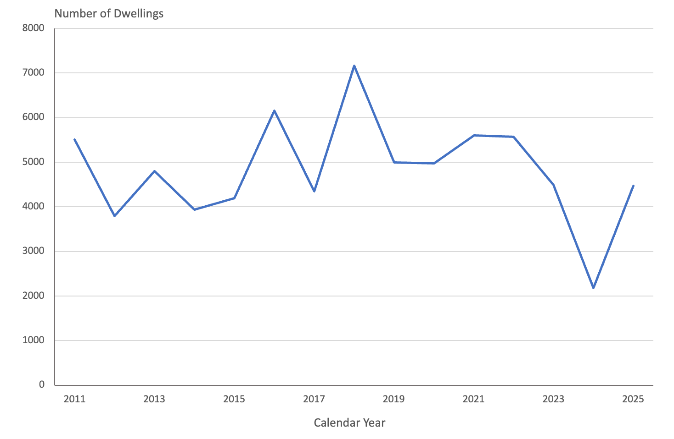
Source: ABS (2026b).
From 2011 to 2025, around 4,800 new dwelling approvals per year on average have been approved for construction in the ACT (Australian Bureau of Statistics, 2026b). However, in the three-year period between 2023 and 2025, less than 3,800 dwellings have been approved for construction per annum on average. The Housing Industry Association (HIA) (2026a, p. 5) has observed:
… progress since announcement of the 30,000 homes target has been insufficient to place the Territory on a credible trajectory toward delivery. The first year following the target’s release has not demonstrated the level of acceleration required. Without structural reform to feasibility settings, workforce capacity and government-imposed cost structures, annual completions are unlikely to scale at the pace required to meet the target.
While the ACT Government’s target of 30,000 new homes by 2030 is consistent with trends over the last 15 years, it may not be achievable based on more contemporary experience. Also, one potential obstacle that could emerge if residential building construction picks-up is emergence of labour shortages.
30,000 new homes by 2030 may not be achievable based on recent experience
To increase the supply of dwellings, the ACT Government has announced its ‘Missing Middle’ housing reforms with a focus on increasing the supply of medium density housing such as low-rise:
- multi-occupancy housing (such as dual- and tri-occupancy housing)
- terraces and townhouses
- apartments (up to three storeys).
As part of its ‘Missing Middle; housing reforms, the ACT Government is:
- Delivering a Canberra House Pattern Book to provide a range of pre-approved designs for missing middle housing, including dual occupancy and tri-occupancy homes.
- Providing a temporary 50 percent remission of the codified Lease Variation Charge (LVC) for developments in Suburban (RZ1) and Suburban Core (RZ2) zones to support the uptake of ‘missing middle’ housing developments (as previously discussed in section 4).
However, the HIA (2026) has warned the ACT Government’s approach of focusing on medium density housing could become unstuck:
The Government’s housing supply strategy is at risk of becoming too dependent of the uptake of the Missing Middle reforms. Achieving the target of delivering 30,000 homes by 2030 will require the government to broaden its focus to improve supply across all housing typologies.

Housing Affordability
According to the ACT Government (2026, p. 152), the ACT is the most affordable jurisdiction to buy or rent a home, as housing remains affordable in the ACT relative to average income levels, despite having the fourth highest median property prices of all of the states and territories and the fifth highest median weekly rental price of all Australian capital cities in the March 2026 quarter. The available evidence would appear to lend support to these claims.
In the March quarter 2026, the mean price of residential dwellings was the highest in New South Wales ($1,324,800), followed by Queensland ($1,123,700), Western Australia (1,103,500) and the ACT ($1,018,000) (Australian Bureau of Statistics, 2026f). This can be seen in Figure 33 below.
Figure 33: Mean Dwelling Price, States and Territories – September Quarter 2025 to March Quarter 2026 ($’000)
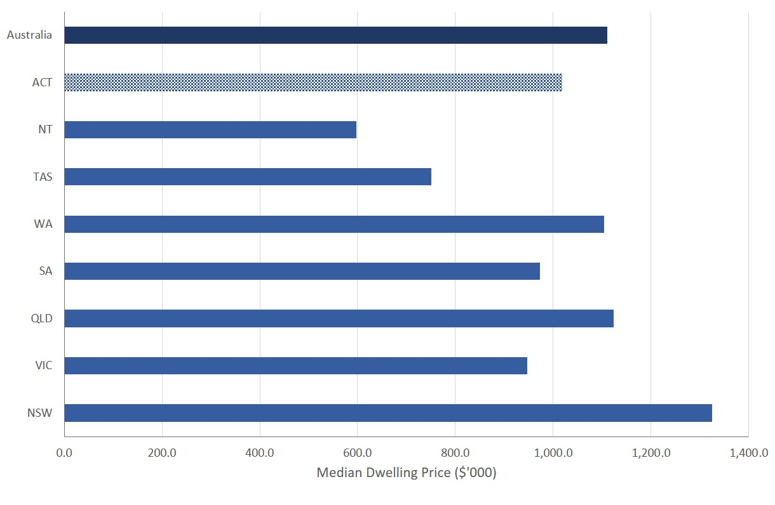
Source: ABS (2026f).
In the March quarter 2026, the median weekly rent for all dwellings was the highest in Sydney ($824 per week), followed by Perth ($761 per week), Brisbane ($720 per week), Darwin ($699 per week) and Canberra ($695 per week) (Cotality, 2026a). This can be seen in Figure 34 below.
Figure 34: Median Rent per Week in Australian Capital Cities – March Quarter 2026
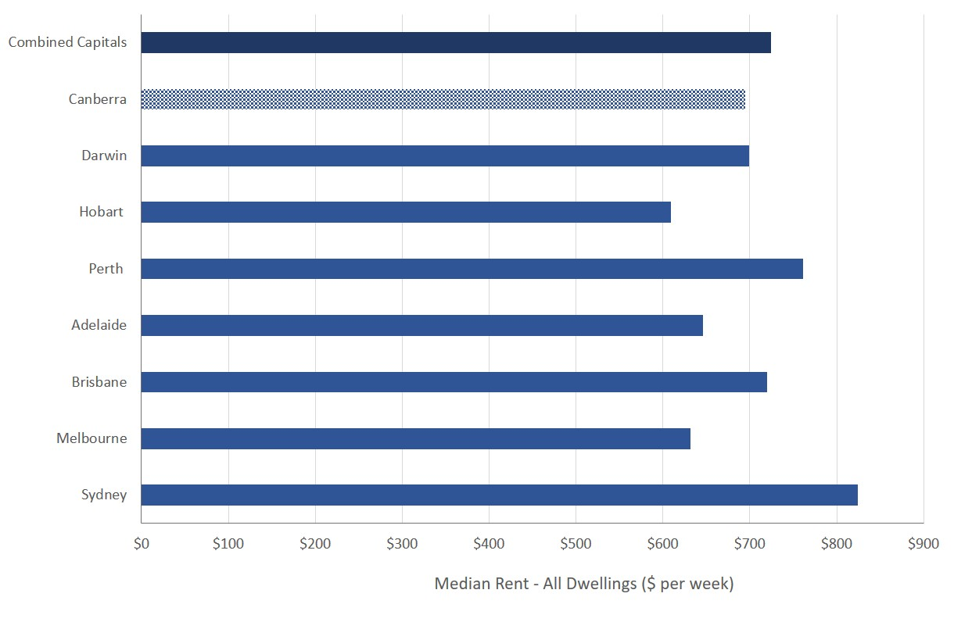
Source: Cotality (2026a).
The most recent Cotality (2025, p. 17) Housing Affordability Report released found that in the September quarter of 2025 the percentage of income required to service a new mortgage for a dwelling in Canberra was the second lowest amongst the capital cities, and the percentage of income required to service rent for a dwelling was the lowest amongst the capital cities. This is outlined in Figure 35 below.
Figure 35: Portion of Income Required to Service a New Mortgage and Rent for a Dwelling in Australian Capital Cities – September 2025
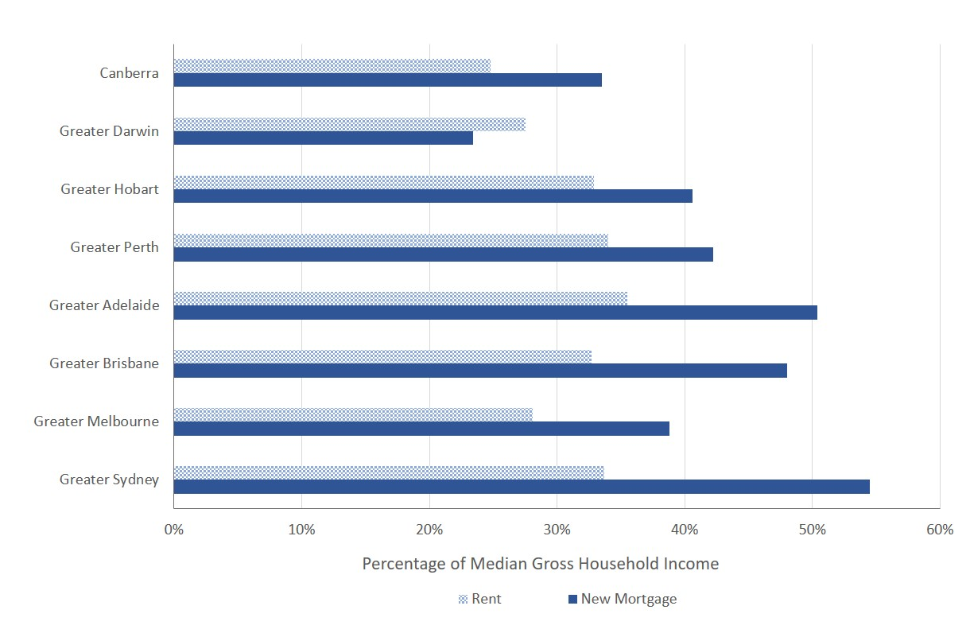
Source: Cotality (2025, p. 8).
Housing affordability in Canberra has improved…
There are two factors that contribute to improved housing affordability. First, ACT residents enjoy the highest relative incomes across all States and Territories, with average ordinary time weekly earnings for full-time adults in the ACT being $2,248.40 in November 2025, 9.6 percent higher than the national average (Australian Bureau of Statistics, 2026a). This has been an ongoing feature in the ACT. Second, the overall value of dwellings in Canberra have fallen relatively as compared to the rest of the country. While dwelling prices have risen by 4.3 percent in Canberra during the last 12 months to the end of May 2026, relative dwelling prices have risen by more, on average, throughout the rest of the country (Cotality, 2026). According to Cotality (2026, p. 5), dwelling values across the capital cities combined have risen by 7.8 percent and by 11.8 percent on average across regional areas in the 12 months to the end of May 2026. Overall, Canberra dwelling values are still 2.1 percent below the record high seen in May 2022 (Cotality, 2026, p. 17).
…but people on lower incomes are being left behind
While overall housing affordability in Canberra has improved, there is also evidence to suggest that lower income households are still struggling. According to the 2025 Rental Affordability Index:
- Affordability across the ACT is predominantly Acceptable, with only limited areas, such as Curtin to Garran and Monash to Macarthur, classified as Moderately Unaffordable.
- High average incomes in Canberra contribute to the city’s affordability.
- However, they mask the challenges faced by low-income and vulnerable households, such as students and minimum-wage couples, who are unable to find Acceptable rentals at the median rate within the ACT. (SGS Economics and Planning Pty Ltd, 2025, p. 99).
The ACT Government (2026, p. 152) has also recognised that lower income residents struggle to access secure and affordable housing.

Provision of Public Housing
In order to address the plight of lower income residents in relation housing affordability, the ACT Government (2026, p. 236) is investing to deliver an additional 450 dwellings towards its commitment to grow the Territory’s public housing portfolio to 13,200 homes by the end of 2030.
The ACT Audit Office (2024, p. 15) has observed that Canberra’s relatively high rent and property prices compared to other Australian capital cities means that Canberrans living on low incomes can be significantly disadvantaged in accessing housing, and that consequently demand for public housing in the ACT is high and increasing
The available evidence suggests the stock of public housing in the ACT has not kept pace with ACT population growth and has remained largely stagnant since 2011 while the ACT resident population has grown by over 31.7 percent between 2011 and 2025. Figure 36 shows that while the ACT population continues to increase, the public housing stock has been relatively flat.
Figure 36: ACT Population and the Provision of ACT Public Housing Dwellings
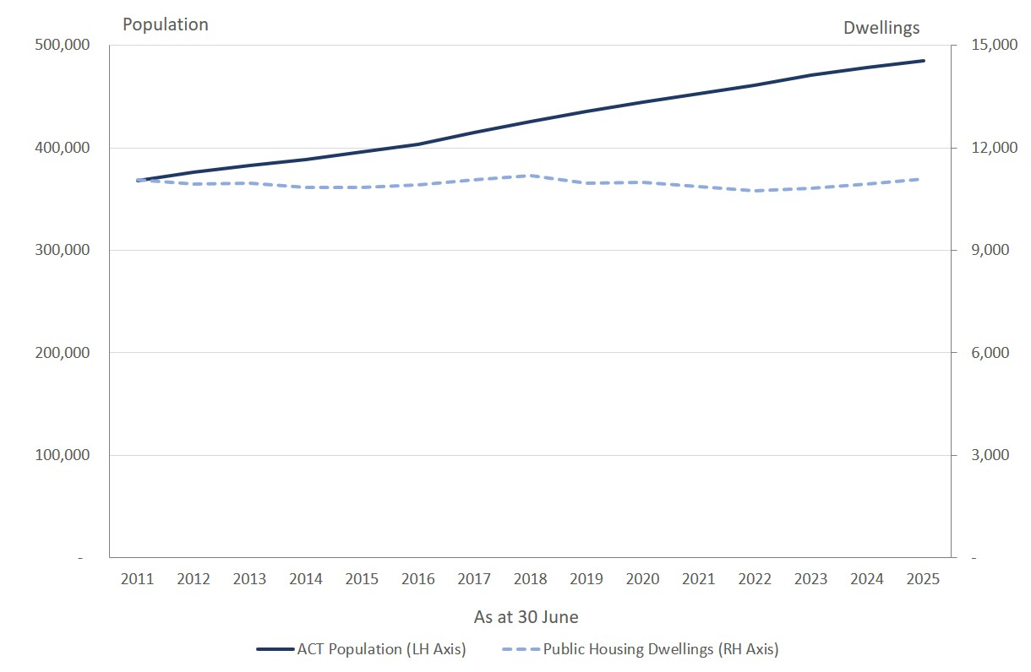
Sources: ABS (2026e) and Productivity Commission (2026).
The supply of public housing is not keeping pace with population growth
While the ACT Government’s budget investment in public housing is likely to increase the overall stock of public housing available in the ACT, the supply of public housing is still unlikely to keep pace with growth in the ACT population as previously observed by the ACT Audit Office (2024, p. 1):
Although there will be more public housing homes in the ACT by the end of the Program in 2027, the supply of public housing homes relative to the number of people living in the Territory will decrease, because the ACT’s population is increasing.

References
ACT Audit Office. (2020). ACT Auditor-General's Report: Residential Land Supply and Release. Report No.4 / 2020, Canberra.
ACT Audit Office. (2024). Management of the Growing and Renewing Public Housing Program. ACT Auditor-General's Performance Audit Report, Canberra.
ACT Government. (2012). Australian Capital Territory Budget 2012-13 Budget Paper No. 3: Budget Overview. Canberra.
ACT Government. (2013). Australian Capital Territory Budget 2013‐14 Budget Paper No. 3. Canberra.
ACT Government. (2014). Australian Capital Territory Budget 2014-15 Budget Paper No. 3. Canberra.
ACT Government. (2015). Australian Capital Territory Budget 2015-16 - Budget Paper No. 3 Budget Outlook. Canberra.
ACT Government. (2016). Australian Capital Territory Budget 2016-17 for Canberra - Budget Paper 3: Budget Outlook. Canberra.
ACT Government. (2018). Australian Capital Territory Budget 2017-18 Budget Review. Canberra.
ACT Government. (2018a). Australian Capital Territory Budget 2018-19 - Budget Paper 3: Budget Outlook. Canberra.
ACT Government. (2019). Australian Capital Territory Budget 2019-20 Building for the Future - Budget Paper 3: Budget Outlook. Canberra.
ACT Government. (2021). Australian Capital Territory Budget 2020-21: Driving Canberra's Recovery - Budget Outlook. Canberra.
ACT Government. (2021a). Australian Capital Territory Budget 2021-22: Budget Outlook. Canberra.
ACT Government. (2022a). 2022-23 Budget Outlook. Canberra.
ACT Government. (2022b). Australian Capital Territory Budget: Budget Statement I - Major Projects Canberra. Canberra.
ACT Government. (2023). 2023-24 Budget Outlook. Canberra.
ACT Government. (2024). 2024-25 Budget Outlook. Canberra.
ACT Government. (2024a). Australian Capital Territory Budget 2024-25: Women’s Budget Statement. Canberra.
ACT Government. (2025). 2025-26 Budget Addendum. Canberra.
ACT Government. (2025a). 2025-26 Budget Outlook. Canberra.
ACT Government. (2026). 2026-27 Budget Outlook. Canberra.
ACT Government. (2026a). Tax Expenditure Statement 2024-25: Australian Capital Territory . Canberra.
Australian Accounting Standards Board. (2010). AASB 9 - Financial Instruments. Melbourne.
Australian Bureau of Statistics. (2021b, July 9). History and purpose of gross state product. Retrieved from Australian Bureau of Statistics: https://www.abs.gov.au/statistics/detailed-methodology-information/concepts-sources-methods/australian-system-national-accounts-concepts-sources-and-methods/2020-21/chapter-21-state-accounts/history-and-purpose-gross-state-product
Australian Bureau of Statistics. (2025, November 20). Australian National Accounts: State Accounts. Retrieved from Australian Bureau of Statistics: https://www.abs.gov.au/statistics/economy/national-accounts/australian-national-accounts-state-accounts/2024-25-financial-year
Australian Bureau of Statistics. (2025a, August 26). Counts of Australian Businesses, including Entries and Exits: July 2021 to June 2025. Retrieved from Australian Bureau of Statistics: https://www.abs.gov.au/statistics/economy/business-indicators/counts-australian-businesses-including-entries-and-exits/latest-release
Australian Bureau of Statistics. (2026, June 3). Australian National Accounts: National Income, Expenditure and Product: March 2026. Retrieved from Australian Bureau of Statistics: https://www.abs.gov.au/statistics/economy/national-accounts/australian-national-accounts-national-income-expenditure-and-product/latest-release
Australian Bureau of Statistics. (2026a, February 26). Average Weekly Earnings, Australia - November 2025. Retrieved from Australian Bureau of Statistics: https://www.abs.gov.au/statistics/labour/earnings-and-working-conditions/average-weekly-earnings-australia/latest-release
Australian Bureau of Statistics. (2026b, June 2). Building Approvals, Australia - April 2026. Retrieved from Australian Bureau of Statistics: https://www.abs.gov.au/statistics/industry/building-and-construction/building-approvals-australia/latest-release
Australian Bureau of Statistics. (2026c, April 27). Consumer Price Index, Australia: April 2026. Retrieved from Australian Bureau of Statistics: https://www.abs.gov.au/statistics/economy/price-indexes-and-inflation/consumer-price-index-australia/apr-2026
Australian Bureau of Statistics. (2026d, June 25). Labour Force, Australia: May 2026. Retrieved from Australian Bureau of Statistics: https://www.abs.gov.au/statistics/labour/employment-and-unemployment/labour-force-australia/latest-release
Australian Bureau of Statistics. (2026e, June 18). National, state and territory population: December 2025. Retrieved from Australian Bureau of Statistics: https://www.abs.gov.au/statistics/people/population/national-state-and-territory-population/latest-release
Australian Bureau of Statistics. (2026f, June 9). Total Value of Dwellings - March Quarter 2026. Retrieved from Australian Bureau of Statistics: https://www.abs.gov.au/statistics/economy/price-indexes-and-inflation/total-value-dwellings/latest-release
Australian Bureau of Statistics. (2026g, May 13). Wage Price Index, Australia: March 2026. Retrieved from Australian Bureau of Statistics: https://www.abs.gov.au/statistics/economy/price-indexes-and-inflation/wage-price-index-australia/mar-2026
Australian Public Service Commission. (2025). State of the Service Report: 2024-25. Canberra.
Centre for Population. (2026). 2025 Population Statement. Canberra: The Commonwealth of Australia.
Commonwealth of Australia. (2026). Budget 2026-27: Agency Resourcing Budget Paper No. 4. Canberra.
Commonwealth of Australia. (2026a). Budget 2026-27: Budget Strategy and Outlook Budget Paper No. 1. Canberra.
Cotality. (2025). Housing Affordability Report Australia - November 2025.
Cotality. (2026). Monthly Housing Chart Pack: May 2026.
Cotality. (2026a). Quartertly Rental Review Australia I Released April 2025.
Eslake, S. (2026). Final Report to the ACT Legislative Assembly Select Committee on the Fiscal Sustainability of the ACT. In Economics.
Eyers, J. (2026, June 11). Westpac investor loans plunge one-fifth on federal budget tax shock. The Australian Financial Review.
Freebairn, J., Stewart, M., & Liu, P. X. (2015). Reform of State Taxes in Australia: Rationale and Options. Melbourne: Melbourne School of Government.
Henry, K., Harmer, J., Piggott, J., Ridout, H., & Smith, G. (2009a). Australia’s future tax system: Report to the Treasurer, Part Two Detailed Analysis volume 1. Canberra: Commonwealth of Australia.
Housing Industry Association. (2026). ACT Budget doubles down on missing middle. Media Release, 10 June.
Housing Industry Association. (2026a). 2026-27 Budget Submission to the ACT Treasury: Increasing Housing Supply, Improving Affordability, and Strengthening Industry. Canberra.
Li, B., & Gao, G. (2021). Estimating quarterly gross state product. Victoria’s Economic Bulletin, 5: June 2021, 1-11.
OECD. (2010). Choosing a Broad Base – Low Rate Approach to Taxation. Paris: OECD Publishing.
Productivity Commission. (2026, June 3). Report on Government Services 2026: Part G, Section 18 - Housing. Retrieved from Productivity Commission: https://www.pc.gov.au/ongoing/report-on-government-services/housing-homelessness/housing/
Read, M. (2024, December 9). How Victoria became one of the rich world’s most indebted states. The Australian Financial Review.
Read, M. (2025, February 9). ACT risks Victoria-style downgrade as deficit blows out to $1b. The Australian Financial Review.
Reardon, T., & Hopkins, D. (2018, February 15). Analysis ACT Tax reform Initiative. HIA National Outlook: A quarterly update on the housing & renovation industry - Summer Edition 2018, pp. 4-11.
Reserve Bank of Australia. (2026). Statement on Monetary Policy May 2026. Sydney.
Riordan, P. (2023, November 23). APS bargaining package of pay and conditions – final offer. Retrieved from Australian Public Service Commission: https://www.apsc.gov.au/aps-news/aps-bargaining-package-pay-and-conditions-final-offer#:~:text=The%20Commonwealth%20will%20improve%20its,as%20a%20one%2Doff%20payment.
SGS Economics and Planning Pty Ltd. (2025). Rental Affordability Index, November 2025. Canberra.
van Onselen, L. (2024, June 21). Welcome to the decade of deficits. Retrieved from Macrobusiness: https://www.macrobusiness.com.au/2024/06/welcome-to-the-decade-of-deficits/

The Commonwealth Government is forecasting year average growth in gross domestic product (GDP) for Australia of 1¾ percent in 2026-27, and 2¼ percent in 2027-28 (Commonwealth of Australia, 2026a, p. 62).
The Reserve Bank of Australia (2026, p. 4) is forecasting year average growth in GDP of 1.4 percent in both 2026-27 and 2027-28.
Based on the ACT Budget estimates, forecasts and projections, the ACT resident population is estimated to be 527,246 at the end of 2029-30 as compared to the Centre for Population projections of 517,471 (with the 2024-25 base adjusted for the most recent population estimates).
Definitions and further discussion of the application of these measures are provided in section 7 of this report.
In 2025-26 the ACT had the equal highest tax-free threshold for the imposition of payroll tax of $2 million along with the Northern Territory.
It should be noted the CPI is currently running at a higher rate than the WPI.
See Australian Accounting Standards Board (2010).
Acceptable rents is where between is where 20 to 25 percent of income is spent on rent (SGS Economics and Planning Pty Ltd, 2025, p. 10).

