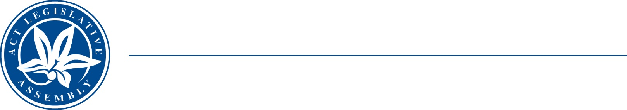
LEGISLATIVE ASSEMBLY
FOR THE AUSTRALIAN CAPITAL TERRITORY

Standing Committee on Economy and Gender and Economic Equality
Mr James Milligan MLA (Chair), Ms Suzanne Orr MLA (Deputy Chair),
Miss Laura Nuttall MLA
MEDIA RELEASE

New inquiry into unpaid work

A new Committee inquiry into unpaid work was announced in the Legislative Assembly today.

The Chair of the Standing Committee on Economy and Gender and Economic Equality, Mr James Milligan MLA, said ‘Unpaid work takes many forms and is largely unrecognised. The Committee will consider the economic and wellbeing contributions of unpaid work and how the ACT Government can support and recognise these.’

The Committee invites submissions from volunteer groups, peak bodies, economists, unions and members of the public.

The Terms of Reference for the inquiry are available on the Committee webpage.

Information about how to make a submission is available on the Assembly website.

Submissions are open until 17 May 2024.

3 April 2024
STATEMENT ENDS.

For further information please contact:
Committee Secretary, Ms Sophie Milne on (02) 6205 0435 or at LACommitteeEGEE@parliament.act.gov.au

