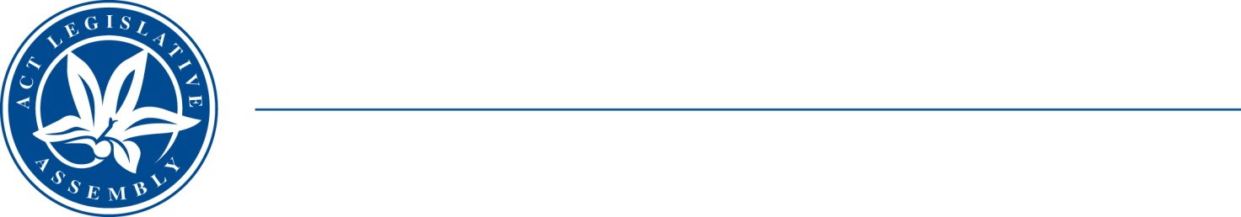
QoN No. 38
Committee Support
LEGISLATIVE ASSEMBLY
FOR THE AUSTRALIAN CAPITAL TERRITORY
Standing Committee on Education and Community Inclusion

Inquiry into Annual and Financial Reports 2021-2022

ANSWER TO QUESTION ON NOTICE

Asked by: Ms Lee MLA

Reference: Hearing on 7 November, Annual Report of 2021-2022.

In relation to: CIT – CEO Travel

- Is the acting CEO based in Canberra?
- On how many occasions has the acting CEO travelled to or from Canberra at CIT’s expenses since commencing in the role?
- Please advise how much CIT has spent on travel and incidental costs each month for the acting CEO since she commenced in the role.

Chris Steel MLA: The answer to the Member’s question is as follows:–

CIT, an independent body with a governing board, advises that:

- The Canberra Institute of Technology (CIT) Interim Chief Executive Officer is employed by the ACT Government under flexible working arrangements and conditions. The Interim CEO is based in Melbourne and travels to Canberra.
- Clause 7 of the Remuneration Tribunal Determination for Full-Time Statutory Office Holders (4 of 2022) provides for the CIT Chief Executive Office to receive a relocation allowance of up to $55,000 including for the costs of travel and accommodation between the former location and the ACT. The CEO has travelled to Canberra each week except when she represented the CIT at a National conference in Adelaide.
- As of 6 December 2022, the total travel expenses paid was $24,306.60

Approved for circulation to the Standing Committee on Education and Community Inclusion

Signature: Date:

By the Minister for Skills, Chris Steel MLA

