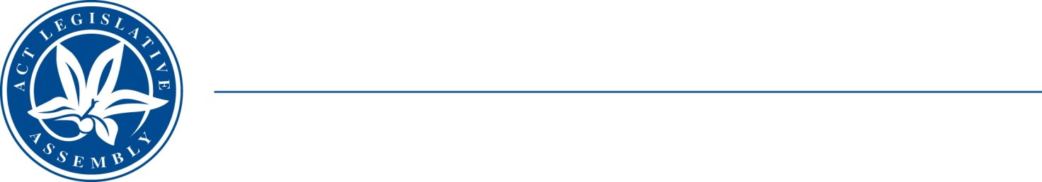
QToN No. 12
Committee Support
LEGISLATIVE ASSEMBLY
FOR THE AUSTRALIAN CAPITAL TERRITORY
Standing Committee on Health and Community Wellbeing

Inquiry into Annual and Financial Reports 2021-2022

ANSWER TO QUESTION TAKEN ON NOTICE

Asked by MR JAMES MILLIGAN MLA on 1 November 2022: MS CATHIE O’NEILL took on notice the following question(s):

Reference: Hansard uncorrected proof transcript 1 November 2022 Page 48

In relation to:

Have there been any complaints from radiation patients who use the service due to the reduction in their dose time or not being able to be treated?

MINISTER STEPHEN-SMITH MLA: The answer to the Member’s question is as follows:–
No, there have been no complaints received by Canberra Health Services from radiation patients regarding a reduction in dose time or not being able to be treated.

Approved for circulation to the Standing Committee on Health and Community Wellbeing

Signature: Date:

By the Minister for Health, Ms Rachel Stephen-Smith MLA

