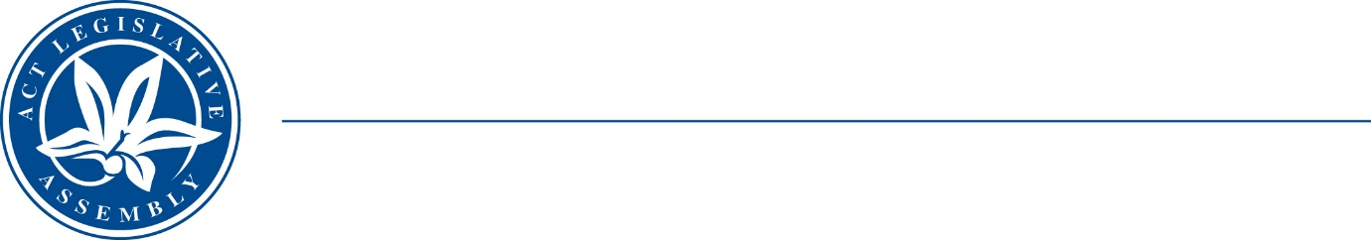
Standing Committee on Public Accounts
Mrs Elizabeth Kikkert MLA (Chair), Mr Michael Pettersson MLA (Deputy Chair),
Mr Andrew Braddock MLA

LEGISLATIVE ASSEMBLY
FOR THE AUSTRALIAN CAPITAL TERRITORY

TERMS OF REFERENCE

Inquiry into responses to Auditor-General recommendations for reports 5/2017, 7/2019 and 6/2020
The Standing Committee on Public Accounts will inquire into and report on matters relating to the Government response to performance audit recommendations made in Auditor-General report:
- No 5/2017 – Maintenance of selected road infrastructure assets
- No 7/2019 – Referral processes for the support of vulnerable children
- No 6/2020 – Transfer of workers’ compensation arrangements from Comcare; and
- any other related matter.
October 2022

