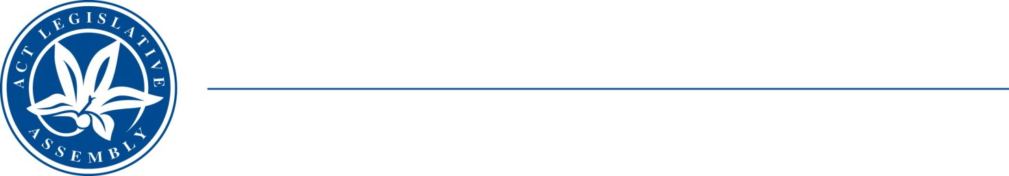
LEGISLATIVE ASSEMBLY
for the Australian Capital Territory

FOR THE AUSTRALIAN CAPITAL TERRITORY

FOR THE AUSTRALIAN CAPITAL TERRITORY

Standing Committee on Planning, Transport and City Services
Jo Clay MLA (Chair), Suzanne Orr MLA (Deputy), Mark Parton MLA

Media release
On 8 April 2021 the Standing Committee agreed that it would extend the deadline for submissions to its inquiry into Giralang Shops to close of business 14 May 2021.
The Committee will hold hearings for the inquiry at 9.30 am on Thursday 27 May 2021, at the Assembly, when it will hear from developer Mr Dimitri Nikias.

Inquiries to:
the Office of Jo Clay MLA, Chair
(02) 62050131
CLAY@parliament.act.gov.au
13 April 2021

