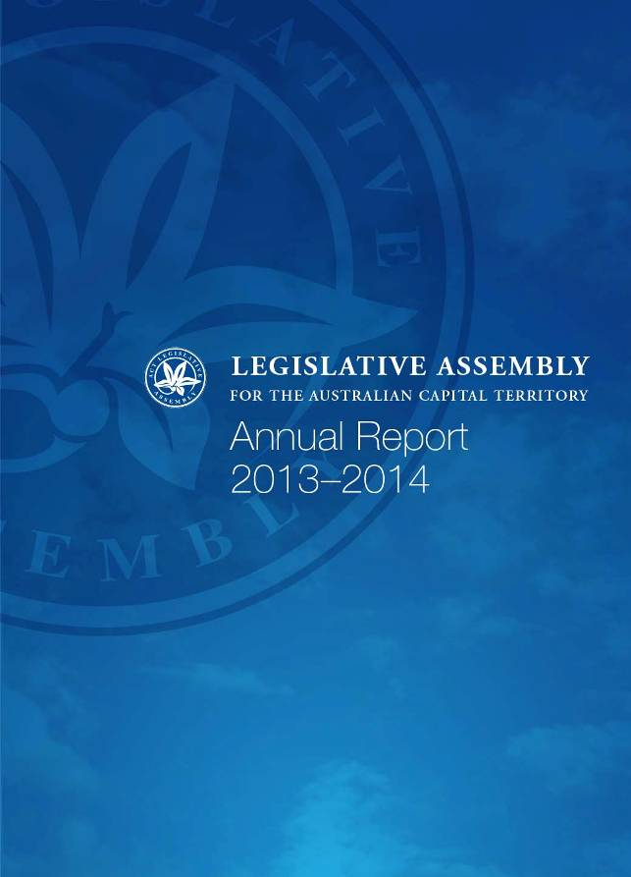

Publishing and Contact Information

ISSN 1036-4390 (Print)

ISSN 1835-0569 (Online)

© Office of the Legislative Assembly This publication is subject to copyright. Except as permitted under the Copyright Act 2003, no part of it may in any form or by any means (electronic, mechanical, microcopying, photocopying, recording or otherwise) be reproduced, stored in a retrieval system or transmitted without prior written permission. Enquiries should be addressed to the publishers.

First published September 2014 Published in Australia by the Office of the Legislative Assembly

Office of the Legislative Assembly Civic Square, London Circuit Canberra ACT 2601 Australia

Telephone 6205 0439 Facsimile 6205 3106

Email – OLA@parliament.act.gov.au

Web – www.parliament.act.gov.au

Produced by: ACT Government Publishing Services Publication No 14/0778

Printed on 100% Recycled Paper

Transmittal certificate

Mrs Vicki Dunne MLA  
Speaker  
Legislative Assembly for the ACT  
Civic Square  
London Circuit  
Canberra ACT 2601

Madam Speaker,

I am pleased to submit to you this annual report on the activities of the Office of the Legislative Assembly for the period 1 July 2013 to 30 June 2014.

I certify that the attached annual report is an honest and accurate account of the operations of the Office during this period.



Tom Duncan  
Clerk  
Legislative Assembly for the ACT

September 20

### CONTENTS

Transmittal certificate 3

The Clerk’s overview 2013-2014 6

Commissioner for Standards 6

Budget protocols 6

Increasing the size of the Assembly 6

Centenary tapestry 6

Audio visual services 6

Records and Information System (OLARIS) 7

E-petitions 7

Presiding Officers and Clerks’ Conference 7

Hansard website 7

Wireless connectivity 7

Executive IT support 8

2013-2014 at a glance 8

Legislation 8

Questioning the executive 8

Committees 8

Community engagement 9

The year ahead 9

The Size of the Assembly 9

Strategic planning 9

E-petitions enhancements 9

Redevelopment of Document Production System 9

Audio visual services 9

Information management systems: further development 10

Members’ entitlements 10

Acquisition of replacement office furniture 11

Section A 12

The organisation 13

Role of the Office 13

Office’s approach 13

Goals of the Office 14

Structure 14

Organisational structure 16

Assembly proceedings 17

Chamber proceedings 17

Assembly committees 17

Procedural digest 21

Officers of the Assembly legislation 22

Marriage Equality Bill 2013 23

Number of ministers 23

Review of the Assembly’s constitution – Size of the Assembly 24

Commissioner for Standards 24

Revised code of conduct agreed 24

Re-affirmation by members to the code of conduct 24

Matter of privilege and reference to standing committee – Disclosure of proceedings, evidence, and documents of Assembly committees 25

Lobbyists register for the Australian Capital Territory 25

Annual reports referred to Assembly committees 25

Assembly hosts 44th Presiding Officers and Clerks Conference 25

Interparliamentary activities 25

Commonwealth Parliamentary Association 25

Kiribati twinning arrangement 26

Papers presented 26

Financial report and management discussion and analysis 27

Analysis of the Office’s performance 27

Budget protocols 29

Social media strategy 31

**Section B** 37

Internal and external scrutiny 38

Legislative Assembly committee reports 39

Legislation report 39

**Section C** 37

Risk management and internal audit 41

Risk management 41

Internal audit 41

Fraud prevention 41

Public interest disclosure 42

Section 45 statement 42

Freedom of information 42

Section 7 statement 42

Section 8 statement 45

Section 79 statement 45

Internal accountability 46

Human resource performance 47

Members’ staff employment 47

Staffing profile 48

Learning and development 51

Workplace health and safety 51

Workplace relations 52

Strategic asset management 53

The Assembly building 53

Capital upgrade funding and expenditure 53

Asset maintenance and repairs 53

Office accommodation 54

Additions and deletions 54

Territory records 56

Human Rights Act 57

Sustainability reporting 57

Centralised sustainability data 57

GreenPower purchased for 2013-2014 57

Appendices 63

Appendix 1 – Sitting days 64

Appendix 2 – Proceedings 65

Appendix 3 – Minutes of proceedings 66

Appendix 4 – Bills and amendments 67

Bills 67

Amendments circulated 67

Appendix 5 – Bills presented 68

Appendix 6 – Questions with and without notice 69

Appendix 7 – Chamber support timeliness performance 70

Appendix 8 – Committees – Eighth Assembly 71

Appendix 9 – Committee statistics – Eighth Assembly 81

Summary of committee statistics 1989-2014 81

Appendix 10 – Hansard and transcription 87

Appendix 11 – Broadcasting and IT 89

Broadcasting & IT related activity 89

Internet and intranet activity 91

Appendix 12 – Library and reference services 92

Library services 92

Reference and information services 94

Appendix 13 – Members of the Eighth Assembly 94

Appendix 14 – Office holders of the Eighth Assembly 95

Appendix 15 – Ministers of the Eighth Assembly 96

Fifth Gallagher Ministry (10 November 2012) 96

Appendix 16 – Remuneration of MLAs 97

Appendix 17 – Non-executive members’ staff employment 98

Appendix 18 – Visits by members and parliamentary officers from other legislatures, delegations and others 100

Appendix 19 – Administrative support for the Assembly branch of the Commonwealth Parliamentary Association 2013-2014 101

Appendix 20 – Education program 102

Appendix 21 – Results of members survey 103

Appendix 22 – Financial statements and management discussion and analysis 104

The Clerk’s overview 2013-2014

## Commissioner for Standards

On 31 October 2013, the Assembly passed a resolution to create the role of Commissioner for Standards.

Following an invitation for expressions of interest, the Speaker, after consulting with the Chief Minster, the Leader of the Opposition, and the ACT Greens member, appointed the Honourable Dr K J Crispin QC to the position.

The Commissioner for Standards is an independent Officer of the Parliament, responsible for investigating specific complaints referred by the Speaker or Deputy Speaker, including possible breaches of the Members’ Code of Conduct. The Commissioner is required to report findings from investigations to the Standing Committee on Administration and Procedure.

The committee will review the operation of the position in two years.

### Budget protocols

The Office negotiated the development of a *Budget Protocols for the Office of the Legislative Assembly* setting out detailed arrangements for the development and consideration of the Office’s budget. More detail on the initiative is outlined later in this report.

### Increasing the size of the Assembly

In June 2014, the Assembly introduced a bill to increase the size of the Legislative Assembly from 17 members to 25 at the next election in 2016. With passage of the bill the number of electorates in the Territory would increase from three to five.

The changes proposed in the bill acknowledge the principal recommendations made by an expert reference group tasked with determining if an increase in the size of the Assembly would be a way of meeting the needs of the ACT’s growing population. The group was chaired by Mr Phillip Green, the Territory’s Electoral Commissioner.

This decision, which had the support of both major parties, will be the first increase to the size of the Assembly since its establishment in 1989.

### Centenary tapestry

In December 2013, the Speaker accepted the ‘Great Centenary Tapestry’ into the Assembly’s art collection. The work is the result of the dedication of hundreds of weavers from across the ACT, and depicts the intricate patterns of well-known Canberra icons against a backdrop of the landscape and the mountains bordering the city. The tapestry marks Canberra’s first 100 years and will be permanently displayed in the Assembly building.

### Audio visual services

As previously reported, the infrastructure that supports the Assembly’s webstreaming and audio visual replay services is now out of date (The webstreaming service was introduced in 2007, with the Assembly and committee replay services following in 2009 and 2011). While the services have so far performed well, the picture quality needs to be improved, and the service is not accessible to some organisations and on all mobile devices.

A budget bid to fund a solution was successful and, at the time of reporting, staff were awaiting the passage of the appropriation bills before commencing to upgrade the current systems.

### Records and Information System (OLARIS)

Effective records management is an important element in the Office’s goal to enhance accountability and governance arrangements.

Office staff continued to increase their use of OLARIS, supported by training and updated records management policies and procedures.

A delay in an ACT government wide upgrade of the TRIM system on which the OLARIS system is based, has also delayed the introduction of a new interface, which is designed to make the system more user friendly and intuitive.

### E-petitions

The Assembly’s e-petitions system was launched in early 2013. The e-petitions system allows ACT residents to electronically add their names to petitions appearing on the Assembly’s website (at https://epetitions.act.gov.au). After an agreed period, e-petitions are presented to the Assembly in a similar manner to hard copy petitions.

The first e-petition was presented to the Assembly in November 2013. Another has been presented since then, and as at 30 June a further three were still open for signatures.

### Presiding Officers and Clerks’ Conference

In July 2013, the ACT was host to the annual Presiding Officers and Clerks’ Conference. The conference attracted delegates from all Australian jurisdictions, as well as New Zealand and Pacific parliaments.

### Hansard website

When the redesigned Assembly website was launched in April 2013, it was not possible to migrate the legacy Hansard content due to its volume and complexity. In March 2014, the Office commenced a feasibility study to look at ways of migrating this material while retaining valuable hyperlinks to historic data. The Office’s website content management system has been found unsuitable to host such a large collection of data, and the study has recommended that a separate Hansard website be maintained, with improved indexing and search functionality.

### Wireless connectivity

Wireless internet coverage was rolled out in the chamber and both committee rooms in January 2014. At the time of reporting, plans were in place to extend coverage to the reception room and the Assembly Library.

### Executive IT support

The Standing Committee on Administration and Procedure agreed to trial an initiative to allow executive members of the Legislative Assembly and their staff to share the on-site IT support service which was generally available to non-executive members only. The trial started on 1 April and finished on 30 June. The support service was limited to fixing faults rather than making changes to systems or accounts. As at 30 June, an increase in support calls of 20.7 per cent had been recorded and an evaluation of the trial had been initiated.

## 2013-2014 at a glance

### Legislation

The Office processed and arranged the notification of 52 executive bills and 3 executive members’ bills (bills introduced by the ACT Greens MLA) that were passed by the Legislative Assembly. The Office also facilitated the tabling of 351 items of subordinate legislation.

### Questioning the executive

The Office supported members in their scrutiny of the executive, processing 172 questions on notice. During the reporting period, 1 498 questions without notice were asked.

### Committees

The Office supported six standing committees and four select committees during the reporting period. These committees:

* tabled 27 reports
* held 57 public hearings
* took evidence from 571 witnesses
* received 171 submissions
* considered 154 statutory appointments
* considered 58 bills (as part of the legislative scrutiny role)
* considered 354 pieces of subordinate legislation

During the reporting period the membership of committees and the standing orders relating to the operation of Assembly committees were the subject of a number of debates in the Assembly. On 8 August 2013, a member moved a motion to alter the composition of committees from 4 members to 3, and tabled an advice from the Clerk on the membership of Assembly Committees dated 23 May 2013. The motion was negatived. Of the 217 committee meetings conducted throughout the year 71 per cent were attended by four members and 29 per cent were attended by three members.

On 28 November 2013, a number of amendments to the standing orders relating to committees were moved, and were subsequently referred to the Standing Committee on Administration and Procedure for inquiry and report. The committee reported on 18 March 2014.

During the reporting period, three Assembly committees made special reports to the Assembly indicating that they were unable to agree to a report.

Appendix 9 contains more detailed committee statistics.

### Community engagement

The Office facilitated visits from 1 924 people during the reporting period. This included presentations to community groups and delegations, public service seminars and school debates.

## The year ahead

### The Size of the Assembly

In the coming year, the Office anticipates that planning work will commence for an increase in the number of members from 17 to 25 at the next election. This will involve staff and the executive management team considering service delivery, funding, accommodation and procedural issues.

### Strategic planning

The Office decided to postpone its strategic planning to the later part of 2014 so that the organisation could properly assess any work that might be required if the Assembly determines to enlarge the number of members from 2016. Given this, the Office will commence its strategic planning process in late 2014.

### E-petitions enhancements

The e-petition system has now been available for over a year. A small project will be undertaken in 2014-2015 to implement a number of minor fixes and enhancements which have come to light since the system was launched.

### Redevelopment of Document Production System

Since 2004, the Office has used a system of macros, templates and databases to produce the daily procedural documents for Assembly sittings. Over time and with new software releases, some functionality has been lost. Coupled with a lack of vendor support, there is a need to redevelop the system, and a funding proposal for doing so will be produced in 2014-2015.

### Audio visual services

The Assembly will update and replace obsolete broadcasting hardware and software, to ensure the ongoing viability of the Assembly’s web-based broadcasts of proceedings. The new system will also improve vision quality by replacing the existing analogue cameras with digital ones and allow the broadcasts to be replayed in modern video formats and on mobile communication devices.

### Information management systems: further development

Further effort will be directed towards improving the Hansard website, particularly its search functionality. Opportunities will be investigated to integrate Hansard production and publication processes with other Office systems, as will the feasibility of replacing the underutilised Assembly Intranet (LAdotNET). The Assembly Library is also considering a number of potential suppliers of a digital repository to house its increasing collection of digitised material.

### Members’ entitlements

A number of significant changes to members’ entitlements will come into effect during 2014-2015 that are expected to impact on the operations of the Office.

Following the ACT Remuneration Tribunal’s comprehensive review of members’ remuneration and allowances that commenced in 2013, on 2 May 2014, the Tribunal issued its *Final Report on the Review of Entitlements for Members of the Australian Capital Territory Legislative Assembly*. The key changes that arose from that review and which largely come into effect on 1 July 2014 were:

* an increase in the base rate of MLAs salary by 6 percent
* a reduction in the loading paid to the Deputy Leader of the Opposition (effective either when the current holder of that office relinquishes the position or at the start of the Ninth Assembly)
* the introduction of a resettlement allowance
* the streamlining of travel allowances
* the abolition of accompanied travel for executive members (abolished in April 2014)
* the abolition of study and accompanied travel for non-executive members (abolished in April 2014)
* the removal of the direct provision of a privately plated motor vehicle, while maintaining an allowance for such provision
* the introduction of a taxi/hire car allowance for all members to ensure that the safety of members is not compromised
* the introduction of a communications allowance, replacing other provisions (including the discretionary office allocation that was available to non-executive members).

The main changes that will lead to reduced administration, which will be monitored and reviewed during 2014-2015, include: the abolition of the study and accompanied travel entitlement; the introduction of the communications allowance in place of the discretionary office allocation arrangements; and the phasing out of leased, privately plated vehicles.

Also during 2014-2015, non-executive members will have access to increased staff salary allocations. Provision for this increase with effect from January 2015 was included in the Office’s 2014-15 Territorial appropriation, although access to the increased funding is dependent on a disallowable instrument being signed by the Chief Minister under the *Legislative Assembly (Members’ Staff) Act 1989* that makes the additional funding available to members. The Office anticipates that the additional funding will lead to an increase in the number of employment agreements processed, the number of staff on payroll and/or the number of consultants/contractors engaged by members.

### Acquisition of replacement office furniture

The Office’s 2014-2015 budget included additional funding of $0.170m to replace office furniture. Most desks used by the Office were acquired in the early 1990s, shortly after the introduction of   
self-government in the ACT. Although the Office has been able to maintain a relatively low rate of workplace injury, an identified health and safety risk relates to the limited capacity to adjust desk height in existing furniture to cater for different ergonomic requirements of staff as turnover occurs. This risk will be addressed through the provision of new furniture. The funding will also enable the supply of replacement desks for non-executive members, who are also using desks in their own suites that were supplied in the early 1990’s and which also do not provide capacity for height adjustment. Workstations for members’ staff offices were upgraded in early 2009.



Tom Duncan  
Clerk

September 2014



**Section A**

Performance  
reporting

The organisation

### Role of the Office

The Office of the Legislative Assembly is established by the *Legislative Assembly (Office of the Legislative Assembly) Act 2012*. Under section 6 of the Act, the Office’s function is to provide impartial advice and support to the Legislative Assembly and its committees and members of the Assembly, including by:

* providing advice on parliamentary practice and procedure, and the functions of the Assembly and committees
* reporting proceedings of the Assembly and meetings of committees
* maintaining an official record of proceedings of the Assembly
* providing library and information facilities and services for members
* providing staff to enable the Assembly and committees to operate efficiently
* providing business support functions, including administering the entitlements of members who are not part of the executive
* maintaining the Assembly precinct

The Office also provides public education about the functions of the Assembly and committees. The Office may exercise any other role given to it under the Act or another Territory law.

### Office’s approach

In delivering its advisory and service delivery functions, the Office continues to operate under the broad approach outlined in the organisation’s *Strategic plan 2009-2014.* The strategic plan will be updated in 2014-15.

### Professionalism

We are knowledgeable, non-partisan and ethical in delivering high-quality services to support the Legislative Assembly.

Personal respect

We always treat our clients and each other with respect.

### Improvement

We find practical ways to improve quality, value for money and personal effectiveness in everything we do.

### Collaboration

We build partnerships with each other and our clients to find the best way of meeting their needs.

### Innovation

We seek to shape the future by sharing ideas, valuing individual and team contributions and welcoming innovation.

### Goals of the Office

The Office continues to work towards the following goals as outlined in the organisation’s *Strategic plan 2009-2014*:

to improve services to the Assembly and its committees

to enhance accountability and governance arrangements

to build more effective mechanisms for public engagement

to work towards an environmentally sustainable Assembly

to maintain a highly skilled, satisfied and committed workforce

### Structure

The Office is organised into five separate sections as follows:

* Chamber Support
* Committee Support
* Hansard, Technology and Library
* Business Support
* Governance and Communications

### Chamber Support

Chamber Support is responsible for:

* servicing the Assembly chamber, including the programming of business
* providing procedural advice and the publication and custody of the records of the chamber
* processing of legislation which has been passed by the Assembly for publication and notification on the Legislation Register as laws of the ACT
* providing administrative and procedural support to the Standing Committee on Administration and Procedure and the servicing of the Standing Committee on Justice and Community Safety when performing its legislative scrutiny role
* fraud and corruption prevention
* internal audit
* administration of interparliamentary relations

### Committee Support

Committee Support provides support services to standing committees and select committees. It is responsible for:

* coordinating inquiry processes
* providing research and analysis for committee inquiries
* coordinating public consultation
* drafting committee reports
* providing procedural advice to committees
* supplying administrative support services

### Hansard, Technology and Library

Hansard, Technology and Library is responsible for:

* producing and publishing accurate and timely transcripts of Assembly debates and evidence given before Assembly committees
* producing live webstreaming and daily audiovisual replays of Assembly and committee proceedings
* managing information technology for non-executive members and the Office and developing ICT policies
* maintaining the Assembly’s website and the Hansard database service
* managing the Office’s records and information
* providing broadcasting and related technical services, and developing broadcasting policy for the Assembly and its committees
* providing library information and reference services

### Business Support

Business Support is responsible for servicing and advising non-executive members, their staff, the Clerk and Office staff in relation to:

* employment arrangements and HR
* workplace management
* payroll
* provision of attendant and security services for the Assembly
* building and facilities management
* administration of members’ entitlements

### Governance and Communications

Governance and Communications is responsible for:

* financial and budgetary management
* public affairs and parliamentary education
* corporate governance and strategic policy
* risk management and business continuity
* content management for the Assembly’s website
* the Assembly art program

## Organisational structure

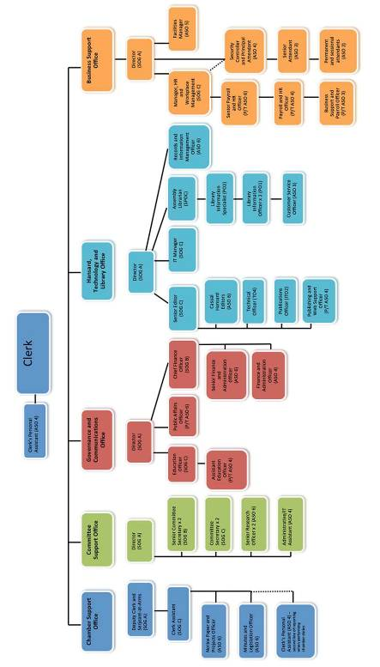

## Assembly proceedings

### Chamber proceedings

In 2013-2014, the Office provided procedural services to members and their staff, facilitating the efficient functioning of the business of the Assembly on 36 sitting days. The following table compares the chamber activity in 2012-2013 with 2013-2014:

Table 1. Chamber activity

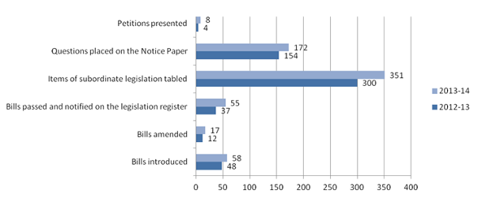

A full range of statistics and trends regarding the business of the Assembly for this and previous years, are provided in the appendices section of this report. For the first time in the Assembly’s history, no private members’ bills were introduced in the reporting period.

### Assembly committees

Committees, supported by the Office, contribute to the work of the Assembly by inquiring into and reporting on a broad range of issues. By conducting inquiries, the committee system aims to ensure that executive government is accountable to the Assembly, and that members of the community have opportunities to participate in the governance of the Territory.

Committee inquiries can arise by direct referral from the Assembly, as a result of statutory requirements, or self-referral by individual committees.

During the year, the Office supported the following standing committees:

* Standing Committee on Administration and Procedure
* Standing Committee on Education, Training and Youth Affairs
* Standing Committee on Health, Community and Social Services
* Standing Committee on Justice and Community Safety (also performing a legislative scrutiny role)
* Standing Committee on Planning, Environment and Territory and Municipal Services
* Standing Committee on Public Accounts

The Office also supported the following select committees during the year:

* The Select Committee on Estimates 2013-2014 established on 28 February 2013 which presented its report to the Assembly on 5 August 2013
* The Select Committee on Regional Development established on 28 February 2013 and completed its inquiry process and reported to the Assembly on 27 February 2014
* The Select Committee on Estimates 2014-2015, established on 27 February 2014 (due to report in August 2014)
* The Select Committee on Amendments tothe *Electoral Act 1992* established on 20 March 2014 which presented its report to the Assembly by transmission to the Speaker on 30 June 2014

### Committee membership

The composition of all committees is a reflection of the party configuration of the Assembly.

The Eighth Assembly passed a resolution on 27 November 2012 to establish standing committees made up of four members: two members from each of the two major parties represented in the Assembly. This is the first such arrangement since the Assembly’s inception in 1989: most committees of previous Assemblies have had three members.

The Standing Committee on Justice and Community Safety and the Public Accounts Committee are both chaired by opposition members.

The chairs and membership details of all committees are listed at Appendix 8.

### Statutory responsibilities of committees

In addition to inquiry activity, three committees have significant statutory responsibilities.

The Standing Committee on Justice and Community Safety (performing its legislative scrutiny role) is required to examine all bills and proposed subordinate legislation to ensure that legislation does not unduly trespass on individual rights and liberties and complies with the Territory’s *Human Rights Act 2004*.

The Standing Committee on Planning, Environment and Territory and Municipal Services is required to examine all draft variations to the Territory Plan referred by the Minister for the Environment and Sustainable Development.

The Standing Committee on Public Accounts, under its resolution of appointment, examines all reports of the Auditor-General which have been presented to the Assembly, monitors reportable contracts of ACT government agencies, and has a range of roles and responsibilities under the *Auditor-General Act 1996*.

### Committee activity

In the period 1 July 2013 to 30 June 2014, the Office supported meetings of standing and select committees on 223 occasions. Committees held 57 public hearings, and tabled 27 reports in the Legislative Assembly. This table shows a snapshot of overall committee activity.

Table 2. Committee statistics 2013-2014

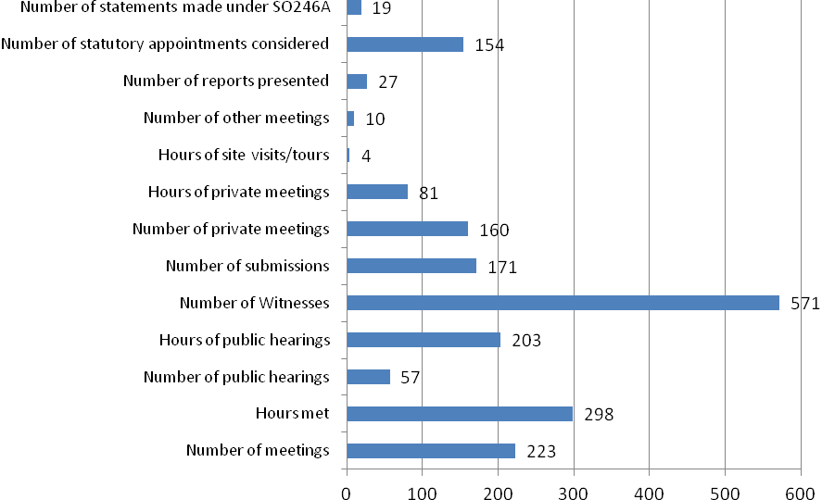

Comprehensive statistics relating to all Assembly committee activity for the reporting year are listed at Appendix 9.

### Government responses to committee reports

The Office continues to monitor the receipt of government responses to committee reports, and eight responses were received during the reporting period.

Of the reports tabled, 25 per cent (two reports) received a government response within 90 days, and 12.5 per cent (one report) received a government response within 120 days.

Seventy-five per cent of government responses to committee reports were not received within the 90 day time frame prescribed in the ‘Handbook for ACT Government Officials on participation in Assembly and other inquiries’.

### Consideration of statutory appointments

Section 228 of the *Legislation Act 2001 (ACT)* requires all ministers to consult with Legislative Assembly committees on proposed appointments to statutory positions on certain boards and advisory bodies. Appointments cannot be made until the committee has responded, or until 30 days have elapsed.

In the 2013-2014 financial year, committees considered 154 statutory appointments to a wide range of government bodies. Under Continuing Resolution 5A, committees are to table a schedule listing appointments the committee considered during the applicable period. The schedule is required to include the date the request for consideration was received from the responsible minister, and the date the committee’s response and comment, if any, was provided.

### Standing Committee on Justice and Community Safety (Legislative Scrutiny Role)

The Standing Committee on Justice and Community Safety, when performing its legislative scrutiny role, met on 12 occasions (a total of 9 hrs 40 min), issued 11 reports and made one statement pursuant to standing order 246A. The committee considered:

* 58 bills
* 354 items of subordinate legislation
* 30 government responses
* two executive members’ responses
* one regulatory impact statement
* government amendments to three executive bills
* six national regulations

The committee also provided comment on two government responses.

### Standing Committee on Administration and Procedure

The Standing Committee on Administration and Procedure met on 20 occasions. The committee’s main task was to set the program for private members’, executive members’ and Assembly business, but it also discussed matters relevant to the administration of the Assembly and reviewed and proposed amendments to certain standing orders. The committee conducted a review of the members’ code of conduct, resulting in a revised code which was adopted on 24 October 2013. The committee also developed protocols for the appointment of a Commissioner for Standards.

In June 2014, the committee tabled its report into its review into the appropriateness of a lobbyists register for the ACT. The recommendations of the report are being considered by the Assembly.

Other matters discussed by the committee included: guidelines for the use of social media, review of the broadcasting guidelines, amendments to standing orders, members’ entitlements, and community engagement proposals.

### Estimates 2013-2014

The Select Committee on Estimates 2013–2014 was established on 28 February 2014.

As noted in last year’s annual report, the Assembly resolved that the committee would, in addition to examining the Appropriation Bill 2013‐2014, examine the Appropriation (Office of the Legislative Assembly) Bill 2013‐2014.

The committee engaged the Centre for International Economics (CIE) to provide independent economic and financial analysis of the budget. CIE provided the committee with a report on the budget entitled *ACT Budget Review 2013‐14.*

The committee held public hearings over 12 days and deliberated on the committee’s report in three days of private meetings. In the hearings, the committee heard evidence from the ministers of all the ministerial portfolios; the officers of all the Territory-owned corporations, such as ACTEW, all ACT statutory offices, and the Speaker of the Assembly, the Clerk and other senior officers of the Office of the Legislative Assembly.

As part of its program to ensure access to the annual assessment of the effect of the Territory budget, the committee also sought submissions and heard evidence from a number of ACT community organisations and groups.

It is a requirement of ministers that answers are provided to questions taken on notice within five working days. Again, not all answers were received before the committee tabled its report to the Assembly, and the committee was subsequently dissolved. Questions remaining unanswered at the time the committee completed its work were managed in accordance with standing order 253A, which requires the Clerk to be provided with a schedule of outstanding responses within 30 days from the tabling of the estimates report in order that the Speaker may table the outstanding responses in the chamber.

### Select Committee on Amendments to the *Electoral Act 1992*

The select committee was established on 20 March 2014, to inquire into a range of electoral issues. The committee received 14 submissions and heard from seven witnesses at three public hearings in May 2014. In its report presented to the acting Speaker on 30 June 2014, the committee made 18 recommendations, of which 16 were unanimous.

The committee, in considering the ACT Electoral Commission’s report on the 2012 ACT election and broader issues, found that the major electoral financing reforms introduced in 2012 were generally working well although some adjustments were needed. On the basis of the High Court’s 2013 decision in *Unions NSW v NSW*, the committee recommended repeal of the provision that prevents anyone other than an ACT voter from making a donation to an ACT election campaign. The committee also recommended legislative changes to ensure that electoral campaign spending does not significantly increase with an increase in the number of MLAs.

Other recommendations included that the 100 metre limit on canvassing near polling booths be increased to 250 metres so as to minimise disruption to voters, that the $20 administrative penalty for failing to vote be doubled, and that the Assembly further consider the current $10 000 limit on donations from a single source in a financial year. A majority of the committee also recommended an increase in public funding from $2 to $8 per eligible first preference vote (Mr Rattenbury MLA dissenting). The committee suggested that two matters should continue to be monitored: the growing trend to pre-poll voting chosen by one in four voters in the 2012 election, and the lower level of voter turnout in ACT elections compared with elections elsewhere.

## Procedural digest

### Officers of the Assembly legislation

On 15 August 2013, the Officers of the Assembly Legislation Amendment Bill 2013 was introduced. The bill was to formally recognise the Auditor-General, the Ombudsman, and the Electoral Commissioner as Officers of the Assembly, to establish the independence of these officers and create a clearer separation between their roles and the executive. The officers will be appointed by the Speaker and their roles overseen by an Assembly committee. The bill was passed by the Assembly on 24 October 2013 and is scheduled to commence on 1 July 2014. Officers of the Assembly should not be confused with the Office of the Legislative Assembly as they are mutually exclusive.

### Standing Committee on Planning, Environment and Territory and Municipal Services

The Eighth Assembly passed a resolution on 27 November 2012, establishing standing committees made up of four members – two from each of the major parties (with no casting vote for the chair). This contrasts with the membership arrangements of committees in previous assemblies, where committees had mostly three members.

On 17 September 2013, the committee chair presented a report on a draft variation to the Territory plan. The report was presented with dissenting comments from two of the four members. Following the presentation of the report, a point of order was raised querying if, in fact, the report had committee agreement.

The minutes of the committee that were tabled with the report showed no motion to adopt a report had been considered or resolved, and the report was referred back to the committee for consideration.

On Tuesday 22 October 2013 the chair of the committee presented a special report stating:

*The Committee has been unable to agree upon a report for this inquiry. Therefore, in accordance with House of Representatives Practice, the Committee presents this Special Report to advise it has been unable to agree upon a report, and to present a summary of its proceedings.*

### Select Committee on Regional Development

On 27 February 2014, the Chair of the Select Committee on Regional Development presented a special report which indicated that the committee had been unable to agree to a report. The Assembly then adopted the following resolution:

*That the report is noted and that the Committee Chair, before the Assembly rises today, table the Chair’s draft and the alternative draft that was considered by the Committee.*

Later that day the Chair presented the ’Chair’s draft’ and the ‘Alternative draft’, and both papers were authorised for publication (committee reports are automatically authorised for publication upon tabling, however, this does not apply to drafts).

### Standing Committee on Planning, Environment and Territory and Municipal Services

On 6 May 2014, the committee chair presented a statement relating to its inquiry into the Planning and Development (Project Facilitation) Amendment Bill 2014. The statement outlined the progress of the committee’s inquiry and concluded with the statement that:

*The Standing Committee on Planning, Environment and Territory and Municipal Services was unable to reach agreement on a report for its Inquiry into the Planning and Development (Project Facilitation) Amendment Bill 2014.*

Immediately after the presentation of that statement the Assembly agreed to a resolution calling for the presentation of the chair’s draft report and any alternate report considered by the committee. The drafts were subsequently tabled.

### Changes to standing orders

On 20 March 2014, the Speaker presented a report from the Standing Committee on Administration and Procedure on standing orders relating to the consideration by committees of draft reports. The committee made three recommendations, namely:

* if the committee cannot agree on which draft report to consider, the chair’s draft will have precedence
* at the conclusion of the consideration and any reconsideration of the draft report selected by the committee, the chair shall move ‘That the report (as amended) be agreed to’
* if the committee is unable to agree upon a report, the chair of the committee must present a written statement to that effect, along with the minutes of proceedings

These new standing orders were adopted by the Assembly.

### Marriage Equality Bill 2013

On 19 September 2013, the Attorney-General introduced the Marriage Equality Bill 2013. The bill provided for, ‘couples who cannot marry under the Commonwealth *Marriage Act 1961* because of the way marriage is defined under that Act to enter into a marriage, regardless of sex, under the Australian Capital Territory law’.

The bill was debated and passed with amendments on 22 October 2013 before a full chamber gallery. The reception room outside the chamber was also filled to capacity.

There was significant media interest in the proceedings and media representatives were reminded, on the day, of the broadcasting guidelines that prohibit photos of visitors in the gallery. That night the ABC showed footage of the gallery, and the next day’s *Canberra Times* contained a front page photo of two members of the public in the gallery area when the bill was declared passed by the Speaker. Following consultation with the Speaker, the Clerk sent letters to the relevant media representatives warning that further breaches could result in the withdrawal of building access passes for a defined period.

In December 2013 the High Court declared that only the Commonwealth had the power to legislate on marriage.

### Number of ministers

On 31 October 2013, the Chief Minister introduced the Australian Capital Territory (Ministers) Bill 2013 (No 2). The bill provides for the number of ministers of the Territory to be increased to enable the Chief Minister to appoint up to eight other ministers.

The bill passed through the Assembly on 26 November 2013, and it is expected, based on press reports, that the Chief Minister will appoint a sixth minister later in 2014.

Accommodation arrangements have already been made in the Assembly building to allow for an additional minister on the second floor, along with the Territory’s five other ministers.

### Review of the Assembly’s constitution – Size of the Assembly

On 5 June 2014 the Attorney-General introduced the Australian Capital Territory (Legislative Assembly) Bill 2014. The purpose of the bill was to increase the size of the Legislative Assembly from 17 members to 25 members, with an accompanying bill providing for five electorates of five members each. The bill is expected to be debated in August where it will need a two-thirds majority to pass the Assembly. If passed, the Assembly will elect 25 members at the October 2016 Territory election.

### Commissioner for Standards

On 31 October 2013, the Assembly agreed to a resolution for the Speaker to appoint a Commissioner for Standards. The motion was moved by the Speaker of the Seventh Assembly. The continuing resolution provides:

* that the Speaker will appoint a Commissioner for Standards for the life of each Assembly and three months after the election into the next Assembly
* that the functions of the Commissioner are to investigate specific matters referred to the Commissioner by the Speaker in relation to complaints against members and by the Deputy Speaker in relation to complaints about the Speaker
* that the Commissioner report to the Standing Committee on Administration and Procedure on any complaints referred and
* that anyone may make a complaint in writing to the Speaker (or the Deputy Speaker in the case of a complaint about the Speaker) who, if the Speaker believes that the complaint is not frivolous or vexatious or for political advantage, may refer the complaint to the Commissioner for investigation and report.

Following expressions of interest, and after consultation with the Chief Minister, the Leader of the Opposition, and the ACT Greens member, on 14 February 2014 the Speaker announced the appointment of the Honourable Dr Ken Crispin, QC to the position. Dr Crispin is a former Judge of the ACT Supreme Court and former President of the ACT Court of Appeal.

### Revised code of conduct agreed

On 24 October 2013, the Assembly agreed to a revised code of conduct for members. This followed a review of the code by the Assembly’s Ethics and Integrity Adviser in 2012. The revised code contains a requirement that members should only make complaints to the newly established Commissioner for Standards where they believe there are reasonable grounds to suspect non-compliance, and not to make any complaint that is frivolous, vexatious, or only for political advantage. It also requires members to cooperate fully with any official inquiry that is undertaken by the Commissioner.

### Re-affirmation by members to the code of conduct

Following a recommendation in the review of the members’ code of conduct (see above) the Assembly passed the following resolution on 24 October 2013:

*That we, the Members of the Eighth Legislative Assembly for the Australian Capital Territory, having adopted a code of conduct for Members, reaffirm our commitment to the principles, obligations and aspirations of the code.*

### Matter of privilege and reference to standing committee – Disclosure of proceedings, evidence, and documents of Assembly committees

On 15 May 2014, a matter of privilege was raised where it was alleged that a minister had knowledge of private deliberations of an Assembly committee prior to a report being tabled in the Assembly. The Assembly referred the operation of standing order 241 (disclosure of proceedings, evidence and documents) to the standing Committee on Administration and Procedure for inquiry and report, with particular reference to the practice of the New Zealand parliament.

The committee is required to report by September 2014.

### Lobbyists register for the Australian Capital Territory

On 5 June 2014, the Standing Committee on Administration and Procedure presented a report called ‘Lobbyist Regulation’, which provided advice to the Assembly about the possible application of a lobbyists register for the Territory. The committee gave two possible scenarios for the application of the register: that it apply to the executive alone; or that it apply to all members.

The Assembly is expected to consider the matter further during the August 2014 sittings.

### Annual reports referred to Assembly committees

On 19 September 2013, all 65 ACT reporting entities’ annual reports were referred to the Assembly’s five standing committees for inquiry and report. Committees were required to report back to the Assembly by the last sitting day in March 2014.

### Assembly hosts 44th Presiding Officers and Clerks Conference

The Legislative Assembly hosted the 44th Presiding Officers and Clerks Conference from 30 June to 4 July 2013. The conference was attended by 26 delegates from legislatures within Australia and 26 delegates from the parliaments of New Zealand and the Pacific Region.

For the first time, other legislatures from the Pacific, including Timor Leste, Palau, New Caledonia and the Federated States of Micronesia were also invited to attend the conference as observers. New Caledonia accepted the invitation and was represented by the President of Congress, the Senior Secretary of Congress and Clerk of Congress.

This was the first occasion that the Legislative Assembly had hosted the conference.

## Interparliamentary activities

### Commonwealth Parliamentary Association

The Office provides administrative support for the ACT branch of the Commonwealth Parliamentary Association (CPA).

In 2013-14 this included making arrangements for:

* the branch’s delegate to attend the 59th annual conference of the CPA in Johannesburg, South Africa in August/September 2013
* the attendance of two branch delegates at the 32nd Australian and Pacific Regional Conference in Melbourne, Victoria, in November 2013. At the regional conference, Dr Bourke MLA presented a paper called ‘Recent developments concerning the code of conduct for members in the Legislative Assembly’.
* the branch’s representative on the Australian Region Commonwealth Women Parliamentarians Steering Committee

The branch provided support to the Speaker as a member of the Australian region management committee.

The branch secretary also acted in the Australian Regional Secretary’s role from November 2013. The Speaker was elected at the General Assembly in South Africa to be one of the three Australian regional representatives on the CPA Executive for a three year period.

### Kiribati twinning arrangement

The ACT Legislative Assembly is twinned with the Kiribati Parliament under an arrangement agreed to at a conference of Presiding Officers and Clerks in 2007. Significant activities during this reporting year included:

* In August 2013, the Legal Adviser to the Assembly’s Standing Committee on Justice and Community Safety (Legislative Scrutiny Role) travelled to Kiribati to provide legal advice to the Parliament’s Public Accounts Committee (PAC) and to review existing legislation and draft amendments to that legislation in order to strengthen the oversight powers and functions of the PAC. The visit was sponsored by the United Nations Development Programme (UNDP).
* A further visit to Kiribati was undertaken in November 2013 by two staff of the Office: the Assembly Librarian and the Secretary of the Assembly’s Standing Committee on Public Accounts. The purpose of the visit was to provide advice on improving the services of the parliament’s library and to provide training to the new secretary of the PAC. The visit was a success with the following outcomes achieved:

1. development of the library’s web page;
2. provision of recommendations on improving the library’s services; and
3. provision of high level training to the secretary of the PAC.

* The visit also highlighted the need for a number of items for the Parliament’s library. On return, the Assembly Librarian arranged for legal texts, supplied by the Federal Attorney-General’s Department, and shelving, donated by the Museum of Australia, to be given to the Parliament. The visit also identified that the handbook for new members of the Parliament’s PAC required updating. As a result the Public Accounts Committee secretary has now completed drafting of an updated handbook, which has been provided to the Parliament for comment. This project has been funded by the Pacific Partnerships Fund.

At various stages throughout the year the Office and the former Clerk provided advice on procedural and administrative matters to the Kiribati parliament.

### Papers presented

At the Presiding Officers and Clerk’s Conference in July 2013, the following papers were presented:

* *The umpire strikes back.* Musings of an opposition member turned Speaker – Vicki Dunne MLA, Speaker of the Legislative Assembly
* *Ten measures of a healthy Parliament* – Tom Duncan, Clerk of the Legislative Assembly

Two staff attended a course on parliamentary law, practice and procedure as part of the University of Tasmania’s ANZACATT training, and presented papers on the following topics:

* *Developing the capacity of committee members—A win for scrutiny?* — Margie Morrison
* *The role of the separation of powers doctrine in arguments for reform to parliamentary budget setting processes* – Michael Sloane

## Financial report and management discussion and analysis

The Office’s financial report and management discussion and analysis are at Appendix 22.

## Analysis of the Office’s performance

### Banking transition

The transition to the new whole-of-government banking services provider, which was commenced in the 2013-2014 year, was finalised in the early part of this reporting period.

### Major building works

Goal 1 – Improve services to the Assembly and its committees

Shortly after the passage of the *Australian Capital Territory (Ministers) Act 2013*, the Chief Minister announced that she intended to appoint a sixth minister.

Following consultation with the Chief Minister’s office, the space on the second floor of the building was reconfigured to accommodate a sixth minister’s suite. The cost of this work was $36,590 and it was funded from the Office’s 2013-2014 Capital Upgrade Program.

### Hansard, Technology and Library Services

Appendices 10 to 12 set out performance against targets for Hansard, Technology and the Assembly Library.

Although Hansard accuracy remained very high, some publication targets were not met due to unavoidable delays, slightly reducing overall performance on timeliness of publication for the year. One library service—cataloguing— also did not meet the performance standard as priority was placed on improving the library intranet as recommended in the review of client information needs. The backlog will be catalogued in the coming year.

Results from the survey of members and their staff were largely positive (Appendix 21). Recurring themes for improvements to information technology services included: ease of using the Assembly’s intranet; email synching; poor speed of the internet; and some instances of unsatisfactory IT support. Respondents were generally pleased with the responsiveness of library services although some comments referred to the library’s underutilisation. All suggestions will be considered and implemented where feasible.

### Library review of client information needs

The Assembly library completed a review of client information needs in September 2013.

Key findings included a low level of general awareness of the resources and services that the library could provide. The analysis acknowledged the great diversity in client needs, and that the future lies in providing relevant online resources that clients can access themselves.

The library’s first response has been to update the library intranet to improve the presentation and accessibility of resources. Future improvements will be subject to funding priorities and include access to a greater variety of journals and databases, a new digital repository, and an electronic resource management system.

### Legislative Assembly Art Advisory Committee

During the reporting period, the Office provided administrative support to the Legislative Assembly Art Advisory Committee. The committee is chaired by the Speaker and is composed of two MLAs from the government and the opposition, three ACT arts community representatives, a curatorial advisor, and a representative of the Office.

The committee met on three occasions during 2013-2014.

The following art works were purchased during the reporting period. Many of the works were specifically purchased to coincide with the 2013 Centenary of Canberra celebrations:

* **GW Bot** – Treaty Glyph – linocut
* **Cathy Franzi** – Hills of Canberra – porcelain, engobe and glaze, wheel thrown and sgraffito
* **Eleanor Gates-Stuart** – Hot Seeds from the StellrScope project – suite of 14 inkjet prints
* **Sara Hellsing** – Recollections 1 – blown and cold worked glass, decal, paint
* **Makeout Inc** – Two etched and pressed stainless steel prototypes for Canberra Centenary platters – electrochemical etched, hydroformed 0.9 mm stainless steel platters
* **Christopher Oates** – Cosier’s General Store, O’Connor; Tocumwal Houses, O’Connor 2012-2013; Underpass, Holder 2013; Orange Tunnel, Acton 2013 – gouache on paper
* **PhotoAcces**s – 100 Views of Canberra, PhotoAccess folio – inkjet prints on paper
* **Bruce Reynolds** – Approach from the South – Giclee print and acrylic paint on lino on wood panel
* **Helen Gray, Beth and Trevor Reid, Beth Miller, Jenny Bowker, Dianne Firth** –Cyclorama – 5 panel art work using various textiles, cotton thread and wool backing

To provide an opportunity for the public to view these new works, many of the acquisitions have been displayed in the Assembly building on the ground floor corridor along London Circuit. They will later be relocated to members’ offices and other areas of the building.

A community tapestry project, *Canberra 100 Community Tapestry,* celebrating the centenary of Canberra commenced in 2012. The project involved the creation of a tapestry by textile artists in collaboration with the Canberra community. The tapestry was completed at the end of 2013, and presented to the Speaker to be permanently displayed at the Assembly.

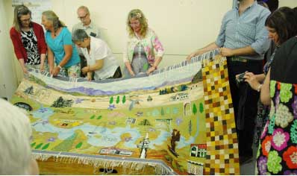

The ‘cutting down’ ceremony. Tapestry designer Annie Trevallian (centre) with some of the volunteer weavers.

As part of efforts to commemorate the centenary of ANZAC, the Australian War Memorial generously provided the Legislative Assembly with the loan of a painting – *Villiers Bretonneux, ruins of the church –* by renowned Australian artist, Will Longstaff. The work, painted in London circa 1918-1919, is located outside the Speaker’s office and will be on display throughout 2014-2015.

The Assembly, in conjunction with the ANU School of Art, continued its support for the ACT Legislative Assembly Art Prize. This initiative involves the Assembly awarding two art prizes of $500 each ($1,000.00 in total) to two final year students at the ANU School of Art. The prizes are made available for the winning students to purchase art supplies and materials. The recipients of the 2013-2014 prizes were Kael Stace for his work *Assemblage 1*, and Harrison Tucker for his work *Dry Structured Stool*. Both works are prominently displayed in the Assembly building.

### Survey of members and staff

During the year, the Office conducted a survey of members and their staff.

Responses were received from three of the five ministers and four of the 47 ministerial staff. Responses were also received from five out of the 12 non-ministerial members, and seven out of 36 non-ministerial staff. Details of the survey results are included in Appendix 21.

Goal 2 – Enhance accountability and governance arrangements

### Budget protocols

The Office developed of a set of budget protocols during the reporting period establishing detailed processes and procedures for the development and consideration of the Office’s budget in an effort to strengthen the application of the separation of powers doctrine and to further implement the *Commonwealth (Latimer House) Principles on the Three Branches of Government*. The protocols, which were agreed to by the Speaker and the Chief Minister on 24 June set out arrangements in relation to:

* budget responsibilities
* the budget process as it applies to the Office
* the retention by the Office of own source revenue
* the retention by the Office of unspent appropriation
* the application of dedicated budget process requirements to the Office
* funding in election years
* employee liabilities funding
* consultation with the Speaker on proposed savings proposals.

The protocols are to be tabled in the Assembly in 2014-2015 and will be reviewed in 2016.

### Website content managers forum

During the year the Office established a website content management forum to explore improvements to the Assembly’s website and develop strategies for compliance with the Web Content and Accessibility Guidelines 2.0.

### Internal audit

The Office’s internal audit committee continued to implement its audit program throughout the reporting period. More information on audit is contained in Section B.

### Public Interest Disclosure procedures

With the passage of the *Public Interest Disclosure Act 2012* all agencies are required to develop and publish the procedures under which they will meet the requirements of the Act.

The OLA procedures were developed in early 2014 and agreed to by the Commissioner for Public Administration. They are available on the Assembly’s website at www.parliament.act.gov.au/_data/assets/pdf_file/0009/599274/OLA_PID_procedures_FINAL.PDF

### Records management

As reported earlier, greater take up by staff of OLA’s electronic records management system resulted in 2 264 record containers being created during 2013-2014. This is a 176 per cent increase compared with the 2012-2013 period. There were also 9 014 record contents created during 2013-2014 resulting in an 83 per cent increase compared with the 2012-2013 period.

Staff in almost all areas of the Office were consistently saving records into the system. During the year a large number of documents relating only to Office staff were removed from the Assembly intranet site and stored in OLARIS.

### Records Management Program

The implementation of the Office’s records and information system (OLARIS) has required significant changes to recordkeeping processes. The records management program is being updated to reflect these changes, and new procedures, approved by the Clerk in June 2014, were disseminated to all staff.

#### Training and advice

In 2013-2014, 83 staff attended 41 training sessions and the Records and Information Manager provided record keeping advice on 327 occasions.

#### Preservation and access

The records management procedures reinforce the importance of effective management and preservation of all records, including those linking Aboriginal and Torres Strait Islanders to their heritage.

Two access requests were received from ACT Archives during 2013-2014. The records requested were not held by the Office.

More information about records management is provided in Section C.

Goal 3 – Build more effective mechanisms for public engagement

### Social media strategy

The Office has consolidated its approach to social media during the reporting period, using Twitter as a broadcast tool to increase public awareness of the business of the Assembly, and as a link to more detailed material available on the Assembly’s website. The number of people following these posts continues to increase. At the end of the reporting period, the Office had approximately 1 520 subscribers, and had published over 100 tweets on Assembly proceedings and general news.

### Community engagement and parliamentary education programs

Throughout the reporting period, 1 924 people visited the Assembly as part of the Assembly’s community engagement and education programs. All programs were evaluated by way of a satisfaction survey at the conclusion of visits with feedback from participants being incorporated into the development and delivery of future programs.

During the reporting period, 99.5 per cent of participants indicated satisfaction with the programs. The success of these programs relies heavily on the involvement of MLAs and during the year there were 105 individual visits from amongst the 17 members.

Detailed statistics on education programs is included at Appendix 20.

### Parliamentary education programs

#### ACT schools constitutional convention (1-2 August 2013)

The schools constitutional convention has been conducted in the ACT since 2000. It is a collaborative venture undertaken by the ACT Legislative Assembly, the Australian and ACT electoral commissions, the Museum of Australian Democracy, the National Archives of Australia, the ACT Education and Training Directorate, and the ANU College of Law.

The convention provides year 11 students with a comprehensive understanding of the Australian Constitution and the mechanisms by which changes can be made to it under section 128.

The topic for the 2013 convention was ‘*Should the Commonwealth Government have specific powers to legislate for the environment?*’ and 80 students from 12 ACT government and non-government schools participated in the event. Five ACT students were selected to participate in the National Schools Constitutional Convention held at the Museum of Australian Democracy in 2013.

The two-day event held at the National Archives, Museum of Australian Democracy and the ACT Legislative Assembly featured role plays, discussion groups, viewing of the original constitutional documents and lectures and presentations on the powers of the Constitution and the means by which changes to the Constitution can be brought about. Student leaders from ACT schools (year 12 students) who attended the National Schools Constitutional Convention in 2013 assisted with all of the above activities.

The ANU College of Law provides significant input to the program, with a number of eminent academics providing detailed information on the role of the Constitution and the referendum process.

In addition, students from the ANU College of Law assisted year 11 student delegates attending the convention with discussions and deliberations around the issue of the Commonwealth Government’s ability to legislate for the environment.

A mock referendum was conducted at the convention. A double majority (a majority of states and a majority of electors) was not achieved with the result being that the Constitution would not be changed to enable the Commonwealth Government to exercise specific powers to legislate for the environment.

A survey of satisfaction following the convention revealed that 100 per cent of students were either ‘highly satisfied’ or ‘satisfied’ with the event.

#### Work experience students/internships

Fourteen students from high schools, colleges and the Canberra Institute of Technology undertook work experience placements in members’ offices during the reporting period. Both members and students reported a high degree of satisfaction with this aspect of the Assembly’s education program.

#### Interschool parliamentary debates program

The interschool parliamentary debates program provides students from years 8 to 12 with the opportunity to practice parliamentary debating skills in the Assembly chamber.

Five interschool parliamentary debates programs were held throughout the year. One program was conducted for year 12 students, two programs were conducted for students in years 8 and 9, and two programs were conducted for year 10 students.

The topics for the debates were selected from the suggestions provided by students that participated in debates the previous year. Three-hundred and thirty-three students and accompanying teachers from government and non-government schools participated in the programs.

The Speaker, Deputy Speaker, Assistant Speakers and MLAs presided over the debates and provided feedback to students on their debating skills and how well particular arguments were presented. Students and teachers completed a satisfaction survey which showed that 100 per cent of participants were either ‘highly satisfied’ or ‘satisfied’ with these programs.

#### School/ college visits

School visits are an integral component of the education program offered by the Assembly and they include individual school visits as well as groups of schools that attend the Interschool Parliamentary Debates program and the annual Constitutional Convention program.

Two-hundred and forty-seven students participated in Assembly school visits and took part in a variety of programs including: mock elections; visits to, and role-plays in, the chamber; and presentations on the role of the Assembly. Teachers completed satisfaction surveys to assess the program and 100 per cent satisfaction was recorded. As in previous years, feedback also indicated that the materials provided were relevant and that the programs supported the current civics and citizenship curricula.

#### Community groups

Presentations about various aspects of the Assembly were made to community groups including probus clubs and the Adult Migrant Education Program (AMEP), Friends of the Belconnen Arts Centre, and Monash Men’s Shed. In addition, seminars, professional development activities, tours and visits to the chamber, including question time, were held throughout the reporting period. Visitors included: members of the public; ACT teachers; staff recently appointed to the Assembly; visitors from Nara, Japan; and members of the ACT Legislative Assembly Art Advisory Committee. Five-hundred people participated in this component of the program. One-hundred per cent of participants were ‘highly satisfied’ or ‘satisfied’ with these presentations. The Office also assisted with the one-day Youth Parliament in conjunction with the YMCA of Canberra, as well as assisting with the one day Rostrum Debating Program for secondary school students.

The Speaker, with the endorsement of the Standing Committee on Administration and Procedure, has initiated an engagement program for the Assembly conducted after hours. The Office assists with tours at these events. During the year, visits from Rotary Clubs and Neighbourhood Watch were conducted.

#### Speaker’s citizenship evenings (welcome ceremonies for new citizens)

The Speaker hosted four citizenship evenings during the year for ACT residents who had recently become Australian citizens.

The evenings provide new citizens with an introduction to the workings of the ACT Legislative Assembly. Participants also have the opportunity to meet MLAs and to view a captioned video about the Assembly and its history. In addition, participants undertake a tour of the building and participate in a question and answer session with the Speaker and MLAs in the chamber. One-hundred and forty-onenew citizens participated in these evenings. The results of a satisfaction survey undertaken at the conclusion of the evening revealed that 100 per cent of attendees were either ‘satisfied’ or ‘highly satisfied’ with the event.

#### Official delegations

Tours of the chamber and visits to question time were held throughout the year for delegations from Australia and overseas, with thirty-eight people taking part. The Office also played a key role in organising the annual Parliamentary Educators Officers conference. See Appendix 18 for details of visiting delegations.

#### Public service seminars

Three major seminars for ACT public servants were held during the reporting period. The topics covered in the seminars included: the role of the Assembly; the importance of Assembly committees, and the legislative process.

Ninety-nine public servants from a wide range of ACT government agencies attended the seminars. Ninety-seven per cent of participants were either ‘satisfied’ or ‘highly satisfied’ with these seminars.

In addition, seminars about how the Assembly operates were conducted for public servants from Canberra Connect (seventy-one staff participating) and Territory and Municipal Services staff (twelve staff participating). One-hundred per cent of participants in both groups were either ‘satisfied’ or ‘highly satisfied’ with these seminars.

### E-petitions

In early 2013 the Assembly’s e-petitions system was launched. The e-petitions system enables the terms of an e-petition to appear on the Assembly’s website (at <https://epetitions.act.gov.au>) and for ACT residents to electronically add their names to the petition. E-petitions remain on the website for an agreed period, after which they are presented to the Assembly in a similar manner to hard copy petitions.

The first e-petition was presented to the Assembly in November 2013. Another was presented in February and as at 30 June a further 3 are still open for signatures. During the reporting year 6 paper petitions were presented to the Assembly.

### Community Radio

In April 2014 after a successful collaboration with OLA’s technical staff ArtSound FM commenced a trial rebroadcast of Assembly question time and adjournment debates. At the time of reporting the trial had not been evaluated.

Goal 4 – Work towards an environmentally sustainable Assembly

The Office will review its environmental sustainability focus as part of the 2014 strategic planning work, and consider its capacity to implement further demand reduction initiatives of the medium and long terms.

The Office continues to closely monitor its energy and water consumption and the amount of waste generated by the Assembly. Statistics comparing the sustainability results for 2012-2013 and 2013-2014 are included in Section C of this report.

Goal 5 – Maintain a highly skilled, satisfied and committed   
 workforce

### Report on the Australasian Parliamentary Educators’ Conference 2013

During the reporting period, a number of staff from the Office attended the 2013 Australasian Parliamentary Education Conference, hosted by the Parliamentary Education Office of the Australian Parliament, the Office of the Legislative Assembly and the Museum of Australian Democracy.

The conference was held over three days with each of the above organisations involved in delivering aspects of the program.

A wide range of delegates from across Australian parliaments and beyond participated. International delegates included parliamentary education officers from New Zealand, Papua New Guinea, Solomon Islands and Tonga.

Presentations on a diverse range of topics were made, including on:

* implementation of the national civics and citizenship curriculum for years 3 to 10
* the relationship of video conferencing with distant communities
* powerful partnerships – teachers and parliamentary educators
* the value of youth parliaments and
* parliamentary education in the Pacific

This three-day conference enabled state, territory and international delegates to discuss major innovations in parliamentary education, as well as an opportunity to exchange ideas, discuss common issues and learn about the different services and programs offered across the parliamentary education sector.

### Certificates of service

On 16 May 2014, the Speaker hosted the annual certificates of service morning tea to recognise the contributions of Office staff members who had dedicated between upwards of years of service to the organisation. The Speaker presented certificates to the following staff:

* Michael Harris — five years
* Devika Nair — 10 years
* Max Kiermaier — 10 years
* Peter Bayne — 15 years
* Ray Blundell — 20 years
* Roger Malot — 25 years

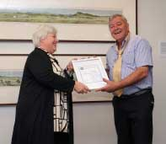

Ray Blundell receiving his service award from the Speaker, Vicki Dunne MLA

### Participation in the activities of the Australian and New Zealand Association of Clerks-at-the-Table (ANZACATT)

The Australian and New Zealand Association of Clerks-at-the-Table (ANZACATT) has members from each house of parliament in Australia, Norfolk Island and New Zealand. ANZACATT compiles two regular publications: a half-yearly bulletin, *Parliament Matters*, and a newsletter called *Table Talk*. Each parliamentary jurisdiction contributes to these publications.

The association also organises an annual professional development seminar for parliamentary officers of the association. Two staff from the Office of the Legislative Assembly attended the January 2014 ANZACATT professional development seminar in Darwin, hosted by the Parliament of the Northern Territory. The theme of the seminar was ‘The Parliamentary Workplace – Members, Mates and Migranes’, and the program covered both committee and chamber activities. The seminar was attended by staff from all Australian parliaments, as well as parliamentary staff from Canada, Scotland, Ohio USA and the UK House of Commons and House of Lords.

### Australasian Study of Parliament Group (ASPG)

The Office continued to provide administrative support for the ACT Chapter of the Australasian Study of Parliament Group (ASPG), with a staff member undertaking the role of Honorary Treasurer for the Chapter.

Two staff attended the annual conference in Perth in October. The theme of the conference was ‘Parliamentary committees, corruption commissions and parliamentary statutory officers’.

### Learning and development

Further details on learning and development are contained in Section C.

**Section B**



Consultation and scrutiny reporting

## Internal and external scrutiny

During the reporting period, the Office was subject to scrutiny by its internal audit committee and by the Auditor-General. Table 4 includes reports and recommendations associated with this scrutiny along with the Office’s responses to relevant findings.

Owing to the nature of the subject matter, findings and recommendations arising from the audit of physical security arrangements are not listed. However, all recommendations have been agreed to or accepted, and action taken to address the findings.

Table 4. Reports on the operations of the Office of the Legislative Assembly (OLA)

| Organisation, nature of inquiry/report | Recommendations | Response |
| --- | --- | --- |
| Oakton – Accounts payable | Governance and Communication should delay the processing of and return any invoices that do not have the appropriate certification | Agree. Where an invoice has not been certified finance staff will return the invoice to the area/director responsible for attention. The Director, G&C will issue a direction |
| Oakton – Accounts payable | The accounts payable function processes and procedures should be formalised and documented | Agree |
| Oakton – Accounts payable | The key internal controls in the accounts payable function should be formalised and documented. These controls should include:  The data entry person should ensure that all appropriate certifications are provided prior to the processing and payment of the invoice;  The data entry person should ensure that the person certifying that approval exists has the appropriate financial delegation;  The person reviewing the data entry should be separate from the person entering the data into MYOB; and  The person entering the data into MYOB should not have approved the expenditure. | Agree. G&C has already adopted a procedure embodied in a new invoice cover sheet which meets the requirements listed above. As part of a larger review of the CFIs and associated procedure, it will articulate these arrangements in a formal procedure and link to the CFIs to provide a policy basis for these requirements to be followed. |
| Axiom – IT Security compliance audit | It is recommended that the OLA document as an attachment to the MicroPay Systems Security Plan, the process for managing the generic administrator account for Micropay  This should also include monitoring reports that the OLA plans to use to monitor administrator access for MicroPay.  The System Security Plan should be endorsed by OLA senior management. | Business Support has now developed a Micropay Meridian – Access and Systems Control Policy which has been annexed to the ICT Security Plan for Micropay.  This policy sets out the processes and controls in place to address this finding. |
| Axiom – IT Security compliance audit | It is recommended that the OLA document as an attachment to the MicroPay Systems Security Plan the key mitigating controls over the lack of segregation in the HR and Payroll processes.  This should include how evidence of the monitoring reviews will be maintained to evidence the operation of these controls.  The System Security Plan should be endorsed by OLA senior management. | Business Support has now developed a Micropay Meridian – Access and Systems Control Policy which has been annexed to the ICT Security Plan for Micropay.  This policy sets out the processes and controls in place to address this finding. |
| Axiom – IT Security compliance audit | Completion of the GHD recommendation 19 (ie, Include in pass request forms advice that card transactions will be logged and the purpose. Ensure the logs are only used for the defined purpose.’ | Agree |

## Legislative Assembly committee reports

The Office was not directly subject to any committee recommendations during the reporting period. However, the Standing Committee on Administration and Procedure made two recommendations in its Report on Annual and Financial Reports 2012-2013 directed towards the Speaker and the Assembly’s Standing Committee on Administration and Procedure. These were:

#### Recommendation 7

The Committee recommends that the Speaker inform the ACT Legislative Assembly on the outcomes of the Office of the Legislative Assembly’s review of the administration of members’ entitlements.

#### Recommendation 8

The Committee recommends that the ACT Legislative Assembly’s Administration and Procedure Committee should give due consideration to uploading members’ travel reports to the Legislative Assembly website at more progressive intervals than twice yearly.

At the time of reporting these two recommendations were still the subject of consideration.

## Legislation report

The Office is responsible for performing a range of functions outlined in section 6 of the *Legislative Assembly (Office of the Legislative Assembly) Act 2012* as well as a number of roles and responsibilities that arise from the legislation listed below.

* *Legislative Assembly Precincts Act 2001*
* *Legislative Assembly (Broadcasting) Act 2001*
* *Legislative Assembly (Members’ Staff) Act 1989* (and associated subordinate legislation)
* *Legislation Act 2001*
* *Australian Capital Territory Self-Government Act 1988* (Cwlth)



**Section C** Legislative   
and policy based reporting

## Risk management and internal audit

### Risk management

The Office remains committed to ensuring that all non-trivial risks are well managed across the organisation and that staff across the Office have the necessary skills and knowledge to incorporate risk management into the management and delivery of key functions for which they are responsible.

The Office defines risk as the ‘effect of uncertainty on the ability of the Office to effectively support the ACT Legislative Assembly in fulfilling its legislative, representative and accountability related responsibilities’.

Based on AS/NZS ISO 31000:2009, the Office’s risk management framework is designed to inform sound decision making across the organisation and assist in promoting awareness and understanding of risk management issues amongst the Office’s directors and staff.

### Internal audit

The Office’s internal audit committee reports directly to the Clerk of the Assembly and operates under a charter, which establishes the role of the committee as being to review and monitor:

* the extent of compliance with applicable laws, regulations and directions, including agency policy
* the effectiveness of the design, implementation and operation of internal controls
* the completeness, accuracy and reliability of financial and operating information and underlying records
* the efficiency and effectiveness of business and program, or service, delivery processes

The committee commissioned two audits during the period. The first was an audit of accounts payable procedures, and the second was an audit of IT security compliance.

Table 5. Internal audit committee members and meetings

| Name | Position | Duration of membership | Meetings attended over the reporting period |
| --- | --- | --- | --- |
| Michael Harris | Independent Chair | Since 13 March 2007 | 3 |
| Max Kiermaier | Member | Since 2 April 2013 | 3 |
| Brian Lloyd | Member | Since 12 November 2010 | 3 |
| Janice Rafferty | Member | 6 November 2009 to 20 November 2013 | 1 |
| Michael Sloane | Member | Since 21 November 2013 | 2 |

## Fraud prevention

The Office has a fraud and corruption framework in place, outlining the Office’s policies and procedures for preventing, identifying and investigating fraud. The framework is informed by a risk assessment examining both the likelihood and impact of particular risks associated with fraud and corruption. The assessment also incorporates an action plan/treatment plan component directed towards lowering the overall risk profile of the Office so far as fraud and corruption issues are concerned.

One potential fraud issue relating to an external supplier emerged during the reporting period. The matter was resolved without loss to the Territory.

## Public interest disclosure

The Office also has in place policies and procedures for receiving and investigating public interest disclosures. The details of the procedures are available at both the members and public entrances of the Assembly building as well as on the Assembly’s intranet.

The Deputy Clerk and Serjeant-at-Arms is the designated contact officer for public interest disclosures and can be contacted on (02) 6205 0171. Public interest disclosures can also be directed to the Clerk on (02) 6205 0173.

### Section 45 statement

The *Public Interest Disclosure Act 2012* provides the mechanism for people to report wrongdoing by ACT public sector entities, including their staff, contractors and volunteers.

The Office of the Legislative Assembly did not receive any public interest disclosures during the reporting period.

## Freedom of information

### Section 7 statement

#### Organisation

The Office is responsible to the Speaker of the Legislative Assembly through the Clerk, who is appointed pursuant to Part 3 of the *Legislative Assembly (Office of the Legislative Assembly) Act 2012*.

The Clerk has all the powers of a Director General but is not subject to the direction of the executive. Office staff, assisting the Clerk in the exercise of his or her powers and functions, are employed pursuant to the *Public Sector Management Act 1994.*

#### Powers

Office staff—namely, the Serjeant-at-Arms and the Principal Attendant—can exercise powers delegated by the Speaker pursuant to section 9(5) of the *Legislative Assembly Precincts Act 2001*.

The Clerk also has powers under the *Legislative Assembly (Broadcasting) Act 2001* in relation to the broadcasting of proceedings, including the approval of electronic access to the proceedings of the Assembly and the withdrawal of access.

#### Arrangements for public participation

Avenues for public participation include submissions to inquiries, access to public hearings of committee inquiries and Assembly meetings, citizen’s right of reply, petitions, and access to administrative records and general files through freedom of information (FOI) requests.

#### FOI procedures and contact points

All FOI requests relating to the Office of the Legislative Assembly should be directed to:

The Clerk  
ACT Legislative Assembly  
London Circuit  
Canberra ACT 2601

**Location: London Circuit, Canberra City, ACT, 2601**

**Business hours: 8:30 am—5:00 pm Monday to Friday**

**Postal address: GPO Box 1020, Canberra, ACT, 2601**

**General enquiries: (02) 6205 0439**

**Committee enquiries: (02) 6205 0127**

**Hansard enquiries: (02) 6205 0422**

**Legislation enquiries: (02) 6205 0440**

Requests can be delivered to the public entrance of the Assembly building between 8:30 am and  
5:00 pm Monday to Friday. Telephone enquiries should be directed to the Office’s general number (02) 6205 0439.

The FOI fact sheet and procedures can be accessed on the Assembly website at: [www.parliament.act.gov.au/__data/assets/pdf_file/0018/435213/Freedom-on-Information-Factsheet-and-procedures-revised-March-2013.pdf](http://www.parliament.act.gov.au/__data/assets/pdf_file/0018/435213/Freedom-on-Information-Factsheet-and-procedures-revised-March-2013.pdf)

### Documents available

The Office has broad responsibility for providing advice to government agencies and the public regarding the business of the Assembly and its committees. To facilitate the provision of information the following documents are published by the Office:

NOTE: Documents identified with an (*) are available on the internet. The web address is: [www.parliament.act.gov.au](http://www.legassembly.act.gov.au).

* A brief overview of the business of the Legislative Assembly for the Australian Capital Territory—concise information on the proceedings and practices used in the Assembly as well as a glossary of terms.
* Annual reports.
* Art cards—a series of postcards with images of artworks from the Assembly’s collection.
* Art catalogue—a booklet featuring artwork from the Assembly’s collection, including a list of items in the catalogue, image descriptions and artist biographies for key artworks.
* Bills list*—an alphabetical listing, by short title, of bills considered by the Assembly. The list details the date of introduction and, where relevant, the date of passage, the act number and particulars on the legislation register. Bills discharged, negatived at the agreement in principle stage, declared urgent and referred to committees are also listed. The list is published on a regular basis.
* Bills Volumes*—bound volumes of all bills presented to the Assembly. The volumes include bills, explanatory statements and amendments that were moved at the detail stage. Available for inspection at the Assembly and Territory libraries. The volumes are published for each Assembly and, from 2006, are available online.
* Business of the Assembly*—a synopsis of the business undertaken by the Assembly each calendar year. This information is published on an annual basis and online.
* Committee reports*—reports presented to the Assembly by standing and select committees. Reports presented during the reporting period are listed in Appendix 8.
* Daily Program*—a guide for members indicating the items of business which the Assembly is expected to consider that day. It is published each sitting day.
* Debates of the Legislative Assembly for the Australian Capital Territory (Hansard)*—a record of Assembly debates, commonly referred to as Hansard. The official Weekly Hansard is produced approximately three weeks after each sitting week of the Assembly. The proof Daily Hansard is produced the day following a sitting of the Assembly.
* Digest of proceedings of the Legislative Assembly for the Australian Capital Territory—a booklet containing subjects and speeches indexes to Hansard, lists of sitting days, members and their official positions and party affiliations, bills, matters of public importance, ministerial statements, petitions, and votes. Published annually.
* Discretionary office allocation expenditure*—information on MLAs’ use of the discretionary office allocation.
* Fact sheets*—provide a variety of historical, administrative and procedural information in relation to the business of the Assembly.
* Get to know your ACT Legislative Assembly*—a pamphlet that provides a concise overview of the history of the Assembly, the ACT electoral process and general information on the Assembly’s sitting days and papers. This pamphlet has been translated into three languages—Arabic, Chinese and Vietnamese—and is available at the public entrance of the Assembly building and on the Assembly website.
* Getting involved in public inquiries—a pamphlet providing information on participating in public inquiries of Assembly committees*. Available from the public entrance of the Assembly and the Committee Office. A range of community groups also have copies of the brochure for distribution.
* Information for persons making submissions to, or appearing as witnesses before, committees of the Legislative Assembly*—a pamphlet providing information to persons involved with the committees of the Assembly.
* Legislative Assembly for the Australian Capital Territory—a brochure explaining the history of the Assembly, including a map of the building.
* Strategic plan 2009-2014*.
* Members’ declarations of interest*—contains statements of registrable interests as declared by members.
* Minutes of Proceedings*—the official record of the proceedings of the Assembly. Pamphlet copies are published in proof form immediately following each sitting of the Assembly, with final copies published later. A proof index to the minutes and a proof index to papers tabled in the Assembly are published internally, as are proof bound volumes of the Minutes of Proceedings.
* Non-executive members’ travel summary*—contains information on the use of travel entitlements by members.
* Notice Paper*—the official list of all outstanding business before the Assembly and setting out the order of business to be followed. The Notice Paper also lists notices of questions (a full list of unanswered questions appears on the first Notice Paper each sitting week or fortnight) and contains an information section on Assembly committees. The Notice Paper is published each sitting day of the Assembly, with the exception of the first sitting day of an Assembly.
* Sitting pattern*—a calendar highlighting Assembly sitting days. A copy of the current sitting pattern is available from the members and public entrances while in stock. An up-to-date version is always available on the Assembly website.
* Standing and temporary orders of the Assembly*.
* Student workbooks—workbooks for primary and secondary students containing information about the Assembly and educational activities to assist with their studies.
* Summary of Bills*—includes a summary of each bill introduced into the Assembly for the current Assembly to date, the minister or member who introduced the bill and the date of introduction. Published on a regular basis.*
* Teacher workbooks—activity pads for teachers to assist in the development of classroom activities.
* Transcripts of public hearings of committees of the Assembly are produced following committee hearings, uncorrected proofs of committee transcripts are available for inspection at the Committee Office. Edited proof transcripts are published on the Assembly’s website as soon as they are verified by Hansard editors; final transcripts are published within 20 working days from the date of the hearing.

Copies of the documents listed above are available from the Office of the Legislative Assembly and, where indicated, are available on the internet.

The Assembly also provides copies at no charge, of a range of publications on various aspects of its history, roles and functions to the public, community groups and schools.

Copies of ACT legislation (bills and acts) and delegated legislation (e.g. regulations and determinations) are at [www.legislation.act.gov.au](http://www.legislation.act.gov.au).

Other types of documents that may be available under the Freedom of Information Act 1989 are general files and administrative records; however, it should be noted that documents are exempt documents if disclosure would infringe the privileges of the Legislative Assembly or other Australian parliaments.

### Section 8 statement

Section 8 of the *Freedom of Information Act 1989* applies to documents that are provided by the agency for the use of, or are used by, the agency or its officers in making decisions or recommendations for the purposes of an enactment or scheme administered by the agency, with respect to rights, privileges or benefits, or to obligations, penalties or other detriments, to which persons are or may be entitled or subject.

The Office has one document that would fall under this definition: *Guidelines for Broadcasting the Public Proceedings of the Legislative Assembly and its Committees*. A copy of this document is available on request.

### Section 79 statement

During the reporting period, the Office received four applications for information pursuant to the FOI legislation.

One request was subsequently withdrawn. Of the remaining requests: full access to the documents was granted in one case; and partial access was granted in the others.

The decisions were made within 31 days of the request being received.

No application was made during the reporting year for an internal review of a decision under section 59.

No application was made during the reporting year to the ACT Civil and Administrative Tribunal for a review of decisions.

No charges and application fees were levied and no requests were received to amend records under section 48.

## Internal accountability

The Office is headed by the Clerk (pursuant to section 10 of the *Legislative Assembly (Office of the Legislative Assembly) Act 2012).* The Clerk is supported by a senior management group made up of five directors.

The Office prepares a master implementation plan each year setting out a program of work for the organisation. The Office also undertakes strategic planning every five years with the next exercise due to commence towards the end of 2014.

The senior management team meets monthly to make decisions relating to:

* the delivery of the Office’s services
* budgeting
* implementation activities
* internal governance and accountability initiatives

Standing items on the agenda include risk management and work safety.

All directors are subject to performance agreements with the Clerk. The agreements set out directors’ key responsibilities and work objectives. Agreements are reviewed on a six-monthly basis to assess performance and monitor implementation.

The senior management group is made up of (as at 30 June 2014):

* Tom Duncan, Clerk
* Max Kiermaier, Deputy Clerk and Serjeant-at-Arms
* Val Barrett, Director, Hansard, Technology and Library
* Ian Duckworth, Director, Business Support
* David Skinner, Director, Governance and Communications
* Andrew Snedden, Director, Committee Support

The key management committees within the Assembly are:

* health and safety committee (recognising the separate employer responsibilities, the committee is composed of representatives from the Office, members’ offices, and the executive)
* internal audit committee
* the joint union management consultative committee (composed of management, union and staff representatives)

The Clerk is the only Senior Executive Service officer within the organisation. The determination of the Clerk’s remuneration arrangements is made pursuant to the *Remuneration Tribunal Act 1995*.

## Human resource performance

During the reporting period, the Office developed staffing arrangements to complete the implementation of the revised organisational structure that was adopted following a review in the previous year.

The Office undertook 14 staff selection processes during the year, including for medium and long term temporary vacancies. One selection process had not been completed by the end of the reporting period but, on average, the number of days between advertising and appointment of the successful candidate was 61. This compares to a service wide average of 49 days. Improving this area of HR performance will be a priority for 2014-2015.

An organisation chart, current at 30 June 2014, is shown in Section A.

A total of five staff employed at the beginning of the reporting period left the organisation during the year (this excludes temporary staff whose employment ended). This represents a turnover rate of 18 per cent. The following table shows the reasons for staff departures.

Table 6. Reasons for staff departures

| Reason | Number of departures |
| --- | --- |
| Promotion/transfer to a Commonwealth agency | 1 |
| Resignation | 3 |
| Retirement (including 2 long term casuals) | 3 |

The Office continued to adopt its capability framework as a basis for staff selection and professional development. The capability framework identifies five key areas of capability that reflect the Office’s workforce requirements and which broadly support the Office’s strategic plan. They are:

* demonstrating professionalism
* communicating
* improving outcomes and innovating
* building effective working relationships and working collaboratively
* adopting strategic thinking

Each key area of capability is broken down into a small number of elements and, for each element, some signature descriptors are identified, with the maturity and scope of those descriptors arranged into four classification streams (ASO1-4; ASO 5-6; SOGC-B; and SOGA) to reflect the differing expectations of roles within the Office.

### Members’ staff employment

A significant element of the Office's human resource management effort relates to its role in the administration of employment of staff by non-executive members under the *Legislative Assembly (Members' Staff) Act 1989 (the LAMS Act)*.

The employment arrangements for non-executive members are based around a staff salary allocation that is determined by the Chief Minister under the LAMS Act. As part of these arrangements, the Office monitors and updates relevant staff salary allocations, and prepares and manages the execution of all staff employment agreements.

A total of 67 employment agreements were administered by the Office over the reporting period. This compares with a total of 103 for the 2012-2013 year, although the prior year figure is unusually high because it was an Assembly election year. A more meaningful comparison would be 2011-2012, in which 59 employment agreements were administered.

Another significant element of the Office’s administration of staff salary allocations for non-executive members relates to the pledging of allocations from one member to another. Under arrangements approved by the Chief Minister, a member may pledge part of their staff salary allocation to another member. Appendix 17 summarises the staff salary allocation of each non-executive member and the total amounts pledged or received by or from other members.

## Staffing profile

Table 7. Full time staff equivalent (FTE) and headcount

| Description | Female | Male | Total % |
| --- | --- | --- | --- |
| FTE by gender | 29.05 | 18.57 | 47.62 |
| Headcount by gender | 34 | 25 | 59 |
| Percentage of workforce (headcount) | 57.63% | 42.37% | 100.00% |

Table 8. Classifications

| Classification group | Female | Male | Total |
| --- | --- | --- | --- |
| Clerk | 0 | 1 | 1 |
| SOGA | 1 | 4 | 5 |
| SOGB | 2 |  | 2 |
| SOGC | 6 | 3 | 9 |
| SPOC | 1 | 0 | 1 |
| ASO6 | 12 | 3 | 15 |
| PO2 | 2 | 0 | 2 |
| ITO2 | 0 | 1 | 1 |
| TO4 | 0 | 1 | 1 |
| ASO5 | 0 | 1 | 1 |
| PO1 | 1 | 0 | 1 |
| ASO4 | 7 | 1 | 8 |
| ASO3 | 2 | 2 | 4 |
| ASO2 | 0 | 8 | 8 |
| TOTAL | 34 | 25 | 59 |

Table 9. Employment category by gender

| Employment Type | Female | Male | Total |
| --- | --- | --- | --- |
| Casual | 4 | 7 | 11 |
| Permanent full-time | 19 | 13 | 32 |
| Permanent part-time | 6 | 5 | 11 |
| Temporary full-time | 5 | 0 | 5 |
| Temporary part-time | 5 | 0 | 5 |
| TOTAL | 34 | 25 | 59 |

Table 10. Average length of service by age-group by gender

| Average length of service (years) | Male pre-baby boomers | Male baby boomer 1946-1964 | Female baby boomer 1946-1964 | Male gen X 1965-1979 | Female gen X 1965-1979 | Male gen Y 1980-1993 | Female gen Y 1980-1993 | Total |
| --- | --- | --- | --- | --- | --- | --- | --- | --- |
| 0-2 | 0 | 4 | 3 | 2 | 7 | 2 | 2 | 20 |
| 3-4 | 0 | 2 | 2 | 0 | 2 | 0 | 0 | 6 |
| 5-6 | 0 | 2 | 2 | 1 | 3 | 0 | 1 | 9 |
| 7-8 | 0 | 1 | 5 | 1 | 1 | 0 | 1 | 9 |
| 9-10 | 1 | 1 | 1 | 0 | 1 | 0 | 0 | 4 |
| 11-12 | 0 | 2 | 1 | 0 | 0 | 0 | 0 | 3 |
| 13-14 | 0 | 0 | 1 | 0 | 1 | 0 | 0 | 2 |
| 14+ | 1 | 3 | 0 | 2 | 0 | 0 | 0 | 6 |
| TOTAL | 2 | 15 | 15 | 6 | 15 | 2 | 4 | 59 |

Table 11. Total average length of service by gender

| Gender | Average length of service |
| --- | --- |
| Female | 4.88 |
| Male | 8.28 |
| TOTAL | 6.32 |

Table 12. Age profile

| Age group | Male | Female | Total |
| --- | --- | --- | --- |
| <20 | 0 | 0 | 0 |
| 20-24 | 1 | 1 | 2 |
| 25-29 | 1 | 1 | 2 |
| 30-34 | 2 | 0 | 2 |
| 35-39 | 2 | 1 | 3 |
| 40-44 | 5 | 1 | 6 |
| 45-49 | 8 | 4 | 12 |
| 50-54 | 6 | 5 | 11 |
| 55-59 | 5 | 4 | 9 |
| 60-64 | 3 | 3 | 6 |
| 65-69 | 1 | 3 | 4 |
| 70+ | 2 | 0 | 2 |
| TOTAL | 36 | 23 | 59 |

NOTE: numbers include temporary employees and staff on extended leave

## Learning and development

In recognition of the need to develop and maintain a skilled and flexible workforce, the Office is committed to the provision of learning opportunities relevant to meeting current and future organisational needs. This commitment is reinforced in the Enterprise Agreement and the Office’s strategic plan, both of which recognise that people are the key to achieving the organisation’s goals.

The Office actively encourages all staff to participate in development activities, both internal and external, through learning and development plans that form part of the Office’s performance and development program. Development includes inter-parliamentary conferences and seminars, other specific training activities, lateral and temporary transfers within and outside the Office, and the availability of study assistance.

During the reporting period, staff participated in over 30 learning and development activities, which involved expenditure of approximately $33 000 plus associated travel costs. This provided learning and development activities in a broad range of areas including:

* inter-parliamentary conferences and seminars
* information technology skills
* information management
* work safety, including emergency preparedness
* respect, equity and diversity
* job specific training

In addition to these activities, the Office continued support for staff through the studies assistance program. The program has continued to provide assistance in the form of paid and unpaid leave and payment of course costs to staff undertaking tertiary studies. For the reporting period, the Office supported two staff and invested approximately $10 000 towards studies assistance.

## Workplace health and safety

The Office is committed to promoting and maintaining a high standard of health and safety and wellbeing for all staff, members, contractors and visitors. However, the Assembly is a unique workplace in relation to workplace health and safety with each member and the Clerk having employer responsibilities in relation to their respective employees. In recognition of these unique arrangements, a workplace injury prevention policy statement – signed in 2012 by the Chief Minister, the Speaker, other party leaders and the Clerk – governs the overall workplace health and safety arrangements in the Assembly work environment. This policy statement is expected to be reaffirmed and resigned in the next reporting period by the Chief Minister, Leader of the Opposition, Speaker and Clerk.

In accordance with the reporting requirements of part 10 of the Work Health and Safety Act 2011 (WHS ACT), there were no notices of non-compliance given to the Clerk in the reporting period.

The Assembly workplace has appointed a work safety committee that met on three occasions during the reporting period. Membership of the committee includes three management representatives, five workplace representatives covering the Office and members’ staff, the health and safety representative, and one union representative.

During the reporting period, the work safety committee undertook the following measures in accordance with the Assembly’s workplace health and safety and injury management plan:

* workplace hazard inspections
* a new work safety risk assessment and a risk management plan
* quarterly work safety risk assessments
* assessments of accident/incident reports and identification of any controls to reduce the risk

During the reporting period:

* the Assembly had no accidents or dangerous occurrences that required the issuing of notices under part 3 section 38 of the Work Safety Act 2011
* all plant and equipment was regularly checked in line with statutory requirements

In July 2013, the Assembly Building was subject to a ‘white powder’ incident after suspicious mail items were delivered to certain Assembly members through the postal system. Following the activation of emergency response procedures, and a lock down of the Assembly premises for several hours, the suspect mail items were tested and shown to be harmless. The Office’s Emergency Planning Committee and Work Safety Committee both reviewed the incident and identified improvements in procedures, including internal communication and mail opening procedures. The incident was reported as a dangerous occurrence to WorkSafe ACT.

The following measures were undertaken to ensure workplace health, safety and welfare at work of all staff:

* influenza vaccinations on-site or reimbursement available if privately arranged
* workstation assessments provided to employees on longer term contracts as required
* trial of the Clerk’s standing workstation
* training on specific workplace health and safety issues, along with general emergency awareness and building evacuation drills
* health and wellbeing allowance
* eyesight testing and reimbursement of spectacles for visually demanding tasks provided as required
* regular articles in the Assembly newsletter on work safety related matters, including promoting the EAP service
* the distribution of the monthly Healthworks brochure to all staff

## Workplace relations

During the reporting period, negotiations and bargaining continued at a whole-of-government level for replacement enterprise agreements for both Office staff and for staff of Assembly members, both of which nominally expired on 30 June 2013.

The replacement agreement for Office staff – the *ACT Public Sector Office of the Legislative Assembly Enterprise Agreement 2013-2017* ***–*** was approved by the Fair Work Commission and came into effect from 26 May 2014. At the end of the reporting period, bargaining arrangements for the replacement Agreement for staff of Assembly members had not progressed and those arrangements are expected to be finalised in the next reporting period.

During the reporting period, one special employment arrangement continued in operation to address the specialist requirements of the position and prevailing market forces.

## Strategic asset management

### The Assembly building

The asset management strategy for the Assembly building is largely based on a set of life cycle data for the various building elements and components which is updated approximately every three years. The last update of this data was undertaken in 2010-2011 and a further revision was scheduled to occur in 2013-2014 but did not proceed pending a review of the methodology used. The review will now be completed in the coming year. The life cycle data gathered assists in developing strategic guidance to the Office on what should be included in the annual capital upgrade program (see below) and on major repairs and maintenance priorities.

### Capital upgrade funding and expenditure

The Office receives capital upgrade funding each year to maintain the Assembly building. The amount is indexed annually and, in 2013-2014, totalled $0.240m. The key works undertaken with this funding were:

Table 13. Key capital works funding and expenditure

| Description of work | Budget $m | Final cost $m |
| --- | --- | --- |
| Building structure – major elements included: Construction of a sixth minister’s suite;  Building fabric restoration works. | 0.070 | 0.065 |
| Building plant – major elements included: Building access control system and equipment upgrade; Emergency lighting upgrade | 0.070 | 0.100 |
| Work safety measures – fire safety upgrade | 0.070 | 0.058 |
| Improved environmental measures – thermally protective window furnishings | 0.030 | 0.016 |
| TOTAL | 0.240 | 0.239 |

### Asset maintenance and repairs

During this year, the Office’s expenditure on building maintenance was $0.516m. The main components of this overall expenditure were cleaning ($0.227m) and scheduled maintenance ($0.164m). The scheduled maintenance expenditure includes servicing of mechanical building systems (e.g. heating, ventilation and cooling systems, fire systems, lifts, auto doors), maintenance of security and access control systems and maintenance of the courtyard gardens. Approximately $0.025m was expended on unscheduled maintenance and repairs.

The external contractor engaged to provide specialised services for maintenance of the building’s mechanical systems provides, as part of that contract, annual condition audits and reports, which are used to inform and assist in the management and planning of future maintenance and capital upgrades.

### Office accommodation

The gross building area for the Assembly building is 7 547m2 and the net lettable area for building valuation purposes is 6 823.8m2. However, significant parts of the net lettable area include floor space that is used only on a periodic or occasional basis or is not occupied by staff. These areas include the Assembly chamber, two committee rooms and a number of function rooms. For the purposes of establishing a rate of office space utilisation, an area of 5 189.9m2 has been identified as the area that the Office of the Legislative Assembly, members and staff ordinarily occupy. In terms of the number of people who occupy the space, it was recognised that some fluctuation occurs, due primarily to the sitting patterns of the Assembly (i.e. when additional staff are engaged) and that the peak number was approximately 148.

Accordingly, the office space utilisation rate is 35.5m2 per occupant.

Table 14. Value and quantity of assets as at 30 June 2014

| Asset class | Value | Quantity |
| --- | --- | --- |
| Assembly building (Territorial budget) | $25.995m | 1 |
| Land (Territorial budget) | $4.560m | 1 |
| Leased motor vehicles* (Territorial budget) | $0.235m | 4 |
| Leased motor vehicles (Controlled budget) | $0.025m | 1 |
| Assembly art collection (Controlled budget) | $0.605m | 197 |
| Assembly library collection (Controlled budget) | $0.549m | various |
| Other Collectables (Controlled budget) | $0.035m | 3 |
|
| Plant and equipment (Controlled budget) | $0.457m | 61 |
| Intangibles (software) | $0.050m | 1 |

### Additions and deletions

Table 15. Assets that were added or removed from assets register during 2013-2014

| Asset Class | Additions (value) | Disposals (value) |
| --- | --- | --- |
| Assembly building (Territorial budget) | Capital upgrade program—see below—($0.239m) | N/A |
| Land (Territorial budget) | N/A | N/A |
| Leased motor vehicles (Territorial budget) | 4 ($0.171m),  replacement vehicles | 2 ($0.073m),  due to the expiry of lease term) |
| Motor vehicle (Territorial budget) | 0 | 1 ($0.021) |
| Assembly art collection  (Controlled budget) | 13  ($0.045m) | 0 |
| Assembly library collection  (Controlled budget) | Various  ($0.005m) | 0 |
| Plant and equipment  (Controlled budget) | 9  ($0.013m) | 1  ($0.017m) |

### Art collection

As at 30 June 2014, the Assembly’s art collection was valued at $0.605m.

### Vehicles

Over the reporting period, in accordance with entitlements determined by the Remuneration Tribunal, 13 non-executive members, as well as the Clerk of the Assembly, were entitled to a fully maintained motor vehicle under a finance lease or a motor vehicle allowance of $17 500 per annum in lieu. The vehicles provided for under finance leases are in accordance with the Territory’s whole-of-government leasing arrangements and are reflected in the Office’s financial statements.

### Contractors

During the year, the Office engaged a number of consultants and contractors to provide works or services that, due to the specialised skills or experience required, were not able to be performed by staff of the Office.

The Office adhered to the relevant provisions of the *Government Procurement Act 2001* and the *Government Procurement Regulation 2007*.

The table below lists details of the expenditure on consultants and contractors where an individual contract exceeded $25 000 or the total expenditure on one consultant or contractor over the year exceeded $25 000.

Table 16. Contracts summary

| Name of contractor or consultant | Comments | Amount  (GST Inclusive) |
| --- | --- | --- |
| Stephen Argument | Legal advice to scrutiny committee | $49,566.96 |
| Peter Bayne | Legal advice to scrutiny committee | $78,036.00 |
| iCognition Pty Ltd | Records management | $38,927.42 |
| Integrated Technical Management Pty Ltd | Building maintenance | $152,035.42 |
| iSentia | Media monitoring | $43,253.49 |
| Merrill Corporation Australia Pty Ltd | Recording and transcription | $138,362.52 |
| National Cleaning Services Australia Pty Ltd | Cleaning services | $226,067.87 |
| Sand Consulting Pty Ltd | Support and maintenance of the webstreaming and audio visual replay systems | $53,930.87 |
| Stephen Skehill | Ethics and integrity advice | $34,010.64 |

## Territory records

### Records management program

The implementation of OLA’s records and information system (OLARIS) has required significant changes to recordkeeping processes. The records management program is being updated to reflect these changes and new procedures were approved by the Clerk in June 2014 and disseminated to all staff.

### Training and advice

During the year, 83 staff attended 41 training sessions and the Records and Information Manager provided advice on record keeping on 327 occasions.

### Preservation and Access

Records management procedures reinforce the importance of effective management and preservation of all records, including those linking Aboriginal and Torres Strait Islanders to their heritage.

Two requests were received from ACT Archives during the year. The Office was unable to provide them as they are not held by the organisation. All requests for access should be directed to the Records and Information Manager in the Office of the Legislative Assembly.

### Activities

A total of 2 264 records were created throughout 2013-2014, comprising physical files and boxes with printed content, and electronic files with attached content. A total of 318 records were transferred to offsite storage during the reporting period.

In the same period 423 records were appraised and sentenced in accordance with the Territory Records Disposal Schedules. OLA’s disposal schedule is set out below.

Table 17: Records disposal schedule

|  |  |  |
| --- | --- | --- |
| Records | Effective | Year and No. |
| Territory Records (Records Disposal Schedule—Legislative Assembly Secretariat Records) Approval 2004 (No 1) | 17 June 2004 | NI2004-177 |

During the reporting period, 155 records were approved for destruction by the Clerk and subsequently destroyed. Notification and details of the destroyed records were submitted to the Territory Records Office.

## Human Rights Act

The Legislative Assembly plays an important role in the operation of *the Human Rights Act 2004*, via its role in scrutinising bills through the Standing Committee on Justice and Community Safety (legislative scrutiny role).

Under section 38(1), the committee is responsible for reporting to the Assembly on any human rights issues arising from certain bills presented to it. In particular, the committee reports on any inconsistencies between proposed legislation and the Human Rights Act.

## Sustainability reporting

The Office compiles relevant sustainability statistics for waste management, energy and water use from data recorded via the whole-of-government reporting platform, its own contractor records and invoicing data.

### Centralised sustainability data

During the year, the Office used the Enterprise Sustainability Platform, available across the ACT public sector, to monitor its sustainability performance.

The platform provides continuously updated, accurate and auditable water, energy (electricity and gas), greenhouse gas emissions data, and utility billing cost information.

The platform was used to provide data for 2013-2014 in this Annual Report.

### GreenPower purchased for 2013-2014

The Office avails itself of the whole-of-government energy contract managed by the ACT Property Group on behalf of the Territory.

During the period the ACT Property Group purchased 7 530 MWh (Mega Watt hours).

Table 18. Environmental sustainability performance statistics

| Indicator | Unit | 2012-2013 result | 2013-2014 result | Variance between 2012-13 and 2013-14 | Percentage variance between 2012-13 and 2013-14 |
| --- | --- | --- | --- | --- | --- |
| General  Total occupancy – all building occupants | Numeric (FTE) | 152.00 | 148.00 | -4.00 | -2.63 |
| General  Non-executive occupancy – Office of the Legislative Assembly, non-executive members and staff | Numeric (FTE) | 96.00 | 89.60 | -6.40 | -6.67 |
| General  Area office space – net lettable area | Square metres (m2) | 3208.00 | 3208.00 | 0.00 | 0.00 |
| General  Area non-office space – net lettable area | Square metres (m2) | 4339.00 | 4339.00 | 0.00 | 0.00 |
| General  Area office space + frequently used spaces (chamber, committee rooms, reception and exhibition rooms etc) | Square metres (m2) | 6418.00 | 6418.00 | 0.00 | 0.00 |
| General  Total area floor space – net lettable area | Square metres (m2) | 7547.00 | 7547.00 | 0.00 | 0.00 |

Stationary energy use (office)

| Indicator | Unit | 2012-2013 result | 2013-2014 result | Variance between 2012-13 and 2013-14 | Percentage variance between 2012-13 and 2013-14 |
| --- | --- | --- | --- | --- | --- |
| Stationary energy use (office)-Electricity use | Megajoules | 2971754.06 | 2856092.83 | -115661.23 | -3.89 |
| Stationary energy use (office)-Electricity use | kWh | 825487.24 | 793359.12 | -32128.12 | -3.89 |
| Stationary energy use (office)-Gas use | Megajoules | 1574262.00 | 1142000.00 | -432262.00 | -27.46 |
| Stationary energy use (office)-Total office energy use (gas+ electricity) | Megajoules | 4546016.06 | 3998092.83 | -547923.23 | -12.05 |
| Stationary energy use (office)-Total office energy use (gas + electricity) | Gigajoules | 4546.02 | 3998.09 | -547.92 | -12.05 |

Energy Intensities

| Indicator | Unit | 2012-2013 result | 2013-2014 result | Variance between 2012-13 and 2013-14 | Percentage variance between 2012-13 and 2013-14 |
| --- | --- | --- | --- | --- | --- |
| Energy Intensities - Energy intensity per person | Megajoules / FTE | 29908.00 | 27014.14 | -2893.86 | -9.68 |
| Energy Intensities - Energy intensity per area of office space | Megajoules / m2 | 1417.09 | 1246.29 | -170.80 | -12.05 |
| Energy Intensities - Energy intensity per area of office space + frequently used spaces | Megajoules / m2 | 708.32 | 622.95 | -85.37 | -12.05 |
| Energy Intensities - Energy intensity per area of total floor space | Megajoules / m2 | 602.36 | 529.76 | -72.60 | -12.05 |

Transport Energy

| Indicator | Unit | 2012-2013 result | 2013-2014 result | Variance between 2012-13 and 2013-14 | Percentage variance between 2012-13 and 2013-14 |
| --- | --- | --- | --- | --- | --- |
| Transport Energy - Total number of vehicles | Numeric | 13.00 | 11.00 | -2.00 | -15.38 |
| Transport Energy -Transport fuel (petrol) | Litres | 7083.00 | 4784.60 | -2298.40 | -32.45 |
| Transport Energy -Transport fuel (diesel) | Litres | 10857.86 | 11318.75 | 460.89 | 4.24 |
| Transport Energy -Transport fuel - Petrol (conversion) | Megajoules | 242238.60 | 163633.32 | -78605.28 | -32.45 |
| Transport fuel - Diesel (conversion) | Megajoules | 416941.82 | 434640.00 | 17698.18 | 4.24 |
| Transport Energy - Total transport energy use (sum of above) | Megajoules | 659180.42 | 598273.32 | -60907.10 | -9.24 |
| Transport Energy - Total transport energy use (conversion) | Gigajoules | 659.18 | 598.27 | -60.91 | -9.24 |

Water consumption

| Indicator | Unit | 2012-2013 result | 2013-2014 result | Variance between 2012-13 and 2013-14 | Percentage variance between 2012-13 and 2013-14 |
| --- | --- | --- | --- | --- | --- |
| Water consumption - Total office water use | Kilolitres | 2297.00 | 3100.00 | 803.00 | 34.96 |
| Water Intensities - Water use per person | Kilolitres / FTE | 15.11 | 20.95 | 5.83 | 38.61 |
| Water Intensities - Water use per area of office space | Kilolitres / m2 | 0.72 | 0.97 | 0.25 | 34.96 |
| Water Intensities - Water use per area of office space + frequently used spaces | Kilolitres / m2 | 0.53 | 0.71 | 0.19 | 34.96 |
| Water Intensities -Water use per area of total floor space | Kilolitres / m2 | 0.30 | 0.41 | 0.11 | 34.96 |

Waste

| Indicator | Unit | 2012-2013 result | 2013-2014 result | Variance between 2012-13 and 2013-14 | Percentage variance between 2012-13 and 2013-14 |
| --- | --- | --- | --- | --- | --- |
| Waste -Total reams of paper purchased | Reams | 1477.00 | 1439.00 | -38.00 | -2.57 |
| Waste - Estimate of cardboard recycled | Cubic metres | 53.90 | 52.80 | -1.10 | -2.04 |
| Waste -Estimate of paper recycled | Cubic metres | 77.04 | 44.88 | -32.16 | -41.74 |
| Waste -Estimate of mixed recycling | Cubic metres | 113.30 | 110.00 | -3.30 | -2.91 |
| Waste -Estimate of organic waste | Cubic metres | 3.24 | 0.06 | -3.18 | -98.15 |
| Waste -Estimate of waste to landfill | Cubic metres | 57.20 | 57.20 | 0.00 | 0.00 |

Resource efficiency

| Indicator | Unit | 2012-2013 result | 2013-2014 result | Variance between 2012-13 and 2013-14 | Percentage variance between 2012-13 and 2013-14 |
| --- | --- | --- | --- | --- | --- |
| Resource efficiency - Office paper used per person (Office and non-executive) | Reams / FTE | 15.39 | 16.06 | 0.67 | 4.39 |
| Resource efficiency - Estimate of cardboard recycled per person | m3 / FTE | 0.35 | 0.36 | 0.00 | 0.61 |
| Resource efficiency - Estimate of paper recycled per person | m3 / FTE | 0.51 | 0.50 | -0.01 | -1.17 |
| Resource efficiency -Estimate of mixed recycling per person | m3 / FTE | 0.75 | 0.74 | 0.00 | -0.29 |
| Resource efficiency -Estimate of organic waste per person | m3 / FTE | 0.02 | 0.00 | -0.02 | -98.10 |
| Resource efficiency -Estimate of landfill waste per person | m3 / FTE | 0.38 | 0.39 | 0.01 | 2.70 |

Greenhouse Gas Emissions

| Indicator | Unit | 2012-2013 result | 2013-2014 result | Variance between 2012-13 and 2013-14 | Percentage variance between 2012-13 and 2013-14 |
| --- | --- | --- | --- | --- | --- |
| Greenhouse Gas Emissions - Office greenhouse gas emissions (electricity + gas) | Tonnes CO2-e | 938.48 | 914.20 | -24.28 | -2.59 |
| Greenhouse Gas Emissions - Greenhouse gas emissions from fleet | Tonnes CO2-e | 56.74 | 43.55 | -13.19 | -23.25 |
| Greenhouse Gas Emissions -Total greenhouse gas emissions (electricity + gas + fleet) | Tonnes CO2-e | 995.22 | 957.75 | -37.47 | -3.77 |

Greenhouse Gas Intensities

| Indicator | Unit | 2012-2013 result | 2013-2014 result | Variance between 2012-13 and 2013-14 | Percentage variance between 2012-13 and 2013-14 |
| --- | --- | --- | --- | --- | --- |
| Total emissions per person (electricity + gas) | Tonnes CO2-e / FTE | 6.17 | 6.18 | 0.00 | 0.05 |
| Building energy emissions per office area | Tonnes CO2-e / m2 | 0.29 | 0.28 | -0.01 | -2.59 |
| Building energy emissions per area of office space and frequently used spaces | Tonnes CO2-e / m2 | 0.1462 | 0.1424 | 0.00 | -2.59 |
| Building energy emissions per total floor space | Tonnes CO2-e / m2 | 0.1244 | 0.1211 | 0.00 | -2.59 |
| Transport emissions per vehicle | Tonnes CO2-e /vehicle | 4.36 | 3.96 | -0.41 | -9.30 |
| Total emissions per person (electricity + gas + fleet) | Tonnes CO2-e / FTE | 6.55 | 6.47 | -0.08 | -1.16 |

Greenhouse Gas Emissions by Scope

| Indicator | Unit | 2012-2013 result | 2013-2014 result | Variance between 2012-13 and 2013-14 | Percentage variance between 2012-13 and 2013-14 |
| --- | --- | --- | --- | --- | --- |
| Direct emissions  (scope 1) | Tonnes CO2-e | 159.82 | 58.62 | -101.20 | -63.32 |
| Indirect emissions  (scope 2) | Tonnes CO2-e | 835.39 | 690.22 | -145.17 | -17.38 |
| Other indirect emissions (scope 3 ) | Tonnes CO2-e |  | 165.36 | 165.36 |  |
| Total emissions | Tonnes CO2-e | 995.21 | 914.20 | -81.01 | -8.14 |

Appendices



## Appendix 1 – Sitting days

| Financial year | No. of sitting days | Number of hours* | Average hours per day* | Sittings after 10pm | Average time of rising Tuesday | Average time of rising Wed/ Thurs |
| --- | --- | --- | --- | --- | --- | --- |
| 1988-1989 | 10 | 55 | 6 | 1 | 6:12 pm | 4:12 pm |
| 1989-1990 | 54 | 353 | 7 | 8 | 9:00 pm | 5:10 pm |
| 1990-1991 | 49 | 338 | 7 | 8 | 9:00 pm | 5:45 pm |
| 1991-1992 | 48 | 354 | 7 | 12 | 10:00 pm | 5:42 pm |
| 1992-1993 | 51 | 356 | 7 | 10 | 9:55 pm | 6:48 pm |
| 1993-1994 | 46 | 324 | 7 | 5 | 9:36 pm | 5:30 pm |
| 1994-1995 | 34 | 249 | 7 | 5 | 9:32 pm | 5:42 pm |

| Financial year | No. of sitting days | Number of hours* | Average hours per day* | Sittings after 10pm | Average time of rising |
| --- | --- | --- | --- | --- | --- |
| 1995-1996 | 45 | 314 | 7 | 2 | 5:33 pm |
| 1996-1997 | 39 | 315 | 8 | 3 | 6:34 pm |
| 1997-1998 | 34 | 278 | 8 | 1 | 6:32 pm |
| 1998-1999 | 40 | 317 | 8 | 6 | 6:43 pm |
| 1999-2000 | 41 | 344 | 8 | 8 | 7:11 pm |
| 2000-2001 | 37 | 306 | 8 | 9 | 6:46 pm |
| 2001-2002 | 34 | 275 | 9 | 4 | 6:22 pm |
| 2002-2003 | 40 | 346 | 9 | 10 | 7:08 pm |
| 2003-2004 | 43 | 414 | 10 | 16 | 8:08 pm |
| 2004-2005 | 36 | 290 | 8 | 5 | 6:38 pm |
| 2005-2006 | 41 | 312 | 8 | 2 | 6:04 pm |
| 2006-2007 | 38 | 292 | 8 | 1 | 6:11 pm |
| 2007-2008 | 40 | 347 | 9 | 7 | 7:10 pm |
| 2008-2009 | 38 | 323 | 9 | 5 | 6:40 pm |
| 2009-2010 | 41 | 350 | 9 | 2 | 6:32 pm |
| 2010-2011 | 44 | 397 | 9 | 6 | 7:01 pm |
| 2011-2012 | 42 | 359 | 9 | 1 | 6:38 pm |
| 2012-2013 | 29 | 222 | 8 | 2 | 5:40 pm |
| 2013-2014 | 36 | 288 | 8 | - | 5:59 pm |

*Includes time expended in suspensions and meal breaks

## Appendix 2 – Proceedings

| Financial year | Sittings – adjournment debate | Sittings – no adjournment debate | Petitions presented and referred to ministers | Votes | Closure of questions agreed to | Matters of public importance discussed |
| --- | --- | --- | --- | --- | --- | --- |
| 1988-1989 | 6 | 4 | 2 | 4 | 1 | 4 |
| 1989-1990 | 37 | 17 | 31 | 127 | 16 | 25 |
| 1990-1991 | 38 | 11 | 23 | 108 | 18 | 30 |
| 1991-1992 | 30 | 18 | 33 | 119 | 21 | 28 |
| 1992-1993 | 32 | 19 | 34 | 137 | 4 | 41 |
| 1993-1994 | 20 | 26 | 10 | 49 | - | 25 |
| 1994-1995 | 21 | 13 | 11 | 57 | 1 | 18 |
| 1995-1996 | 29 | 16 | 46 | 96 | 3 | 10 |
| 1996-1997 | 31 | 8 | 36 | 100 | - | 10 |
| 1997-1998 | 24 | 10 | 25 | 76 | 1 | 10 |
| 1998-1999 | 29 | 11 | 20 | 88 | 1 | 10 |
| 1999-2000 | 35 | 6 | 14 | 118 | 2 | 4 |
| 2000-2001 | 18 | 19 | 6 | 128 | - | 4 |
| 2001-2002 | 26 | 8 | 23 | 65 | 3 | 15 |
| 2002-2003 | 27 | 13 | 23 | 84 | 0 | 12 |
| 2003-2004 | 39 | 4 | 34 | 132 | - | 25 |
| 2004-2005 | 32 | 4 | 6 | 86 | 6 | 20 |
| 2005-2006 | 39 | 2 | 13 | 95 | 7 | 24 |
| 2006-2007 | 35 | 3 | 40 | 77 | 11 | 22 |
| 2007-2008 | 33 | 7 | 25 | 92 | 10 | 21 |
| 2008-2009 | 32 | 6 | 15 | 98 | 4 | 26 |
| 2009-2010 | 38 | 3 | 10 | 107 | - | 23 |
| 2010-2011 | 42 | 2 | 16 | 149 | 1 | 23 |
| 2011-2012 | 41 | 1 | 12 | 154 | 3 | 25 |
| 2012-2013 | 24 | 5 | 4 | 74 | 1 | 14 |
| 2013-2014 | 33 | 3 | 8 | 81 | - | 20 |

## Appendix 3 – Minutes of proceedings

| Year | Number of pages | Number of sittings | Average number pages per sitting |
| --- | --- | --- | --- |
| 1988-1989 | 40 | 10 | 4 |
| 1989-1990 | 226 | 54 | 4 |
| 1990-1991 | 215 | 49 | 4 |
| 1991-1992 | 292 | 48 | 6 |
| 1992-1993 | 295 | 51 | 6 |
| 1993-1994 | 389 | 36 | 9 |
| 1994-1995 | 269 | 46 | 8 |
| 1995-1996 | 302 | 34 | 7 |
| 1996-1997 | 322 | 45 | 8 |
| 1997-1998 | 342 | 39 | 10 |
| 1998-1999 | 342 | 34 | 9 |
| 1999-2000 | 480 | 40 | 12 |
| 2000-2001 | 590 | 41 | 16 |
| 2001-2002 | 606 | 37 | 18 |
| 2002-2003 | 575 | 34 | 14 |
| 2003-2004 | 704 | 40 | 16 |
| 2004-2005 | 463 | 43 | 13 |
| 2005-2006 | 471 | 36 | 12 |
| 2006-2007 | 301 | 41 | 8 |
| 2007-2008 | 484 | 38 | 12 |
| 2008-2009 | 491 | 40 | 13 |
| 2009-2010 | 473 | 38 | 12 |
| 2010-2011 | 610 | 41 | 14 |
| 2011-2012 | 593 | 44 | 14 |
| 2012-2013 | 342 | 42 | 12 |
| 2013-2014 | 390 | 29 | 11 |

## Appendix 4 – Bills and amendments

### Bills

| Bill description | Executive | Executive Members | Private Members | Assembly | Total |
| --- | --- | --- | --- | --- | --- |
| Introduced | 56 | 2 | - | - | 58 |
| Discharged | 1 | - | - | - | 1 |
| Withdrawn | - | - | - | - | - |
| Not agreed in principle | - | 1 | - | - | 1 |
| Negatived | - | - | - | - | - |
| Passed | 52 | 3 | - | - | 55 |
| Amended | 14 | 3 | - | - | 17 |
| Still before the Assembly | 17 | - | 2 | - | 19 |

### Amendments circulated

| Year | Motions | Bills | Total |
| --- | --- | --- | --- |
| Feb-June 2001 | - | - | 427 |
| 2001-2002 | - | - | 488 |
| 2002-2003 | - | - | 472 |
| 2003-2004 | 47 | 487 | 534 |
| 2004-2005 | 46 | 389 | 435 |
| 2005-2006 | 47 | 425 | 472 |
| 2006-2007 | 44 | 82 | 126 |
| 2007-2008 | 39 | 497 | 536 |
| 2008-2009 | 90 | 314 | 404 |
| 2009-2010 | 94 | 245 | 339 |
| 2010-2011 | 149 | 348 | 497 |
| 2011-2012 | 176 | 340 | 516 |
| 2012-2013 | 60 | 148 | 208 |
| 2013-2014 | 78 | 139 | 217 |

## Appendix 5 – Bills presented

| Financial year | Executive | Executive Members (refer to note below) | Private Members | Assembly | Total |
| --- | --- | --- | --- | --- | --- |
| 1988-1989 | 9 | - | 1 | - | 10 |
| 1989-1990 | 48 | - | 11 | - | 59 |
| 1990-1991 | 71 | - | 15 | - | 86 |
| 1991-1992 | 106 | - | 26 | - | 132 |
| 1992-1993 | 95 | - | 25 | - | 120 |
| 1993-1994 | 94 | - | 15 | - | 109 |
| 1994-1995 | 72 | - | 14 | - | 86 |
| 1995-1996 | 77 | - | 15 | - | 92 |
| 1996-1997 | 91 | - | 22 | - | 113 |
| 1997-1998 | 108 | - | 26 | - | 134 |
| 1998-1999 | 68 | 2 | 31 | - | 101 |
| 1999-2000 | 98 | 4 | 33 | - | 135 |
| 2000-2001 | 87 | - | 24 | - | 111 |
| 2001-2002 | 47 | - | 22 | - | 69 |
| 2002-2003 | 67 | - | 26 | - | 93 |
| 2003-2004 | 79 | - | 27 | - | 106 |
| 2004-2005 | 64 | - | 11 | - | 75 |
| 2005-2006 | 47 | - | 11 | - | 58 |
| 2006-2007 | 52 | - | 8 | - | 60 |
| 2007-2008 | 47 | - | 19 | - | 66 |
| 2008-2009 | 44 | - | 19 | - | 63 |
| 2009-2010 | 55 | - | 17 | - | 72 |
| 2010-2011 | 63 | - | 11 | - | 74 |
| 2011-2012 | 61 | - | 22 | 1 | 84 |
| 2012-2013 | 41 | 4 | 3 | - | 48 |
| 2013-2014 | 56 | 2 | - | - | 58 |

Note: In 1998, Assembly standing orders were amended to make provision for executive members’ business. At the conclusion of the Fourth Assembly, this provision lapsed. In November 2012, the standing orders were again amended to accommodate executive members’ business.

In 2012, the Speaker introduced a bill which was considered under Assembly business.

## Appendix 6 – Questions with and without notice

| Financial year | Questions on notice | Questions without notice | Supplementary questions | Average No. asked per sitting (refer to note below) |
| --- | --- | --- | --- | --- |
| 1988-1989 | 9 | 131 | 34 | 17.4 |
| 1989-1990 | 187 | 684 | 207 | 16.5 |
| 1990-1991 | 241 | 685 | 176 | 14.5 |
| 1991-1992 | 448 | 490 | 188 | 14 |
| 1992-1993 | 582 | 510 | 163 | 13.2 |
| 1993-1994 | 520 | 407 | 173 | 12.6 |
| 1994-1995 | 247 | 376 | 206 | 17 |
| 1995-1996 | 210 | 514 | 371 | 19.7 |
| 1996-1997 | 163 | 398 | 293 | 17.7 |
| 1997-1998 | 68 | 363 | 284 | 11 |
| 1998-1999 | 141 | 352 | 327 | 17 |
| 1999-2000 | 108 | 406 | 332 | 18 |
| 2000-2001 | 122 | 352 | 278 | 17 |
| 2001-2002 | 268 | 370 | 302 | 19.7 |
| 2002-2003 | 575 | 425 | 330 | 18.8 |
| 2003-2004 | 820 | 410 | 347 | 17.6 |
| 2004-2005 | 608 | 356 | 283 | 17.8 |
| 2005-2006 | 712 | 399 | 314 | 17.4 |
| 2006-2007 | 455 | 366 | 296 | 17.4 |
| 2007-2008 | 519 | 378 | 299 | 16.9 |
| 2008-2009 | 351 | 401 | 330 | 19.2 |
| 2009-2010 | 751 | 417 | 1008 | 34.7 |
| 2010-2011 | 697 | 445 | 1257 | 38.7 |
| 2011-2012 | 725 | 457 | 1329 | 42.5 |
| 2012-2013 | 154 | 258 | 764 | 35 |
| 2013-2014 | 172 | 381 | 1117 | 42 |

Note: Includes supplementary questions, Includes further supplementary questions per standing order 113B and Rostered Ministers’ questions—In addition, 69 questions and 67 supplementary questions were asked of rostered Ministers from September 2011 to February 2012

## Appendix 7 – Chamber support timeliness performance

| Timeliness standard | 2012-2013 | 01/07 to 31/12 2013 | 01/01 to 30/06 2014 |
| --- | --- | --- | --- |
| Daily Program available by 9:00am each sitting day (Target: 100%) | 87.5% | 100% | 100% |
| Procedures ready for distribution at 9:30am each sitting (Target: 100%) | 100% | 100% | 100% |
| Notice Paper published by 8:00pm prior to sitting (Target: 100%) | 69.5% refer to note below | 88.9% | 94% |
| Answers to QONs provided to MLAs and Hansard within 1 working day of receipt (Target: 100%) | 100% | 100% | 100% |
| Legislation processed and forwarded to PCO for notification within 7 working days of receipt from PCO (Target: 100%) | 100% | 100% | 100% |
| Proof Minutes of Proceedings published within 2 hours of rising/11:00am Friday (Target: 100%) | 91.4% | 94.4% | 100% |
| Final Minutes of Proceedings published within 2 weeks of conclusion of sitting week/fortnight (Target: 100%) | 100% | 100% | 100% |
| Index to Minutes of Proceedings available online within 7 working days after final minutes published (Target: 100%) | 100% | 100% | 100% |
| Index to Papers available online within 7 working days after final minutes published (Target: 100%) | 100% | 100% | 100% |
| Statistics for Business of the Assembly updated within 7 working days of final minutes published (Target: 100%) | 100% | 100% | 100% |
| Pre-final Bills List published within 5 working days following sitting week/fortnight (Target: 100%) | 100% | 100% | 100% |
| Final Bills List published within 2 working days following notification of Bills on Legislation Register (Target: 100%) | 100% | 75% | 100% |
| Summary of Bills list published within 2 working days following sitting week/fortnight (Target: 100%) | 100% | 100% | 100% |

Note: Assembly sat past 8:00pm on two occasions and adjourned just prior to 8:00pm on two other occasions.

Assembly sat past 8:00pm on one occasion and technical website issues on another occasion.

Technical web issues delayed publication. Website issues delayed publication on one occasion.

## Appendix 8 – Committees – Eighth Assembly

### Standing Committee on Administration and Procedure

#### Membership (pursuant to Standing Order 16)

The Speaker, Mrs Vicki Dunne

Government Whip, Mr Mick Gentleman

Opposition Whip, Mr Brendan Smyth

Crossbench representative, Mr Shane Rattenbury

Vice for Mr Brendan Smyth for duration of committee’s consideration of a Citizen’s Right of Reply), Mr Alistair Coe

Secretary: Mr Tom Duncan

Assistant Secretary: Ms Janice Rafferty

#### Terms of reference

1. Inquire into and report on, as appropriate:  
   the Assembly’s annual estimates of expenditure  
   the practices and procedure of the Assembly; and  
   the standing orders of the Assembly
2. Advise the Speaker on:  
   Members’ entitlements including facilities and services;  
   the operation of the transcription service (Hansard);  
   the availability to the public of Assembly documents;  
   the operation of the Assembly Library; and
3. Arrange the order of private Members’ business, Assembly business and Executive Members’ business.

#### New inquiries

Report consideration standing orders (referred 28 November 2013)

Lobbyist Register (referred for advice 27 February 2014)

Citizen’s Right of Reply—Mr Jorian Gardner (pursuant to Continuing Resolution 4)

Standing order 241 (referred 15 May 2014)

#### Reports presented

Report 1—Inquiry into Standing Orders relating to the Consideration of Committee Reports (referred 28 November 2013, tabled 20 March 2014).

Report 2—Application for Citizen’s Right of Reply: Mr Jorian Gardner (tabled 5 June 2014).

Report 3—Lobbyist Regulation (referred 27 February 2014, tabled 5 June 2014).

### Standing Committee on Education, Training and Youth Affairs

#### Membership

Chair, Ms Mary Porter AM

Deputy Chair, Mr Steve Doszpot

Ms Yvette Berry, Mrs Giulia Jones

Secretary: Mr Andrew Snedden

#### Resolution of appointment

To examine matters related to early childhood education and care, primary, secondary, post secondary and tertiary education, non-Government education, youth services, technology, arts and culture.

#### New inquiries

Annual and Financial Reports 2012-2013 (referred 19 September 2013)

Inquiry into Vocational Education and Training (referred 6 June 2013)

#### Report presented

Report 2: Report on Annual and Financial Reports 2012-2013 (referred 19 September 2013, tabled 20 March 2014).

Statements made pursuant to Standing Order 246A

Schedule of statutory appointments—period 1 January to 30 June 2013 *(15 August 2013)*.

Schedule of statutory appointments—period 1 July to 31 December 2013 *(20 March 2014)*.

### Standing Committee on Health, Ageing, Community and Social Services

#### Membership

Chair, Dr Chris Bourke

Deputy Chair, Mr Andrew Wall

Ms Yvette Berry, Ms Nicole Lawder

Past committee member: Mr Jeremy Hanson CSC (discharged 24 October 2013)

Secretaries: Mrs Nicola Kosseck and Mr Trevor Rowe

#### Resolution of appointment

To examine matters related to hospitals, community, public and mental health, health promotion and disease prevention, disability matters, drug and substance misuse, targeted health programs and community services, including services for older persons and women, families, housing, poverty, and multicultural and indigenous affairs.

#### New inquiries

Annual and Financial Reports 2012-2013 (referred 19 September 2013)

#### Report presented

Report 2: Inquiry into ACT Public Service Aboriginal and Torres Strait Islander employment (self-referred 2 May 2013, tabled 8 April 2014).

Report 3. Report of Annual and Financial Reports 2012-2013 (referred 19 September 2013, tabled 10 April 2013)

Statements made pursuant to standing order 246A

Schedule of statutory appointments—period 1 January to 30 June 2013 (*8 August 2013*).

### Standing Committee on Justice and Community Safety

#### Membership

Chair, Mr Steve Doszpot

Mr Mick Gentleman (Deputy Chair)

Ms Yvette Berry, Mrs Giulia Jones

Secretary: Dr Brian Lloyd

#### Resolution of appointment

To perform a legislative scrutiny role and examine matters related to community and individual rights, consumer rights, courts, police and emergency services, corrections including a prison, governance and industrial relations, administrative law, civil liberties and human rights, censorship, company law, law and order, criminal law, consumer affairs and regulatory services.

#### New inquiries

Annual and Financial Reports 2012-2013 (referred 19 September 2013)

Inquiry into sentencing (referred 7 May 2013)

#### Report presented

Report 2: Report on Annual and Financial Reports 2012-2013 (referred 19 September 2013, tabled 18 March 2014)

Statements made pursuant to Standing Order 246A

Schedule of statutory appointments—period 1 January to 30 June 2013 *(22 October 2013)*.

Schedule of statutory appointments—period 1 July to 31 December 2013 *(10 April 2014)*.

### Standing Committee on Justice and Community Safety (Legislative Scrutiny Role)

#### Membership

Chair, Mr Steve Doszpot

Deputy Chair, Mr Mick Gentleman

Ms Yvette Berry

Mrs Giulia Jones

Secretary: Mr Max Kiermaier

Assistant Secretary: Ms Anne Shannon

Acting Assistant Secretary: Ms Joanne Cullen

Legal Adviser (Bills): Mr Peter Bayne

Legal Adviser (Subordinate legislation): Mr Stephen Argument

#### Terms of reference

To perform a legislative scrutiny role and examine matters related to community and individual rights, consumer rights, courts, police and emergency services, corrections including a prison, governance and industrial relations, administrative law, civil liberties and human rights, censorship, company law, law and order, criminal law, consumer affairs and regulatory services.

The Standing Committee on Justice and Community Safety, when performing its legislative scrutiny role, shall:

1. consider whether any instrument of a legislative nature made under an Act which is subject to disallowance and/or disapproval by the Assembly (including a regulation, rule or by-law):
2. is in accord with the general objects of the Act under which it is made;
3. unduly trespasses on rights previously established by law;
4. makes rights, liberties and/or obligations unduly dependent upon non-reviewable decisions; or
5. contains matter which in the opinion of the Committee should properly be dealt with in an Act of the Legislative Assembly;
6. consider whether any explanatory statement or explanatory memorandum associated with legislation and any regulatory impact statement meets the technical or stylistic standards expected by the Committee;
7. consider whether the clauses of bills (and amendments proposed by the Government to its own bills) introduced into the Assembly:
8. unduly trespass on personal rights and liberties;
9. make rights, liberties and/or obligations unduly dependent upon insufficiently defined administrative powers;
10. make rights, liberties and/or obligations unduly dependent upon non-reviewable decisions;
11. inappropriately delegate legislative powers; or
12. insufficiently subject the exercise of legislative power to parliamentary scrutiny;
13. report to the Legislative Assembly about human rights issues raised by bills presented to the Assembly pursuant to section 38 of the Human Rights Act 2004; and
14. report to the Assembly on these or any related matter and if the Assembly is not sitting when the Committee is ready to report on bills and subordinate legislation, the Committee may send its report to the Speaker, or, in the absence of the Speaker, to the Deputy Speaker, who is authorised to give directions for its printing, publication and circulation.

#### Scrutiny reports presented

**No. 9** (published 29 July 2013, tabled 6 August 2013)

**No. 10** (published 12 August 2013, tabled 13 August 2013)

**No. 11** (published 9 September 2013, tabled, 17 September 2013)

**No. 12** (published 14 October 2013, tabled 22 October 2013)

**No. 13** (published 22 November 2013, tabled 26 November 2013)

**No. 14** (published 19 February 2014, tabled 25 February 2014)

**No. 15** (published 12 March 2014, tabled 18 March 2014)

**No. 16** (published 1 April 2014, tabled 8 April 2014)

**No. 17** (published 30 April 2014, tabled 6 May 2014)

**No. 18** (published 12 May 2014, tabled 13 May 2014)

**No. 19** (published 27 May 2014, tabled 3 June 2014)

#### Statement made pursuant to standing order 246A

Disallowable Instrument DI2013-229—Energy Efficiency (Cost of Living) Improvement (Priority Household Target) Determination 2013 (No. 1).

### Standing Committee on Planning, Environment and Territory and Municipal Services

#### Membership

Mr Mick Gentleman (Chair), Mr Alistair Coe (Deputy Chair)

Dr Chris Bourke, Mr Andrew Wall

Secretary: Ms Veronica Strkalj and Ms Margie Morrison

#### Resolution of appointment

To examine matters related to planning, public works, land management, municipal and transport services, heritage and sport and recreation and matters related to all aspects of climate change policy and programs, water and energy policy and programs, provision of water and energy services, conservation, environment and ecological sustainability.

#### New inquiries

Annual and Financial Reports 2012-2013 (referred 19 September 2013)

Report 2 – Report on Draft Variation to the Territory Plan No 308: Cooyong Street Urban Renewal Area (referred back to the Standing Committee on Planning, Environment and Territory and Municipal Services 17 September 2013).

Inquiry into vulnerable road users (referred 9 May 2013)

Implementation of Action Plan 2 (Climate Change Strategy) (*referred 27 February 2014*).

Planning and Development (Project Facilitation) Amendment Bill 2014 (*referred 8 April 2014*).

#### Report presented

Report 2—Report on Draft Variation to the Territory Plan No. 308—Cooyong Street urban renewal area (*referred 8 February 2013* pursuant to *Section 73(2) of the Planning and Development Act 2007, released 6 September 2013, tabled 17 September 2013*) (*referred back to the Standing Committee on Planning, Environment and Territory and Municipal Services 17 September 2013*).

Report 3—Report on Draft Variation to the Territory Plan No. 308—Cooyong Street urban renewal area—Special Report (*referred 17 September 2013, tabled 22 October 2013, Government response 25 February 2014*).

Report 4 – Report on Annual and Financial Reports 2012-2013 (*referred 19 September 2013, tabled 10 April 2014*).

Report 5 — Vulnerable road users (*referred 9 May 2013, tabled 5 June 2014*).

#### Papers Presented

Chair’s Draft Report—Inquiry into the *Planning and Development (Project Facilitation) Amendment Bill 2014* (*referred 8 April 2014, tabled 6 May 2014*).

Alternative Report—Inquiry into the *Planning and Development (Project Facilitation) Amendment Bill 2014* (*referred 8 April 2014, tabled 6 May 2014*).

### Standing Committee on Public Accounts

#### Membership

Mr Brendan Smyth (Chair), Ms Mary Porter AM (Deputy Chair)

Dr Chris Bourke, Ms Nicole Lawder (appointed 8 August 2013)

Mr Alistair Coe (discharged 8 August 2013)

Secretary: Dr Andréa Cullen

#### Resolution of appointment

1. to examine
2. the accounts of the receipts and expenditure of the Australian Capital Territory and its authorities; and
3. all reports of the Auditor-General which have been presented to the Assembly;
4. report to the Assembly any items or matters in those accounts, statements and reports, or any circumstances connected with them, to which the Committee is of the opinion that the attention of the Assembly should be directed;
5. inquire into any question in connection with the public accounts which is referred to it by the Assembly and to report to the Assembly on that question; and
6. examine matters relating to economic and business development, small business, tourism, market and regulatory reform, public sector management, taxation and revenue.

#### New inquiries

Annual and Financial Reports 2013-2013 *(referred 19 September 2013).*

Appropriation Bill 2013-2014 (No. 2) and Appropriation (Office of the Legislative Assembly) Bill 2013-2014 (No. 2) *(referred 20 March 2014).*

Review of Auditor-General’s Report No 5/2013: Bushfire Preparedness (*adopted as an inquiry 20 March 2014*).

Review of Auditor-General’s Report No 4/2013: National partnership agreement on homelessness (*adopted as an inquiry 5 June 2014*).

#### Reports presented

Report 4—Report on Annual and Financial Reports 2012-2013 *(referred 19 September 2013, tabled 20 March 2014).*

Report 5—Inquiry into Appropriation Bill 2013-14 (No. 2) and Appropriation (Office of the Legislative Assembly) Bill 2013-14 (No. 2) (*referred 20 March 2014, tabled 6 May 2014, Government response 13 May 2014*).

Statements made pursuant to Standing Order 246A

Committee had resolved to make no further inquiries into the following Auditor-General’s Reports, but had written to other Committees to bring relevant reports to their attention: Nos. 6/2012, 8/2012, 10/2012 and 2/2013 (*27 February 2014*)

Committee had resolved to inquire into and report on the following Auditor-General’s Reports: No. 4/2013: National partnership agreement on homelessness (*5 June 2014*) and No. 5/2013: Bushfire Preparedness (*20 March 2014*).

Schedule of statutory appointments—Period 1 January to 30 June 2013 *(17 September 2013)*.

Schedule of statutory appointments—Period 1 July to 31 December 2013 *(27 February 2014)*.

Reportable contracts—Agencies reporting reportable contracts for the period 1 April 2013 to 31 March 2014 *(15 May 2014)*.

Auditor-General’s Office—2014-2015 Budget submission *(15 May 2014)*.

### Select Committee on Estimates 2014-2015

#### Membership

Mr Brendan Smyth (Chair), Ms Mary Porter AM (Deputy Chair)

Ms Giulia Jones, Ms Yvette Berry

Secretary: Mr Brian Lloyd

#### Resolution of appointment

1. a Select Committee on Estimates 2014-2015 be appointed to examine the expenditure proposals contained in the Appropriation Bill 2014-2015, the Appropriation (Office of the Legislative Assembly) Bill 2014-2015 and any revenue estimates proposed by the Government in the 2014-2015 Budget and prepare a report to the Assembly;
2. in keeping with Continuing Resolution 8A, the committee be composed of:
3. two Members to be nominated by the Government; and
4. two Members to be nominated by the Opposition;to be notified in writing to the Speaker by 4:00 pm today;
5. an Opposition Member shall be elected chair of the committee by the committee;
6. funds be provided by the Assembly to permit the engagement of external expertise to work with the committee to facilitate the analysis of the Budget and the preparation of the report of the committee;
7. the committee is to report by Tuesday, 5 August 2014;
8. if the Assembly is not sitting when the committee has completed its inquiry, the committee may send its report to the Speaker or, in the absence of the Speaker, to the Deputy Speaker, who is authorised to give directions for its printing, publishing and circulation; and
9. the foregoing provisions of this resolution, so far as they are inconsistent with the standing orders, have effect notwithstanding anything contained in the standing orders.

#### New inquiry

[Appropriation Bill 2014-2015 and Appropriation (Office of the Legislative Assembly) Bill 2014-201](http://www.parliament.act.gov.au/committees/index1.asp?committee=177&inquiry=1053)5 (referred 27 February 2014)

### Select Committee on Estimates 2013-14 (Dissolved)

#### Membership

Mr Jeremy Hanson CSC (Chair),

Dr Chris Bourke (Deputy Chair)

Mr Mick Gentleman, Mr Brendan Smyth

Secretary: Mrs Nicola Kosseck

#### Resolution of appointment

1. a Select Committee on Estimates 2013-2014 be appointed to examine the expenditure proposals contained in the Appropriation Bill 2013-2014, the Appropriation (Office of the Legislative Assembly) Bill 2013-2014 and any revenue estimates proposed by the Government in the 2013-2014 Budget and prepare a report to the Parliament; the committee be composed of:
2. two Members to be nominated by the Government; and
3. two Members to be nominated by the Opposition;
4. to be notified in writing to the Speaker by 4:00 pm today;
5. an Opposition Member shall be elected chair of the committee by the committee;
6. funds be provided by the Parliament to permit the engagement of external expertise to work with the committee to facilitate the analysis of the Budget and the preparation of the report of the committee;
7. the committee is to report by Tuesday, 6 August 2013;
8. if the Assembly is not sitting when the committee has completed its inquiry, the committee may send its report to the Speaker or, in the absence of the Speaker, to the Deputy Speaker, who is authorised to give directions for its printing, publishing and circulation; and
9. the foregoing provisions of this resolution, so far as they are inconsistent with the standing orders, have effect notwithstanding anything contained in the standing order.

#### Report presented

Report 1. [Appropriation Bill 2013-2014 and Appropriation (Office of the Legislative Assembly) Bill 2013-201](http://www.parliament.act.gov.au/committees/index1.asp?committee=177&inquiry=1053)4 (referred 28 February 2013, tabled 8 August 2013, Government response 13 August 2013).

### Select Committee on Regional Development (Dissolved)

#### Membership

Ms Yvette Berry (Chair), Mr Andrew Wall (Deputy Chair)

Ms Mary Porter AM, Mr Brendan Smyth

Secretary: Dr Brian Lloyd

#### Resolution of appointment

1. this Assembly notes:
2. that the ACT acts as a regional centre to the surrounding regions of NSW; and
3. that the ACT Government has an ongoing relationship with the NSW Government and surrounding local governments;
4. a Select Committee on Regional Development be established;
5. the select committee shall consist of two members nominated by the Government and two members nominated by the Opposition, to be nominated to the Speaker by 4:00 pm on this sitting day.
6. that a Government Member shall be elected chair of the committee;
7. the select committee shall inquire and report into the ACT’s relationship with the surrounding region, including, but not limited to:
8. the identification of opportunities and supporting governance structures to coordinate economic development, including tourism and transport across the region;
9. the coordination of service planning and service delivery, particularly in the areas of health and education;
10. the opportunities for collaborative procurement by ACT Government with surrounding local governments;
11. further cooperation at the local government level on environmental and conservation matters and building community resilience to deal with natural disasters, extreme weather events and climate change; and
12. any other relevant matter; and
13. the select committee shall report no later than the last sitting week in September 2013.

#### Report presented

Special Report (referred 28 February 2013, tabled 27 February 2014).

#### Papers presented

Chair’s Draft Report (tabled 27 February 2014).

Alternative Draft Report (tabled 27 February 2014).

## Appendix 9 – Committee statistics – Eighth Assembly

### Summary of committee statistics 1989-2014

| Financial year | Meetings | Meetings supported by Chamber Support | Total number of meetings | Public hearings | Reports | Reports produced by Chamber Support | Total reports |
| --- | --- | --- | --- | --- | --- | --- | --- |
| 1989-1990 | 165 | 45 | 210 | 57 | 18 | 11 | 29 |
| 1990-1991 | 185 | 54 | 239 | 45 | 16 | 24 | 40 |
| 1991-1992 | 90 | 29 | 119 | 23 | 12 | 12 | 24 |
| 1992-1993 | 141 | 52 | 193 | 34 | 18 | 28 | 46 |
| 1992-1993 | 141 | 52 | 193 | 34 | 18 | 28 | 46 |
| 1993-1994 | 144 | 48 | 192 | 53 | 3 | 31 | 34 |
| 1994-1995 | 126 | 37 | 163 | 36 | 16 | 18 | 34 |
| 1995-1996 | 113 | 48 | 161 | 61 | 12 | 25 | 37 |
| 1996-1997 | 129 | 40 | 169 | 59 | 11 | 21 | 32 |
| 1997-1998 | 109 | 45 | 154 | 45 | 35 | 19 | 54 |
| 1998-1999 | - | - | 327 | - | 61 | 20 | 81 |
| 1999-2000 | - | - | 293 | - | 57 | 21 | 78 |
| 2000-2001 | - | - | 228 | - | 41 | 15 | 56 |
| 2001-2002 | - | - | 126 | - | 38 | 19 | 57 |
| 2002-2003 | 230 | 38 | 268 | 81 | 31 | 19 | 50 |
| 2003-2004 | 222 | 41 | 263 | 62 | 40 | 20 | 60 |
| 2004-2005 | 152 | 35 | 187 | 38 | 27 | 20 | 47 |
| 2005-2006 | 231 | 34 | 265 | 61 | 18 | 15 | 33 |
| 2006-2007 | 232 | 36 | 268 | 69 | 21 | 16 | 37 |
| 2007-2008 | 206 | 36 | 242 | 59 | 15 | 17 | 32 |
| 2008-2009 | 221 | 31 | 252 | 61 | 23 | 13 | 36 |
| 2009-2010 | 264 | 47 | 311 | 74 | 21 | 20 | 41 |
| 2010-2011 | 230 | 37 | 267 | 57 | 25 | 16 | 41 |
| 2011-2012 | 287 | 46 | 333 | 95 | 23 | 16 | 39 |
| 2012-2013 | 182 | 28 | 210 | 54 | 21 | 11 | 32 |
| 2013-2014 | 191 | 32 | 223 | 57 | 13 | 14 | 27 |

### Consolidated committee statistics 2012-2013

Consolidated statistical return

| Type of meetings – activity | Total |
| --- | --- |
| Total number of meetings | 223 |
| Number of private meetings | 160 |
| Number of private meetings attended by all (four) members | 110 |
| Number of private meetings attended by three members | 50 |
| Number of public hearings | 57 |
| Number of public meetings attended by all (four) members | 44 |
| Number of public meetings attended by three members | 12 |
| Number of public meetings attended by two members | 1 |
| Number of site visits/study tours | 2 |
| Other kinds of meetings (briefings, round tables, workshops, etc) | 4 |

| Hours of meetings | Total |
| --- | --- |
| Hours of committee meetings [total] | 297:37 |
| Hours of private meetings | 80:38 |
| Hours of public hearings | 203:08 |
| Hours of site visits/study tours | 4:21 |
| Hours of other kinds of meetings | 9:30 |

| Inquiry outcomes | Total |
| --- | --- |
| Number of Witnesses | 571 |
| Number of submissions | 171 |
| Number of referrals | 24 |
| Number of reports presented | 27 |
| Number of statements made under SO246A | 19 |
| Number of statutory appointments considered | 154 |
| Number of bills considered | 58 |
| Items of subordinate legislation considered | 354 |

Detailed statistics 2013-2014

Standing Committees

|  | Administration and Procedure* | Education, Training  and Youth  Affairs | Health, Ageing,  Community and  Social Services | Justice and  Community Safety (JACS ) | JACS (Legislative Scrutiny Role)* | Planning, Environment  and Territory and Municipal Services | Public Accounts |
| --- | --- | --- | --- | --- | --- | --- | --- |
| Number of committee meetings (total) | 20 | 15 | 22 | 30 | 12 | 43 | 33 |
| Number of private meetings | 20 | 13 | 17 | 21 | 12 | 26 | 21 |
| Number of public hearings | 0 | 2 | 5 | 7 | 0 | 14 | 11 |
| Number of site visits/ study tours | 0 | 0 | 0 | 1 | 0 | 1 | 0 |
| Other kinds of meetings (briefings, round tables, workshops, etc) | 0 | 0 | 0 | 1 | 0 | 2 | 1 |

Hours of Meetings

|  | Administration and Procedure* | Education, Training  and Youth  Affairs | Health, Ageing,  Community and  Social Services | Justice and  Community Safety (JACS ) | JACS (Legislative Scrutiny Role)* | Planning, Environment  and Territory and Municipal Services | Public Accounts |
| --- | --- | --- | --- | --- | --- | --- | --- |
| Hours of committee meetings [total] | 9:46 | 18:43 | 28:16 | 31:06 | 9:40 | 44:03 | 39:14 |
| Hours of private meetings | 9:46 | 3:55 | 8:31 | 8:06 | 9:40 | 9:35 | 16:01 |
| Hours of public hearings | 0:00 | 14:48 | 19:45 | 19:24 | 0:00 | 31:13 | 16:13 |
| Hours of site visits/study tours | 0:00 | 0:00 | 0:00 | 2:01 | 0:00 | 2:20 | 0:00 |
| Hours of other kinds of meetings | 0:00 | 0:00 | 0:00 | 1:35 | 0:00 | 0:55 | 7:00 |

Inquiry outcomes

|  | Administration and Procedure* | Education, Training  and Youth  Affairs | Health, Ageing,  Community and  Social Services | Justice and  Community Safety (JACS ) | JACS (Legislative Scrutiny Role)* | Planning, Environment  and Territory and Municipal Services | Public Accounts |
| --- | --- | --- | --- | --- | --- | --- | --- |
| Number of Witnesses | 0 | 41 | 60 | 58 | 0 | 97 | 111 |
| Number of submissions | 0 | 8 | 6 | 18 | 0 | 79 | 6 |
| Number of referrals | 3 | 1 | 1 | 1 | 0 | 4 | 12 |
| Number of reports presented | 3 | 1 | 2 | 1 | 11 | 4 | 2 |
| Number of statements made under SO246A | 0 | 2 | 1 | 2 | 1 | 5 | 7 |
| Number of statutory appointments considered | N/A | 47 | 5 | 60 | N/A | 25 | 17 |
| Number of bills considered |  |  |  |  | 58 |  |  |
| Items of subordinate legislation considered |  |  |  |  | 354 |  |  |

**Select Committees**

|  |  |  |  |  |  |
| --- | --- | --- | --- | --- | --- |
|  | Amendments to the Electoral Act 1992 (3 members only) | Estimates 2013-2014 | Estimates 2014-2015 | Regional  Development | Total |
| Number of committee meetings (total) | 15 | 6 | 23 | 4 | 223 |
| Number of private meetings | 12 | 5 | 10 | 3 | 160 |
| Number of public hearings | 3 | 1 | 13 | 1 | 57 |
| Number of site visits/ study tours | 0 | 0 | 0 | 0 | 2 |

**Hours**

|  |  |  |  |  |  |
| --- | --- | --- | --- | --- | --- |
|  | Amendments to the Electoral Act 1992 (3 members only) | Estimates 2013-2014 | Estimates 2014-2015 | Regional  Development | Total |
| Other kinds of meetings (briefings, round tables, workshops, etc) | 0 | 0 | 0 | 0 | 4 |
| Hours of committee meetings [total] | 10:31 | 4:54 | 96:41 | 4:43 | 297:37 |
| Hours of private meetings | 7:16 | 3:24 | 3:31 | 0:53 | 80:38 |
| Hours of public hearings | 3:15 | 1:30 | 93:10 | 3:50 | 203:08 |
| Hours of site visits/study tours | 0:00 | 0:00 | 0:00 | 0:00 | 4:21 |

**Inquiry outcomes**

|  |  |  |  |  |  |
| --- | --- | --- | --- | --- | --- |
| Hours of other kinds of meetings | 0:00 | 0:00 | 0:00 | 0:00 | 9:30 |
| Number of Witnesses | 7 | 4 | 181 | 12 | 571 |
| Number of submissions | 14 | 0 | 21 | 19 | 171 |
| Number of referrals | 1 | 0 | 1 | 0 | 24 |
| Number of reports presented | 1 | 1 | 0 | 1 | 27 |
| Number of statements made under SO246A | 1 | 0 | 0 | 0 | 19 |
| Number of statutory appointments considered | 0 | 0 | 0 | 0 | 154 |
| Number of bills considered |  |  |  |  | 58 |
| Items of subordinate legislation considered |  |  |  |  | 354 |

*Committees supported by Chamber Support

## Appendix 10 – Hansard and transcription

### Net hours of transcription

| Description | 2011-2012 average per quarter | 2012-2013 average per quarter | 2013-2014 average per quarter |
| --- | --- | --- | --- |
| Assembly | 69:55 hrs | 39:14 hrs | 51:06 hrs |
| Committees | 52:43 hrs | 27:36 hrs | 40:56 hrs |

*See also chart below, figures expressed in hours and minutes

### Assembly Hansard timeliness

| Description | 2011-2012 average per quarter | 2012-2013 average per quarter | 2013-2014 average per quarter |
| --- | --- | --- | --- |
| Question time transcript emailed to members by 6:30 pm (Target 95%) | 100% | 100% | 97.9% |
| Question time transcript published on Assembly web site by 7:00 pm (Target: 95%) | 100% | 100% | 100% |
| Uncorrected proof transcript emailed to members by 10:30 pm on day of sitting (assuming adjournment by 7:00 pm) (Target 95%) | 97.2% | 100% | 93.65% |
| Proof *Daily Hansard* published 4 working days after day of sitting (assuming adjournment by 7:00 pm) (Target 95%) | 100% | 100% | 100% |
| Official Weekly Hansard (electronic & hardcopy) |  |  |  |
| Electronic Weekly Hansard published 10 working days after last sitting day of the sitting week (Target 95%) | 100% | 100% | 100% |
| Hard copy Weekly Hansard published 20 working days after last sitting day of the sitting week (Target 95%) | 100% | 93.75% | 85.5% |

Daily on Demand

| Description | 2011-2012 average per quarter | 2012-2013 average per quarter | 2013-2014 average per quarter |
| --- | --- | --- | --- |
| DOD to be available for replay on Assembly website by the following times:  Morning sessions by 1:00 pm, Question time 45 minutes after the end of QT, Afternoon and evening sessions by the next morning. (Target overall 95%) | 98.75% | 100% | 100% |

Committees on Demand

|  |  |  |  |
| --- | --- | --- | --- |
| COD to be available for replay on Assembly website by the following times:  Morning sessions by 1:00 pm; Afternoon and evening sessions on the morning after the day of sitting. (Target overall 95%) | 99% | 100% | 100% |

Committee Hansard timeliness

|  |  |  |  |
| --- | --- | --- | --- |
| Uncorrected proof transcripts of: | 2011-2012 average per quarter | 2012-2013 average per quarter | 2013-2014 average per quarter |
| reference & annual report hearings delivered to committee 3 working days after day of meeting (Target 95%) | 100% | 100% | 100% |
| estimates hearings delivered to committee next working day (Target 95%) | 100% | 100% | 100% |

|  |  |  |  |
| --- | --- | --- | --- |
| Final transcripts: | 2011-2012 average per quarter | 2012-2013 average per quarter | 2013-2014 average per quarter |
| published on Assembly website 20 working days after day of meeting (subject to clearance by responsible committee secretary). (Target 95%) | 80.75% | 100% | 95.75% |
| Hansard accuracy |  |  |  |
| Number of significant errors reported by clients per 100 pages of proof Daily Hansard | Nil | Nil | 0.05 of an error per 100 pages |
| Number of significant errors reported by clients per 100 pages of proof committee transcripts produced | 1.0 errors per 100 pages | 1.35 errors per 100 pages | 2.3 errors per 100 pages |



## Appendix 11 – Broadcasting and IT

### Broadcasting & IT related activity

| Number of instances of broadcasting services in relation to: | 2011-2012 average per quarter | 2012-2013 average per quarter | 2013-2014 average per quarter |
| --- | --- | --- | --- |
| press conferences | 1 | 1.25 | 2.25 |
| multimedia events | 15 | 18 | 22.5 |
| teleconferences | 2.5 | 0.5 | 1.5 |
| clocks/phones/TVs/videos/ aerial | 35.5 | 17 | 20.75 |
| Number of logged service calls for the provision of IT advice and support | 217.75 | 261 | 270.75 |
|  |  |  |  |

| Broadcasting & IT systems availability | 2011-2012 average per quarter | 2012-2013average per quarter | 2013-2014 average per quarter |
| --- | --- | --- | --- |
| Number of incidents of non-scheduled non-availability of major components of broadcasting infrastructure | 0.5 | Nil | 0.25 |
| Number of incidents of non-scheduled non-availability of network and major IT system applications | 2 | 1.5 | 0.75 |

Internet and intranet activity

| Internet | 2011-2012 average per quarter | 2012-2013 average per quarter | 2013-2014 average per quarter |
| --- | --- | --- | --- |
| Trend client usage of LA internet site (http://www.parliament.act.gov.au) | 371MB | 374.5MB | 23,934.25 |
| Hansard trend client usage of LA Hansard site (http://www.hansard.act.gov.au) | 269MB | 318MB | 14,824.75 |

|  |  |  |  |
| --- | --- | --- | --- |
| Webstreaming | 2011-2012 average per quarter | 2012-2013 average per quarter | 2013-2014 average per quarter |
| Within ACTGOV | 810 | 656.75 | 794.25 |
| Outside ACTGOV (see also chart below) | 569 | 459.25 | 1,302.25 |

|  |  |  |  |
| --- | --- | --- | --- |
| Daily on Demand (DOD) | 2011-2012 average per quarter | 2012-2013 average per quarter | 2013-2014 average per quarter |
| Number of visits to DOD page: (see chart below) | 1320 | 731.75 | 680.25 |

|  |  |  |  |
| --- | --- | --- | --- |
| Committees on Demand (COD) | 2011-2012 average per quarter | 2012-2013 average per quarter | 2013-2014 average per quarter |
| Number of visits to COD page: (see chart below) | 428 | 447.25 | 398.25 |



NOTES: For performance measurement purposes, the Hansard and Communications Office maintains trend statistics relating to client use of two Legislative Assembly websites: the Assembly's website http://www.parliament.act.gov.au and the Hansard site http://www.hansard.act.gov.

Visitor statistics are no longer based on file sizes. Since the new website was launched statistics have been obtained through Google Analytics. Client use is measured in terms of ‘unique sessions’. If a user is inactive on the site for 30 minutes or more, future activity is attributed to a new session.



The Legislative Assembly uses a tracking service which recognises ‘unique visitors’ by their unique IP addresses. Multiple ‘hits’ from a single IP address over a short interval are counted as only one unique visitor as ‘hits’ are likely to be reloads or browser attempts to reconnect. The Assembly will monitor visitor trends over time as a more reliable way to evaluate site usage.



Visitor statistics are obtained through Google Analytics. Client use is measured in terms of ‘unique sessions’. If a user is inactive on the site for 30 minutes or more, future activity is attributed to a new session.

## Appendix 12 – Library and reference services

### Library services

| Ease of locating resources | 2011-2012 average per quarter | 2012-2013 average per quarter | 2013-2014 average per quarter |
| --- | --- | --- | --- |
| Number of publications catalogued or indexed | 112.75 | 107.25 | 133 |
| Percentage of publications catalogued or indexed within 6 weeks of receipt (Cataloguing includes original and copy cataloguing)  (Target 100%) | 100% | 100% | 53.3% |
| Number of journals received from publishers | 95 | 64.25 | 45.50 |
| Percentage of journals on shelves within 5 working days of receipt of latest edition  (Target 100%) | 100% | 100% | 100% |

|  |  |  |  |
| --- | --- | --- | --- |
| Interlibrary loans | 2011-2012 average per quarter | 2012-2013 average per quarter | 2013-2014 average per quarter |
| Number of interlibrary loans requested | 40 | 36.75 | 36.75 |
| Percentage of interlibrary loan requests processed within one working day  (Target 95%) | 100% | 100% | 100% |
| Percentage of interlibrary loans notified to borrower within one working day of receipt of item (Target 95%) | 100% | 100% | 100% |

Reference and information services

| Number of requests for information received from | 2011-2012 average per quarter | 2012-2013 average per quarter | 2013-2014 average per quarter |
| --- | --- | --- | --- |
| Assembly clients | 144.75 | 43.5 | 61.75 |
| ACT Government clients | 21.5 | 22 | 21 |
| Other clients | 12.75 | 10.75 | 8.75 |
| Simple inquiry: percentage resolved within one hour  (Target 90%) | 90.25% | 92% | 90.5% |
| Complex inquiry: percentage resolved within five working days of notification  (Target 70%) | 96.5% | 83.25% | 83% |
| Percentage of users satisfied with quality of information provided  (Target 90%) | n/a | 100% | 100% |

Other services - Australian standards

| Number of requests for information received from: | 2011-2012  average per quarter | 2012-2013  average per quarter | 2013-2014  average per quarter |
| --- | --- | --- | --- |
| Assembly clients | 5.75 | 0.25 | 1.75 |
| ACT Government clients | 170.25 | 187.25 | 260.25 |
| Percentage of Australian Standards delivered to clients within one working day (Target 95%) | 99.75% | 97.75% | 100% |

| Current Awareness Service | 2011-2012  average per quarter | 2012-2013  average per quarter | 2013-2014  average per quarter |
| --- | --- | --- | --- |
| Number of media releases forwarded by email | 1785 | 726 | 2,245.5 |
| Number of visits to LA Library Intranet | 3036.25 | 7034.75 | 7,697.75 |
| Number of TV and radio files accessed | 183.5 | 207.25 | 172 |
| Number of other online services accessed | 4266.5 | 10458.50 | 8,696.25 |
| Percentage of items from selected online media websites uploaded to intranet by 12 noon daily, Mon to Fri (Target 100%) | 100% | 99.25% | 99.5% |
| Percentage of Table of Contents of selected journals delivered to clients within three working days of receipt of latest edition (Target 100%) | 100% | 100% | 100% |

## Appendix 13 – Members of the Eighth Assembly

BARR, Mr Andrew

BERRY, Ms Yvette

BOURKE, Dr Chris

BURCH, Ms Joy

COE, Mr Alistair

CORBELL, Mr Simon

DOSZPOT, Mr Steve

DUNNE, Mrs Vicki

GALLAGHER, Ms Katy

GENTLEMAN, Mr Mick

HANSON, Mr Jeremy, CSC

JONES, Mrs Giulia

LAWDER, Ms Nicole (declared elected to fill the casual vacancy on 26 June 2013)

PORTER, Ms Mary, AM

RATTENBURY, Mr Shane

SESELJA, Mr Zed (resigned 11 June 2013)

SMYTH, Mr BRENDAN

WALL, Mr Andrew

## Appendix 14 – Office holders of the Eighth Assembly

SPEAKER: Mrs Vicki Dunne

DEPUTY SPEAKER: Ms Mary Porter AM

ASSISTANT SPEAKERS: Mr Steve Doszpot (resigned), Mr Mick Gentleman and Ms Nicole Lawder (nominated 25 February 2014)

## Appendix 15 – Ministers of the Eighth Assembly

Fifth Gallagher Ministry (10 November 2012)

| Katy Gallagher | Chief Minister  Minister for Regional Development  Minister for Health  Minister for Higher Education |
| --- | --- |
| Andrew Barr | Deputy Chief Minister  Treasurer  Minister for Economic Development  Minister for Sport and Recreation  Minister for Tourism and Events  Minister for Community Services |
| Simon Corbell | Attorney General  Minister for Police and Emergency Services  Minister for Workplace Safety and Industrial Relations  Minister for the Environment and Sustainable Development |
| Joy Burch | Minister for Education and Training  Minister for Disability, Children and Young People  Minister for the Arts  Minister for Women  Minister for Multicultural Affairs  Minister for Racing and Gaming |
| Shane Rattenbury | Minister for Territory and Municipal Services  Minister for Corrections  Minister for Housing  Minister for Aboriginal and Torres Strait Islander Affairs  Minister for Ageing |

## Appendix 16 – Remuneration of MLAs

ACT Remuneration Tribunal determination No 2 of 2013, which was effective from 1 July 2013, provided that the base rate of salary for all members of the Legislative Assembly shall be $125,259 per annum.

The determination also provided that a member holding any of the following offices would be entitled to the corresponding additional salary as shown in the following table:

|  |  |
| --- | --- |
| Chief Minister | $137,785 |
| Deputy Chief Minister | $100,207 |
| Minister | $87,681 |
| Leader of the Opposition | $87,681 |
| Presiding Officer | $68,892 |
| Deputy Leader of the Opposition | $56,366 |
| Deputy Presiding Officer | $18,789 |
| Government Whip | $12,526 |
| Opposition Whip | $12,526 |
| Presiding Member of a committee which is concerned with public affairs rather than domestic affairs of the Legislative Assembly | $12,526 |

In the Accompanying Statement to its determination, the Tribunal’s explained it had made no alteration to remuneration for MLAs from the rates that applied during 2012-2013, pending a thorough review of salary, allowances and entitlements.

## Appendix 17 – Non-executive members’ staff employment

Number of staff employment agreements processed

| Year | No of LAMS contracts | No of non-executive members | Average contracts/ member |
| --- | --- | --- | --- |
| 1999-2000 | 63 | 12 | 5.25 |
| 2000-2001 | 50 | 12 | 4.17 |
| 2001-2002 (pre-election) | 47 | 12 | 3.92 |
| 2001-2002 (post-election) | 67 | 13 | 5.15 |
| 2001-2002 total | 114 | 12.5 | 9.12 |
| 2002-2003 | 149 | 12.5 | 11.92 |
| 2003-2004 (prior to new staff structure) | 61 | 12 | 5.08 |
| 2003-2004 (translation to new staff structure) | 33 | 12 | 2.75 |
| 2003-2004 (following new staff structure) | 50 | 12 | 4.17 |
| 2003-2004 total | 144 | 12 | 12.00 |
| 2004-2005 (pre-election) | 26 | 12 | 2.17 |
| 2004-2005 (post-election) | 107 | 12 | 8.92 |
| 2004-2005 total | 133 | 12 | 11.08 |
| 2005-2006 | 87 | 12 | 7.25 |
| 2006-2007 | 120 | 12 | 10.0 |
| 2007-2008 | 102 | 12 | 8.5 |
| 2008-2009 (pre-election) | 16 | 12 | 1.33 |
| 2008-2009 (post-election) | 98 | 12 | 8.17 |
| 2008-2009 total | 114 | 12 | 9.5 |
| 2009-2010 | 71 | 12 | 5.91 |
| 2010-2011 | 79 | 13refer to note | 6.08 |
| 2011-2012 | 59 | 12 refer to note | 4.92 |
| 2012-2013 (pre-election) | 12 | 12 | 1.00 |
| 2012-2013 (post-election) | 91 | 12 | 7.58 |
| 2013-2014 | 66 | 12 | 5.50 |

Note: 13th non-executive member from 2 June 2011 to 23 November 2011.

Number of non-executive MLAs staff employed at each classification at 30 June 2014

| Classification | Number of staff | Full time equivalent |
| --- | --- | --- |
| Senior Adviser Level 2 | 2 | 2 |
| Senior Adviser Level 1 | 5 | 5 |
| Adviser Level 2 | 7 | 7 |
| Adviser Level 1 (upper) | 7 | 16.28 |
| Adviser Level 1 (lower) | 16 | 9.38 |
| TOTAL | 37 | 35.66 |

Usage of staff salary allocation by non-executive members, including pledges made or received

| Member | Rollover | Pledge received | Pledge made | Staff expenses | Future rollover | Unused allocation |
| --- | --- | --- | --- | --- | --- | --- |
| Berry | $10,578.95 | $0.00 | $0.00 | $150,745.80 | $16,067.70 | $4,442.45 |
| Bourke | $10,403.99 | $0.00 | $0.00 | $155,557.11 | $15,523.88 | $0.00 |
| Coe | $11,723.16 | $19,035.26 | $8,000.00 | $182,453.95 | $17,834.80 | $817.67 |
| Doszpot | $10,578.95 | $0.00 | $8,000.00 | $136,177.26 | $16,067.70 | $11,010.99 |
| Dunne | $14,327.38 | $0.00 | $7,000.00 | $199,146.49 | $21,856.70 | $4,891.20 |
| Gentleman | $10,578.95 | $0.00 | $0.00 | $149,735.20 | $16,067.70 | $5,453.05 |
| Hanson CSC | $32,016.50 | $40,000.00 | $0.00 | $550,769.64 | $13,000.86 | $0.00 |
| Jones | $10,578.95 | $5,000.00 | $13,000.00 | $146,973.93 | $16,067.70 | $214.32 |
| Lawder | $123.12 | $0.00 | $20,035.26 | $114,671.95 | $16,067.70 | $10,025.22 |
| Porter AM | $8,515.40 | $0.00 | $0.00 | $178,064.91 | $3,127.49 | $0.00 |
| Smyth | $10,578.95 | $0.00 | $8,000.00 | $142,782.24 | $16,067.70 | $4,406.01 |
| Wall | $10,578.95 | $0.00 | $0.00 | $164,727.23 | $6,528.72 | $0.00 |
| TOTAL | $140,583.25 | $64,035.26 | $64,035.26 | $2,271,805.71 | $174,278.65 | $41,260.91 |

## Appendix 18 – Visits by members and parliamentary officers from other legislatures, delegations and others

| Date | Name | Place of Origin |
| --- | --- | --- |
| 7 August 2013 | Study trip – Professor Nicola Lupo | Italy |
| 19 August 2013 | Study trip – 15 member delegation from the City Council of Ulaanbaatar | Mongolia |
| 4 September 2013 | Study trip – Lok Sabha Secretariat | India |
| 11 December 2013 | Study trip – Standing Committee on Legal Affairs and Human Rights | Kenya |
| 18 February 2014 | Study trip – Secretariat of the Rajya Sabha | India |
| 7 March 2014 | Visit – Ms Marianne Conaty, Deputy Clerk and Mr Ben Harris, Clerk Assistant (Chamber) | Northern Territory |
| 24 March 2014 | Visit – Rt Hon David Carter MP, Speaker and Ms Mary Harris, Clerk | New Zealand |

## Appendix 19 – Administrative support for the Assembly branch of the Commonwealth Parliamentary Association 2013-2014

The Australian Capital Territory Legislative Assembly branch of the Commonwealth Parliamentary Association (CPA) met on one occasion during the year. However, a number of matters of interest were communicated to members through email and correspondence. Of significance at the meeting was the decision of the Commonwealth Parliament CPA branch to withdraw from the CPA. The branch unanimously resolved to remain a member of the CPA, in line with all other Australian State and Territory parliaments. The Speaker attended the mid-year executive meeting of the CPA, representing the Australian region and reinforced the branch’s commitment to the CPA.

Correspondence from the CPA headquarters and the Australian region are regularly circulated to members and the issues raised include twinning arrangements with the Parliament of Kiribati; proposed agenda items for future conferences; and restructure of the CPA.

During the year the ACT branch was represented at the following events:

* attendance of two branch delegates at the 32nd Australian and Pacific Regional Conference, Melbourne, Victoria, November 2013;
* attendance of the branch’s delegate at the 59th annual conference of the CPA in Johannesburg, South Africa
* attendance at meeting of Australian Region Steering Committee of the Commonwealth Women Parliamentarians in Sydney; and
* 25th Commonwealth Parliamentary Association Seminar, Tanzania 25-31 May 2014; and

On the resolution of the ACT branch of the Association it has been agreed that the expenditure incurred from the Assembly’s budget for each CPA Conference and Seminar be included in the Assembly’s annual report. Some members undertook travel to various CPA events using the allowances made available through study travel. Direct net expenditure associated with the seminars and conferences attended during 2013-2014 have been as follows:

* attendance of two branch delegates at the 32nd Australian and Pacific Regional Conference, Melbourne, November 2013 (Dr Bourke, Mrs Jones: $1 351);
* attendance of Speaker (as a Member of the Australian Region Executive Committee) at the 32nd Australian and Pacific Regional Conference, Melbourne, November 2013 (Mrs Dunne: $ 556);
* attendance of the Branch’s delegate at the 59th annual conference of the CPA in South Africa in August/September 2013 (Mr Smyth: $7 617);
* attendance at meeting of Australian Region Steering Committee of the Commonwealth Women Parliamentarians (Ms Porter AM: $1 124); and
* attendance at CPA - Executive meeting in London (Mrs Dunne: $7 626)

In addition, the Association membership subscription for the Branch for the year was $14 383, and the branch contributed to the cost of the regional conference held in Melbourne, Victoria, an amount of $5 862.50.

## Appendix 20 – Education program

| Program | Number of participants 2011-2012 | Number of participants 2012-2013 | Number of participants 2013-2014 |
| --- | --- | --- | --- |
| Community groups | 205 | 213 | 500 |
| Delegations | 48 | 99 | 141 |
| Speakers citizenship evening | 126 | 214 | 141 |
| Public service Seminar/Tour (includes teacher PD) | 254 | 183 | 234 |
| Seminars & conventions | 59 | 46 | 156 |
| Work experience/internship | 15 | 10 | 16 |
| School students (from individual school visits) | 656 | 167 | 247 |
| School students (outreach visits to schools) | 134 | 0 | 29 |
| School students (school debates) | 301 | 322 | 333 |
| School students (constitutional convention) | 57 | 48 | 80 |
| Youth parliament | 0 | 11 | 13 |
| Older Persons Assembly | 70 | 0 | 0 |
| Total | 1925 | 1313 | 1924 |

## Appendix 21 – Results of members survey

| Area of Service Delivery | 2011-2012  Highly satisfied/ satisfied | 2012-2013  Highly satisfied/ satisfied | 2013-2014  Highly satisfied/ satisfied |
| --- | --- | --- | --- |
| Overall | N/A | N/A | 95% |
| Office of the Clerk | 99.36% | 100% | 100% |
| Chamber support services | 98.0% | 95.5% | 97% |
| Committee support services | 90.1% | 99% | 95% |
| Hansard and transcription services | 99.2% | 94% | 97% |
| Information technology | 84.3% | 77% | 85% |
| Broadcasting and electronic publishing | 97.5% | 98% | 97% |
| Library and information services | 99% | 98% | 100% |
| Business Support Office | N/A | N/A | 100% |
| Attendant services | 98.4% | 97% | 99% |
| Facilities and building services | 97.6% | 95% | 99% |
| Human Resource services | 98.9% | 87% | 98% |
| Governance and Communications Office | N/A | N/A | 100% |
| Education services | 96.6% | 94% | 100% |
| Twitter | 100% | 89% | 97% |
| Financial administration | 94.5% | 87.5% | Not surveyed |
| Ethics and Integrity Adviser | 100% | 100% | 100% |
| Expert economic advice to the Select Committee on Estimates | 100% | 100% | 100% |
| Legal advisers to the Standing Committee on Justice and Community Safety (performing its scrutiny role) | 100% | 100% | 100% |
| Matters of public importance – your Assembly@work | 100% | 100% | 100% |

Note: Nil responses have not been included in these figures

## Appendix 22 – Financial statements and management discussion and analysis

### Management Discussion and Analysis Office of the Legislative Assembly for the Financial Year Ended 30 June 2014

#### General overview

The following management discussion and analysis provides an overview of the financial results of the Office of the Legislative Assembly for 2013-14.

#### Objectives

The functions of the Office are codified in section 6 of the Legislative Assembly (Office of the Legislative Assembly) Act 2012. Section 6 provides that the Office’s function is to provide impartial advice and support to the Legislative Assembly, its committees and members of the Assembly, including by:

1. providing advice on parliamentary practice and procedure and the functions of the Assembly and committees;
2. reporting proceedings of the Assembly and meetings of committees;
3. maintaining an official record of proceedings of the Assembly;
4. providing library and information facilities and services for members;
5. providing staff to enable the Assembly and committees to operate efficiently;
6. providing business support functions, including administering the entitlements of members who are not part of the executive; and
7. maintaining the Assembly precincts.

The Office also has the role of providing public education about the functions of the Assembly and its committees. The Office may exercise any other function given to it under the Act or another Territory law.

#### Risk management

The Office maintains an ongoing program of risk assessment, treatment and review in accordance with the principles embodied in AS/NZS ISO 31000.

The Office’s Internal Audit Committee continues to play an important role in regularly reviewing the risk management program of the organisation, providing assurance to the Clerk of the Assembly in relation to a number of governance functions and contributing to the maintenance of an effective internal control framework across the Office.

#### Reporting entities

The 2013-14 financial statements relate to the Controlled and Territorial entities administered by the Office. The financial information is based on audited financial statements for 2012-13 and 2013 14, and the forward estimates contained in Budget Paper No. 4 for 2014-15.

### The Office’s Financial Performance

#### Net Cost of Services

The Office’s Net Cost of Services is the total expenditure of the Office less Total Own Source Revenue. It is summarised in the following table and illustrated in the graph below. The majority of the Office’s Own Source Revenue relates to Resources Received Free of Charge. It is an accounting requirement that the value of such services is treated as revenue, but there is also a corresponding expense recognised in the financial statements. Accordingly, fluctuations in the cost of these services have no impact on the Net Cost of Services.

| Type of Expense | Actual  2012-13 $m | Original Budget  2013-14 $m | Actual  2013-14 $m | Forward estimate  2014-15 $m | Forward estimate  2015-16 $m | Forward  estimate  2016-17 |
| --- | --- | --- | --- | --- | --- | --- |
| Total Expenditure | 7.947 | 8.441 | 8.226 | 8.735 | 9.003 | 9.035 |
| Total Own Source Revenue | 0.919 | 0.865 | 0.732 | 0.918 | 0.944 | 0.944 |
| Net Cost of Services | 7.028 | 7.576 | 7.494 | 7.817 | 8.059 | 8.091 |



#### Comparison to Original Budget

The Office’s Net Cost of Services for 2013-14 of $7.494m was $0.082m or 1.1 per cent lower than the 2013-14 Budget.

#### Comparison to 2012-13 Actual Net Cost of Services

The Office’s Net Cost of Services for 2013-14 was $0.466m or 6.6 per cent higher than the Actual Net Cost of Services result for 2012-13.

A number of factors were responsible for this variance. These factors, including significant offsetting effects, are summarised below.

* An increase of $0.275m in wages and salaries expenditure (increased from $3.249m to $3.524m). This increase is mainly due to the revised wage indexation of 2 per cent in accordance with the Office of the Assembly Enterprise Agreement for 2013-17.
* An increase of $0.063m in expenditure in casual staffing and overtime expenditure costs (increased from $0.218m to $0.281m). This increase is mainly attributable to increased Assembly activity in 2013-14 with the Assembly returning to a normal pattern of sittings, following the 2012 Territory election. The Office’s staffing and overtime have returned to expected levels for this reporting period.
* An increase of $0.054m in the Office’s long service leave expense (increased from $0.050m to $0.104m). The increase is mainly due to fewer employees accessing the long service leave entitlement and the application of on-costs on the higher balance of unused leave entitlements. An increase in the present value rate to 103.5% (2013: 101.3%) also increased the expense.
* A number of expenditure decreases were recorded over the 2013-14 results, including expenditure on repairs and maintenance for the Assembly building (decrease of $0.066) and printing and stationery (decrease of $0.036m). These and other minor expenditure decreases across the Office partially offset the overall increase in Net Cost of Services recorded during the period.

#### Future trends

The Office’s Net Cost of Services may remain relatively static in the out-years, with only a minor (3.4 per cent) increase between the 2014-15 Budget and 2016-17 Budget, consistent with the consumer price indexation and revised wage indexation.

However, in the event that the Assembly passes the Australian Capital Territory (Legislative Assembly) Bill 2014 and the Electoral Amendment Bill 2014, leading to an enlarged Assembly in 2016, the Office anticipates some additional in costs from 2015-16 onwards.

#### Total Expenditure

The following table disaggregates the Office's actual and budgeted expenditure for 2013-14 as well as actual expenditure for 2012-13.

| Expenditure type | Actual 2013-14 $m | Budget 2013-14 $m | Actual 2012-13 $m |
| --- | --- | --- | --- |
| Employees | 4.261 | 4.393 | 3.863 |
| Superannuation | 0.604 | 0.588 | 0.604 |
| Supplies and Services | 3.295 | 3.404 | 3.422 |
| Depreciation and Amortisation | 0.061 | 0.054 | 0.056 |
| Other | 0.005 | 0.002 | 0.002 |
| TOTAL | 8.226 | 8.441 | 7.947 |

#### Components of expenditure

The components of the Office's 2013-14 actual expenditure are shown in the following chart.



Employee expenses, combined with superannuation expenses, accounted for $4.865m, or

59 per cent, of the Office's total expenditure (2 per cent higher than 2012-13). Expenditure on Supplies and Services, totalling $3.295m, was the second largest component of the Office’s overall expenditure, representing 40 per cent of the total (2 per cent lower than 2012-13).

In 2013-14, in line with previous years’ results, the two largest costs incurred in relation to the Office’s Supplies and Services expenditure related to:

* building management ($0.647m, or 20 per cent of Supplies and Services expenditure); and
* information technology running costs ($0.717m, or 22 per cent of Supplies and Services expenditure).

#### Comparison to 2013-14 Budget

The Office's total expenditure of $8.226m in 2013-14 was $0.215m lower (2.5 per cent lower) than originally budgeted. The Office’s expenditure on Salaries and Wages was $0.132m or 3 per cent lower than 2013-14 Budget and expenditure on Supplies and Services was $0.109m less than budgeted.

These lower-than-budgeted results are mainly due to management efforts to reduce expenditure in order that greater provision can be made to meet the Office’s employee benefit liabilities into the future.

#### Comparison to 2012-13 Actual Expenditure

The Office's total expenditure of $8.226m in 2013-14 was $0.279m higher (3.5 per cent higher) than in 2012-13.

The variance is mainly due to the Assembly returning to normal levels of activity following the Assembly election in 2012.

#### Future trends

The Office's total expenditure is budgeted to increase in line with applicable indexation adjustments over the next three years.

However, in the event that the Assembly passes the Australian Capital Territory (Legislative Assembly) Bill 2014 and the Electoral Amendment Bill 2014, leading to an enlarged Assembly in 2016, the Office anticipates some additional costs from 2015-16 onwards.

#### Total Own Source Revenue

The most significant component of Own Source Revenue relates to those resources received by the Legislative Assembly free of charge from other ACT entities. These sources of revenue are discussed in more detail in Notes 5 to 10 of the 2013-14 Controlled Financial Statements. In 2013-14, these were:

* legislative drafting services provided by the Parliamentary Counsel’s Office to non-executive MLAs and one executive MLA ($0.128m);
* legal services provided to the Office of the Legislative Assembly by the ACT Government Solicitor’s Office ($0.007m);
* the value of rental ($0.527m) relating to the proportion of space within the Legislative Assembly building occupied by the Office of the Legislative Assembly.

The table and chart below show a breakdown of the Office's Own Source Revenue for 2013-14 (both budgeted and actual) as well as the actual 2012-13 amounts. The table also shows the individual amount represented as a proportion of Total Own Source Revenue.

| Income type | Actual 2013-14 $m | Proportion of Total 2013-14 Own Source Revenue | Budget 2013-14 $m | Actual 2012-13 $m |
| --- | --- | --- | --- | --- |
| Resources Provided Free of Charge | 0.662 | 91% | 0.795 | 0.828 |
| Interest, Distributions and Gains | 0.03 | 95% | 0.025 | 0.033 |
| Other Revenue | 0.031 | 4% | 0.042 | 0.058 |
| Total | 0.732 | 100% | 0.862 | 0.919 |

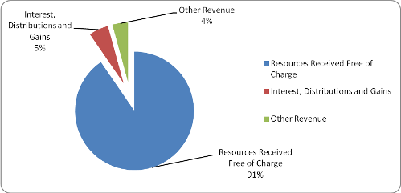

#### Comparison to Budget and 2013-14 Actual Own Source Revenue

The Office's Actual Own Source Revenue for 2013-14 was $0.130m less than the budgeted amount. This was almost entirely due to a lower-than-anticipated legislative drafting activity.

The reduction in Actual Own Source Revenue between 2012-13 and 2013-14 ($0.187m) is also related to a reduction in both legislative drafting and legal services between the two reporting periods.

### Controlled Financial Position

#### Total Assets

The value of the Office's Total Assets at 30 June 2014 was $2.961m. The composition and proportions of this total amount are shown in the following table and chart.

| Current Asset category | Value$m |
| --- | --- |
| Cash and cash equivalents | 0.031 |
| Receivables | 0.041 |
| Investments | 1.195 |
| Other Assets | 0.006 |

| Non-Current Asset category | Value$m |
| --- | --- |
| Property, Plant and Equipment | 1.636 |
| Intangible Assets | 0.052 |
| TOTAL | 2.961 |



As the above chart shows, the two main components of the Office’s assets are Property, Plant and Equipment ($1.636m, or 55 per cent of Total Assets) and Investments ($1.195m, or 40 per cent of Total Assets).

#### Property, Plant and Equipment

The total value and proportion of the Office’s Property, Plant and Equipment at 30 June 2014 is shown in the table and chart below.

| Motor Vehicles under a Finance Lease $m | Equipment $m | Furniture and Fittings $m | Library Collection $m | Artwork & Other Collectables $m |
| --- | --- | --- | --- | --- |
| 0.025 | 0.194 | 0.263 | 0.549 | 0.605 |



#### Cash, Cash Equivalents and Investments

The total value and proportion of the Office’s Cash, Cash Equivalents, and Investments at

30 June 2014 is shown in the following table and chart.

| Cash at Bank and Cash on Hand $m | Investments $m |
| --- | --- |
| 0.031 | 1.195 |

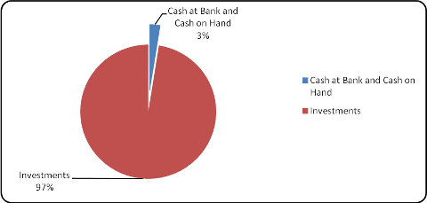

#### Comparison to Budget

The following table and chart show the composition and proportion of the Office’s Total Asset position as at 30 June 2014 compared to the 2013-14 Budget and as at 30 June 2013.

| Current Asset category | Actual  30 June 2014$m | Original Budget  30 June 2014 $m | Actual  30 June 2013 $m |
| --- | --- | --- | --- |
| Cash and cash equivalents | 0.031 | 0.062 | 0.051 |
| Receivables | 0.041 | 0.064 | 0.061 |
| Investments | 1.195 | 0.510 | 0.701 |
| Other Assets | 0.006 | 0 | 0.002 |

|  |  |  |  |
| --- | --- | --- | --- |
| Non-Current Asset category | Actual 30 June 2014$m | Original Budget 30 June 2014 $m | Actual  30 June 2013 $m |
| Property, Plant and Equipment | 1.636 | 1.365 | 1.407 |
| Intangible Assets | 0.052 | 0 | 0.046 |
| Closing Work in Progress | 0 | 0 | 0.013 |
| Total Assets | 2.961 | 2.001 | 2.281 |

The Total Asset position of $2.961m at 30 June 2014 was $0.960m higher than the 2014 budgeted amount. This was mainly due to:

* the higher-than-budgeted investment balance; and
* the asset revaluation that was performed in 2013-14, resulting in a larger value being   
  attributed to Property Plant and Equipment.

#### Comparison to 30 June 2013 Actual

The increase of $0.68m from the 30 June 2013 Total Asset Value was mainly due to the increased investment balance and the asset revaluation (discussed above).

#### Future trends

The Office will continue to adopt a strategy of increasing its financial assets to offset employee benefit liabilities into the future.

#### Total Liabilities

The following table shows the composition of the Office's Total Liabilities as at 30 June 2014, compared to the 2013-14 Budget and as at 30 June 2013.

| Liability category | Actual 30 June 2014 $m | Original Budget 30 June 2014 $m | Actual  30 June 2013 $m |
| --- | --- | --- | --- |
| Current - Payables | 0.520 | 0.331 | 0.299 |
| Current - Finance Leases | 0.024 | 0.012 | 0.009 |
| Current - Employee Benefits | 1.551 | 1.519 | 1.466 |
| Current Other Liabilities | 0.103 | 0.71 | 0.071 |
| Non-Current - Finance Leases | 0 | 0.23 | 0.024 |
| Non-Current Employee Benefits | 0.125 | 0.193 | 0.084 |
| Total Liabilities | 2.323 | 2.149 | 1.953 |



The value of current and non-current employee benefits at 30 June 2014 totalled $1.676m and accounted for 72 per cent of Total Liabilities at that date. The probability that each staff member's leave entitlements will be paid out in the event that they resign or retire, and results in a high proportion of benefits being classified as current. In practice, the likelihood that all staff would leave the organisation over the next 12 months is low. However, as noted above, the Office will continue to make greater provision for current employee benefits liabilities in the out-years by way of increasing the Office’s financial asset position.

#### Comparison to Budget

The Total Liabilities recorded by the Office in 2013-14 were $0.174m greater than 2013-14 Budget. This largely arose due to a lower-than-expected use of leave entitlements during the period.

#### Comparison to 2012-13 Actual

The Office recorded a $0.370m increase in Total Liabilities compared with 2012-13. This is mainly due to an increase in leave liabilities associated with decreased use of leave entitlements throughout the period.

### Territorial Statement of Income and Expenses

#### Total Income

Territorial income is almost entirely in the form of a Payment for Expenses on Behalf of the Territory to meet the cost of salaries and related employment entitlements for non executive MLAs and their staff.

The payment for Expenses on Behalf of the Territory was $5.410m in 2013-14, which was $0.334m (6 per cent), more than originally budgeted.

The decrease was mainly due to a reduction in employee expenses for the reporting period resulting from lower than anticipated vehicle lease expenses for the non-executive members motor vehicles and wages and salaries.

Total Income for the Territorial Entity was $5.791m, which was $0.392m less than originally budgeted.

#### Total Expenditure

Total Territorial expenditure for 2013-14 was $6.311m.

Comparison to 2013-14 Budget

Total expenditure was $0.722m less than budgeted. This lower-than-budgeted expenditure is largely due to the following factors:

* lower-than-anticipated staffing in members’ offices;
* lower-than-anticipated superannuation expenses ($0.161m) due to a reduction in the number of employees who were entitled to be members of a defined benefit scheme, and a corresponding increase in the number of employees in lower rate fund-of-choice schemes; and
* a reduction ($0.239m) in the Vehicle Lease Expenses incurred due to a reduction in the number of members electing to use their entitlement to a fully maintained vehicle and instead opting to receive an in lieu payment.

#### Comparison to 2012-13 Actual Expenditure

The total expenditure of $6.311m in 2013-14 was $0.390m less (5.8 per cent) than for the previous financial year ($6.701m).

The components of Total Territorial Expenditure for 2013-14 are set out in the table and illustrated in the chart below.

| Employee Expenses $m | Superannuation Expenses $m | Supplies and Services $m | Depreciation $m | Borrowing Costs and Other Expenses $m | TOTAL $m |
| --- | --- | --- | --- | --- | --- |
| 4.633 | 0.568 | 0.531 | 0.556 | 0.022 | 6.311 |

#### Breakdown of Total Expenditure 2013-14



### Territorial Financial Position

#### Total Assets

The value of the Office's Territorial Total Assets at 30 June 2014 was $31.058m. The composition and proportions of this total amount are shown in the following table and chart.

| Asset category | Value $m |
| --- | --- |
| Current Cash and cash equivalents | 0.254 |
| Current Receivables | 0.014 |
| Non-Current Property, Plant and Equipment | 30.790 |
| TOTAL | 31.058 |

The Total Asset position of $31.058m at 30 June 2014 was $2.939m higher than the 2014 budgeted amount. This was mainly due to:

* the asset revaluation that was performed in 2013-14, resulting in a larger value being attributed to Property Plant and Equipment.

#### Comparison to 30 June 2013 Actual

The increase of $2.368m from the 30 June 2013 Total Asset Value was mainly due to the increased asset revaluation (discussed above).

#### Future trends

It is anticipated that there will be additional costs incurred by the Office’s Territorial Entity in the event that the Assembly’s membership is enlarged to 25 in 2016.

#### Total Liabilities

The following table shows the composition of the Office's Territorial Total Liabilities as at

30 June 2014, compared to the 2013-14 Budget and as at 30 June 2013.

| **Liability category** | **Actual**  **30 June 2014** **$m** | Original Budget 30 June 2014 $m | Actual 30 June 2013 $m |
| --- | --- | --- | --- |
| Current Payables | 0.096 | 0.071 | 0.070 |
| Current Finance Leases | 0.124 | 0.157 | 0.079 |
| Current Employee Benefits | 0.389 | 0.475 | 0.308 |
| Non-Current Finance Leases | 0.109 | 0.139 | 0.087 |
| Non-Current Employee Benefits | 0 | 0.002 | 0.002 |
| Total Liabilities | 0.719 | 0.844 | 0.546 |

The value of current and non-current employee benefits at 30 June 2014 totalled $0.389m and accounted for 54 per cent of Total Liabilities at that date. Each staff member’s leave entitlements are classified as current.

#### Comparison to Budget

The Total Liabilities recorded by the Office in 2013-14 were $0.125m lower than 2013-14 Budget. This largely arose due to a higher-than-expected use of leave entitlements during the period and a lower-than-anticipated number of members opting to use their entitlement for a fully maintained motor vehicle under a finance lease.

#### Comparison to 2012-13 Actual

The Office recorded a $0.173m increase in Total Liabilities compared with 2012-13. This is mainly due to an increase in motor vehicles under a finance lease. A greater number of members opted to use their entitlement to a fully maintained motor vehicle at the end of the reporting period in lieu of a cash allowance.

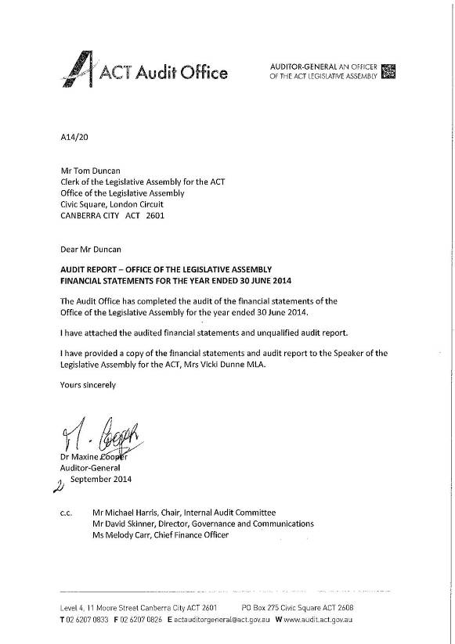

## 

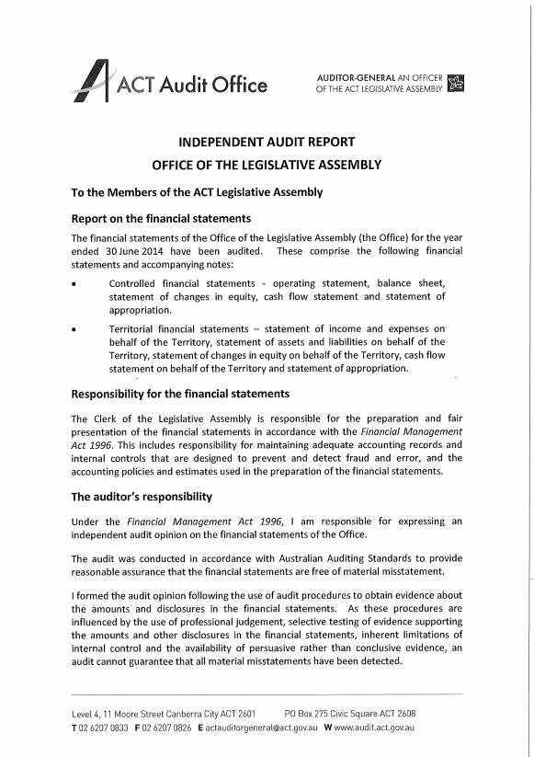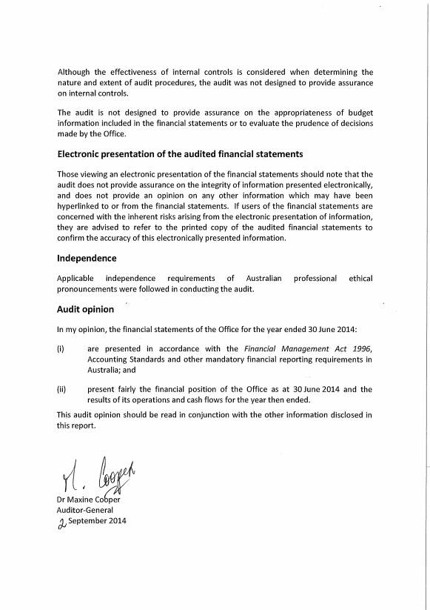

## Office of the Legislative Assembly

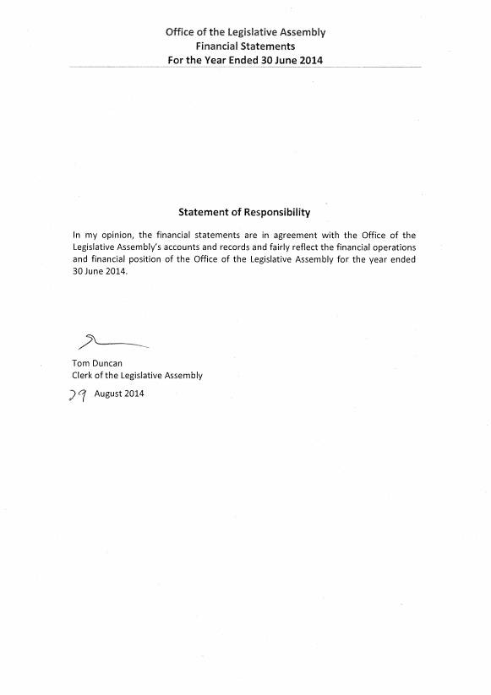

CONTROLLED FINANCIAL STATEMENTS

FOR THE YEAR ENDED 30 JUNE 2014

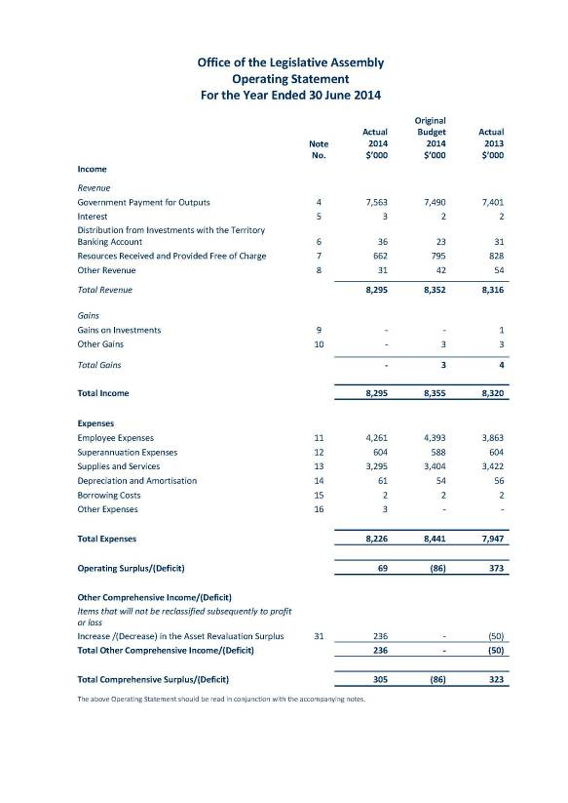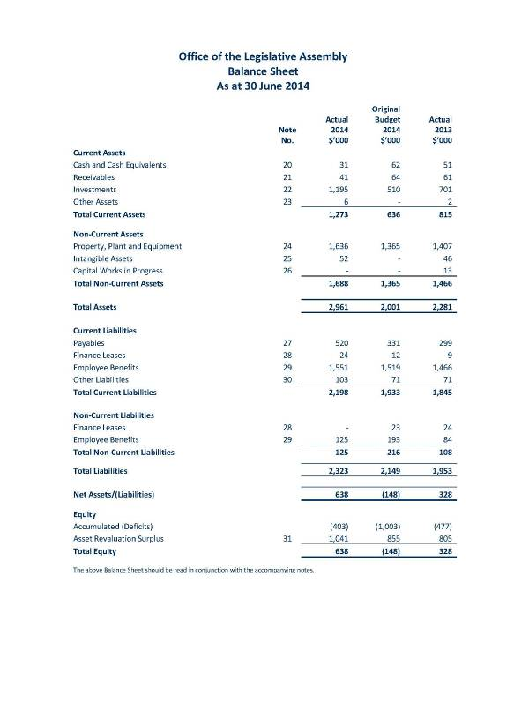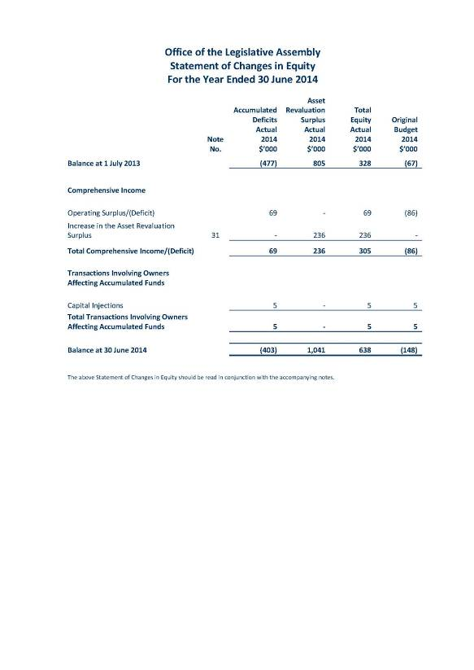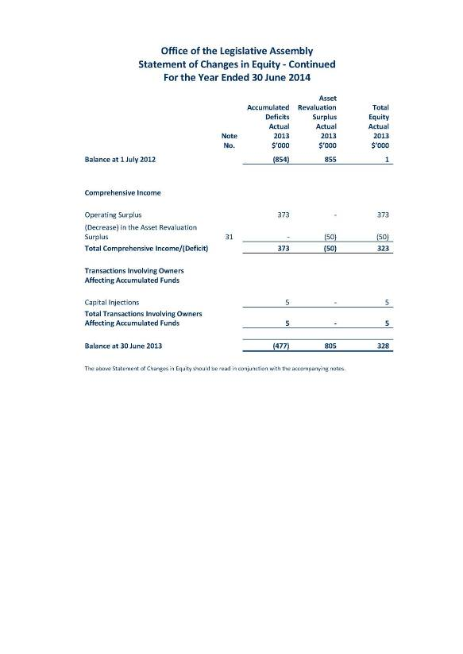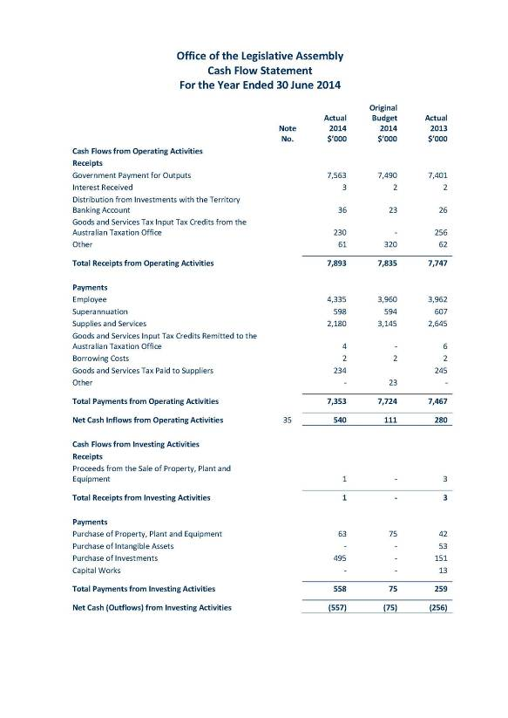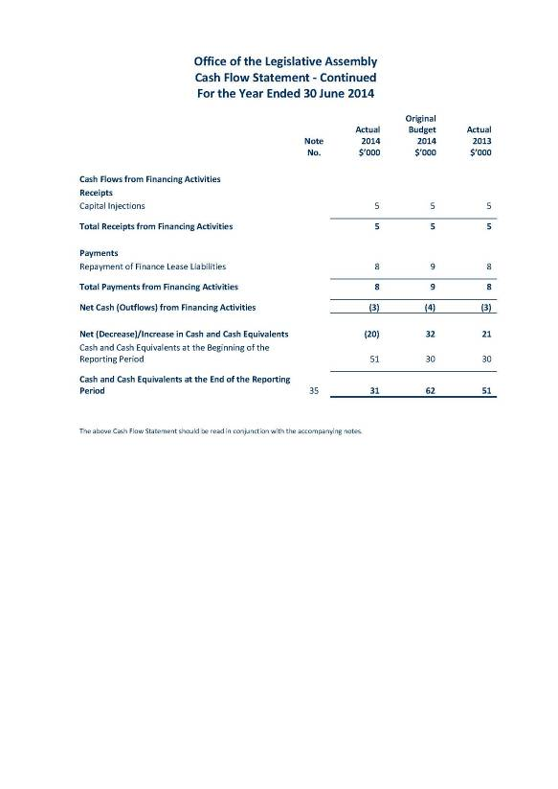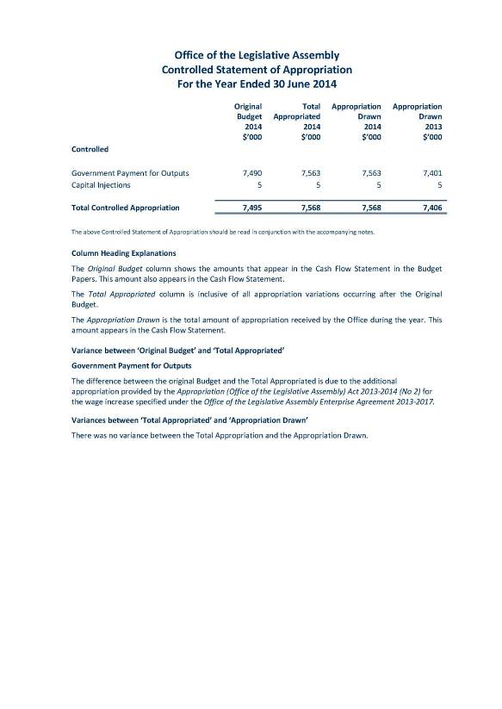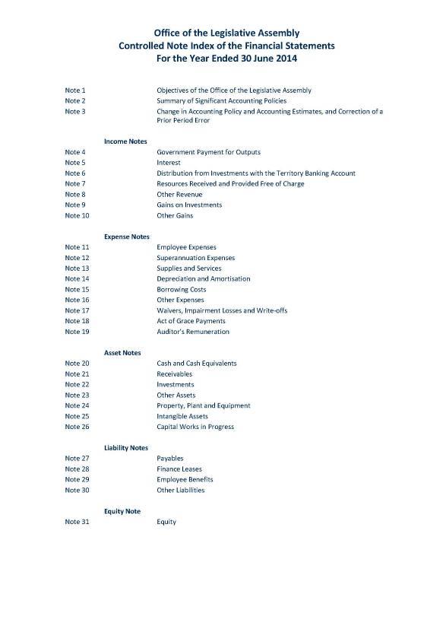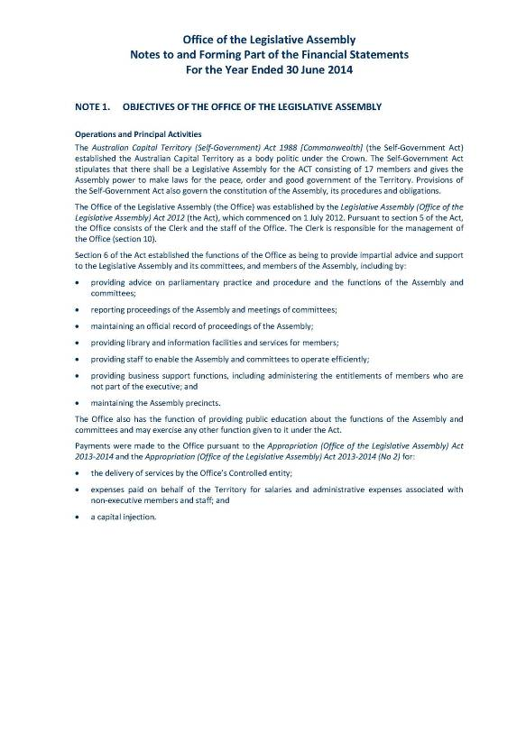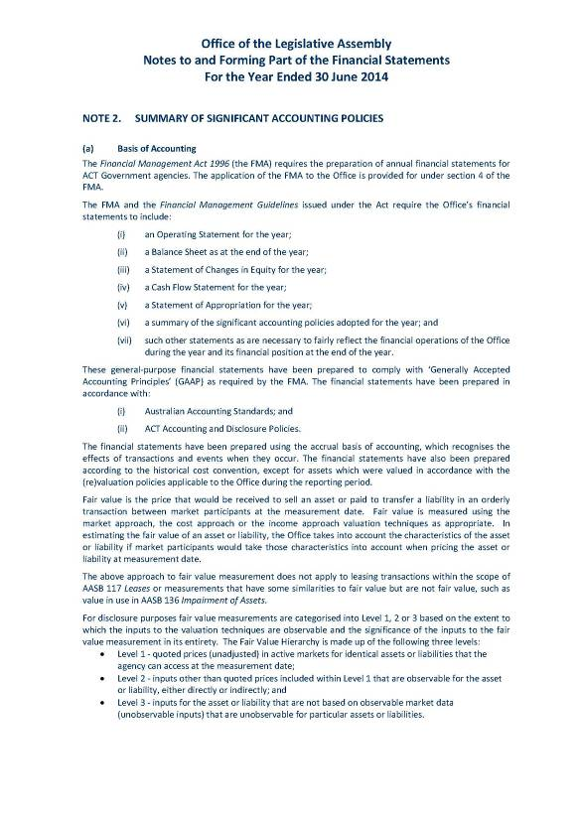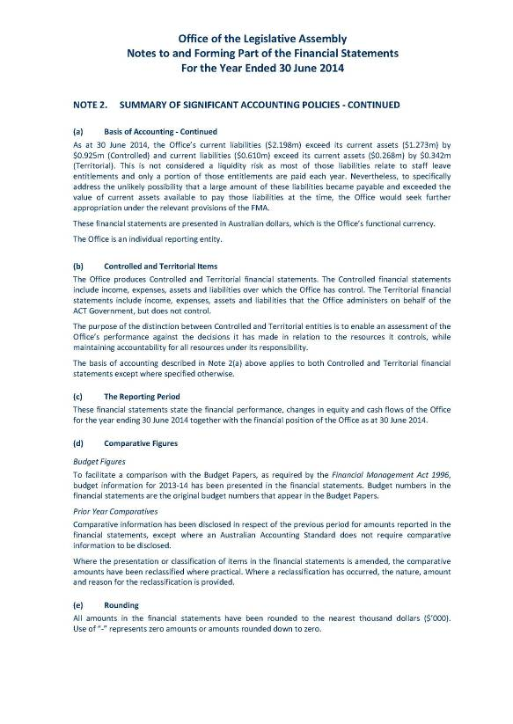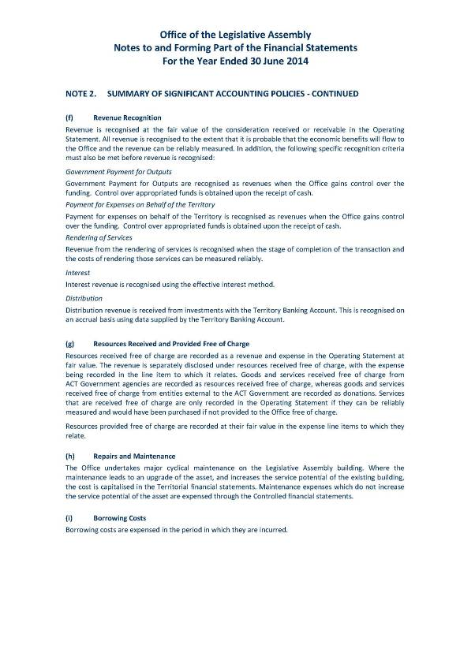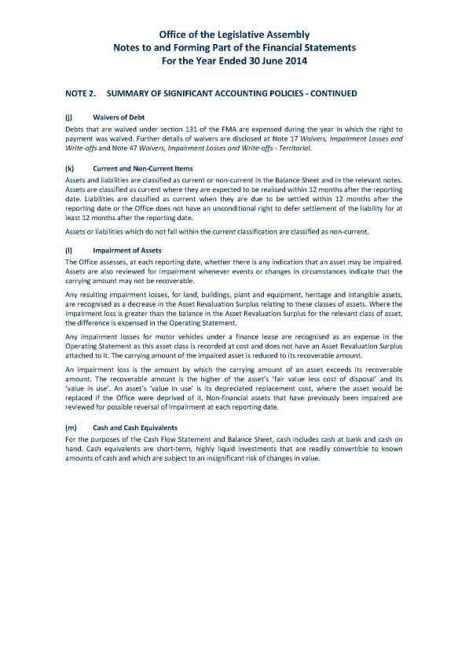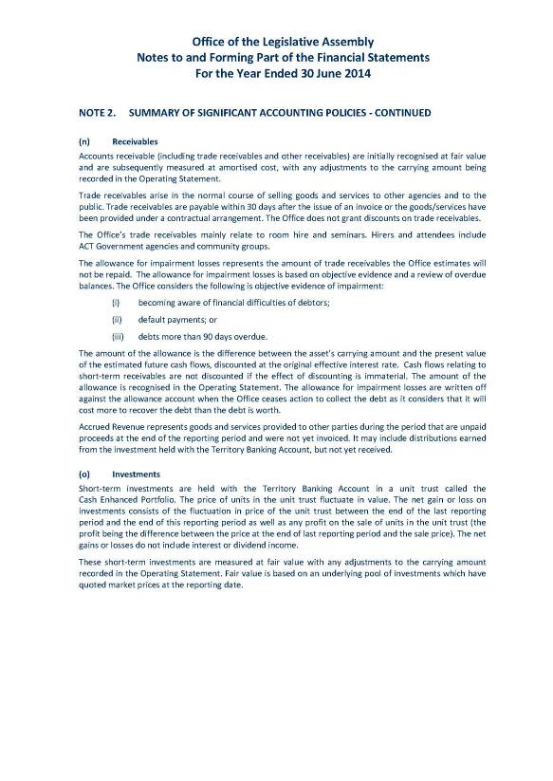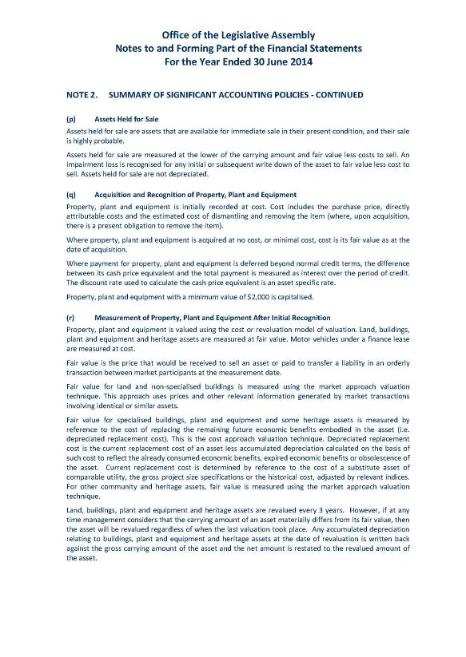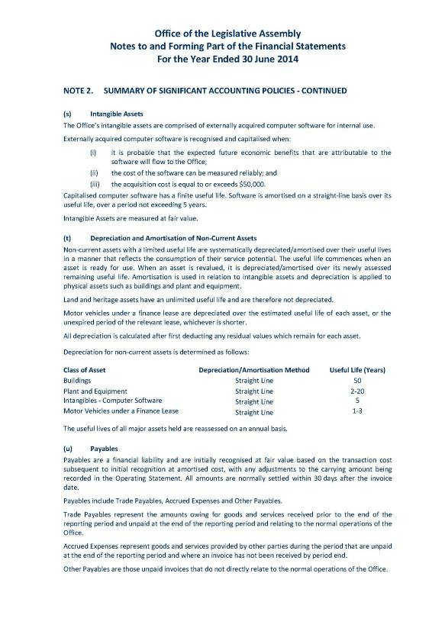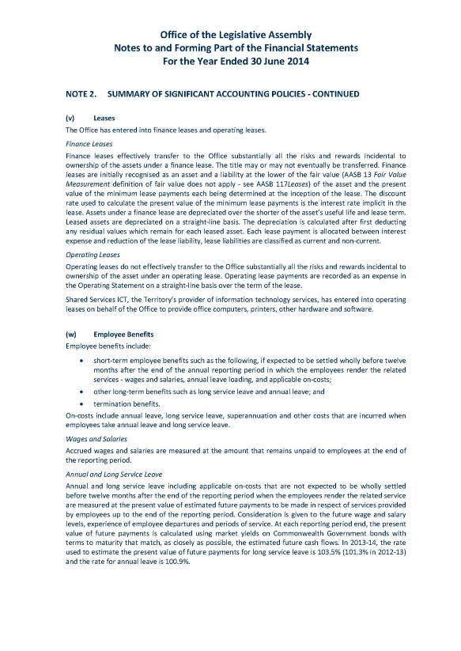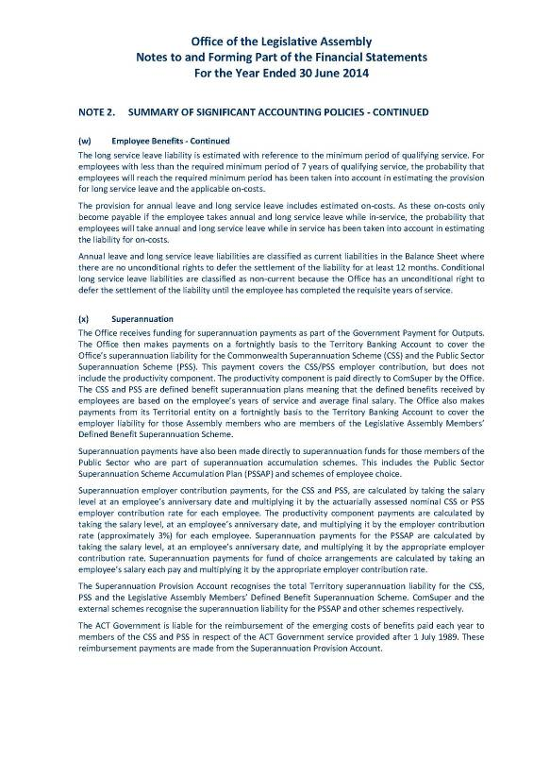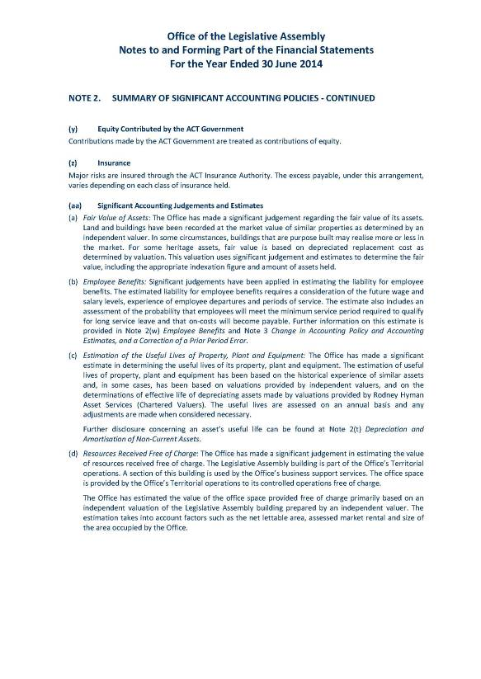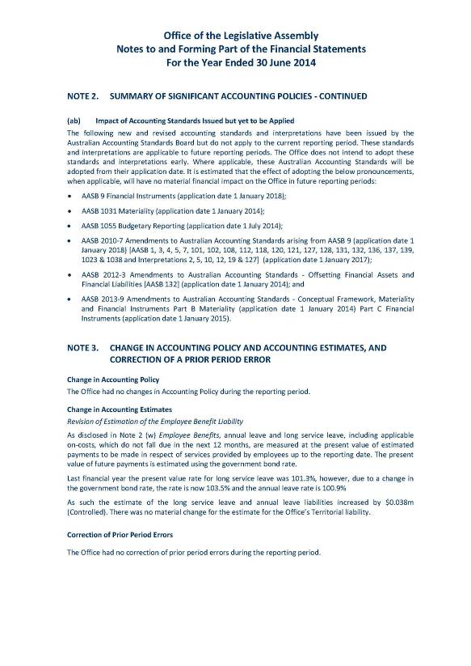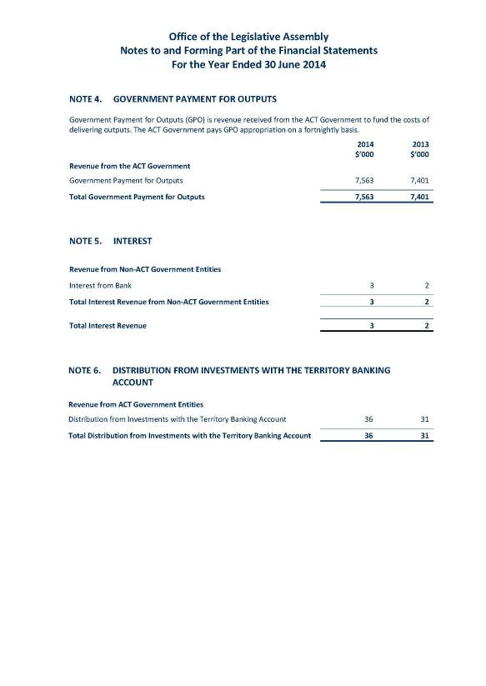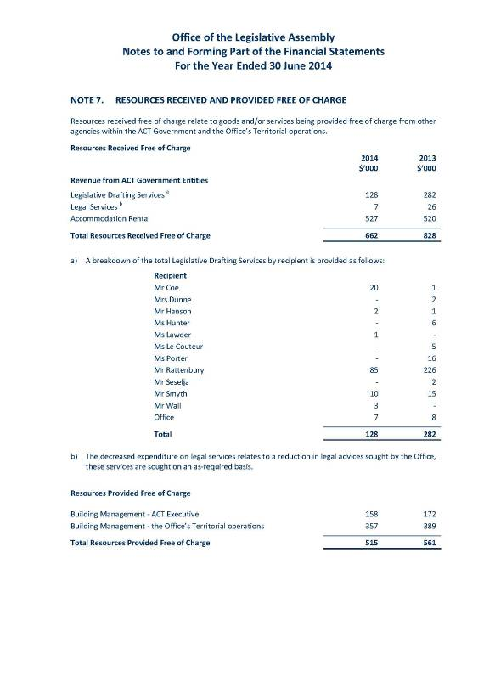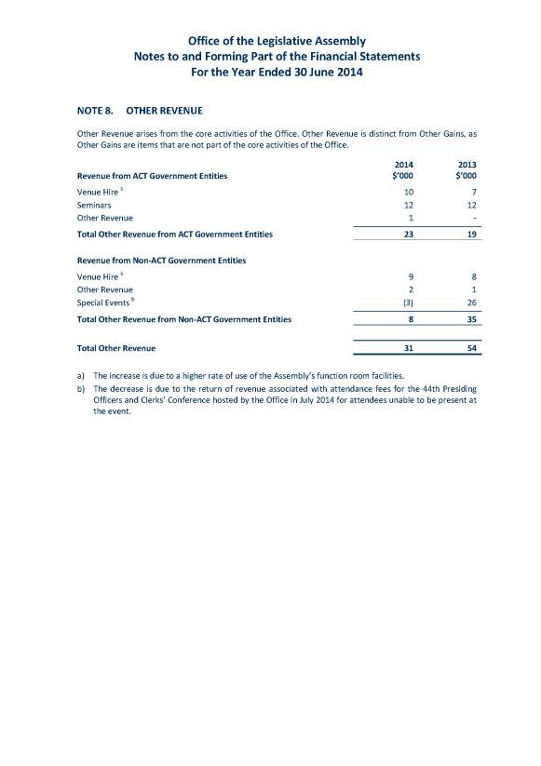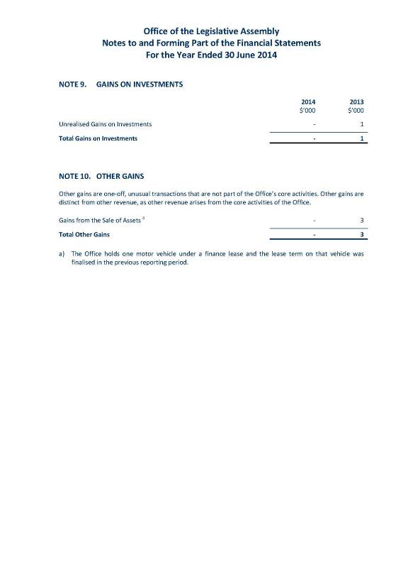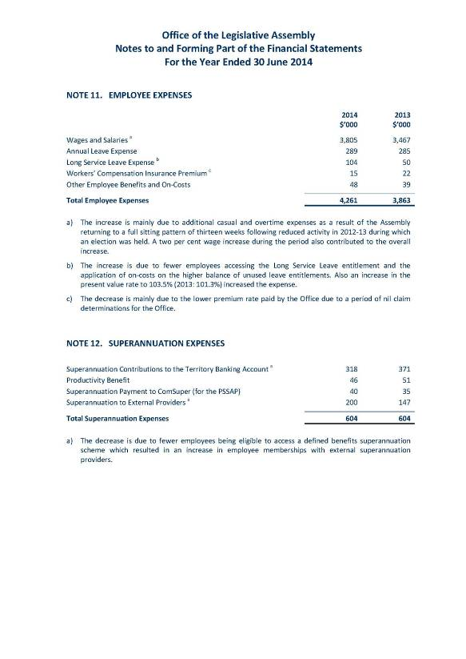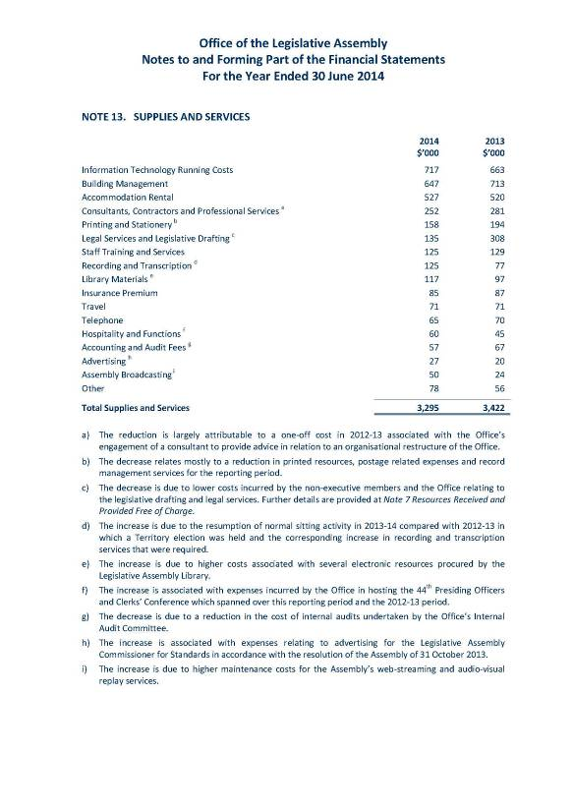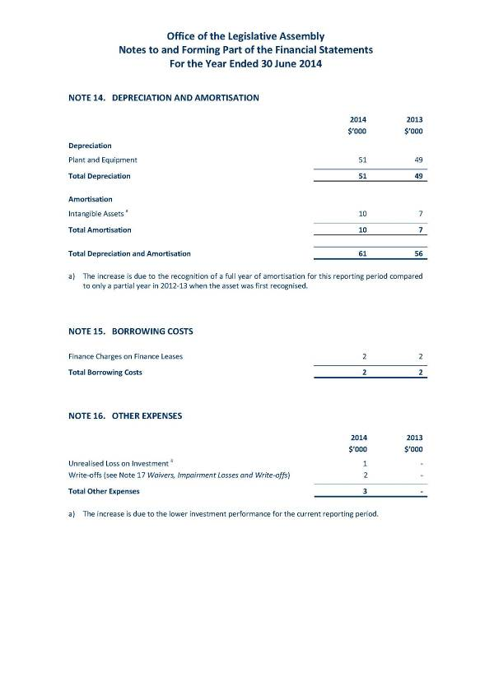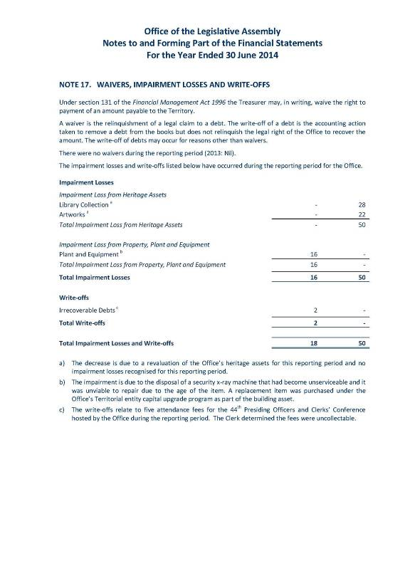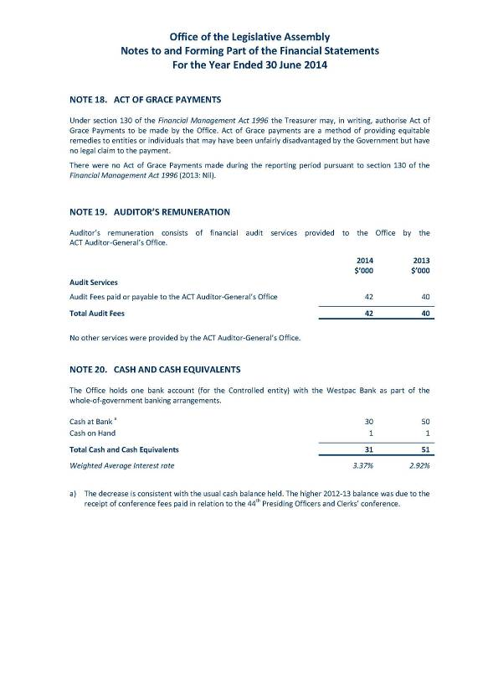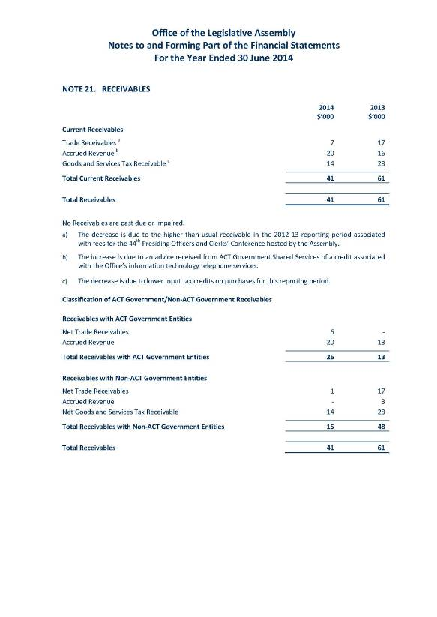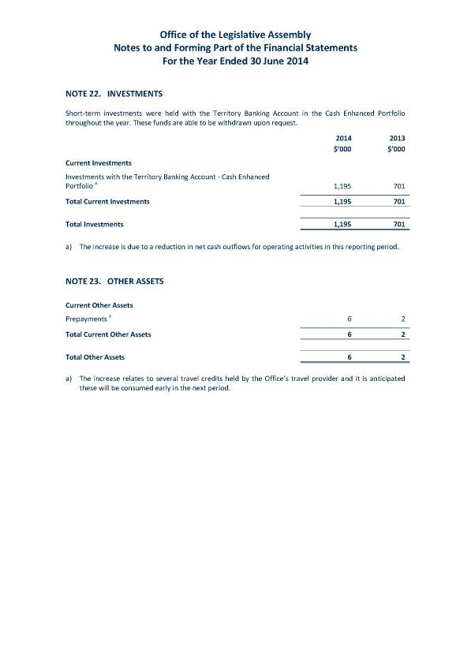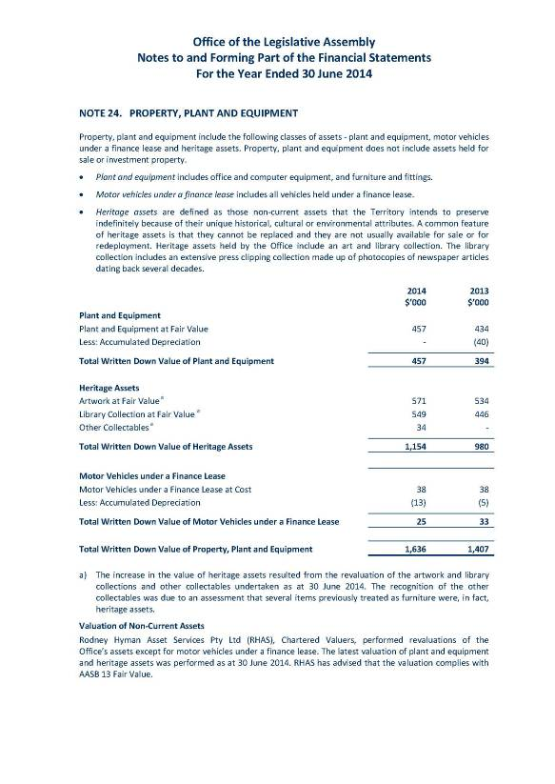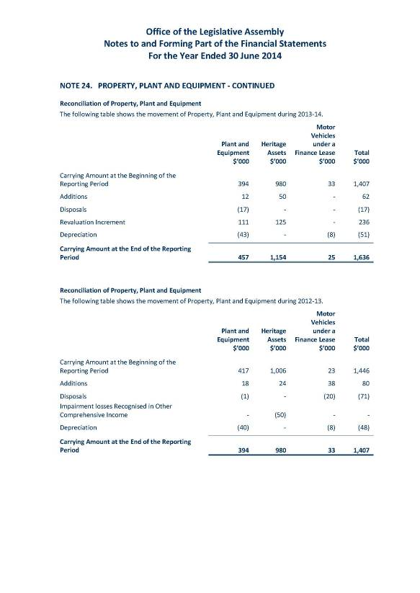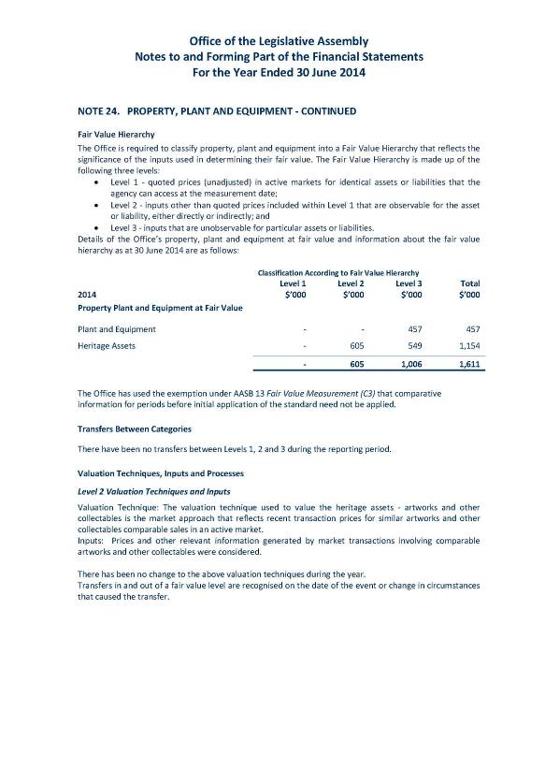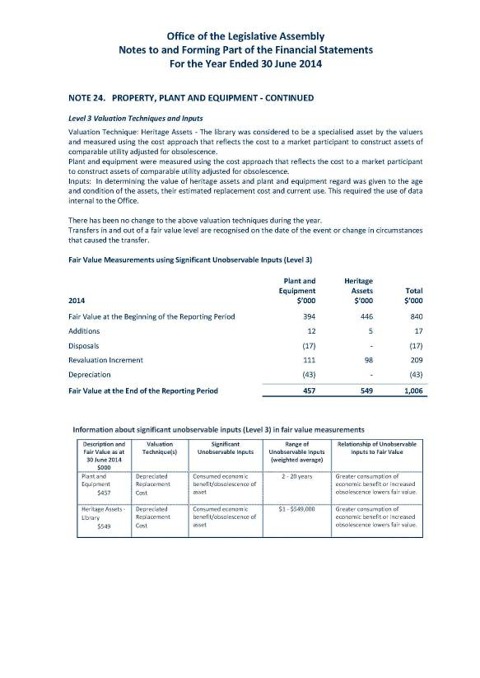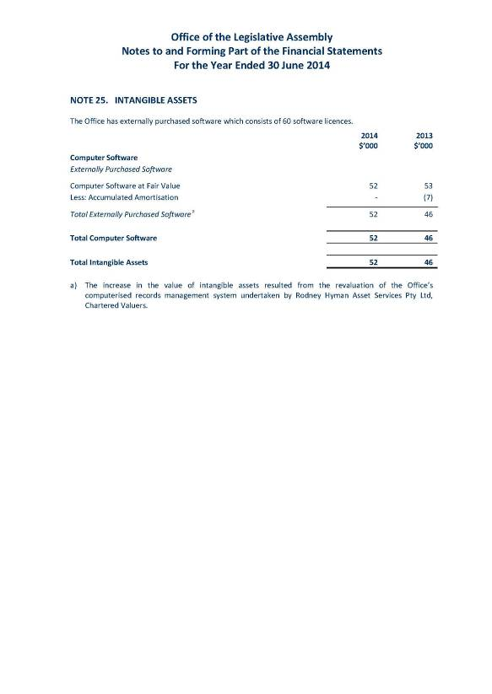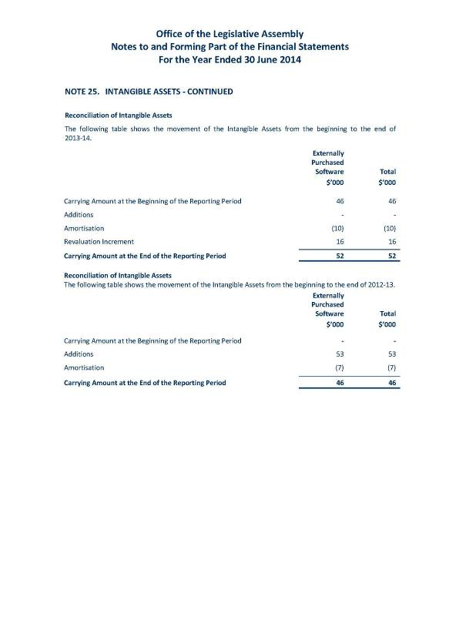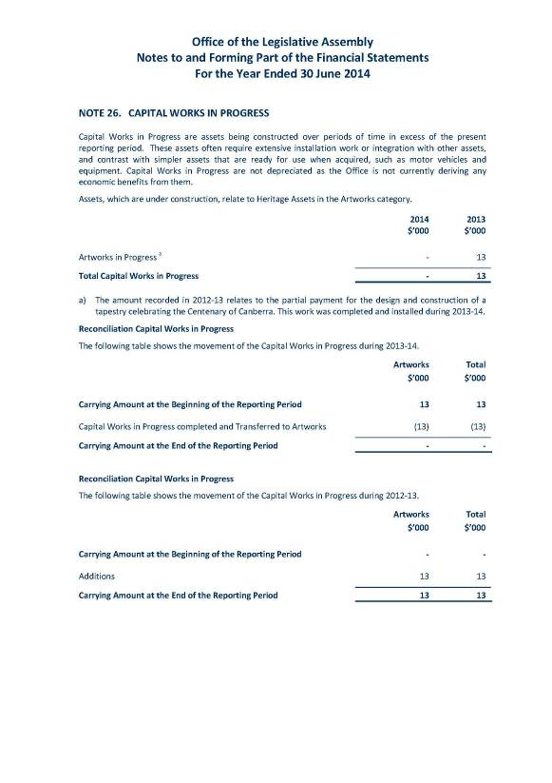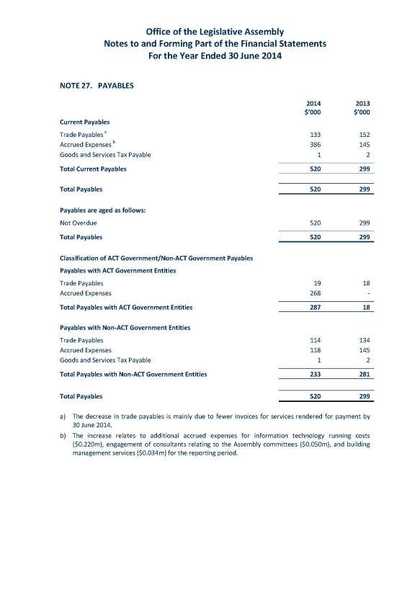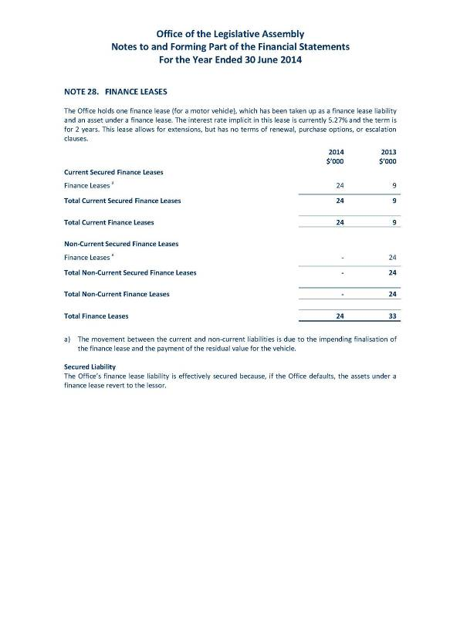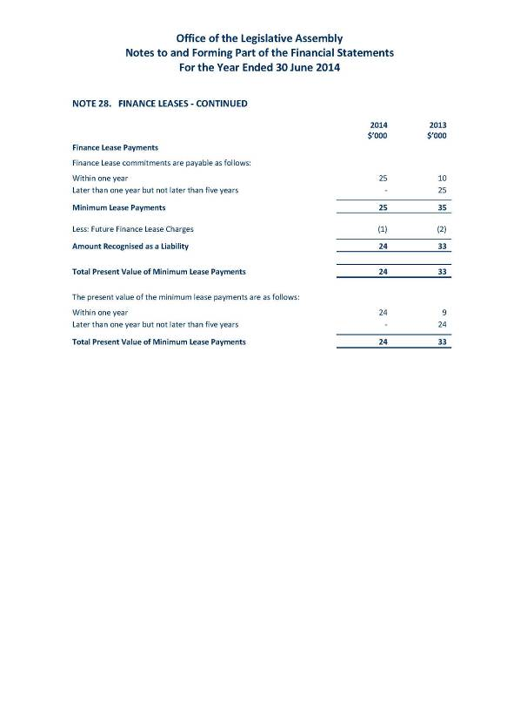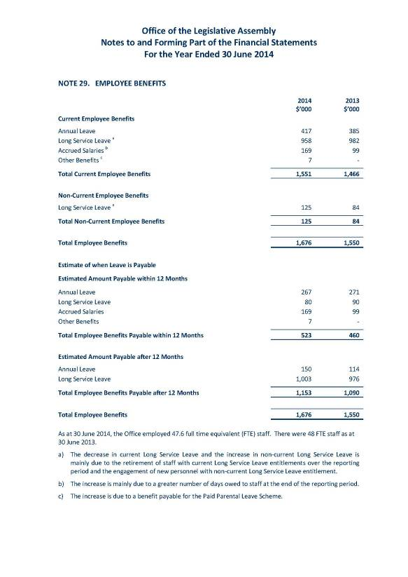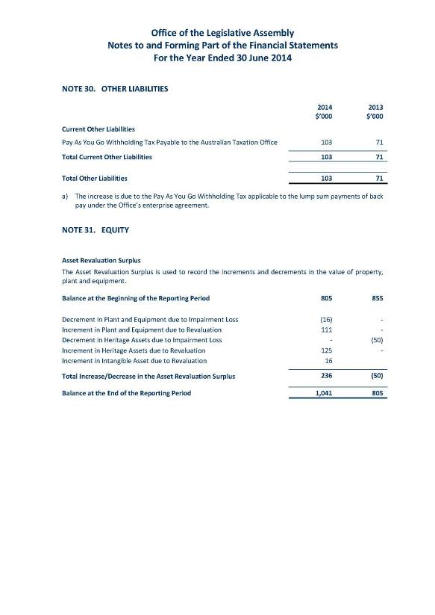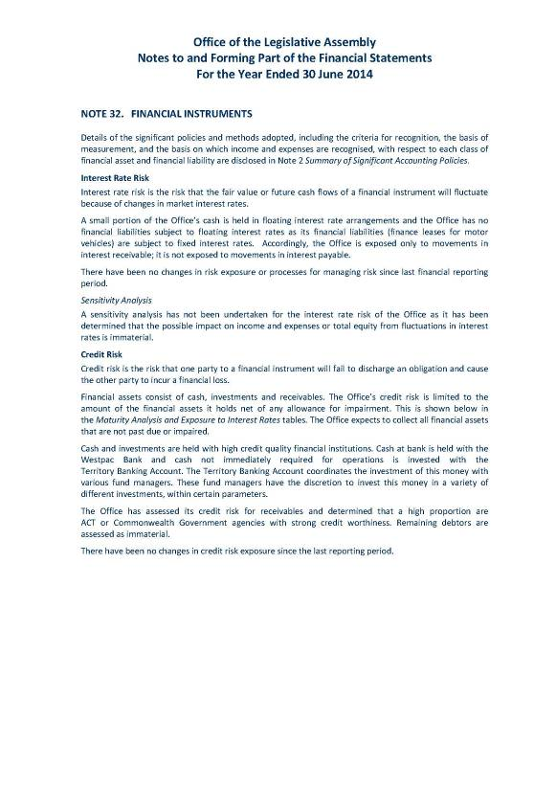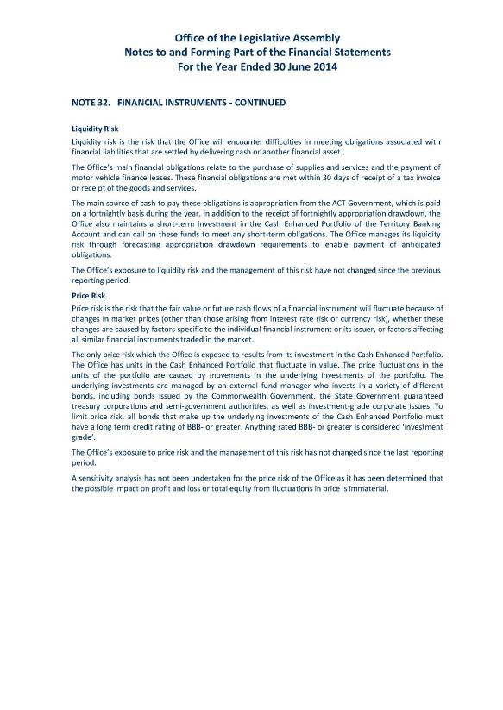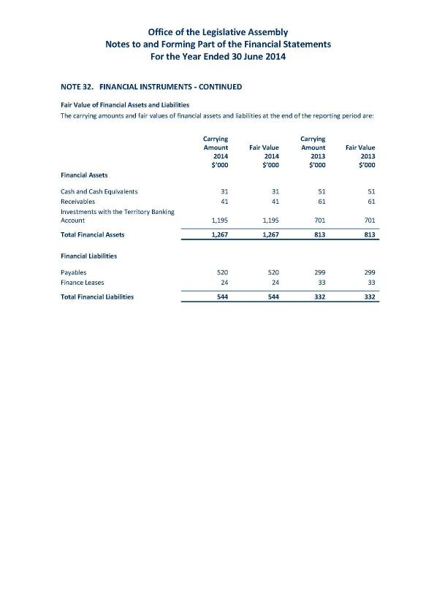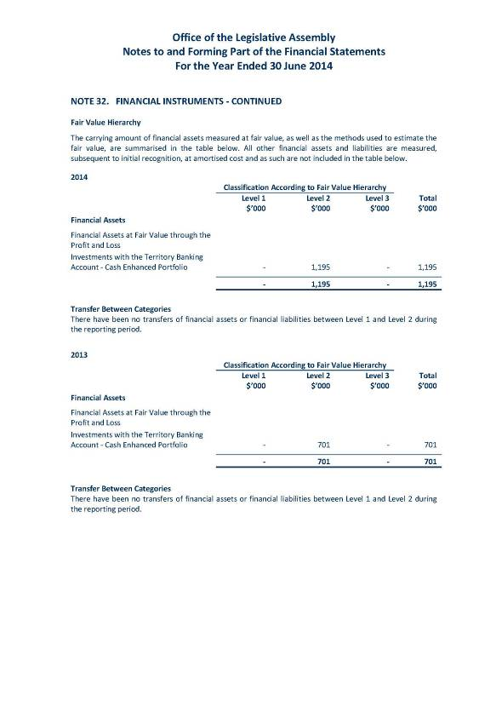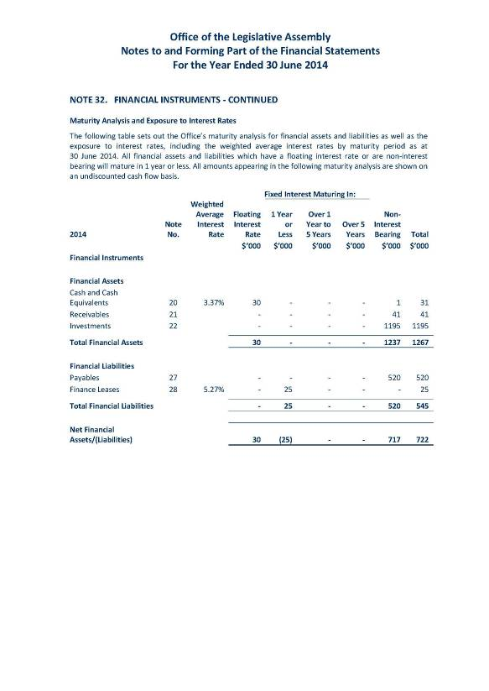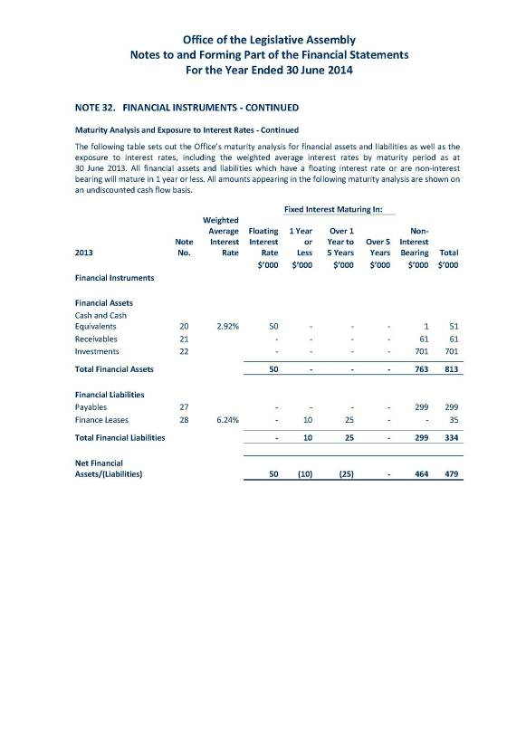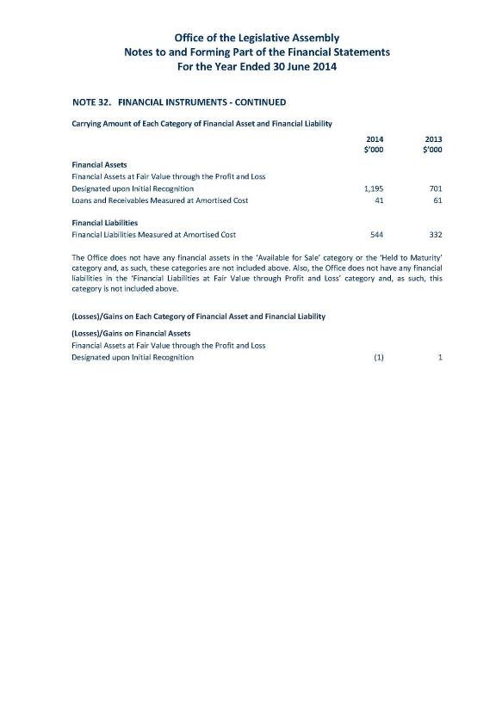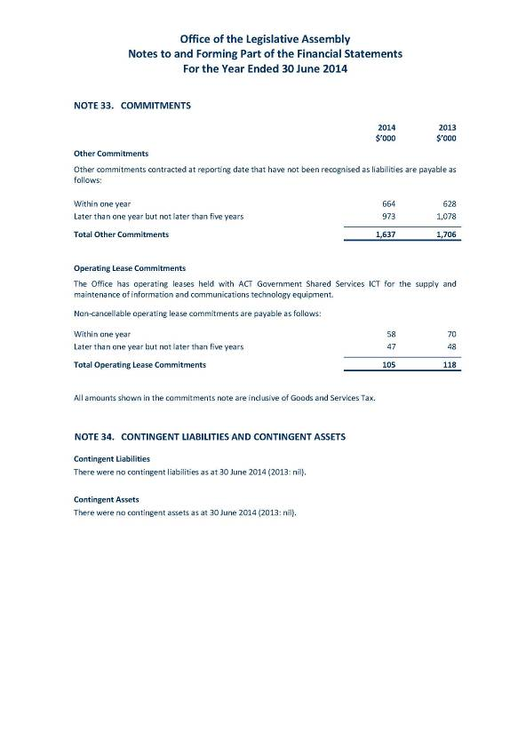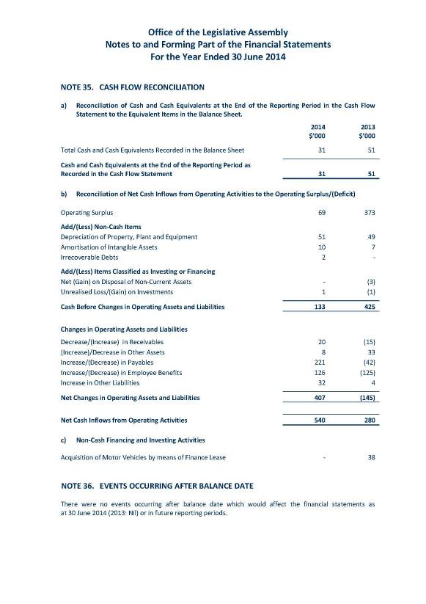

## Office of the Legislative Assembly



territorial FINANCIAL STATEMENTS

FOR THE YEAR ENDED 30 JUNE 2014

