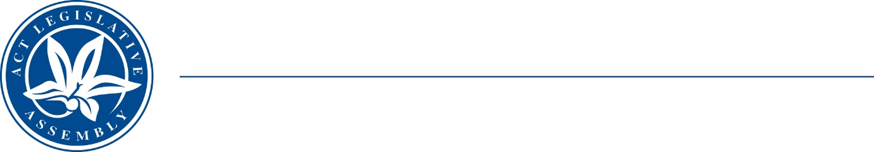
Standing Committee on Public Accounts
Mrs Elizabeth Kikkert MLA (Chair), Mr Michael Pettersson MLA (Deputy Chair),
Mr Andrew Braddock MLA

LEGISLATIVE ASSEMBLY
FOR THE AUSTRALIAN CAPITAL TERRITORY

TERMS OF REFERENCE

Inquiry into responses to Auditor-General Performance Reports July – December 2022
The Standing Committee on Public Accounts will inquire into and report on matters relating to the Government response to performance audit recommendations made in Auditor-General report:
- No 5/2022 – Procurement and contracting activities for the Acton Waterfront Project;
- No 7/2022 – ACT Childhood Healthy Eating and Active Living Programs; and
- No 9/2022 – ACT Emergency Services Agency Cleaning Services Arrangements; and
- any other related matter.

