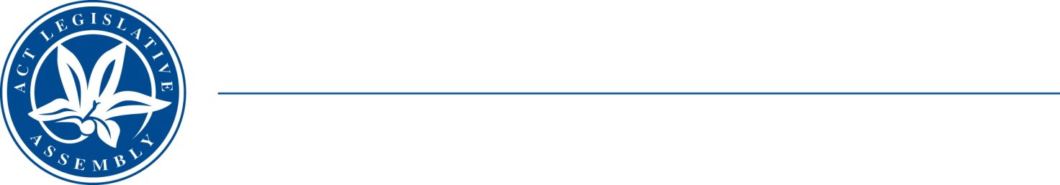
QoN No. 72
Committee Support
LEGISLATIVE ASSEMBLY
FOR THE AUSTRALIAN CAPITAL TERRITORY
Standing Committee on Health and Community Wellbeing

Inquiry into Annual and Financial Reports 2021-2022

ANSWER TO QUESTION ON NOTICE

Asked by MS ELIZABETH KIKKERT MLA on 10 November 2022:
Reference: Canberra Health Services Annual Report 2021‐2022, p31, first dot point
In relation to: Overdoses in the AMC

- Has Justice Health examined the feasibility of providing naloxone as part of release packs for detainees with a history of opioid use as recommended by the Inspector in his 2019 Healthy Prison Review?
- If not, why not?
- If so, what were the results of that study and was a report on options finalised by the end of 2020 as committed to by the government in their response to that report?
- How many overdoses occurred in the AMC during the following financial years:
- 2019-2020,
- 2020-2021,
- 2021-2022,
- 2022-present?
MINISTER EMMA DAVIDSON MLA: The answer to the Member’s question is as follows:
- Justice Health Services (JHS) provides naloxone as part of the release pack for all detainees who have been engaged in the Opioid Maintenance Treatment (OMT) program whilst at the AMC.
- ACTCS records show the following detainee overdoses occurred:
a. In 2019-2020, there were three (3) reported overdoses at the AMC.
b. In 2020-2021, there were three (3) reported overdoses at the AMC
c. In 2021-2022, there were no reported overdoses.
d. In 2022 to present, there have been no reported overdoses.

Approved for circulation to the Standing Committee on Health and Community Wellbeing

Signature: Date:

By the Minister for Justice Health, Ms Emma Davidson MLA

