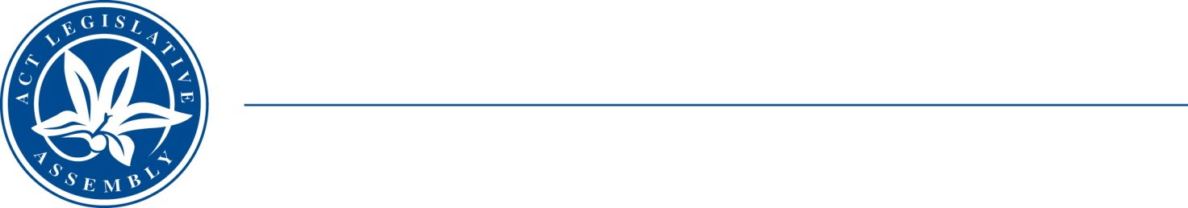
QToN No. 2
Committee Support
LEGISLATIVE ASSEMBLY
FOR THE AUSTRALIAN CAPITAL TERRITORY
Standing Committee on Health and Community Wellbeing

Inquiry into Annual and Financial Reports 2021-2022

ANSWER TO QUESTION TAKEN ON NOTICE

Asked by MR JAMES MILLIGAN MLA on 1 November 2022: MR DAVE PEFFER took on notice the following question(s):

Reference: Hansard uncorrected proof transcript 1 November 2022 Page 9

In relation to:

Cost of Executive Risk Management Training

MINISTER STEPHEN-SMITH MLA: The answer to the Member’s question is as follows:–

- A risk management workshop for executives was held in May 2022 at a cost of $3,061 plus GST, supported by the ACT Insurance Authority (ACTIA).
- ACTIA risk management eLearning is also available to all CHS team members. There is no cost associated with provision of this training.
- Face to face risk education sessions are conducted for CHS Executives and divisions as requested. These are provided within existing CHS resources.

Approved for circulation to the Standing Committee on Health and Community Wellbeing

Signature: Date:

By the Minister for Health, Ms Rachel Stephen-Smith MLA

