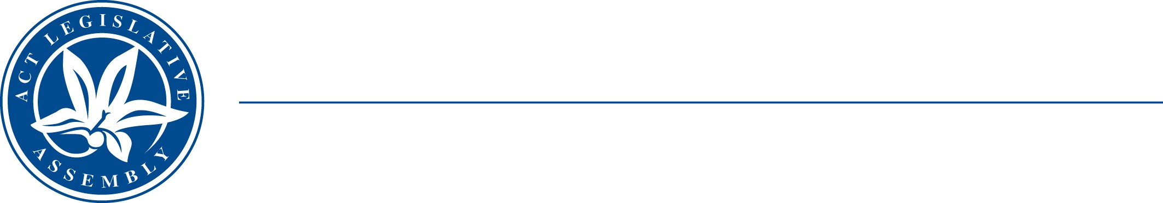
LEGISLATIVE ASSEMBLY
FOR THE AUSTRALIAN CAPITAL TERRITORY

STANDING COMMITTEE ON EDUCATION AND COMMUNITY INCLUSION
Michael Pettersson MLA (Chair), Johnathan Davis MLA (Deputy Chair), Nicole Lawder MLA

MEDIA RELEASE

INQUIRY INTO ACCESS TO SERVICES AND INFORMATON IN AUSLAN
The Education and Community Inclusion Committee today announced an inquiry into access to services and information in Auslan. Auslan is the language of Australia’s Deaf community.
The inquiry will consider disadvantage and discrimination faced by members of the ACT Deaf community due to lack of access to services and information in Auslan. It will also consider options to improve access to services and information in Auslan across the public and private sectors, the creation of objectives and targets to measure improvements, and mechanisms to report against those indicators.
Full terms of reference are available on the Committee’s webpage: https://www.parliament.act.gov.au/parliamentary-business/in-committees/committees/eci/inquiry-into-access-to-services-and-information-in-auslan
The Chair of the Committee, Mr Pettersson MLA, said that “Deaf people face significant challenges every day due to lack services and information in accessible formats. We want the Deaf community to advise us on how the ACT Government can improve their quality of life.”
The Committee invites submissions addressing any or all aspects of the terms of reference. Submissions can be made in a variety of formats, including in writing and by video recording, and can be emailed to LACommitteeECI@parliament.act.gov.au.
Submissions to the inquiry opened on 31 May 2022 and close on Friday 15 July 2022.
The Committee appreciates the value of lived experience and wishes to ensure that the inquiry is as accessible as possible. Accordingly, the Committee proposes to engage Auslan interpreters for public hearings and other settings in which the Committee is taking oral evidence, and to invite submissions in a variety of formats.
Members of the Committee will be available to answer questions from the media from 12.00pm on 31 May 2022 at the ACT Legislative Assembly Reception Room, accompanied by an Auslan interpreter.
31 May 2022
STATEMENT ENDS.
For further information, please contact:
Committee Chair, Mr Michael Pettersson MLA, on (02) 6205 1436
Committee Secretary on (02) 6207 5498 or at LACommitteeECI@parliament.act.gov.au

