Inquiry into a Proposal for a Mammal Emblem for the ACT
Standing Committee on Environment and Transport and City Services
July 2018
Report 6

The Committee

Committee Membership

Current Members
- Ms Suzanne Orr MLA Chair
- Miss Candice Burch MLA Member from 15 February, and Deputy Chair from 28 February 2018
- Ms Tara Cheyne MLA Member
- Ms Nicole Lawder MLA Member (from 15 February 2018)

Previous Members
- Mr Steve Doszpot MLA Deputy Chair (until 25 November 2017)
- Mr Mark Parton MLA Member (until 15 February 2018)

Secretariat
- Andrew Sneddon Secretary (until 9 April 2018)
- Hamish Finlay Secretary (from 10 April 2018 until 8 May 2018)
- Brianna McGill Secretary (from 9 May 2018)
- Lydia Chung Administration

Contact Information
Telephone 02 6205 0134
Facsimile 02 6205 0432
Post GPO Box 1020, CANBERRA ACT 2601
Email committees@parliament.act.gov.au
Website www.parliament.act.gov.au

Resolution of appointment
The Legislative Assembly for the ACT agreed by resolution on 13 December 2016 to establish legislative and general purpose standing committees to inquire into and report on matters referred to them by the Assembly or matters that are considered by the committees to be of concern to the community, including:
A Standing Committee on Environment and Transport and City Services to examine matters related to city and transport services, public infrastructure, heritage, and sport and recreation and matters related to all aspects of climate change policy and programs, water and energy policy and programs, provision of water and energy services, conservation, environment and ecological sustainability.

Terms of reference
The Legislative Assembly for the ACT passed the following resolution on 30 November 2017 referring the Inquiry into a Proposal for a Mammal Emblem for the ACT to the Standing Committee on Environment and Transport and City Services:
That this Assembly:
(1) notes:
(a) that the current emblems for the ACT are the floral emblem, the Wahlenbergia gloriosa (Royal Bluebell) adopted in 1982 and the faunal emblem, Callocephalon fimbriatum (Gang-gang Cockatoo) adopted in 1997;
(b) that all other Australian States and Territories have a mammal emblem, distinct from their bird emblem;
(c) that Tasmania was the last State or Territory to adopt a mammal emblem, with the Tasmanian Devil formally proclaimed in May 2015;
(d) that other emblems adopted by other States and Territories are the Southern Hairy-Nosed Wombat (South Australia), Numbat (Western Australia), Red Kangaroo (Northern Territory), Koala (Queensland), Platypus (New South Wales) and the Leadbeater’s Possum (Victoria); and
(e) that there has been an increase in local interest of the fact that the ACT does not have a mammal emblem;
(2) further notes that the ACT Government does not place legislative requirements around the use of the existing faunal and floral emblems, meaning they can be used by anyone on publications, uniforms or websites; and
(3) resolves that the Standing Committee on Environment and Transport and City Services shall report back to the Assembly on whether the ACT should have a mammal emblem and a recommendation on what that should be by September 2018.

Table of Contents
The Committee i
Committee Membership i
Secretariat i
Contact Information i
Resolution of appointment ii
Terms of reference ii
Recommendations vi
1. Introduction 1
Conduct of the Inquiry 1
2 Current ACT Emblems 4
Floral Emblem: Royal Bluebell 4
Faunal (Bird) Emblem: Gang-gang Cockatoo 5
3 Whether the ACT should have a Mammal Emblem 7
Mammal emblems in other Australian jurisdictions 7
All submissions support the idea of a mammal emblem 7
Suggested criteria for selecting a mammal emblem 7
Committee comment 12
4 What the ACT Mammal Emblem should be 13
Animals Nominated in Submissions 13
Shortlisting candidates for mammal emblem 13
ACT community participation in the decision via an online survey 18
Committee comment 23
5 Other Emblems and Imagery for the ACT 26
ACT Coat of Arms 26
Territory Flag 28
Other Emblems 29
Committee Comment 29
Appendix A – Submissions 31
Appendix B – Site Visits 33
Mulligans Flat Woodland Sanctuary 33
Tidbinbilla Nature Reserve 33
Appendix C – Online Survey 35
Survey Questions 35
Promotion of the Survey 36
Survey Results 37

Recommendations
Recommendation 1
3.26 The Committee recommends that the ACT Legislative Assembly adopt a mammal emblem for the Australian Capital Territory.
Recommendation 2
4.48 The Committee recommends that, given the extremely close result of the public survey, the ACT Legislative Assembly consider the possibility of granting mammal emblem status jointly to the Southern Brush-tailed Rock-wallaby and the Eastern Bettong.
4.49 If two mammal emblems are not considered an appropriate option, the Committee recommends the ACT Legislative Assembly consider adopting the Southern Brush-tailed Rock-wallaby as the mammal emblem for the ACT.
Recommendation 3
5.7 The Committee recommends that the ACT Government notes the potential for the adoption of a mammal emblem to lead to the design of a Coat of Arms for the ACT, and the possible redesign of the ACT flag.

Introduction
          - The Standing Committee on Environment and Transport and City Services (Committee) was asked by resolution passed in the Legislative Assembly for the ACT (Legislative Assembly) on 30 November 2017 to inquire and report on a Proposal for a Mammal Emblem for the ACT.

Conduct of the Inquiry

Submissions
          - The Committee called for public submissions to be lodged with the Committee by 23 March 2018. This opportunity was publicised through media releases, notice in The Canberra Times, notice on the Committee website, mainstream media coverage, and social media.
          - The Committee wrote by email to individuals, groups and organisations it considered likely to be interested in the inquiry. It also developed an information pack which was distributed to all ACT schools to enable teachers and students to participate in the inquiry.
          - During this Inquiry the Committee received 30 submissions. One late submission was accepted on 4 July 2018. Submissions are publicly available on the Committee’s website, and listed in Appendix A.
          - The 30 submissions provided the Committee with the views of more than 295 people or organisations:
- Franklin Early Childhood School conducted an activity with their students, and in their submission presented the votes or preferences of 239 children.
- Aranda Primary School facilitated an activity with children in Year 3 and Year 4, and in their submission presented individual letters from 27 students expressing their view on which mammal should be the emblem.
- Scouts ACT surveyed their membership in order to inform their submission, however did not specify the number of people consulted.

Site visits to Mulligans Flat and Tidbinbilla
          - The Committee decided not to conduct public hearings during this inquiry, but to instead visit wildlife and conservation experts to obtain briefings on the range of animals native to the ACT.
          - In May 2018 the Committee visited Mulligans Flat Woodland Sanctuary and Tidbinbilla Nature Reserve. The visits are described in Appendix B, and two short video overviews of the site visits are available on the Legislative Assembly website.

Online Survey
          - All submissions to this inquiry expressed support for the idea of a mammal emblem for the ACT, and they nominated a range of animals for consideration. From the list of animals suggested by the community, the Committee identified a shortlist of two candidates, and invited the ACT community to express their views on these candidates via an online survey.
          - The online survey was conducted for two weeks from 7 June to 26 June 2018. It was publicised through media releases, notice on the Committee website, mainstream media coverage, and social media. The results of the survey are reported in Appendix C.

Structure of the Report
          - This report is informed by submissions, information gathered on site visits, and the results of the online survey.
          - Chapter 2 describes the current Territory emblems, and their origins.
          - Chapter 3 addresses the question of whether the ACT should have a mammal emblem.
          - Chapter 4 addresses the question of what animal should be selected.
          - Chapter 5 mentions some additional suggestions for Territory emblems and symbolic imagery which were put to the Committee during the inquiry.

Acknowledgements
          - The Committee wishes to thank the following people, and acknowledge their important contribution to the inquiry:
- All the individuals and organisations that made submissions to the inquiry, particularly the schools that facilitated the participation of their students;
- Staff at Mulligans Flat Woodland Sanctuary and Tidbinbilla Nature Reserve who met with the Committee and shared their expertise;
- Everyone who participated in the online survey, and shared it with their family, friends and communities, to enable more people to have their say.

Current ACT Emblems
          - The ACT currently has a floral emblem and a bird emblem.

Floral Emblem: Royal Bluebell
          - The Royal Bluebell (Wahlenbergia gloriosa), depicted at Image 1, was announced as the floral emblem for the ACT on 26 May 1982 by the federal Minister for the Capital Territory, Mr Michael Hodgman.
          - At that time, the ACT was the only Australian State or Territory without a floral emblem. Minister Hodgman established an expert committee to provide botanical advice on local species considered suitable to be a floral emblem. Chaired by the Director of the Australian National Botanic Gardens, Dr Robert Boden, the expert committee selected three candidate flowers, in the following priority order:
- Royal Bluebell (Wahlenbergia gloriosa)
- Blue Flax Lily (Dianella tasmanica)
- Blue Veronica (Parahebe perfoliata)
          - The expert committee did not consult with the ACT community when preparing their advice. The Minister took the first recommendation in the list, and the Royal Bluebell was formally adopted by gazettal and a proclamation by the Governor General.
          - Fourteen years later, following self-government for the Territory, the emblem was endorsed by resolution of the ACT Legislative Assembly and publication in the Australian Capital Territory Gazette No.22, 4 June 1997.
Image 1: Royal Bluebell (Wahlenbergia gloriosa)
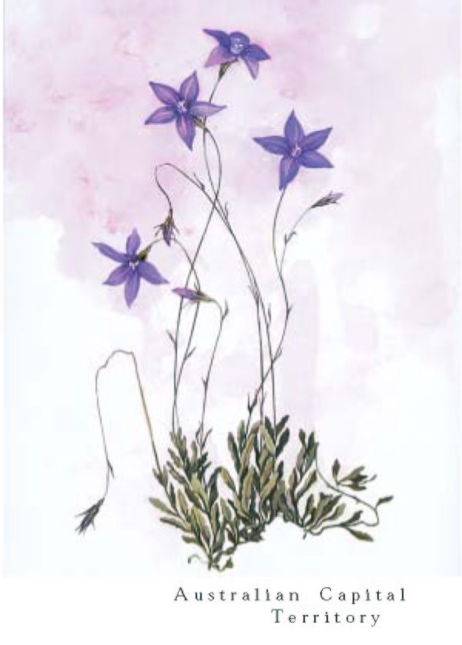

Faunal (Bird) Emblem: Gang-gang Cockatoo
          - The Gang-gang Cockatoo (Callocephalon fimbriatum), depicted at Image 2, was adopted as the faunal (or bird) emblem for the ACT by the Legislative Assembly in February 1997.
          - The selection of this emblem resulted from a resolution and committee inquiry in the Legislative Assembly. On 7 December 1995 the Chief Minister, Mrs Kate Carnell MLA, moved a resolution that was passed by the Assembly asking the Standing Committee on Economic Development and Tourism to ‘inquire into and report on the available options for faunal emblems to represent the Australian Capital Territory and in particular to consider a suitable animal and/or bird emblem.’
          - The Standing Committee on Economic Development and Tourism Inquiry into a Bird and/or Another Mammal Emblem found that the most popular suggestions for a faunal emblem for the Territory at the time were:
- Gang-gang Cockatoo;
- Southern Lined Earless Dragon; and
- Corroboree Frog.
          - In October 1996 the committee report recommended the ACT Government consider proclaiming one or more of these animals as a faunal emblem.
          - On 27 February 1997 the Legislative Assembly passed a resolution adopting the Gang-gang Cockatoo as the faunal emblem for the Territory, and endorsing the Royal Bluebell as the floral emblem.
Image 2: Gang-gang Cockatoo (Callocephalon fimbriatum)
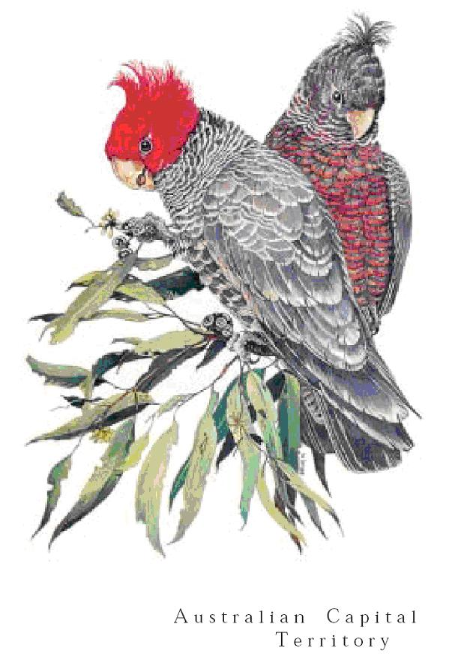

Whether the ACT should have a Mammal Emblem
          - The first question in the terms of reference presented to the Committee is whether the ACT should have a mammal emblem.

Mammal emblems in other Australian jurisdictions
          - In 2018 the ACT finds itself the only Australian State or Territory without a mammal emblem. The animals chosen by the other jurisdictions to be their mammal emblem are as follows:
- Koala (Queensland);
- Leadbeater’s Possum (Victoria);
- Numbat (Western Australia);
- Platypus (New South Wales);
- Red Kangaroo (Northern Territory);
- Southern Hairy-Nosed Wombat (South Australia); and
- Tasmanian Devil (Tasmania).

All submissions support the idea of a mammal emblem
          - The Committee received 30 submissions, which present the views more than 295 people or organisations. All submissions support the concept of adopting a mammal emblem for the ACT; none present concerns or objections to the principle.

Suggested criteria for selecting a mammal emblem
          - Submissions to this inquiry contain a range of perspectives on what the criteria for choosing a mammal emblem should be, and an overview is provided here.

Vulnerable and Endangered Species
          - In recent decades Australian States have used the process of adopting an emblem to raise public awareness and support conservation of vulnerable or endangered animals. For example, the endangered Numbat was proclaimed the animal emblem of Western Australia in 1973. Victoria’s Leadbeater’s Possum is also endangered. The Tasmanian Devil is a threatened species, and was the most recent mammal emblem to be declared in 2015.
          - A strong theme in submissions to the inquiry is that the prominence and publicity given to a Territory mammal emblem will provide an opportunity to promote awareness and conservation of a vulnerable or endangered species.
          - Some submissions suggested the Committee choose an animal that is endangered or protected. They highlighted that the act of choosing an emblem will increase public awareness of vulnerable species, for example:
In selecting a mammal emblem, I suggest that the Committee give favourable consideration to selecting a mammal identified and protected under the Nature Conservation Act 2014 (ACT).
If people knew more about them and they become our emblem then they will be looked after better and won't become extinct.
          - Ms Gunn said that the act of choosing an emblem could recognise the achievements of local wildlife conservation programs and support their work in the future:
Rehabilitating a wild population has been a significant achievement and bringing attention to this will help this work into the future.
          - Mr Jones told the Committee that choosing a vulnerable species as the Territory emblem would be a symbolic reminder of government and community responsibility to the environment:
Choosing a mammal emblem is an act of recognition. It signifies that we share this land with unique native animals and we have a duty to protect them and the natural environment they rely on… As an emblem for the ACT, the rock-wallaby symbolises the beauty of the animal world but also the responsibility of government and citizens alike to protect native habitats and coexist with the natural environment.
          - Mr Street said that local species rehabilitation programs have special meaning for the ACT, and this could be recognised in the adoption of an emblem:
I would prefer the Eastern Bettong. It is something very special - an animal that was made extinct on the mainland being brought back here via the ACT. IMHO it can be seen as Canberra's gift to mainland Australia, and so is has a very special meaning to us.

Species that are Prevalent and Familiar
          - An alternative perspective offered in five submissions is that the mammal emblem should be a species that is well known in the community, and commonly occurring in the local environment.
          - Ms Flanagan told the Committee that the mammal emblem should be an animal that is well established in the ACT region, such that people encounter it in daily life:
As has been established by the ACT Inquiry to select a bird emblem, emblems should be selected based on the community's affinity to the animal, a sense of familiarity and its common occurrence in the area. Some mammals are now being supported as candidates due to their lack of qualification in this area - because of their classification as threatened species. This would be completely contradictory to the purpose of an emblem. It does not make sense to select an emblem on the rationale that it is not well established in that geographical area. Let our environmental programs continue the important work for threatened and reintroduced species in the ACT, but don't use it as a mascot. Emblems should be animals we interact with, that we see on the bike path, or on the side of the road.
          - Two submissions stated that, while conservation of endangered species is important work, it should not inform the selection process for a mammal emblem. For example, in the view of Scouts ACT:
The allocation of monies towards species conservation should be a separate community discussion from this one regarding a more symbolic emblem.
          - Dr Braysher told the Committee (in a submission received on 15 June, after the shortlisting of candidates) that neither the Brush-tailed Rock-wallaby nor the Eastern Bettong are likely to be re-established in the wild in the ACT:
If one of these two are chosen, the result will be a mammal emblem that only exists in captivity or one that has to be continually released in an attempt to re-establish it and at great ongoing cost to manage native and non-native predators.

Attractive Appearance and Identifiable Shape
          - The Committee received some submissions that focused on the visual appearance of the animal. For example, Connor and Dominic, two students attending Franklin Early Childhood School described their preferred animal as ‘cute’:
They are cute and small like a rabbit but aren’t pests.
It is cute and cuddly and looks good in photos.
          - One submission pointed out that emblems are used in designs for logos and coats of arms, and it helps if the animal has a shape that can be depicted well in graphic imagery:
Good emblem selection begins with an easily identifiable subject. Emblems should be distinctive enough to be seen clearly from far away and in low resolution. The echidna succeeds beyond comparison on this front.

Symbolic Characteristics
          - Some submissions attributed certain characteristics to their preferred animal, and suggested similar description could be applied to the community of the ACT. For example, Scouts ACT referred to ‘resilience’:
Scouting members … feel that the Echidna better represents the ACT due to its resilience, ability to survive in a tough environment and by its popularity across the community, as seen through the Scout demographic of enquiring minds.
          - Hannah from Aranda Primary School wrote:
The fact is, echidnas are small but strong and so is the ACT.

Listen to the local Aboriginal community
          - The Committee was told it is important to consult with the local Aboriginal community in deciding an appropriate emblem:
Representatives of the Ngunnawal people would obviously have suggestions to make about the most appropriate mammal species to be adopted as an emblem for this place… We do not have sufficient knowledge of local fauna to propose any specific mammal as a preferred emblem. We are confident that the Committee would have access to such advice from Aboriginal people and other experts in that field.
          - Mr Bond suggested that when an emblem is chosen, the ACT community could learn name of the animal as spoken in the language of the traditional owners of the land:
When announcing the mammal, I also request the Committee liaise with the traditional owners of the ACT so that the name can be given in their language as well. This should be done for existing emblems as this information is not on www.cmd.act.gov.au/communication/flags.

Context of emblems already chosen by other Australian States and Territories
          - While the choice of emblem is a matter for the ACT, some submissions highlighted that the ACT emblem will be viewed in the context of the seven other mammal emblems of Australian States and Territories. For example, emblems are listed together on websites such as Australian Geographic and Australian National Botanic Gardens.
          - Some submissions called for the ACT to complement the other States and Territories, and ‘complete the set’ of Australia’s iconic native mammals by choosing the Echidna. Ms Flanagan told the Committee that there would be ‘consistency’ if the ACT chose the Echidna, an ‘iconic’ animal not currently on the list of State or Territory emblems:
Considering that the ACT is the last remaining state or territory in Australia to determine a mammal emblem, we have a responsibility not to entirely mimic, but to make a selection consistent with the emblems of other states and territories. The ACT has an opportunity to complete the set of Australia's iconic native mammals through its mammal emblem. When we think of Australian animals, we think of kangaroos, koalas, wombats and platypuses. We think of iconic, distinctive creatures unlike those across the rest of the world. We have the opportunity to ensure that Australia's last iconic animal, and one of only two monotremes, receives the recognition it deserves as the mammal emblem for Australia's capital city.
          - Logchayaa from Aranda Primary School also highlighted the unique characteristics of the Echidna, and pointed out that our nearest neighbour NSW has chosen the other monotreme species as their mammal emblem:
Many biologists and archaeologists were impressed when they discovered that Echidnas are Monotremes (mammals that lay eggs) which shocked them. Also they discovered that echidnas and platypuses were the only animals that are monotremes in Australia and they were the close relatives as well as close species. This last fact is critically important because NSW has platypuses as their emblem, meaning we should have Echidnas as ours.
          - The Committee was told there could be confusion if the ACT were to choose the Eastern Grey Kangaroo or Southern Brush-Tailed Wallaby, as the Red Kangaroo is already the emblem for the Northern Territory.

Committee comment
          - Evidence presented in submissions to the Committee included a range of views about the criteria on which an animal should be selected to be the ACT mammal emblem. However there was no objection in any submission to the idea or principle of the ACT having a mammal emblem.
Given the fact that the ACT is the only Australian State or Territory not to have a mammal emblem, and the apparent community support for a mammal emblem in submissions to this inquiry, the Committee considers it appropriate to recommend that the ACT have a mammal emblem.
Recommendation 1
- The Committee recommends that the ACT Legislative Assembly adopt a mammal emblem for the Australian Capital Territory.

What the ACT Mammal Emblem should be
          - The second question presented to the Committee in the terms of reference is what the ACT mammal emblem should be.

Animals Nominated in Submissions
          - The Committee invited the ACT community to nominate animals for mammal emblem. The Committee received 30 submissions, which present the views of more than 295 people or organisations. The animals mentioned most frequently in submissions were:
- Eastern Bettong (preferred by 130 people or organisations in submissions)
- Echidna (preferred by 78 people or organisations in submissions)
- Southern Brush-Tailed Rock-Wallaby (preferred by 75 people or organisations in submissions)
          - Other animals mentioned with less frequency in submissions (ie. on less than five occasions) were: Eastern Grey Kangaroo, Fruit Bat, Little Forest Bat, Magpie, Possum, Possum Glider, Spotted-tail Quoll, and Swamp Wallaby.
          - In March 2018 the inquiry received national attention in the mainstream media and on social media platforms when radio station Tripe J made a submission nominating Canberra electronic music duo Peking Duk for the ACT mammal emblem.
          - Staff from Mulligans Flat Woodland Sanctuary informed the Committee that the resulting exposure they received on the Triple J Hack program had a positive impact on their work, increasing their profile such that National Geographic contacted them to write an article on the Eastern Bettong.

Shortlisting candidates for mammal emblem
          - The Committee decided to distil the list of candidates to the strongest contenders, and then invite the community to express their views to the Committee for a second time.

Animals under consideration for the shortlist
          - When visiting wildlife and conservation experts at Tidbinbilla and Mulligans Flat in May 2018, the Committee asked for information about the following five animals: local bat species, Eastern Bettong, Echidna, Southern Brush-tailed Rock-wallaby, and the Spotted Tail Quoll. These animals were chosen based on the support they received in submissions.

Bats
          - The Committee was interested to learn that the most prevalent mammal in the ACT may be the bat. Mr Pennay told the Committee that:
bats make up one of the largest groups of mammals in Australia and the largest group of mammals in the ACT – in fact bat species account for almost half of all mammal species in the ACT and are larger than any other group of mammals.
          - Bats are beneficial in eating mosquitos, spreading pollen, and providing food for native birds and goannas. They were described as ‘beautiful and underappreciated’.
          - The Committee was told there are no endemic bats to the ACT, but probably the most common bat in the ACT is the Little Forest Bat, whose distribution is limited to southeastern Australia. Bats are not at risk of extinction.

Eastern Bettong
          - The Eastern Bettong received the greatest level of support in submissions to the Committee.
          - The Eastern Bettong once lived across southeastern Australia, including on the land now known as the ACT, but became extinct on the mainland in the 1920s. Bettongs from Tasmania were reintroduced to the ACT at Mulligans Flat Woodland Sanctuary in 2012. A captive ‘insurance population’ lives at Tidbinbilla, and experimental reintroduction ‘beyond the fence’ has occurred in Lower Cotter Catchment.
          - The Committee heard them described as ‘an ambassador for conservation’. Eastern Bettongs are considered to be ‘an ecosystem engineer’, meaning:
they have a large influence on the ecosystem in which they live. Bettongs main food is truffles and their digging for food turns over and loosens soil, promoted regeneration of native vegetation, and disperses fungi.’
          - The ACT is the only place on mainland Australia where people can see the Eastern Bettong. They are widespread in Tasmania, though may be threatened if foxes become established on the island.

Echidna
          - The Echidna received significant support in submissions to the Committee.
          - The Echidna is the most widespread mammal on the Australian mainland. The Committee heard it described as ‘charismatic’. It is indisputably a unique and important animal, being one of only two monotremes on Earth (mammals that lay eggs).
          - Echidnas are abundant and at no risk of extinction. They can be found in a wide variety of habitats including urban areas of Canberra.

Southern brush-tailed Rock-wallaby
          - The Southern Brush-tailed Rock-wallaby received significant support in submissions to the Committee.
          - They are endangered, and were last seen in the wild in the ACT in 1959.
          - In 1996 Tidbinbilla Nature Reserve began a conservation program from a captive population of just three animals. Using pioneering breeding techniques Tidbinbilla has successfully bred over 60 animals, and partnered with NSW and Victoria in previous reintroductions to the wild.
          - The Committee was told that the Tidbinbilla population is now around 30, and after a new sanctuary is constructed in 2018 there are hopes that the population will increase to over 100 animals before future reintroductions, ‘providing an important insurance population of brush-tailed rock wallabies’.
          - Tidbinbilla Nature Reserve is working with the Ngunnawal people to tell the story of the rock-wallaby’s cultural significance to the Aboriginal community.

Spotted Tail Quoll and Eastern Quoll
          - The Committee learned that there is a significant difference between the Spotted Tail Quoll (which was nominated in submissions) and the Eastern Quoll.
          - The Spotted Tail Quoll is the largest carnivorous marsupial in Australia. It is bigger than the Eastern Quoll, and exists in smaller numbers. It has been seen in the suburbs of Charnwood and Holt, though it is believed the animals sighted in the ACT were transient, not locally established. The Spotted Tail Quoll is wide ranging across Australia, and is not unique to the ACT.
          - The Eastern Quoll is part of a breeding program at Mulligans Flat Woodland Sanctuary. The Eastern Quoll was highly abundant in the past, but became extinct on the mainland in the 1960s, and it has been missing from the ACT for 80 years. There are currently 40-50 animals in the sanctuary.

Criteria for deciding the shortlist
          - The Committee carefully considered the range of viewpoints expressed in submissions about the criteria on which a mammal emblem should be chosen (see paragraphs 3.4 to 3.24).
          - When choosing a shortlist, the Committee decided it would be guided by the following five factors:
- the level of support expressed for the animal in submissions to the inquiry;
- the animal's connection to the ACT region;
- the animal’s contribution to the local environment;
- whether they are classified as 'vulnerable' or 'endangered'; and
- potential for publicity as the Territory emblem to contribute to conservation efforts planned or underway.
          - Based on the five criteria listed above, the Committee decided that the two strongest contenders for selection as a mammal emblem for the ACT are the Eastern Bettong and the Southern Brush-tailed Rock-wallaby. Both animals received significant support in submissions; they have a connection to the Territory through local conservation programs; one is endangered, and the other makes an important contribution to biodiversity; and there is potential for either to benefit from publicity that would come from being the Territory emblem.
          - The Committee appreciates the value and importance of the other animals, but decided not to include them in the shortlist for the mammal emblem. Bats and Echidnas are widespread across Australia, so their survival is not threatened, and they do not have a specific connection to the ACT. While the Spotted Tail Quoll was nominated in submissions and it is a vulnerable species, it is the separate Eastern Quoll that is part of the conservation program at Mulligans Flat Woodland Sanctuary (and was not mentioned in submissions).
          - After the shortlist was publicly announced, the Committee received a late submission on 15 June 2018 criticising the choice of animals on the shortlist. Dr Mike Braysher told the Committee that it is inadvisable to choose the Eastern Bettong or Brush-Tailed Rock-wallaby as the emblem, because their reintroduction into the wild is unlikely to be successful:
I note that the emblem has been reduced to two, Brush-tailed Rock Wallaby (BTRW) and the Eastern bettong. Both these species are extinct in the wilds of the ACT and only exist in captivity. Neither have much prospect of being re-established in the wild in the ACT, primarily because the factors (note plural) are not fully known or ones that are known (such as fox, wild dog – dingo, and cat predation) cannot be managed over a landscape scale nor for the foreseeable future. If one of these two are chosen, the result will be a mammal emblem that only exists in captivity or one that has to be continually released in an attempt to re-establish it and at great ongoing cost to manage native and non-native predators. We will end up like Victoria with their bird emblem the helmeted honey eater, or which is better known amongst scientists as the helmeted money eater. It is only still in Victoria through a long-term breeding program at Melbourne Zoo and continual release to the wild where they soon die out. Choosing a mammal with similar characteristics for the ACT mammal emblem will lead to a similar situation. Much better to choose a mammal that has good long term prospects in the wild such as the echidna or the swamp wallaby, and spend the limited resources that we have on conserving those species and their habitats that still exist in the ACT.
          - The Committee acknowledges that there are other legitimate approaches to choosing a mammal emblem, which would result in a different shortlist. As discussed above in paragraphs 3.11 to 3.14, the Committee received several articulate submissions calling for the mammal emblem to be a species that is well established, familiar, and commonly found in the local environment.
          - Nonetheless, the Committee prioritised biodiversity and conservation when deciding the emblem shortlist, based on the higher level of support for this approach in submissions to the inquiry, and the precedent demonstrated by other Australian States when adopting emblems in recent years (see paragraph 3.5).

ACT community participation in the decision via an online survey
          - After creating a shortlist of two candidates, the Committee provided the ACT community a second opportunity to express their view on which animal they think should be the mammal emblem.
          - The Committee designed an online survey which was open to ACT residents from 7 June to 26 June 2018. The survey was publicised through the Committee website, The Canberra Times, ABC Radio, Mix 106.3 Radio, 2CC Radio, Twitter and Facebook. The Committee invited people without computer access to contact the Secretary to register their vote by phone.

Survey Design
          - The survey invited people to choose between the Eastern Bettong and the Southern Brush-tailed Rock-wallaby:
The story of the Eastern Bettong
The Eastern Bettong once lived across southern Australia but, due to human activity and the introduction of feral species, became extinct on the mainland in the 1920s. A population of bettongs from Tasmania was reintroduced to Canberra in 2012, and Mulligans Flat Woodland Sanctuary in Canberra is currently the only place that people can see a bettong on mainland Australia. Mulligans Flat are trialing a program reintroducing bettongs to the wild in the Lower Cotter Catchment. Bettongs have an important role in the ecosystem, turning over soil to look for food, which promotes regeneration of vegetation.
The story of the Southern Brush-tailed Rock-wallaby
The Southern Brush-tailed Rock-wallaby has a long association with the ACT and important cultural connections with the local Aboriginal community. Due to hunting for the fur trade and the introduction of feral animals, the Southern variant of the species is at risk of extinction. In 1996 Tidbinbilla Nature Reserve began a conservation program from a captive population of just three animals. Using pioneering breeding techniques Tidbinbilla has successfully bred over 60 animals, and contributed to reintroduction and partner conservation programs. The Tidbinbilla population is now around 30, and after a new sanctuary is constructed in 2018 there are hopes the population will reach 100, enabling their reintroduction into the wild.
          - Respondents were told that the survey results, as well as other material, will be used to inform the Committee’s consideration of which mammal should be chosen as the ACT mammal emblem. Full survey questions are included at Appendix C.

Survey Results
          - A total of 3,514 people participated in the online survey.
          - The results were remarkably close, with just 40 votes difference between the two choices:
- Southern Brush-tailed Rock-wallaby received 1,777 votes (50.56%); and
- Eastern Bettong received 1,737 votes (49.43%).
Graph 1: Results of the online survey conducted by the Committee
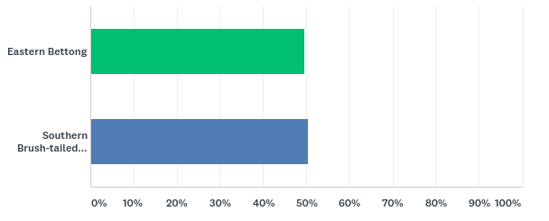

Reasons people voted for the Southern Brush-tailed Rock-wallaby
          - The most common reasons for voting for the Southern Brush-tailed Rock-wallaby are summarised here, with a sample of some of the comments provided in the online survey.

Wallaby’s stronger connection to Canberra:
‘More Canberran’
‘Because I feel these animals have history in the ACT and are important to the ACT’
‘Because it seems a very homegrown ACT survival story rather than shipping them in from interstate. Also I remember learning about them at Tidbinbilla as a kid.’

Aboriginal cultural connections:
‘Long association with the ACT and important cultural connections with the local Aboriginal community’
‘Connection to traditional owners of this land’
‘I think it’s important to honour the ties to the Indigenous community’

Personal connection or experience with the Wallaby:
‘… I have seen them up close in Tidbinbilla and Namadgi and those happy memories will stay with me.’
‘Because I still fondly remember an afternoon of wonderful show-off entertainment from the Rock-Wallabies at Tidbinbilla a few years ago.’
‘Both are great choices but I have been visiting Tidbinbilla since I was a kid and have spotted the beautiful rock-wallaby on many occasions’

To support the conservation work undertaken at Tidbinbilla Nature Reserve:
‘Because they are my favourite and I really want to bring more attention to the breeding program at Tidbinbilla’
‘… Important work has been done at Tidbinbilla, very much a symbol of Canberra.’
‘Because of its historic and cultural connection to this region, and because our local sanctuary Tidbinbilla has done so much towards saving it from extinction.’

Because this variant of Wallaby is so close to extinction:
‘Because it is in greater danger of extinction’
‘More endangered than the bettong, who I also love’
‘Bettongs … are not a nationally threatened species. The wallabies are threatened.’

Attractive appearance:
‘They are cute’
‘Looks better’
‘Its tail is awesome!’

Wallaby is more familiar and recognisable than the Bettong:
‘I think it’s a much more recognisable emblem, known by far more people. As sweet as Bettongs are, how many people have ever seen one?’
‘The wallaby is an iconic and more recognisable animal’
‘I’ve never heard of a bettong, so the wallaby seems more relevant’

Wallaby has a silhouette more suited to an emblem:
‘The silhouette of the rock-wallaby is more striking and recognisable (therefore well suited to an emblem)’
‘Would look better on an emblem’
‘… From a PR point of view, it has a great visual image – handy for stylising or photos!’

Perceived symbolism of the Wallaby:
‘The Wallaby is a noble animal’
‘Their resilience’
‘It’s an agile marsupial that can adapt to any situation’

‘Rhonda the Rock Wallaby’ Twitter account created by David Sharaz:
‘Rhonda is cute. Ok David Sharaz convinced me.’
‘David Shiraz’s [sic] campaign video’
‘David shiraz [sic] sold it to me, he is a legend’

Perception that the Bettong has characteristics similar to a rat:
‘They’re both great, but the rock wallabies are less likely to just look like rats on an emblem!’
The bettong looks too much like a rat. You can imagine the fun people outside Canberra would have with that!’
‘Sorry, the Bettong looks a bit too much like a rat’

Reasons people voted for the Eastern Bettong
          - The most common reasons for voting for the Bettong are summarised here, with a sample of some of the comments provided in the online survey.

Attractive appearance:
‘It’s small and cute (Like the ACT)’
‘I’ve seen one at Mulligans Flat, they’re gorgeous’
‘They are adorable’

To support the conservation work undertaken at Mulligans Flat Woodland Sanctuary:
‘Mulligans Flat is doing great work’
‘Because of the fabulous work Mulligans Flat have done to bring the Bettong back to Canberra’
‘If we make the bettong our state emblem then it would mean that the Mulligans repopulation program will continue to get funding. Go #BrianBettong’

To give the animal more attention and raise awareness:
‘Bettongs need more attention Nationally, Rock wallaby are already well known. Being our emblem will help educate people on what Bettongs are’
‘Bettongs are not very well known and this may help to lift its profile amongst Australians’
‘I love the bettong. They deserve their spot in the sun!’

Bettong’s connection to Canberra:
‘Due to Canberra being the only place it can be found on mainland Australia’
‘Because of the significance to the ACT’
‘Because it says ACT on a whole lot of levels’

Profile of ‘Brian Bettong’ in the ACT community and on social media:
‘Because Brian is awesome’
‘Because I follow him on Twitter!’
‘Brian. He is a great ambassador for threatened species protection. The team at Mulligans flat are smashing it with the marketing, and they have built an amazing profile…’

Personal connection or experience with the Bettong:
‘I was able to pet one during an environmental display in Civic and I fell in love’
‘I have seen a bettong from Mulligans Flat and they are so cute’
‘I live next to mulligans flat reserve’

The Bettong benefits the ecosystem and enhances the environment:
‘The fact that Eastern Bettong promotes regeneration of vegetation’
‘I like the way that Eastern Bettong improves and enhances its environment through its behaviours (such as digging), in a similar way to how Canberrans improve their environment – the ACT and the rest of the country.’
‘While both species have significant local histories and ecological roles, the bettong is both a pivotal ecosystem engineer and incredibly successful flagship species for conservation. This latter role is especially important – promotion of the eastern bettong helps promote funding and education for grassy woodlands generally. This critically endangered ecosystem is ubiquitous of Canberra.’

The Bettong is more distinctive than the Wallaby:
‘More interesting and unique than a wallaby’
‘The bettong is a bit distinctive and would stand out from other emblems’
‘Because although the Rock-wallaby is lovely, it doesn’t look as distinctive’

Wallaby is similar to the Kangaroo, and both are already represented in national symbols:
‘The wallaby looks too much like a kangaroo which already decorates many Australian things’
‘… kangaroos/wallabies have been used as many symbols/mascots while the bettong is more unique’
‘because it is easier to differentiate it from mammals in other states in particular from the red kangaroo’

Perceived symbolism of the Bettong:
‘The Bettong is small but important just like the ACT’
‘Bettongs are small, but make a positive impact, like the ACT!’
‘It’s a little different, and it’s not obvious/what’s expected… a little like Canberra.’

It was a Difficult Decision
          - A substantial number of people voting for either animal in the online survey expressed in their comments that it was a difficult decision, and they found it hard to choose, because they also support the other candidate. For example:
‘Enee menee minee mo, they both deserve it’
‘I could only choose one and it was very hard! I flipped a coin.’
‘Both would be for a good cause as they are small in number, but had to pick one!’
‘… I would be happy with either though – they are both beautiful and important in Canberra.’
‘… Both animals are important, it was a hard decision.’
‘… I’d be delighted with either, both are so precious.’
‘Because I couldn’t choose both, why can’t we have both?’
‘… Can we have them both? : )’
‘We could have both you know!’

Committee comment
          - The Committee acknowledge the limitations of an online survey as a tool for public decision making. A voluntary online survey is not a scientific study, nor is it a formal referendum. The survey results do not constitute a definitive statement of the views of the ACT community on a preferred mammal emblem.
          - However the online survey conducted during this inquiry was a genuine activity in community engagement, and a successful mechanism for the Committee to hear directly from people in the ACT during the process of identifying a mammal emblem.
          - This is the first occasion on which an Assembly Committee has used an online survey as a means to engage with the ACT community. While we believe this exercise was successful, we acknowledge not everyone is comfortable with online interactions as a form of communication. The Committee welcomes feedback and suggestions about methods of engagement with the community, in order to inform future inquiries.
          - On this occasion, an online survey of 3,514 people was almost evenly split between two candidates for the mammal emblem. Given the results were so close, the Legislative Assembly may wish to consider the possibility of joint mammal emblems. The Committee does not make this suggestion simply to avoid making a decision, but considers it a legitimate option for the following four reasons.
- First, the survey results indicate genuine affection for both animals in the community;
- Second, joint recognition would unify the two sides of the city, as some voters for the Bettong identified themselves as north siders, and some voters for the Rock-wallaby identified themselves as south siders;
- Third, the animals symbolise the diverse mix of people in the ACT, as the Rock-wallaby is a long-established animal with strong cultural connections, while the Bettong was recently reintroduced from Tasmania; and
- Finally, the Bettong represents the ACT’s efforts to promote biodiversity, and the survival of the Rock-wallaby represents the ground breaking work in conservation that occurred here in the ACT.
          - A debate in the Assembly would enable the ACT community to explore the feasibility and suitability of the notion of joint mammal emblems. If, after a public airing of the issues, it is not considered appropriate for the ACT to have joint mammal emblems, the Committee recommends that the Assembly consider adopting the Southern Brush-tailed Rock-wallaby for mammal emblem.
          - The Committee nominates the Rock-wallaby for three reasons: it received slightly greater support in the online survey; it arguably has greater potential to benefit from the increased publicity that would come with being the Territory emblem; and because the species is endangered, while the Eastern Bettong has an established population in Tasmania.

Recommendation 2
- The Committee recommends that, given the extremely close result of the public survey, the ACT Legislative Assembly consider the possibility of granting mammal emblem status jointly to the Southern Brush-tailed Rock-wallaby and the Eastern Bettong.
- If two mammal emblems are not considered an appropriate option, the Committee recommends the ACT Legislative Assembly consider adopting the Southern Brush-tailed Rock-wallaby as the mammal emblem for the ACT.

Other Emblems and Imagery for the ACT
          - Before concluding this report the Committee wishes to mention several suggestions raised in submissions about other potential emblems and symbolic imagery for the ACT:
- Four submissions to the Inquiry suggested that a mammal emblem for the ACT creates the potential to design a coat of arms for the ACT;
- Another submission recommended the design of a new ACT flag;
- One submission raised the idea of an insect emblem; and
- A respondent to the online survey suggested an aquatic emblem.

ACT Coat of Arms
          - The ACT does not currently have a coat of arms, and it was suggested to the Committee that the adoption of a mammal emblem would present an opportunity to design one.
          - The coat of arms seen on the ACT flag is a modified form of the Coat of Arms of the City of Canberra. The Canberra Coat of Arms, depicted in Image 3, was designed in April 1928 for use on the newly commissioned ship, HMAS Canberra.
Image 3: Coat of Arms of the City of Canberra
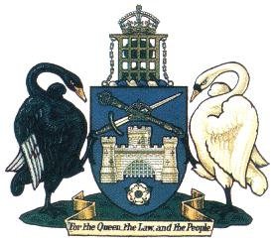
          - Mr Fewtrell and Mr Headon wrote in their submission that the Canberra coat of arms is not reflective of the people or environment of the ACT:
there is other work to be done in relation to civic symbols. We refer specifically to the need to address the current Canberra Coat of Arms. This civic symbol does no justice to the people or the natural environment of the ACT. It is English in its symbolism and tenor. It speaks of other places, not our land or our place. Its adoption at the time of self-government was seemingly an expedient 'fix', born of political compromise. It is something that a mature and confident ACT needs to address. The simplest approach would not be to change the Canberra Coat of Arms, but rather design an ACT Coat of Arms, as the Territory is currently the only jurisdiction without one.
          - Mr Jones expressed a similar view in his submission:
Finally, the choice of the rock-wallaby, or indeed another mammal emblem would provide a compelling feature to appear on a new ACT coat of arms. The present coat of aims is an embarrassing anachronism that does not represent the principles held dear by Canberrans. It features, among other things, a crown denoting royal authority and a white rose in honour of the Duke of York, later King George VI. Canberrans voted strongly for a republic in 1999 and again raised the issue of changing the coat of aims at the centenary celebrations in 2013. A new coat of aims featuring the official mammal emblem would be a far better reflection of the democratic values of the ACT and its commitment to protect and preserve the natural environment of this bush capital.
          - Mr Squires wrote that the design of the new coat of arms could involve community participation, and integrate the ACT floral emblem, bird emblem, and new mammal emblem:
While the ACT is currently the only State/Territory without an official mammal emblem, it is also the only one without an official coat of arms. This would be a great time for the ACT Government to rectify this by initiating a process of public engagement to design an ACT Emblem/Coat of Arms. The ACT Government is currently using the Coat of Arms of the City of Canberra, a purpose for which it was not designed… An ACT Emblem would provide a great opportunity to use relevant and meaningful symbolism for the ACT, and could use the bird emblem, floral emblem and the new mammal emblem together. It would be a great statement of pride in our Territory, and put our unique culture and environment at the forefront of our symbols.
          - The submission by Mr Ostyn included an example of a design of potential new coat of arms with a Spotted Tail Quoll, Gang-gang Cockatoo and Royal Bluebell, depicted at Image 4.
Image 4: Sample design of ACT Coat of Arms proposed by Ivo Ostyn
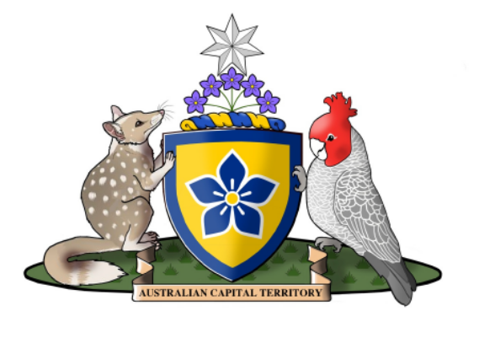

Territory Flag
          - The Australian Capital Territory Flag, depicted in Image 5, was designed in 1993 following widespread community consultation. It includes a modified version of the Canberra Coat of Arms. The Legislative Assembly adopted the Territory flag on 25 March 1993.
Image 5: ACT Flag
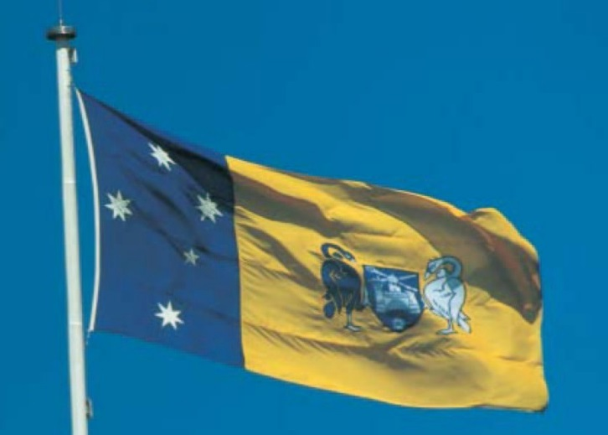
          - The designer of the current ACT flag, Mr Ostyn, suggested to the Committee that the adoption of a mammal emblem will provide opportunity to update the flag:
Once an ACT Mammal has been chosen and implemented I would suggest to government to have a serious look at all our symbols including a Territory Coat of arms and the flag.

Other Emblems
          - Mr Bond in his submission suggested an insect emblem for the ACT:
I would also suggest that the Committee investigate an insect emblem for the ACT. I understand that 45 individual states of the fifty United States of America have either one designated insect, or have multiple categories (e.g., state insect and state butterfly, etc.)
          - A respondent to the online survey suggested an aquatic emblem:
… Can we have an aquatic symbol too?
          - In this context, the Committee notes that our nearest neighbour New South Wales has adopted a fish emblem, gemstone emblem, and fossil emblem, and many of the States of the United States of America have a reptile emblem, insect emblem and tree emblem.

Committee Comment
          - The Committee is conscious of the fact that a coat of arms and new flag is not within the terms of reference of this inquiry. However, animal emblems are traditionally incorporated into jurisdictional coats of arms, and creating an ACT coat of arms would logically necessitate the redesign of the current Territory flag. Therefore it is relevant and appropriate for the Committee to acknowledge the matter.
          - The Committee recognises the important history of the Coat of Arms of the City of Canberra, and the memory of 84 armed services personnel lost on the HMAS Canberra in 1942. The Committee notes that the Canberra Coat of Arms was originally created for a purpose separate to a jurisdictional Coat of Arms. The Committee suggests that, if a mammal emblem is adopted, consideration be given to design of an official Coat of Arms for the ACT, to bring the Territory in line with all other Australian jurisdictions. The Committee believes that the Canberra Coat of Arms would retain its dignity and heritage if a separate ACT Coat of Arms is created.
          - Finally, the Committee notes the potential for future community discussion about expanding the list of emblems adopted for the ACT, such as, for example:
- reptile emblem;
- fish emblem;
- insect emblem;
- tree emblem;
- gemstone emblem; or
- fossil emblem.
Recommendation 3
- The Committee recommends that the ACT Government notes the potential for the adoption of a mammal emblem to lead to the design of a Coat of Arms for the ACT, and the possible redesign of the ACT flag.

Suzanne Orr MLA
Chair
27 July 2018

Appendix A – Submissions
Submission Number | Submitter | Received
1 | Dunja Radosavljevic | 28 March 2018
2 | Kerry Burton | 28 March 2018
3 | Rebecca Wright | 28 March 2018
4 | Chris Wansink | 28 March 2018
5 | Drew McKinnie | 28 March 2018
6 | Marc | 28 March 2018
7 | Peter van Vliet | 28 March 2018
8 | Jessica Forde | 28 March 2018
9 | Liam Craigie | 28 March 2018
10 | Jude Dodd | 28 March 2018
11 | Susan MacDougall | 28 March 2018
12 | Malcolm Street | 28 March 2018
13 | Anthea Gunn | 28 March 2018
14 | Michael Pennay | 28 March 2018
15 | Damien Bond | 28 March 2018
16 | Steven Squires | 28 March 2018
17 | Woodlands & Wetlands Trust | 28 March 2018
18 | Terry Fewtrell & David Headon | 28 March 2018
19 | Scouts ACT | 28 March 2018
20 | Franklin Early Childhood School | 28 March 2018
21 | Benjamin Jones | 28 March 2018
22 | Jayne Flanagan | 28 March 2018
23 | Triple J | 28 March 2018
24 | Elizabeth Wandrag | 28 March 2018
25 | Ingrid McCarthy | 28 March 2018
26 | Aranda Primary School | 28 March 2018
27 | Ivo Ostyn | 16 May 2018
28 | Tyler Williams | 16 May 2018
29 | Mark Collins | 16 May 2018
30 | Mike Braysher | 4 July 2018

Appendix B – Site Visits
          - The Committee decided not to conduct public hearings during this inquiry, but to instead travel to the community to visit wildlife and conservation experts to obtain briefings on the range of animals native to the ACT.

Mulligans Flat Woodland Sanctuary
          - The Committee visited Mulligans Flat Woodland Sanctuary on 23 May 2018, and spoke to:
- Ms Alison Russell-French – President Woodlands & Wetlands Trust
- Professor Adrian Manning – Lead scientist at the Sanctuary
- Dr Jason Cummings – CEO of Woodlands and Wetlands Trust
- Dr Kate Grarock – Sanctuary Ecologist
- Mr Daniel Iglesias – Director, ACT Parks and Conservation Service
          - A short video overviews of the site visit is available on the Legislative Assembly website.
Image 6: The Committee at Mulligans Flat
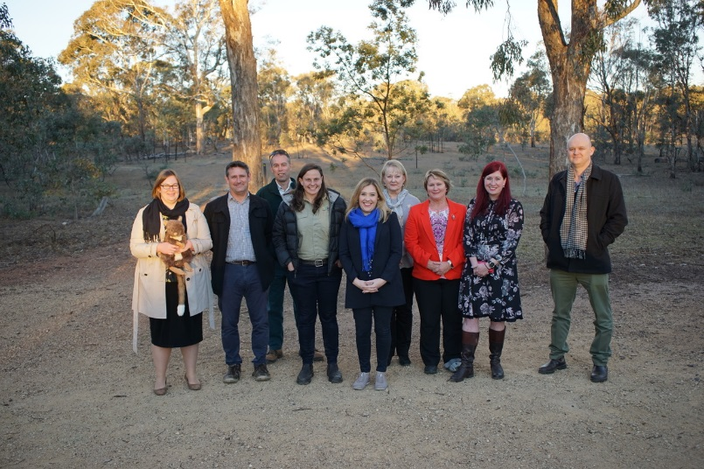

Tidbinbilla Nature Reserve
          - The Committee visited Tidbinbilla Nature Reserve on 30 May 2018, and spoke to:
- Mr Peter Cotsell – Regional Manager, Southern Parks and Reserves
- Dr Jennifer Pierson – wildlife ecologist and Senior Wildlife Manager
- Ms Nicole Hill – Wildlife Officer
          - A short video overviews of the site visit is available on the Legislative Assembly website.
Image 7: The Committee at Tidbinbilla
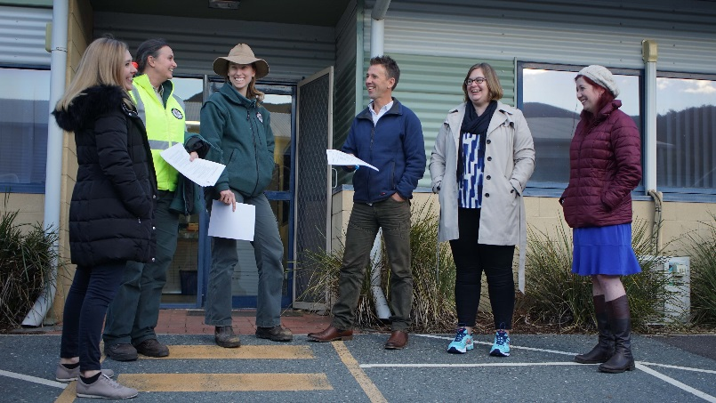

Appendix C – Online Survey

Survey Questions
          - After created a shortlist of two candidates, the Committee provided the ACT community a second opportunity to express their view on which animal they think should be the mammal emblem.
          - The Committee designed an online survey which was open to ACT residents from 7 June to 26 June 2018 at www.surveymonkey.com/r/ACTMammalEmblem. The Committee invited anyone without computer access to instead phone the Secretary to register their vote.

Survey Design
          - The survey invited people to choose between the Eastern Bettong and the Southern Brush-tailed Rock-wallaby. The survey questions are reported here:
Choosing a Mammal Emblem for the ACT
A Legislative Assembly Committee is looking into a proposal for a mammal emblem for the ACT.
If you live in the ACT you can have your say in this survey, which invites you to choose between the two strongest candidates for the emblem.
For information about the Inquiry, and how this survey was designed, please go to the Committee website.
The Story of the Eastern Bettong
The Eastern Bettong once lived across southern Australia but, due to human activity and the introduction of feral species, became extinct on the mainland in the 1920s. A population of bettongs from Tasmania was reintroduced to Canberra in 2012, and Mulligans Flat Woodland Sanctuary in Canberra is currently the only place that people can see a bettong on mainland Australia. Mulligans Flat are trialing a program reintroducing bettongs to the wild in the Lower Cotter Catchment. Bettongs have an important role in the ecosystem, turning over soil to look for food, which promotes regeneration of vegetation.
The story of the Southern Brush-tailed Rock-wallaby
The Southern Brush-tailed Rock-wallaby has a long association with the ACT and important cultural connections with the local Aboriginal community. Due to hunting for the fur trade and the introduction of feral animals, the Southern variant of the species is at risk of extinction. In 1996 Tidbinbilla Nature Reserve began a conservation program from a captive population of just three animals. Using pioneering breeding techniques Tidbinbilla has successfully bred over 60 animals, and contributed to reintroduction and partner conservation programs. The Tidbinbilla population is now around 30, and after a new sanctuary is constructed in 2018 there are hopes the population will reach 100, enabling their reintroduction into the wild.
Which animal do you think should be the mammal emblem for the ACT?
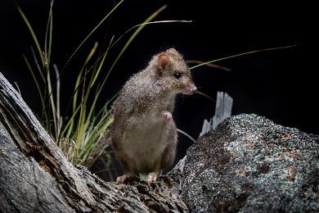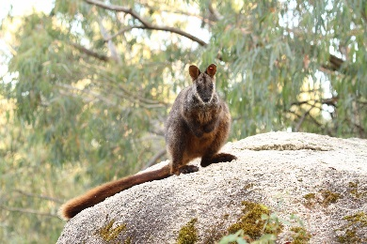
Photo credits: Eastern Bettong by Adam McGrath at Mulligans Flat Woodland Sanctuary; Southern Brush-tailed Rock-wallaby by Tidbinbilla Nature Reserve.
Why did you make this choice?
[Free text box for responses]
Please provide your postcode and email address
The reason for this question is to show that you live in the ACT, and you are only voting once. We will not use your email address for any other purpose.
[Free text boxes for responses]
Thank you.
Please forward this survey to friends, colleagues and family members living in the ACT who may be interested. Further information about the Inquiry into a Proposal for a Mammal Emblem is available on the Legislative Assembly website.

Promotion of the Survey
          - The survey was publicised through the Committee website, The Canberra Times, ABC Radio, Mix 106.3 Radio, 2CC Radio, Twitter and Facebook.
          - The Committee circulated the following social media tiles to attract attention to the survey:
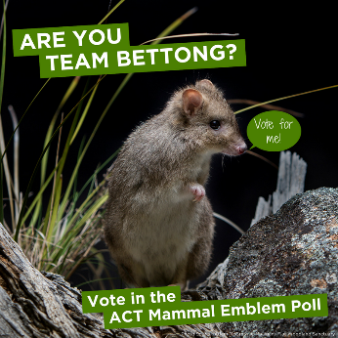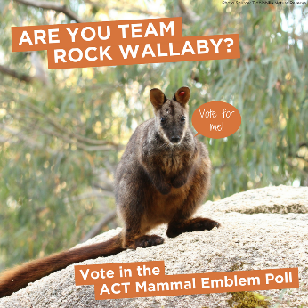
          - There was coverage of the survey on the mainstream media, and on social media. Mulligans Flat Woodland Sanctuary used their ‘Brian Bettong’ Twitter account to promote the survey. In response a local radio personality David Sharaz created a Twitter page for ‘Rhonda the Rock Wallaby’.

Survey Results
          - A total of 3,514 people participated in the online survey.
          - The results were remarkably close, with just 40 votes difference between the two choices:
- Southern Brush-tailed Rock-wallaby received 1,777 votes (50.56%); and
- Eastern Bettong received 1,737 votes (49.43%).
Graph 2: Results of the online survey conducted by the Committee
An overview of the reasons people gave for making their particular choice is contained in the body of the report at paragraphs 4.39 to 4.41.

Legislative Assembly for the ACT, Minutes of Proceedings No. 2, 13 December 2016, p. 13, accessible at: https://www.parliament.act.gov.au/__data/assets/pdf_file/0008/1017980/MoP002F1.pdf.
Legislative Assembly for the ACT, Minutes of Proceedings No. 43, 30 November 2017, p. 632, accessible at: https://www.parliament.act.gov.au/__data/assets/pdf_file/0004/1133743/MOP043F1.pdf
Legislative Assembly for the ACT, Standing Committee on Environment and Transport and City Services, web page titled ‘Inquiry into a Proposal for a Mammal Emblem for the ACT’, https://www.parliament.act.gov.au/in-committees/standing-committees-current-assembly/standing-committee-on-environment-and-transport-and-city-services/inquiry-for-a-mammal-emblem-for-the-act, accessed 24 July 2018.
Submission of Franklin Early Childhood School
Submission of Aranda Primary School
Submission of Scouts ACT
Legislative Assembly for the ACT, web page titled ‘Committee snapshots’, https://www.parliament.act.gov.au/Explore-your-Assembly/videos/committee-snapshots, accessed 24 July 2018.
ACT Government, Chief Minister, Treasury and Economic Development Directorate, web page titled ‘ACT Flags and Emblems’, http://www.cmd.act.gov.au/communication/flags, accessed 14 June 2018; Australian National Botanic Gardens, web page titled ‘Royal Bluebell’, https://www.anbg.gov.au/emblems/act.emblem.html, accessed 19 June 2018.
Archives ACT, web page titled ‘Previous find of the month – September 2010 – Royal Bluebell: Canberra’s Floral Emblem’, https://www.archives.act.gov.au/find_of_the_month/2010/september/find_of_the_month, accessed 19 June 2018.
Archives ACT, web page titled ‘Previous find of the month – September 2010 – Royal Bluebell: Canberra’s Floral Emblem’, https://www.archives.act.gov.au/find_of_the_month/2010/september/find_of_the_month, accessed 19 June 2018.
Australian Capital Territory Gazette No. 22, 4 June 1997, ‘Australian Capital Territory Faunal and Floral Emblems’, http://www.legislation.act.gov.au/ni/1997-134/current/pdf/1997-134.pdf, accessed 19 June 2018.
ACT Government, Chief Minister, Treasury and Economic Development Directorate, web page titled ‘ACT Flags and Emblems’, http://www.cmd.act.gov.au/communication/flags, accessed 24 July 2018.
Legislative Assembly for the ACT, Hansard, 27 February 1997, p. 623, accessible at http://www.hansard.act.gov.au/hansard/1997/pdfs/19970227.pdf.
Legislative Assembly for the ACT, Minutes of Proceedings No. 31, 7 December 1995, p. 222, accessible at https://www.parliament.act.gov.au/__data/assets/pdf_file/0009/370557/95MoP031.pdf#1.
Legislative Assembly for the ACT (October 1996) Report No. 3 of the Standing Committee on Economic Development and Tourism, Inquiry into a Bird and/or another Animal Emblem, accessible at https://www.parliament.act.gov.au/__data/assets/pdf_file/0012/377769/Rpt3bird_and_amporanotheranimalemblam.pdf.
Legislative Assembly for the ACT (October 1996) Report No. 3 of the Standing Committee on Economic Development and Tourism, Inquiry into a Bird and/or another Animal Emblem, accessible at https://www.parliament.act.gov.au/__data/assets/pdf_file/0012/377769/Rpt3bird_and_amporanotheranimalemblam.pdf.
Legislative Assembly for the ACT, Hansard, 27 February 1997, p. 623, accessible at http://www.hansard.act.gov.au/hansard/1997/pdfs/19970227.pdf.
ACT Government, Chief Minister, Treasury and Economic Development Directorate, web page titled ‘ACT Flags and Emblems’, http://www.cmd.act.gov.au/communication/flags, accessed 24 July 2018.
Terms of Reference, see page ii.
Western Australia Department of the Premier and Cabinet, web page titled ‘Animal Emblem’, https://www.dpc.wa.gov.au/guidelinesandpolicies/symbolsofwa/pages/animalemblemnumbat.aspx, accessed 24 July 2018.
Victoria Government, Department of Premier and Cabinet, web page titled ‘Animal Emblem: Leadbeater’s Possum, https://www.dpc.vic.gov.au/index.php/news-publications/victorian-symbols-emblems/leadbeaters-possum, accessed 24 July 2018.
Tasmania Parliament, web page titled ‘Tasmanian State Emblems, http://www.parliament.tas.gov.au/tpl/InfoSheets/StateEmblems.htm, accessed 24 July 2018.
Submission of Damien Bond.
Submission of Kate at Franklin Early Childhood School.
Submission of Anthea Gunn.
Submission of Benjamin Jones.
Submission of Malcolm Street.
Submission of Jayne Flanagan.
Submission of Scouts ACT.
Submission Mike Braysher.
Submission of Connor at Franklin Early Childhood School.
Submission of Dominic at Franklin Early Childhood School.
Submission of Jayne Flanagan.
Submission of Scouts ACT.
Submission of Hannah at Aranda Primary School.
Submission of Terry Fewtrell and David Headon.
Submission of Damien Bond.
Australian National Botanic Gardens, web page titled ‘Floral Emblems of Australia’, http://www.anbg.gov.au/emblems/, accessed 24 July 2018; Australian Geographic, web page titled ‘Australia’s Animal Emblems’, http://www.australiangeographic.com.au/topics/wildlife/2014/08/australias-animal-fauna-emblems, accessed 24 July 2018.
Submission of Jayne Flanagan.
Submission of Logchayaa from Aranda Primary School.
Submissions of Kerry Burton; Abby from Aranda Primary School; and Harrison from Aranda Primary School.
Submission of Triple J; ‘Canberra’s hunt for a mammal emblem has been narrowed to two’, The Canberra Times, 7 June 2018.
Communication with the Committee during site visit on 23 May 2018; National Geographic, web page titled ‘Meet Brian the Rescued Mini-Kangaroo’, https://news.nationalgeographic.com/2018/04/animals-australia-conservation-bettongs/, published 5 April 2018.
Submission of Michael Pennay.
Submission of Michael Pennay; conversation during site visit at Mulligans Flat.
Conversation during site visit at Mulligans Flat.
Submission of Michael Pennay.
Submission of Michael Pennay.
Conversation during site visit at Mulligans Flat.
Submission of Woodland and Wetlands Trust.
Fact sheet provided by Tidbinbilla Nature Reserve; conversation during site visit at Mulligans Flat.
Submission of Woodland and Wetlands Trust.
Fact sheet provided by Tidbinbilla Nature Reserve.
Submission of Woodland and Wetlands Trust.
Fact sheet provided by Tidbinbilla Nature Reserve.
Fact sheet provided by Tidbinbilla Nature Reserve; Submission of Logchayaa from Aranda Primary School.
Conversation during site visit at Mulligans Flat.
Submission of Jayne Flanagan.
Fact sheet provided by Tidbinbilla Nature Reserve.
Fact sheet provided by Tidbinbilla Nature Reserve.
Submission of Elizabeth Wandrag; communication at Tidbinbilla; fact sheet provided by Tidbinbilla Nature Reserve.
Communication during site visit at Tidbinbilla Nature Reserve.
Fact sheet provided by Tidbinbilla Nature Reserve.
Conversation during site visit at Mulligans Flat.
Communication during site visit at Tidbinbilla Nature Reserve.
Conversation during site visit at Mulligans Flat.
Conversation during site visit at Mulligans Flat.
Submission of Mike Braysher.
A total of 75 interstate votes were excluded from the final survey results. The percentage figures were rounded to two decimal places.
One Member of the Committee, Ms Nicole Lawder MLA, disagreed with this suggestion.
Submissions of Steven Squires; Terry Fewtrell and David Headon; Benjamin Jones; and Ivo Ostyn.
Submission of Ivo Ostyn.
Submission of Damien Bond.
Survey respondent no. 1696.
ACT Government, Chief Minister, Treasury and Economic Development Directorate, web page titled ‘ACT Flags and Emblems’, http://www.cmd.act.gov.au/communication/flags, accessed 24 July 2018.
Submission of Terry Fewtrell and David Headon.
Submission of Benjamin Jones.
Submission of Steven Squires.
Submission of Ivo Ostyn.
Submission of Ivo Ostyn.
ACT Government, Chief Minister, Treasury and Economic Development Directorate, web page titled ‘ACT Flags and Emblems’, http://www.cmd.act.gov.au/communication/flags, accessed 24 July 2018; Legislative Assembly for the ACT, Minutes of Proceedings No. 55, 25 March 1993, p. 316, accessible at https://www.parliament.act.gov.au/__data/assets/pdf_file/0008/750266/93MoP55.pdf#1.
ACT Government, Chief Minister, Treasury and Economic Development Directorate, web page titled ‘ACT Flags and Emblems’, http://www.cmd.act.gov.au/communication/flags, accessed 24 July 2018.
Submission of Ivo Ostyn.
Submission of Damien Bond.
Survey respondent no. 1696.
NSW Government, web page titled ‘State Emblems’, https://www.nsw.gov.au/about-new-south-wales/state-emblems/, accessed 24 July 2018; State Symbols USA, https://statesymbolusa.org, accessed 24 July 2018.
Legislative Assembly for the ACT, web page titled ‘Committee snapshots’, https://www.parliament.act.gov.au/Explore-your-Assembly/videos/committee-snapshots, accessed 24 July 2018.
Legislative Assembly for the ACT, web page titled ‘Committee snapshots’, https://www.parliament.act.gov.au/Explore-your-Assembly/videos/committee-snapshots, accessed 24 July 2018.
Legislative Assembly for the ACT, Standing Committee on Environment and Transport and City Services, https://www.parliament.act.gov.au/in-committees/standing-committees-current-assembly/standing-committee-on-environment-and-transport-and-city-services/inquiry-for-a-mammal-emblem-for-the-act#
Brian Bettong account on Twitter, https://twitter.com/brianbettong?lang=en, accessed 24 July 2018; Rhonda Rocks account on Twitter, https://twitter.com/rhonda_rocks?lang=en, accessed 24 July 2018.
A total of 75 interstate votes were excluded from the final survey results. The percentage figures were rounded to two decimal places.

