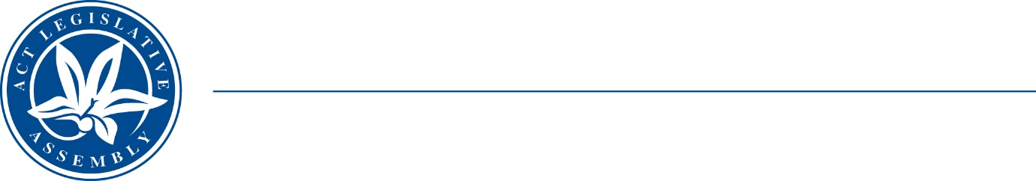
Standing Committee on justice and community safety
Mr Peter Cain MLA (Chair), Dr Marisa Paterson MLA (Deputy Chair),
Mr Andrew Braddock MLA
Ms Caroline Le Couteur MLA

LEGISLATIVE ASSEMBLY
FOR THE AUSTRALIAN CAPITAL TERRITORY

TERMS OF REFERENCE

Inquiry into the Administration of Bail

The Committee will inquire and report on the administration of bail in the ACT with reference to:

- Support service interaction for people on bail
- Young people on bail
- Mental health and bail
- Supervision of people on bail
- Prevention of re-offending on bail
- Dangerous driving offending on bail
- Presumption of bail
- Bail support programs
- Any other related matter

