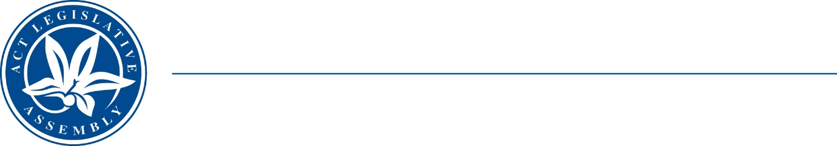
Standing Committee on Economy and Gender and Economic Equality
Ms Leanne Castley MLA (Chair), Ms Suzanne Orr MLA (Deputy Chair),
Mr Johnathan Davis MLA
Ms Caroline Le Couteur MLA

LEGISLATIVE ASSEMBLY
FOR THE AUSTRALIAN CAPITAL TERRITORY

Media Release

Extension of submission deadline

Inquiry into HOUSING AND RENTAL AFFORDABILITY
The ACT Legislative Assembly’s Standing Committee on Economy and Gender and Economic Equality (the Committee) has extended the deadline for submissions to its Inquiry into Housing and Rental Affordability until after the tabling of the ACT Budget for 2022-23. The Committee has made this decision to allow interested community groups and individuals to consider the implication of the Budget in making a submission to the Inquiry. The new deadline for submissions is 5pm Monday 8 August 2022.
The Committee’s terms of reference for the Inquiry are available on the Legislative Assembly website.
Information about how to make a submission is available on the Assembly website.

STATEMENT ENDS—28 July 2022
–––––––––––––––––––––––––––––––––––––––––––––––––––––––––––––––––––––––––––––––––––––––––
contacts: | Ms Leanne Castley MLA  (for comment on the inquiry) | Committee Chair | (02) 620 50283
contacts: | Mr Samuel Thompson  (for further information) | Committee Secretary | (02) 620 50435

