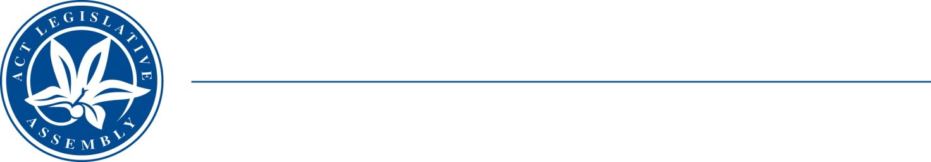
LEGISLATIVE ASSEMBLY
for the Australian Capital Territory

FOR THE AUSTRALIAN CAPITAL TERRITORY

FOR THE AUSTRALIAN CAPITAL TERRITORY

Standing Committee on Planning, Transport and City Services
Jo Clay MLA (Chair), Suzanne Orr MLA (Deputy), Mark Parton MLA

Media Release
On 22 June 2021 the Road Transport (Safety and Traffic Management) Amendment Bill 2021 (No 2) was presented in the Assembly by the Chair of the Committee, Jo Clay MLA.
The Bill stands referred to the Standing Committee on Planning, Transport and City Services under a resolution of the Assembly of 2 December 2021.
On 1 July 2021 the agreed to inquire further into the Bill, and is calling for submissions to the inquiry, with a closing date of 23 July 2021.

Further inquiries:
Office of the Chair, Jo Clay MLA: 6205 0131 or CLAY@parliament.act.gov.au
Dr Brian Lloyd, Secretary: 6205 0137 or brian.lloyd@parliament.act.gov.au
2 July 2021
[End]

