# Inquiry into ACT Libraries

Standing Committee on Environment and Transport and City Services

November 2018

Report 7

## The Committee

### Committee Membership

#### Current Members

* Ms Suzanne Orr MLA Chair
* Miss Candice Burch MLA Member (from 15 Feb 2018) and Deputy Chair (from 28 Feb 2018)
* Mr James Milligan MLA Member (from 20 September 2018)

#### Previous Members

* Mr Steve Doszpot MLA Deputy Chair (until 25 November 2017)
* Mr Mark Parton MLA Member (until 15 February 2018)
* Ms Tara Cheyne MLA Member (until 20 September 2018)
* Ms Nicole Lawder MLA Member (from 15 February 2018 to 20 September 2018)

### Secretariat

* Brianna McGill Secretary
* Jindriska Coufalova Senior Research Officer
* Lydia Chung Administration
* Michelle Atkins Administration

### Contact information

Telephone 02 6205 0124

Post GPO Box 1020, CANBERRA ACT 2601

Email [LACommitteeETCS@parliament.act.gov.au](mailto:LACommitteeETCS@parliament.act.gov.au)

Website [www.parliament.act.gov.au](http://www.parliament.act.gov.au)

### Resolution of appointment

The Legislative Assembly for the ACT agreed by resolution on 13 December 2016 to establish legislative and general purpose standing committees to inquire into and report on matters referred to them by the Assembly or matters that are considered by the committees to be of concern to the community, including:

A Standing Committee on Environment and Transport and City Services to examine matters related to city and transport services, public infrastructure, heritage, and sport and recreation and matters related to all aspects of climate change policy and programs, water and energy policy and programs, provision of water and energy services, conservation, environment and ecological sustainability.[1]

### Terms of reference

The Standing Committee on the Environment and Transport and City Services resolved to inquire into the current and future need for library sites and the best, most cost effective model of library service points with particular reference to:

1. The role of libraries within the ACT community.
2. Strategic planning for libraries in the ACT including:
   1. Current practice;
   2. Potential revisions to current practice and the associated benefits; and
   3. Opportunities for community involvement.
3. The nature and extent of current and future demand for different library services including:
   1. Non-digital offerings;
   2. Digital offerings;
   3. Education and training opportunities;
   4. Facilities available for public use;
   5. Spaces for learning, creativity and for achieving social inclusion;
   6. Other government services co-located with libraries; and
   7. Any other library services sought by the community.
4. The extent to which ACT Libraries are positioned to respond flexibly to meet current and future community opportunities and demands.
5. The extent to which ACT Libraries are accessible to the community, including:
   1. Opening hours;
   2. Locations; and
   3. Disability access.
6. The cost effectiveness of existing branches.
7. Comparative analysis of ACT Libraries with library services in other jurisdictions and community take-up of these services.
8. Any legislative considerations that may be relevant.
9. Any other relevant matter.

The Terms of Reference were agreed in advance on 28 February 2018, however the inquiry commenced with the public announcement on 2 August 2018.

## Acronyms

|  |  |
| --- | --- |
| ABEA | ACT Bilingual Education Alliance |
| ALIA | Australian Library and Information Association |
| ACTLIS | Former ACT Library and Information Service |
| APLA | Australian Public Library Alliance |
| CMCF | Canberra Multicultural Community Forum |
| COTA | Council on the Ageing ACT |
| IFLA | International Federation of Library Associations |
| NLA | National Library of Australia |
| NSLA | National and State Libraries Australia |
| NSLAA | National and State Libraries Australasia |
| PWD | People with Disabilities ACT |
| TAMS | Former Territory and Municipal Services Department |
| TCCS | Transport Canberra and City Services |
| WWD | Women with Disabilities ACT |

Table of Contents

The Committee i

Committee Membership i

Secretariat i

Contact information i

Resolution of appointment ii

Terms of reference ii

Acronyms iv

Recommendations ix

1 Introduction 1

Conduct of the Inquiry 1

Structure of the report 2

Acknowledgements 2

2 History of public libraries 4

International origins of public libraries 4

History of public libraries in Australia 4

History of library services in Canberra 6

3 Role of public libraries 10

4 Current public library services in the ACT 13

Legislative and policy context 13

Organisational structure 13

Purpose and vision 21

Funding and expenditure 21

Workforce 22

5 Community perspectives on Libraries ACT 24

Role of public libraries in the Canberra community 24

Impact of the library on people’s lives 26

How Canberrans use the library 28

Libraries as a community space 31

Appreciation for library staff 35

Opening hours 37

Branch locations 41

Appreciation for ability to manage loans online 47

Calls for improvement to the website and catalogue 48

Physical collection (books, magazines, newspapers) 50

Electronic resources and digital services 51

Car parking and integration with public transport 52

Concern that the inquiry signals plans for potential branch closures or reduction in funding 53

Feedback to the Committee on the inquiry process 54

6 Performance of Libraries ACT 55

ACT Government reporting 55

National Standards and Guidelines 55

Overview of Libraries ACT performance 56

Expenditure 58

Return on investment 60

Library membership 61

Library loans 63

Library visits 65

Digital visitor numbers 66

Awareness of library services in the community 66

Comparison between ACT Library branches 67

Comparison with other States and Territories 71

Print collection 71

Digital collection 72

Collection management 72

Staff qualifications, training and rostering 76

Co-location with government and community services 78

Lifelong learning programs 84

Public computers with internet access 91

Meeting rooms available for public use 92

Volunteers 95

Legal deposit legislation 96

7 Community Engagement and Social Inclusion 98

Providing safe and welcoming spaces for people vulnerable to social isolation 98

Community participation in decision making 99

People with disability 102

Children and young people 109

Older people 111

Aboriginal and Torres Strait Islander community 112

Culturally and linguistically diverse communities 116

Fines for overdue books 120

8 Conclusion 123

Appendix A – Witnesses 125

17 October 2018 125

Appendix B – Submissions 126

Appendix C – Questions taken on Notice/ Questions on Notice 129

## Recommendations

Recommendation 1

5.5 The Committee recommends that the evidence submitted to this inquiry in submissions and hearings also be considered by ACT Government during the development of the next strategic plan for Libraries ACT.

Recommendation 2

5.56 The Committee recommends that the ACT Government review opening hours as part of the strategic plan, in consultation with the community.

Recommendation 3

5.57 The Committee recommends that the ACT Government explore ways to facilitate after-hours access to Libraries ACT services without introducing significant staff costs, such as parcel collect lockers.

Recommendation 4

5.75 The Committee recommends that the ACT Government consider an additional library branch for the Molonglo and Weston Creek region as the population grows.

Recommendation 5

5.83 The Committee recommends that the ACT Government upgrade the Libraries ACT website and online catalogue, following consultation with the community, and identification of best practice website design and functionality among public libraries nationally and internationally.

Recommendation 6

6.38 The Committee recommends that the ACT Government enhance the marketing and communications of library services, to increase community awareness of the free resources available to them.

Recommendation 7

6.99 The Committee recommends that the ACT Government explore opportunities for further partnerships between Libraries ACT and government and community services.

Recommendation 8

6.118 The Committee recommends that the ACT Government develop and promote specialist digital literacy training programs at libraries for people with disability.

Recommendation 9

6.140 The Committee recommends that the ACT Government develop an electronic booking system for meeting rooms in library branches, to reduce administrative burden on library staff and improve accessibility for the community.

Recommendation 10

6.141 The Committee recommends that the ACT Government increase the number of meeting rooms available to the community, and facilitate after-hours access, particularly at Woden Library.

Recommendation 11

6.147 The Committee recommends that the ACT Government enhance and promote volunteering opportunities available in Libraries ACT.

Recommendation 12

7.15 The Committee recommends that the ACT Government engage in a co-design process with the community when developing the new strategic plan for Libraries ACT.

Recommendation 13

7.16 The Committee recommends that the ACT Government design an engagement strategy to guide future community participation in decisions about library services, in partnership with the following community groups and the organisations representing them: children and young people, older people, people with disability, the Aboriginal and Torres Strait Islander community, culturally and linguistically diverse communities, people with mental illness, people experiencing homelessness, and the LGBTIQ community.

Recommendation 14

7.29 The Committee recommends that Libraries ACT develop and implement a Disability Action Plan, as an ongoing framework for continuous evaluation and improvement of the accessibility of library services, and that they do so in partnership with the disability community.

## Introduction

* 1. The Standing Committee on Environment and Transport and City Services (Committee) commenced an inquiry into ACT Libraries on 2 August 2018.

### Conduct of the Inquiry

* 1. The Committee announced this inquiry on 2 August 2018 and called for public submissions to be lodged with the Committee by 21 September 2018. This opportunity was publicised through media releases, notice in The Canberra Times, notice on the Committee website, mainstream media coverage, and social media channels.
  2. The Committee designed posters for display in each branch of ACT Libraries for 6 weeks from 13 August to 21 September 2018, inviting library users to participate in the inquiry. ACT Libraries advertised the inquiry on their website, and printed flyers for distribution in the branches.
  3. The Committee wrote by email to individuals, groups and organisations it considered likely to be interested in the inquiry. The Committee was conscious that some people who regularly use libraries do not have the resources to write a formal submission to an Assembly inquiry. Therefore it wrote to peak bodies, advocacy organisations and service providers working with children and young people, older people, people with disability, and homeless people; and organisations in the mental health sector, Aboriginal and Torres Strait Islander community, LGBTIQ community, and multicultural communities. Some of these organisations were able to convey to the Committee the experiences and perspectives of their members/clients.
  4. During this inquiry the Committee received [84 submissions](https://www.parliament.act.gov.au/in-committees/standing-committees-current-assembly/standing-committee-on-environment-and-transport-and-city-services/inquiry-into-act-libraries),[2] which are published on the Committee website and listed in Appendix B to this report.
  5. The Committee held one public hearing on 17 October 2018 and heard evidence from 8 witnesses. A list of witnesses who appeared before the Committee is provided at Appendix A. The [transcript of proceedings](https://www.parliament.act.gov.au/in-committees/standing-committees-current-assembly/standing-committee-on-environment-and-transport-and-city-services/inquiry-into-act-libraries)[3] is available on the Committee website.
  6. There was one question taken on notice at the public hearing, and two questions on notice after the hearing, and these are listed in Appendix C. [Questions and answers](https://www.parliament.act.gov.au/in-committees/standing-committees-current-assembly/standing-committee-on-environment-and-transport-and-city-services/inquiry-into-act-libraries)[4] are available on the Committee website.

### Structure of the report

* 1. This report is informed by research, submissions, and evidence provided at public hearings.
  2. Chapter 2 describes the international origins of public libraries, and the history of public library services in the Canberra region.
  3. Chapter 3 briefly outlines the purpose and role of public libraries, and the typical characteristics of modern public library services.
  4. Library services are constantly evolving and changing, and Chapter 4 provides a snapshot of public library services as they currently exist in the ACT in 2018.
  5. Chapter 5 contains an overview of the issues and topics most frequently raised in public submissions to this inquiry.
  6. Chapter 6 examines the performance of ACT public libraries against ACT Government performance indicators, and national guidelines and standards.
  7. Chapter 7 considers the efforts by Libraries ACT to engage with the community, and to be accessible and inclusive to a wide range of community groups with diverse needs.
  8. Chapter 8 concludes this report by emphasising the value and importance of public libraries for the ACT community.

### Acknowledgements

* 1. The Committee wishes to thank the following people, and acknowledge their important contribution to the inquiry:
* All the individuals and organisations who made submissions to the inquiry, and the organisations who appeared before the Committee at the public hearing.
* Libraries ACT, who publicised the inquiry through their website, and displayed posters and flyers at library branches, in order to inform people of the opportunity to participate in this inquiry.
* Council on the Ageing (COTA) ACT, who surveyed their membership in preparing their submission.
* Health Care Consumer Association, who consulted with their membership in preparing their submission.
* People with Disabilities ACT, who informed its membership and other organisations in the disability sector of the opportunity to participate in the inquiry.

## History of public libraries

* 1. Chapter 2 describes the international origins of public libraries, and the history of public library services in the Canberra region.

### International origins of public libraries

* 1. In the English language the word ‘library’ can refer to a collection of books, or the building or space that houses them. The origins of libraries trace back to the beginning of written script in the Middle East around 3400 BC. Originally there was no distinction between an archive and a library; the first libraries were established to hold legal, commercial and administrative records in ancient Mesopotamia (covering the land area now known as Iraq), and later in Ancient Egypt and Ancient Greece. During the Roman Empire many private libraries were established as the concept of book collecting developed.[5]
  2. These early libraries were not accessible to the general public; they were state archives of administrative documents, or private collections of literature. The first ‘public’ libraries were established under the Roman Empire around 30 BC (though they were not available to all people). During the Middle Ages, monasteries and universities played an important role in the preservation of knowledge and the development of libraries in Europe. Libraries also developed separately in the Arab world, China, and southeast Asia.[6]
  3. In the 17th and 18th centuries book collecting became more widespread, and subscription libraries were common in Europe and America. The 18th and 19th centuries saw an expansion of public libraries in these regions, but they were dependent on private patronage; industrialisation had made a small number of business people extremely wealthy, and some of them became philanthropists and funded free public libraries. Eventually by the middle of the 19th century the idea was accepted that community libraries might be provided at public expense, and made freely available to everyone (or at least people with literacy and leisure).[7]

### History of public libraries in Australia

* 1. For most of Australia’s history, knowledge was retained and shared not in books and library buildings, but in relationships. Over tens of thousands of years, and continuing today, Aboriginal people and Torres Strait Islanders have expressed and transmitted knowledge and cultural heritage to new generations in the forms of story, art and dance.
  2. UNESCO describes Indigenous knowledge as ‘the understandings, skills and philosophies developed by societies with long histories of interaction with their natural surroundings’.[8] Indigenous knowledge is constantly evolving; it is dynamic not static, and includes:

‘traditional cultural expression such as the songs, dances, stories and languages; and the traditional knowledge including ecological knowledge of biodiversity, medicinal knowledge, environmental management knowledge and cultural and spiritual knowledge and practices. Indigenous Knowledge is the intangible cultural heritage of Indigenous people.’[9]

* 1. At the time of European settlement in 1788, the knowledge of Aboriginal and Torres Strait Islander people, the original inhabitants of the land and seas in Australia, was not codified or written down, but rather: ‘important information was recorded in storytelling, art and dance, then elders taught the younger ones, when the time was right… The rights and responsibilities of passing on Indigenous Knowledge was traditionally guided by customary laws.’[10]
  2. The first library to open in Australia was the Australian Subscription Library, built in 1926 on Pitt Street in Sydney, and later moving to Macquarie Street, the site of the current State Library of NSW. However for the first 43 years it charged fees for membership, and only became a free public library in 1869 when the New South Wales Government purchased the organisation and established the Sydney Free Public Library. In 1895 it became the Public Library of NSW, and in 1975 it became the State Library of NSW.[11]
  3. The modern concept of a ‘public library’ is a building that it is available to everyone; publicly funded; and free. On this definition, the first public library in Australia was the Melbourne Public Library, established in 1854. It was ‘one of the first free public libraries in the world’, and later evolved to become the State Library Victoria.[12] The founders believed that:

‘access to knowledge was critical for the development of a civil and prosperous community, and created the Library as 'the people’s university' – a place of learning and discovery for all Victorians. They also charged the Library with preserving Victoria's heritage by collecting items of historical and cultural significance for future generations.’[13]

### History of library services in Canberra

* 1. In 1855, during the early decades of European settlement in the Canberra region, the rector of St John’s Church established a library for his parishioners called ‘Canberra Church Lending Library’.[14] The rules of the lending library stated that:

‘a book could be borrowed for two weeks; that anyone who lost a book had to pay the full price of the book; that if a book were damaged or soiled, the borrower has to pay a fine determined by the librarian; that a borrower who had an overdue book was liable for a fine of one penny per week or part of a week; and that one borrower was not allowed to transfer a book to another. Fines were used to buy new books, and contributions to the library were welcome.’[15]

* 1. The library closed sometime before 1905, but the Church still exists today in the suburb of Reid.[16]
  2. In the 1920s the Canberra Social Service Association, a volunteer group operating out of a tin building in Acton, established the Canberra Community Library. Volunteers delivered books to workers who came to the region to build the infrastructure of the National Capital and were billeted in work camps. This library was still in existence in 1936.[17]
  3. The first government-funded public library service emerged after 1927, when the Federal Parliament moved from Melbourne to Canberra, and local citizens were given access to the Commonwealth Parliamentary Library. In 1931 lending of books to the general public began from Parliament House on Saturday mornings. In 1935 a reading room for the people of Canberra was opened on Kings Avenue.’[18]

#### Transitions in governance and management

* 1. Library services in Canberra have evolved with the development of the city, and self government. From the 1930s to 1970s an extension division of the National Library of Australia (NLA) was responsible for developing public library services in the ACT. In 1960 the name *Canberra Public Library Service* was adopted, and the Canberra Public Library Service Advisory Committee was established in 1963 to enable local citizens to put forward their views on the management of the service to the Council of the NLA.[19]
  2. In 1981 responsibility for Canberra Public Library Service was transferred from the NLA to the Commonwealth Department of Capital Territory, and the name changed to *ACT Library Service* in 1986. In 1989 there was another major transition when responsibility for library services transferred to ACT Government with self-government for the territory. Two further name changes followed; to *ACT Library and Information Service* in 2000, and *Libraries ACT* in 2011.[20]

#### Relocations of library branches

* 1. The physical locations of public library services in Canberra have changed significantly over time, as the city has grown. As mentioned above, the first government funded service opened in 1935 on Kings Avenue, and this building became the headquarters for the Canberra Public Library Service in 1960. In 1970 the Central Library collection relocated to Leichhardt Street Kingston, relocating again in 1994 to Blaxland Crescent Griffith, before that branch closed in 2006.[21]
  2. In the 1950s and 1960s small children’s libraries were operated on a part time basis by volunteers on temporary sites in Kingston, Ainslie, Yarralumla, Turner, Lyneham, Red Hill, Narrabundah, Curtin and O’Connor. These service locations were gradually closed in the 1970s and 1980s. For a short time library services also operated from temporary sites at Hughes, Downer and Mawson. [22]
  3. The current nine branches of Libraries ACT opened in sequence between 1969 and 2011. In 1969 Dickson Library opened as the first permanent district library. Woden Town Centre Library was the second to open in 1977. Belconnen Town Centre Library began operating in 1981 (after operating from a temporary site at Jamison). Erindale Library was officially opened by HRH the Princess of Wales in 1983. Tuggeranong Library commenced operation in 1990. Kippax Library opened in 2005 on Hardwick Crescent (after operating from a temporary site nearby). Civic Library moved to its current site in Civic Square in 2006 (though it had a long history before this time, operating in East Row from 1990, and in North Building from 1961). The small Kingston Library shopfront opened on Giles Street in 2009. Finally, in 2011 the new Gungahlin library opened on the corner of Hibberson and Gozzard streets (after operating from a temporary site nearby).[23]
  4. A Mobile Library operated for more than four decades from 1959, and the Home Library Service was introduced in 1981. The ACT Heritage Library opened in 1995.[24]

#### Evolution of the library collection

* 1. The content of the ACT library collection has changed over time, as new forms of material have become available for borrowing. Fiction books were added to the collection in 1948, and paperbacks included in 1974. In 1975 music listening facilities were introduced (people could listen to records in the library but not take them home), and printed music was loaned from 1977. The library offered spoken word cassettes during the 1980s, initially as a service for people with vision impairment. CDs and DVDs were then included in the collection, and in 2006 eBook and eAudiobook services were introduced.[25]

#### Technological change

* 1. Developments in technology over the decades have changed the way people interact with and use public library services in the ACT. Before computers and digital scanning technology, libraries in Canberra used a Westminster token system, and a modified Newark Card System, to manually record loans.[26] Under the Westminster system, readers were given plastic tokens which they exchanged for each book they wished to borrow; ‘[t]here was no record of who had out what books, so no overdue letters could be sent, but once a year each reader was written to and they had to produce all their tokens or pay a forfeit.’[27] Under the Newark system:

‘when a book is lent the date of issue or the date due is stamped on the book card, on a plate in the book, and on the borrower's card and the borrower's name or number also is recorded on the book card which is filed until the book is returned and the return is recorded on the borrower's card.’[28]

* 1. The way people borrow library books has changed dramatically with the development of digital technology. Computerised cataloguing was introduced to Canberra Public Library Service in 1975, and the catalogue converted to microfiche in 1977. Barcoding of the library collection began in 1989, and this led to a significant increase in borrowing limits; from two items in the 1970s, and four items in the 1980s, to 100 items at the peak, and then back down to the current 50 items per member. The introduction of radio-frequency identification (RFID) technology in 2010 led to gradual introduction of a self-checkout system for borrowing items, rather than approaching a librarian at the loans desk for checkout.[29]
  2. When use of the internet became widespread in the 1990s, libraries fairly quickly made it available to the community. Dial-up internet access was established within library branches in 1996, and in 2010 wireless internet access was introduced.[30]
  3. Communication between the library and borrowers has also changed significantly. Dial-up access from home computers to the ACT Library Service catalogue was established in 1995, and the first library website was launched in 2000, named the ‘ACT Virtual Library’. 2006 saw the launch of SMS messaging for library notices, and an email service notifying borrowers of the possibility of their library items becoming overdue. In 2009 libraries began using social media. Libraries ACT launched a new device-responsive library website in 2013 to respond to the emergence of smart phones and tablets.[31]

## Role of public libraries

* 1. Chapter 3 briefly outlines the purpose and role of public libraries, and the typical characteristics of modern public library services.
  2. As demonstrated in Chapter 2, ‘the history of libraries has been a story of constant change and adaptation’,[32] and the role of libraries is continuously evolving:

‘Public libraries across Australia are transforming their facilities, programs, services, technologies and staff skills to meet the challenges of our increasingly digital society.’[33]

‘As new technology has changed and allowed ever new ways of creating, storing, organising, and providing information, public expectation of the role of libraries has increased.’[34]

* 1. The International Federation of Library Associations (IFLA) defines public libraries in this way:

‘A public library is an organisation established, supported and funded by the community, either through local, regional or national government or through some other form of community organisation. It provides access to knowledge, information, lifelong learning, and works of the imagination through a range of resources and services and is equally available to all members of the community regardless of race, nationality, age, gender, religion, language, disability, economic and employment status and educational attainment.’[35]

* 1. IFLA describes the purpose of public libraries:

‘The primary purpose of the public library is to provide resources and services in a variety of media to meet the needs of individuals and groups for education, information and personal development including recreation and leisure. They have an important role in the development and maintenance of a democratic society by giving the individual access to a wide and varied range of knowledge, ideas and opinions.’[36]

* 1. Australian Library and Information Association (ALIA) informed the Committee that a modern Australian public library typically offers:

‘books, magazines, newspapers, DVDs, wifi, PC internet access, learning programs, fun activities and expert staff help.’[37]

* 1. The Committee heard that there is no single model for a modern public library service, but that an effective library service evolves in partnership with the surrounding community:

‘The point is, of course, that there is no one perfect plan for what makes a library in the modern world and the role of libraries is evolving as much as the needs of libraries are evolving. The most popular libraries, I have found, are not necessarily measured by resources, but by how well they work with the members of the local community to better understand their needs and adapt to those needs.’[38]

‘Providing good library services is a constant and dynamic process of building, repositioning, repurposing and responding to demographic and technology changes. This ongoing development must be appropriately funded and informed by community consultation.’[39]

* 1. Public libraries are founded on the principles of access and equity; they are free and available to all:

‘The services of the public library are provided on the basis of equality of access for all, regardless of age, race, sex, religion, nationality, language or social status.’[40]

‘The goal of libraries has always been to provide access and equity, with the belief that nobody should be denied access to any information because he or she cannot afford the cost of a book or a periodical, nor access to the internet or any other form of information.’[41]

* 1. Libraries provide economic and social benefits to communities, and contribute to an informed and democratic society:

‘the public library is acting as an agency for social and personal development and can be a positive agency for change in the community. By providing a wide range of materials to support education and by making information accessible to all, the public library can bring economic and social benefits to individuals and to the community. It contributes to the creation and maintenance of a well–informed and democratic society and helps to empower people in the enrichment and development of their lives and that of the community in which they live.’[42]

* 1. The Committee was told that by promoting literacy and lifelong learning, libraries improve people’s quality of life:

‘Libraries provide practical and flexible literacy services to allow the whole community to access services and improve their skills… Education and good literacy, which are increasingly in the digital context, improve quality of life. A person is more likely to have a job, to earn an income, to be in good health, and to be involved with the local and global economy if they have functional literacy skills. Businesses of all sizes are more productive with a more literate workforce and greater digital capability.’[43]

* 1. National and State Libraries Australia (NSLA) described in their submission how people interact with libraries:

‘Libraries are at the heart of the educational, cultural and creative life. They are inclusive spaces open to everyone. People interact with libraries online and in person so they can access, use and share global knowledge and ideas. They come to libraries to learn, to read, to ask for help, to access technology and to spend time in the shared public spaces. People trust libraries.’[44]

* 1. ACT Government told the Committee that libraries have the potential to change lives:

‘Libraries are an invaluable asset in helping communities respond to change and are unique in their ability to do so. Arguably, few organisations or services have the capacity, or the ability to change so many lives. As noted by Anne-Marie Schwirtlich, the then CEO and State Librarian of the State Library of Victoria: “No other agency in society has the multiplicity of roles, or user range and diversity, or potential to influence so many lives.”’[45]

## Current public library services in the ACT

* 1. Library services are constantly evolving and changing, and Chapter 4 provides a snapshot of public library services as they currently exist in the ACT in 2018.

### Legislative and policy context

* 1. Libraries ACT is a business unit within Transport Canberra and City Services (TCCS), a Directorate of ACT Government. Libraries ACT receives an annual budgetary allocation from ACT Government to provide: ‘library services to the community through Libraries ACT’s branches, home library service, the ACT Virtual Library and the Heritage Library.’[46] Libraries ACT operations are guided by two strategic plans,[47] and a range of internal policy documents.[48]
  2. In other Australian jurisdictions (except Tasmania) public libraries are provided by local councils, while the state governments each operate a state library to ‘collect, preserve and provide access to the documentary history of Australia’.[49] In contrast, Libraries ACT combines both functions (public library services and state library) in one organisation.

### Organisational structure

* 1. Libraries ACT is currently grouped into the following business units: ACT Public Libraries (nine branches listed below); Library Support Office (including Digital Services and Lifelong Learning Team); Customer Information Centre; Collection Management and Virtual Library; Home Library Service; and ACT Heritage Library.[50]
  2. Libraries ACT comprises the ACT Heritage Library and nine public library branches, located in Belconnen, Civic, Dickson, Erindale, Gungahlin, Kingston, Kippax, Tuggeranong, and Woden. A brief description of each library is provided here (in alphabetical order).

#### ACT Heritage Library

* 1. The ACT Heritage Library ‘helps tell the stories of Canberra and its people’:[51]

‘The ACT Heritage Library collects, preserves and makes accessible the social, cultural, and environmental history of Canberra as a place and a community. A visit to the Heritage Library introduces you to 106,500 publications, photographs, diaries, maps and other items about our lives as Canberrans.’[52]

* 1. Currently located within Woden Library, the Committee was told that ‘[b]y the end of 2018, the ACT Heritage Library will move from its current site on the first floor of the Woden branch to new premises at 255 Canberra Avenue, Fyshwick’,[53] with plans for a future move to a purpose built facility:

‘The new space at 255 Canberra Avenue Fyshwick is being fitted with fire retardant walls and climate control to manage both temperature and humidity conditions for often fragile paper and other materials. This relocation is a medium term, temporary one. In the future it is hoped that a purpose built or modified facility can be created, shared with Archives ACT and the Canberra Museum and Gallery. All three agencies, while with a different focus, need similar storage conditions to ensure the preservation of irreplaceable documents and objects of significance to the ACT’s cultural and historical heritage.’[54]

#### Belconnen Library

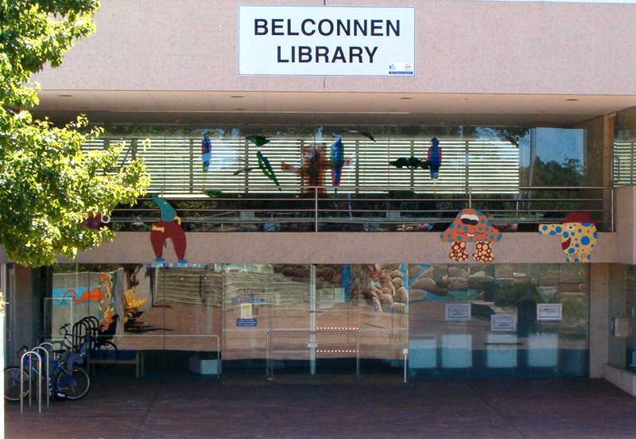

* 1. Location: 12 Chandler Street, Belconnen.
  2. Description of Belconnen Library provided by ACT Government:

‘Opened in 1981, the Belconnen Library is a significant distance from other services that the community wants to access in a multi-purpose trip. There is limited parking around the library. Considering both the resident and working populations of Belconnen it would be expected that this branch performs as well, or better than, Woden, which is not the case. The Belconnen Branch Library currently also hosts the Home Library Service, which provides home delivered library materials for the elderly and housebound in our community. This building was recognised in 1982 with the Royal Australian Institute of Architects (RAIA) ACT Chapter Canberra Medallion, and in the 2010 ACT Architecture Awards as winner of the 25 Year Award for Enduring Architecture.’[55]

#### Civic Library

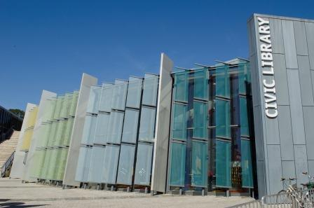

* 1. Location: Civic Square, London Circuit, Canberra City.
  2. Description of Civic Library provided by ACT Government:

‘This branch opened on its current site in 2006 after moving from the city bus interchange. Visits and loans dropped following this move, with a lack of easy parking and London Circuit as a physical barrier for shoppers and workers in the city centre. Currently the Civic Branch does not offer many programs for children, although as new city apartments come on line and should demographics in this area change, the library service may change this approach. As with many city-based libraries, Civic is used frequently as a pick up point for requested items. The Access Canberra Drivers’ Licence Centre is located in this branch.’[56]

#### Dickson Library

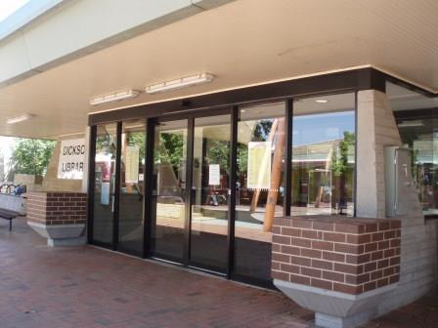

* 1. Location: Dickson Shops (off Antill Street), Dickson.
  2. Description of Dickson Library provided by ACT Government:

‘An Enrico Taglietti designed building, this branch was opened in 1969. It is a high performer and is the busiest branch per square metre. The building was awarded the Royal Australian Institute Association (RAIA) ACT Chapter 25 Year Award in 1995. It is in an ideal location and the community have a great deal of fondness for this branch, many of whom grew up using it as their local library. In June 2018 the library was temporarily closed for urgent repair works and was partially re-opened on 6 July. As with buildings of this age, there are increasing maintenance issues and the library service is constrained about what can be undertaken in the library by the fact that it doesn’t meet current building codes and it is heritage listed. It is expected this branch will become even busier as more apartments are built along the Northbourne Avenue corridor and supermarkets are added to the shopping centre. This will necessitate some important future planning for the site. In November 2016, approximately 450 people arrived at the Dickson Branch for a single Giggle & Wiggle session. As a result of this increasing use, the library service introduced bookings and multiple sessions for this program.’[57]

#### Erindale Library

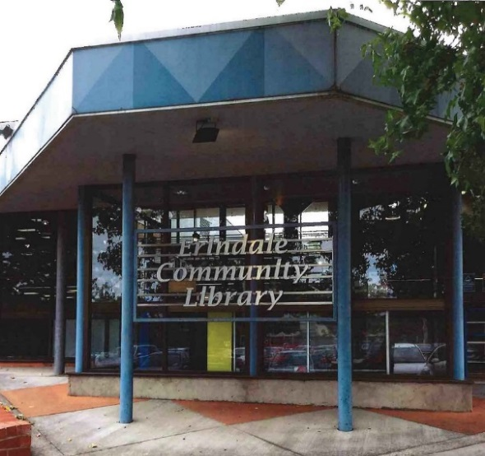

* 1. Location: McBryde Crescent, Wanniassa.
  2. Description of Erindale Library provided by ACT Government:

‘Erindale is a shared facility with the Erindale College. It is a relatively quiet branch. It is remembered fondly by locals as the branch opened in 1983 by Her Royal Highness the Princess of Wales. Like many of our branches, Erindale has been host over the years to different community groups and activities. It is also the branch with high ceilings and an installation which has displayed community quilts over many years.’[58]

#### Gungahlin Library

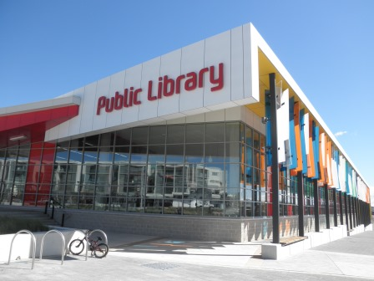

* 1. Location: Corner of Hibberson and Gozzard streets, Gungahlin.
  2. Description of Gungahlin Library provided by ACT Government:

‘The first Gungahlin library was a small facility originally opened in 2001. It relocated in 2011 as a shared facility with the Gungahlin College. The library was built on 21st century library principles of lifelong learning, literacy and social inclusion, with flexible learning spaces and up to date technology. This library is quite well located, adjacent to the town centre shopping precinct. It has trialled a different method of displaying the non-fiction collection – in zones rather than by the Dewey Decimal system. This is an experiment in providing the community with a bookshop-like experience and is currently being reviewed to see if it will be rolled out across all public library branches. Gungahlin is a relatively high performing branch although some in the community prefer to use libraries that are not shared with college students. It is the newest building in the library service, and as a result it is the one which most reflects 21st century, contemporary library design.’[59]

#### Kingston Library

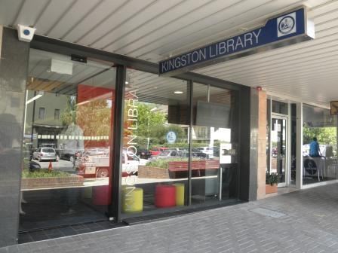

* 1. Location: 52 Giles Street, Kingston.
  2. Description of Kingston Library provided by ACT Government:

Opened in 2009, this branch is the result of the first ALP/Greens Agreement. The brief to the architect for this library was ‘funky New York loft bookshop’ and the library is a diminutive 190 square metres. The community have embraced this little library although it is relatively expensive to run given the commercial rent paid and the number of visitors. This branch was recognised in the 2010 ACT Architecture Awards with a commendation in the Interior Architecture category.’[60]

#### Kippax Library

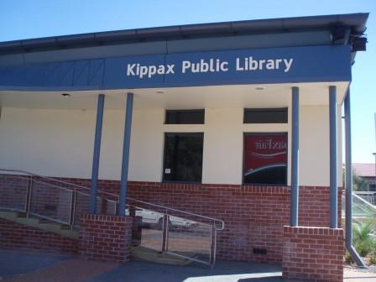

* 1. Location: Hardwick Crescent, Holt.
  2. Description of Kippax Library provided by ACT Government:

‘This library opened in 2005 and is a suburban rather than town centre branch. Its benefits include its proximity to the Kippax Fair shopping centre and the easy and free parking available. It is quite traditional in its design and lacks flexible learning spaces of a significant size. Future planning for this branch will be important as the Ginninderry development progresses and the catchment population increases. Consideration of floor space, the types of spaces, facilities and service levels will be needed. This library enjoys a strong relationship with the West Belconnen Child and Family Centre and works collaboratively to develop programs and other opportunities for the community.’[61]

#### Tuggeranong Library

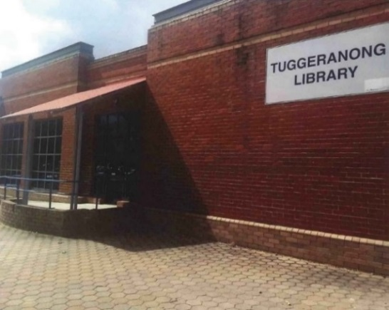

* 1. Location: Cowlishaw Street, Tuggeranong.
  2. Description of Tuggeranong Library provided by ACT Government:

‘The most southern of our branches was opened in 1990 and was recognised with an architectural design award. While an award-winning building, the design does present challenges to operating a 21st century public library service. Shared with the Lake Tuggeranong College, this branch is located with a beautiful view of the lake. This branch is tucked out of the way and there is not a lot of passing foot traffic to encourage new users. It is not close enough to the main street of Tuggeranong for the community to park the car and do the multi-purpose trip – shop and visit the library.’[62]

#### Woden Library

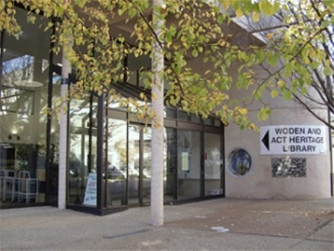

* 1. Location: Corinna Street, Phillip.
  2. Description of Woden Library provided by ACT Government:

‘The busiest branch in terms of visitors and loans, the Woden Branch is well located and used. It enjoys the benefit of being located adjacent to the Westfield Shopping Centre and Commonwealth Government offices. Opened in 1977, the heritage listing on this building allows more flexibility than Dickson and when the ACT Heritage Library moves out later this year, a small refurbishment will occur. Already, the resumed space from the re-location of the Access Canberra shopfront is being put to good use by the community as a meeting and learning space. Woden branch hosts a café which is a social enterprise. Through this, the ACT Government is able to support migrants starting out on their employment journey, while improving the customer experience for library patrons. With the upcoming redevelopment of the Albemarle and Alexander buildings into apartments, there are opportunities to extend the range of services to residents in close proximity to the library and planning for this will occur in the very near future.’[63]

### Purpose and vision

* 1. In the current strategic plan, Libraries ACT declares that ‘[w]e champion literacy, learning and the pleasure of reading, and inspire and connect people, engaging them with their community and the world.’[64] ACT Government informed the Committee that the role of Libraries ACT is:

‘Lifelong learning -- Providing access to learning resources and programs on topics including health and wellbeing, sustainability, music, art, writing, science and life skills, and supporting learning outside formal education pathways.

‘Connecting people with information and ideas in various formats (print, audio visual, digital, and new and emerging formats).

‘Supporting literacy for all ages – Starting at birth and progressing through early childhood library resources and programs are essential in supporting children’s language development, which at age 3 is the single most important predictor of language skill at age 9, directly impacting their learning and lifelong achievement. This support continues into adult hood, with a volunteer adult literacy tutoring program for the approximately 31% of adult Canberrans unable to read or write well enough to successfully support themselves in daily life.

‘Offering access to technology and support and opportunities to develop digital skills.

‘Reflecting the diversity of our community – Sharing and celebrating different cultures, including that of our Aboriginal and Torres Strait Islander people, and of the various multicultural communities who have immigrated to Australia.

‘Social inclusion – Offering a place that welcomes all members of the community, and provides access to information and services they may not be able to otherwise access. For some library users, a visit to (or from) the library is the only contact they have with other people.

‘Providing meeting spaces and places which can act as a “community lounge room”.

‘Providing a trusted, unbiased venue for Government to engage with the community and seek their feedback or ideas.’[65]

### Funding and expenditure

* 1. Libraries ACT total income in 2015-16 was $13,310,698.[66] Table 1 shows minor variations in funding over the five years from 2012 to 2016:

Table 1: ACT Government expenditure on public library services over the five year period 2012 to 2016[67]

|  | 2011-12 | 2012-13 | 2013-14 | 2014-15 | 2015-16 |
| --- | --- | --- | --- | --- | --- |
| Expenditure | $13.47m | $14.02m | $13.19m | $13.60m | $13.49m |

* 1. In its Submission to the inquiry, ACT Government provided a diagram explaining how the Libraries ACT budget is allocated (see Diagram 1). The major costs for Libraries ACT are employee expenses (63%), followed by library materials (14%), and office rent (9%):

Diagram 1: Libraries ACT Expenditure, 2017-18, $million[68]

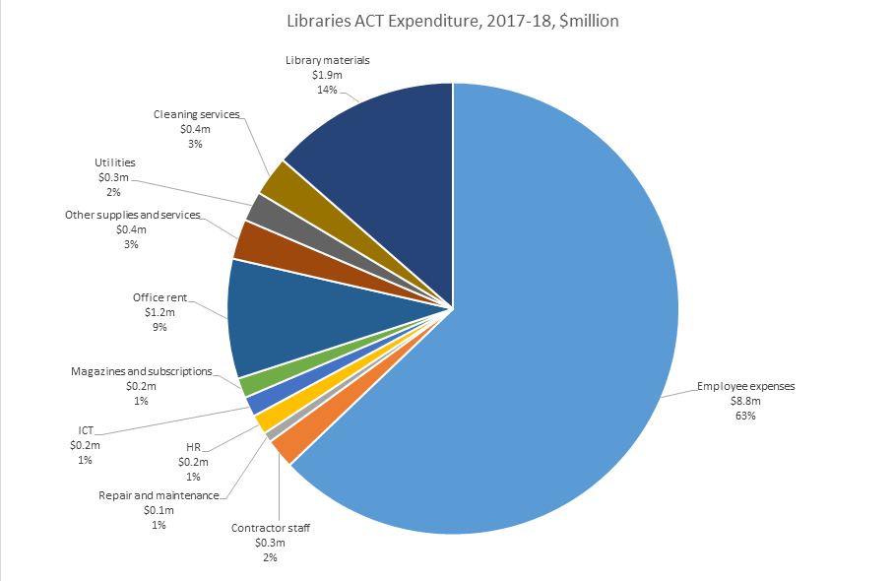

### Workforce

* 1. In 2015-16 there were 95.6 permanent full time equivalent (FTE) positions in Libraries ACT, and the proportion of professional positions was 24.1%.[69] At the time of this inquiry staff numbers remain at 95.2 FTE.[70]
  2. Diagram 2 was provided by ACT Government in its submission, and shows the percentage of the workforce engaged in different activities within the organisation. Most staff (66%) work in library branches; 22% work on projects (heritage library, home library service, digital services, collections, lifelong learning programs), and 10% work in administration.

Diagram 2: Libraries ACT Staff, 2017-18[71]

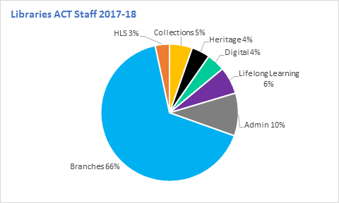

* 1. Graph 1 shows the distribution of staff across library branches. Woden and Dickson libraries have the largest staff allocation (10.9 and 9.3 FTE), while Kingston has the least (3.2 FTE).

Graph 1: Staff numbers employed at each branch of Libraries ACT (full time equivalent positions)[72]

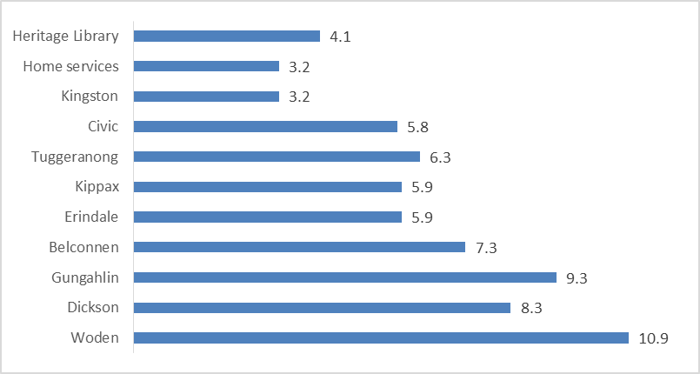

## Community perspectives on Libraries ACT

* 1. Chapter 5 contains an overview of the issues and topics most frequently raised in public submissions to this inquiry.
  2. Almost every submission received during this inquiry expressed a positive attitude towards the library, and many conveyed gratitude and affection. At the same time, most submissions put forward suggestions for improvement in library services.
  3. The three most frequently raised topics in the 84 submissions to this inquiry were: opening hours; followed by branch locations; and expressions of appreciation for library staff. Other common themes raised in many submissions were: role of public libraries in the community; importance of libraries as a community space; appreciation for the ability to request items and manage loans online; and requests for improvement to the library website and catalogue.
  4. The submissions contain rich qualitative information about people’s experiences with libraries in Canberra, and the Committee encourages Libraries ACT to consider this material in detail during its internal processes of review.

Recommendation 1

The Committee recommends that the evidence submitted to this inquiry in submissions and hearings also be considered by ACT Government during the development of the next strategic plan for Libraries ACT.

### Role of public libraries in the Canberra community

* 1. The Committee received many comments expressing the importance of Libraries ACT as an essential and highly valued service, and a sample is provided here:

‘The role of the Libraries in the ACT Community is vital.’[73]

‘I greatly value ACT Libraries and consider that the service should be expanded and better funded. It’s an important community resource.’[74]

‘Thank you for providing this important service to our community.’[75]

‘I truly believe that the ACT Libraries is the jewel in the crown of the ACT government.’[76]

‘we feel it’s vital to a strong community to have an excellent public library.’[77]

‘There’s not much wrong with the library service, and there’s probably no library which would not be improved with more staff, more space, more programs and more collection items, so while I have made suggestions for improvement, I think that overall the service is well-run and highly valued by the community.’[78]

‘I would like to convey how deeply I value and appreciate the service we receive at all the libraries in Canberra that I have used.’[79]

‘we were motivated to write because the library system has been, and continues to be, very important in our lives and we would all like to see it continue to be supported and flourish.’[80]

* 1. The Committee heard that libraries facilitate knowledge, learning and education, and promote wellbeing:

‘A city that values libraries and books is a city that values community, thinking, knowledge, lifelong curiosity and learning.’[81]

‘I believe the ACT Library plays a very important role in the ACT community. It contributes to residents’ education and well being at every stage of life.’[82]

* 1. Several submissions spoke about the role of libraries in fostering social inclusion and social interactions, for example:

‘ACT’s libraries play an important role in fostering social inclusion and community wellbeing, and providing services for the ACT community. Free-to-access services, products and advice are an important factor in ensuring equal access to opportunities for those struggling in the community, both financially and emotionally.’[83]

‘In a world that is increasingly expensive, consumer driven, and isolated - ACT Public Libraries continue to provide a welcoming and safe place for the community to gather.’[84]

‘The library is the last free space for all in the community and i think is an important part of civil society. When I go to the Kippax library I see families, retirees, new arrivals and many other sectors of the Canberra community enjoying the facilities. I think this is particularly important for those who are lonely or do not have the money to have internet at home.’[85]

* 1. The Committee was told that libraries contribute to an informed community, which is necessary for functioning of democracy:

‘The ready availability of a wide range of information sources on current events is critical to maintain a well-informed citizenry which can form educated and intelligent views on key issues facing the community and polity.’[86]

‘I see libraries as crucial supports to an educated, civil society. To read—and these days to watch, to hear and to search for on the internet—about things beyond a person's immediate experience is a well-proven means of getting out of yourself and appreciating the wider world. Libraries help people learn about and value our world and other people, and mature into contributing citizens.’[87]

### Impact of the library on people’s lives

* 1. The Committee received dozens of statements from individual Canberrans about the positive impact of libraries in their lives, including:

‘As a pensioner, I could not access such an interesting range of current material without the Libraries, so the service adds greatly to my quality of life.’[88]

‘Overall, I love the ACT library service and it would be very hard to live without it.’ (Person with a disability)[89]

‘We love the library, it’s an essential part of our life.’[90]

‘For myself the library is a source of lifelong learning and pleasurable reading.’[91]

‘ACT Libraries have enhanced the life of my family’.[92]

‘Living in the ACT is enlivened by the joys of ACT Libraries.’[93]

‘[Books] help me relax, learn and experience worlds, lives and events beyond my everyday existence.’[94]

‘there is nothing more valuable that the ACT government provides for me culturally than the library, and I hold the library system close to my heart.’[95]

* 1. People told the Committee that the library enables them to read more than would be possible if they had to purchase all their books:

‘I can borrow magazines rather than having to buy them. If I had to buy all the books I read in a year, I would be very poor and would undoubtedly read much less. I feel more learned and well read because I have a great local library.’[96]

‘The ACT Public Libraries services (both physical and digital) are integral to our family… We are all avid readers, and the ACT Public Libraries enable us to keep up a reading habit that would be completely unsustainable if we had to buy books.’[97]

* 1. Two people told the Committee that the location and quality of library services has informed their choice of where to live:

‘I moved to Lyons two years ago. One of the considerations in my making the move to there was the availability of the Library, as well as other services such as the shopping mall. I hope the library will be kept at Woden.’[98]

‘One of the reasons I decided to stay in the ACT and not move to the coast/another regional area was because of the excellent library service available to ACT patrons.’[99]

* 1. Several submissions expressed the importance of libraries for parents of small children, both for the child’s development, and for their own wellbeing:

‘In the past two years, the local library has been a saviour. Having a fantastic local library means I can easily request adult books I’d like to read to pick up when they’re ready and I can borrow piles and piles and piles of kids picture books and learn to read books for my toddler who demands new books every week.’[100]

* 1. The Committee heard that libraries are an important service for older people in retirement:

‘Retirement gave me the opportunity to read widely. The Woden Library has enabled me to achieve that joy and stimulation. The services provided and the brilliant staff have enhanced my pleasure and development. Thank you!’[101]

‘COTA ACT sought COTA ACT members’ views on ACT libraries via the COTA ACT monthly e-newsletter. Twenty one responses were received. The majority of responses were received from regular users of the ACT libraries, many of whom have been using the library for decades. The responses were overwhelmingly in support of the ACT Libraries and their importance in the lives of older Canberrans and the broader community.’[102]

* 1. Many submissions described the importance of libraries for promoting mental health and preventing social isolation, for example:

‘As I am a pensioner living on my own the library is my shield against isolation & depression. I meet up with others in a similar situation to my self & value the opportunity the library provides for friendship & communication. Over the long years I have used the library I have also established really good friendships with the Library staff & even getting to meet some of their family members. This has provided me with much joy & sometimes they are the only people I have opportunity to speak to during the day.’[103]

* 1. One person told the Committee she values the library so much she would be willing to contribute voluntary donations:

‘Our family gets so much value from the ACT library that I would be happy to contribute to support the library. You could consider having a facility for donations so that users of the library can show their appreciation by contributing – for example sponsoring book purchases?’[104]

### How Canberrans use the library

* 1. The Committee received dozens of detailed accounts of how people use and interact with library services in the ACT, and a representative sample is provided below.
  2. Submissions contained descriptions of the range of ways adults use Libraries ACT, including:

‘I am a regular borrower of both hard copy and ebook novels, cookbooks and travel guides, usually from the Civic library.’[105]

‘I use it regularly, borrowing print and audio books every two to four weeks. I use the branch at Woden... I have once attended a community information session there (on bicycle repair, conducted by Bicycle Jam).’[106]

‘I recently completed post graduate studies online. This meant I couldn't utilise my university library, in another state, for a quiet place to study. My local library provided me with a study place (studying at home equals too many distractions).’[107]

‘Knit / Crochet group, borrowing books, using the WIFI’.[108]

‘I most regularly frequent the Belconnen library, but have used the Tuggeranong, Woden, Civic and Kippax libraries at particular times as well. I have used many services, including the facilitated book groups, the run your own book groups, the giggle and wiggle sessions and the story time/craft sessions as well.’[109]

‘I mainly use the library for its non-digital and digital offerings. I appreciate the access to other government services (such as the shop front in Civic library) for convenience when I do need to interact with the government.’[110]

* 1. Workers told the Committee how they borrow items to read or listen to during their commute:

‘I borrow hard copy books and books on CD’s to read on the bus to work or on long car journeys, and at home.’[111]

‘I don’t use the library service much now I am retired as I no longer face long bus commutes each day, which were great for reading.’[112]

‘When I was commuting weekly to Sydney for study for a few years, I could access new audio books for the trip every week.’[113]

* 1. A substantial number of submissions were received from parents of children, for example:

‘We use the library service regularly and deeply appreciate the access it provides to books, magazines, audio books, DVDs and eResources, all of which are used by members of our family. We have also enjoyed a number of events offered by Libraries ACT over the years, introducing us to new technologies.’[114]

‘As an ACT resident with children, the ACT public library system has been an integral part of our lives. From attending story time with young children – at a point when any opportunity to get out of the house and be part of a community was to be grasped with both hands – to the current day when my daughter is old enough to take herself to the library and study for hours, the library has provided a safe and welcoming environment.’[115]

‘My family has four library users; myself (42 years old) with the others aged 11, 14 and 16. We access the Tuggeranong Library on a fortnightly basis and use all mediums, digital and non-digital. Non digital formats are very much still relevant: children’s books, newspapers, magazines, fiction and non –fiction.’[116]

* 1. Many people contributing a submission to the inquiry identified themselves as retirees or older Canberrans:

‘I visit my local library at Dickson at least twice each week to return and borrow books that I reserve online. I have been doing so since I retired 8 years ago.’[117]

‘I’m a regular and frequent user of the Belconnen Library, particularly since I retired as I now have more time for reading. I’m predominantly a borrower of books but I’ve also used the computers at the library when my home computer wasn’t working, and I’ve occasionally attended meetings at library rooms.’[118]

‘As an ACT Senior, I use the local library at least 3-4 times each week. It provides me with a range of literature and services that I could not access otherwise.’[119]

* 1. The Committee was told that many grandparents go to the library with their grandchildren:

‘We use the library services on a regular basis for books, audio books and dvd’s and when my grandchildren visit from Melbourne we always go to the library to get books.’[120]

‘As a family we have frequented the library at Kippax since the portable building was set up last century. I would borrow books for the children as they grew… Now I bring my grandchildren.’[121]

* 1. Submissions indicate that the library is important in the lives of people with disability:

‘I use ACT Libraries services almost every day. I am a person with a disability and use the library to both do research into my illness and listen to books for pleasure. I’m not able to visit libraries in person any more so I rely on digital access via BorrowBox. Digital offerings, especially audiobooks, are very important to my quality of life.’[122]

* 1. The Committee heard that people’s use of libraries changes with each stage of life:

‘My experiences with the libraries in the last 30 years has been invaluable. I have met the most amazing librarians that support me through my High School, College and University years. I now use the library all the time to borrow books, CDs, DVDs and magazines. I have introduced many people to the library system and they appreciate it as much as I do’[123]

‘I have used Canberra public libraries throughout my life. As a student, I used the Kingston and Griffith Libraries to assist with schoolwork, and also to borrow books for reading… When my children were very young, we used to visit the library weekly for reading and craft sessions. The kids loved them, and gained a love of books and libraries. I now also use e-resources such as online music, magazines, journals and books and audio books... Over the past few years, I’ve also started using Woden Library. I visit regularly to read magazines and newspapers that I can’t afford to buy. My mother is very frail, and I regularly borrow books for her to read. This gives her a quality of life that she would not have if it wasn’t for the public library.’[124]

### Libraries as a community space

#### Public space in which everyone is welcome

* 1. Most submissions celebrated libraries as a public space that is available to everyone:

‘[Libraries ACT] manage important public spaces where all of the community are welcomed’.[125]

‘The library staff make everyone welcome and handle all enquiries and all situations without judgement or prejudice.’[126]

* 1. Submissions described a welcoming atmosphere in libraries:

‘I also like the atmosphere when you go into the library.’[127]

‘It is a comfortable and inviting space’.[128]

‘The vibe is comfortable, relaxed’.[129]

‘The friendly, inviting atmosphere when we enter.’[130]

* 1. The Committee heard libraries described as a community hub:

‘ACT Libraries provide a valuable community hub through which individuals can seek out information, participate in community activities, and engage with others.’[131]

‘I think that the library at Kippax serves as a real point of community connection. It is positioned right in the centre of the shopping area, with windows all around, and it really is a hub of the community. We are so blessed to have such a wonderful resource.’[132]

‘On a recent visit to Belconnen Branch, there was a group of children engaged in the children’s area, a number of adults accessing the internet on computers, readers at the magazines and scattered tables, regulars engrossed in newspapers ... It was working really well as a community hub.’[133]

* 1. Sense of community and social cohesion were mentioned many times in submissions:

‘I enjoy seeing the Gungahlin library spaces being used for children’s reading time, and for community events like Science Week. It definitely helps to create the sense of community and social inclusion.’[134]

‘The local library has become one of the few locally accessible community resources that contributes to forming a sense of a cohesive local community.’[135]

‘Libraries remain a key place for people of all ages and all backgrounds to meet. They are one of the few places that fulfil this function outside of retail spaces. In a world where it feels like social cohesion is declining, I think we need to do as much as we can to encourage this to continue.’[136]

* 1. The Committee heard that libraries provide a meeting space for formal and informal community groups:

‘Belconnen Library provides a central and convenient meeting space for the Belconnen Community Council.’[137]

‘Most Saturdays, I meet a small group of women at the library in Gungahlin. We bring our knitting or crochet projects and sit in the area near Café Ink.’[138]

* 1. One submission described libraries as a ‘third space’ where people can ‘just be’:

‘A public library has one vital role for its community which is not met through any other public indoors space; they are a “third space” in that: They are public, not the workplace nor home; They are not a retail space, which is available to anyone but trying to sell people something; and They are not a place restricted to a particular community, such as a school, youth centre, church or community centre, which people attend for a specific purpose; but rather Uniquely, libraries are a space where people can just “be” and be tolerated for that. They could be browsing the books, using the technology or doing homework but they don’t have to be doing anything. A library is the one indoor community facility where that is possible.’[139]

* 1. The Committee was told that libraries are a place to spend time without pressure, expectation or judgement:

‘I feel that the greatest contribution our libraries can make is to be there for traditional use as well as for digital access. Such spaces are hard to find – somewhere you can sit and enjoy the morning paper, without pressures to be or do anything else for that time.’[140]

‘They provide a welcoming physical space without judgement. People can spend as much or as little time as required.’[141]

‘neutral, judgment free space’[142]

‘ACT Libraries provide a welcoming and safe space for people of all ages and backgrounds. I am glad to know that there is a place for people to just ‘be’, without any expectation that they will have to buy anything or give an account for being there.’[143]

* 1. For some people libraries are a safe place, or safe haven:

‘the comfortable safe haven a library provides.’[144]

‘When we go to the Dickson library (even in its current half completed state) we feel at home. It's a safe place for us, and a place that brings us all joy.’[145]

‘The physical presence of a library itself is an important resource as a safe space where not only can you access the libraries in-house services & resources but also those provided by the community using the library space.’[146]

#### Concern or resistance to the changing role of libraries

* 1. In contrast, a small minority of submissions expressed concern or resistance to the notion of libraries as community spaces, and the rate or direction in which libraries are changing.
  2. Several submissions objected to the concept of libraries as community spaces:

‘The library is not the venue to provide space for public use. There are other centres and areas for that, eg community buildings, outdoor spaces etc. The library should not be over extending its role… The library’s prime role is to provide the public with books and electronic entertainment and reference material. The library is not a place for community activities. It should not be used as a general meeting place or for hobby groups, such as quilting, knitting or model making. Such groups take up library space, create additional noise and cause parking congestion. An exception to this is where reading groups are provided for children to encourage them to read instead of only using electronic media.’[147]

* 1. One submitter is of the view that Libraries ACT is experiencing what he called ‘role confusion’, or ‘dumbing down’:

‘There has been a distinct lowering in the intellectual atmosphere of most public libraries in my lifetime. No doubt there is an element of nostalgic misremembering on my part, but in the "olden days" libraries had a studious but quietly joyful atmosphere. One felt one was entering a place devoted not just to recreation and entertainment but to the serious pursuit of learning. Nowadays, perhaps in a reaction to a perceived "relevance crisis", many libraries seem to be determined to turn themselves into "community centres", attempting to appeal to as wide a segment of the populace as possible. Marketing seems to be regarded as an essential aspect of library management, with colourful and twee displays that speak more of the staff's perceptions of their "customers" than the products and services the library can provide. Of course we want libraries to be heavily patronised, and libraries have been responding to the shift in the ways people obtain their information for decades now, but there comes a point when the product becomes blurred and blends in with the surrounding assault on the senses. Is it a café, is it a driver's licence office, is it a drop–in centre for the homeless?’[148]

* 1. In this submitters’ view, public libraries cannot successfully provide both library services and community services to a high standard, due to:

‘a certain dissonance, lack of gravitas or role confusion caused by the Library being neither fish nor fowl.’[149]

* 1. Some submissions expressed concern about noise management in some libraries:

‘If community spaces must be developed within or next to our libraries, please do so with an eye to controlling noise! On the rare occasions I've had the privilege of being in a library at story time for the children, I've loved the excitement and drama. But these enlivening events are exceptions, not the norm, in our libraries. There are so very few quiet, indoor public spaces in our cities. I can relax, breathe and just be in a library and in a way I simply can't in the jangling cacophony of a shopping mall. And I see plenty of other people who like to spend time in our libraries—they too seem to value this relatively quiet and calm environment.’[150]

‘ACT public libraries are invariably noisier than they should be. Patrons use mobile phones, staff chatter amongst themselves, even in customer service areas. There is noise from lifts, and automatic doors constantly opening and closing. Supposedly quiet upstairs 'study areas' at Tuggeranong and Woden are far from quiet (because sound rises from the ground floor). Where are the glass enclosed group study rooms for College students? The noise from the co–located café at Woden is also very distracting.’[151]

* 1. The Committee was told libraries should retain their ‘traditional function’ of a quiet space for borrowing books:

‘I hope all the new ideas don’t get in the way of the simplicity of the traditional function of the library.’[152]

‘Please let our libraries stay libraries and continue to provide the wonderful things that they traditionally have – access to knowledge and a place to absorb it.’[153]

‘Please let our libraries stay libraries and continue to provide the two crucial things they always have: Access both to knowledge and to other worlds of experience, and the quiet spaces in which to absorb them.’[154]

### Appreciation for library staff

* 1. Appreciation for library staff was the third most frequent topic raised in submissions to the Inquiry. Library staff were described to the Committee as friendly, professional, polite, helpful, knowledgeable, kind, welcoming, hardworking, for example:

‘it is always a pleasure to enter such a well-designed facility and interact with the friendly and professional staff.’[155]

‘I have always found the staff to be polite, friendly and helpful.’[156]

‘The knowledgeable, helpful, competent and kind staff.’[157]

‘The librarians are friendly, helpful and knowledgeable.’[158]

‘The staff are unfailingly helpful and courteous’[159]

‘I find Library staff friendly and welcoming.’[160]

‘The librarians are helpful and welcoming.’[161]

‘The library staff at all the libraries we have visited in the ACT have always been professional, knowledgable, accommodating and courteous. They're a fantastic asset to each and every library!’[162]

‘I'm a frequent library user and am very happy with the ACT's current library services—and with the wonderful team of librarians who work so hard and well to provide them.’[163]

‘Overall the Gungahlin staff are gems.’[164]

* 1. Submissions convey the view that librarians play an important role building relationships in the local community:

‘The staff at Kippax are unfailingly welcoming, relaxed and helpful with any enquiries. They clearly know a lot of the regulars but have gone beyond the polite, impersonal interactions one would expect, to engaging and getting to know individuals in the library community, and building relationships with them. I have no doubt this contributes enormously to people being attracted to the place and comfortable spending time there.’[165]

* 1. The Committee heard that librarians are trusted people in the community:

‘I would like to pay tribute to the library staff. Over my entire life in Canberra they have been unfailingly helpful, professional and lovely. The librarians at Kingston have assisted my daughter with locating digital resources and explained how to search the catalogue and order books in from other branches. They have been understanding and kind when she needed to pay a fine for late return of a library book, something she was quite nervous about. In an era of “fake news” and reducing trust in our institutions, it is valuable to me that there are professionals that still hold a trusted place in my childrens’ wider community.’[166]

* 1. Very few submissions contained negative comments about library staff. Some submissions expressed a desire for librarians to spend more time talking to borrowers about what to read next:

‘I absolutely love my area library (Kippax Library). The staff are extremely helpful, knowledgeable and caring. However, I feel that the current ACT Library System is understaffed and overworked. Librarians used to have more time to help you find resources and discuss your needs.’[167]

‘Apart from the wonderful children’s programs, and the programs and events advertised on the website, interaction between library staff and customers seems to be limited to managing Internet bookings, fixing printing problems and other low level tasks. It would be great if staff were able to give advice on what to read/view/listen to next.’[168]

### Opening hours

* 1. Opening hours was the topic most frequently raised in submissions to the inquiry. Library opening hours have changed over the decades, including most recently in 2008, 2011 and 2013.[169] ACT Government explained the basis for these changes in previous annual reports:

‘New opening hours in the public libraries were introduced in January 2008. These new hours were determined after community consultation and analysis of patterns of use in each branch.’[170]

‘We also introduced new operating hours in December 2013 in order to place staff resources where there is the most demand during peak hours.’[171]

* 1. Currently all nine library branches are open from 10am to 5.30pm on weekdays (except Kingston is closed on Wednesdays). There are three branches with extended late night hours until 8pm on one day each week (Woden on Monday, Gungahlin on Wednesday, and Dickson on Friday). All branches are open on Saturdays from 10am to 4pm. Five branches are open on Sundays from 10pm to 4pm (Belconnen, Dickson, Gungahlin, Tuggeranong, and Woden).[172]
  2. Some submissions to this inquiry expressed satisfaction with current opening hours.[173] Other submissions expressed the desire for expanded opening times, due to the difficulty some people experience in getting to libraries during business hours, for example:

‘The opening hours are not conducive to working full time and being able to access the library easily. It would be good if there was some later night openings, and also longer opening hours on the weekend.’[174]

‘In terms of opening hours, I particularly appreciate the extended hours offered by Gungahlin library, as I am not able to get to that library during the week otherwise (working elsewhere Mon-Friday). If changes are being considered, I would strongly recommended keeping one day a week with extended hours at each library.’[175]

‘I believe that offering library services on weekdays only during the business hours is a big waste of resources, as this arrangement benefits only a minor part of the population not in full-time employment.’[176]

* 1. Some submissions requested late night opening times, for example:

‘Being open for at least one evening a week. While of no particular advantage to myself, I can see the benefit for those who work and for children who cannot get to the Library after school due to being in after school care or other commitments.’[177]

‘I do miss the late night openings, even if it was only one night a week, and one of my very happy childhood memories was my dad taking me and my siblings to the library in the evenings (at Jamison library). I still remember the creak of the floorboards and the wonderful smell of books as we chose our treasures to borrow, possibly why I am a bit of a library addict as an adult. So I do request consideration of one late night weekly opening at Kippax to make it more accessible outside of regular business hours.’[178]

‘Please extend the opening hours on Friday night to later, like till 7:00pm for example. We sometimes want to stock up the books for the weekend because the weekend opening hours are shorter and with the kids’ activities happen during the weekend, it’s hard for us to visit the library over the weekend. I think many families experience the same thing.’[179]

* 1. Other submissions requested earlier weekday opening times, for example:

‘The only way I can think of for the library to be improved is for it to open at 9am, as it would be great to drop the kids off at school and then go straight to the library.’[180]

‘Respondents to the COTA ACT survey indicated that many would appreciate longer opening hours, especially an earlier opening hour e.g. 9.00am.’[181]

‘Current opening hours are very restrictive. We have often wanted to pick up before school, work or sport and are unable. 10am and 12 noon opening times are prehistoric.’[182]

* 1. There were also requests for longer opening hours on weekends, for example:

‘Would it be possible to open libraries on Sunday and close on Monday rather than just have a few main libraries open on Sunday? I know longer hours on a rotated basis through the week were tried a few years ago but perhaps that was too complicated’[183]

‘As I have now retired, the opening hours are of lesser concern to me, but I would encourage the [Woden] library to stay open on weekends, as it currently is.’[184]

* 1. As these quotes demonstrate, it is a challenging task to set opening hours for libraries in a way that balances people’s different needs and preferences. ACT Government explained their position on opening hours:

‘Our libraries are open 411.5 hours per week, which compares well with bench marking libraries/jurisdictional comparisons. Library opening hours take into account loan statistics, patterns of use and community feedback, and manages this by focussing resources in branches where they will be most effective. They aim to balance sustainable delivery of services with access to branches on weekdays, evenings and weekends, and takes into account an increase in use of electronic resources.’[185]

* 1. ACT Government told the Committee that patterns of library use do not reflect the requests for longer opening hours:

‘Often the community calls for additional opening hours however despite this feedback, when such hours have been offered, use has been low. Evening opening at most branches was offered for many years, however low use caused this to be reduced to three evenings per week – Monday at Woden, Wednesday at Gungahlin and Friday at Dickson. Patterns of use often show a significant drop in use during the last 2-3 hours of opening. Early morning opening from 8.30 am one day per week at each branch was introduced in response to community feedback in 2008. In order to make this possible, each branch also opened at 11 am one day per week. However, patterns of use in response to this did not reflect the requests and these hours of opening ceased at the end of 2010. Sunday morning opening was offered in 2008 and use was poor and ceased by 2011 at which time Sunday afternoon opening was offered at five branches. The three most recent changes to opening hours occurred in 2008, 2011 and 2013.’[186]

* 1. During the hearing, the Committee asked ACT Government to describe the limitations or barriers to extending opening hours for ACT libraries, and was told that in the past there was low take-up of extended opening hours:

‘Just cost. We have been quite prepared to wear that cost, but when we did the numbers, we were sometimes opening the library between 5.30 and 8 in the evening for a handful of people... The three that are currently open in the evening are open because they are busy and they do get the foot traffic: Woden, Gungahlin and Dickson.[187]

* 1. The Minister suggested opening hours would more likely be extended if future libraries were co-located in a retail precinct with higher foot traffic:

‘There was a trial undertaken 10 years ago on extending opening hours. As Vanessa alluded to earlier, it was not particularly successful. Having said that, if there were a collocated library in a retail precinct in the future, for example, then the issue of opening hours might need to be reconsidered to align with broader shopping centre hours. That might provide foot traffic to it. It is something that we need to continue to look at, depending on the location of each library.’[188]

* 1. Three submissions suggested the use of after-hours collection lockers as a way to provide people with access to library materials without the staffing costs of opening branches for extended periods:

‘Can the committee examine the possibility of after-hours collections in lockers similar to Australia Post?’[189]

‘Maybe investigate a parcel post option where customers are given a pin key to access a parcel box so they can retrieve their reserved items.’[190]

‘I think the Library should seriously consider offering additional pick up/return points outside of libraries themselves, much as Australia Post has done with its parcel lockers. Even having the option to pick up items after hours would be incredibly useful, but if you could pick up/return items at selected local shops and/or other ACT Government facilities. I expect this would make people even more likely to use the library.’[191]

* 1. The *Guidelines, standards and outcome measures for Australian Public Libraries* encourage library services to regularly review opening hours: ‘Opening hours, once set, are regularly reviewed to take into account changing demographics and community circumstances.’[192]

#### Committee comment

* 1. The Committee suggests that ACT Government periodically report the average library usage rates at different locations, days of the week, and times of the day, so that the community understands the factors informing decisions about opening hours. The Committee notes that availability of meeting rooms is relevant to this discussion of opening hours, and a recommendation on meeting rooms is made at paragraph 6.146.

Recommendation 2

The Committee recommends that the ACT Government review opening hours as part of the strategic plan, in consultation with the community.

Recommendation 3

The Committee recommends that the ACT Government explore ways to facilitate after-hours access to Libraries ACT services without introducing significant staff costs, such as parcel collect lockers.

### Branch locations

* 1. Locations of library branches was the second most frequent topic in submissions. Some submissions suggested the provision of library services should keep pace with expansion of the city, for example:

‘The location of branches needs to follow the pattern of population growth.’[193]

‘The ACT Library needs to plan for future sites for branches.’[194]

‘with the increasing spread of the city there may be a need in the future for additional libraries.’[195]

* 1. Several submissions expressed the view that the current branch locations are not equitably distributed across the city:

‘the distribution of ACT Library branches seem inequitable in terms of the size of the population they serve and in their geographical proximity to one another… ACT Libraries are currently located widely across the ACT but the distribution of the current library branches is inequitable. Some districts of Canberra are very well resourced with libraries, while other districts have no library within their district or in the neighbouring district. I am particularly concerned by the lack of a library branch in the Weston Creek and Molonglo districts. I acknowledge that the area of Lanyon Valley, not separately recognised as a district for ACT Population projection purposes, also has no library branch.’[196]

* 1. The Committee heard several calls for a new library to be opened in the Weston Creek and Molonglo region:

‘as Canberra continues to expand and grow, newer suburbs are further away from a Libraries ACT branch. Of particular concern to WCCC is the growing area of the Molonglo Valley. The new suburbs of Wright, Coombs, Denman Prospect, and the forthcoming suburb of Whitlam, are home to diverse populations, but particularly home to new families with young children, for whom the library is an important resource for their child’s development. The closest branch to the Molonglo Valley is the Woden Branch which is some 8-12 kilometres away.’[197]

‘Canberra is a rapidly expanding city and one would have expected more Branches to have opened by now. I think only Gungahlin and Kingston have opened in the last 20 years, and the latter was a substitute for the previous Griffith Branch. Where are the Branches serving Lanyon and Molonglo, for example?’[198]

‘The distribution of libraries across the ACT has lacked an outlet in Weston Creek, however one trusts an outlet in the new region of Molonglo will correct this deficiency’[199]

‘The location of branches should follow where the new suburbs go. Western creek and the Molonglo valley needs a library.’[200]

* 1. One submission suggested the need to plan for the projected increased population in the Inner North, and another highlighted the distance from Lanyon to Tuggeranong Library:

‘The location, size and opening hours of the branches needs to be reviewed to take account of changes (current and planned) to population density and accessibility requirements (eg evenings and Sundays). In particular the Inner North of Canberra has a huge population increase planned. This includes increased Government housing. The Inner North will certainly benefit from another library in the area.’[201]

‘Lanyon Valley lacks a physical library service point. Will this be addressed in the future?’[202]

#### Best practice library design

* 1. Two submissions expressed appreciation for Kingston Library, and suggested the design or more boutique mini-libraries in regions of Canberra that currently lack a library:

‘I am glad that Kingston Library is my local library… Might I suggest that the committee consider opening further ‘shopfront’-style branches in smaller suburban centres, as a means of promoting wider and more equitable access for more Canberrans?... I can only imagine how much easier it might be for people with mobility issues, or with children, or without a car, if they could access a branch closer to their home.’[203]

* 1. An alternative view expressed to the Committee is that, rather than build multiple small local libraries, it is better to have a fewer number of large, centralised, well designed, well-resourced libraries that are integrated with public transport and shopping precincts:

‘Shop front style libraries could be a solution for already crowded centres however, they do not provide the same level of community facilities that a fully-fledged library does. The activities provided by larger libraries are very valuable for social inclusion, and where possible, should be provided regionally to support marginalised members of our community, such as women with disability and older people.’[204]

‘In Brisbane, for example there is a public library inside the Garden City complex right next to the (now defunct) Toys R Us –it was a brilliant location because it was highly visible.’[205]

* 1. This view aligns with current literature on best practice library design, as summarised by ALIA and NSLA in their submissions:

‘Libraries need to be located in easily accessible centres, on good transport routes, and ideally co-located with retail and complementary government services.’[206]

‘libraries need to be located in those communities with the greatest need, responding to changes in geographic population patterns over time. Libraries also need to be located close to the other services that citizens use in their everyday lives, such as community service hubs and shopping centres. They need strong public transport links and to be open for extended hours. Internationally and in Australia and New Zealand, the value in symbiotic positioning of libraries is clear. New and inviting spaces, close to where people visit and congregate, encourage visitation and ensure ongoing interaction with reading and learning. People Places, a guide for public library buildings in New South Wales, provides tools for planning and benchmarking demographic changes and library requirements.’[207]

* 1. During the hearing, the Committee asked ALIA whether it is better to have larger town centre libraries, or smaller community libraries that are in walking distance:

‘There are two models. There is the model, for example in Brisbane, where you have a major city library, very well resourced, very well staffed, and then you have branches around that benefit from the oversight of that city library. But that is quite an expensive model to operate. The other version is to have a few anchor libraries that people do have to travel a short distance to reach, but that is a more sustainable model. Having a lot of branches is a very expensive way to go. A few very well-resourced libraries is possibly more cost effective.’[208]

#### ACT Government position

* 1. Library branch locations have been examined in previous Assembly inquiries. Seven years ago the Select Committee on Estimates 2011-12 recommended that the ACT Government table in the Legislative Assembly its ‘policy concerning the location of libraries and access to libraries’.[209] The ACT Government responded by claiming the distribution of library branches meets national guidelines:

‘The Government’s approach to the location of, and access to, libraries is in line with the Australian Library and Information Association’s (ALIA) Standards, Guidelines and Policies. In addition, public libraries in the ACT are located in regional areas where the community naturally gathers, such as shopping precincts. The growing use of online access to the library’s collection and services has been facilitated by the Government’s approach to providing e-government options.’[210]

* 1. In the subsequent TAMS annual report (2011-12) the ACT Government stated there are no plans for any further libraries in the ACT, suggesting that growing provision of online library services mitigates the necessity for physical proximity:

‘As this is in line with ALIA’s Standards, Guidelines and Policies there are no plans for any further libraries in the ACT. Libraries ACT upgraded their online catalogue in 2011 and have enhanced online accessibility to collections and services. There has also been substantial growth in e-book and other download services.’[211]

* 1. Six years ago the Select Committee on Estimates 2012-2013 recommended ‘that, as part of its library strategy, the ACT Government ensures that most ACT residents live no further than three kilometres from an ACT public library.’[212] The ACT Government disagreed with this recommendation, and took a different view of what is a reasonable distance for people to travel to the library:

‘Not agreed. The Library Services Consolidation Project – ACT Library Service, September 2006 found most ACT residents lived within a four kilometre radius of a public library. A few suburbs fall outside that, and are currently serviced by mobile libraries. In comparison, a major Victorian study, Dollars, Sense and Public Libraries, 2011, showed that 53 percent of Victorians in urban centres lived less than 5 kilometres, and 20 percent lived over 16 kilometres, from their nearest public library.’[213]

* 1. ACT Government elaborated their position in the subsequent TAMS annual report of 2012-13, explaining the reasons for their decision not to build additional small local libraries in Canberra:

‘International trends are to situate well stocked, resourced and equipped libraries in shopping precincts. The 2008 library services study for the Gungahlin library found that over 72 percent of residents wanted to shop and visit the library in one trip, making regional libraries in town centres a model preferred by the community. Small local libraries are expensive to operate and do not offer value for money in the same way as large regional library facilities which include spaces for community learning programs and activities.’[214]

* 1. In evidence to this current inquiry, the ACT Government stated:

‘Research conducted in 2008 for the planning of Gungahlin Library found that 72.4% of respondents linked their library visits with other activities, with majority of respondents combining their library visits with shopping 73.2%. This is borne out by the relative success of some branches over others. Woden, Dickson and Gungahlin are the best performing branches, each in close proximity to shops and relatively easy parking. These branches provide best value for money to the community as the costs of providing the service are amortised across more visits and loans. There are economies of scale to providing a major regional library compared to multiple small suburban branches.’[215]

* 1. ACT Government provided the Committee with a map of current library locations showing the distances from each in radii of 4km, 7km, 10km and 20km:

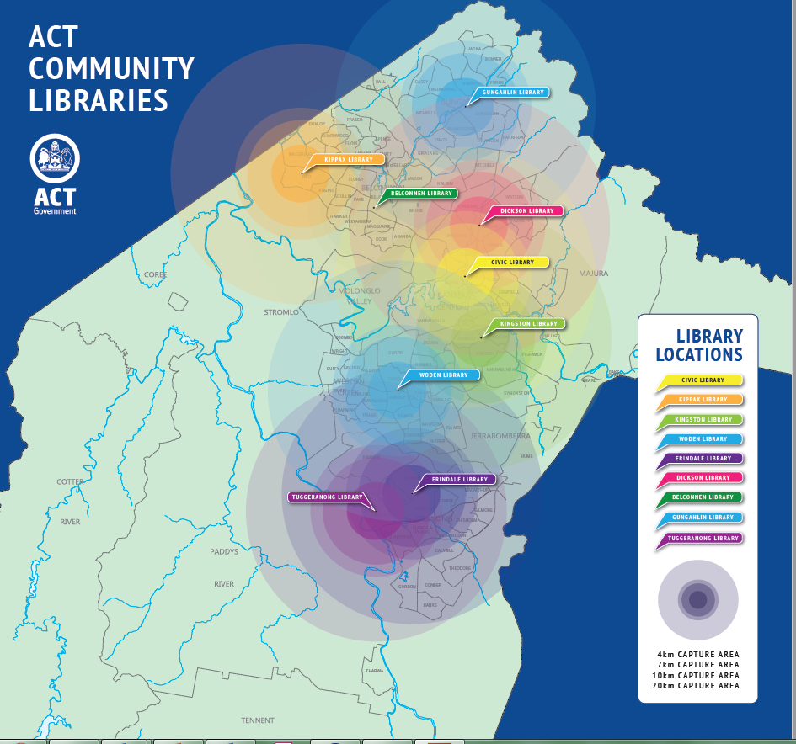

* 1. At hearing the Committee asked ACT Government what work is being done to monitor population projections and anticipate the need for new branches in areas of the city under development. ACT Government indicated it is likely a new library will be built in Molonglo:

*Minister*: ‘Most areas are served by current libraries. Some of them will serve growing populations, and Kippax Library is a great example of an existing library that is quite well placed to cater for the growing population of west Belconnen and Ginninderry into the future. We are looking at what the areas of growth are across the ACT. Obviously Molonglo is going to be a very significant community, so I would imagine at some point in the future there will be a library there. That potentially may cater for the broader region as well, including Weston Creek, which is currently served quite well by Woden Library. I am not sure that there has been any detailed analysis; Vanessa may have some further detail on that.’[216]

*Director of Libraries ACT*: ‘Probably the one that has had a little bit of analysis done on it is Dickson. With the growth of the Northbourne corridor we have been looking at that library and its capacity. As I said, it is a 50-year-old building so we have some constraints around it as well. But at the moment, no other plans.’[217]

* 1. The Minister indicated that any future library design is likely to include co-location with government services and shopping centres:

‘If we were looking at a future library, collocation would certainly be part of that. It would be part of a co-design process, but collocation is critical, whether that be retail—there are some great examples of that elsewhere, and we have referenced in our submission some really great analysis of the benefits to retail precincts of having collocation and benefits to the library in terms of foot traffic—or community services as well.’[218]

#### Committee comment

* 1. The Committee emphasises the need for ACT Government to actively monitor population projections for each region of Canberra, and anticipate the need for new or expanded library branches in areas of the city that are expanding or densifying with new housing developments, such as Gungahlin, the Inner North, Ginninderry, and in particular Molonglo which appears to be the least captured by existing libraries.

Recommendation 4

The Committee recommends that the ACT Government consider an additional library branch for the Molonglo and Weston Creek region as the population grows.

### Appreciation for ability to manage loans online

* 1. Many submissions described the efficiency, convenience and excitement of requesting items online, and then being notified by email or SMS when they are ready for collection, for example:

‘Being able to order books online, then receive an SMS message when they are ready for collection, is a great service.’[219]

‘The library request system is fantastic.’[220]

‘I reserve a lot of resource using the new titles list and appreciate being able to pick them up. It is a bit like Christmas being able to get a range of new things with having to pay for them’[221]

‘We use the website to order /request almost all of our items and simply pick up when notified. This always leads to browsing and further borrowing.’[222]

‘I love being able to put items on reserve and get a happy text when they are in.’[223]

* 1. Some submitters recognised that this system enables people to request a wider range of items located across multiple branches, which is not possible in some other jurisdictions where public libraries are operated by independent local councils:

‘I really appreciate the on-line catalogue which I use to order books which I then collect at the Belconnen Library when I’m advised that they’re available. Given that books are located in branches all over Canberra, this is a terrific service and makes borrowing practical and time-effective for borrowers.’[224]

‘through the hold system, we have access to the entire library catalogue, not just the books at one branch.’[225]

* 1. The online system also allows library users to monitor hold requests, renew loans, check due dates, and receive reminders when items are due for return.[226] It also makes the library more accessible for some people with disability (a topic discussed further at paragraph 7.17).

### Calls for improvement to the website and catalogue

* 1. While there was widespread appreciation in submissions for the ability to request books, manage loans, and download digital resources online, there were also frequent calls for the Libraries ACT website and online catalogue to be updated and modernised, for example:

‘A much better designed, organised and integrated website. I have the impression that this area of operations has not been well resourced.’[227]

‘The website is difficult to use and outdated. You can’t retrieve a forgotten password on line, which is a big nuisance.’[228]

‘The search function on the website – you often have to adjust the parameters of the search significantly to turn up the book you know the library holds.’[229]

‘The library’s Sirsi Dynix catalogue system has a very plain user interface which could easily be made more attractive to encourage use. Also, there are unimplemented modules within the system, for example, Visibility, which would direct library users from Google to the library’s catalogue.’[230]

* 1. Several people expressed frustration that the catalogue contains items no longer held by the library, for example:

‘Update the online catalogue – not just the software but the contents in it. It is very frustrating to find records for items that are no longer held.’[231]

‘There are many "phantom" items in the catalogue which the Library does not hold, or which are held but without holdings statements. Again, surely exception reports could be run and the entries cleared up. Great holiday job for a Library Science student.’[232]

* 1. The Committee heard suggestions that Libraries ACT improve the interface or develop an app to provide better experience with the library catalogue on mobile devices:

‘The library’s digital environment could also be updated to support ease of use. The current web interface is often very small on tablets (let along phones). Moving to a larger visual design would be helpful for children and older patrons.’[233]

‘It is really hard to try and log into your account on the phone and find the books you are looking for, so an app or something similar would be really helpful.’[234]

* 1. ACT Government informed the Committee that the Libraries ACT website is ‘currently being updated to provide an improved experience for users’:[235]

‘The ACT government recognises that the library’s computer system and website need updating, and funds have been provided to update both of these important tools. We expect a new integrated library management system to be operational in early 2019 and for the website to be live soon.’[236]

Recommendation 5

The Committee recommends that the ACT Government upgrade the Libraries ACT website and online catalogue, following consultation with the community, and identification of best practice website design and functionality among public libraries nationally and internationally.

### Physical collection (books, magazines, newspapers)

* 1. Several submissions spoke about the continuing importance of physical books, even with the growth of electronic and digital resources:

‘Of course we need to move with the times, and the availability of BorrowBox and other on-line facilities should continue to grow. While such amenities provide valuable on-line services for all, and particularly those with mobility challenges, they should be seen as an adjunct to, rather than a substitute for, locally accessible real buildings with real books.’[237]

‘[The library] continues to support print and other hard copy resources (such as CDs, DVDs and so on) and I think these continue to hold a really important part in people’s lives, despite the digital revolution.’[238]

‘Although many resources are available in electronic forms it is important to maintain printed forms including Large Print versions.’[239]

‘Please Keep Physical Books. We strongly believe in the value of physical books, particularly for the young.’[240]

‘elderly patrons do not always have access to and/or desire to use digital services and therefore hard copy materials must still be provided for the elderly. Parents bond with their children by reading/ sharing books with them. Likewise young children learn to dream and love books through Picture Books.’[241]

* 1. ALIA told the Committee that printed books will remain a core service for public libraries even with increasing availability of digital resources:

‘While book borrowing in print will remain a core service, there is a much greater emphasis on digital formats and tech services – public access computers, ebooks, free WiFi.’[242]

### Electronic resources and digital services

* 1. Many submissions mentioned the increasing availability of electronic resources and digital downloads in public libraries. Some expressed enthusiasm for the convenience and flexibility they provide, for example:

‘What a privilege it is to be able to walk around with the Oxford English Dictionary on my iPad.’[243]

‘I have also recently discovered the ‘Libby’ app that allows the borrowing of digital books and audiobooks. It is a fantastic resource and I would encourage the ACT Government to allow it to continue to grow.’[244]

‘Being able to download books to tablets is also great and works very well.’[245]

‘I was so happy when I moved from Sydney to Canberra to find the local libraries offered free access to e-Books that I could download to my iPad. I love this service and the ability to reserve books online.’[246]

‘Having discovered the joy of audio books by necessity because I could not get the actual book, I am now a fan and have them for the car so thanks for that.’[247]

* 1. The Committee was told that electronic and digital resources make the library more accessible to some people because they do not require travel to a physical branch.[248] The Committee heard that the convenience of electronic resources and digital downloads would draw more people to the library if these services were better promoted and marketed.[249]
  2. One submission encouraged Libraries ACT to expand the range of digital offerings as technology develops:

‘I value the range of eResources which are available. I regularly use Borrowbox and Libby for audio and ebooks, RBdigital for magazines and Freegal for music. I have also used Mango for language learning before travelling and I sometimes use eResources when I want to research something. I hope that the Library will be able to continue to maintain these facilities and also to add to them if new resources become available.’[250]

* 1. Despite the increasing uptake of digital services among library users, some submissions to this inquiry expressed uncertainty about how to use electronic resources, described difficulty in accessing them, and recommended the library provide better guidance on what services are available, and how to use them:

‘I am unfamiliar with eBook services because I do not use them and do not know how to do so, despite advice 25 percent of readers use it. Perhaps a simple explanation sheet could be made available to encourage more readers?’[251]

‘Examine the difficulties of using digital resources and try to find ways to simplify the process… Have means of obtaining help to use digital resources readily available – maybe in the form of better guidelines on the library website and in the library itself.’[252]

‘Libraries ACT offers a wide range of digital offerings for library users… However, these services can be confusing to access and navigate… WCCC recommends that Libraries ACT consider the creation and provision of simple, online, step-by-step user guides to help Canberrans access and use the digital offerings. This would improve accessibility to the digital service offering, helping new users engage with digital content.’[253]

‘I would suggest the library explore whether there are other ebook/eaudiobook platforms they could subscribe to, and also that these are properly cross-referenced in the library catalogue as at the moment they are often either not listed, or items are listed as being available online when they are not. I am also impressed by the Library’s other digital offerings. My main suggestion for improvement is to make it easier to browse these and find out what is there. At the moment it is not really that obvious unless you go digging down through a few layers of pages on the website.’[254]

* 1. During hearings ALIA summarised the current challenges for libraries in using digital platforms:

‘there are platforms for fiction and non-fiction provided by OverDrive, Bolinda and other aggregators. The difficulty with those is that people have to go into the library catalogue and then go out to those platforms to download the items, and that can make it clunky. With an open API from the library management system to those things, it is possible to overcome that. Some work on that through the library management system would be good.’[255]

### Car parking and integration with public transport

* 1. Thirteen submissions raised concerns about public transport and parking spaces near libraries:

‘Libraries need easy access to public transport ie at a bus stop. For instance Belconnen Library is difficult to use due to location. If possible also short term parking slots nearby for pick up and drop off.’[256]

‘Concerns about parking was identified as an issue for some libraries, particularly for people who were unable to walk long distances.’[257]

‘Car parking around libraries should be improved. Free car parking should be offered for at least an hour. Disability car parking spaces could be increased.’[258]

‘More disabled parking needs to be provided at the libraries. This particularly applies to co-located libraries. Parking anywhere near Kingston Library is difficult to find, and this problem is almost as bad at some of the other libraries.’[259]

* 1. The Committee heard conflicting views about the convenience or inconvenience of the location and access to particular branches; some people find Belconnen Library convenient and easy to access,[260] and some do not.[261] Some people find Woden Library convenient and easy to access,[262] and some do not.[263] This highlights the diversity of needs and preferences of library users.

### Concern that the inquiry signals plans for potential branch closures or reduction in funding

* 1. Sixteen submissions expressed concern that this inquiry signals potential branch closures, or reduction in funding, for example:

‘Please do not use this inquiry simply as an excuse to cut costs.’[264]

‘I sincerely hope that this review of ACT Libraries will not lead to any lessening of services.’[265]

‘Please don’t cut any of the services’[266]

‘I regard the ACT Library Service as wonderful. Please don't reduce its funding.’[267]

‘Our consultation with consumers highlighted concerns that underlying this Inquiry is a view to push future library services online and shut down more of the physical library branches. HCCA and its members do not support such a move.’[268]

* 1. To clarify the situation, this independent inquiry was initiated not by ACT Government, but by the Legislative Assembly Standing Committee on Environment and Transport and City Services, comprised of MLAs from both sides of the Chamber. ACT Government was one of 84 people and organisations who participated in the inquiry by making a submission.

### Feedback to the Committee on the inquiry process

* 1. The Committee received feedback in five submissions about the process of the inquiry, including the fact that formal written submissions are not an accessible format of engagement for many people, including:

‘It was difficult to give this feedback. An easier format (questionnaire?) may have helped others who have difficulty accessing computers or submitting comments.’[269]

‘Let me start by addressing the formal nature of this submission process; I believe this is a bit out of touch with some library patrons and a simple online community survey may have achieved a lot more varied responses.’[270]

‘What efforts have been made to get the information about the library review out to non-users? They are actually the people most in need of library services but generally do not realize the extent of the materials and services offered by the library.’[271]

* 1. The Committee is conscious that some people who regularly use libraries do not have the resources to write a formal submission to an Assembly inquiry. Therefore we wrote to peak bodies, advocacy organisations and service providers working with children and young people, older people, people with disability, and homeless people; and organisations in the mental health sector, Aboriginal and Torres Strait Islander community, LGBTIQ community, and multicultural communities. Some of these organisations were able to convey to the Committee the experiences and perspectives of their members/clients.
  2. The Committee acknowledges the limitations of the formal Assembly Inquiry process, and welcomes further feedback and suggestions about how community engagement might be improved during future inquiries.

## Performance of Libraries ACT

* 1. Chapter 6 examines the performance of ACT public libraries against ACT Government performance indicators, and national guidelines and standards.

### ACT Government reporting

* 1. Transport Canberra and City Services reports annually on the following data and performance indicators for Libraries ACT: physical visits to libraries per capita; items borrowed per capita; percentage of population who are registered library members; customer satisfaction with library services; direct cost of public library services per capita; percentage of library collection purchased in previous five years; and number of ACT publications or collections added to the heritage collection.[272]
  2. National and State Libraries Australia (NSLA) is a collective body representing the National Library of Australia, the State Libraries of New South Wales, Queensland, South Australia, Tasmania, Victoria and Western Australia, the ACT Heritage Library and the Northern Territory Library. NSLA produces an annual *Australian Public Libraries Statistical Report* that identifies and measures the usage and activities of Australia’s public libraries and the services they offer.[273] The Statistical Report compiles comparative data from all states and territories. The most recent Statistical Report was released in November 2017, containing data from the 2015-16 year. As Libraries ACT contribute data to NSLA, there is some alignment in the presentation of data between TCCS annual reports and the NSLA Statistical Report, but also some variation.

### National Standards and Guidelines

* 1. Australian Library and Information Association (ALIA) is the national professional organisation for the Australian library and information services sector. With the Australian Public Library Alliance (APLA), ALIA developed the *Guidelines, Standards and Outcome Measures for Australian Public Libraries* (ALIA National Standards) in 2016, which provides evidence based guidance for the development of library services in Australia.[274] This document contains 16 guidelines, 15 standards and six areas of outcome measurement, providing an evaluation mechanism and benchmarking tool for public accountability:

‘This document presents evidence-based guidelines, standards and outcome measures for the planning, development, delivery and review of public library services in Australia. Guidelines document best practice and are intended as operational suggestions for improving library performance. Standards are quality levels for benchmarking, comparison and attainment. Outcome measures indicate the type of impact that provision and use of public library services can have on individuals and communities.’[275]

* 1. The Standards are primarily based on the NSLA Statistical Report.[276] The ALIA National Standards comprise a ‘framework for Australian public libraries’ to ‘bring together and illustrate the essential components of a public library’:[277]

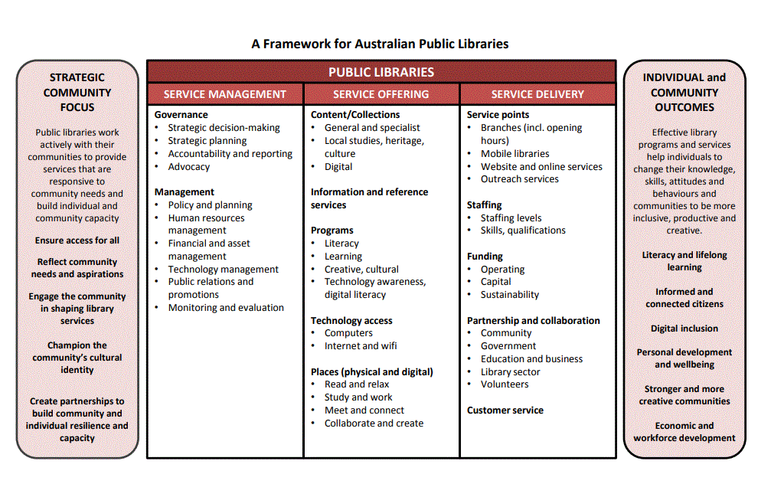

### Overview of Libraries ACT performance

* 1. The Australian Library and Information Association (ALIA) is the national professional organisation for the Australian library and information services sector. In evidence to the Committee, ALIA gave a positive assessment of the performance of Libraries ACT:

‘Libraries ACT is currently providing an excellent service to residents in the capital and doing so in an efficient and cost-effective way within the Territory Government. Libraries ACT is known as an innovator in the library world… According to the latest national public library statistics, ACT libraries have the highest membership (63.6% of the population) and the third highest number of customer visits per annum per capita (5), yet the total expenditure per capita is the lowest in Australia ($34.06) as is the staffing level (one staff member per 4,143 residents)... These figures paint a picture of Libraries ACT as a well-used, highly valued, tightly managed, efficient library service. They also suggest that there is little capacity to embrace new opportunities as they arise.’[278]

* 1. ALIA told the Committee that ‘Libraries ACT has a strong reputation in the Australian library world’, for the following reasons:

‘Community engagement leading to authentic community-focused programs; Adopting new technologies where they bring benefit to their users and make for more efficient operations; Promoting digital inclusion initiatives so no-one need feel left behind; Measuring and evaluating programs and services, and benchmarking with other libraries.’[279]

* 1. ALIA states that ‘Libraries ACT is known as an innovator’, most recently for:

‘Its success in early literacy for pre-schoolers and in adult literacy programs for migrants, both English-speaking and non-English speaking; The appointment of a coordinator to improve services for Aboriginal and Torres Strait Islander people; Its investment in technology, embracing the broader future of libraries as digital hubs, creative spaces, maker spaces; Workforce training and professional development.’[280]

* 1. National & State Libraries Australasia (NSLA) is the peak body for the National Library and the State and Territory libraries throughout Australia. NSLA also gave a positive assessment of Libraries ACT in evidence to the Committee:

‘Libraries ACT is a respected and dynamic public library and heritage library network that provides excellent essential services to the ACT community through strong management, focused-priorities, innovation and consultation.’[281]

* 1. ACT Government provided this overall assessment of Libraries ACT performance:

‘Around 60 per cent of our growing population are library members, and while the loan of materials has declined over the past few years in line with national trends, visits are still strong and participation in learning programs is high.’[282]

### Expenditure

* 1. The funding for Libraries ACT was described above in paragraph 4.27. NSLA figures on expenditure per capita shows that the ACT Government spends significantly less money on library services than other states and territories. Table 2 compares ACT expenditure with the national average over the five year period 2012 to 2016:

Table 2: ACT Government expenditure per capita on public library services, compared with the national average, over the five year period 2012 to 2016[283]

|  | 2011-12 | 2012-13 | 2013-14 | 2014-15 | 2015-16 |
| --- | --- | --- | --- | --- | --- |
| ACT expenditure per capita | $35.94 | $36.58 | $34.18 | $34.79 | $34.06 |
| National average expenditure per capita | $44.55 | $44.44 | $44.66 | $48.00 | $49.11 |

* 1. NSLA data shows that ACT has the lowest expenditure per capita on public library services when compared with the other states and territories, as shown in Graph 2 below:

Graph 2: Expenditure per capita on library services in each state and territory, over the five year period 2012 to 2016[284]

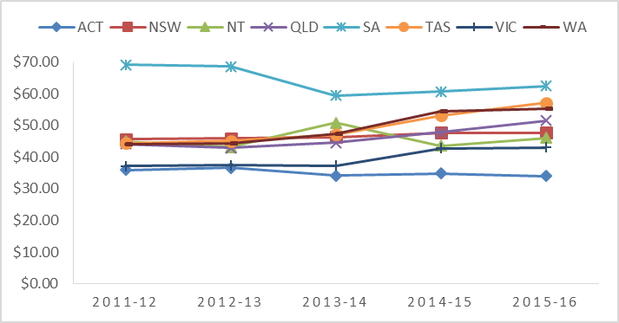

* 1. Graph 3 below compares per capita expenditure on library services in each state and territory for 2015-16, the most recent period in which data is available. Libraries ACT total expenditure per capita is the lowest in Australia, at $34.06, while the highest is South Australia at $62.37:

Graph 3: Expenditure per capita on library services in each state and territory[285]

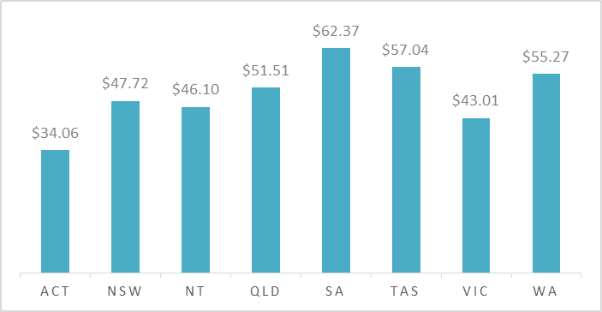

* 1. The ALIA National Standards recommend caution when comparing expenditure between jurisdictions:

‘Library expenditure per capita is not necessarily an indicator of a ‘better’ library service. This indicator is one where a high figure might be seen as representing service quality and a low figure might be seen as indicating service efficiency. It is argued that expenditure close to the state or territory average is the preferred position. Library expenditure per capita should be interpreted in light of local factors (e.g. library size, population served, staff per capita), customer satisfaction and library outcomes.’[286]

* 1. ALIA recommend Libraries ACT be provided with ‘a funding model which will compare with that of other large city library services in Australia’.[287]
  2. During the hearing the Committee asked about the reason for the comparatively low expenditure on library services in the ACT, and heard the ACT Government view is that this is due to the small size of the territory:

*Minister*: ‘We have the highest cost-benefit ratio, and that is partially reflective of the fact that we are a city-state and we have quite efficient library services for the investment that we make in them…’[288]

*Director of Libraries ACT*: ‘The fact that we are a city-state does contribute significantly to that cost effectiveness or however you would like to portray it. When you think about some of my colleagues in other states, they are trying to fund libraries in very tiny communities in very remote places, and that becomes very expensive. I think it is South Australia that is currently the highest per capita. Of course, they have to sustain libraries in places like Coober Pedy and Ceduna, and it is very expensive to run library services in those places. It is very much a reflection of the fact that we are very geographically tight and that we can run one library service. If you think about, again, places like South Australia or Western Australia, each council runs their libraries and there is an overhead in having little, separate libraries in those tiny places that we do not have because we are one library service.[289]

### Return on investment

* 1. ACT Government in their submission described a report commissioned by ALIA in 2013 on the *National Welfare and Economic Contributions of Public Libraries*.[290] This analysis found that Libraries ACT demonstrated the best return on investment of all states and territories:

‘This research into the economic benefits of public libraries in Australia found that the ACT had the best return on investment, with $4.10 of benefit for every $1 spent on public libraries in the ACT.’ [291]

* 1. Nationally the benefits of libraries outweighed the costs by a factor of 2.9, under this analysis:

‘it is estimated that a net annual benefit of some $1.97 billion is provided to Australians by public library services. This is reflected in a benefit cost ratio of 2.9, meaning that the annual benefits generated outweigh the annual costs by a factor of 2.9. This is considered to be a sound return on investment.’[292]

* 1. The report encourages increased funding in library services, as the analysis shows the larger the investment, the larger the benefits:

‘Importantly, the level of investment in public library services does not display a pattern of diminishing returns. Estimates of per capita costs and benefits, using the research carried out in Victoria and Queensland in 14 case study communities, highlight that the larger the investment made into public libraries, the larger the benefits derived by the respective communities. Collectively these findings provide a strong basis for arguing for increased levels of funding for public library services.’[293]

### Library membership

* 1. TCCS annual report for 2017-18 reported that 67% of the ACT population are registered members of Libraries ACT:[294]

‘Libraries have a strong membership history and continue to attract new members at the rate of approximately 14,500 per year. The above target result is largely attributed to new members attracted by the increased range of e-resources and e-books’[295]

* 1. The precise membership rate depends on the source of data; in the hearing for the inquiry ACT Government explained that ‘[b]etween 60% and 67% of Canberrans are library members’, which is the range of difference in the data from the annual TCCS survey and the library management system.[296] Membership rates are also complicated by the fact that ‘[r]egistered library members include people from the ACT and the surrounding NSW region.’[297]
  2. TCCS annual reports show a steady increase in library membership over the past five years, as shown in Table 3 below:

Table 3: Libraries ACT membership over past five years[298]

|  | 2013-14 | 2014-15 | 2015-16 | 2016-17 | 2017-18 |
| --- | --- | --- | --- | --- | --- |
| Percentage of population who are registered library users | 58% | 61% | 63.6% | 65% | 67% |

* 1. Graph 4 below displays the trends in Libraries ACT membership over the seven year period 2011 to 2018, compared with the national average:

Graph 4: Percentage of the ACT population who are library members, compared with the national average, over the seven year period 2010 to 2018[299]

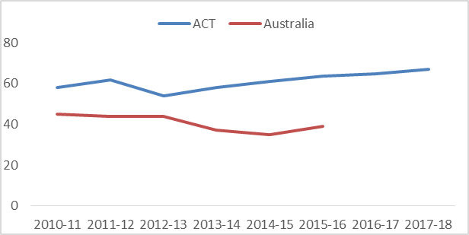

* 1. In 2015-16 (the most recent year for which comparative data is available) Libraries ACT had the highest library membership rate of all states and territories, as displayed in Graph 5 below:

Graph 5: Percentage of the population who are library members in each state and territory[300]

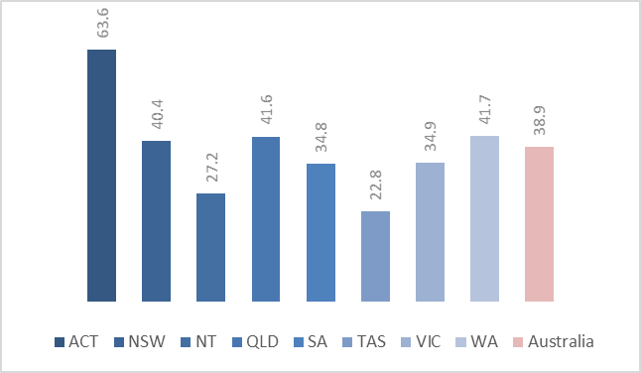

* 1. The ALIA National Standards recommend caution when interpreting data on library membership: ‘This standard is only a partial indicator of library engagement, and should not be used in isolation as a measure of service engagement or use’ without consideration of the following:[301]

‘*Active membership*: From 2013-14 Victoria narrowed its definition to ‘active’ membership, which only records registered members who borrowed a physical collection item in the previous 12 months.

*Non-resident membership*: Some libraries show a very high percentage of membership because members include non-residents who travel to or through the LGA to work or for holidays, and are not, by definition, included in the base ‘eligible population’…

*Hidden membership*: Libraries customers who are not registered members visit the library to attend programs and events, use meeting or leisure spaces, read newspapers or use the computers. While these users may not be captured in the count of members (e.g. some libraries require library membership to use wifi, others do not), they are captured in ‘visit’ statistics. Some customers also may use a single card for all family members, thereby understating the spread of usage.’[302]

### Library loans

* 1. In 2017-18 Libraries ACT loaned 2,199,554 physical items and 425,289 eResources.[303] Digital loans include: ‘all digital downloads, e.g. e-books, e-audio, music, magazines, newspapers, subscription databases, children's resources and learning resources.’[304]
  2. Data from TCCS annual reports for the past five years shows a consistent decline in physical loans, but a steady increase in digital loans over that period (see Table 4):

Table 4: Physical and digital items borrowed through Libraries ACT over past five years[305]

|  | 2013-14 | 2014-15 | 2015-16 | 2016-17 | 2017-18 |
| --- | --- | --- | --- | --- | --- |
| Physical items borrowed | 3,052,300 | 2,803,697 | 2,514,615 | 2,362,795 | 2,199,554 |
| Digital resources borrowed | 238,828 | 256,136 | 342,360 | 379,970 | 425,289 |

* 1. Graph 6 represents Table 4 in visual form, showing digital loans (red) increasing, physical loans (blue) decreasing, and overall loans (green) decreasing:

Graph 6: Physical and digital items borrowed through Libraries ACT over past five years[306]

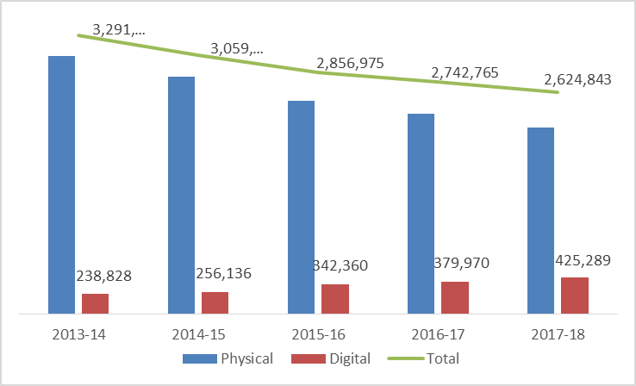

* 1. When loan numbers are adjusted per capita there is an overall downward trend in library loans in the ACT when physical and digital items are considered together (see Table 5):

Table 5: Items borrowed per capita in Libraries ACT over past five years[307]

|  | 2013-14 | 2014-15 | 2015-16 | 2016-17 | 2017-18 |
| --- | --- | --- | --- | --- | --- |
| Items borrowed per capita | 7.95 | 7.83 | 7.21 | 6.7 | 6.3 |

* 1. In Graph 7 this per capita data is presented alongside comparable figures for the other states and territories, showing loans have decreased in all jurisdictions for the past five years:

Graph 7: Library items borrowed per capita across all Australian jurisdictions[308]

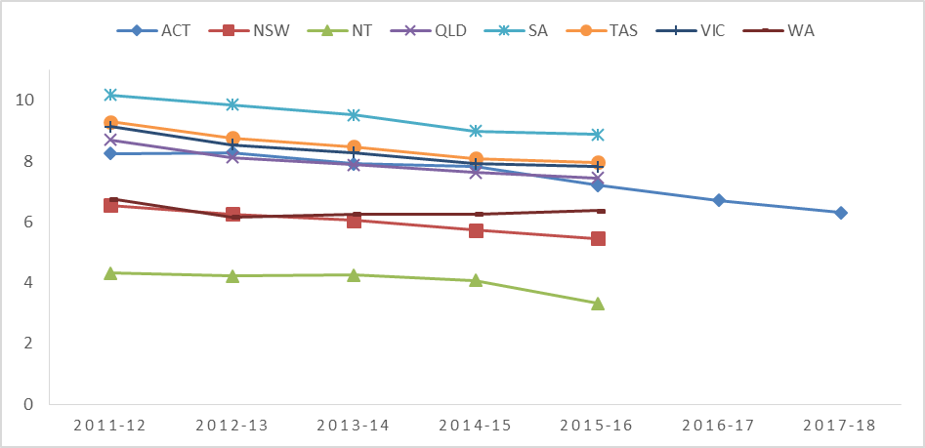

* 1. In its submission to the inquiry ACT Government provided longer historical data showing local ACT borrowing trends back to 2003 (se Graph 8). This longer perspective of fifteen years shows fluctuation in borrowing trends, cycling up and down over time. Loan numbers today are lower than at the peak of 2012-13, however they are higher than in 2009-10 or 2004-05:

Graph 8: Library loans 2003-2018[309]

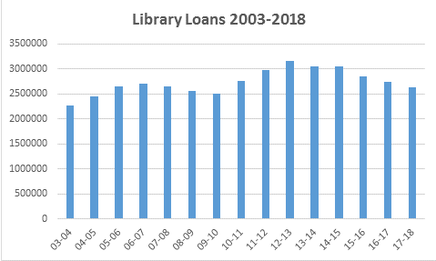

* 1. ACT Government provided their view on the reasons for the recent decline in borrowing at libraries across Australia:

‘Loans of resources have declined over the last few years. This is in line with libraries nationally. Some of this relates to access to the internet for answering specific information related questions but it also reflects the time-poor nature of our community, as evidenced by the continued high use of the Library’s request system.’[310]

### Library visits

* 1. In 2015-16 there were 1,964,398 visits to Libraries ACT.[311] The ACT Government submission provided a graph showing library visits over the fifteen year period 2004 to 2018, which shows steady visitor numbers with only minor fluctuation (see Graph 9):

Graph 9: Library visits 2003-2018[312]

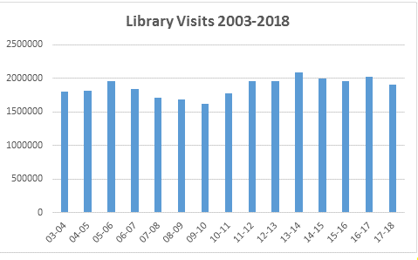

* 1. This apparent consistency of patronage at library branches is interesting given the decrease in borrowing rates (discussed at paragraph 6.26 above). The ACT Government suggested to the Committee that this is due to the role of libraries as community meeting space and learning space:

‘The role of libraries as community meeting and learning spaces continues to grow, as evidenced by the strong trend in library visits. A recent exit survey of library visitors identified that after borrowing or returning items, most people visited the library to spend time in the library space (studying or reading) followed by using the Library’s wifi.’[313]

### Digital visitor numbers

* 1. In 2017-18 the Libraries ACT website received more than 1.3 million page views.[314]

### Awareness of library services in the community

* 1. Thirteen submissions suggested Libraries ACT could benefit from more publicity and promotion of library services, for example:

‘Library services should be better promoted so that the public is more aware of what is available and is constantly reminded to utilise those services.’[315]

‘it would be desirable to publicise more widely, and expand the use of the library service’[316]

‘We believe the ACT Libraries could be much better promoted in the community and could be used by more people if they knew they could access the latest material.’[317]

‘It amazes me that this service is free to all. I wish more people knew about how valuable it is.’[318]

* 1. ACT Government acknowledges this view:

‘The community feels that the broad scope of services provided by our libraries is not well understood and increased and improved marketing and communications is needed.’[319]

Recommendation 6

The Committee recommends that the ACT Government enhance the marketing and communications of library services, to increase community awareness of the free resources available to them.

### Comparison between ACT Library branches

* 1. When asked about the best performing library branches, the Minister informed the Committee:

‘Woden, Dickson, Gungahlin and Belconnen are some of the strongest performing libraries with the most staff members and the most visitors and are among some of the best value in the community in terms of cost per visit.’[320]

* 1. The cost effectiveness of Libraries ACT branches (2016-17) is summarised in Table 6, which was provided by ACT Government in their submission to the Committee:

Table 6: Comparison of cost effectiveness of Libraries ACT branches[321]

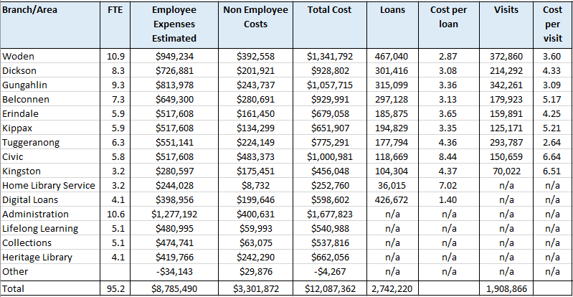

* 1. The Committee created a series of graphs to present the information contained in Table 6.
  2. Graph 1 in paragraph 4.31 above shows the number of full time equivalent staff employed in each branch.
  3. Graph 10 below shows the loans and visitor numbers for each library branch. This graph shows that Woden Library is the busiest, most frequented branch of Libraries ACT, both on loans and visitor numbers. Gungahlin, Dickson and Belconnen are at the second tier, with a similar number of loans; but of the three Gungahlin has higher visitor numbers, perhaps because it is co-located with Gungahlin College. Erindale, Kippax and Tuggeranong are roughly comparable at the third tier, with similar loan numbers; but again, of the three Tuggeranong stands out with visitor numbers, perhaps because it is co-located with Tuggeranong College. Kingston and Civic form a fourth tier, with the fewest loans (though Civic has higher visitor numbers than Kippax):

Graph 10: Loans and visitor numbers at each branch of Libraries ACT, 2016-17[322]

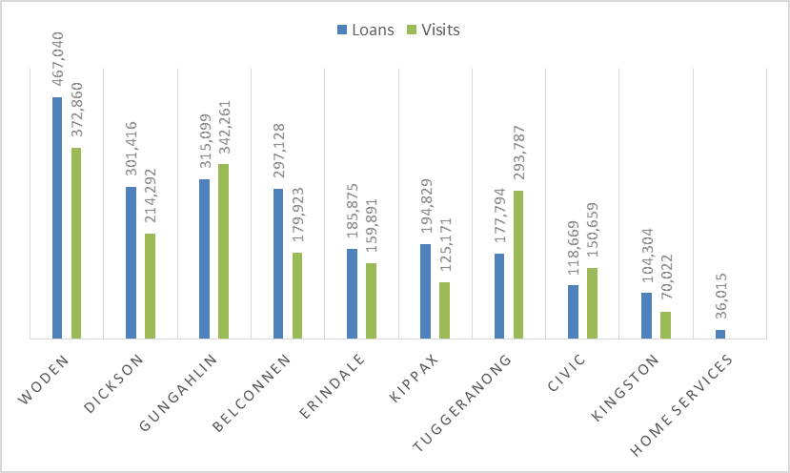

* 1. Graph 11 shows cost per loan and cost per visit for each branch of Libraries ACT. This graph shows that the busiest branches are more cost efficient. The less frequented branches cost proportionately more to operate:

Graph 11: Cost per loan and cost per visit for each branch of Libraries ACT, 2016-17[323]

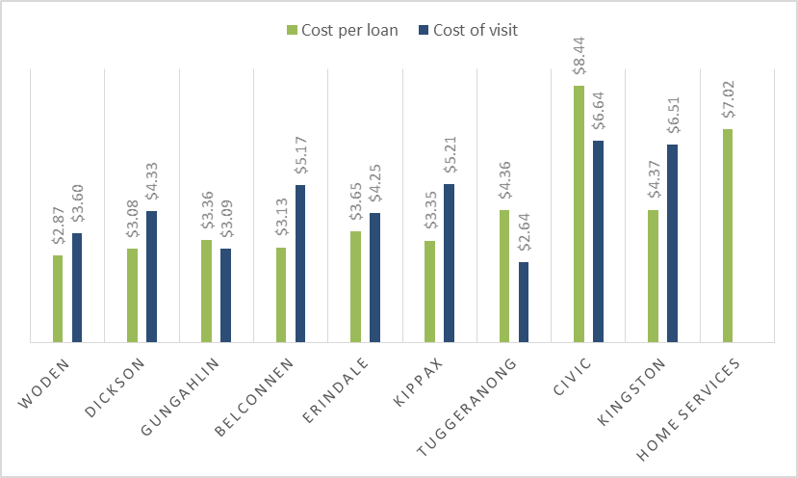

* 1. ‘Non-employee costs’ at Kingston and Civic is significantly higher than other libraries, and the Committee was told that this is due primarily to commercial rent:

‘The major contributor at those particular locations is rent. Non-employee costs make up about 48 per cent of the cost at Civic library, and that is understandable given it is a city location, and about 38 per cent of costs at Kingston. This compares to an average of around 20 per cent of non-employee costs across other libraries in the ACT. Certainly rent is a major part of that.’[324]

* 1. A separate table provided by ACT Government to the Committee shows participation in lifelong learning programs per branch in 2017-18, see Table 7 below.

Table 7: Participation in lifelong learning programs at each branch of Libraries ACT in 2017-18[325]

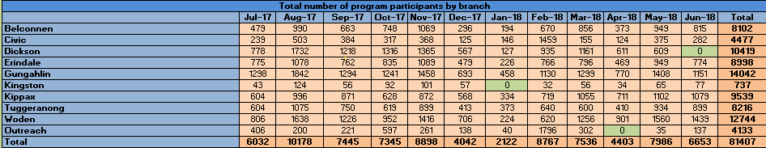

* 1. Graph 12 presents this data in visual form. It shows that the libraries most frequently used for lifelong learning programs are Woden, Gungahlin and Dickson. Kingston and Civic are the least utilised for this purpose:

Graph 12: Participation in lifelong learning programs at each branch of Libraries ACT in 2017-18[326]

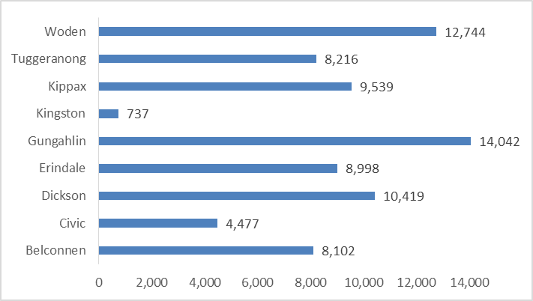

### Comparison with other States and Territories

* 1. In their submission to this inquiry, ACT Government provided a table showing how the ACT compares with other states and territories, and it is reproduced here at Table 8:

Table 8: Comparing performance of Libraries ACT with other states and territories[327]

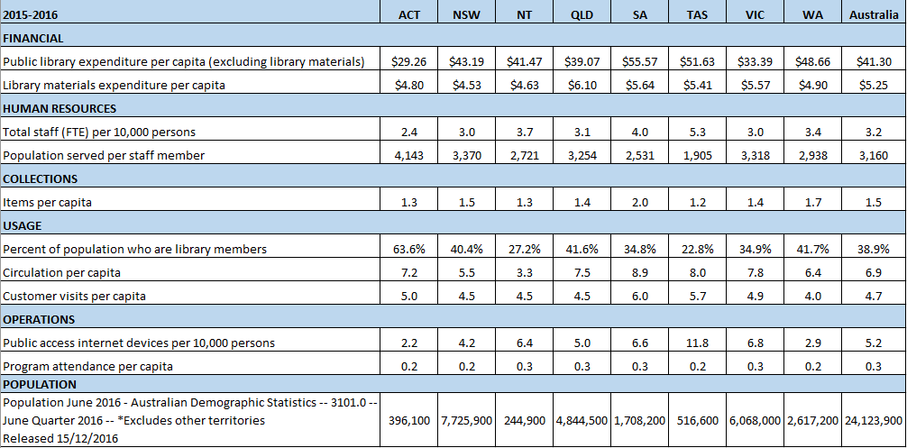

* 1. Table 8 shows that the ACT compares well with other states and territories in terms of:
* Highest percentage of population who are library members (paragraph 6.20).
  1. However the ACT compares poorly with other states and territories in terms of:
* Lowest number of public access internet devices per 10,000 persons (paragraph 6.126);
* Lowest expenditure on library services per capita (paragraph 6.11); and
* Lower end of spectrum on expenditure per capita on library material (paragraph 6.56).
  1. Detailed discussion about each of these items is presented in other sections of this report, under the relevant topic heading.

### Print collection

* 1. Libraries ACT holds a physical collection of: ‘more than 547,300 items, including fiction, non-fiction, large print, children’s DVDs and CDs, and 106,200 in the ACT Heritage Library’.[328]
  2. In 2015-16 the total number of physical items in the Libraries ACT collection was 642,636. This included 469,422 printed books; 34,698 audio CDs; and 36,686 DVDs and Blu-ray discs.[329]

### Digital collection

* 1. The digital collection held by Libraries ACT includes ‘eBooks, eAudio books and digital magazines… downloaded music, downloaded articles and streamed content.’[330]
  2. The Committee was told that Libraries ACT provide access to ‘millions of digital items through 30+ electronic resources such as reference databases, full text articles, and language learning programs’ and downloadable digital resources, as described here:

‘more than 425,000 digital resources were downloaded from the library in 2017-2018 including:

‘92,705 eBooks -- the library has subscribed to an eBook service for its members since 2006 and currently offers a growing collection of thousands of titles for download

‘87,910 eAudio books – available through the same services as eBooks

‘68,178 eMagazines – full, cover to cover magazines are available in digital form through the RBdigital service with members able to read them online or download and keep issues of the hundreds of popular Australian and international titles

‘78,836 music tracks – the full Sony Music catalogue of hundreds of thousands of music tracks is available to members via the Freegal service which enables members to stream and download and keep a specific number of tracks each week

‘98,110 articles and other downloads’.[331]

### Collection management

#### Expenditure on library materials

* 1. NSLA data shows that ACT Government expenditure on library materials steadily and significantly reduced between the five years from 2012 to 2016, by -27.9% (see Table 9).

Table 9: ACT Government expenditure on library materials[332]

|  | 2011-12 | 2012-13 | 2013-14 | 2014-15 | 2015-16 |
| --- | --- | --- | --- | --- | --- |
| ACT Government expenditure on library materials | $2.64m | $2.48m | $1.82m | $1.97m | $1.90m |

* 1. Graph 13 presents this data visually:

Graph 13: ACT Government expenditure on library materials for the five year period 2012 to 2016 ($ millions)[333]

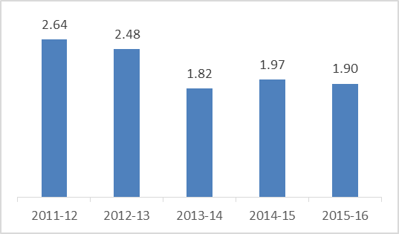

* 1. ACT Government presented more recent data in the form of a pie chart in their submission (see Diagram 3); it varies slightly from the NSLA data, and covers the more recent five year period from 2014 to 2018:

Diagram 3: Library Materials Past Five Years[334]

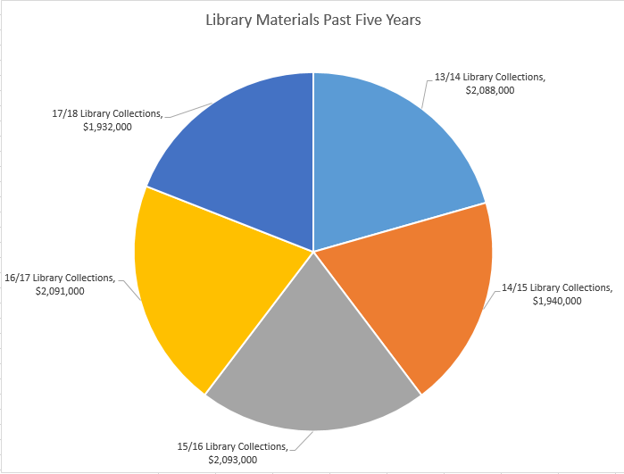

* 1. The figures provided by ACT Government in Diagram 3 were used by the Committee to create Graph 14. This graph shows less variation in expenditure when the data for years 2011-12 and 2012-13 are excluded:

Graph 14: ACT Government expenditure on library materials for the five year period 2014 to 2018[335]

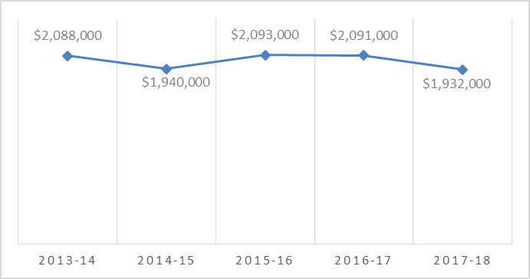

* 1. The ALIA National Standards recommend caution when examining data on expenditure on library materials over time, as ‘variation can be the result of cyclical or targeted investment in collections development.[336]
  2. Graph 15 uses NSLA data comparing ACT expenditure on library material per capita with the other states and territory, and shows that five years ago ACT was the highest investor, but is now amongst the lowest:

Graph 15: Expenditure on library materials per capita in each state and territory, 2012 to 2016[337]

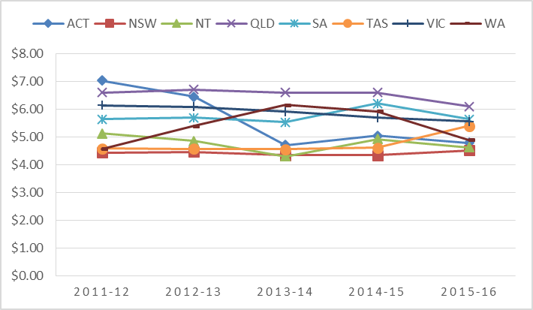

#### Content of collection

* 1. Currency of library collections is one of the standards against which public libraries are measured. In 2015-16 the percentage of the Libraries ACT collection purchased in previous 5 years was 55%.[338] In 2017-18 the percentage of library collection purchased in previous five years had reduced to 53%, which failed to meet the performance indicator target of 60%.[339] ACT Government reported this explanation for the variance:

‘This indicator includes physical items only. The below target result is due to less physical items purchased due to increased customer demand for digital collection items. Libraries continue to respond to customer trends towards digital resources.’[340]

* 1. The Committee heard a range of different opinions on which items or resources in the library collection should be increased, which demonstrates the challenges for Libraries ACT in balancing everyone’s needs and wishes. ACT Government wrote about some of these challenges in their submission:

‘There is also a tension for the library in provision of resources, to balance buying enough copies of new and popular titles with wasting resources after an initial rush for them. Similarly there can be an expectation the public library should buy material which is for curriculum support (primary, secondary, tertiary), which is actually the role of school and university libraries, or to purchase resources for niche subjects which are not part of the library’s collection development policy. The library is planning to introduce a consumer council or group to enable subject matter experts from the community to provide input into new library initiatives.’[341]

* 1. Some submissions expressed positive views on the scope of the collection, for example:

‘I have used libraries throughout Australia when I have been on holidays in various locations, especially in regional locations such as Newcastle. Each time I use a library elsewhere, I am reminded of how extensive the ACT catalogue is compared with other library locations.’[342]

* 1. Several submissions express appreciation for the ability to suggest items for the collection, and pleasure that suggestions are often taken up, for example:

‘From time to time I put in a request for the library to purchase a book that I am particularly interested in (although this is rare as most titles I look for are in the library, even those receiving current attention).’[343]

‘I really appreciate the Library’s willingness to purchase new releases quickly, and to respond to suggestions for purchase as well.’[344]

‘Library staff are always helpful and I’ve suggested a few purchases in the past and was pleased to see that my suggestion was taken up.’[345]

* 1. ACT Government told the Committee that 40% of such suggestions for purchase are filled:

‘Suggestions for purchase made by the community (40% of suggestions are fulfilled, the rest are either not still in print, are duplicate requests, or do not meet the library’s collection development policy)’[346]

### Staff qualifications, training and rostering

* 1. International and national guidelines emphasise the importance of training for library staff:

‘Staff employed in libraries need ongoing support to develop their skills in an ever-evolving information environment.’[347]

‘Public library staff require a range of skills and qualities, including interpersonal skills, social awareness, team- work and leadership and competence in the practices and procedures of the organisation.’[348]

* 1. In 2009-10 TCCS recognised that ‘[l]ibrary staff need new skills in addition to traditional library skills.’[349] The strategic plan says Libraries ACT ‘[r]ecruit and retain professional staff with a diverse range of skills and positive attitude.’[350]
  2. ACT Government outlined the following position on staff training in their submission:

‘It is important to have appropriate expertise and professional staff to deliver library services, and to recruit staff with relevant qualifications and/or specialist skills and experience. Professional development (PD) plays an essential role in positioning Libraries ACT staff to be aware, understand and be equipped to meeting opportunities and demands. Libraries ACT staff have access to a range of PD opportunities including library and related industry training, workshops and conferences.’[351]

* 1. NSLA data shows 24.1% of Libraries ACT staff are professional librarians.[352] The Committee heard that some library users are concerned about what they perceive is a reduction in the number of qualified librarians:

‘Recruit qualified library staff, so that each branch at least has one or two library/information services trained and experience staff. There has been a progressive de-professionalism of the team tasked to deliver the libraries ever increasing range of services… I understand that the now the majority of the front of house staff do not have any library qualifications.’[353]

* 1. Several participants in this inquiry raised concerns about consistency of staffing, due to the system of rostering staff across branches, for example:

‘It has been common for Library staff to be transferred frequently across branches. More consistency and less movement of staff creates relationships between customers and staff which is a wonderful and significant element of building community.’[354]

‘Limit rotation of staff to a needs basis, rather than as a routine (if the multiple placement system is still the current practice). This encourages ownership of “their library” - why worry about something being broken or collection issues if you were not there the next day???? The staff also get to know the regular patrons and their needs.’[355]

* 1. Some submissions expressed their perception that there is increasing use of casual staff:

‘The current staff employment practice seems to be leaning towards casualization of the vital library staff.’[356]

‘It is important to have staff who can provide solid answers to reference and general inquiries. This is lacking when the staff change is frequent and Library qualifications are undervalued.’[357]

* 1. One library user wrote to the Committee and described the importance of a personal relationship with library staff, as on some days visiting the library is the only contact she has with other people:

‘Over the long years I have used the library I have also established really good friendships with the Library staff & even getting to meet some of their family members. This has provided me with much joy & sometimes they are the only people I have opportunity to speak to during the day. However, now that the library has so many staff changes on such a regular basis this level of friendship is no longer possible & it has been a really long time since I have seen my friends.’[358]

#### Committee comment

* 1. The Committee suggests that ACT Government note the comments in submissions about the importance for some library users of their relationships with their local librarians, and review the current practice of routinely rotating library staff between branches, to assess whether a sense of community within each branch can be achieved by having staff based in one library.

### Co-location with government and community services

* 1. Some submissions expressed enthusiasm for the idea of co-locating government services with library branches;[359] while others were disapproving of co-location, concerned that libraries may experience dilution and loss of focus (see also reference to ‘role confusion’ in paragraph 5.35 above):

‘Our ACT libraries are brilliant just as they are: as libraries… To my mind, it would be a mistake to dilute library services by combining libraries with other government outreach or social services—this would lead to a dilution in library services and a loss of focus in what is currently a powerful civilising and educational tool in our community. There's nothing wrong with community hubs, but libraries need a committed space, in which the focus is on the provision of library services.’[360]

* 1. During the hearing, ACT Government explained that the reason Libraries ACT participate in partnerships and co-location is to engage with sections of the community who are not currently library users:

‘collocation with community services organisations very much helps us target the people who are not currently library users. It depends on which number you take—whether you take our library management system or whether you take the recent TCCS survey—but somewhere between 60 and 67 per cent of people in the ACT are members of the library. That leaves that 35-odd, 40 per cent of people who are not. Out of that we have quite a feeling that some of those people are clients of community services or health services where a partnership and a collocation would help people understand what libraries do and that libraries are for everyone.’[361]

#### Joint use libraries with Education Directorate

* 1. For several decades Libraries ACT has had joint use arrangements with the Education Directorate, and currently the libraries at Erindale, Tuggeranong and Gungahlin are co-located with the local College.
  2. ACT Government acknowledges that ‘some in the community prefer to use libraries that are not shared with college students’,[362] and this opinion was expressed in some submissions, for example:

‘The role of the Library is not education and training. The Directorate of Education and Training has that role. School classes should NOT be conducted in the library. (How soon would it be before the library becomes a defacto classroom because of overcrowding in schools?)’[363]

‘Request to physically expand Gungahlin Library towards the shopping centre (this library shares its services with Gungahlin College, and becomes quite congested when students are in the library)’[364]

#### Access Canberra shopfront at Civic

* 1. Access Canberra currently operates a shopfront within Civic Library, and comments in submissions expressed the convenience of this arrangement:

‘I have used ACT shopfront and found it very convenient having it co-located in the library. The number system meant I was able to wander the shelves while waiting my turn, so I borrowed a book and renewed my licence in the one trip, very convenient.’[365]

‘I would like to support further investigations of whether government services could be co-located (without sacrificing service or library space). I recently had to get a working with vulnerable people card, and being able to wait with the kids at Civic library was much preferable to being stuck in normal government shopfront.’[366]

* 1. ACT Government indicated during this inquiry the possibility of future shopfronts in other libraries:

‘Further opportunities for co-location include the potential for small Access Canberra service points in libraries’[367]

#### Partnerships with Child and Family Centres

* 1. ACT Government described the emerging partnership between Libraries ACT and Child and Family Centres:

‘Our library service enjoys a great relationship with the ACT government’s child and family centres, providing programs and support to the community that accesses those services. The library even provides its deleted children’s books to these centres so they can be given free to families so that kids can have more books to read in their homes no matter what their families’ financial circumstances are.’[368]

* 1. They informed the Committee that the purpose of the partnership is to engage with people who are not currently library users, and support families to develop early childhood literacy:

‘Whilst Libraries ACT has a high level of membership it remains that approximately 33%-40% of the population are not current members or even users of the Library service. Through the work of the library’s Family Literacy Coordinator we have strong empirical evidence that many of the people who are accessing services through the Child and Family Centres are not library users. Continuing to foster this relationship enables a targeted customer-centred approach and ensures that Libraries ACT can support families in developing early childhood literacy which is fundamental to the development of ongoing literacy and therefore civic engagement.’[369]

* 1. ALIA expressed support for these efforts:

‘Libraries have an increasing part to play in child and family community services, with baby rhyme-time and story-time and STEM activities seen as playing a crucial role in early childhood learning, language and literacy development.’[370]

* 1. ACT Government indicated during this inquiry the possibility of future physical co-location of libraries and child and family centres:

‘Further opportunities for co-location include… further development of existing relationships and/or co-location with Child and Family Centres.’[371]

##### Committee comment

* 1. The Committee notes with approval the partnerships being developed between Libraries ACT and Child and Family Centres. The Committee hopes that Libraries ACT will continue to develop effective ways to engage important community groups who do not currently access library services, but have the greatest potential to benefit from improved literacy.

#### Other partnerships with government agencies and community organisations

##### Current partnerships

* 1. Legal Aid ACT provides free outreach services through library branches, and views it as a valuable partnership for the community, because it allows them to assist a wider range of people to resolve legal problems in their lives:

‘Legal Aid ACT has been working with ACT Libraries to provide outreach services since November 2017. This has been a valuable partnership, through which Legal Aid ACT has assisted many vulnerable members of the community who may not otherwise have accessed Legal Aid. The principal function of these outreach sessions is to meet with individuals who may be experiencing legal problems and make them aware of the services available to assist them. This may involve on the spot advice, referrals to other community organisations, referrals to Legal Aid ACT's helpline or duty services, or a recommendation that the individual apply for a grant of legal aid. Legal Aid ACT views this partnership as an effective model of collaborative service delivery, through which we can utilize existing community services to access disadvantaged sections of the population likely to be experiencing legal problems.’[372]

* 1. Council on the Ageing ACT (COTA) told the Committee they have a close working relationship with Libraries ACT, as libraries are an outlet for issuing ACT Seniors Cards and Seniors Discount Directories, a program administered by COTA ACT on behalf of the ACT Government:

‘COTA ACT appreciates the valuable service provided by ACT Libraries as an outlet for issuing ACT Seniors Cards and Seniors Discount Directories. Older people often prefer to apply for Seniors Card at their local library as it is convenient, there is usually no waiting time and staff seen to be very helpful. COTA ACT would like to see this relationship with the ACT Libraries continue and strengthen.’[373]

* 1. Libraries ACT operate as a venue for the Tax Help program operated by the Commonwealth Tax Office (ATO). Volunteers trained by the ATO attend libraries to assist people to complete their tax returns online.[374]
  2. Justice of the Peace (JPs) appointed by ACT Government under the *Justices of the Peace Act 1989* make themselves available to assist people at library branches.[375]
  3. Staff in Libraries ACT provide assistance to people in navigating ACT Government services online. NSLA informed the Committee that this is an increasing role for libraries across Australia, and may be under-recognised, resulting in cost-shifting to libraries:

‘Libraries… are the natural place for people to come when they need to interact with digital government. All levels of government rely on libraries to help people successfully navigate public services and the demand is growing. People turn to libraries for free, non-judgemental assistance with government services. Libraries: assist through one-to-one support; provide access to computers and internet connectivity; address digital disadvantage through learning programs and other support. Under the digital transformation agenda, government services are rapidly moving online and will continue to change as technology changes. Libraries are key resources for delivering these digital government services, and library staff – experienced information specialists – play an important role in user support. This role is growing though frequently under-recognised during government planning processes, shifting costs to libraries.’[376]

* 1. Libraries ACT acts as a venue for ACT Government agencies and community organisations to engage with the community:

‘Libraries ACT supports… other government agencies and directorates by helping to distribute information, providing spaces for community consultation and delivering collaborative programs.’[377]

‘Libraries ACT has partnered with a broad range of ACT Government and community organisations to help the community access information and services, and continues to do so. These organisations include: Nutrition Australia, the ACT Writers’ Centre, ACT NoWaste, Child and Family Centres, Transport Canberra, and The Smith Family.’[378]

* 1. Health Care Consumer Association (HCCA) told the Committee they value their partnership with Libraries ACT in running health literacy workshops across Canberra.[379]

##### Potential future partnerships

* 1. ACT Government told the Committee there is potential for Libraries ACT to expand the range of partnerships with government and community organisations:

‘we are always open to many more partnerships and, as I said, limited only by the number of hours that we can put into it.’[380]

* 1. ACT Government informed the Committee that early discussions have been held between Libraries ACT, the Community Services Directorate and Education Directorate in relation to ‘cross-agency development of strategies to work together on early literacy and collaboration to support the early years.’[381]
  2. Health Care Consumer Association suggested the potential for Libraries ACT to partner with the Health Directorate in health promotion activities:

‘While this [use of libraries by health and well-being organisations] does happen to some extent, it could be expanded. Especially where libraries are in close proximity to community health centres. There could be consideration of an MOU between the ACT Health Directorate and TCCS to plan and implement some programs over coming years. Groups such as a range of Chronic Disease, Healthy Lifestyle, even Pain Management could be considered.’[382]

* 1. The Committee heard the suggestion that Library staff could be trained and supported to make referrals to community services:

‘Legal Aid ACT believes that staff at ACT Libraries are in a unique position to identify the social and legal needs of their clients and provide referrals to other community organisations. This could be facilitated by providing training to ACT Libraries staff on the functions of other community service providers, so that staff can identify and recommend an appropriate service.’[383]

* 1. One submission pointed out that outreach activities and programs would be enhanced with the provision of community transport to libraries:

‘The Canberra population is aging and many older people are isolated and lack transport. The proportion of the population with disabilities is now 21% according to information provided at the Better Suburbs Forum. Rather than just delivering books and other items to them it would be good for these users to be brought to libraries. In Lindfield in Sydney my father (a retired professor) in his eighties was picked up and taken to Gordon Library in Ku-ring-gai once a week. It was the social and intellectual highlight of his week. All the people on the bus got to know each other.’[384]

* 1. The Committee did not receive any evidence of community transport services to ACT libraries, however TCCS reported in 2010-11 that ‘[a] partnership between Woden Community Services Inc. and Libraries ACT is currently trialling a weekly bus to the library. The aim is to bring socially isolated people to the Woden library.[385]

Recommendation 7

The Committee recommends that the ACT Government explore opportunities for further partnerships between Libraries ACT and government and community services.

### Lifelong learning programs

* 1. The terms of reference for this inquiry include ‘education and training opportunities’ however the ACT Government submission described these services as ‘lifelong learning programs’.[386]
  2. During the hearing, the ACT Government described the purpose and importance of lifelong learning programs within Libraries ACT:

‘What we know is that if a person is a lifelong learner they are able to learn their way out of any difficulty. They are able to improve their lives. They are able to improve their family’s lives. They have got the skill to be able to learn new skills and to learn new information and knowledge. That is why libraries exist. We provide access to the information and the skills to be able to become a lifelong learner.[387]

* 1. ACT Government described lifelong learning programs in the most recent TCCS annual report, and in the ACT Government submission to this inquiry:

‘Libraries ACT is a catalyst for lifelong learning by connecting people with information and ideas in various formats and supporting learning outside formal education pathways. [Resources and programs are designed] on topics including health and wellbeing, sustainability, music, art, writing, science and life skills.’[388]

‘Libraries ACT provides a range of formal and informal learning and training opportunities primarily delivered through: External parties offering classes and programs using Libraries ACT rooms and facilities; [and] A range of programs and training delivered by Libraries ACT staff, or brokered by them, covering a variety of topics in the following categories: Books, art and music; Digital literacy; Family literacy; Health and wellbeing; Heritage; Life literacy (e.g. life skills and personal development); Multiculturalism, diversity and disability; Aboriginal and Torres Strait Islander culture; STEAM (Science, Technology, Engineering, Art, Maths); Sustainability and the environment’[389]

* 1. The Committee was told that the lifelong learning program in Libraries ACT is based on close engagement with the community:

‘We often partner with organisations who come to us and say that they have got an important message they need to get out to the community. With 60-odd per cent of the population who are library members, that is a very powerful market for them. Health messages, personal interest messages, we run the repair your bike program; there are all sorts of different programs that we run that are designed to meet a need in the community or help an organisation that needs to get a message out.’[390]

#### Early literacy programs

* 1. Libraries ACT provides early literacy programs for young children and their families:

‘Early literacy programs such as Giggle & Wiggle and Story Time offer an experience for children and their parents and carers which supports language and literacy development in the crucial early years. These programs model reading and related behaviours, and present books and activities which adults can share with their children at home.’[391]

* 1. TCCS reports that in 2017-18, almost 54,000 participants attended Giggle and Wiggle and Storytime.[392] The purpose of Giggle and Wiggle is to promote early literacy and language skills:

‘This program reaches almost 36,000 people each year and it teaches parents how to interact with their babies so their early literacy and language skills are well developed during a time when their brains are most sensitive to that early language development that sets the foundation for all later cognitive development and puts children in their best position for later learning and literacy.’[393]

* 1. Many submissions from the community commented with approval on the children’s programs provided at libraries. Parents told the Committee that they enjoy attending the sessions, and other library users said they enjoy the atmosphere they create, for example:

‘The children’s programs are wonderful – for both children and their parents.’[394]

‘Attending Giggle and Wiggle on a Thursday with my children was a real highlight each week and I made some good friends through that process. Early introduction to the library is also essential for building strong literacy in children.’[395]

‘I love seeing the little ones coming with parents and Carers to enjoy the delights of reading.’[396]

* 1. The Committee was told that the programs for babies and pre-schoolers help parents of young children to establish social connections,[397] and introduce them to the wider range of library services.[398]
  2. One submission recommended that early literacy programs also be held on weekends:

‘Maybe having a wiggle and giggle session on the weekend at a library for mums who love libraries and work full time.’[399]

* 1. During the hearing for this inquiry the Minister announced plans for this to occur:

‘Giggle and Wiggle sessions will increase in 2019. After feedback from the ACT Government’s Better Suburbs consultation and statement, sessions will be held on weekends to increase the availability of this program to more Canberrans.’[400]

#### Digital training sessions

* 1. Libraries ACT provide digital training sessions to the community, in individual or group settings:

‘Digital one-on-one and group training sessions are offered by the library to help the community embrace the opportunities provided by technology, and support them to develop skills, knowledge and confidence in using it. This is particularly important as more services, including Government services, move online. Those without skills or access need help to find and use them.’[401]

* 1. TCCS reports that in 2017-18 Libraries ACT facilitated 268 technology training sessions to the community, with the aim of ‘teaching participants to be smart, safe and responsible citizens in the digital world.’[402]
  2. NSLA told the Committee that Libraries ACT has been a ‘forerunner’ in being a ‘place for learning about cyber-safety’.[403] The ACT Government informed the Committee that Libraries ACT is an accredited eSmart library under the Alannah & Madeline Foundation Telstra eSmart libraries program.[404]

##### Bridging the digital divide

* 1. IFLA declares that libraries have a role in bridging the gap between ‘the information rich and the information poor’.[405] The Committee heard evidence of the importance of digital literacy classes, and individual computer training, for people who do not have access to digital technology at home.[406]
  2. ALIA told the Committee that libraries play an important role in bridging the ‘digital divide’:

‘I think Canberra is an interesting city. We have very advantaged people within the city. We also have people who live with disadvantage. I think it is easy for those of us in a job which has technical aspects to it to believe that everyone has internet connection, has access to devices and can engage with government and also on a personal level with sites, that we would be online all the time. That is not the reality for a lot of people. Libraries bridge the digital divide. In a smart city sense we need people who are able to engage with the knowledge economy. We need people who are comfortable, confident, safe users of the internet. If we do not give people those skills very early on then they need those libraries to pick up the services. We provide the devices, we provide the training, we provide the internet. That is a really strong contribution.’[407]

##### Digital literacy of people with disability

* 1. The Committee was told that: ‘Current library programs to provide computer literacy training need to include people with disabilities.’[408]
  2. In their submission Women with Disabilities ACT (WWD) recommend that Libraries ACT prioritise the digital literacy of people with disability in the new strategic plan; and provide disability specific computer training, integrated with accessibility technology, and community transport:

‘Libraries are an important public access point for those who do not have internet at home or have limited computer literacy. As stated in the Libraries ACT Strategy 2015 -19, a goal for libraries ACT is to “Create digital hubs in library branches with state-of-the-art digital and ICT equipment and access”. This goal should be enhanced to address the digital literacy of people with disabilities. WWDACT’s 2015 report highlighted that low digital literacy was a barrier to employment for women with disability in the ACT. Libraries could offer a space for disability specific computer classes, in addition to the current sessions for seniors which are held only at Woden Library. A range of accessibility technology could also be included in classes for participants to learn to use. Co-ordinated with community transport, this could be a way to help people with disabilities gain skills for engaging with the digital community and could also assist those looking for employment, enhancing outcomes of existing local and federal programs. The classes would have the secondary effect of reducing isolation and enhancing community connectedness with links to other Library Programs or activities.’[409]

* 1. During the hearing, WWD recommended that one-on-one internet training be tailored for people with cognitive and learning disabilities:

‘In a recent “What’s on?” from the libraries, I was pleased to see that one on one internet training is now available at nearly all libraries, not just Woden. People with cognitive and learning disabilities could particularly benefit from these programs being tailored for them. Facilitating this through libraries would also be done in a way to promote inclusion in communities.’[410]

Recommendation 8

The Committee recommends that the ACT Government develop and promote specialist digital literacy training programs at libraries for people with disability.

#### Spaces for learning and creativity

* 1. During the hearing the ACT Government expressed interest in providing creative learning opportunities in libraries:

‘Not everybody learns by reading, even though that is dear to my heart. Libraries are very much moving into delivering learning opportunities that are reading and doing, listening, participating.’[411]

* 1. TCCS reports that ACT Government opened a Makerspace at Civic Library in 2015-16, providing access to ‘3D printers, educational small computing devices, electronics, simple robotics and computer animated design and editing software.’[412]
  2. The Libraries ACT website describes the Makerspace in the following terms:

‘The Makerspace houses a range of electronics and computing equipment that is available for use – 3D printers, Raspberry Pis, Mindstorm robot etc. It is a self-facilitated project and each individual shares the responsibility for making appropriate use of the space, tools and technology made available. The Makerspace is open for shared use on the first and third Fridays of the month from 2 - 5 pm. Feel free to drop by and have a look.’[413]

* 1. Some submissions expressed interest in libraries providing spaces for children and adults to engage in other forms of creative activity not related to computers, for example:

‘We strongly value libraries as inviting spaces that nurture creativity and imagination. We would love to see more “maker space” capacities, especially for children, with creative, open-ended, analogue activities. As communities face problems associated with too much screen time (for children and adults), libraries can play a very important role where communities come together face to face and engage with material objects.’[414]

#### Participation in lifelong learning programs

* 1. ACT Government told the Committee that in 2017-2018 there were almost 82,000 participants in lifelong learning programs. They provided a breakdown of participant data across each program, reproduced here in Table 10.[415] This data shows that in the most recent reporting year, across all library branches: 35,718 people attended Giggle and Wiggle sessions; 18,793 people attended Story Time; 534 people attended author events; 438 people attended digital literacy one-on-one sessions; and 266 people attended digital literacy group sessions:

Table 10: Community participation in lifelong learning programs, program attendance by program type[416]

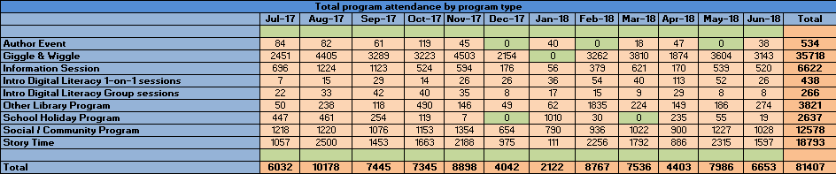

* 1. ACT Government provided the Committee with another set of data displaying the participation numbers for different types of programs, displayed here in Table 11. It shows that young children were the largest group of participants in library programs (with 54,280 attendances); 6,154 people participated in multicultural or disability programs; and 1,336 people participated in programs designed for Aboriginal people and Torres Strait Islanders:

Table 11: Community participation in lifelong learning programs by stream 2017-18[417]

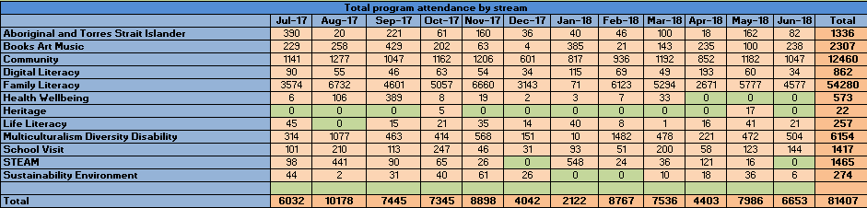

* 1. ACT Government submission provided a graph showing total numbers of participants in lifelong learning programs for the six years 2013 to 2018, reproduced here in Graph 16.

Graph 16: Lifelong learning programs, program attendance 2012-13 to 2017-18[418]

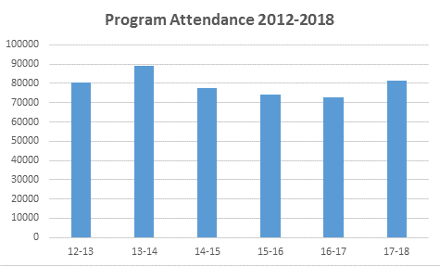

### Public computers with internet access

* 1. Libraries ACT provide computers in public libraries with free internet access, and in 2015-16, the most recent year of reporting, the number of devices across all library branches was 88.[419] ‘About 72,000 hours of free internet use are accessed by the community each year.’[420]
  2. NSLA comparative data shows that Libraries ACT provides proportionately fewer public computers with internet access than other states and territories. Table 12 compares ACT with the national average, showing that ACT libraries have available approximately half the number of computers with internet access than the national average:

Table 12: Public access internet devices per 10,000 persons[421]

|  | 2011-12 | 2012-13 | 2013-14 | 2014-15 | 2015-16 |
| --- | --- | --- | --- | --- | --- |
| ACT devices per 10,000 persons | 2.03 | 2.37 | 2.36 | 2.23 | 2.22 |
| National average devices per 10,000 persons | 4.40 | 4.43 | 4.90 | 5.49 | 5.31 |

* 1. Graph 17 shows the number (per capita) of public computers with internet access provided in libraries in each state and territory in 2015-16, the most recent year for which data is available. It visually demonstrates the comparatively small number of devices in the ACT:

Graph 17: Public access internet devices per 10,000 people in each state and territory in 2015-16

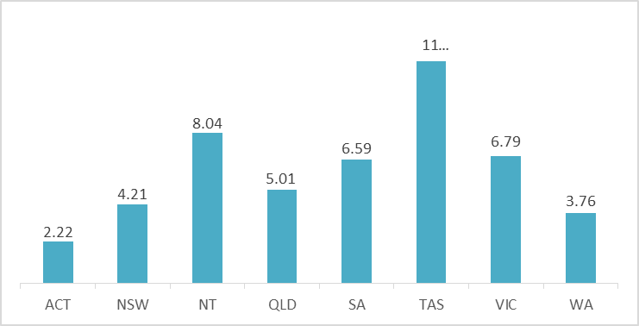

* 1. The ALIA National Standards recommend caution when comparing provision of public computers between jurisdictions:

‘The number of computers provided in the library depends on the nature of demand in the library’s community, including seasonal requirements; and local factors such as the degree of penetration of internet access in households, the take-up of mobile devices, and the availability of broadband connectivity.’[422]

* 1. The Committee heard evidence of the importance of public computers with internet access for people who do not have access to digital technology at home.[423] Women with Disability ACT told the Committee that libraries are an important public access point for people who do not have internet at home, a high proportion of whom are women with disability:

‘According to the most recent Australian Bureau of Statistics report on Household Use of Information Technology, 6% of households in the ACT have no access to the internet. The internet is a crucial part of modern life in many cases, which is demonstrated by its high use for banking (72% of internet users) and purchasing goods and services (61%). More people are also using the internet to access health services (an increase from 22% in 2014/15 to 46% in 2016/17) and formal education (31.7%). Due to multiple disadvantage and gender-based stigma, women with disability are likely to have less access to the internet, particularly older women.[424]

* 1. The digital divide is discussed above at paragraph 6.113, and accessibility and inclusion for people with disability is discussed below at paragraph 7.17.

#### Committee comment

* 1. The Committee notes the proportionately low number of computers at ACT libraries when compared with other states and territories. This may be explained by the comparatively high rates of digital inclusion in the ACT,[425] however the Committee suggests that ACT Government review the adequacy of the current level of service.

### Meeting rooms available for public use

* 1. Libraries ACT provide meeting rooms for hire by community groups, and the following description was provided in the ACT Government submission:

‘Library facilities available for public use include a variety of spaces for use by community groups to facilitate community learning, literacy, economic development and social inclusion. Rooms vary in size and charges for room hire vary across sites depending on size and facilities available. Cost is also determined by user category: commercial groups, not for profit groups, Government agencies, and small unincorporated groups with a learning outcome. The library is required to comply with the National Competition Policy with regard to commercial users. Rooms are used by groups for varied purposes including: Language and English conversation; Health, wellbeing and support; Parent groups; Special interests and hobbies (e.g. art, board games); Business meetings and workshops; Community council meetings; Government meetings, consultation and community education’.[426]

* 1. ACT Government told the Committee that providing meeting rooms for community use makes the library more accessible, because:

‘people will come to things, to programs and activities, when they may never have walked through the door to actually borrow a book.[427]

* 1. Submissions to the Committee contained expressions of appreciation for access to meeting rooms.[428] However the Committee also heard complaints about the ‘administrative burden’ of booking meeting rooms, for example:

‘It could also be worth making it easier for community groups to hire library venues for their meetings.’[429]

‘It is not easy to book rooms as they ask for a lot of information.’[430]

‘There is a form that needs to be filled. Because it requires a signature, you need to print it, sign it, scan it and then send it via email to the library.’[431]

* 1. ACT Government informed the Committee of plans to implement a new online booking system for meeting rooms in libraries:

‘People are wanting better access to our community rooms, which is something that we have taken on board and we are trying to implement a new system, a new online booking system.’[432]

* 1. Submissions to the inquiry included suggestions for increased after-hours access to meeting rooms, for example:

‘A short term priority is to provide after hours access to the ground floor meeting room for the use of the community and also to contribute to activating the area outside of standard work hours.’[433]

‘Library access, such as extended opening hours, could be expanded to allow community health and well-being organisations coordinating education and discussion groups to meet at night.’[434]

‘It could also be worth making it easier for community groups to hire library venues for their meetings, including by expanding after hours access where possible.’[435]

* 1. The Committee asked if ACT Government plans to expand the number of meeting rooms, particularly in the south of the city, and after-hours, and was told there are future plans to make a meeting room at Woden available after-hours:

*Minister*: ‘There was a 2017-18 budget initiative to move the ACT Heritage Library to Fyshwick, which is going to free up space in the mezzanine level of Woden library which can potentially be used by community groups and also to deliver library programs. When Access Canberra moved out of Woden library on the ground level, that also freed up space for a community room, and that has been used by community groups as well. One of the issues that has been raised with us by groups like Woden community council is getting access to that community space, particularly after hours. It does not currently have a dedicated access point. The centralised access presents access to the whole library, and that is problematic from a security perspective. We have certainly taken the feedback from them and are looking at what options might be available to make sure that there is access to a community space. They are at a premium on the south side, and some of the major clubs have shut down in the area, which has meant pressure on the rooms.[436]

*Director of Library Services*: ‘As part of the move from Woden library for the Heritage Library and that ground floor area, we have definitely earmarked some money to try to make that downstairs room available after hours. There is a kitchen associated with that as well, so it could be quite multi-use.[437]

* 1. Women with Disabilities ACT recommended that Libraries ACT install a hearing loop in some of the library community rooms, and consider video conferencing facilities, to open up a greater range of possibilities for people with disability to engage in community activities:

‘Libraries in the ACT could be further improved by providing accessible tools for community use. Current facilities for hire could be fitted with hearing loops to provide more accessible facilities for information sessions, classes and consultations. For example, WWDACT would love to have use of hearing loop facilities across the ACT to help maximise our community’s engagement with systemic advocacy. However, it can be very difficult to find suitable facilities close to the town centres along the length and breadth of the territory and costs to hire a hearing loop can be significant for community events.’[438]

‘Video conferencing would also be a great asset for those without facilities of their own and would allow use of live captioning or Auslan interpretation at events. This is particularly worth considering as there are so few Auslan interpreters available in Canberra. Video conferencing facilities would also help Canberrans tap into resources from around the country and would allow classes to be held with speakers from across Australia, broadening the possibilities for community education and events for all Canberrans.’[439]

Recommendation 9

The Committee recommends that the ACT Government develop an electronic booking system for meeting rooms in library branches, to reduce administrative burden on library staff and improve accessibility for the community.

Recommendation 10

The Committee recommends that the ACT Government increase the number of meeting rooms available to the community, and facilitate after-hours access, particularly at Woden Library.

### Volunteers

* 1. Three submissions to the Committee suggested greater use of volunteers to assist library staff in certain tasks.[440]
  2. Libraries ACT has a Volunteers Policy, which is stated to be under review, and a volunteer application form on their website.[441] The Libraries ACT website contains a list of activities currently performed by volunteers:

‘Currently we have volunteers who: Sort ephemera and photos at the ACT Heritage Library; Deliver items to members of the community who are physically unable to visit the library and often socially isolated; Facilitate English Conversation Classes; Sort former library items for the Book Roundabout project; Run social programs; Help members of the Canberra community improve their literacy skills; Assist with the running of the Makerspace at Civic.’[442]

* 1. During the hearing, the ACT Bilingual Education Alliance suggested greater coordination of volunteers to teach English conversation groups or run bilingual story time:

‘I think there is a possibility to provide more courses or conversations for non-English speakers or for people who would like to develop. For example, in my case, I wanted to volunteer, but there was no location. The group that was meeting was at the other side of the city, and it was not possible for me to commute just for this particular time and not for other times. I offered that I could have smaller groups or individual classes, but there was no structure or flexibility developed. I know they are working on that, so it should be encouraged and somehow helped.’[443]

* 1. The ALIA National Standards encourage library services to ensure that:

‘Volunteers are not used as a substitute for appropriately trained and paid library staff. Volunteers are not used to establish and maintain library services or outreach programs which would normally be established and maintained by paid library staff.’[444]

Recommendation 11

The Committee recommends that the ACT Government enhance and promote volunteering opportunities available in Libraries ACT.

### Legal deposit legislation

* 1. As described in paragraph 4.3, Libraries ACT is both a public library service, and a territory library. Other Australian jurisdictions have legal deposit legislation compelling publishers to deposit copies of all published material the national and relevant state/territory library free of charge, ether in electronic or a physical format. The purpose is to ensure that ‘a comprehensive collection of material relating to Australia and its people is developed, described, maintained and preserved for the use of current and future generations’.[445]
  2. ALIA informed the Committee that:

‘The ACT sadly lacks this legislation which, if in place, would ensure the safekeeping and long-term preservation of the documentary heritage of the territory.’[446]

* 1. When asked if the ACT needs legal deposit legislation given our proximity to the National Library, ALIA responded:

‘Absolutely. The National Library collects the nation’s published materials, but at a state and territory level the state and territory libraries collect the smaller organisations’ materials, the work of that community. The work of the ACT Heritage Library is to collect for the ACT as a community rather than as a national capital. Without that, we are putting at risk important community documents, annual reports of organisations that otherwise will not necessarily be preserved.’[447]

* 1. The Committee asked for the ACT Government position on territory-based legal deposit legislation, and was informed that it is not something the government is currently considering:

‘Legal deposit legislation is in place to compel people who publish items and publish publications to deposit them at the National Library and their relevant state library. The issue for the ACT is that that is not what we want to do. The National Library has already got all that mainstream published material. The material that we collect for the Heritage Library is much more community based. Annual reports and newsletters of community groups; we have an extremely strong collection of material around local performing arts, so much so that we had a company, a media company in the UK, get in touch with us for something that we held in our collection. The legal deposit legislation, if it were ever to be considered in the ACT, would be much more around that community deposit, which is the stuff that the National Library does not want but which is rich for us in terms of being able to talk about what it is like to be in Canberra.[448]

#### Committee comment

* 1. The Committee suggests that if the ACT Government intends to continue with a voluntary approach to archival of publications in the ACT community, it increase the promotion of the ACT Heritage Library to the community so that local authors and community groups are aware of the opportunity it provides for ongoing preservation and access of the material they produce.

## Community Engagement and Social Inclusion

* 1. Chapter 7 considers the efforts by Libraries ACT to engage with the community, and to be accessible and inclusive to a wide range of community groups with diverse needs.

### Providing safe and welcoming spaces for people vulnerable to social isolation

* 1. IFLA guidelines describe the role of the library as a public space:

‘The public library has an important role as a public space and meeting place. This is particularly important in communities where there are few places for people to meet. It is sometimes called ‘the drawing room of the community.’ Use of the library for research, education, and leisure interests, brings people into informal contact, providing a positive social experience. Library facilities should be designed and built to foster social and cultural activities which support community interests.’[449]

* 1. The ALIA National Standards encourage library services to ‘[p]rovide safe and trusted public spaces where everyone is welcome.’[450] One of the objectives of Libraries ACT is to ‘provide safe, welcoming spaces’ and to ‘encourage the community to see libraries as their “third place” after home and work and to meet and share in them.’[451]
  2. Submissions to the Committee emphasised the important role that libraries play in the lives of people who are potentially vulnerable to social isolation:

‘There is an understanding that libraries are for everyone and no-one is turned away.’[452]

‘Libraries have key roles in promoting social participation and in lessening social isolation. This is especially so for those of us who experience social and economic disadvantage’[453]

‘It can be easy for some people to experience loneliness and social isolation and a library is a wonderful and non-threatening place for people to interact with others.’[454]

‘I would also like to acknowledge the role of the library in supporting the community, particularly the vulnerable in our society. People who have nowhere to go during the day are provided with a safe place that they can feel secure and have access to computers, books and some social interactions. I think the value of libraries for this cannot be underestimated. I was unemployed for a short period of time, and most days I would visit the library to use the internet or simply to have somewhere to go that wasn’t expensive.’[455]

‘Libraries are MUCH more than housing of literature and resources… Many people use Libraries who do not have a home computer, access to the internet and who don’t have a family or many friends supporting them.’[456]

‘It is important to note that libraries are universally accepting, everyone is welcome. Vulnerable members of our community are especially made to feel welcome, I am aware that homeless people often wander into the local library to read the paper, browse the internet, or to just sit and rest in a comfy chair and to be warm and have a conversation or a snooze!’[457]

* 1. ACT Government informed the Committee that ACT Libraries are ‘working with other agencies to identify opportunities for supporting homeless people’ and ‘[s]ince 2017 Libraries ACT has partnered with Take 1 Leave 1: The Winter Coat Project to provide access to winter coats for disadvantaged people in each of our branches.’[458]

### Community participation in decision making

* 1. The ALIA National Standards encourage library services to ‘engage the community in shaping library services’.[459] ALIA told the Committee that ‘[f]or Libraries ACT to fulfil its potential, Canberrans need to be closely engaged in the evolution of library spaces, programs and services,’[460] and they recommend Libraries ACT adopt ‘[a] deliberative co-design approach to future library programs, services, physical buildings and locations, along the Aarhus model.’[461]
  2. ‘Co-design’ is a process of community engagement involving a genuine partnership with stakeholders, and collaboration in decision making.[462] It is beneficial because it ensures the outcome of the process will meet everyone’s needs.
  3. ACT Government expressed to the Committee an intention for community involvement in development of the new Strategic Plan for Libraries ACT:

‘In 2019, Libraries ACT will be developing a new strategic plan for its public libraries. Its current plan, “Renewing libraries: libraries, literacy, and learning,” concludes in 2019. The library hopes to collaborate widely with the community to develop this new strategy as well as looking to best practice in libraries from across the world and in other jurisdictions of Australia. Of course, the findings of this inquiry will also inform the libraries’ next strategic plan.’[463]

* 1. The ACT Government submission also indicates support for a co-design approach:

‘Given the increasing interest in our community in genuine co-design activities, this could be applied to planning for libraries into the future. Such an approach for a library service is best illustrated by the Aarhus Library in Denmark, where the library building and the services delivered were the result of an extensive community/government co-design process… The State Library of Victoria undertook a broad co-design process for their $88.1 million redevelopment, including working with school students, families, and toddlers.’[464]

* 1. During the hearing the Minister expressed enthusiasm for the idea:

*Minister*: ‘I am certainly very interested in that idea of a co-design process.’[465]

*Director of Library Services*: ‘The one in Aarhus was a very deep and rich co-design process with their community and it was actually over quite an extended period, which I would not be recommending here. But certainly it was a way of making sure that there was, as I said, deep and rich consultation with people and it meant that the majority of people in the community really embraced that library.’[466]

* 1. ACT Government told the Committee it recognises the need to engage with both users and non-users of libraries:

‘Between 60% and 67% of Canberrans are library members. Many of these are engaged with the library, provide feedback and are likely to be interested in contributing to a new strategic plan for libraries in the city. It is important that the views of the 33% to 40% who are not registered users are considered and their needs met. Current practices to develop a new strategic plan are less likely to engage with these people.’[467]

* 1. ALIA encourages community participation, not just periodically for strategic plan every five years, but continually in the development of library programs, services, branch locations, and building design:

‘we recommend that the Standing Committee examine… A deliberative co-design approach to future library programs, services, physical buildings and locations, along the Aarhus model.’[468]

* 1. Two submissions suggested Libraries ACT establish member advisory groups, or focus groups:

‘I think the library service could experiment with member advisory groups at a local level. For example, the Dickson library advisory/reference group could meet once a quarter to review usage patterns and make suggestions for collection development, activity programs and other issues of local concern.’[469]

‘Establish a focus group to review proposals for new or changed services and policies. There is a lot of wisdom for free out there – might as well use it!’[470]

* 1. ACT Government submission mentions plans for a consumer council, and during the hearing the Committee asked the ACT Government to describe what this might mean:

‘The idea behind it would be to bring together people from various sectors—Aboriginal and Torres Strait Islander people, the disability sector, the women’s representatives, representatives that work with young children—to use them as a sounding board for planning, for programming, for services and that kind of stuff; so, separate from a co-design process, which is a very big and deep planning process, this consumer group would be a regular group that we would talk to about all of the new initiatives we are planning and get advice back from them about what it is that their communities really need from us.[471]

Recommendation 12

The Committee recommends that the ACT Government engage in a co-design process with the community when developing the new strategic plan for Libraries ACT.

Recommendation 13

The Committee recommends that the ACT Government design an engagement strategy to guide future community participation in decisions about library services, in partnership with the following community groups and the organisations representing them: children and young people, older people, people with disability, the Aboriginal and Torres Strait Islander community, culturally and linguistically diverse communities, people with mental illness, people experiencing homelessness, and the LGBTIQ community.

### People with disability

* 1. The ALIA National Standards encourage library services to: ‘maximise accessibility’ and ‘minimise barriers to access for all users, and specifically for those with physical limitations and disabilities.’[472]
  2. For libraries to meet the goal of being a safe indoor public space, they must be universally accessible. ‘Universal design’ is the practice of creating buildings, products, environments or services that are accessible to everyone, regardless of age, disability or other factors. The seven principles of universal design are: equitable use; flexibility in use; simple and intuitive to use; perceptible information; tolerance for error; low physical effort; and size and space for approach and use. They are ‘a reference point or framework for designing any building, open space, product, phone app, or document’ to ensure they are easy to use and everyone can participate.[473] Such principles can inform the development of library services.
  3. People with Disabilities ACT (PWD) reminded the Committee that accessibility requires attention to more than physical access to library premises:

‘Accessibility includes access to the information holdings, public meeting spaces and library learning, educational and community awareness programs conducted at library premises.’[474]

* 1. Women with Disabilities ACT (WWD) told the Committee that libraries have a responsibility to set a high standard for access and inclusion, because of their important role in the community:

‘WWDACT believes that Libraries ACT fulfils an important role as an access point for information, community meeting place and education facility. However, more can be done to improve accessibility for people with disability and set a standard for access and inclusion in the ACT. Strategic investment in libraries can provide communities with the means to better include people with disability, to the benefit of the entire community.’[475]

* 1. ACT Government provided the following description of current level of accessibility of libraries:

‘The following services are currently available across the Libraries ACT network: Large Print collateral on request, translator and interpreter services, access to teletypewriter service and Speak and Listen service for speech or hearing impaired customers. Collections are provided in audio and large print as well as a large range of e-resources. Public access computers can be set to large font for ease of reading with some computers being set up permanently. All branches have had disability access and disability toilet facilities retro fitted.’[476]

#### People’s experiences

* 1. The Committee heard that libraries are important to people with disability, as they are to everyone in the community:

‘Libraries are very important to people with disabilities just as they are to people in the general community because we are people first and our disabilities are second. They are repositories of information, both hard copy and in electronic forms and centres of learning and education and digital access. They are also very important as meeting spaces for community organisations and places of social interaction.’[477]

* 1. The Committee appreciated the opportunity in this inquiry to learn about the experiences of some of the people in our community who interact with library services and live with a disability:

‘I use the library constantly, and read every day. I use the library almost entirely through the HLS – Home Library Service. I have no car. I am an Age Pensioner, previously a Disability Support Pensioner for 14 years. I can walk and use buses, although I have limited mobility and use a walking stick. I have an autoimmune condition, which means fatigue and I am not able to carry things. When the library was moved next to the Legislative Assembly, I found it increasingly difficult, as I can’t carry books. Fortunately, at that time the Mobile Library service was functioning and parked near my home. When the Mobile Library was discontinued, it was decided that I could go on the Home Library Service list, for which I’m grateful.’[478]

‘In my family I have a disabled son and the staff have been very kind to him and the collection of chapter books and picture books have been great for his reading development as well as the online services such as story box’[479]

‘Prior to being unable to leave the house, I found ACT libraries very accessible because they had disabled parking, wheelchair access and were quiet (important for people with cognitive difficulties and noise sensitivity). Being able to reserve and renew books online was important when I couldn’t get to the library due to ill health or spend time browsing.’[480]

‘Currently, Libraries ACT facilities are inconsistent in their accessibility. For example, the Kippax library has a ramp for wheelchair and walker access, but it was described to us as “unstable” by a WWDACT member. A user on twitter described a situation in March of this year where the accessible toilet at Belconnen Library did not have a functional light. In this case, this was the only accessible toilet nearby, meaning that the reliability of this was paramount to the accessibility of facilities around the library. The community room at Woden Library has “limited wheelchair access”, meaning that some members of the community may not be able to access it.’[481]

#### Accessibility audit

* 1. PWD recommended Libraries ACT conduct an audit of compliance with building standards and universal design principles:

‘PWD ACT recommends that The ACT Library Service conducts an audit of its library buildings to determine the extent to which library premises comply with the Commonwealth Disability Discrimination Act Standards for Access to Premises and principles of universal design; relevant to accessibility of premises. Such an audit should include recommendations for overcoming identified access issues and a timetable for this remedial action to be taken.’[482]

* 1. PWD also recommend an audit of library services and resources:

‘PWD ACT also recommends that the ACT Library Service conducts an audit of the information holdings at each of its library premises to determine the extent to which the information holdings at each premises are held in appropriate formats so as to be accessible to people with a variety of disabilities. Relevant formats include: ordinary and large print, electronic in various formats, audio, braille and plain English. The audit should identify access gaps in library information holdings, actions to address these gaps and a timetable for these actions to be taken.’[483]

* 1. In its submission to the inquiry the ACT Government announced there are plans for ‘an accessibility audit of Libraries ACT’ in ‘the latter months of 2018’.[484] During the hearing the ACT Government confirmed that the accessibility audit will cover both physical access and technology.[485]

#### Disability Action Plan

* 1. Several witnesses highlighted that the Libraries ACT strategic plan does not refer to ‘disability’, and Libraries ACT does not have a Disability Action Plan:

‘At the moment, there is not really a way to know if Libraries ACT is indeed responsive to all the needs of the community, as it currently does not have a disability action plan, nor is disability mentioned at all in the strategic plan.’[486]

‘The ACT Library Service has a number of community access initiatives. However, the current Strategic Plan for library services does not mention disability. PWD ACT recommends that the ACT Library Service actively engage with people with disabilities and their organisations to develop and implement a specific Disability Action Plan to achieve accessibility of ACT library services for people with disabilities. In doing so the ACT Library Service should engage with organisations representing people with disabilities from culturally and linguistically diverse backgrounds and people with disabilities who are from Aboriginal and Torres Strait Islander backgrounds.’[487]

‘Examples of library Disability Action Plans are available from the State Library of Queensland and the State Library of Victoria.’[488]

* 1. ACT Government informed the Committee there are plans for Libraries ACT to develop a disability inclusion action plan following the outcomes of the accessibility audit:

‘An accessibility audit of Libraries ACT is planned for the latter months of 2018. From this a disability inclusion action plan will be developed for Libraries ACT, with the knowledge that it is often the barriers that exist in community rather than disability itself that limits a person’s ability to fully participate. The principles of Universal Design will be embedded in the plan. Accessibility means more than physical access to a building and includes access to resources, programming and information. Access for people with disability is not a ‘one size fits all’ solution. Improvements that will be investigated over the next 12 months include improved services for people with a physical, hearing, vision, or cognitive impairment.’[489]

Recommendation 14

The Committee recommends that Libraries ACT develop and implement a Disability Action Plan, as an ongoing framework for continuous evaluation and improvement of the accessibility of library services, and that they do so in partnership with the disability community.

#### Digital divide

* 1. The digital literacy of people with disability is discussed above at paragraph 6.115. In that section of the report the Committee recommends that ACT Government develop and promote specialist digital literacy training programs at libraries for people with disability. The Committee heard further suggestions for how Libraries ACT might help bridge the digital divide for people with disability.
  2. WWD told the Committee that libraries can provide equipment, software and information to better enable people with disability to use the public computers to access library material or participate in broader life activities:

‘Equipment for accessibility could potentially be quite expensive for members of the community and may be a barrier to some using it at home… for people with print disabilities, having access to screen readers on library computers would be quite useful, as well as having information on keyboard access to using the websites that are available, with things like BorrowBox, and how you navigate that using a keyboard for people who cannot use a mouse for one reason or another. There are a whole range of accessible technologies available depending on people’s disabilities. It would require a bit of work to work out exactly what we could bring in.’[490]

* 1. PWD described some of the adaptive technology used by people with a range of disabilities:

‘Many people with disabilities need to use adaptive technology including screen magnification programs such as Zoom Text, speech output programs such as JAWS and alternatives to keyboard and mouse input, such as Drag and Dictate and Naturally Speaking. Computers set up with these adaptive technologies should be available at each library. Each library should also have staff who are trained in these adaptive technologies and who are able to assist people in their use.’[491]

* 1. Both PWD and WWD highlighted the importance of training library staff to be able to support the use of adaptive technology:

‘libraries should have various adaptations to make internet information accessible, such as screen reader technology and technology to allow people who cannot input by keyboard or mouse to use the internet, such as programs like Dragon Dictate. It is very important, though, to be aware that it is no use as a person with disability to come to a library to use the computer and the staff member does not know about the adaptive software used and cannot help you out of a problem. Unfortunately, electronic information as it is presented on the internet is not always fully accessible and sometimes you need to be able to work the technology itself, the adapted programs, to make the information accessible.’[492]

* 1. ACT Government informed the Committee there are plans to improve website accessibility:

‘There are a range of guidelines which will help inform actions for improving access for people with disability such as Web Content Accessibility Guidelines , with Libraries ACT compliant with WCAG 2.0 (AA). With a new website, currently being developed, the site will be WCAG 2.0 (AAA) compliant with the exception of some of the ACT Heritage Library pages.’[493]

#### Promoting library services to the disability community

* 1. The Committee heard from witnesses who encouraged Libraries ACT to actively promote their services and facilities to the disability community. If activities are made accessible, and visibly labelled as such, people with disability will know they are safe and welcomed:

‘PWD ACT also recommends that the ACT Library Service fund and promotes its libraries as a “go to” place for people with disabilities whereby people can nurture relationships and facilitate “meet ups” through an information hub… In this regard, we envisage libraries as having similar programs for people with disabilities as they currently have for mums and young children. Library ‘tours’ could offer based on different subjects or ‘tours’ on special formats specifically for people with disabilities.’[494]

‘With one-on-one sessions with the internet and things like that, having those specifically labelled as accessible. Making sure that staff are trained in working with people with, say, intellectual disabilities and making sure that that is visible to the community so that they can access those services and know that they are safe, they are suitable, would be quite helpful. Even if their staff may already be trained, it is not necessarily visible in any way.’[495]

#### Consultation with the disability community

* 1. PWD told the Committee that people with disability can provide guidance to Libraries ACT on the design of library services:

‘They are best placed in bringing to bear their lived experience of their disabilities and in giving accurate and practical advice to policymakers in the library space on how libraries, their information holdings and their programs can be made accessible and inclusive.’[496]

* 1. During the hearing the Minister announced the creation of a new position of Disability Learning Coordinator:

‘Libraries ACT has also decided to add to the lifelong team with a new disability learning coordinator. This position will be advertised soon. And, like the Aboriginal and Torres Strait Islander and multicultural positions, this person will engage with people with disabilities to ensure that they are able to fully access our library services.’[497]

* 1. Committee asked about role of the Disability Learning Coordinator and the other dedicated outreach positions in Libraries ACT:

‘Their job is to engage with those target audiences or community groups and to work out what we can offer to meet their needs and how we can celebrate them and their diversity through the library so that more people get to experience all of Canberra’s diversity.’[498]

#### Other suggestions from the disability community

* 1. The Committee heard that libraries play an important role in social inclusion of women with disability, and that the group learning opportunities currently available at libraries could be enhanced and promoted to support their participation:

‘we know that social isolation is a problem for women with disabilities in the ACT. Libraries, with their high patronage and range of locations, could certainly contribute to reducing this by ensuring that regular social activities are supported to include women with disabilities. Indeed, in one of our surveys, women with disability indicated that they were interested in more community activities, group learning opportunities, similar to those already found at libraries. If Libraries ACT could work towards ensuring that all their events are accessible, and visibly so, reaching out to the community, it may facilitate greater inclusion.’[499]

* 1. During the hearing WWD highlighted the different needs of people with different forms of disability, and recommended:

‘better resources and activities for people with cognitive and learning disabilities.’[500]

* 1. Two witnesses pointed out that many of the existing mainstream library resources are suitable for people with cognitive or learning disabilities, but they are not necessarily presented in a way that people can easily locate them:

‘It is important to note that materials which are useful for people with disabilities are already in libraries although their value to different groups may not be recognised. Such materials would include: High-interest/low-vocabulary materials including English as Second Language materials (ESL); Music collections; Spoken-word collections; Picture books; Books in enlarged print (particularly junior books).’[501]

‘In the UK, the University of Birmingham did a study, which is available online, about how people with learning disabilities can use other materials that are already available in libraries quite effectively. ALIA also have some guidelines on this. Labelling those existing materials, for example, English as a second language materials, which are high content, low vocabulary materials, could really make a difference, but that would require a bit of work in assessing the existing collection. There are also books available specifically for people with cognitive and learning disabilities. And there are ways that you can do things, like having displays to highlight those books, things like that. It is not necessarily buying new resources, though that would be welcome.’[502]

* 1. The Committee was told that Libraries ACT could liaise with specialist library services to learn from their expertise in supporting people with disability:

‘the potential for enhanced cooperation between the ACT library service and specialist library services such as libraries specialising in materials for people with intellectual disability or easy English materials or libraries for the vision impaired, such as the Vision Australia library.’[503]

### Children and young people

* 1. The International Federation of Library Associations states that libraries have a particular responsibility to children and young people:

‘The public library should attempt to meet the needs of all groups in the community regardless of age and physical, economic or social circumstances. However, it has a special responsibility to meet the needs of children and young people. If children can be inspired by the excitement of knowledge and by works of the imagination at an early age, they are likely to benefit from these vital elements of personal development throughout their lives, both enriching them and enhancing their contribution to society. Children can also encourage parents and other adults to make use of the library.’[504]

* 1. Libraries ACT introduced the Giggle and Wiggle program for babies and toddlers in 2009-10,[505] and Story Time for 3 to 5 year olds began in 2010-11.[506] These programs are discussed at paragraph 6.104 above.
  2. Many submissions to the inquiry expressed the important role of libraries in children’s development, for example:

‘Early literacy programs help develop: A love of books and lifelong use of libraries; Pre-reading skills and a desire to learn to read; Listening and language skills; Cooperative behaviour as part of a group; Understanding of simple concepts; Imagination and creativity’[507]

‘I would like to thank the ACT libraries for providing a welcoming environment with story times and stacks of attractive books to entrance young children. Libraries play a major role in developing literacy in young Australians’[508]

‘Libraries in the ACT also support learning throughout the school years. They provide access to reference materials that complement and supplement resources at school and at home. They also provide free access to a range of interesting books and written materials of all types, thus helping to encourage the love of reading - the key to life-long learning. The availability of library branches after school hours and at weekends makes available safe quiet places for homework and study.’[509]

#### Committee comment

* 1. The Committee emphasises the importance of Libraries ACT’s work to actively engage families with young children who are not currently library users. The Committee encourages continuation and extension of the partnerships with Child and Family Centres (see paragraph 6.81).

### Older people

* 1. Submissions highlighted the importance of libraries in the lives of many older Canberrans:

‘Public libraries are an extremely important resource for older members of the ACT community, providing a source of information and entertainment, a hub for access to communications technology, and a venue for the delivery of community programs. COTA ACT members responding to our survey indicated they made extensive use of the wide range of services on offer at the libraries and were very satisfied with the services provided.’[510]

‘Libraries are important especially for the older community, not so much as getting books but for the friendship of meeting and talking to other people… also older people use the library just to keep warm/cool.’[511]

* 1. Council on the Ageing ACT directed the Committee’s attention to research from 2011 which estimated that 25-30% of computer users in libraries are seniors:

‘Canberra’s public libraries provide a hub for much needed technology education for seniors, as well as access to computers and Wi-Fi for those who cannot afford to purchase these devices and services. Approximately 25 to 30 percent of library computer users are estimated to be seniors.’[512]

#### Home Library Service

* 1. The Home Library Service coordinates monthly deliveries of books, audio books and other material to housebound members of the community including those who are aged, unwell, experiencing mobility problems, or unable to handle print material.[513] TCCS reports that in 2017-18 this service was provided to 317 people:

‘Libraries ACT also coordinated monthly deliveries of books, audio books and other material to 317 members of the community who, for reasons including disability, illness and limited mobility, were unable to access public libraries in person.’[514]

* 1. The Committee heard that the Home Library Service is important for preventing social isolation among older people, and is greatly appreciated:

‘The Home Library Service provides a very important role for older Canberrans who are isolated and unable to access services outside their home due to health or other issues. In addition to providing them with reading material, the service may provide one of the few interactions an isolated older person has in a week.’[515]

‘The librarians who select books for the house-bound provide a wonderful community service.’[516]

‘Home Library service is an excellent amenity. I volunteer in an aged care facility, and the residents and activity staff really appreciate this service.’[517]

‘The Home Library Service is heavily used by those who cannot get to the library and does a lot to help shut in people access reading materials. It helps people to still feel part of the local community and is an important service provided by the ACT government.’[518]

##### Committee comment

* 1. The Committee notes that as Australia experiences ageing of the population over coming decades, the capacity for Libraries ACT to meet the needs of older people in Canberra will be increasingly important.

### Aboriginal and Torres Strait Islander community

* 1. The National and State Libraries Australasia (NSLAA) produced the *National Policy Framework for Aboriginal and Torres Strait Islander Library Services and Collections* (NSLAA Policy Framework) which states that ‘Aboriginal and Torres Strait Islander library services and collections are a fundamental part of core business’, and that library services are to be ‘designed and delivered in consultation with and involvement of Aboriginal people and Torres Strait Islanders’.[519]

#### Building relationships and ensuring cultural safety

* 1. The Australian library and information services sector is aware of the need for libraries to build relationships with Aboriginal and Torres Strait Islander communities, and provide cultural safety in library services. ACT Government informed the Committee that, as a member of NSLA, Libraries ACT is helping to develop:

‘An Indigenous Cultural Competency program to ensure libraries are more culturally safe for Aboriginal and Torres Strait Islander staff and customers, and make “programs, services and collections accessible, respectful and responsive”.’[520]

* 1. During the hearing, the Minister spoke of the importance of engaging with Aboriginal and Torres Strait Islander people:

‘Engaging with Aboriginal and Torres Strait Islander people is also very important to our library services. Libraries has an Aboriginal and Torres Islander learning coordinator who works with the local Indigenous community to promote library services as well as facilitating celebration of Aboriginal and Torres Strait Islander cultures in the broader community.’[521]

* 1. In 2017 TCCS reported on outreach activities developed by Libraries ACT in partnership with West Belconnen Child and Family Centre:

‘Deadly Digital Libraries ACT and the West Belconnen Child and Family Centre, developed programs for Koori Kids (8-12 years) and Koori Leadership (12+) groups in the area. Sessions introduced younger kids to some of the library’s eResources (e.g. Literacy Planet, Tumblebooks, Britannica Kids) and makerspace technologies (e.g. coding games, electronics). Older kids were introduced to activities such as 3D printing and digital storytelling to share their own stories.’[522]

* 1. ACT Government informed the Committee that Libraries ACT ‘strives to reflect the diversity of the ACT community’:

‘In 2017-18 the library offered programs sharing and celebrating Aboriginal and Torres Strait Islander culture with the wider community, including about Aboriginal dot painting, artefact making, and scar trees and other indigenous plants. For International Mother Language Day the library offered story time featuring Ngunnawal language.’[523]

#### Participation in decision making

* 1. The NSLAA Policy Framework encourages library services to involve Aboriginal and Torres Strait Islander communities in decision making about library services, through:

‘The involvement of Aboriginal people and Torres Strait Islanders at all levels in the decision-making processes; The involvement of Aboriginal people and Torres Strait Islanders on library boards, steering/advisory/reference committees, and/or special interest groups; Broader consultations with Aboriginal and Torres Strait Islander communities’.[524]

* 1. In paragraph 7.16 above the Committee recommended that ACT Government design an engagement strategy to guide future community participation in decisions about library services, in partnership with the Aboriginal and Torres Strait Islander community, among others.

#### Employment of Aboriginal people and Torres Strait Islanders in Libraries ACT

* 1. The NSLAA Policy Framework includes the goals of prioritising the employment of Aboriginal people and Torres Strait Islanders in library services, and then ‘striving for levels of employment that reflect national figures on the proportion of Indigenous to non-Indigenous Australians’.[525] Employing Aboriginal people and Torres Strait Islanders within libraries helps make library services more relevant to the community.
  2. Libraries ACT employs an Aboriginal and Torres Strait Islander Coordinator whose role is to:

‘work closely with their specific communities to connect them with the library and its services, develop programs and services that meet their needs, and to share and celebrate their cultures.’[526]

#### Collection management

* 1. The NSLAA Policy Framework encourages library services to work towards:

‘Continued identification of Aboriginal and Torres Strait Islander material within existing collections; strategies/priorities to achieve the most comprehensive Aboriginal and Torres Strait Islander collections as possible as a nation, including the gaps left by the exclusion of Australia’s Indigenous perspectives; strategies to promote the preservation of Aboriginal and Torres Strait Islander languages and to ensure they are supported by and reflected in collections; commitment to the proper treatment of the material within collections according to established Protocols; recognition of different issues that characterise the retrospective, contemporary and evolving information domain’.[527]

* 1. ACT Government informed the Committee that:

‘Work is also taking place to review and improve collections for [the Aboriginal and Torres Strait Islander and multicultural] communities.’[528]

#### Recording the Indigenous history of Canberra

* 1. The ACT Heritage Library within Libraries ACT ‘helps tell the stories of Canberra and its people. We collect, preserve, promote and provide access to the documents that record the lives of Canberrans at home and in the wider community.’[529]
  2. The strategic plan for the ACT Heritage Library provides no reference to how the service is engaging with the local Aboriginal and Torres Strait Islander community to discuss their possible inclusion and participation in the collection.[530]
  3. The ALIA National Standards and the NSLAA Policy Framework require ACT Government through the ACT Heritage Library to consider how it engages the local Aboriginal and Torres Strait Islander community. Their history deserves preservation in the same way as any other community group in the Canberra region. However the process needs to be culturally safe, and there are complex sensitivities to be understood in the interaction between Indigenous people and libraries as public institutions, including:

‘preservation of traditional cultural property and oral traditions; the moral rights of Indigenous Australians to ownership of their knowledge.’[531]

‘The importance of Indigenous knowledge restoration and maintenance to Aboriginal people and Torres Strait Islanders, and its implications for systems of documentation, storage, retrieval, and access; The complex space between Indigenous knowledge systems and Western knowledge, and its implications for the library and information sector; Traditional library and information management systems and practices will need to adapt, if they are to be meaningful to Aboriginal people and Torres Strait Islanders’.[532]

#### Committee comment

* 1. The Committee encourages Libraries ACT to:
* consult with the Aboriginal and Torres Strait Islander community on how they might wish to be involved with the ACT Heritage Library, or whether Libraries ACT can support the community to preserve their history in another way, and
* review the ACT Heritage Library to assess what adjustments might be made to enhance cultural safety for the Aboriginal and Torres Strait Islander community.

### Culturally and linguistically diverse communities

* 1. The ALIA National Standards encourage library services to provide services to culturally and linguistically diverse communities, and in doing so:

‘place particular emphasis on: purchasing minority language material where there is a distinct CALD population; developing communications strategies in community languages, and provision of programs in community languages (e.g. multilingual Story Time).’[533]

* 1. ACT Bilingual Education Alliance (ABEA) told the Committee that libraries as meeting places have an important role in the lives of people newly arrived in Australia:

‘While we understand the importance and increasing popularity of eBooks and online access to other resources, libraries are important social and educational centres. The role of their physical settings, with the richness of interpersonal and language interaction they can provide, should not be underestimated. Their multiple locations, easy access by public transport and extended opening hours are key factors to the value and social impact of ACT Libraries.’[534]

* 1. Canberra Multicultural Community Forum said that:

‘The ACT libraries offer a valuable service for Canberra’s multicultural and multilingual community.’[535]

#### Building relationships

* 1. ACT Government informed the Committee that Libraries ACT employs a Multicultural Community Coordinator to:

‘work closely with their specific communities to connect them with the library and its services, develop programs and services that meet their needs, and to share and celebrate their cultures.’[536]

* 1. The Committee heard that Libraries ACT have developed partnerships with multicultural community groups:

‘ACTBEA has worked closely with Libraries ACT over the past few years, principally through the Multicultural Learning Coordinator but also through attending quarterly meetings of the ‘Love 2 Read Canberra’ Group which ACT Libraries chairs.’[537]

‘Regular programs for multicultural communities include… orientation visits from organisations that work with new migrants and refugees, such as the Migrant and Refugee Service, and Navitas who deliver the Adult Migrant English Program (AMEP) in the ACT.’[538]

* 1. The Committee was told that the multicultural community can not only benefit from, but contribute to libraries, as volunteers:

‘As a peak body, CMCF is well placed to assist the libraries to contact community groups who could help to facilitate English language classes, and with the provision of interpreters and volunteers for various activities.’[539]

* 1. Witnesses encouraged Libraries ACT to undertake greater promotion of library services within multicultural communities:

‘We suggest that further ways to publicise library activities be explored to ensure that all sectors of the community are aware the educational, training and social possibilities they offer. For example through broadcasting in other languages on community radio.’[540]

‘Put strategies in place to further encourage Canberrans from different language and cultural backgrounds, particularly older community members, to benefit from, and contribute to, activities in ACT Libraries.’[541]

* 1. The Committee asked what Libraries ACT do to promote programs into CALD communities:

‘we have the multicultural learning coordinator and part of her job is to get out with all of those communities and talk to their representatives and to get the message out. It is not perfect, but we find the person-to-person approach is probably the best.’[542]

#### Library resources in languages other than English

* 1. ACT Government informed the Committee that Libraries ACT provide print ‘[r]esources in more than 18 languages other than English’ and that work is taking place ‘to review and improve collections’ for multicultural communities.[543]
  2. Feedback in submissions suggested the need for regular review of the quality and range of library resources in languages other than English, for example:

‘The Spanish collection including books, DVDs, CDs and magazines is very outdated and needs to be updated’[544]

‘Regular review library resources and services in other languages to ensure they are meeting the needs of a changing multicultural demographic.’[545]

Libraries started introducing bilingual books and textbooks and texts in other languages. We see benefits in it. We see people using their resources. We would like to encourage libraries to keep developing and expanding resources’[546]

* 1. ACT Government described to the Committee the challenges involved in meeting all requests for resources in other languages:

‘We get some feedback from new and emerging communities, language communities, about wanting to have collections in their languages. That is often difficult because sometimes those particular new residents have come from places where there is no publishing industry. They have come from a place where war is happening and no-one is publishing books. That is always a challenge as well.’[547]

* 1. Witnesses at the Committee hearing recommended that libraries not only purchase materials but make them more visible and easier for people to find:

‘At the libraries, the tables for quick picks are well located. Generally they have English books. These could include books in other languages.’[548]

‘And the other thing is that we forgot to put in the submission that last September in the Assembly all parties agreed to a motion when they were talking about mother language celebrations. They were talking about corners in every library to display and collect books in other languages. I have not seen any follow-up from that.’[549]

#### Digital literacy training

* 1. The Committee heard that some digital literacy training is designed for multicultural communities:

‘the library’s partnership with Global Sisters provides an online privacy security training program to women from culturally diverse backgrounds’[550]

* 1. The Committee asked whether Libraries ACT plans to deliver digital training in languages other than English, and was told it is under consideration:

‘Most definitely, particularly with languages other than English. We are very aware that we run our programs in English. Yes, we are considering that.’[551]

#### Use of translation and interpreters

* 1. Participants in the inquiry encouraged Libraries ACT to display information in other languages, and to employ bilingual staff, or use telephone interpreter services to assist interactions with library users:

‘Hearing and seeing other languages in libraries can encourage families with non-English speaking backgrounds to make more use of libraries, explore and access their resources, and read to their children in whichever language they feel most comfortable.’[552]

‘We need librarians that may speak a second language if possible’[553]

‘We ran something at the library last weekend; it was a workshop on raising children in more than one language. One of the parents said they found it quite daunting to go in to join the library because all the information is in English. I do not know whether library staff are trained to be quick to use the telephone interpreter service. It is a right for people using government services to be able to speak to an interpreter on the phone.’[554]

#### Lifelong learning programs

* 1. The Committee heard positive reports of the bilingual story time sessions, in promoting children’s development and parents’ social connectedness:

‘As with Giggle & Wiggle and Story Times in English, the bilingual sessions led by skilled library staff and community members provide networking opportunities and increase parents’ awareness of how they can contribute to the cognitive and literacy development of their children. Through their professional staff and multilingual resources, the Libraries thus help lay a foundation for success at school for all.’[555]

‘CMCF is also pleased to see the expansion of Bilingual Story times at ACT libraries. These were held on an ad hoc basis in the past, but are now being made a regular part of library programs. CMCF congratulates ACT Libraries for this. a. It opens up the world of other languages, cultures and stories to all. b. It also encourages consumers who speak another language to feel accepted in libraries. c. Including the consumers in library activities makes them feel welcome and encourages them to make full use of the many resources which can assist them and their children to fully participate in life and work in the ACT.’[556]

* 1. ACT Government informed the Committee of plans to expand the program:

‘Bilingual story times are currently being held in Hindi and Mandarin, with Arabic, Farsi and Vietnamese commencing soon. It is planned to introduce additional languages as suitable presenters are found.’[557]

* 1. The Committee was told that Libraries ACT provide the venues for English conversation groups, which are run by volunteers:[558]

‘The English conversation classes are valuable and the use of rooms for the same, at no cost, should be continued. These not only assist English language development but also help build social networks.’[559]

### Fines for overdue books

* 1. The ALIA National Standards state that: ‘Fees, charges and fines should not be set at a level that would deter anyone from using the library, especially children.’[560]
  2. The ACT Government submission did not refer to library fines, or outline the purpose they are intended to achieve; whether it is to ensure library items are not stolen, or facilitate fair use of library resources, or achieve cost recovery.
  3. Overdue loans can result from people not being able to travel to the library to return the item, therefore the issue of fines is closely linked to the topics of: branch locations (see paragraph 5.58); opening hours (see paragraph 5.43); and accessibility for people with disability (see paragraph 7.17).
  4. One view put to the Committee is that fines make borrowers more responsible:

‘I welcome the charge for overdue books while accepting it isn’t financially viable but hopefully makes borrowers more responsible.’[561]

* 1. An alternative view heard by the Committee is that fines create a barrier to accessing library services, particularly for people on low incomes who have greatest need for library material:

‘Fees amnesties should be introduced more often for those clients that are disadvantaged. I do not want them to fear returning items and come back to borrow items again’[562]

‘Libraries across the world are increasingly recognising that library fines are a serious barrier to accessing their services. I refer the committee to this article, written by the CEO of the New York Public Library for a detailed analysis on why library fines discourage the public from library use and may be ineffective: Marx, Anthony W. “The case against library fines – according to the head of the New York Public Library” Quartz (18/12/2017) <https://qz.com/1158839/the-case-against-library-fines-according-to-the-head-of-the-new-york-public-library/>. Our family accepts library fines as part of using the library service and we usually keep them under control. However, I know personally of some families who no longer use ACT Library services, due to fines that can accrue. On limited budgets, they are not able to risk accruing such fines. The fines can be sizable. My family recently experienced a family tragedy and over the course of one week, checking library records was not a high priority. In that one week, my family of four accrued fines of over $75 between us. Through this experience, we discovered that once fines reach a certain level on a card, no material can be renewed, resulting in greater fines. Due to the lack of a nearby library branch, we also had to wait an extra day for one of the adults to specifically travel by car to return the many books to a branch in another district of Canberra. As a one off, we could afford this fine but I now completely understand why many families cannot risk fines reaching this level. I would recommend that consideration be given to blocking people’s ability to borrow further items once any item reaches a certain number of days overdue, rather than fining them. If fines do continue, I recommend that no one should be blocked from renewing materials already borrowed due merely to the level of the fine on the card. This rapidly “snowballs” the fine and quickly makes it a very large fine. Finally, one other cause of escalating fines with ACT Libraries is that if an item is more than a few days’ overdue, it cannot be renewed, even if it is not reserved by another patron. I would recommend that any item which is not reserved by another patron and which has not been renewed the maximum number of times ought to be able to be renewed, no matter how overdue it is.’[563]

* 1. One submission acknowledged the complexity of the issue of library fines:

‘I also think maybe scrapping library fines might be a good idea. I’m not sure how you’d manage it. Maybe you would only do it for regular users, or if the book wasn’t requested by someone else.’[564]

* 1. Three suggestions put to the Committee were: that there be exemptions for concession card holders; [565] or periodic amnesties during which people could contribute to charity in lieu of paying a fine; [566] or that revenue from fines should be invested in library services, not general revenue.[567]

#### Committee comment

* 1. The Committee encourages Libraries ACT to review the application of financial penalties for overdue books. This process could involve:
* defining the purpose of applying fines;
* evaluating whether the chosen system of fines achieves this purpose;
* reviewing the literature to determine best practice; and
* assessing whether fines have the unintended consequence of excluding people on low incomes from accessing library services in the ACT.
  1. If the ACT Government decides to continue to apply library fines for overdue books, the Committee suggests that the money be invested in a fund to purchase library materials, not placed in general revenue.

## Conclusion

* 1. Chapter 8 concludes this report by emphasising the value and importance of public libraries for the ACT community.
  2. During this inquiry it was a privilege for the Committee to read dozens of personal descriptions of the impact of libraries in people’s lives. It is clear that libraries are highly valued in the Canberra community, and held in great affection. Libraries improve quality of life, promote lifelong learning, and contribute to social inclusion.
  3. The Committee appreciates the efforts of all the people and organisations who took time to write a submission and put forward constructive suggestions for improvements in library services.

Suzanne Orr MLA

Chair

8 November 2018

## Appendix A – Witnesses

### 17 October 2018

* Sue McKerracher, Chief Executive Officer, Australian Library and Information Association
* Clare Moore, Chief Executive Officer, Women with Disabilities ACT
* Robert Altamore, Office Manager, People with Disabilities ACT
* Mandy Scott, Secretary, ACT Bilingual Education Alliance
* Katarzyna Williams, President, ACT Bilingual Education Alliance
* John Boersig, Chief Executive Officer, Legal Aid ACT
* Jayanti Gupta, Committee Member, Canberra Multicultural Community Forum
* Chris Steel MLA, Minister for City Services
* Jim Corrigan, Deputy Director General, Transport Canberra and City Services
* Vanessa Little, Director, Libraries ACT, Transport Canberra and City Service

## Appendix B – Submissions

|  |  |  |
| --- | --- | --- |
| **Submission Number** | **Submitter** | **Received** |
| 1 | Jennifer Donohoe | 06 August 2018 |
| 2 | Trevor Wilson | 07 August 2018 |
| 3 | Jennifer Holmes | 13 August 2018 |
| 4 | Roger Bacon | 20 August 2018 |
| 5 | Trish Roberts | 22 August 2018 |
| 6 | Graham Freeman | 24 August 2018 |
| 7 | Aaron Poutu | 24 August 2018 |
| 8 | Tara Parker | 26 August 2018 |
| 9 | Giang | 27 August 2018 |
| 10 | Robin McCallum | 27 August 2018 |
| 11 | Grace Price | 27 August 2018 |
| 12 | Sarah Lewis | 28 August 2018 |
| 13 | Ian McCallum | 29 August 2018 |
| 14 | Deborah Hamilton | 30 August 2018 |
| 15 | Susan Gurr | 30 August 2018 |
| 16 | Wendy Whitham | 1 September 2018 |
| 17 | Robert Orsi | 1 September 2018 |
| 18 | Anne-Marie Slattery | 3 September 2018 |
| 19 | Lynne Gutterson | 3 September 2018 |
| 20 | Jessica Thompson | 3 September 2018 |
| 21 | Margaret Curran | 4 September 2018 |
| 22 | Shaheem Black | 5 September 2018 |
| 23 | Alison Jones | 5 September 2018 |
| 24 | Philip Clark | 6 September 2018 |
| 25 | Name withheld | 6 September 2018 |
| 26 | Dean Miller | 6 September 2018 |
| 27 | Craig Cormick | 7 September 2018 |
| 28 | Alex Brooking | 7 September 2018 |
| 29 | Jouni Juntunen | 8 September 2018 |
| 30 | Jennifer Hobson | 9 September 2018 |
| 31 | Greg Cornwell | 9 September 2018 |
| 32 | David Wade | 10 September 2018 |
| 33 | Kim Kingston | 11 September 2018 |
| 34 | Legal Aid ACT | 12 September 2018 |
| 35 | Kelly Davidson | 12 September 2018 |
| 36 | Women with Disabilities ACT | 13 September 2018 |
| 37 | Jemima Yarnold | 14 September 2018 |
| 38 | Bob Vickery & Meg Shirlow | 14 September 2018 |
| 39 | Rollo Brett | 14 September 2018 |
| 40 | Peter Williams | 14 September 2018 |
| 41 | Marion Hanna | 16 September 2018 |
| 42 | Sasha Nimmo | 17 September 2018 |
| 43 | Marianela Aguilera | 17 September 2018 |
| 44 | Barbara Godfrey | 18 September 2018 |
| 45 | Julie Sienkowski | 18 September 2018 |
| 46 | Australian Library and Information Association | 18 September 2018 |
| 47 | 55Plus Book Club | 18 September 2018 |
| 48 | Rebecca Fleming | 18 September 2018 |
| 49 | COTA ACT | 19 September 2018 |
| 50 | Linda Hort | 19 September 2018 |
| 51 | Kristine Johnson | 19 September 2018 |
| 52 | Jen Corkery | 20 September 2018 |
| 53 | D Banham | 20 September 2018 |
| 54 | Mandy Cox | 20 September 2018 |
| 55 | Kate Beach | 20 September 2018 |
| 56 | Glenda James | 20 September 2018 |
| 57 | Julie Gallagher | 21 September 2018 |
| 58 | ACT Government | 21 September 2018 |
| 59 | Weston Creek Community Council | 21 September 2018 |
| 60 | Rose Costelloe | 21 September 2018 |
| 61 | Jenny Nash | 21 September 2018 |
| 62 | National and State Libraries Australia | 21 September 2018 |
| 63 | Stewart Unwin | 21 September 2018 |
| 64 | Alicia Costello | 21 September 2018 |
| 65 | Paul Dunn | 21 September 2018 |
| 66 | Canberra Multicultural Community Forum | 21 September 2018 |
| 67 | ACT Bilingual Education Alliance | 21 September 2018 |
| 68 | Matt Walsh | 21 September 2018 |
| 69 | Health Care Consumers Association | 21 September 2018 |
| 70 | Patricia Hepworth | 21 September 2018 |
| 71 | Coralie Chandler | 21 September 2018 |
| 72 | Matthew Stuckings | 21 September 2018 |
| 73 | Woden Valley Community Council | 21 September 2018 |
| 74 | Ian Murray | 22 September 2018 |
| 75 | Gerard De Ruyter | 23 September 2018 |
| 76 | Wendy Robson | 23 September 2018 |
| 77 | Victoria Toulkidis | 24 September 2018 |
| 78 | Judith Pabian | 25 September 2018 |
| 79 | Helen Roberts | 26 September 2018 |
| 80 | Karna O'Dea | 27 September 2018 |
| 81 | Name withheld | 02 October 2018 |
| 82 | People with Disabilities ACT | 03 October 2018 |
| 83 | Annette Small | 07 October 2018 |
| 84 | Name withheld | 08 October 2018 |

## Appendix C – Questions taken on Notice/ Questions on Notice

Questions taken on Notice 17 October 2018

|  |  |  |  |  |  |
| --- | --- | --- | --- | --- | --- |
| No. | Hearing date | Asked by | Directorate/ Portfolio | Subject | Answer date |
| 1 | 17 Oct 18 | Ms Orr | TCCS | Return on investment | 26 Oct 18 |

Questions on Notice 22 October 2018

|  |  |  |  |  |  |
| --- | --- | --- | --- | --- | --- |
| No. | Hearing date | Asked by | Directorate/ Portfolio | Subject | Answer date |
| **1** | 17 Oct 18 | Miss Burch | TCCS | Volunteer opportunities | 8 Nov 18 |
| **2** | 17 Oct 18 | Mr Milligan | ALIA | Library branches | 25 Oct 18 |
| **3** | 17 Oct 18 | Mr Milligan | CMCF | Library branches | 29 Oct 18 |
| **4** | 17 Oct 18 | Mr Milligan | WWD | Library branches | 31 Oct 18 |
| **5** | 17 Oct 18 | Mr MIlligan | ABEA | Library branches | 29 Oct 18 |

1. Legislative Assembly for the ACT, Minutes of Proceedings No. 2, 13 December 2016, p. 13, accessible at: <https://www.parliament.act.gov.au/__data/assets/pdf_file/0008/1017980/MoP002F1.pdf>
2. https://www.parliament.act.gov.au/in-committees/standing-committees-current-assembly/standing-committee-on-environment-and-transport-and-city-services/inquiry-into-act-libraries
3. http://www.hansard.act.gov.au/hansard/2017/comms/environment09.pdf
4. https://www.parliament.act.gov.au/in-committees/standing-committees-current-assembly/standing-committee-on-environment-and-transport-and-city-services/inquiry-into-act-libraries
5. Britannica Online Encyclopedia, <https://www.britannica.com/topic/library>, pp. 1, 3, 5; James Campbell (2013) *The Library: A World History*, Thames & Hudson, London, pp. 19, 37, 40.
6. James Campbell (2013) *The Library: A World History*, Thames & Hudson, London, pp. 47, 55, 61.
7. Britannica Online Encyclopedia, <https://www.britannica.com/topic/library>, p. 9, 10, 12; James Campbell (2013) *The Library: A World History*, Thames & Hudson, London, pp. 205, 254.
8. UNESCO website: <http://www.unesco.org/new/en/natural-sciences/priority-areas/links/related-information/what-is-local-and-indigenous-knowledge/>
9. Terri Janke and Company (2018) *Indigenous Knowledge: Issues for protection and management*, <https://www.ipaustralia.gov.au/sites/g/files/net856/f/ipaust_ikdiscussionpaper_28march2018.pdf> , p. 17.
10. Ibid., p. 20.
11. State Library of NSW website: <http://www.sl.nsw.gov.au/about-library/history-library>
12. State Library of Victoria website: <https://www.slv.vic.gov.au/about-us/history-and-vision>
13. Ibid.
14. John Webber (1989) ‘The growth of public lending services in Canberra 1855/1982’, *Canberra Historical Journal*, No. 23, p. 38.
15. Ibid., p. 39.
16. Ibid.
17. Ibid.
18. Ibid., pp. 39-40.
19. R Else-Mitchell (1986) ‘The Canberra Public Library Service past and future’, *Library Association of Australia, ACT Branch Newsletter*, No. 61; John Webber (1989) ‘The growth of public lending services in Canberra 1855/1982’, *Canberra Historical Journal*, No. 23; Submission 58, ACT Government.
20. Canberra Public Library Service, *Annual Report 1980-81*, p. 1; Libraries ACT website: https://www.library.act.gov.au/how_to_use_the_library/library_history; Transport Canberra and City Services, *Annual Report 2010-11*, p. 21; Submission 58, ACT Government.
21. John Webber (1989) ‘The growth of public lending services in Canberra 1855/1982’, *Canberra Historical Journal*, No. 23, p. 40; Canberra Public Library Service, *Annual Report 1979-80*; Libraries ACT website: <https://www.library.act.gov.au/how_to_use_the_library/library_history>.
22. Canberra Public Library Service, *Annual Report 1979-80*; John Webber (1989) ‘The growth of public lending services in Canberra 1855/1982’, *Canberra Historical Journal*, No. 23, p. 40; Submission 58, ACT Government; Libraries ACT website: <https://www.library.act.gov.au/how_to_use_the_library/library_history>; Canberra Public Library Service, *Annual Report 1982-83.*
23. Canberra Public Library Service, *Annual Report 1979-80*; Territory and Municipal Services, *Annual Report 2010-11*, p. 21; Territory and Municipal Services, *Annual Report 2009-10*; Territory and Municipal Services, *Annual Report 2006-07*; Territory and Municipal Services, *Annual Report 2005-06*; Canberra Public Library Service, *Annual Report 1982-83*; Canberra Public Library Service, *Annual Report 1981-82*; Canberra Public Library Service, *Annual Report 1979-80*; Libraries ACT website: <https://www.library.act.gov.au/how_to_use_the_library/library_history>; Submission 58, ACT Government.
24. Libraries ACT website: <https://www.library.act.gov.au/how_to_use_the_library/library_history>; Submission 58, ACT Government.
25. John Webber (1989) ‘The growth of public lending services in Canberra 1855/1982’, *Canberra Historical Journal*, No. 23, p. 40; Territory and Municipal Services, *Annual Report 2006-07*; Canberra Public Library Service, *Annual Report 1979-80*, p. 14; Canberra Public Library Service, *Annual Report 1984-85*.
26. Canberra Public Library Service, *Annual Report 1979-80.*
27. Westminster Libraries website: <https://wcclibraries.wordpress.com/tag/browne-system/>
28. Mirriam Webster Dictionary: <https://www.merriam-webster.com/dictionary/Newark%20charging%20system>;
29. Canberra Public Library Service, *Annual Report 1979-80*; Territory and Municipal Services, *Annual Report 2010-11*, p. 110; Territory and Municipal Services, *Annual Report 2008-09*; Libraries ACT website: <https://www.library.act.gov.au/how_to_use_the_library/library_history>.
30. Territory and Municipal Services, *Annual Report 2009-10*, p. 39; Libraries ACT website: <https://www.library.act.gov.au/how_to_use_the_library/library_history>; Submission 58, ACT Government.
31. Territory and Municipal Services, *Annual Report 2006-07*; Territory and Municipal Services, *Annual Report 2009-10*.
32. James Campbell (2013) *The Library: A World History*, Thames & Hudson, London, p. 15.
33. Submission 46, Australian Library and Information Association.
34. Britannica Online Encyclopedia, <https://www.britannica.com/topic/library>, p. 2.
35. Christie Koontz and Barbara Gubbin (eds.) (2010) *The IFLA Public Library Service Guidelines*, IFLA Publications Series 147,<https://www.degruyter.com/downloadpdf/books/9783110232271/9783110232271.1/9783110232271.1.pdf>, p. 1
36. Christie Koontz and Barbara Gubbin (eds.) (2010) *The IFLA Public Library Service Guidelines*, pp. 2, 101.
37. Submission 46, Australian Library and Information Association.
38. Submission 27, Craig Cormick.
39. Submission 62, National and State Libraries Australia.
40. IFLA/UNESCO (1994) *Public Library Manifesto*, <https://www.ifla.org/publications/iflaunesco-public-library-manifesto-1994>
41. Submission 27, Craig Cormick.
42. Christie Koontz and Barbara Gubbin (eds.) (2010) *The IFLA Public Library Service Guidelines*, p. 10.
43. Submission 62, National and State Libraries Australia.
44. Submission 62, National and State Libraries Australia.
45. Submission 58, ACT Government.
46. ACT Government, *Budget 2018-19*, Budget Statements H, p. 19.
47. Libraries ACT, *Renewing Libraries: Libraries, Literacy and Learning Strategy 2015 – 2019*, <https://www.library.act.gov.au/__data/assets/pdf_file/0009/728280/1500147-Libraries-Strategy_FA_web-FINAL.pdf>; *ACT Heritage Library Strategic Plan 2018-2023*, <https://www.library.act.gov.au/__data/assets/pdf_file/0003/1238502/ACT-Heritage-Library-Strategic-Plan-2018-2023-002.pdf>.
48. Accessible at <https://www.library.act.gov.au/how_to_use_the_library/library_policies>.
49. Australian Library and Information Association website, <https://www.alia.org.au/which-sector-are-you-interested/national-state-and-territory-libraries>.
50. ACT Government Directory.
51. National and State Libraries Australia (2017) *Australian Public Libraries Statistical Report 2015-16*, <https://www.nsla.org.au/sites/default/files/documents/nsla.aust-pub-lib-stats_2015-16.pdf>, p. 21.
52. ACT Government, *Transcript of Evidence*, 17 October 2018, p. 29.
53. Submission 58, ACT Government.
54. Submission 58, ACT Government.
55. Submission 58, ACT Government.
56. Submission 58, ACT Government.
57. Submission 58, ACT Government.
58. Submission 58, ACT Government.
59. Submission 58, ACT Government.
60. Submission 58, ACT Government.
61. Submission 58, ACT Government.
62. Submission 58, ACT Government.
63. Submission 58, ACT Government.
64. Libraries ACT Strategic Plan, <https://www.library.act.gov.au/__data/assets/pdf_file/0009/728280/1500147-Libraries-Strategy_FA_web-FINAL.pdf>, p. 6.
65. Submission 58, ACT Government.
66. National and State Libraries Australia (2017) *Australian Public Libraries Statistical Report 2015-16*, p. 27.
67. National and State Libraries Australia (2017) *Australian Public Libraries Statistical Report 2015-16*, p. 10.
68. Submission 58, ACT Government.
69. National and State Libraries Australia (2017) *Australian Public Libraries Statistical Report 2015-16*, p. 28.
70. Submission 58, ACT Government.
71. Submission 58, ACT Government.
72. Graph created using data provided in Submission 58 by ACT Government.
73. Submission 3, Jennifer Holmes.
74. Submission 4, Roger Bacon.
75. Submission 42, Sasha Nimmo.
76. Submission 64, Alicia Costello.
77. Submission 22, Shaheem Black.
78. Submission 13, Ian McCallum.
79. Submission 55, Kate Beach.
80. Submission 70, Patricia Hepworth.
81. Submission 10, Robin McCallum.
82. Submission 15, Susan Gurr.
83. Submission 12, Sarah Lewis.
84. Submission 35, Kelly Davidson.
85. Submission 80, Karna O’Dea.
86. Submission 28, Alex Brooking.
87. Submission 68, Matt Walsh.
88. Submission 4, Roger Bacon.
89. Submission 5, Trish Roberts.
90. Submission 9, Giang Malcher.
91. Submission 10, Robin McCallum.
92. Submission 15, Susan Gurr.
93. Submission 39, Rollo Brett.
94. Submission 68, Matt Walsh.
95. Submission 64, Alicia Costello.
96. Submission 20, Jessica Thompson.
97. Submission 35, Kelly Davidson.
98. Submission 50, Linda Hort.
99. Submission 53, D Banham.
100. Submission 20, Jessica Thompson.
101. Submission 39, Rollo Brett.
102. Submission 49, Council on the Ageing ACT.
103. Submission 70, Patricia Hepworth.
104. Submission 84, name withheld.
105. Submission 40, Peter Williams.
106. Submission 50, Linda Hort.
107. Submission 53, D Banham.
108. Submission 18, Anne-Marie Slattery.
109. Submission 64, Alicia Costello.
110. Submission 12, Sarah Lewis.
111. Submission 8, Tara Parker.
112. Submission 54, Mandy Cox.
113. Submission 72, Matthew Stuckings.
114. Submission 23, Alison Jones.
115. Submission 70, Patricia Hepworth.
116. Submission 52, Jen Corkery.
117. Submission 14, Deborah Hamilton.
118. Submission 16, Wendy Whitham.
119. Submission 28, Alex Brooking.
120. Submission 44, Barbara Godfrey.
121. Submission 10, Robin McCallum.
122. Submission 42, Sasha Nimmo.
123. Submission 43, Marianela Aguilera.
124. Submission 77, Victoria Toulkidis.
125. Submission 62, National and State Libraries Australia.
126. Submission 61, Jenny Nash.
127. Submission 37, Jemima Yarnold.
128. Submission 57, Julie Gallagher.
129. Submission 61, Jenny Nash.
130. Submission 10, Robin McCallum.
131. Submission 34, Legal Aid ACT.
132. Submission 55, Kate Beach.
133. Submission 30, Jennifer Hobson.
134. Submission 12, Sarah Lewis.
135. Submission 28, Alex Brooking.
136. Submission 81, name withheld.
137. Submission 15, Susan Gurr.
138. Submission 18, Anne-Marie Slattery.
139. Submission 23, Alison Jones.
140. Submission 30, Jennifer Hobson.
141. Submission 57, Julie Gallagher.
142. Submission 23, Alison Jones.
143. Submission 72, Matthew Stuckings.
144. Submission 31, Greg Cornwell.
145. Submission 35, Kelly Davidson.
146. Submission 54, Mandy Cox.
147. Submission 24, Philip Clark.
148. Submission 63, Stewart Unwin.
149. Submission 63, Stewart Unwin.
150. Submission 68, Matt Walsh.
151. Submission 63, Stewart Unwin.
152. Submission 1, Jennifer Donohoe.
153. Submission 45, Julie Sienkowski.
154. Submission 68, Matt Walsh.
155. Submission 4, Roger Bacon.
156. Submission 6, Graham Freeman.
157. Submission 10, Robin McCallum.
158. Submission 11, Grace Price.
159. Submission 14, Deborah Hamilton.
160. Submission 15, Susan Gurr.
161. Submission 22, Shaheem Black.
162. Submission 35, Kelly Davidson.
163. Submission 68, Matt Walsh.
164. Submission 76, Wendy Robson.
165. Submission 61, Jenny Nash.
166. Submission 70, Patricia Hepworth.
167. Submission 43, Marianela Aguilera.
168. Submission 13, Ian McCallum.
169. Submission 58, ACT Government.
170. Territory and Municipal Services, *Annual Report 2007-08*.
171. Territory and Municipal Services, *Annual Report 2013-14*, p. 11.
172. Libraries ACT website: <https://www.library.act.gov.au/how_to_use_the_library/library_locations_and_opening_hours>.
173. Submission 16, Wendy Whitham; Submission 45, Julie Sienkowski; Submission 80, Karna O’Dea.
174. Submission 64, Alicia Costello.
175. Submission 12, Sarah Lewis.
176. Submission 29, Jouni Juntenen.
177. Submission 32, David Wade.
178. Submission 55, Kate Beach.
179. Submission 9, Giang Malcher.
180. Submission 33, Kim Kingston.
181. Submission 49, Council on the Ageing ACT.
182. Submission 52, Jen Corkery.
183. Submission 79, Helen Roberts.
184. Submission 50, Linda Hort.
185. Submission 58, ACT Government.
186. Submission 58, ACT Government.
187. ACT Government, *Transcript of Evidence*, 17 October 2018, p. 40.
188. ACT Government, *Transcript of Evidence*, 17 October 2018, p. 40.
189. Submission 52, Jen Corkery.
190. Submission 53, D Banham.
191. Submission 81, name withheld.
192. ALIA (2016) *Guidelines, Standards and Outcome Measures for Australian Public Libraries*, <https://read.alia.org.au/sites/default/files/documents/guidelines_standards_and_outcome_measures_for_australian_public_libraries.pdf>, p. 51.
193. Submission 13, Ian McCallum.
194. Submission 24, Philip Clark.
195. Submission 57, Julie Gallagher.
196. Submission 23, Alison Jones.
197. Submission 59, Weston Creek Community Council.
198. Submission 63, Stewart Unwin.
199. Submission 31, Greg Cornwell.
200. Submission 80, Karna O’Dea.
201. Submission 38, Bob Vickery & Meg Shirlow.
202. Submission 53, D Banham.
203. Submission 72, Matthew Stuckings.
204. Women with Disabilities ACT, response to Question on Notice following hearing on 17 October 2018.
205. Submission 54, Mandy Cox.
206. Submission 46, Australian Library and Information Association.
207. Submission 62, National and State Libraries Australia.
208. Australian Library and Information Association, ACT Government, Transcript of Evidence, 17 October 2018, p. 4.
209. Legislative Assembly for the ACT, Select Committee on Estimates 2011-12, *Report on Appropriation Bill 2011-12*.
210. ACT Government Response to the Select Committee on Estimates 2011-12.
211. Territory and Municipal Services, *Annual Report 2011-12*, p. 69.
212. Legislative Assembly for the ACT, Select Committee on Estimates 2012-13, *Report on Appropriation Bill 2011-12 and Appropriation (Office of the Legislative Assembly) Bill 2012-13*.
213. ACT Government response to the Select Committee on Estimates 2012-13.
214. Territory and Municipal Services, *Annual Report 2012-13*, p. 44.
215. Submission 58, ACT Government.
216. ACT Government, *Transcript of Evidence*, 17 October 2018, p. 35.
217. ACT Government, *Transcript of Evidence*, 17 October 2018, pp. 36-37
218. ACT Government, *Transcript of Evidence*, 17 October 2018, p. 37
219. Submission 13, Ian McCallum.
220. Submission 22, Shaheem Black.
221. Submission 80, Karna O’Dea.
222. Submission 52, Jen Corkery.
223. Submission 76, Wendy Robson.
224. Submission 16, Wendy Whitham.
225. Submission 84, name withheld.
226. Submission 4, Roger Bacon; Submission 15, Susan Gurr.
227. Submission 4, Roger Bacon.
228. Submission 8, Tara Parker.
229. Submission 64, Alicia Costello.
230. Submission 13, Ian McCallum.
231. Submission 54, Mandy Cox.
232. Submission 63, Stewart Unwin.
233. Submission 22, Shaheem Black.
234. Submission 37, Jemima Yarnold.
235. Submission 58, ACT Government.
236. ACT Government, *Transcript of Evidence*, 17 October 2018, p. 31.
237. Submission 21, Margaret Curran.
238. Submission 50, Linda Hort.
239. Submission 38, Bob Vickery & Meg Shirlow.
240. Submission 22, Shaheem Black.
241. Submission 53, D Banham.
242. Submission 46, Australian Library and Information Association.
243. Submission 4, Roger Bacon.
244. Submission 12, Sarah Lewis.
245. Submission 14, Deborah Hamilton.
246. Submission 40, Peter Williams.
247. Submission 76, Wendy Robson.
248. Submission 81, name withheld.
249. Submission 53, D Banham.
250. Submission 15, Susan Gurr.
251. Submission 31, Greg Cornwell.
252. Submission 51, Kristine Johnson.
253. Submission 59, Weston Creek Community Council.
254. Submission 81, name withheld.
255. Australian Library and Information Association, *Transcript of Evidence*, 17 October 2018, pp. 4-5.
256. Submission 38, Bob Vickery & Meg Shirlow.
257. Submission 49, Council on the Ageing ACT.
258. Submission 65, Paul Dunn.
259. Submission 24, Philip Clark.
260. Submission 15, Susan Gurr.
261. Submission 16, Wendy Whitham; Submission 71, Coralie Chandler.
262. Submission 41, Marion Hanna.
263. Submission 73, Woden Valley Community Council.
264. Submission 12, Sarah Lewis.
265. Submission 44, Barbara Godfrey.
266. Submission 9, Giang Malcher.
267. Submission 41, Marion Hanna.
268. Submission 69, Health Care Consumers Association.
269. Submission 8, Tara Parker.
270. Submission 52, Jen Corkery.
271. Submission 79, Helen Roberts.
272. Transport Canberra and City Services, *Annual Report 2017-18*, p.275.
273. National and State Libraries Australia: <https://www.nsla.org.au/resources/annual-australian-public-library-statistics>
274. ALIA (2016) *Guidelines, Standards and Outcome Measures for Australian Public Libraries*.
275. ALIA (2016) *Guidelines, Standards and Outcome Measures for Australian Public Libraries*, p. 6.
276. Ibid., p. 62.
277. Ibid., p. 17.
278. Submission 46, Australian Library and Information Association.
279. Ibid.
280. Ibid.
281. Submission 62, National and State Libraries Australia.
282. ACT Government, *Transcript of Evidence*, 17 October 2018, p. 29.
283. National and State Libraries Australia (2017) *Australian Public Libraries Statistical Report 2015-16*, p. 11.
284. National and State Libraries Australia (2017) *Australian Public Libraries Statistical Report 2015-16*, p. 12.
285. Table created using data in National and State Libraries Australia (2017) *Australian Public Libraries Statistical Report 2015-16*, p. 12.
286. ALIA (2016) *Guidelines, Standards and Outcome Measures for Australian Public Libraries*, p. 62.
287. Australian Library and Information Association, *Transcript of Evidence*, 17 October 2018, p. 2.
288. ACT Government, *Transcript of Evidence*, 17 October 2018, p. 43.
289. ACT Government, *Transcript of Evidence*, 17 October 2018, p. 43.
290. SGS Economics and Planning (2013) National Welfare & Economic Contribution of Public Libraries, <https://www.alia.org.au/sites/default/files/Contribution%20of%20Australian%20Public%20Libraries%20Report.pdf>.
291. Submission 58, ACT Government.
292. SGS Economics and Planning (2013) National Welfare & Economic Contribution of Public Libraries, p. 6.
293. SGS Economics and Planning (2013) National Welfare & Economic Contribution of Public Libraries, p. ii.
294. Transport Canberra and City Services, *Annual Report 2017-18*, p. 38.
295. Ibid., p. 275.
296. Submission 58, ACT Government; ACT Government, *Transcript of Evidence*, 17 October 2018, p. 37.
297. Transport Canberra and City Services, *Annual Report 2017-18*, p. 275.
298. Table created using data contained in Transport Canberra and City Services, *Annual Reports.*
299. National and State Libraries Australia (2017) *Australian Public Libraries Statistical Report 2015-16*; additional two years of ACT data obtained from TCCS Annual Reports.
300. National and State Libraries Australia (2017) *Australian Public Libraries Statistical Report 2015-16*, p. 31.
301. ALIA (2016) *Guidelines, Standards and Outcome Measures for Australian Public Libraries*, p. 67.
302. Ibid.
303. Transport Canberra and City Services, *Annual Report 2017-18*, p. 38
304. Ibid., p. 275.
305. Table created using data contained in Transport Canberra and City Services, *Annual Reports.*
306. Table created using data contained in Transport Canberra and City Services, *Annual Reports.*
307. Table created using data contained in Transport Canberra and City Services, *Annual Reports.*
308. National and State Libraries Australia (2017) *Australian Public Libraries Statistical Report 2015-16*, p. 9; additional two years of ACT data obtained from TCCS Annual Reports.
309. Submission 58, ACT Government.
310. Submission 58, ACT Government.
311. National and State Libraries Australia (2017) *Australian Public Libraries Statistical Report 2015-16*, p. 30.
312. Submission 58, ACT Government.
313. Ibid.
314. Transport Canberra and City Services, *Annual Report 2017-18*, p. 39.
315. Submission 66, Canberra Multicultural Community Forum.
316. Submission 28, Alex Brooking.
317. Submission 52, Jen Corkery.
318. Submission 84, name withheld.
319. Submission 58, ACT Government.
320. ACT Government, *Transcript of Evidence*, 17 October 2018, p. 32.
321. Submission 58, ACT Government.
322. Graph created using data provided in Submission 58 by ACT Government.
323. Graph created using data provided in Submission 58 by ACT Government.
324. ACT Government, *Transcript of Evidence*, 17 October 2018, p. 32.
325. Submission 58, ACT Government.
326. Graph created using data provided in Submission 58 by ACT Government.
327. Submission 58, ACT Government.
328. Submission 58, ACT Government.
329. National and State Libraries Australia (2017) *Australian Public Libraries Statistical Report 2015-16*, p. 28.
330. Transport Canberra and City Services, *Annual Report 2016-17*, p. 29.
331. Submission 58, ACT Government.
332. National and State Libraries Australia (2017) *Australian Public Libraries Statistical Report 2015-16*, p. 13.
333. Graph constructed using data from National and State Libraries Australia (2017) *Australian Public Libraries Statistical Report 2015-16*.
334. Submission 58, ACT Government.
335. Graph created using data contained in Transport Canberra and City Services, *Annual Reports.*
336. ALIA (2016) *Guidelines, Standards and Outcome Measures for Australian Public Libraries*, p. 65.
337. National and State Libraries Australia (2017) *Australian Public Libraries Statistical Report 2015-16*, p. 15.
338. National and State Libraries Australia (2017) *Australian Public Libraries Statistical Report 2015-16*, p. 28.
339. Transport Canberra and City Services, *Annual Report 2017-18*, p. 275.
340. Ibid.
341. Submission 58, ACT Government.
342. Submission 61, Jenny Nash.
343. Ibid.
344. Submission 81, name withheld.
345. Submission 44, Barbara Godfrey.
346. Submission 58, ACT Government.
347. Submission 46, Australian Library and Information Association.
348. Philip Gill (ed.) (2001) *The Public Library Service: the IFLA/UNESCO Guidelines for Development*, p. 62.
349. Transport Canberra and City Services, *Annual Report 2009-10*.
350. Libraries ACT, *Libraries, Literacy and Learning Strategy 2015-19*, p. 11.
351. Submission 58, ACT Government.
352. National and State Libraries Australia (2017) *Australian Public Libraries Statistical Report 2015-16*, p. 28.
353. Submission 54, Mandy Cox.
354. Submission 83, Annette Small.
355. Submission 54, Mandy Cox.
356. Submission 39, Rollo Brett.
357. Submission 83, Annette Small.
358. Submission 71, Coralie Chandler.
359. Submission 54, Mandy Cox; Submission 65, Paul Dunn; Submission 78, Judith Pabian.
360. Submission 68, Matt Walsh; see also Submission 24, Philip Clark; Submission 45, Julie Sienkowski.
361. ACT Government, *Transcript of Evidence*, 17 October 2018, p. 37.
362. Submission 58, ACT Government.
363. Submission 24, Philip Clark.
364. Submission 7, Aaron Poutu.
365. Submission 48, Rebecca Fleming.
366. Submission 70, Patricia Hepworth.
367. Submission 58, ACT Government.
368. ACT Government, *Transcript of Evidence*, 17 October 2018, pp. 30-32.
369. Submission 58, ACT Government.
370. Submission 46, Australian Library and Information Association.
371. Submission 58, ACT Government.
372. Submission 34, Legal Aid ACT.
373. Submission 49, Council on the Ageing ACT.
374. Submission 58, ACT Government; Australian Tax Office: <https://www.ato.gov.au/Individuals/Lodging-your-tax-return/Tax-Help-program/>.
375. Submission 58; Access Canberra: <https://www.accesscanberra.act.gov.au/app/answers/detail/a_id/19/~/find-a-justice-of-the-peace-%28jp%29>.
376. Submission 62, National and State Libraries Australia.
377. Submission 58, ACT Government.
378. Submission 58, ACT Government.
379. Submission 69, Health Care Consumers Association.
380. ACT Government, *Transcript of Evidence*, 17 October 2018, p. 34.
381. Submission 58, ACT Government.
382. Submission 69, Health Care Consumers Association.
383. Submission 34, Legal Aid ACT.
384. Submission 79, Helen Roberts.
385. Transport Canberra and City Services, *Annual Report 2010-11*, p. 129.
386. Submission 58, ACT Government.
387. ACT Government, *Transcript of Evidence*, 17 October 2018, p. 41.
388. Transport Canberra and City Services, *Annual Report 2017-18*, p. 38.
389. Submission 58, ACT Government.
390. ACT Government, *Transcript of Evidence*, 17 October 2018, p. 42.
391. Submission 58, ACT Government.
392. Transport Canberra and City Services, *Annual Report 2017-18*, p. 38.
393. ACT Government, *Transcript of Evidence*, 17 October 2018, p. 30.
394. Submission 13, Ian McCallum.
395. Submission 64, Alicia Costello.
396. Submission 76, Wendy Robson.
397. Submission 80, Karna O’Dea.
398. Submission 10, Robin McCallum.
399. Submission 20, Jessica Thompson.
400. ACT Government, *Transcript of Evidence*, 17 October 2018, p. 30.
401. Submission 58, ACT Government.
402. Transport Canberra and City Services, *Annual Report 2017-18*, p. 38.
403. Submission 62, National and State Libraries Australia.
404. ACT Government, *Transcript of Evidence*, 17 October 2018, p. 31.
405. Christie Koontz and Barbara Gubbin (eds.) (2010) *The IFLA Public Library Service Guidelines*, p. 5.
406. Submission 54, Mandy Cox; Submission 34, Legal Aid ACT; Submission 13, Ian McCallum; Submission 69, Health Care Consumers Association.
407. Australian Library and Information Association, *Transcript of Evidence*, 17 October 2018, p. 3.
408. Submission 82, People with Disabilities ACT.
409. Submission 36, Women with Disabilities ACT.
410. Women with Disabilities ACT, *Transcript of Evidence*, 17 October 2018, p. 7.
411. ACT Government, *Transcript of Evidence*, 17 October 2018, p. 41.
412. Transport Canberra and City Services, *Annual Report 2015-16*, p. 18.
413. Libraries ACT: <https://www.library.act.gov.au/programs-and-events/libraries-act-makerspace-now-open>
414. Submission 22, Shaheem Black.
415. Submission 58, ACT Government.
416. Submission 58, ACT Government.
417. Submission 58, ACT Government.
418. Submission 58, ACT Government.
419. National and State Libraries Australia (2017) *Australian Public Libraries Statistical Report 2015-16*, p. 16.
420. ACT Government, *Transcript of Evidence*, 17 October 2018, p. 30.
421. National and State Libraries Australia (2017) *Australian Public Libraries Statistical Report 2015-16*, p. 17.
422. ALIA (2016) *Guidelines, Standards and Outcome Measures for Australian Public Libraries*, p. 66.
423. Submission 13, Ian McCallum; Submission 15, Susan Gurr; Submission 59, Weston Creek Community Council; Submission 71, Coralie Chandler.
424. Submission 36, Women with Disabilities ACT.
425. Roy Morgan (2018) Measuring Australia’s Digital Divide: The Australian Digital Inclusion Index 2018, <https://digitalinclusionindex.org.au/wp-content/uploads/2018/08/Australian-digital-inclusion-index-2018.pdf>
426. Submission 58, ACT Government.
427. ACT Government, *Transcript of Evidence*, 17 October 2018, p. 44.
428. Submission 48, Rebecca Fleming; Submission 78, Judith Pabian.
429. Submission 81, name withheld.
430. Submission 66, Canberra Multicultural Community Forum.
431. Canberra Multicultural Community Forum, *Transcript of Evidence*, 17 October 2018, pp. 24-25.
432. ACT Government, *Transcript of Evidence*, 17 October 2018, p. 33.
433. Submission 73, Woden Valley Community Council.
434. Submission 69, Health Care Consumers Association.
435. Submission 81, name withheld.
436. ACT Government, *Transcript of Evidence*, 17 October 2018, pp. 39-40.
437. ACT Government, *Transcript of Evidence*, 17 October 2018, p. 40.
438. Submission 36, Women with Disabilities ACT.
439. Submission 36, Women with Disabilities ACT.
440. Submission 2, Trevor Wilson; Submission 31, Greg Cornwell; Submission 39, Rollo Brett.
441. Libraries ACT: <https://www.library.act.gov.au/__data/assets/pdf_file/0004/361813/Libraries-ACT-Volunteer-Policy.pdf>
442. Ibid.
443. ACT Bilingual Education Alliance, *Transcript of Evidence*, 17 October 2018, pp. 15-16.
444. ALIA (2016) *Guidelines, Standards and Outcome Measures for Australian Public Libraries*, p. 57.
445. National Library of Australia: <https://www.nla.gov.au/sites/default/files/deposit-of-electronic-publications.pdf>.
446. Australian Library and Information Association, *Transcript of Evidence*, 17 October 2018, p. 2.
447. Australian Library and Information Association, *Transcript of Evidence*, 17 October 2018, p. 3
448. ACT Government, *Transcript of Evidence*, 17 October 2018, p. 42.
449. Christie Koontz and Barbara Gubbin (eds.) (2010) *The IFLA Public Library Service Guidelines*, p. 9.
450. ALIA (2016) *Guidelines, Standards and Outcome Measures for Australian Public Libraries*, p. 21.
451. Libraries ACT, *Renewing Libraries: Libraries, Literacy and Learning Strategy 2015 – 2019*, p. 9.
452. Submission 46, Australian Library and Information Association.
453. People with Disabilities ACT, *Transcript of Evidence*, 17 October 2018, p. 10.
454. Submission 57, Julie Gallagher.
455. Submission 64, Alicia Costello.
456. Submission 83, Annette Small.
457. Consumer quoted in Submission 69, Health Care Consumers Association.
458. Submission 58, ACT Government.
459. ALIA (2016) *Guidelines, Standards and Outcome Measures for Australian Public Libraries*, p. 22.
460. Australian Library and Information Association, *Transcript of Evidence*, 17 October 2018, p. 2.
461. Submission 46, Australian Library and Information Association.
462. Strong Bright Hearts & The Municipality of Arrhus (2008) *The Library’s Voice: A guide to user-driven innovation*, <https://www.aakb.dk/sites/www.aakb.dk/files/files/file_attachments/2013-06-25_1210/the_librarys_voice_eng1.pdf>
463. ACT Government, *Transcript of Evidence*, 17 October 2018, pp. 31-32.
464. Submission 58, ACT Government.
465. ACT Government, *Transcript of Evidence*, 17 October 2018, p. 35.
466. ACT Government, *Transcript of Evidence*, 17 October 2018, p. 35.
467. Submission 58, ACT Government.
468. Submission 46, Australian Library and Information Association.
469. Submission 13, Ian McCallum.
470. Submission 54, Mandy Cox.
471. ACT Government, *Transcript of Evidence*, 17 October 2018, p. 35.
472. ALIA (2016) *Guidelines, Standards and Outcome Measures for Australian Public Libraries*, p. 22.
473. Universal Design Australia: <http://universaldesignaustralia.net.au/about-us-3/>.
474. Submission 82, People with Disabilities ACT.
475. Submission 36, Women with Disabilities ACT.
476. Submission 58, ACT Government.
477. People with Disabilities ACT, *Transcript of Evidence*, 17 October 2018, p. 10.
478. Submission 5, Trish Roberts.
479. Submission 80, Karna O’Dea.
480. Submission 42, Sasha Nimmo.
481. Submission 36, Women with Disabilities ACT.
482. Submission 82, People with Disabilities ACT.
483. Submission 82, People with Disabilities ACT.
484. Submission 58, ACT Government.
485. ACT Government, *Transcript of Evidence*, 17 October 2018, p. 44.
486. Women with Disabilities ACT, *Transcript of Evidence*, 17 October 2018, p. 6.
487. Submission 82, People with Disabilities ACT.
488. Submission 36, Women with Disabilities ACT.
489. Submission 58, ACT Government.
490. Women with Disabilities ACT, *Transcript of Evidence*, 17 October 2018, p. 8.
491. Submission 82, People with Disabilities ACT.
492. People with Disabilities ACT, *Transcript of Evidence*, 17 October 2018, p. 11.
493. Submission 58, ACT Government.
494. Submission 82, People with Disabilities ACT.
495. Women with Disabilities ACT, *Transcript of Evidence*, 17 October 2018, p. 9.
496. People with Disabilities ACT, *Transcript of Evidence*, 17 October 2018, p. 11.
497. ACT Government, *Transcript of Evidence*, 17 October 2018, p. 31.
498. ACT Government, *Transcript of Evidence*, 17 October 2018, pp. 38-39.
499. Women with Disabilities ACT, *Transcript of Evidence*, 17 October 2018, p. 7.
500. Women with Disabilities ACT, *Transcript of Evidence*, 17 October 2018, p. 6.
501. ALIA (1998) *Guidelines on Library Standards for People with Disabilities*, paragraph 3.1.3.
502. Women with Disabilities ACT, *Transcript of Evidence*, 17 October 2018, p. 8.
503. People with Disabilities ACT, *Transcript of Evidence*, 17 October 2018, p. 12.
504. Christie Koontz and Barbara Gubbin (eds.) (2010) *The IFLA Public Library Service Guidelines*, p. 7.
505. Transport Canberra and City Services, *Annual Report 2009-10*.
506. Transport Canberra and City Services, *Annual Report 2011-12*, p. 25.
507. Submission 58, ACT Government.
508. Submission 41, Marion Hanna.
509. Submission 67, ACT Bilingual Education Alliance.
510. Submission 49, Council on the Ageing ACT.
511. Submission 69, Health Care Consumers Association.
512. Submission 49, Council on the Ageing ACT.
513. Transport Canberra and City Services, *Annual Report 2016-17*, p. 29.
514. Transport Canberra and City Services, *Annual Report 2017-18*, p. 38.
515. Submission 49, Council on the Ageing ACT.
516. Submission 41, Marion Hanna.
517. Submission 54, Mandy Cox.
518. Submission 80, Karna O’Dea.
519. National and State Libraries Australasia, *National Policy Framework for Aboriginal and Torres Strait Islander Library Services and Collections*, <http://www.slq.qld.gov.au/__data/assets/pdf_file/0017/74141/NSLA_National_Policy_Framework_for_Aboriginal_and_Torres_Strait_Islander_Library_Services_and_Collections.pdf>.
520. Submission 58, ACT Government.
521. ACT Government, *Transcript of Evidence*, 17 October 2018, p. 30.
522. Transport Canberra and City Services, *Annual Report 2016-17*, p. 12.
523. Submission 58, ACT Government.
524. National and State Libraries Australasia, *National Policy Framework for Aboriginal and Torres Strait Islander Library Services and Collections*.
525. Ibid.
526. Submission 58, ACT Government.
527. National and State Libraries Australasia, *National Policy Framework for Aboriginal and Torres Strait Islander Library Services and Collections*.
528. Submission 58, ACT Government.
529. Libraries ACT: <https://www.library.act.gov.au/find/history>.
530. Libraries ACT, *ACT Heritage Library Strategic Plan 2018-2023.*
531. ALIA (2016) *Guidelines, Standards and Outcome Measures for Australian Public Libraries*, p. 23.
532. National and State Libraries Australasia, *National Policy Framework for Aboriginal and Torres Strait Islander Library Services and Collections*.
533. ALIA (2016) *Guidelines, Standards and Outcome Measures for Australian Public Libraries*, p. 23.
534. Submission 67, ACT Bilingual Education Alliance.
535. Submission 66, Canberra Multicultural Community Forum.
536. Submission 58, ACT Government.
537. Submission 67, ACT Bilingual Education Alliance.
538. Submission 58, ACT Government.
539. Submission 66, Canberra Multicultural Community Forum.
540. Submission 67, ACT Bilingual Education Alliance.
541. Submission 66, Canberra Multicultural Community Forum.
542. ACT Government, *Transcript of Evidence*, 17 October 2018, p. 37.
543. Submission 58, ACT Government.
544. Submission 43, Marianela Aguilera.
545. Submission 66, Canberra Multicultural Community Forum.
546. ACT Bilingual Education Alliance, *Transcript of Evidence*, 17 October 2018, p. 15.
547. ACT Government, *Transcript of Evidence*, 17 October 2018, p. 34.
548. Submission 66, Canberra Multicultural Community Forum.
549. ACT Bilingual Education Alliance, *Transcript of Evidence*, 17 October 2018, p. 19.
550. ACT Government, *Transcript of Evidence*, 17 October 2018, p. 31.
551. ACT Government, *Transcript of Evidence*, 17 October 2018, p. 39.
552. Submission 67, ACT Bilingual Education Alliance.
553. Submission 43, Marianela Aguilera.
554. ACT Bilingual Education Alliance, *Transcript of Evidence*, 17 October 2018, p. 16.
555. Submission 67, ACT Bilingual Education Alliance.
556. Submission 66, Canberra Multicultural Community Forum.
557. Submission 58, ACT Government.
558. Submission 58, ACT Government.
559. Submission 66, Canberra Multicultural Community Forum.
560. ALIA (2016) *Guidelines, Standards and Outcome Measures for Australian Public Libraries*, p. 55.
561. Submission 31, Greg Cornwell.
562. Submission 43, Marianela Aguilera.
563. Submission 23, Alison Jones.
564. Submission 20, Jessica Thompson.
565. Submission 4, Roger Bacon.
566. Submission 83, Annette Small.
567. Submission 80, Karna O’Dea.