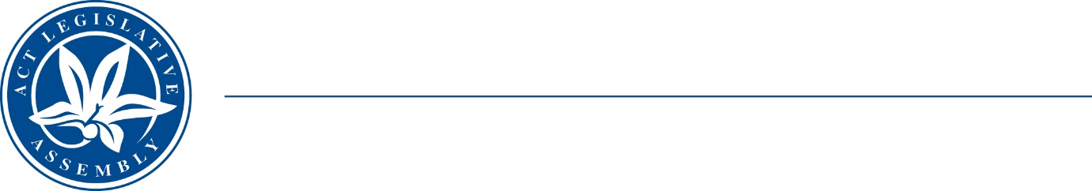
Standing Committee on Planning, Transport and City Services
Ms Jo Clay MLA (Chair), Ms Suzanne Orr MLA (Deputy Chair),
Mr Mark Parton MLA
Ms Caroline Le Couteur MLA

LEGISLATIVE ASSEMBLY
FOR THE AUSTRALIAN CAPITAL TERRITORY

MEDIA RELEASE

Inquiry into the Territory Plan and other associated documents – update

The Standing Committee on Planning, Transport and City Services (the Committee) is inviting Expressions of Interest (EOIs) to be received by Friday 27 October 2023, and hopes to hear from as many people as possible on key issues relating to the Territory Plan and other associated documents.

The Committee notes that the ACT Government received a large volume of feedback during the government’s ACT Planning System Review and Reform Project’s YourSay consultation process, which included over 1,700 responses from the community. The Committee has received all these comments and submissions and are considering these documents as part of this inquiry.

As the interim Territory Plan differs from the consultation draft, and associated documents such as the Design Guides were not published during the consultation period, the Committee is keen to hear from members of the public on these matters.

The Chair of the Committee, Ms Jo Clay MLA, said, “While the Committee is seeking EOIs to appear at the public hearings, the Committee also welcomes members of the public to:
- provide anything additional to say that was not covered in an earlier written submission to the ACT Government; or
- written submissions which focus on the above two new matters (the interim Territory Plan and/or Design Guides).
The Committee is also ongoingly seeking brief EOIs which should contain your name, whether you are writing as an individual or on behalf of an organisation, and why you would like to speak to the Committee on this topic.”

EOIs of no more than 2 pages should be sent to LACommitteePTCS@parliament.act.gov.au.

The Terms of Reference for the inquiry are available on the Committee’s webpage.

Public hearings will be conducted on Wednesday 6 and Thursday 7 December 2023. The Committee will report back to the Assembly by Monday 11 March 2024.

12 October 2023
STATEMENT ENDS.

For further information please contact:
Committee Chair, Ms Jo Clay MLA on (02) 6205 0131
A/g Committee Secretary, Ms Miona Ikeda on (02) 6205 0199 or at LACommitteePTCS@parliament.act.gov.au

