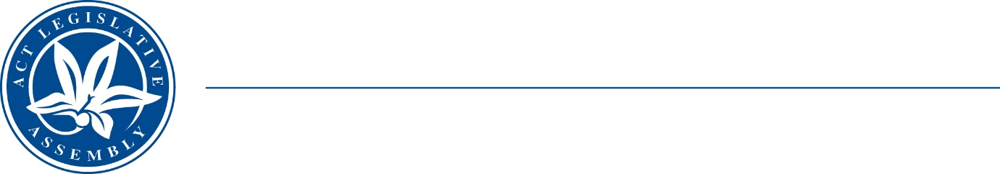
Standing Committee on Economy and Gender and Economic Equality
Ms Leanne Castley MLA (Chair), Ms Suzanne Orr MLA (Deputy Chair),
Mr Johnathan Davis MLA
Ms Caroline Le Couteur MLA

LEGISLATIVE ASSEMBLY
FOR THE AUSTRALIAN CAPITAL TERRITORY

Media Release

Report Tabling

Inquiry into LONG SERVICE LEAVE (PORTABLE SCHEMES) AMENDMENT BILL 2022
The Chair of the Standing Committee on Economy and Gender and Economic Equality, Ms Leanne Castley MLA, today tabled the Committee’s report into its Inquiry into Long Service Leave (Portable Schemes) Amendment Bill 2022. A dissenting report was tabled by Ms Castley.
The Committee’s report is available on the Assembly’s website.
Under the Assembly’s standing Orders, the Government is required to respond to committee reports withing four months of tabling.

STATEMENT ENDS—23 January 2023
–––––––––––––––––––––––––––––––––––––––––––––––––––––––––––––––––––––––––––––––––––––––––
contacts: | Ms Sophie Milne | Committee Secretary | (02) 620 50435

