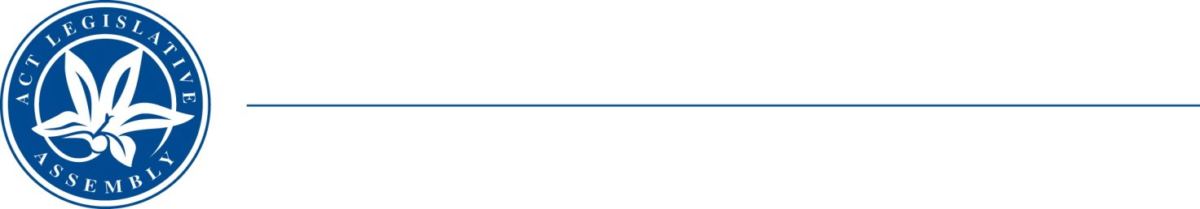
LEGISLATIVE ASSEMBLY
for the Australian Capital Territory

FOR THE AUSTRALIAN CAPITAL TERRITORY

FOR THE AUSTRALIAN CAPITAL TERRITORY

Standing Committee on Planning, Transport and City Services
Jo Clay MLA (Chair), Suzanne Orr MLA (Deputy Chair), Mark Parton MLA

Terms of Reference
Inquiry into EV Vehicle Adoption in the ACT
That the Standing Committee on Planning, Transport and City Services inquire into barriers to EV uptake and solutions and incentives to encourage uptake in the Territory, including:
- Skills development needs to support an expanding EV uptake
- Industry development opportunities
- Planning laws and regulations and education and promotions in relation to charging infrastructure requirements in a variety of residential, public and commercial configurations and precincts
- ACT Government’s role in providing charging infrastructure
- Regional charging infrastructure and whether this is a barrier to local uptake, end-of-life battery disposal, and impact of EVs on ACT power supply requirements and vehicle-to-grid issues
- Application of Territory taxes and charges for EV purchases including registration charges
- Federal taxes and charges for EV purchases, including import taxes
- Other Federal barriers to EV uptake, cost and availability of EVs, including fuel efficiency standards, impact of EV uptake on existing motor and service industry sectors including possible transition assistance, equity and just-transition issues for people on lower incomes
Any other matter relevant to this issue.

