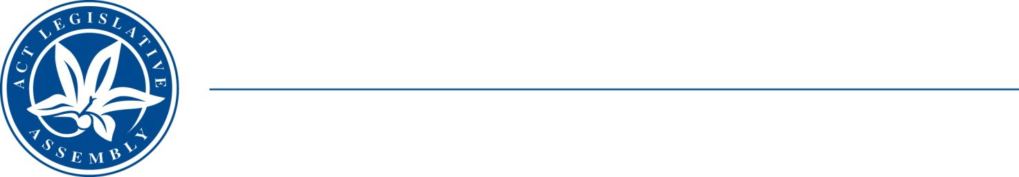
LEGISLATIVE ASSEMBLY
for the Australian Capital Territory

FOR THE AUSTRALIAN CAPITAL TERRITORY

FOR THE AUSTRALIAN CAPITAL TERRITORY

Standing Committee on Planning, Transport and City Services
Jo Clay MLA (Chair), Suzanne Orr MLA (Deputy Chair), Mark Parton MLA

Media Release
On 3 March 2021 the Standing Committee on Planning, Transport and City Services resolved to inquire into a petition on Giralang Shops lodged in the Legislative Assembly. This will include seeking an update from the developer on progress on the Giralang Shops Development.
The Committee noted:
- the development was first proposed in 2004;
- four development applications lodged but not completed since then; and an
- ongoing desire on the part of Giralang residents to enjoy the amenity of local shops and the site.
The Committee intends to hold a public hearing for the inquiry on Thursday 15 April 2021.
Submissions are invited, for a closing date of 8 April 2021.

Media inquiries to the Chair, Ms Jo Clay MLA, (02) 6205 0131 or clay@parliament.act.gov.au

Released: 12 March 2021

Petition 4-21 concerning Giralang Shops, lodged in the Legislative Assembly 10 February 2021. See Legislative Assembly for the ACT, Minutes of Proceedings, 10 February 2021, p.57, viewed 10 March 2021, available at: https://www.parliament.act.gov.au/__data/assets/pdf_file/0007/1700917/MoP005F.pdf

