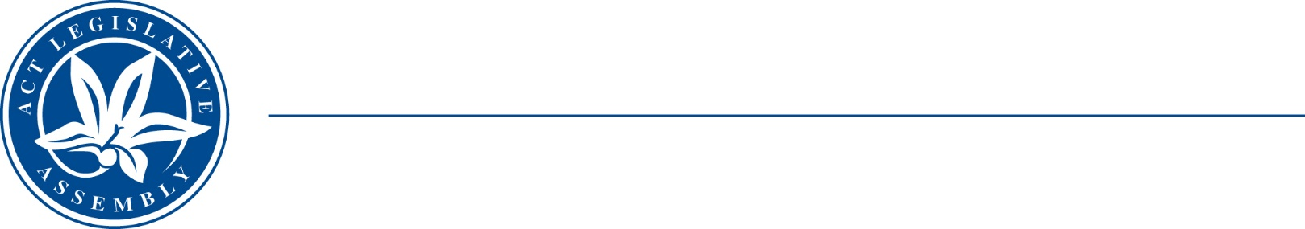
LEGISLATIVE ASSEMBLY
FOR THE AUSTRALIAN CAPITAL TERRITORY

Standing Committee on Economy and Gender and Economic Equality
Mr James Milligan MLA (Chair), Ms Suzanne Orr MLA (Deputy Chair),
Miss Laura Nuttall MLA
MEDIA RELEASE

Inquiry into micro, small and medium business in the ACT region—report tabled

The Chair of the Standing Committee on Economy and Gender and Economic Equality, Mr James Milligan MLA, today tabled the Committee’s report on its Inquiry into micro, small and medium business in the ACT region.

The Committee received 10 submissions and was pleased to hear from several peak bodies and industry associations. The Committee decided not to hold public hearings, and to proceed on the written evidence provided.

The Committee’s report makes 12 recommendations relating to the regulatory environment, ACT Government assistance, and building skills and training opportunities.

‘The Committee would like to thank everyone who contributed their expertise to this inquiry,’ Mr Milligan said.

The Committee’s report is available on the Assembly’s webpage at https://www.parliament.act.gov.au/parliamentary-business/in-committees/recent-reports
Under the Assembly’s standing orders, the ACT Government is required to respond to committee reports within four months of tabling.

27 August 2024
STATEMENT ENDS.

For further information please contact:
Committee Secretary, Ms Sophie Milne on (02) 6205 0435 or at LACommitteeEGEE@parliament.act.gov.au

