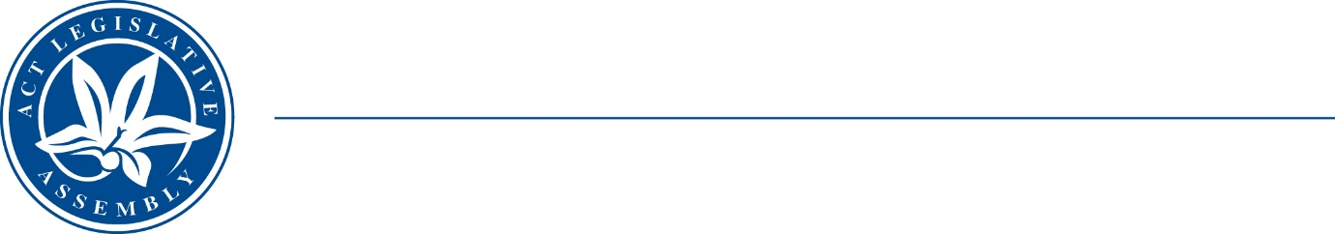
Standing Committee on Planning, Transport and City Services
Ms Jo Clay MLA (Chair), Ms Suzanne Orr MLA (Deputy Chair),
Mr Mark Parton MLA
Ms Caroline Le Couteur MLA

LEGISLATIVE ASSEMBLY
FOR THE AUSTRALIAN CAPITAL TERRITORY

MEDIA RELEASE
Inquiry into electric vehicle (EV) adoption in the ACT
The Standing Committee on Planning, Transport and City Services will hold a public hearing for its Inquiry into electric vehicle (EV) adoption in the ACT on Wednesday 1 March 2023.
The Committee Chair, Ms Jo Clay MLA, said, ‘The Committee is very pleased to see such strong engagement from community and industry with this inquiry. We have received 73 written submissions covering a wide range of issues such as charging infrastructure for the general public and in multi-unit dwellings, fuel efficiency standards, range anxiety, impacts on the electrical grid, and fire hazards. We look forward to hearing from several submitters, as well as the Minister for Water, Energy and Emissions Reduction and the Minister for Transport and City Services and Minister for Skills, at the hearing.’
Members of the public are welcome to attend the hearing in the Prince Edward Island Room of the Legislative Assembly from 9 am to 5 pm on 1 March 2023. Proceedings will also be live-streamed on the Assembly website.
The Terms of Reference of the inquiry are available at: https://www.parliament.act.gov.au/parliamentary-business/in-committees/committees/ptcs/inquiry-into-ev-adoption
27 February 2023
STATEMENT ENDS.

For further information please contact:
Committee Chair, Ms Jo Clay MLA on (02) 6205 0131
Acting Committee Secretary, Ms Miona Ikeda on (02) 6205 0199 or at LACommitteePTCS@parliament.act.gov.au

